**CHAPTER NAME - ROLE OF MAGNIFICATION IN DENTISTRY**

**AUTHORS – DR K SATHYA NARAYANAN, DR TINI TREESA BENNY, DR ANJANA ALEYS MATHEW**

**ORGANIZATION NAME – SATHYABAMA DENTAL COLLEGE AND HOSPITAL, CHENNAI**

**CHAPTER CONTENTS**

1. **INTRODUCTION**
2. **MAGNIFICATION SYSTEMS**
3. **LOUPES**
4. **DENTAL OPERATING MICROSCOPE**
5. **OPERATIVE DESIGN PRINCIPLES**
6. **ERGONOMICS**
7. **ENDOSCOPE**
8. **OROSCOPE**
9. **RECENT ADVANCES**
10. **CONCLUSION**

**INTRODUCTION**

Diagnosis of any oral disease is almost entirely based on visual examination, sometimes aided by radiographs. In addition, evaluation of the activity of the carious lesion is also done using visual criteria. Increasing the visual capacity of the operator should, therefore, potentially reduce the number of operative treatments. At higher magnification, many signs of inactivity of the lesion (dark colour, shininess, no retention of dental plaque) encourage postponement of such operative treatment, as long as the caries risk does not change (33). It is, therefore, clear that all dentists, specifically restorative dentists and endodontists routinely perform procedures requiring resolution well beyond the 0.2-mm limit of human sight. The human naked eye is capable of distinguishing fine details, but it is no match for what can be accomplished when an image is sharpened and enlarged (34).Any device that enhances or improves a clinician's resolving power is extremely beneficial in producing high-quality precision dentistry. This is where magnification helps. Magnification systems like loupes and the dental operating microscope fill that optical void and provide clinicians an increased image size with improved clarity by many orders of magnitude, improved posture while practicing, which translates into less stress and fatigue during the day, a higher confidence level, and ultimately a higher quality of care (33).

**MAGNIFICATION SYSTEMS**

Broadly, the concept of magnification-enhanced dentistry incorporates the use of two types of optical magnification systems:

(a) Loupes

(b) Dental operating microscope

In addition to these, surgical endodontics makes use of two other systems, specifically:

c) Endoscope

d) Orascope

**LOUPES**

The most common magnification system used in dentistry is the magnifying loupe. Magnifying loupes were developed to address the problem of proximity, decreased depth of field, and eyestrain occasioned by moving closer to the subject (1). Loupes consist of two monocular microscopes, with side-by-side lenses that work on the principle of convergent optics. (2)

* **CONVERGENT OPTICS**

Convergent optics is defined as the technique employed by all loupe systems to create a stereoscopic image. In order to create a focused image, lenses in loupes are angled slightly toward each other in the horizontal plane (convergence) (Figure 1). The convergence angle is either adjustable or fixed, depending on the particular loupe system chosen. (3) Their major disadvantage is that the eyes converge to view an image (Keplerian optics), which can result in eye strain, fatigue, and even vision changes with the prolonged use of poorly fitted loupes (35).

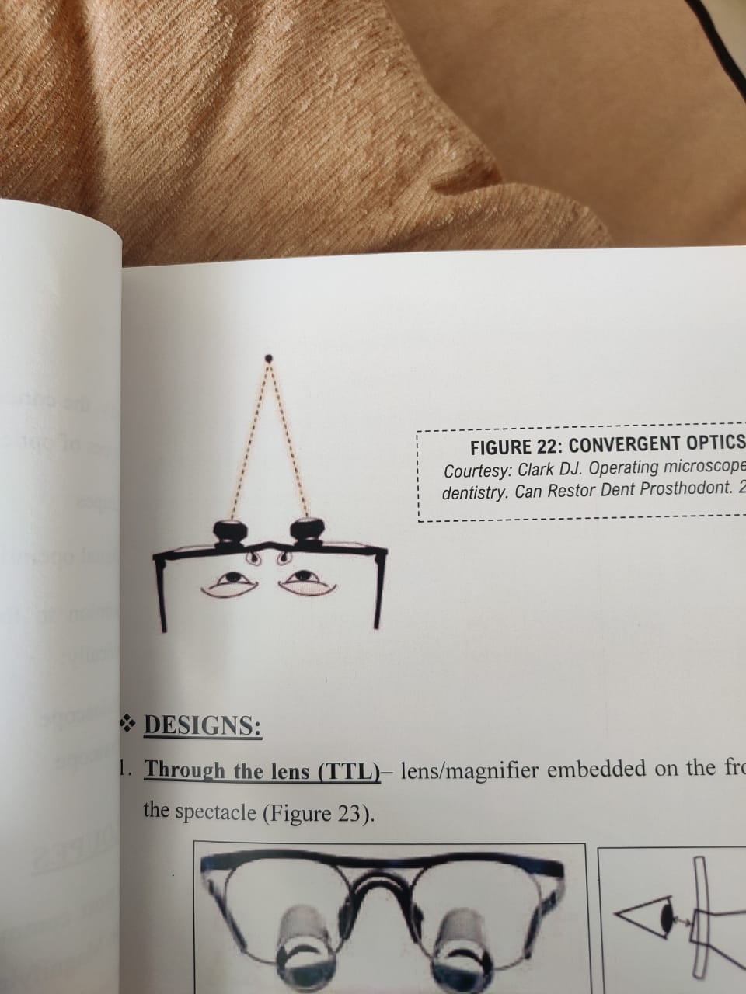

Fig.1.Convergent optics of loups

**CLASSIFICATION**

There are 3 types of binocular magnifying loupes (1):

(1) a diopter, flat-plane, single lens loupe,

(2) a surgical telescope with a Galilean system configuration (2-lens system)

(3) a surgical telescope with a Keplerian system configuration (prism roof design that folds the path of light).

* **SIMPLE LOUPES**

These are also called diopter/ flat plane systems. Simple loupes consist of 1 pair of positive meniscus lenses (Figure 2). These loupes are basically magnification lenses and are limited by spherical aberration and color fringing at magnification powers above 1.5x. Color fringing occurs because the single lens causes different wavelengths (colors) of light to be focused at different points. The only selling point of this type of loupe has traditionally been low cost; however, because of advances in optical technology, this type of system is not currently offered by any of the major optical suppliers surveyed. It is available in most drugstores as "reading glasses." (3)

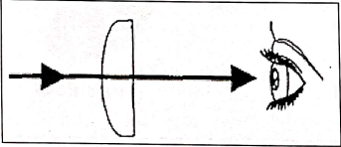

Fig.2. Simple Loupes

**SURGICAL TELESCOPES**

* Galilean (conical shaped lens) (Figure 3,4)
* Keplerian (cylindrical lens) (Figure 3,5)

These designs produce enlarged viewing image with a glass based multiple-lens system that is positioned at a working distance between 11 and 20 in (28–51 cm). The most used and suggested working distance is between 11 and 15 in (28–38cm) (1).

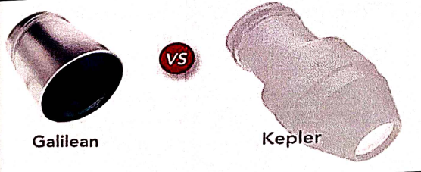

Fig 3. Galilean and Keplerian Loupes

* **COMPOUND LENSES**

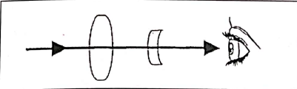

Fig 4 compound lenses

Compound loupes consist of a set of 2 magnification lenses separated by air spaces (Figure 4,5). The inner eyepiece lens is concave while the outer objective lens is convex. Together, these lenses offer greatly improved optical qualities over those of simple glasses. With the additional lens in this system, higher magnification powers, greater depth of field, and greater working distances can be achieved without increase in size and weight (magnification from 2x to 4.5x) (3,4).

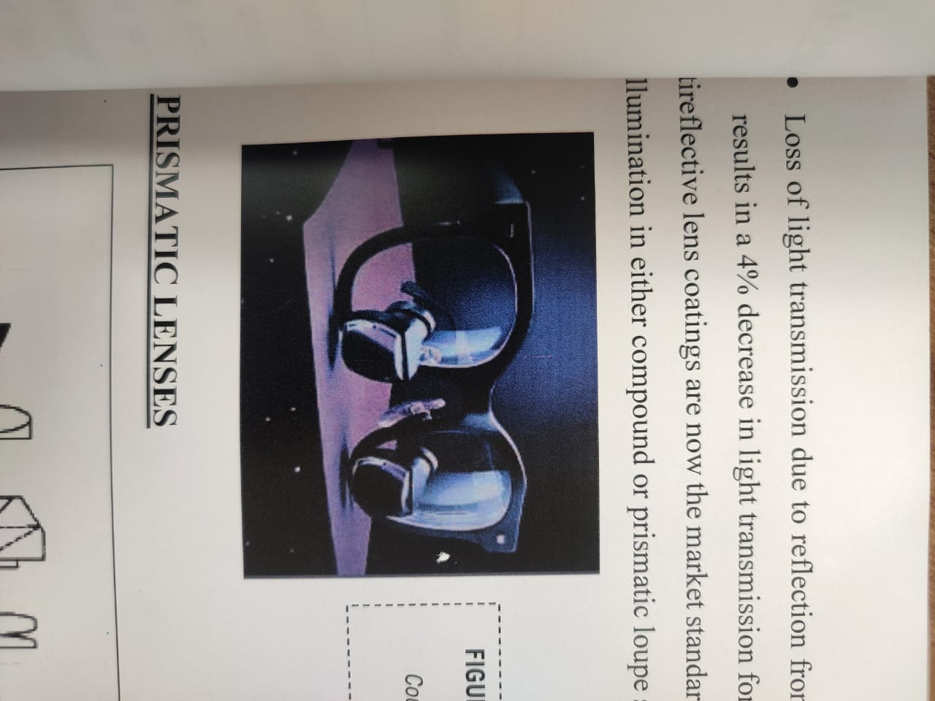

Fig 5. Galilean/Compound Loupes

* **PRISMATIC LENSES**

.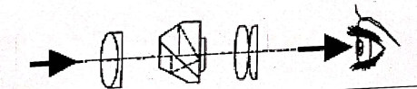

Fig 6. Prismatic loupes

Prismatic loupes provide the highest optical quality available today. These loupes consist of 2 convex lenses along with a Schmidt prism and are essentially low-power telescopes with complicated light paths, which provide magnifications up to 6x. The prism lengthens the path of light through a series of mirror reflections inside the loupe. This "folding" of the light effectively allows the barrel of the loupe to be shortened (Figure 6,7). (1)

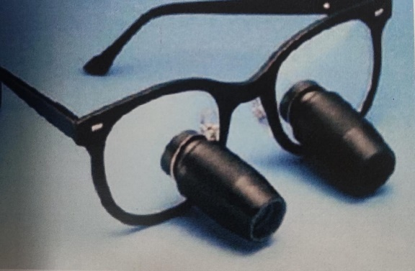

Fig.7.Keplerian system of loupes

**GETTING STARTED: SELECTION OF LOUPES**

Although there are no straight forward recommendations that can be made, some knowledge about optical principles and loupe design can be used in order to make prudent judgments. (5).

1. POWER:

Loupe systems contain multiple positive and negative lenses (compound loupes). Because corrective prescription lenses may also be employed, the effective diopter (refractive) power of a loupe is not consistently related to its magnifying power. The resolution and field size of the operating site are much more relevant quality criteria than is the size of the image. One must give the greatest attention to the sharpness of the image at the most appropriate and comfortable working distance. These criteria largely depend on personal preference and height of the operator as well as the type of procedures performed. (3) The taller the practitioner is, the higher the magnification should be, since the practitioner's head is farther from the operating site and the image is smaller. (5)

2) PRESCRIPTIONS

In order to maximize visual optics and to prevent eyestrain and fatigue, dentists should use their normal visual correction.

For flip-up loupes:

Optical prescriptions can only be placed in the carrier/frame lens in a flip-up loupe system. This design facilitates changes in the surgeon's prescription, which can be handled by any local optician. When the barrels are flipped down, the dentist will be able to look through the carrier lens, with their corrected vision, and then look through the barrels for additional clarity.

For through-the-lens systems:

Prescriptions can be placed in both the optical barrels (at the back of the barrel) and in the carrier lens. Such loupes must be sent back to the manufacturing company for any future prescription changes. Contact lens wearers may choose not to have their correction incorporated into the loupes (3)

3) DESIGN:

In the case of surgical telescopes, the designer must coordinate the point of focus with the placement of the scope in front of the eye. The farther away from the eye and the higher the angle off the frame, the more forward is the scope's center of gravity. The resulting torque manifests itself most noticeably to the operator as discomfort on the bridge of the nose. The more downward the angle and the closer it is to the midline of the body, the more comfortable is the device (5).

4) MATERIAL:

Plastic devices are lighter and less expensive than the ground glass alternatives but pose many problems. Plastics soften at relatively low temperatures, thus producing a far greater index of refraction than glass. They are much more easily scratched than glass. Because of thermal limits and chemical reactions, antireflective coatings are extremely difficult to apply. The qualities of glass lenses are centered on the ABBE number (a measure of a medium's ability to bend light relative to the dispersion) and index of refraction. Lead monoxide (PbO) increases the index of refraction as do boron oxide & fluorides (5).

5) POSITION & POSTURE:

The dentist must be able to see over the device in order to maintain eye contact when talking to the patient. The loupes must allow vision over the device in order to monitor the passing of instruments and the activities of personnel. Of particular interest to the dentist concerned with operator positioning is the effect of certain types of surgical telescopes on one's posture. Loupes mounted in the lower third of the lens and with sufficient downward angle allow the head to remain more in line with the long axis between shoulder and hip. The center of body mass is balanced when the use of anti-gravity muscles is minimized. The choice is influenced by the operator's age, physical condition, operatory arrangement, type of practice, personal habits. While wearing loupes, clinicians should be able to sit or stand in a comfortable position with normal posture. This requires proper selection of focal length and declination angle, as well as proper alignment of the binocular loupe optics (5).

6) INFECTION CONTROL

Magnification loupes are not disposable and must be cleaned and disinfected between each patient. They collect debris from many procedures during a clinical day. Ideally, all areas of the loupe should be disinfected with a high-level disinfectant after each patient. Disinfecting with high ethyl alcohol solution is recommended. If the lenses are water resistant, products such as Lysol Disinfectant Spray may be sprayed into a gauze sponge and used to wipe the frames and lenses. Whenever possible, the clean, disinfected loupes should be in position on the clinician when the clinical procedure is started and left in place until the clinical procedure is completed, and hand contact with the loupes should be avoided during the procedure (36).

**DENTAL OPERATING MICROSCOPE**

Apotheker and Jako in 1981 introduced the first dental operating microscope (Figure 8) with the following goals in mind:

1. Stereoscopic and binocular vision.

2. Magnification of approximately 5-10x with high resolution and good contrast.

3. A wide field and flat view.

4. An adequate working distance between the object & microscope (200-300 mm).

5. Ease of maneuverability with attachment to either the dental unit, the dental chair, a floor mount, or a ceiling mount.

6. Adequate illumination (without the dental light) for direct observation and photographic recording.

7. Compatibility with newer technical advances, such as the surgical laser and monochromatic illumination.

8. Moderate cost.

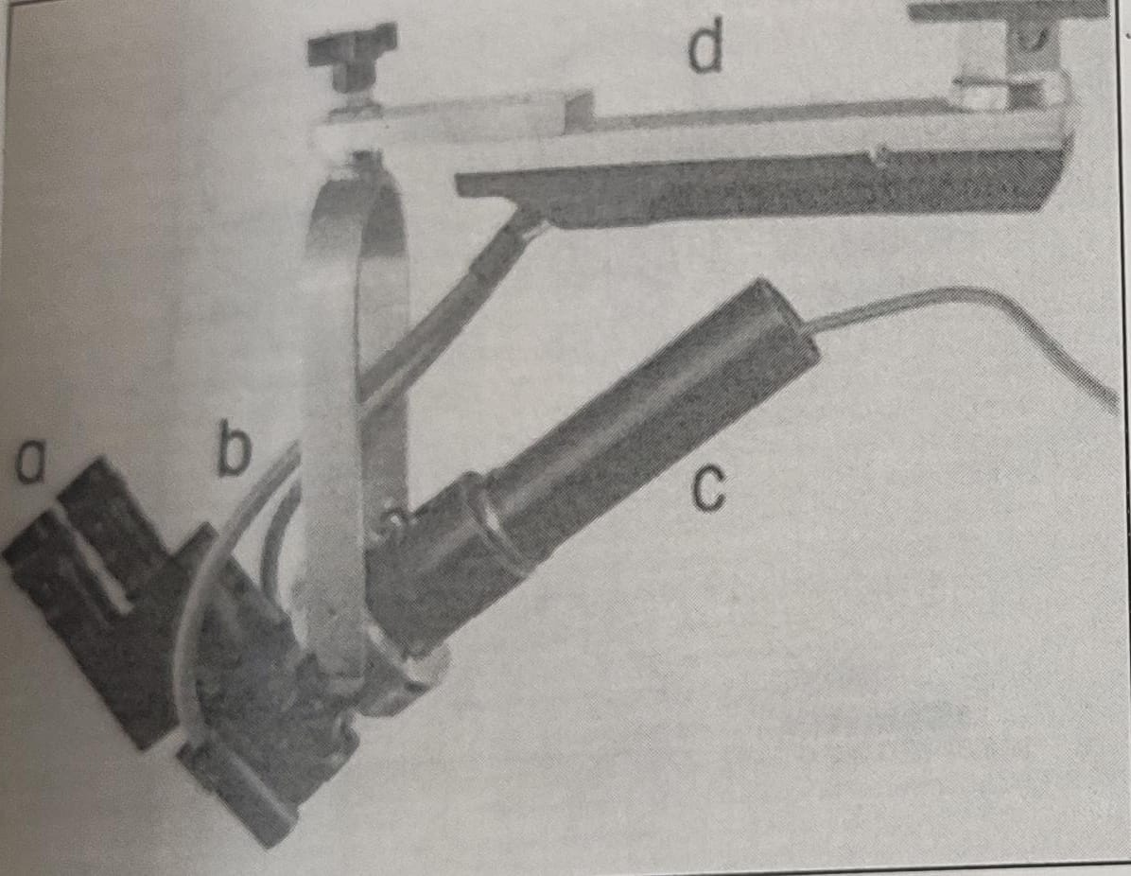

Fig 8. Components of apotheker's dental microscope.

a -Adjustable eyepieces, b-Coaxial fiberoptic illumination, c -Microvideo camera with zoom capability d- Suspension

Two types of stereoscopic microscopes were in use at the time. (Figure 9) (6)

1. Greenough type

* Two monocular microscopes arranged side by side at an angle so that the two objectives focus on the same object like a pair of loupes.
* Disadvantage of this design is that the user must converge his eyes to view the image, and prolonged use of the microscope can result in eyestrain and fatigue.

2. Galilean type

* Based on the application of the magnifying loupe in combination with a binocular viewing system.
* Met all pre-determined criteria for a dental microscope by employing parallel binoculars and thereby better protection to the user from eyestrain.
* Designed on the Galilean principles and incorporated fully coated optics and achromatic lenses. This attachment allowed an assistant or a student to observe procedures under magnification.

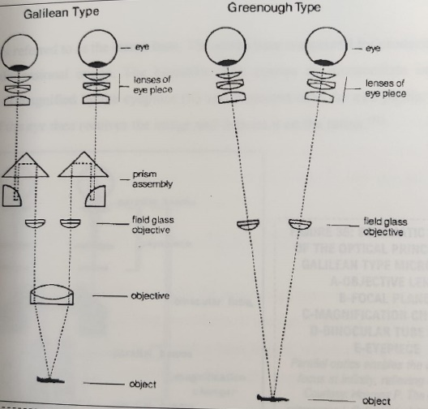

Fig 9. Galilean type and Greenough type microscope

NEW AND IMPROVED DENTAL OPERATING MICROSCOPE

In 1999, Gary Carr introduced a dental operating microscope that had Galilean optics and was ergonomically configured for dentistry, with several advantages that allowed for easy use of the scope for nearly all endodontic and restorative procedures (Figure 10). This DOM had a magnification changer that allowed for 5 discrete magnifications (3.5x-30x), had a stable mounting on either the wall or ceiling, had angled binoculars allowing for sit-down dentistry, and was configured with adapters for an assistant's scope and video or 35-mm cameras. It used a confocal illumination module so that the light path was in the same optical path as the visual path, and this arrangement gave far superior illumination than the angled light path of the earlier scope. (1)

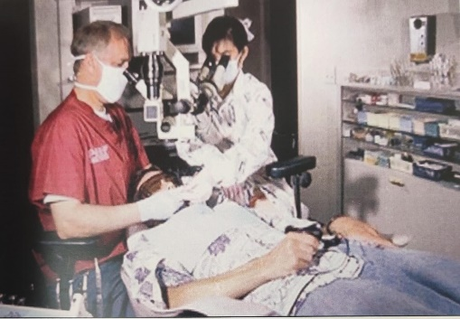

Fig.10. GARY CARR'S MODERN DENTAL OPERATING MICROSCOPE Today's OM allows the doctor and the assistant to ergonomically view the same field. This OM is fitted with a CCD

**PARTS OF A MICROSCOPE**

The DOM is a complicated system of lenses that allows stereoscopic vision at magnification of approximately 4x-40x with excellent illumination of the working area (2).

❖ Objective lens

The objective lens is the first optical component at the front end of a DOM that the image information crosses on its path from the object to the eye. The most common working distances are 200, 250 and 300 mm. The focal distance is engraved on the lens mount. This roughly equates to the working distance of the lens. In order to view the image clearly, the objective lens (e.g., f = 250 mm) must have a working distance of approximately 250 mm to the object. The object is then within the focal point of the lens. The DOM can be raised or lowered to focus the object, provided the lens has been set to a distance of 250 mm from the object. The shorter the focal distance, i.e., the working distance of the lens, the greater the end magnification and the greater the resolution. (7)

* Binocular tubes

The function of binoculars is to hold the eyepieces. The binocular tube head contains a lens with a defined focal distance which projects an intermediate image into the focal plane of the eyepieces inside the tube head to create an upright, accurate image. The distance between the pupils varies from person to person and ranges from 54 to 76 mm.

TYPES:

* Straight
* Inclined

DOMs are used in an almost perpendicular position above the patient in dentistry. (7) Swiveling tubes that permit continuously adjustable viewing allow for more flexibility in the vertical dimension and also permit multiple axis locations of the microscope body while maintaining comfortable binocular-eye positions, (8) A 45° inclined tube head is fixed at an angle of 45° and offers limited ergonomics. An inclinable tube head (0-180°) allows the dentist to alter the angle of the eyepiece holders by 180° (Figure 11) Even more flexible and adaptable to different body heights and working postures of the dentist is the foldable tube head (Figure 12) (7).

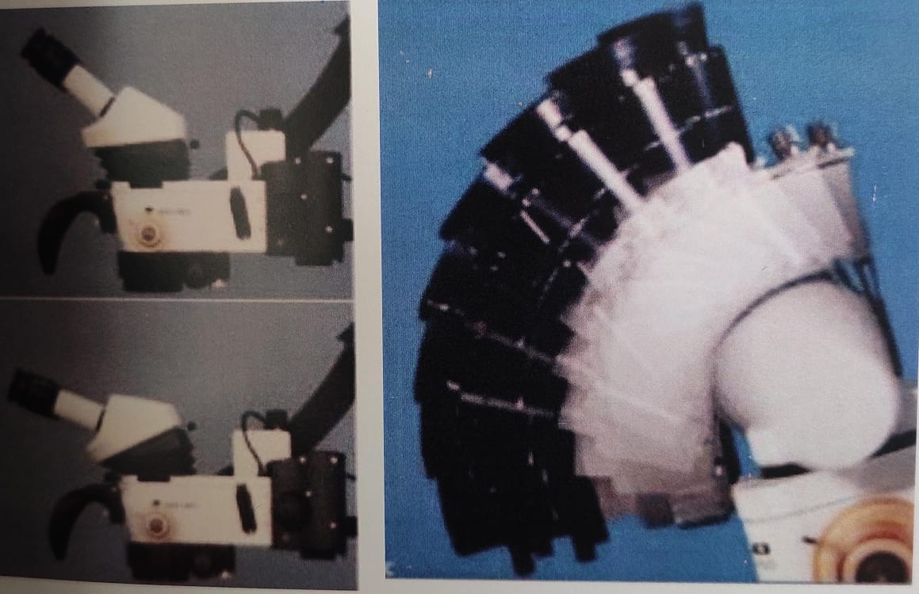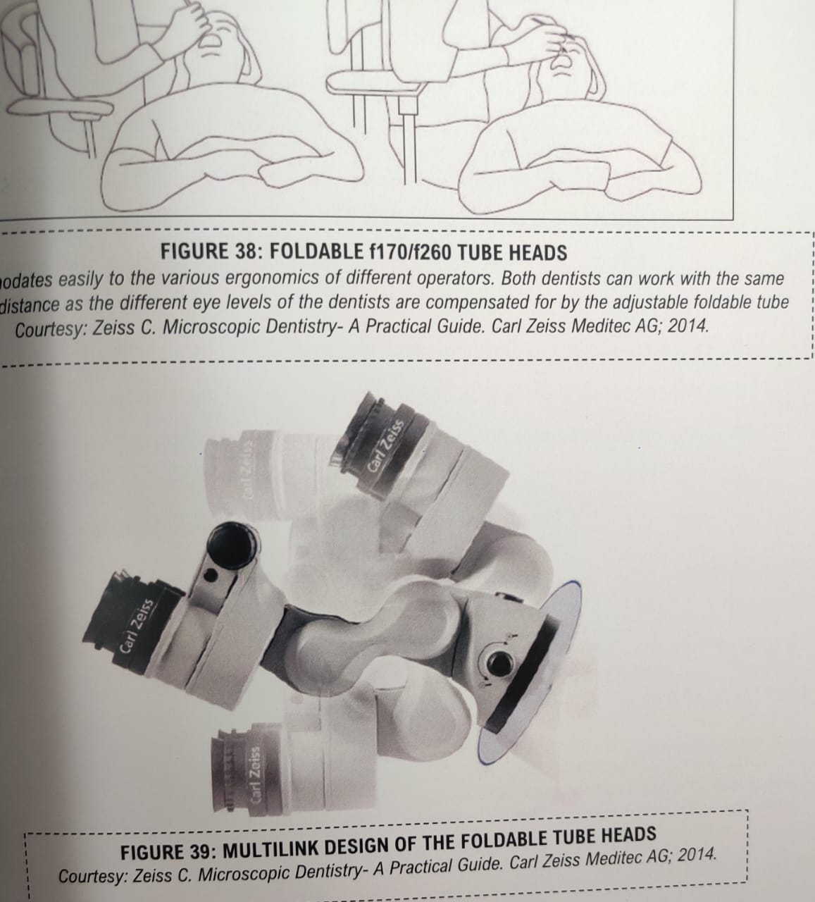

Fig .11. INCLINABLE BINOCULARS Fig 12. Multilink design of the foldable tube heads

* Eyepieces

The magnification factor (10x or 12.5x) is labelled on the eyepieces. Anyone requiring higher magnifications (e.g., for endodontics) will choose eyepieces with 12.5x magnification. Eyepieces with 10x magnification do, however, a considerably larger field of view, and can therefore provide a better overview of the entire treatment area. Eyepieces are fitted with a ring for dioptric adjustment. This means that dentists with perfect or impaired vision can use the DOM. The dentist's eyes must be at a certain distance to the eyepieces so that they are in the exit pupils of the eyepieces and can see the entire field of view. Dentists who wear glasses should retract the distancing rings as the glasses already function as a spacer (Figure 13). (7)

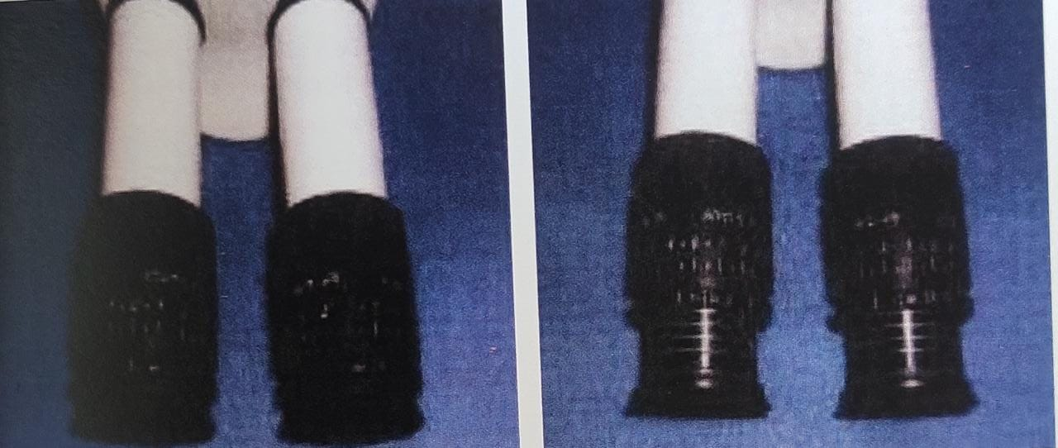

Fig .13 left-eyecups retracted for operators who wear glasses; right-eyecups, extended for operators who do not wear glasses.

Setting the eyepieces

Diopter range is -5 to +5 for adjustment of eye-lenses. An adjustable interpupillary distance permits correct, stereoscopic vision throughout the visual field (Figure 42). The focal length required for focusing on the work area between the objective lens and the operating field can be adjusted manually with small knob until the 2 divergent circles of light combines to form a single clear focus area (8).

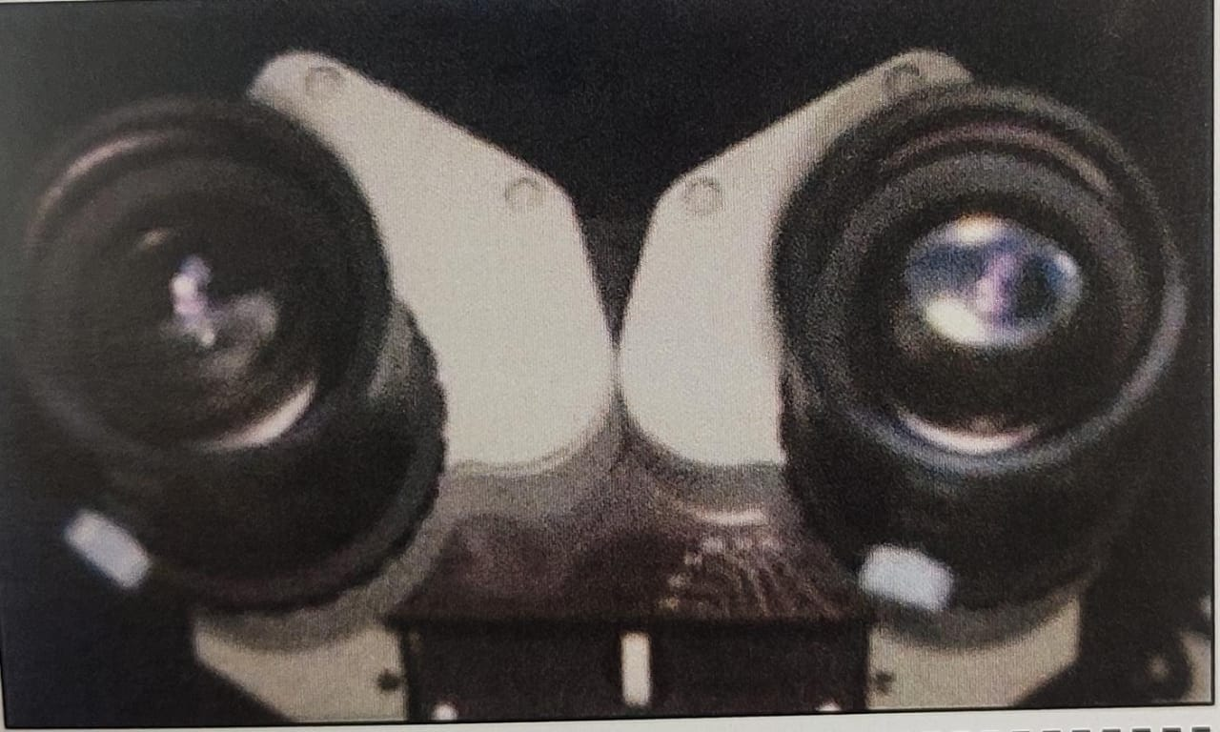

Fig.14. Adjustable intraocular distance permits correct alignment of eyepieces to individual needs.

❖ Magnification changers

During treatment it is important that the magnification factor can be altered to gain an overview at lower magnifications and to view in more detail at higher magnifications. There are two technical solutions for this purpose:

1. Magnification changer (Galilean changer)

2. Stepless zoom system. (7)

Magnification changers are located in the head of the microscope and are available as 3,4,5/6-step manual step/zoom changers or power zoom changers (8).Manual step changers consist of 2 telescope systems that are mounted on a turret (similar to laboratory microscopes). The turret is connected to a dial, which is located on the side of the microscope housing. The dial positions one lens in front of the other within the changer to produce a fixed magnification factor (9). Rotating the dial reverses the lens positions and produces a second magnification factor (Figure 15). Usually the magnification factors are 0.4, 0.6,1.0, 1.6, 2.5. (7)

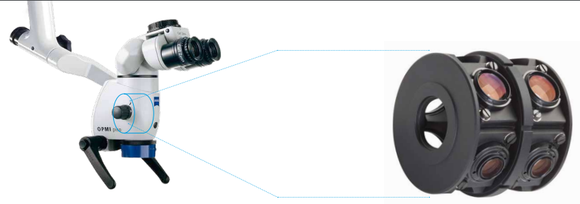

Fig 15. Magnification step-changers

A manual zoom changer is merely a series of lenses that move back and forth on a focusing ring to give a wide range of magnification factors. A power zoom changer is a mechanized version of the manual zoom changer. Power and manual zoom changers (stepless changers) (Figure 16) avoid the momentary visual disruption or jump that is observed with manual step changers as you rotate the turret and progress up or down in magnification.

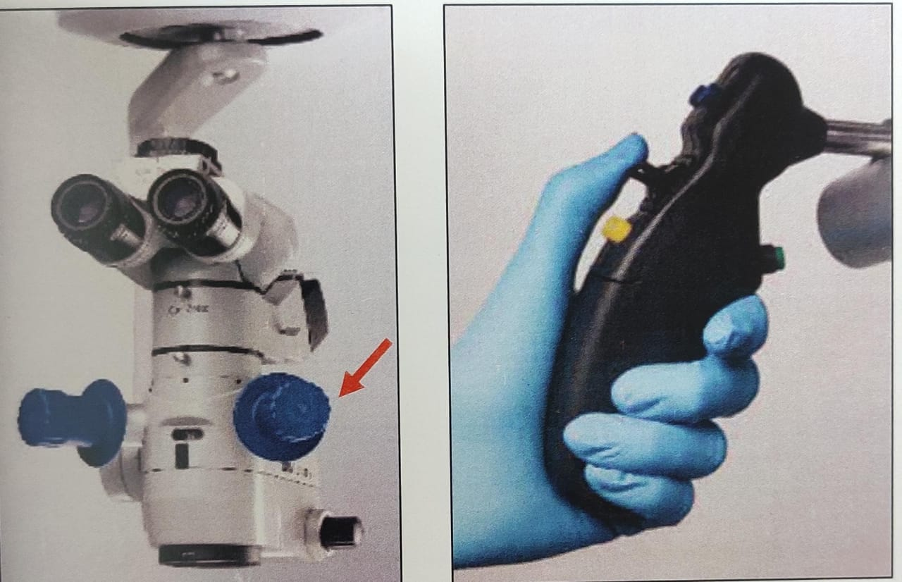 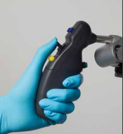

Fig 16. Left-manual zoom; right-motorized zoom

❖ Total magnification

Power of magnification is decided by a magnification factor. A combination of 4 factors determine the total magnification of an operating microscope (Table 1).

They are:

i. Focal length of the binocular

ii. Focal length of the objective lens

iii. Eyepiece power

iv. Magnification changer factor

Thus, the formula for the total magnification can be equated as follows: (10)

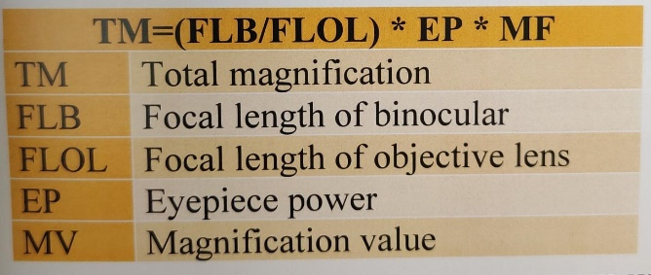Table 1. The formula for calculating total magnification

❖ Lighting unit

The light source is situated in a pre-centred lamp/bulb socket on the back side of the microscope. A collecting system and two reflecting prisms transmit the light through the front objective in the immediate vicinity of the ray paths of the image, without, however, in any way interfering with these rays (12).The illumination finally reaches the operating field area almost parallel to the viewing axes and produces a bright, uniformly illuminated, circular spot. This spot is concentric with the microscope's field of view. This type of illumination, termed "coaxial," is capable of providing shadow-free illumination. (13)

Light sources can be:

1. Incandescent bulbs (older models)

2. Quartz halogen light bulb

* First dental microscope light source used
* Light is carried via fiberoptics which have a tendency to absorb light and cause deficiencies
* Artificial yellow light due to higher color temperature which is not indicated for high-quality documentation.

3. Xenon light.

100-watt xenon lights produce white light like daylight at 5000° kelvin and function up to 10 times longer than halogen lamps and deliver exceptionally bright images with sharper contrast. (2)

4. Light emitting diode (LED)

Similar to xenon in color temperature and appear close to natural daylight Heat emission from led radiates from the back of the light source, resulting in a greatly reduced temperature surrounding the microscope. (14)

ACCESSORIES

* Filters

This provides uncompromised faculty in handling light-sensitive materials under microscope-assisted vision during adhesive and bonding procedures. With the orange filter in position, the operator can work with full visibility from the coaxial illumination and magnification without the frustration of premature curing of the photosensitive materials. A green filter is also available for surgical procedures(8)

* Beam splitter

The beam splitter is the principal part that makes possible the attachment of other observation and documentation accessories. It is possible to insert beam-splitting cubes in the path of the parallel rays that allow a portion of the rays to pass unhindered, yet divert another portion of the rays away from the original path to the outside at a 90° angle. The beam splitter divides each path of light into two parts (50:50); one goes to the operator eye and the other goes to the accessory (Figure 17). (37)

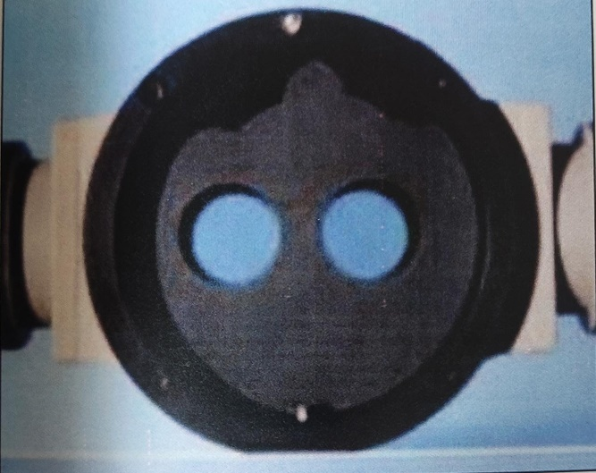

Fig 17. Beam splitter

❖ Documentation accessories

These are the video camera and the 35 mm camera. They can be mounted separately or combined, through specifically designed photo or video adaptors connected to the beam splitter (Figure 18). The digital camera can also download the images directly into a computer, allowing the rapid organization of a rich database of images. The video camera can be connected to a monitor, a videotape recorder, and a video printer. The monitor can be used not only to motivate the patient, who can see the entire videotaped procedure, but mainly to the second surgical assistant, who can follow the surgical procedure and give to the operator the right instruments at the right moment. (11)

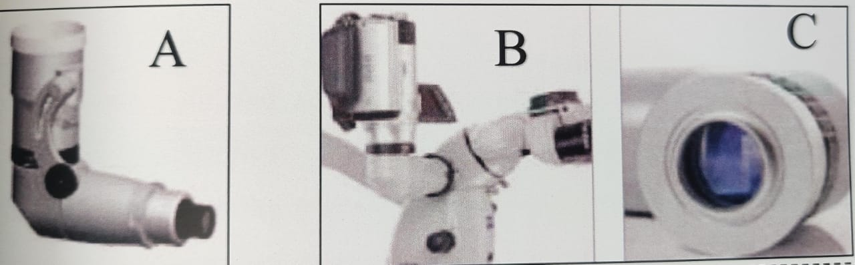

Fig 18. A) still adapter for cameras; b, c) flexiomotion adapter for video cameras

* Co-observation tube

Co-observation means that a second person (e.g. assistant) or even more persons (e.g. students, colleagues) can follow the treatment under the operating microscope. Usually, a camera is used to show the live image on a monitor. The advantage of a camera-based co-observation is that one or more persons can follow the treatment without directly looking through the operating microscope. To achieve 3D perception for the co-observer it is possible to mount a co-observation tube. The co-observation tube can be connected via an optical splitter between the body and the binocular tube. (7)

❖ Mounting system

The stability of the microscope is an important feature that helps prevent micromovement of the scope, causing disruption of the operator's visual image during use. (8) Depending on the space available in the operatory, the mounting system can be selected options include:

* Ceiling
* Wall
* Floor mounting (Figure 19)

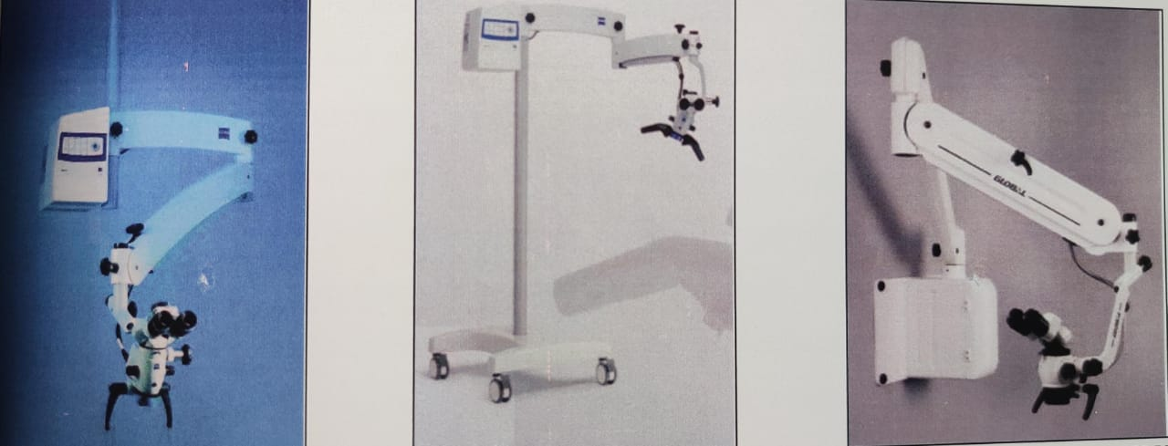

Fig 19. [L-r] ceiling, floor, wall mounted microscopes

The ceiling and wall mount have fixed positions and cannot be moved; however, they help in space management. The floor mount can be transported easily but may occupy more space. The microscope should be ideally mounted in a position that is to the left of the patient for the right-handed operator and approximately at the patient's hip area. This position not only allows for sufficient maneuverability of the microscope in multiple planes, but it also allows easy storage during times of non-use (2).

**OPERATOR POSITION**

The dentist has to determine whether the work will be performed with direct or indirect vision of the operating field, which implies changes in the microscope position, if there is a need to focus the image directly or with the aid of mirrors. The dentist should always assume a location behind the patient's head, with an orientation between 9 and 12 o'clock position, sitting on a bench or adjustable chair. For nearly all endodontic procedures, the 11- or 12-o'clock position is best suited (Figure 20). (15) Positions other than the 11- or 12-o'clock position (eg, 9-o'clock position) may seem more comfortable when first learning to use a DOM, but as greater skills are acquired, changing to other positions rarely serves any purpose.

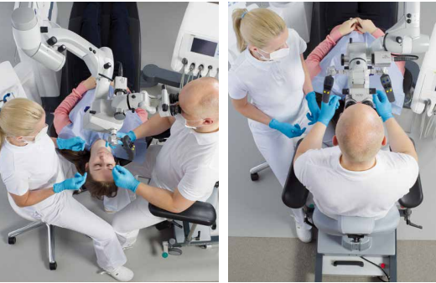

Fig 20. Operator position. Left:9 o clock position; right: 12 o clock position

Once seated:

* The operator should adjust the seating position so that the hips are 90° to the floor, the knees are 90° to the hips, and the forearms are 90° to the upper arms.
* The operator's forearms should lie comfortably on the armrest of the operator's chair, and feet should be placed flat on the floor.
* The back should be in a neutral position, erect and perpendicular to the floor, with the natural lordosis of the back being supported by the lumbar support of the chair.
* The eyepiece is inclined so that the head and neck are held at an angle that can be comfortably sustained (1).

**OPERATOR CHAIR**

The dentist's chair must have at least five wheels, allowing it to form an angle between 105° and 110° between the dentist's leg and thigh when seated, ensuring that the pelvis is tilted forward. The chair seat's dimensions should allow the dentist to sit without pressure on any region of the pelvis and thighs. The seat must be divided into two parts to assure a balanced position, presenting a horizontal portion with a 15 cm minimum length (the maximum distance between the ischial tuberosities and the back of the body) and a front anti-clinal angle of 20° in relation to the horizontal plane, which is considered optimal to support thighs. The maximum seat depth should be 40 cm, the width 40 cm to 43 cm, and the height of the lumbar support 12 cm to 30 cm in length, to not exceed the iliac crest level. The lumbar support can be vertically adjustable between 17 cm and 22 cm, and up to 24 cm for very tall dentists. Otherwise, it will inhibit free arm movements. Correct ocular selection is also critical, as it will affect the correct position of the dental operating microscope. (16)

**ROUGH POSITIONING OF THE PATIENT**

The patient should be positioned varying from a slight supine to a Trendelenburg position, so that the working area is as close as possible to the DOM. Head position can be further adjusted by using the horizontal and vertical control buttons of the chair, allowing to control the relative distance to the microscope. To perform procedures in the maxilla and in the mandible the most suitable positions for the head placement are those usually adopted in daily work; i.e., the occlusal plane perpendicular to the ground for the maxilla procedures, and the occlusal plane parallel to the ground for the mandible procedures (Figure 57). (16)

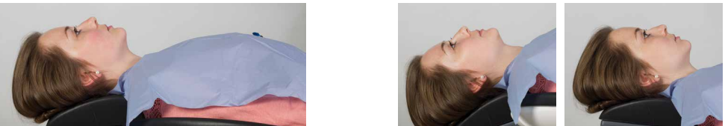

Fig 21. Patient position A-Supine position B-Head rest adjusted for indirect (mirror) view of mandible where the mandibular occlusal plane is vertical C-Head rest positioned for indirect view of the maxillary teeth with maxillary occlusal plane vertical

**ADJUSTMENT OF THE INTERPUPILLARY DISTANCE**

Looking through the binocular, each eye sees a small circle of light. The interpupillary distance should be now adjusted by taking the two halves of the binocular head of the microscope and moving them apart and then together, until the two circles are combined and only one illuminated circle is seen (Figure 23). Adjustable rubber cups extend from the ends of the eyepieces. Those glasses should have the cups in the lowered/retracted position and those who work without glasses should work with the cups in the raised position (Figure 24) (11).

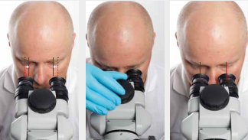

Fig 23. Interpupillary distance

(left) a-widest distance; b-adjusting distance; c-correct distance (right)- Start from the widest position of the eyepieces and use knob of the tube head to adjust the distance of the eyepieces to your interpupillary distance so that the two eyepiece images merge into one

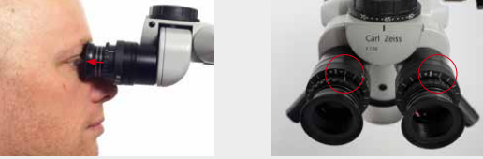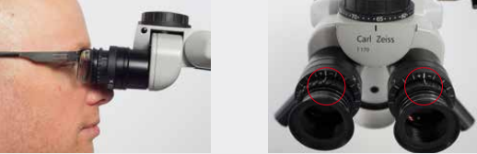

Fig 24. Adjusting eyepieces

Eyecups: Adjust the eyecups in such a way that the entire field of view can be seen.

* Viewing without eyeglasses: screw out the eyecups until 2-3 silver rings are visible
* Viewing with eyeglasses: screw in the eyecups all the way (no silver ring visible)

Diopter correction: Set the diopter setting ring on the DOM to 0 diopters.

* Viewing without eyeglasses: set diopter correction according to your correction value of the eye
* Viewing with eyeglasses: set diopter setting ring on the OPMI to 0 diopters

**OPERATORY DESIGN PRINCIPLES**

The DOM was originally introduced into standard dental operatory that have been designed in the conventional way, with outdated ergonomic concepts using the traditional operatory side cabinets, dual sinks, over-the-patient delivery systems, etc (Figure 27). This historical design turned out to be extremely inefficient because of the ergonomic constraints imposed by the way the DOM is actually used in endodontic procedures. There is an ergonomic flow to using a DOM efficiently, and careful operatory design is critical in enabling this flow. One of the main reasons clinicians struggle with using the DOM for all procedures is that the ergonomic design of the operatory prohibits it. Clinicians who attempt to use the DOM for all procedures but do not have appropriate ergonomic designs to their operatories experience significant frustrations (1).

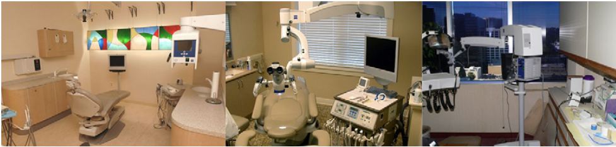

Fig 27: Traditional operatory. Large side cabinets, sinks, and so forth. A design such as this makes efficient DOM use problematic

**ERGONOMIC MOTIONS**

An understanding of efficient workflow using a DOM entails knowledge of the basics of ergonomic motion (1). Ergonomic motion is divided into 5 classes of motion

* Class I motion: moving only the fingers (Figure 28)
* Class II motion: moving only the fingers and wrists (Figure 29)
* Class III motion: movement originating from the elbow (Figure 30)
* Class IV motion: movement originating from the shoulder (Figure 31)
* Class V motion: movement that involves twisting or bending at the waist. (Figure 32)

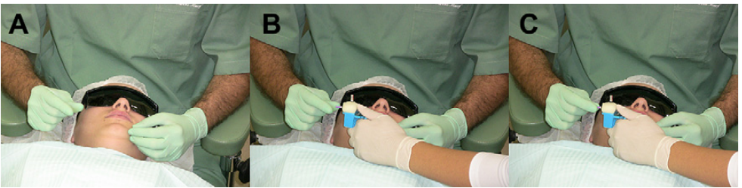

Fig. 28 (A) Fingers waiting for the file. (B) File placed in between fingers. (C) Fingers capturing file.

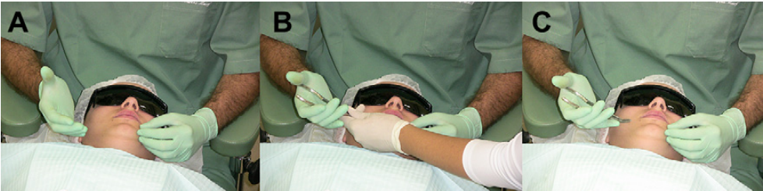

Fig. 29. (A) Hand waiting for the instrument. (B) Fingers and wrist movement receiving the instrument. (C) Fingers movement receiving the instrument.

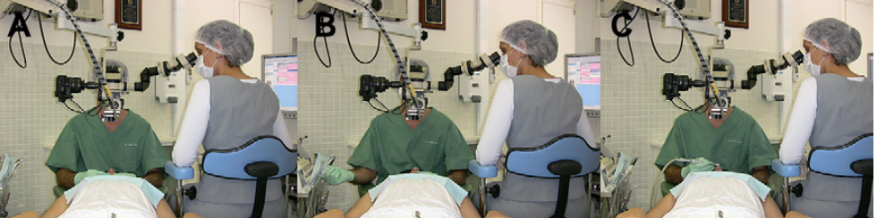Fig. 30. (A) Elbow rested at the stool support. (B) Supported elbow rotation and instrument apprehension. (C) Supported elbow rotation to working position

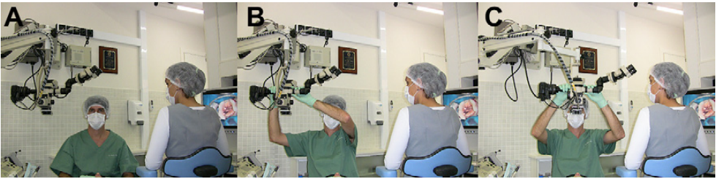

Fig. 31. (A) Professional at the neutral position. (B) Shoulders, arms, elbows, and hands moving to reach the OM. (C) OM moved to the ideal position without rotational movement of the waist.

**ERGONOMICS**

The word ergonomics results from combining the words ergos (work) and nomos (law), and it is the science that studies the interaction of the human body with the working environment constituent factors where it is integrated. Currently the concept of ergonomics is defined as "the science that aims to fit the human being with his work environment in a comfortable and productive way, adapting the working conditions to man's anatomical and physiological characteristics." It is concerned with the body biomechanics, trying to understand in detail all the movements performed by the professional, and how its poor development may affect the body. Its perspective is from the final analysis the elaboration of guidelines, with the objective of eliminating anti-anatomical postures and non- productive movements at work, preventing or extending the physical and mental fatigue limits of the worker, and preventing the onset of signs and symptoms of diseases, thus contributing to better professional performance (16).

**MUSCULOSKELETAL DISORDERS (MSDs)**

In a 1946 study, Biller et al found that 65 percent of dentists complained of back pain. Even after the evolution to seated four-handed dentistry and ergonomic equipment, studies found back, neck, shoulder or arm pain present in up to 81 percent of dental operators. Being seated has made little difference in how frequently operators experience pain. It did, however, change the part of the body in which operators experience pain. When operators sit, pain occurs not only in their backs, but also their necks, shoulders and arms (38).

The World Health Organization defines a musculoskeletal disorder (MSD) as "a disorder of the muscles, tendons, peripheral nerves or vascular system not directly resulting from an acute or instantaneous event”.(39) These disorders are considered to be work-related when the work environment and the performance of work contribute significantly, but are only one of a number of factors contributing to the causation of a multifactorial disease. While the occasional backache or neck ache is not a cause for alarm, if regularly occurring pain or discomfort is ignored, the cumulative physiological damage can lead to an injury, lowered productivity due to missed work or in a career-ending injury

The most common MSDs in dentistry include the following. (40)

* Chronic low back pain
* Tension neck syndrome:
* Trapezius myalgia
* Rotator cuff impingement
* Carpal tunnel syndrome

The negative physiological effects of using static seated postures may be exacerbated by four-handed dentistry, which was introduced to decrease operator stress and fatigue while achieving maximum efficiency. Operators who practice four-handed dentistry tend to work for longer periods without taking a break and report significantly higher frequencies of pain than those not practicing four-handed dentistry (41).

.

**PROLONGED STATIC POSTURES (PSPs)**

The human body was designed for movement. Dentists frequently assume static postures, which require more than 50 percent of the body's muscles to contract to hold the body motionless while resisting gravity. The static forces resulting from such postures have been shown to be much more taxing than dynamic (moving) forces. When the human body is subjected repeatedly to PSPs, it can initiate a series of events that may result in pain, injury or a career-ending MSD. Muscle imbalances, ischemia, trigger points, joint hypomobility and spinal disk degeneration are some of the physiological consequences of PSPs (40).

**MUSCLEIMBALANCES**

The delivery of modern clinical dentistry means that practitioners regularly maintain a neutral, balanced posture. Even with the best ergonomic equipment, operators can find themselves in sustained awkward postures. These postures often consist of forward bending and repeated rotation of the head, neck and trunk to one side. Over time, the muscles responsible for rotating the body to one side can become stronger and shorter, while the opposing muscles become weaker and elongated. The stressed shortened muscles can become ischemic and painful, exerting asymmetrical forces on the spine that can cause misalignment of the spinal column and decreased range of motion in one direction over the other. The forward-head-and-rounded- shoulder posture also increases forces on the upper neck muscles (upper trapezius and levator scapulae) and spinal vertebral disks. This stress can result in ischemia and pain in the overworked muscles. Within the cervical vertebral disk, increased pressure leads to degenerative changes, putting the disk at risk of injury. Repeatedly leaning toward a patient can cause strain and overexertion in the low Jack extensors, while the deep stabilizing abdominal muscle tends to become weaker. Over months or years, the body will adapt to the abnormal posture caused these muscle imbalances and maintain this unbalanced posture not only at work, but in leisure activities as well (Figure 33). This abnormal posture can lead to muscle necrosis, pain and protective muscle contractions that immobilize or splint" the affected area, facilitating the development of an MSD. (17)

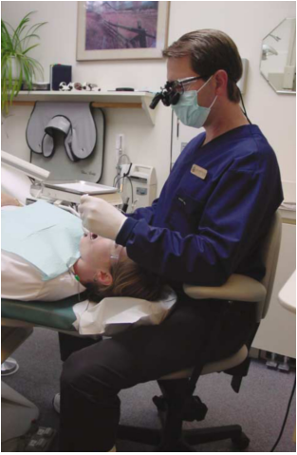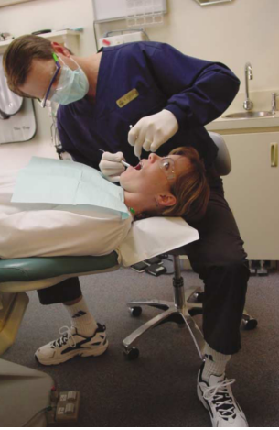

Fig .33. LEFT- optimal working position to reduce muscle stress; RIGHT- repeated awkward postures lead to muscle imbalance

**ERGONOMICAL PRINCIPLES**

Achieving good ergonomics of the triad position for dental procedures, which results from obtaining correct body position of the dentist relative to the microscope, to the patient, and to the operative field at the same time has been a major difficulty. The other two major problems faced by dentists are the fine motor skills and perception of details. Therefore, 6 main areas of research in surgical microscope ergonomics have been developed, namely,

1) Visual perception

2) Tremor control and fine or meticulous manipulation development

3) Biomechanics' motions of the hand and the arm

4) Skills acquisition process

5) Neutral body posture

6) Microsurgery instruments design (16)

Visual perception

Visual perception is assumed to be a pillar of microsurgical technique. All the work is conducted in a very small surgical field and tactile sense is no longer the most important factor for controlling the procedures. At the beginning the movements performed under magnification are much slower than those without it due to the acquisition of new skills.

Physiological tremor

Finger movements controlled by the long flexor and extensor muscles that move our fingers are relatively crude, So, active finger extensions or flexions are also crude. However, when the wrist is stabilised by resting on a flat surface, angled in a dorsiflexion position at approximately 20°, more accurate, finely controlled finger movement can be accomplished due to reduction in muscle tremor (19). Physiological tremor is the uncontrolled movement arising from both the intended and unintended actions of our bodies (20). According to Voigt (1963) (21), the physiological tremor is characterized by a 0.5 to 3.0 mm amplitude and 7- 30 vibrations/second frequency. It is physiological and its intensity is directly related to the development of so-called fine or meticulous manipulation. However, it may differ based on factors which may or may not be controlled by the dentist.

During microsurgery, physiologic tremor manifests as a naturally occurring unwanted hand and finger movement. (22) To minimize them, a relaxed state of mind, good body comfort and posture, a well-supported hand, and a stable instrument holding position must be ensured. Mental focus and patience during the procedure are also crucial in maintaining precise motor control skills.

Biomechanics

It relates to the ability to develop with precision, complex motions types during microsurgery, learning and improving techniques of how to handle the skills acquisition capacity. It was defined by Glencross in 1977 as the ability in learning making patterns of highly advanced movements in order to achieve excellent results. The skills acquisition process is divided the into three phases or stages:

* Coding - phase in which the individual will learn to associate a certain movement with a specific result.
* Temporal organization - intermediate stage in the skills acquisition process, and is the ability of the individual to relate the encoded movements seized during the first phase to a rhythmic sequence allowing for errors correction in real time.
* Hierarchical organization - results from a sequence's combination of rhythmic movements developed in accordance with a comprehensive global strategy of work. (16)

Neutral body posture

Prolonged work under high magnification systems like surgical microscope, requires by the dentist the develop of a good body posture, which should be neutral. The dentist should be positioned with the vertebral column straight; the seat height should be adjusted to allow the elbow joint to stay at the working area level, the arms must stay along the trunk, and the forearms and hands must be fully supported in order to decrease the tremors. (16)

Instrument design

With magnification, high precision dentistry with minimum tissue trauma can be achieved. This is also in part due to microsurgical instruments. These must be approximately 15 cm in length. For an average sized hand, this provides adequate length for an instrument held in a pen grip to rest in the web between the thumb and index finger. Instruments should be circular in cross section to allow for a smooth rotation movement without slipping. The working tips of micro-instruments are much smaller than those of regular instruments. When properly cared for, they are resistant to distortion from repeated use and sterilization, are non- magnetised, and lighter than stainless steel instruments. (20)

**POSTURAL AWARENESS TECHNIQUES**

* Maintain the low back curve – Tilt the seat angle slightly forward five to 15° to increase the low back curve. This will place your hips slightly higher than your knees and increase the hip angle to greater than 90°, which may allow for closer positioning to the patient. Chairs without the tilt feature can be retrofitted with an ergonomic wedge-shaped cushion.

* Sit close to the patient and position knees under the patient's chair if possible.

* Consider using a saddle-style operator stool that promotes the natural low back curve by increasing the hip angle to approximately 130°. Using this type of stool may allow you to be closer to the patient when the patient chair shave thick backs and headrests.

* Adjust the chair so your hips are slightly higher than your knees and distribute your weight evenly by placing your feet firmly on the floor. The forward edge of the chair should not compress the backs of your thighs.

* Use the lumbar support of the chair as much as possible by adjusting the lumbar support forward to contact your back.

* Stabilize the low back curve by contracting the transverse abdominal muscles. To do this while sitting, sit tall with a slight curve in the low back, exhale, pull your navel toward the spine without letting the curve flatten. Continue breathing while holding the contraction for one breath cycle. Repeat five times. Strive to maintain this stabilization regularly throughout the workday

* Pivot forward from your hips, not your waist. Stabilize the low back curve by performing the previous exercise before pivoting forward. (18)

**ENDOSCOPY**

An endoscope is a illuminated, usually fibre-optic flexible or rigid tubular instrument for visualizing the interior of a hollow organ or part (such as the An endoscope is an illuminated, usually fiber-optic flexible or rigid tubular bladder or esophagus) for diagnostic or therapeutic purposes that typically has one or more channels to enable passage of instruments (such as forceps/scissors) and/or tissue (23,24), Goss and Bosanquet reported that Ohnishi first used the endoscope in dentistry to perform an arthroscopic procedure of the temporomandibular joint in 1975. Held et al (25) and Shulman & Leung (26) reported the first use of the endoscope in surgical and nonsurgical endodontics in 1996. Bahcall et al (27) presented an endoscopic technique for endodontic surgery in 1999.

ROD-LENS ENDOSCOPE

The rod-lens endoscope is made up of rods of glass work injunction with a camera, light source and a monitor (Figure 35). The option of a digital recorder (either streaming video or still capture) can be added to the system for documentation of a procedure. The rod-lens endoscope allows clinicians greater magnification than what can be achieved with loupes or a microscope with the optical resolution comparable to the microscope and loupes. Zooming in the endoscope is also faster and more comfortable than using the microscope. However, it can be bulky and difficult to maintain a fixed field of vision as compared to a microscope. (28)

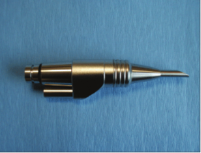

fig 35: rod-lens endoscope

The recommended rod-lens endoscope sizes for endodontic surgical application is a 2.7 mm lens diameter, 70° angulation , 3 cm length rod-lens and a 4 mm lens diameter, 30° angulation, and 4 cm length rod-lens (Figure 36,37). By using the 70-degree instrument, it has been possible to visualize the palatal root apices of maxillary posterior teeth. Another application that has become popular in our office has been the magnified visualization of the pulp chamber to aid in the identification of the canal orifices. This has been especially useful in cases of advanced chamber obliteration caused by the deposition of secondary and tertiary dentin (29).

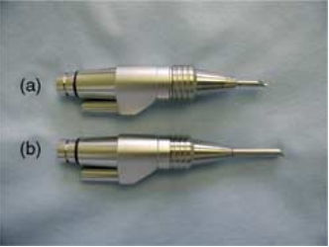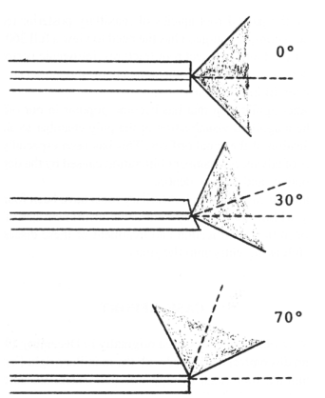

Figure 37: Types of endoscopes

a) 2.7mm tip diameter, 70°, 3 cm rod lens endoscope;

b) 4mm tip diameter, 30°, 4cm length endoscope

Figure 36: Endoscope angulations and field of vision

Shaded areas represent the field of vision that is

turned from 0 to 30 or 70° depending on the optics

of the rod- lens system

The endoscope can provide the same advantages with:

(a) Affordability--cost can be kept to a minimum with one detachable light source and two endoscopes (30 and 70 degrees);

(b) Maneuverability--the scope weighs only ounces, and the entire video monitor system can be placed on a cart and moved from room to room;

(c) Expandability--the basic unit can be supplemented with a light-weight camera, monitor, videorecorder, and printer;

(d) Versatility--the operator can directly view the surgical site through the endoscope and operate with the other hand or, by using the indirect technique, view the monitor. A major difficulty

encountered by the endodontist, performing surgery in areas without straight-line (direct) access, is visualization. The endoscope with a 30- or 70-degree tip, unlike the surgical microscope, can literally "look around the comer." (25)

**ORASCOPE**

An orascope is made up of fibre optics whereas an endoscope is made of glass rods. Like the rod-lens endoscope, it works with a camera, light source and a monitor. (29) Fiber optics are made of plastics, and therefore, are small, lightweight, and flexible. It is important to note that the image quality from fiber optic magnification has a direct correlation to the number of fibers and size of the lens used. The fiber optic endoscope is designed or intracanal visualization. (30) The orascope has a 0.8 mm tip diameter, 0° lens und the working portion is 15 mm in length. The orascope is made up of 10,000 parallel visual fibers (10K fibre optic orascope) (Figure 38). Each visual fiber is between 3.7 microns and 5.0 microns in diameter. A ring of much larger light transmitting fibers surrounds the visual fibers for illumination of a treatment field. prior to the placement of the 0.8 mm fiber optic scope, it is recommended that -2.5 × loupes or a SOM be used for conventional endodontic visualization to access the canals. (29)

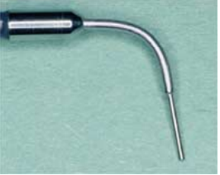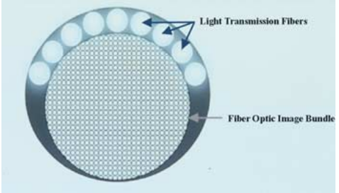

FIGURE 38: ORASCOPE

LEFT- 0.8mm tip diameter, 0°, 10K fibre orascope; RIGHT- fibre optics in orascope

**ORASCOPE USE DURING CONVENTIONAL ENDODONTICS**

Once the pulp chamber is cleaned of soft tissue, the 4mm lens diameter, 30-degree endoscope may be used to have a higher magnification to the floor of the access cavity. This is useful for locating additional holding orifices and verifying tissue removal. Instead of holding a mirror, the operator holds the endoscope, which may be stabilized by resting it on a cusp tip. The 0.8 mm orascope is used to visualize the canal system (Figure 39). To accommodate its placement, the canal must be enlarged to size 90 in the coronal 15mm. if the canal is not widened sufficiently, a wedging of the probe may damage some of the fiber bundles within the scope. The focus and depth of the field is from zero to infinity, allowing for imaging of apical third without having been placed into this region of the canal. The canal must be dry at this point. Although the scope will see through sodium hypochlorite, this solution has a high refractive index, which causes significant reflected light to prevent a readable image. (29)

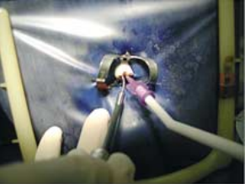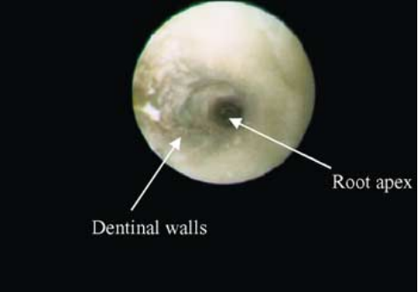

FIGURE 39: LEFT- placement of 0.8mm orascope along with micro suction; RIGHT- in vivo image of intracanal visualization with 0.8mm orascope

**RECENT ADVANCES**

**VARIOSCOPE**

Also referred to as Augmented Reality, it is a lightweight miniature head- mounted operating microscope for surgical navigation. It features display of additional computer-generated sceneries. It has an integrated camera for documentation. One of the greatest advantages of the varioscope is mobility of the operator head, which is contrary to the surgical microscopes which lack maneuverability due to cumbersome equipment. (31)

**VIDEOSCOPE**

Al-Shaikhly et al (32) compared a dental operating microscope (DOM) with a high-resolution videoscope in terms of depth of field (DOF), resolution, and effect on fine motor skills. Two observers used test targets to measure the resolution and DOF of the DOM and the VS. In addition, 18 participants (12 dental students and 6 endodontic residents) performed an accuracy test on a manikin head using DOM, VS, or loupes. Each participant completed a post-test survey. The 3 magnifications of the DOM had higher resolutions and DOF than the VS. Accuracy testing showed the DOM produced better results than the VS for both resident and student groups; however, the VS was not significantly different than loupes. Although the DOM outperformed the VS, the VS was designed to be used in periodontal surgical treatments. The disadvantages of using the VS in endodontic procedures include difficulty in orientation, lower magnification compared with DOM, and unclear efficacy of the VS when Working in a limited space. The authors concluded that the DOM stands out as the leading magnification tool in endodontics. However, the VS has potential in endodontic procedures. The VS might be used as an adjunct to other visualization aids and with some modifications in manufacturing and design could potentially be an alternative cheaper magnifying tool to microscopes.

**HEADS-UP DISPLAY**

Newer technology in the arena of magnification is the heads-up display, which involves a camera that is placed over the patient, projecting the image to a monitor. The projection of the image can be 2-dimensional (Magna Vu) or 3- 3-dimensional (3-D) (MoraVision) and may help reduce the learning curve that has been associated with the operating microscope. The ergonomic benefits of these heads-up displays have also been discussed as perhaps having possible improvements in treatment outcome and communication through documentation with video and captured stills. These systems are, in many cases, more expensive than the operating microscope, ranging in price from $25,000 to $50,000 (with the 3-D system being more expensive) (42).

**CONCLUSION**

Patients have become more demanding about what they want and are more critical about what kind of results they are willing to accept. Such patient scrutiny demands self-criticism on the part of the dentist. The OM is an important addition to the dental armamentarium, specifically endodontics. It helps set the bar of excellence at the highest level. Endodontic surgeons today deliver services with confidence and greater precision that what was possible 20 years ago by any standard. The development of a sophisticated armamentarium, groundbreaking techniques, and the willingness to embrace them has enabled this paradigm shift and is the future of the specialty. The AAE expects that advances in magnification technologies and other treatment modalities will continue to improve endodontic outcomes in the years to come. The position of the AAE is that the microscope is an integral and important part of the performance of modern endodontic techniques. The use of microscopes in providing precision care have carried over into restorative dentistry, and it will eventually become a universal approach for all phases of dentistry.

REFERANCES

1. Carr GB, Murgel CAF. The Use of the Operating Microscope in Endodontics. Dental Clinics of North America. 2010 Apr;54(2):191- 214.
2. Hegde R, Hegde V. Magnification-enhanced contemporary dentistry: Getting started. J Interdiscip Dentistry. 2016;6(2):91
3. Baker JM, Meals RA. A practical guide to surgical loupes. The Journal of Hand Surgery. 1997 Nov;22(6):967–74.
4. Arens DE. Introduction to Magnification in Endodontics. J Esthet Restor Dent. 2003 Dec;15(7):426–39.
5. Caplan SA. Magnification in Dentistry. J Esthet Restor Dent. 1990 Jan;2(1):17-21
6. Apotheker H, Jako GJ. A microscope for use in dentistry. Microsurgery. 1981;3(1):7-10.
7. Zeiss C. Microscopic Dentistry-A Practical Guide. Carl Zeiss Meditec AG; 2014.
8. Sheets CG, Paquette JM, Hatate K. Masters of Esthetic Dentistry.: the clinical microscope in an esthetic restorative practice. J Esthet Restor Dent. 2001 May;13(3):187-200.
9. Rubinstein R. Magnification and illumination in apical surgery. Endodontic Topics. 2005 Jul;11(1):56–77.
10. Castellucci A. Magnification in endodontics: the use of the operating microscope. Vol. 15, Practical procedures & aesthetic dentistry: PPAD. Pract Proced Aesthet Dent; 2003
11. Castellucci A. The use of the operating microscope in endodontics. Endodontics, III Tridente, Firenze. 2009;956-997.
12. Merino EM. Endodontic microsurgery. Quintessence London; 2009
13. Hoerenz P. The operating microscope I. Optical principles, illumination systems, and support systems. Microsurgery. 1980 Mar;1(5):364–9
14. Kim S, Kratchman S, Karabucak B, Kohli M, Setzer F. Microsurgery in endodontics. John Wiley & Sons; 2017.
15. Kinomoto Y, Takeshige F, Hayashi M, Ebisu S. Optimal Positioning for a Dental Operating Microscope During Nonsurgical Endodontics. Journal of Endodontics. 2004 Dec;30(12):860–2.
16. Carreira LM. The importance of Ergonomics for Dental Medicine Procedures in the Triad Position: The Patient, the Dentist, and the Surgical Microscope. ARC Journal of Dental Science [Internet]. 2016
17. Burke FJ, Main JR, Freeman R. The practice of dentistry: an assessment of reasons for premature retirement. British dental journal. 1997;182(7):250–254.
18. Valachi B, Valachi K. Preventing musculoskeletal disorders in clinical dentistry. The Journal of the American Dental Association. 2003 Dec;134(12):1604–12.
19. Barraquer JI. The history of the microscope in ocular surgery. Microsurgery. 1980;1(4):288–99.
20. Tibbetts LS, Shanelec D. Principles and practice of periodontal microsurgery. Int J Microdent. 2009;1(1):2–12.
21. Patkin M. ERGONOMICS APPLIED TO THE PRACTICE OF MICROSURGERY 1. ANZ J Surg. 1977 Jun;47(3):320–9.
22. Serafin D. Microsurgery: past, present, and future. Plastic and reconstructive surgery. 1980;66(5):781-785.
23. https://www.merriam-webster.com/dictionary/endoscope
24. <https://www.cancer.gov/publications/dictionaries/cancer-terms/def/endoscopy>
25. Held SA, Kao YH, Wells DW. Endoscope—An endodontic application. Journal of Endodontics. 1996 Jun;22(6):327–9.
26. Shulman BB, Leung A. Endoscopic surgery: an alternative technique. Dentistry today. 1996;15(9):42–44.
27. Bahcall JK, Di Fiore PM, Poulakidas TK. An endoscopic technique for endodontic surgery. Journal of Endodontics. 1999 Feb;25(2):132-5. 75.
28. Bahcall J. Visualization in endodontics. Eur J Gen Dent. 2013;2(2):96. 34. Gultz JSL, Settembrini L, James K, Scherer W. Can you see it? A visual acuity study. J Dent Educ. 1996;60(2):222.
29. Bahcall J, Barss J. Orascopic visualization technique for conventional and surgical endodontics. Int Endod J. 2003 Jun;36(6):441–7.
30. Bahcall JK, Barss JT. Fiberoptic endoscope usage for intracanal visualization. Journal of endodontics. 2001;27(2):128-129.
31. Doornbusch H, Veenstra K. Frequently asked questions about the dental microscope. The Microscope in Dentistry Editorial Germany: Carl Zeiss Surgical GmbH. 2007;
32. Al Shaikhly B, Harrel SK, Umorin M, Augsburger RA, Jalali P. Comparison of a Dental Operating Microscope and High-resolution 250 Videoscope for Endodontic Procedures. Journal of Endodontics. 2020 May;46(5):688-93
33. . Sitbon Y, Attathom T, St-Georges AJ. Minimal intervention dentistry II: part 1. Contribution of the operating microscope to dentistry. Br Dent J. 2014 Feb;216(3):125–30.
34. Arens DE. Introduction to Magnification in Endodontics. J Esthet Restor Dent. 2003 Dec;15(7):426–39
35. James T, Gilmour AS. Magnifying Loupes in Modern Dental Practice: An Update. Dental Update. 2010 Nov 2;37(9):633–6
36. Christensen GJ. Magnification in dentistry. The Journal of the American Dental Association. 2003 Dec;134(12):1647-50.
37. Hoerenz P. The operating microscope. III. Accessories. Microsurgery 1980;2(1):22-26.
38. Biller FE. The occupational hazards in dental practice. Oral Hygiene. 1946;36:1194.
39. Musculoskeletal conditions [Internet]. [cited 2020 Nov 19]. Available from: https://www.who.int/news-room/fact- sheets/detail/musculoskeletal-conditions
40. Valachi B, Valachi K. Mechanisms leading to musculoskeletal disorders in dentistry. The Journal of the American Dental Association. 2003 Oct;134(10):1344–50.
41. Marshall ED, Duncombe LM, Robinson RQ, Kilbreath SL. Musculoskeletal symptoms in new south wales dentists. Australian dental journal. 1997;42(4):240–246.
42. Buchanan S. Endodontic News - MoraVisionTM 3D: A paradigm shift in the ergonomics of dental imaging [Internet]. Available from: https://endopracticeus.com/industry-news/moravision-3d-paradigm-