HIGH-PERFORMANCE INTELLIGENT FRAMEWORK IN A DISTRIBUTED ENVIRONMENT
Dr.M.Arunachalam
Professor, Sri Krishna College of Engineering and Technology,
Coimbatore

Dr.P.Mohan Kumar
Professor, Hindustan Institute of Technology and Science,
Chennai

Dr.R.Aghila
Professor, Kamaraj College of Engineering and Technology,
Virudhunagar.

ABSTRACT: Multi-distributed high-performance computers from many companies are aggregated into a single computing platform to provide handlers through uniform contact besides convention outlines. As the Job arrangement strategies in high-performance computing environment are lacking in flexibility, an enhanced computational intelligence automated system is proposed for the refinement of the Principal planner aimed at every job. The swarm intelligence method is used in the core task scheduling to reduce the average scheduling time for completing tasks by assigning jobs to each node in the most efficient manner. The suggested scheduling technique outperforms the standard work scheduling approach with reduced waiting time, increased system throughput and better system resource utilization.
KEYWORDS – Computational intelligence, scheduling, high-performance computing, resource utilization.

I. INTRODUCTION
High-performance computing system (HPC) is the ability to run simultaneous workloads on many processors. The execution of parallel applications in HPCs is hampered by the necessity of inter-processor communication. When data is sent between activities on multiple processors, there is an additional overhead. Using HPCs featuring diverse computers increases the need of creating high-quality job schedules. An additional factor that needs to be considered when developing a scheduling algorithm is how long a job will take to complete while running on different processors. Task scheduling has become increasingly critical as high-performance computing and heterogeneous clusters have grown in size [1] - [3]. A general model of scheduler structure is depicted in Figure 1.
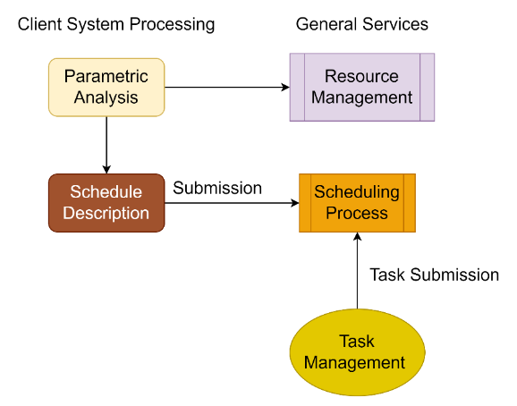
Figure 1. General Structure of scheduler model
A cluster management system is critical in a high-performance computer. Cluster management relies heavily on scheduling. To schedule a job, the entire process from submission to completion and the cluster's pieces must be taken into consideration [20]. We can take full advantage of high - performing computation cluster system services and guarantee that the process is quick and efficient by building using an effective task scheduling method. The task-resource connection is what we mean by "task scheduling." As a result of extracting and evaluating the system management tasks, it is possible to enhance the task scheduling performance in direct relation to the load characteristics [4].
The goal of a task scheduler is to use computer resources better, reduce overall task execution time, and increase user satisfaction by allocating running tasks to the most appropriate processing nodes. Combinatorial optimization issue is a special application of task scheduling, which is NP-hard as the cluster size grows. It's becoming increasingly common, though, to use an intelligent algorithm to solve these kinds of difficulties. Artificial fish swarm algorithms are used to enhance task scheduling performance, for example, when node execution ability and overall task execution time are considered as optimization goals for nodes in swarms [5].
Since cluster expansion is inevitable, past and present hardware will have to be replaced, which will generate internal heterogeneity issues [19]. In some cases, network topology heterogeneity can be caused by differences in the models of the CPU and memory on individual nodes, or by the addition or deletion of hardware. Task scheduling techniques for diverse contexts have therefore been the subject of several academic studies and advances as a result. If the work execution planning strategy is saved using the LATE algorithm, then the task library's fastest and easiest tasks are prioritized for execution [18].
The LATE algorithm is a common method for dealing with the issue of speculative execution. The LATE approach does not address the issue of optimizing data locality, but the issue of reading data from several systems has been resolved. The literature, on the other hand, makes use of the results of previously performed work [6].
Although this method is quick and easy to use, it is tough to get greater outcomes with it. The work scheduling method can be improved by using swarm intelligence algorithm [16]. In order to better understand and optimize the routine of work arrangement procedures in a high-performance setting, literature provides consequences of experiments with various intelligent algorithms. Using an intelligent approach, the researchers were able to demonstrate that task execution time may be reduced while also improving the scheduling effect [17].
II. EXISTING WORK
Computational intelligence techniques may be used to schedule tasks in high-performance computing environments, and we'll discuss these methods in detail in this section. Real-time approachesare known as methodology employed in these computing environments [15]. Once the user's request parameters and resources have been validated and verified, the client creates an order to improve reliability Job Submission Description Language for the essential facility dispensation scheme, which then processes the request for service. After receiving a user's task submission demand, the core service processing system will instantly begin the task scheduling module [7].
Rendering to a manipulator'sdemand for requestfacility description, kind, and computing duration, it determines a list of presently accessible resources. Then, after finishing the transformation and development of the jobproposalmoel, run the jobplan on anHPC using the shortest queue time resources scheduling job. This approach is clear and straightforward to put into practice. Simultaneous dispensation in the structure'sessentialfacilities is under great demand when the task assignment requests are significantly filled. It is also constrained by the greatest variety of network connections that may be made between dispersed modules [8].
Due to the increasing complexity of job scheduling issues, new intelligence algorithms including Evolutionary Algorithms, Simulated Annealing, and Taboo Search have been developed in recent years. Using a standard task scheduling method in a significant computational environment is insufficient: ignore the quality of service while focusing on efficiency; focus on justice while reducing efficiency [9]. High performance computing's programming framework has an intelligent scheduling mechanism. Both the total completion time and average completion time are reduced when improved task scheduling is used.
The results of a simulation experiment comparing real-time task scheduling with intelligent scheduling show that the proposed methodology is more efficient in a high-performance computing environment [14]. As a result of extensive study into computer technology and a scheduling challenge, researchers have proposed a strategy constructed on structure of an optimally efficient task allocation algorithm and a greedy algorithm. The standard task scheduling method emphasizes efficiency, but the recently suggested approach emphasizes service quality and achieves, for the first time, a doubleequilibrium in job alignment in HPC settings [10].
In swarm intelligence approaches, algorithms belong to the ant colony algorithm family and represent certain met heuristic optimizations [11]. A broader range of mathematical problems may now be solved using the original concept, which has now evolved to include new problems based on various elements of ant behavior. Ant Colony Optimization (ACO) uses a model-based search and has some resemblances to algorithms for estimating distributions.
In a high-performance computer environment, the question of how to properly schedule jobs is critical. An ant colony algorithm and reinforcement learning-based cooperative task scheduling approach are developed in light of the fact that resource allocation is an NP-hard issue, and the current task resource allocation technique has long scheduling times and unbalances system burden [12]. Initially, the ant system was used to unravel the visiting trip issue, everyplace the aimfor discover the unswerving distance between two points on a given route. The basic algorithm is built on a collection of ants, each of which completes one of the potential circuits across the city.
Every time the ant moves between cities, it does so according to some set of laws. Each city may only be visited once, therefore a faraway one has a lower probability of getting picked. An edge between two cities with a more intense pheromone trail has a better chance of being picked if the journey is short; if the journey is long, the ant deposits more pheromones on all edges it has crossed During each repeat, the pheromone trails go away [13].
III. PROPOSED SYSTEM
Assume a high-performance computing cluster is in place. Hence, task scheduling inside a high-performance computing architecture is all about finding the shortest overall path of resource allocation. This can be observed, in an HPC setting, the quality of a job scheduling algorithm is increasingly being measured by the amount of time it takes to complete all of its jobs. This present jobline, job set shows separate jobs, and each task might still execute on one thread component.
Environmental queues are introduced in an intelligence-optimized job scheduling paradigm. The resource approximator, resource organizerand resource gatherer are the three main components of the core module. There is a library of application and user mapping information in the front-end service, which collects queue information from the HPC properties on a regular origin; this information includes the queue name and status as well as the approximated hubs that can be used. Mostly on root of anHPCline, queue computing resources are defined. Prioritizing duties on an environmental level and operating on a particular user are both conducted to rectify the collected data in an automated fashion.
Task queries that cannot obtain high computing properties and tasks which surpass the handler'sbounds are added to the task queue by the front-end scheduler. When it comes to front-end scheduling, FIFO principles guide processing these job queues and responding to task requests. If the work is completed, remove it off the front task tracker; otherwise, it will remain in the queue until it is completed. The work status is refined after the introduction of an intelligent scheduling algorithm in the high-performance computing system, making administration, operation, and maintenance easier. The user, on the other hand, must maintain a clear display of current task progress. Consequently, operational status is split into user and system status. Figure 2 shows the proposed system architecture.
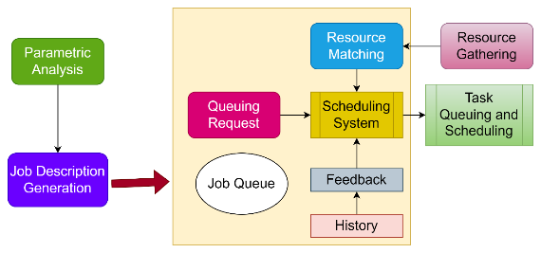
Figure 2. Proposed System Architecture
The user's perspective displays that the computer is uploading files and that the task request has been approved and is being queued or scheduled in the primary job queue. Failed operation denotes either a normal or anomalous termination to a job that is executing on a high-performance computing environment. New is state of task request when it first enters the core queues; Delay is the state when it first appears in front-end queues, and Scheduling indicates that the scheduler is working on it; Scheduled designates that the scheduling flops, and Final is the state when irregularhandlerinformationrecords are sent over high-performance servers.
In this way, the procedure is analogous to an ant creeping over a graph G. Every vertex on G represents a task, and the crawling stops after all chores have been completed. Each job may only be assigned once, and the value of each decision-making variable has particular restrictions. Solution s' expected execution time is an objective function, and the algorithm's purpose is to discover a solution that reduces the anticipated execution time to the minimum feasible value.
Every conceivable choice has a signal pertaining to , initializedwith commencement procedure and is efficient as the procedureprogresses. In a certain assignment procedure, each assessment of the choiceflexible is linked to the earlierprocess. The minimum obtained with approach is computed based to the variety of jobs, the duration of the tasks, and the processing power of the resources because of the active and diverse nature of supplycollection in HPC.
IV. RESULTS AND DISCUSSION
Particle swarm and ant colony algorithms are the most used swarm intelligence algorithms, and they both imitate real bird and ant colony behavior. There are certain drawbacks to use swarm intelligence algorithms, which mimic the natural social behavior of animals. Many parameters must be configured for the ant colony algorithm to work. A substantial percentage of exploratory arbitrary motions are required already when the data item is scooped up or laid down in the ant colony clustering method. In addition, its input parameters are extremely sensitive to small changes in values. Memory configuration of nodes is listed in Table 1.
Table 1. Memory configuration of nodes
Simulated trials on a high-performance computer environment were used to verify the efficacy of the suggested technique. A four-node HPC cluster was used for the experiments, each of which provides a task function. One administration node, 13 submission nodes, and 316 computing nodes make up the HPC system (execution nodes). In addition, the system includes multiple sequencers, storage servers, and other components that are primarily connected by 10-gigabit Ethernet.
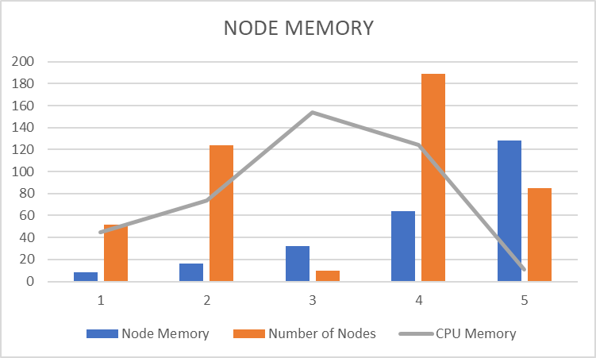
Figure 3. Node memory analysis
This Symmetric Multi-processing (SMP) design server is used by compute nodes, and AMD 64-bit processors are primarily used. 2600 MHz is the most common CPU clock speed, while 24 to 30 logical CPUs are the most common node numbers. Storage nodes are used as the primary data storage in an HPC system. The resource management and job scheduling are carried out via the operation management system. A client-side submission is required. The compute node's CPU core count and memory usage are displayed. The nodes' hardware and operating system setups are listed. This experiment uses the same parameter settings throughout the experiment to ensure that the results are comparable. Node memory analysis is depicted in Figure 3.
Table 2 shows the performance of the proposed system. Numerous HPC activities demand substantial resources and time to be run successfully. For instance, a multi-threaded operation may demand as much as eight 4-core nodes, 8.5 GB of peak RAM, and 1.5 terabytes of storage space to complete a single test. It may take a week or so to complete the entire process. Because of this, we find it important to thoroughly comprehend the features and arrangement features of tasks and systems in order to improve and optimize their schedules and act. All measurable tests for the proposed approach are carried out correctly and fairly examine the performance of the scheduling algorithm.
Table 2. Performance of proposed system
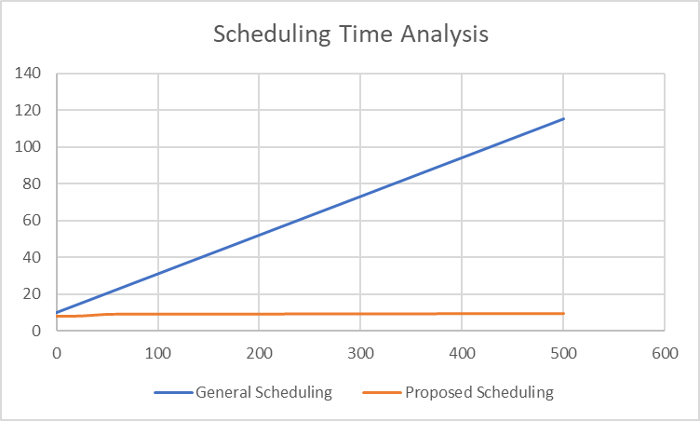
Figure 4. Scheduling time analysis
In the first experiment, a job was delivered to the HPC every second throughout the scheduling time window of one second. All of these tasks were given varying degrees of computational difficulty at random (about 100 points). Two batches of 2000 jobs each are sent to the HPC for processing. To begin, our swarm intelligence scheduling algorithm schedules 1000 jobs for the HPC. After completion of first 1000 jobs, we began submitting the second thousand.
The figure 4 compares the average execution time of swarm intelligence scheduling algorithm with respect to arbitrary arrangement approach. It is observed that the proposed swarm intelligence scheduling algorithm takes less than 0.3 seconds to accomplish nearly 500 of the 1000 jobs, and less than 0.5 seconds to complete more than 800 of them. The error rate analysis is depicted in Figure 5.
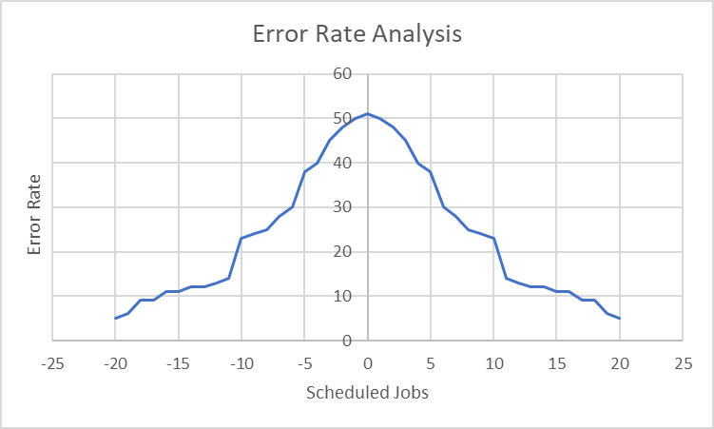
Figure 5. Error Rate Analysis
Everyone knows that the middleware in the system is responsible for determining which high-performance computing resources are most suited to the tasks that users submit. Some task submission requests fail due to several internet connections under large concurrent task submission requests as transmission and the numbers of task assignment requests significantly grow.
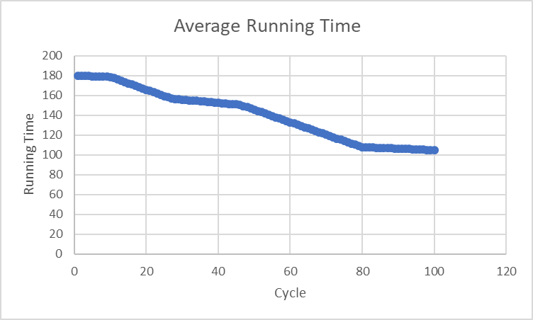
Figure 6. Average running time
In Figure 6, average running time of the proposed system is shown. The proposed algorithm is clearly faster than the existing approach. Swarm intelligence scheduling was used to accomplish over 800 jobs on the HPC, whereas random scheduling only managed to complete 400. As a result, comparing and analyzing the prediction inaccuracy will be essential. The flat federation indicates the prophecy fault, while the perpendicular federation reflects the jobs in our experiment. The variation was 5.95 and the mean of the predicted errors was 3.8 seconds. It's worth noting that the real execution time might have been several dozen seconds. Hence, the forecast error was acceptable. Sampled analysis of average running time is listed in Table 3.
Table 3. Analysis of Average running time
We performed a total of 20 experiments to arrive at the final average. In each test, many jobs might arrive at the HPC at the same time and the number of tasks varies from 40 to 100. Tasks planned using average and random scheduling were measured for average execution time. Swarm-based scheduling has the greatest results, as observed. When they scheduled 80 jobs, the average execution time of our approach was around 20s longer than the average execution time of the existing approach. Convergence time analysis between two algorithms are shown in Figure 7.
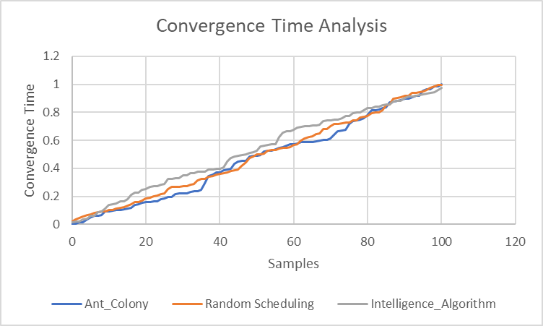
Figure 7. Convergence time analysis
In this case, we can see how the computational intelligence algorithm is coming to a point of convergence. Near-optimal allocation can be found to converge in roughly 50 iterations, according to the research. Our suggested scheduling technique outperforms the standard job scheduling approach in simulations with reduced waiting time, increased system throughput and better system resource utilization.
V.CONCLUSION
Based on the literature study, we have suggested an intelligent scheduling model for numerous services in HPC. An enhanced swarm intelligence system has been created that uses projected outcomes to plan tasks. Task completion times can be reduced as much as 50% using the swarm intelligence algorithm. It is evidenced that the suggested approach is superior over typical task scheduling method in terms of performance. Therefore, the workflow scheduling system based on proposed approach would efficiently decrease the waiting time and enhance the processes, productivity, responsiveness, and organization supply exploitation with improved impact.

REFERENCES
- Ates E, Tuncer O, Zhang Y, Turk A, Brandt J, Leung VJ, Egele M, Coskun AK (2017) Diagnosing performance variations in HPC applications using machine learning. International supercomputing conference. Springer, pp 355–373.
- Agrawal A, Nakka N, Choudhary A (2011) Predicting node failure in high performance computing systems from failure and usage logs. In: 2011 IEEE international symposium on parallel and distributed processing workshops and Phd Forum. IEEE, pp 1557–1566.
- Bartolini A, Borghesi A, Lombardi M, Milano M, Benini L (2019) Anomaly detection using autoencoders in high performance computing systems. Proc AAAI Conf ArtifIntell 33:9428–9433.
- Brereton OP, Kitchenham B, Budgen D, Turner M, Bailey J, Linkman S (2009) Systematic literature reviews in software engineering-a systematic literature review. Inf Softw Technol 51(1):7– 15.
- Birant D, Yurek O.E, (2019) Remaining useful life estimation for predictive maintenance using feature engineering. In: Innovations in Intelligent Systems and Applications Conference (ASYU). IEEE, pp 1–5.
- Brewer W, Martínez D, Strelzoff A, Wilson A, Wade D (2020) Rotorcraft virtual sensors via deep regression. J Parallel Distrib Comput 135:114–126.
- Ding Q, Li X, Sun JQ (2018) Remaining useful life estimation in prognostics using deep convolution neural networks. Reliab Eng Syst 172:1–11.
- Giannetti C, Essien A, (2020) A deep learning model for smart manufacturing using convolutional LSTM neural network autoencoders. IEEE Trans Ind Inform 16(9):6069–6078.
- Guldamlasioglu S, Aydin O, (2017) Using LSTM networks to predict engine condition on large scale data processing framework. In: 2017 4th International Conference on Electrical and Electronic Engineering (ICEEE). IEEE, pp 281–285.
- Libri A, Borghesi A, Benini L, Bartolini A (2019) Online anomaly detection in hpc systems. In: 2019 IEEE International Conference on Artificial Intelligence Circuits and Systems (AICAS). IEEE, pp 229–233.
- Mueller F, Das A, Siegel C, Vishnu A (2018) Desh: deep learning for system health prediction of lead times to failure in hpc. In: Proceedings of the 27th international symposium on high-performance parallel and distributed computing. pp 40–51.
- Nascimento EGS, Souza RM, Miranda UA, Silva WJD, Lepikson HA (2021) Deep learning for diagnosis and classification of faults in industrial rotating machinery. Comput Ind Eng 153:107060.
- Pang CK, Hu B, Luo M, Li X, Chan HL (2012) A two-stage equipment predictive maintenance framework for high-performance manufacturing systems. In: 2012 7th IEEE Conference on Industrial Electronics and Applications (ICIEA). IEEE, pp 1343–1348.
- Rizzo F, Caponetto R, Russotti L, Xibilia M (2019) Deep learning algorithm for predictive maintenance of rotating machines through the analysis of the orbits shape of the rotor shaft. Ergonomics and applied human factors. International conference on smart innovation. Springer, pp 245–250.
- Soares F A, Carvalho T P, Vita R, Francisco R d P, Basto J P, Alcalá S G (2019) A systematic literature review of machine learning methods applied to predictive maintenance. Comput Ind Eng 137:106024.
- Terboven C, Klinkenberg J, Lankes S, Müller MS (2017) Data mining-based analysis of hpc center operations. In: 2017 IEEE International Conference on Cluster Computing (CLUSTER). IEEE, pp 766–773. Li X, Ding Q, Sun JQ (2018) Remaining useful life estimation in prognostics using deep convolution neural networks. ReliabEng Syst Saf 172:1–11.
- Wang J, Zhang S, Li X, Su S (2017) Curve-registration-based feature extraction for predictive maintenance of industrial equipment. International Conference on Collaborative Computing: Networking, Applications and Worksharing. Springer, pp 253–263.
- Xu J, Zhang K, Min M.R, Jiang G, Pelechrinis K, Zhang H (2016) Automated IT system failure prediction: a deep learning approach. In: 2016 IEEE International Conference on Big Data (Big Data). IEEE, pp 1291–1300.
- Yuan M, Wu Y, Dong S, Lin L, Liu Y (2018) Remaining useful life estimation of engineered systems using vanilla LSTM neural networks. Neurocomputing 275:167–179.
- Zhang Z, Guan Q, Fu S (2012) Ensemble of bayesian predictors and decision trees for proactive failure management in cloud computing systems. J Communication 7(1):52–61.

