POWER GENERATION THROUGH HUMAN LOCOMOTION USING PIEZOELECTRIC SENSORS

¹Sumitha Manoj,
Electronics and Communication Engineering,
RajaRajeswari College of Engineering, Karnataka, India

ABSTRACT The primary focus of this essay is on how humans can generate electricity from their movements when they walk and the pressure they apply on the ground. The term "Footstep power generation system" refers to the process by which mechanical energy is converted into electrical energy utilizing transducers and the pressure applied by a footstep. By converting kinetic energy into electrical energy, the power generating floor essentially creates power. The major goal is to end the global power crisis, even though it won't be adequate to meet the excessive demand for electricity. However, it will be able to change and reduce reliance on outdated methods of producing electricity. It can be deployed on footpaths by the side of the road, in parks and jogging trails, as well as many other public locations, such as airports, and will significantly alter the way electrical power is produced. In order to use it later, we can create energy that can be stored in a rechargeable battery, which can also be installed in public areas like streetlights and mobile charging stations.

Keyword: - Piezo-electric Sensor, Mobile charging, Footstep.

1. INTRODUCTION
This study work serves as an illustration of how electrical energy can be created from the force of a footstep on the ground. It will surprise you to learn how much energy may be produced by a typical footstep on the ground. Each person takes hundreds of steps each day. Due of people's habit of walking, each step they take generates electrical energy. Each person loses a significant amount of energy during a typical walk, which is the system's primary energy source. A system that generates power using unconventional energy sources, such as walking on floors, gardens, and other surfaces, is being developed. Established in densely populated areas, this system. The process through which the load will run has been constructed into a suitable system, and home appliances will operate on an alternating current output voltage.Walking on the floor generates energy that is both noise- and pollution-free. That form of energy is beneficial and doesn't even require any kind of fuel or power source to function. The current solution in this contemporary society, where energy consumption is rising daily, is renewable energy. In this piece of research, a system is created that generates power via unconventional methods, such walking on floors, gardens, and other surfaces. Established in densely populated areas, this system. The "Footstep Power Generation" system's fundamental application relies on a piezoelectric sensor, which will have wooden plates positioned and adjusted on it as well as a moving spring.
When a human steps on that mat, force is generated, which causes the magnet to migrate into the hollow and become fixed to the upper part of the wooden sheet. However, the mat's bottom hardwood sheet is where the hollow is fastened. The process through which the load will run has been constructed into a suitable system, and home appliances will operate on an alternating current output voltage. And the objective is to charge the battery using direct current, then use an inverter to change the direct power into alternating current for everyday use. Finally, considering the global demand for energy, designing for such forms of power generation is quite beneficial.
  - Existing Problem
- Increase in use of non-renewable energy which causes pollution.
- Increasing prices of the fuel resources
- Unable to meet demand because of increase in power usage.
- Electricity transmission losses
- Frequent power outages
- Electro mobility
- Grid modernization
- Threat of cyber attacks

  - Proposed Solution
The primary characteristic of power generated by piezo through footsteps is the transformation of mechanical energy into electrical energy by the transform ring, or movement of a footstep on the floor. The piezoelectric phenomenon, which transforms pressure into electrical energy, is crucial to how this project functions. A piezoelectric tile, made up of piezoelectric sensors connected in series, has been installed here. Here, pressure is inputted and transformed into an electrical form before being stored in a rechargeable battery. The system's PIC Microcontroller serves as its brain, converting variable voltage to constant voltage. A diode is positioned to stop current flow in the opposite direction. The user is given 15 minutes of charging time and an RFID reader is put to determine whether they are permitted. How much battery voltage is stored is shown on a liquid crystal display.
1.3 Objectives of Project
The main objectives of the project work are:
- To design and implement an ecologically safe way of generating dc voltage using an array of piezo electric sensor.
- To boost the voltage generated from the piezo sensors using DC - DC boost converter.
- To power a mobile for charging.

2. LITERATURE REVIEW
2.1 Introduction
A through literature review is crucial to learning about the subject of interest. Give acknowledgment to other scholars when using information from the various literatures to avoid duplication. We can spot inconsistencies like research gaps, disagreements between earlier studies, and unanswered questions from earlier studies by reviewing a variety of literatures. We provided some scholars with referrals so they could learn more about the project. Below is a list of the scholars to whom we have referred.

2.2 Base Papers
Reference paper [1] Power Generation through footsteps using piezo-electric effect along with GPS Tracking, International Conference for Emerging Technology (INCET).
AUTHOR : Rajendra Prasad, Avala Bhanuja, Bhavani. L, Bhoomika N
YEAR: 2019
Energy consumption is the major element. Piezoelectric sensors produce energy in the form of AC voltage as their output by using the piezoelectric effect. A piezoelectric sensor network along the sidewalk is constructed in this model, and it is provided to the streetlight lane alongside it. For a modest production, a smart shoe is also used that includes GPS monitoring. This suggested work model differs from the existing one in that it now incorporates GPS tracking and a method for switching streetlights.
Reference paper [2] Reverse electro wetting as a new approach to high-power energy harvesting.
AUTHOR: Tom Krupenkin & J. Ashley Taylor
YEAR: 2011
Over the past 10 years, electrical batteries have been a major barrier to the development of portable devices. Although high-power mechanical energy harvesting may potentially eliminate the need for batteries, a workable mechanical-to-electrical energy conversion technique has never been developed. Here, we present an original reverse electrowetting-based method for converting mechanical energy into electrical energy. Electrical energy is created through the interaction of arrays of moving, microscopic liquid droplets with novel, multilayer dielectric sheets that are only a few nanometers thick. This technique is particularly well suited for high-power energy harvesting from a wide range of environmental mechanical energy sources because it can directly employ a wide range of mechanical forces and displacements, produce high power densities up to 10 3 W m 2, and directly output a wide range of currents and voltages.
Reference paper [3]: Generation of Electricity by Using Footsteps as a Source of Energy
AUTHOR: P. R. Magdum, S. J. Chikhale
YEAR:2017
One of the most extensively used types of energy in the world, electricity is a fundamental component of nature. We obtain electricity (a secondary energy source) by the conversion of primary energy sources including coal, natural gas, oil, nuclear power, and other natural sources. According to research, the globe has already used up all of its reserves of energy. The environment is polluted by fossil fuels. Care must be taken when handling both raw and waste materials when using nuclear energy. According to research, non-renewable energy sources produce a greater amount of power than renewable energy sources. Recent years' heavy use of the resources that were accessible led to a desire for the next generation. We must use renewable energy sources for electricity production and conservation if we are to solve this issue. As a result, attention is increasingly turning to clean, sustainable sources of energy that are renewable. The purpose of this research is to provide a thorough analysis of the various ways that leaping platforms are now exploited as sources of electricity.
Reference paper [4]: FOOTSTEP POWER GENERATION FOR RURAL ENERGY APPLICATION TO RUN A.C. AND D.C. LOADS
AUTHOR: Kethavath Gopal, Adaikkalam Daniel Praneet
YEAR: 2020
Recently, as the nation's population has increased, so has the need for electricity. More energy was being wasted simultaneously in a number of different ways. This essay's main objective is to demonstrate how human movement—specifically, pressure put on the feet while walking—can be used to generate electricity. The term "footstep power generation system" describes the method of using transducers to transform mechanical energy, such as the pressure created by a footstep, into electrical energy. The process of turning kinetic energy into electrical energy, or power generation, takes place on the power generating floor. Conventional power generating sources cannot be used to address the current global issue of escalating electricity consumption. The main objective is to end the power crisis, even though it won't be sufficient to supply the world's overwhelming demand for electricity. However, it will be able to change and lessen dependence on antiquated techniques of electricity production. A piezoelectric sensor is used to convert the wasted energy into a form that may be used in order to resolve this problem. This sensor converts the pressure that is applied to it into a voltage. By using this energy-saving method, the footstep power generation system, we are producing power.
3. SYSTEM DESIGN

Conventional power generating sources cannot be used to address the current global issue of escalating electricity consumption. The main objective is to end the power crisis, even though it won't be sufficient to supply the world's overwhelming demand for electricity. It will be possible to change and lessen reliance on antiquated electricity production techniques, nevertheless. A piezoelectric sensor is used to convert the wasted energy into a form that may be used in order to resolve this problem. This sensor converts the pressure that is applied to it into a voltage. By using this energy-saving method, the footstep power generation system, we are producing power.

3.1 BLOCK DIAGRAM

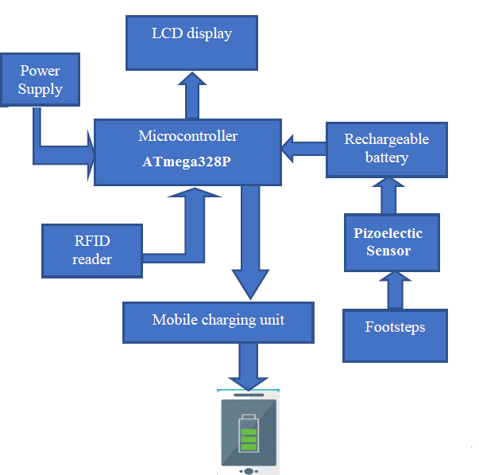

Fig. 3.1 Block Diagram

3.2 METHODOLOGY

Conventional power generating sources cannot be used to address the current global issue of escalating electricity consumption. The main objective is to end the power crisis, even though it won't be sufficient to supply the world's overwhelming demand for electricity. It will be possible to change and lessen reliance on antiquated electricity production techniques, nevertheless. A piezoelectric sensor is used to convert the wasted energy into a form that may be used in order to resolve this problem. This sensor converts the pressure that is applied to it into a voltage. By using this energy-saving method, the footstep power generation system, we are producing power.
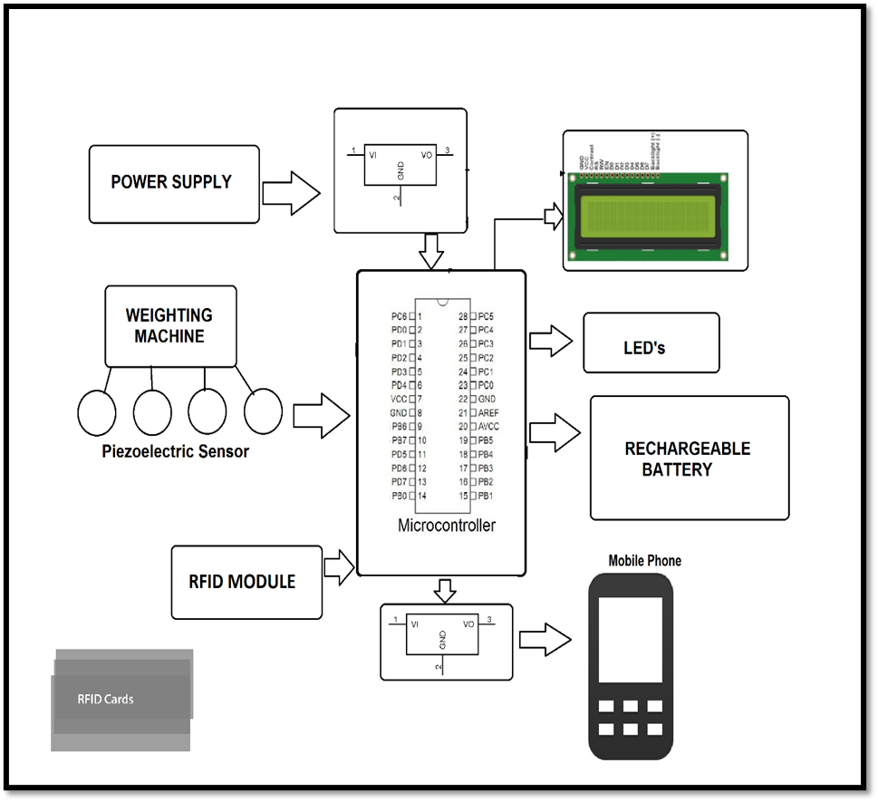

Fig. 3.2 Physical Setup

4. EXPERIMENTAL SETUP

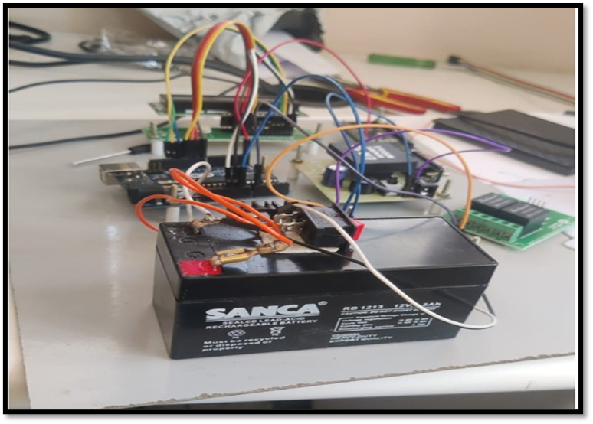
Fig 4. 1 Experimental Setup

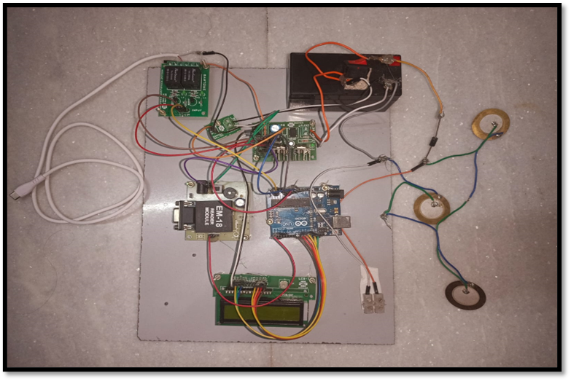
Fig 4.2 Final Circuit

4.3 Charging:

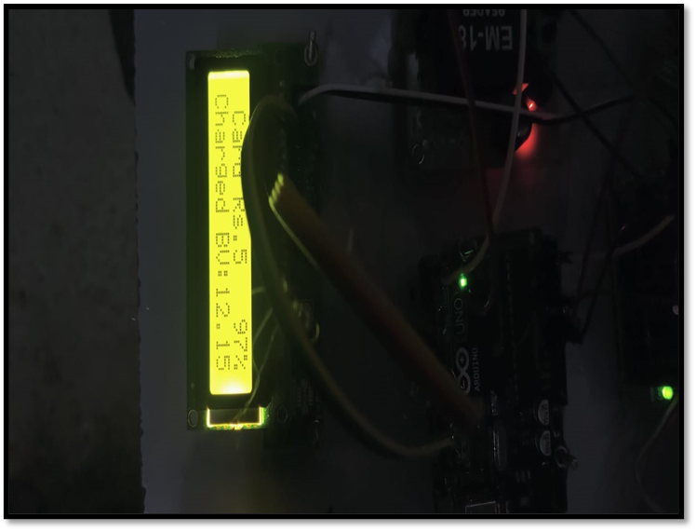

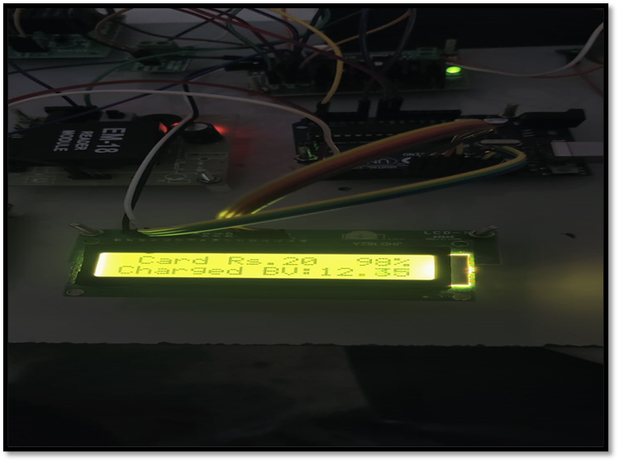
Fig 4.3 Battery Charging
5. IOT APP RESULTS:


Fig 5. IOT App results

6. CONCLUSION
Steps are the main way that energy is produced. There are absolutely no pollutants created by this type of power generation, and it does not require any energy from traditional energy sources. The places, which are all tracks, do not need any form of mains power to generate unconventional energy like electricity. It is a well-known fact that 11% of our primary energy comes from non-conventional sources. If this project is carried out, it will not only worsen the problems with the energy scarcity but also have a beneficial effect on the ecology all over the world.creation process.
7. REFERENCES
- R.Manasa Veena, B. Harika Reddy “Maximum Energy Harvesting from Electromagnetic Micro Generators by Footsteps Using Photo Sensor in International Conference on Computation of Power, Energy Information and Communication 2016.

- Taliyan.S.S "Electricity from footsteps" in IEEE Trans. On Power Generation, vo1.23. no.4, pp 2521-2530, April 2010.

- Jose Ananth Vino. V,AP,Bharath University "Power Generation Using Foot Step" in International Journal of Engineering Trends and Technology (UETT) -Volume I Issue2-May 20 II ISSN: 2231-5381

- Rama Krishna. K "Generation of electric power through footsteps" in International Journal of Multidisciplinary and Current Research Vol.2, ISSN: 2321-3124, Sep-2014

- Adhithan.A, Vignesh.K, Manikandan.M "Proposed Method of Footstep Power Generation Using Piezo Electric Sensor" International Advanced Research Journal in Science, Engineering and Technology Vol. 2, Issue 4, April 2015.

- Tanvi Dikshit, Dhawal Shrivastava, Abhijeet Gorey, Ashish Gupta, Parag Parandkar, Sumant Katiyal, “Energy Harvesting via Piezoelectricity”, BVICAM’s International Journal of Information Technology 2010.

- Y. C. Shu and I. C. Lien, "Analysis of power output for piezoelectric energy harvesting systems", Smart Materials and Structures 15 (2006), pp. 1499-1512.

- V.Dharmambal, Dr. Nisha KCR, Bhavana C, “Piezo Film based Renewable Energy System “, 2016 International Conference on Circuit, Power, and Computing Technologies [ICCPCT]

- Santhosh Mugali, “Footstep Power Generation Using Piezo-electric Transducers”, International Journal of Latest Technology in Engineering, Management and Applied Science, p. 2-5, Volume 7, May 2018.

- Iqbal Mahmud, “Electrical Power Generation Using Footsteps”, European Scientific Journal, 2018.

