Regulation of Mobile Usage

Dr. Vshal Shrivastava¹, Er. Sangeeta Sharma² , Professor¹, Assistant Professor²,Computer Science Engineering^{1,2}
Arya College of Engineering &I.T.^{1,2}
(RTU)
Jaipur,India
vishalshrivastava.cs@aryacollege.in¹ ,sangeetayuwansh1@gmail.com²

Abstract— This research paper examines the regulation of mobile phone utilization and its effect on society. With the expansion of mobile phones and their far and wide use, concerns have emerged in regards to their expected adverse consequences on human wellbeing, social connections, and efficiency. The paper surveys the current examination on the effect of mobile phone utilization, incorporating the dangers related with exorbitant use and fixation, and the likely advantages of managing mobile phone use. The degree of virtual entertainment dependence isn't that serious with just slight habit recognized. There is a huge positive relationship between virtual entertainment enslavement and psychological wellness, explicitly loss of focus, despondency, and tension, in that grouping. In general the review proposes that to stay away from psychological wellness issues (sadness, nervousness, and loss of focus), understudies ought to restrict their experience via virtual entertainment and lower their reliance propensity on them. This research paper gives experiences into the present status of guideline of mobile phone utilization and gives proposals for future arrangement advancement to advance mindful and sound mobile phone use.

Keywords— social media, depression, anxiety, mobile phone utilization, regulation of mobile phone use.

Introduction
Mobile phones have turned into a basic piece of our day to day routines, with an expected 5.22 billion individuals all over the planet involving cell phones in 2020. While these gadgets have revolutionized the manner in which we convey, work, and access data, concerns affect human wellbeing, social connections, and efficiency. With the expansion of mobile phones, the requirement for regulation has become progressively dire to address these worries.
Detailed examination by the group at Kepios shows that there are 4.76 billion online entertainment clients all over the planet in January 2023, likening to 59.4 percent of the complete worldwide populace.
Online entertainment client numbers have kept on developing throughout the course of recent months as well, with 137 million new clients joining virtual entertainment since this time a year ago.
That compares to annualized development of 3%, at a typical pace of multiple new clients each and every second.
The most recent figures show that well more than 9 out of 10 web clients presently utilize online entertainment every month
Web-based entertainment fixation, informal communities habit, and Web dependence have often been explored by researchers in correspondence and brain science as of late. This peculiarity got public consideration after the issue became broad across the globe without raising worries among general society aside from the subject matter experts. web-based entertainment habit has been utilized to allude to an individual who invests a lot of energy in virtual entertainment stages like Facebook, YouTube, Instagram, Twitter, and different types of online entertainment which influence their lives.
The most generally utilized online entertainment stages are Facebook, YouTube, Instagram, Twitter, Wire, and WhatsApp (kepios, 2023). As per the Worldwide web-based entertainment enslavement, there were around 400 million

dynamic virtual entertainment clients overall in 2023(Kepios,2023) contrasted with 2.62 billion out of 2018 (Statista, 2018).

LITERATURE REVIEW
1. Mental health issues
Emotional well-being has been a worldwide worry as of late. As per the World Wellbeing Association (WHO), emotional well-being is characterized as the condition of prosperity in which people understand their own capacities, can adapt to the typical burdens of life, can work beneficially and productively, and are capable to add to their local area (WHO, 2022). The three most normal issues in psychological wellness are misery, stress, and nervousness. As per American Psychiatry Affiliation, psychological well-being issue is characterized as the issue to work in the social angle and it is connected with the circumstances including changes in feeling, thinking, and additionally conduct of a person. It is related with melancholy, tension, and pain with issues working in friendly, work, or family exercises. Emotional well-being influences day to day existence like efficiency (working, considering), family relationship, and actual wellbeing. In a report by American Psychiatry Affiliation, one of every five (19%) of American grown-ups encountered some type of psychological well-being issue and one of every 24 (4.1%) experienced serious emotional well-being issues (Ranna, 2021).
Psychological well-being has been seen to be associated with the commonness of online entertainment compulsion among youthful college understudies. Over the most recent few years, Web habit and online entertainment enslavement
Have turned into a worldwide worry to people in general and these can be named medical problems. From a clinical clinician's viewpoint, the dependence via virtual entertainment is a waste and represents a serious worry to its
Clients' wellbeing, particularly youngsters. "Facebook Dependence Problem" and "Interpersonal organization Site
Dependence Confusion" happen on the grounds that compulsion measures, like disregard of individual life, mental distraction, idealism, temperament altering encounters, resistance, and covering the habit-forming conduct give off an impression of being available in certain individuals who utilize person to person communication destinations unnecessarily (Kuss and Griffiths, 2020), which lead to the commonness of web-based entertainment dependence.

2. FOMO (Fear of missing out)
Fear of missing out (FOMO) and social media addiction. While FOMO has been around far longer than social media, sites such as Facebook and Instagram seem to exacerbate feelings that others are having more fun or living better lives than you are. The idea that you’re missing out on certain things can impact your self-esteem, trigger anxiety, and fuel even greater social media use, much like an addiction. FOMO can compel you to pick up your phone every few minutes to check for updates, or compulsively respond to each and every alert—even if that means taking risks while you’re driving, missing out on sleep at night, or prioritizing social media interaction over real world relationships.

3. Social Media Addiction and Depression
According to American Psychiatry Association, depression is defined as a common and serious medical illness that negatively affects the feelings of individuals and also the way they think and act. Depression leads to emotional and physical problems, and it also reduces a person’s ability to function at work and at home. Depressed individuals become sad easily and lose interest in activities they used to enjoy (Ranna, 2021). The same report shows that depression is more commonly seen among females (5.1%) than males (3.6%). The total number of people estimated to be living with depression increased by 18.4% between 2019 and 2019. Win et al. (2021) found that 34% of Chinese university students were classified as addicted. Moreover, loneliness was reported to be significantly and positively correlated with social networking site addiction. In Myanmar, Win et al. (2021) found that Internet addiction could contribute to 45% of depression among university students in Myanmar. In contrast, Rahman (2022) found a negative relationship between Facebook addiction and mental health.
4. Social Media Addiction and Anxiety
According to American Psychiatry Association, anxiety refers to the anticipation of a future concern and is more associated with muscle tension and avoidance behavior (Ranna, 2022). In this study, anxiety is one of the consequences of excessive use of social media, meaning that social media addiction, in particular, causes the individuals who use social media excessively to become easily frustrated, experience fear, and escape or isolate from other people. WHO (2021) reported that an estimated 3.6% of the global population had anxiety disorders in 2019 with a higher prevalence among females (4.6%) than males (2.6%). Prior studies (e.g., Kumar & Mondal, 2018; Nima et al., 2020; Win et al., 2021) identified that among the worst effects of Internet and social media addiction are anxiety, stress, and depression. The study conducted by Win et al. (2021) in Myanmar found that increased usage of the Internet resulted in anxiety with 36.5% of the respondents suffering from anxiety. Nima et al. (2019) revealed the existence of a positive and significant correlation between the level of anxiety and Internet addiction. Additionally, Razieh et al. (2012) found that Internet users had a higher level of anxiety compared to non-Internet users at 80.8% and 28.5%, respectively, while 59% of the social network addicted users suffered from anxiety.

METHODOLOGY
Social media can be a tricky beast. Sometimes you’re and scrolling; other times you’re feeling flat from FOMO. So, it pays to know how best to manage your use of socials. It's not an easy thing to do, but reducing your usage will free up time to spend on other things and help you to be more focused. Here are five ways to make your socials work for you. The study utilized a quantitative examination configuration utilizing an organization inspecting overview methodology as the information assortment technique. A self-managed poll was utilized as the instrument of the study furthermore, disseminated up close and personal and on the web, which helped in gathering an enormous number of information inside a brief timeframe. The vast majority of the reactions were accumulated online by means of long range informal communication locales that incorporate Facebook courier and WhatsApp. The leftover reactions were gathered through physical contact with the respondents.

- Area of Study and Sampling
The area of population for this study consisted mostly college going youth between the age group of 18-30 in ARYA COLLEGE OF ENGINEERING AND IT, JAIPUR, INDIA. The data was collected majorly from the engineering students and this study managed to obtain total number of 125 respondents, 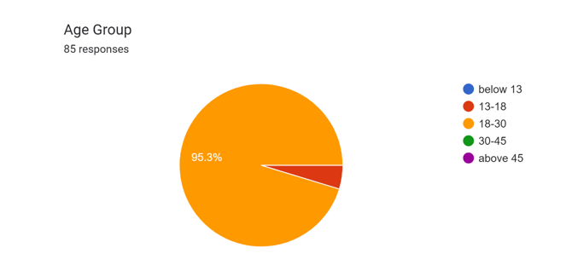out of which 40 were face to face interactions with the students and 85 were online based survey.

2. Results
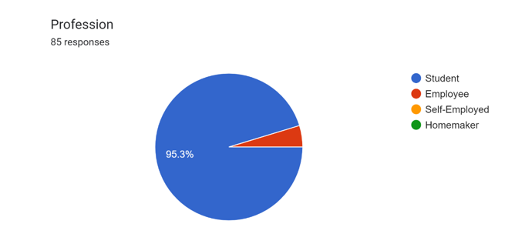
Obtained result showed that around 95.3% were student oriented survey and rest were either employee or self employed people.

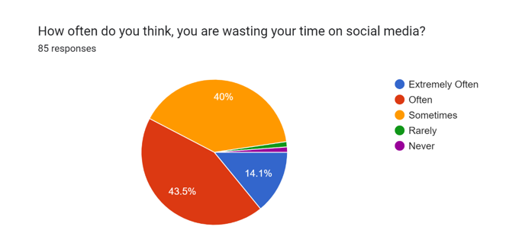
Many question was based on a 5-point likert scale or 4-point likert scale, ranging from extermely often to never and the result showed that 14.1% respondents agreed that they extermely often waste their time on social media,43.5% belonged to often category, whereas 40% agreed to sometime waste their time on social media and the other respondents voted for rarely or never wasting their time on social media.
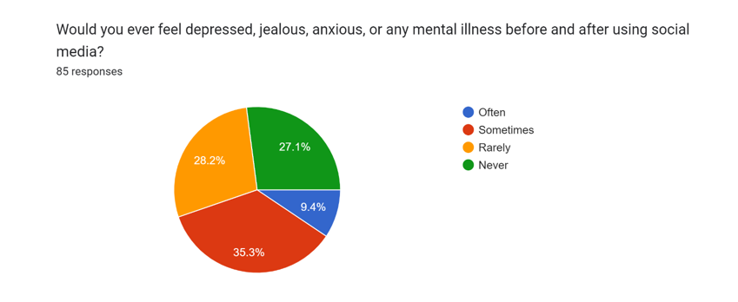
Regarding the anixety on usage of social media 35.3% of the respondent said they sometime feel anxious and other mental illness. 28.2% reported that they rarely fell these mental illness and 27.1% denied with the statement .9.4% strongly agreed that social media has adverse effect on mental health.
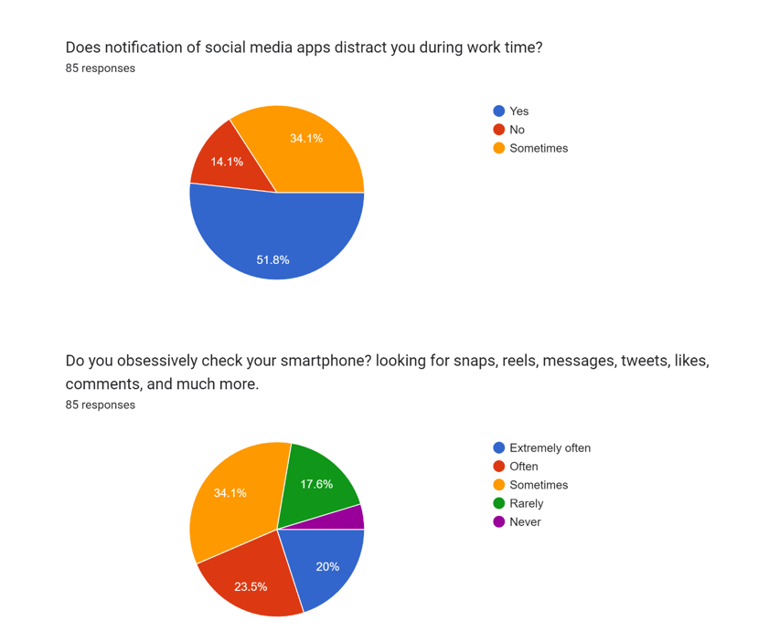
When it comes to the distraction the social media’s notification has cause , around 51.8% respondent said they are easily distracted , 34.1% claiming that they sometime gets distracted by them, and the other who never get distracted contribute 14.1% of the respondent.

Regarding the obession attached with the smartphones 20% respondent said that they are obsessively checking for the snaps, tweets, reels, messages and etc on their phones, around 23.5% claimed that they often check their phones in distractive manner, 34.1% voted that they smothimes look for reels, tweets , messages and etc , whereas 17.6% said that they rarely check their phones for social media notifications.
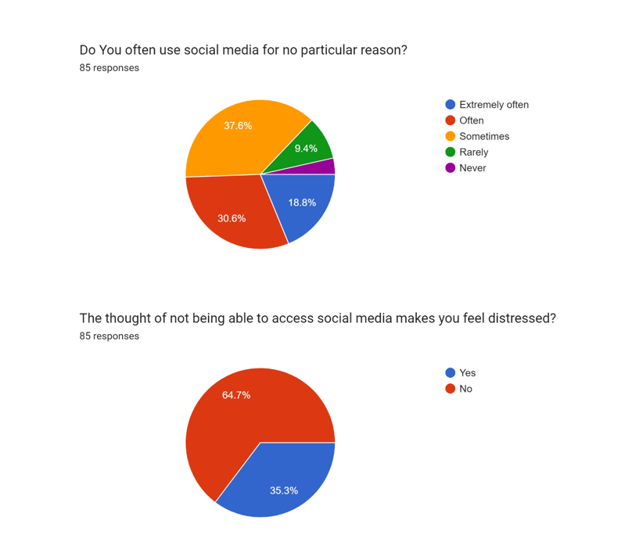
Result of wastage of using social media platforms revealed that 18.8% of the respondent exteremly often use social media for no particular reason & 30.6% said that oftenly waste their time on social media , 37.6% voted for sometime and 9.4% and rest said that rarely or never waste their time on social media.

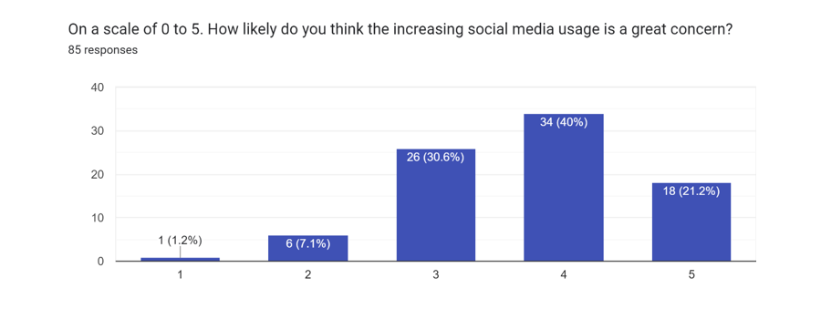
When surved about the concern of increasing social media usage on scale of 0 to 5 about 40% of the respondent voted 4 out of 5, 21.2% of them voted 5 out of 5, 30.6% voted 3 out of 5 and 7.1% and 1.2% responded 2 and 1 out of 5.
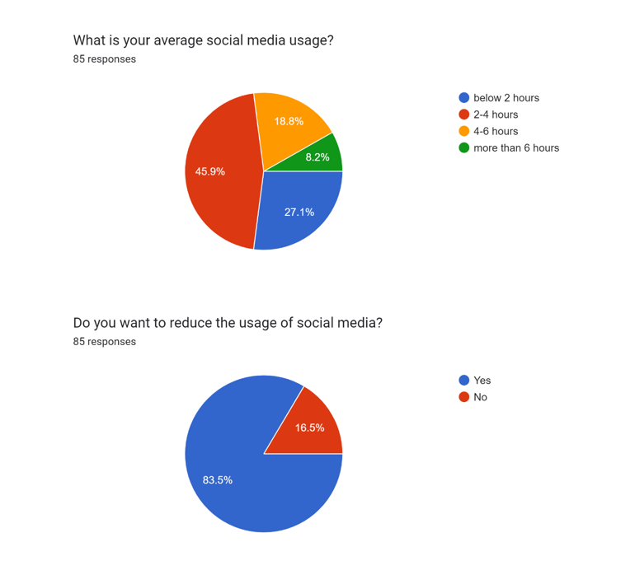
The Time spent on social media is important in this study which shows that 45.9% of the respondent said that they spent average 2-4 hours in surfing social media, followed by almost 18.8% spending around 4-6 hours per day, followed by 27.1% claiming that they spent less than 2 hours a day, and almost 8.2% respondent said that they spent more than 6 hours daily on social media

After which when asked about the necessity to reduce the usage of social media 83.5% voted for yes and rest 16.5% didn’t feel the need to reduce the social media usage.

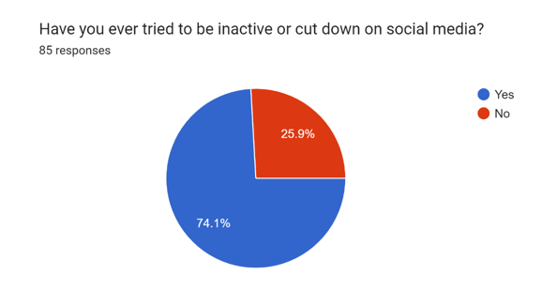
When surveyed about the efforts to cut down or deactivate their social media handels 74.1% respondents said that yes they have tried and 25.9% disagreed with the question.
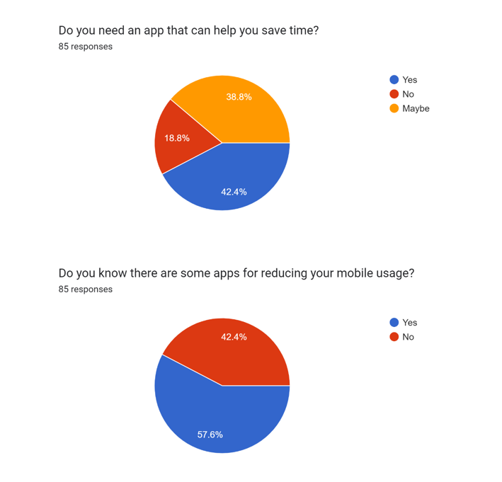
Around 42.4% of the respondent felt that there is need of application that can help them to reduce the usage of social media and 38.8% said maybe they need such an application of them and rest of them voted as no, that they donot feel the need of such applications.

Results regarding the awarness about such application revealed that 57.6% of respondent are aware about the application that exist and helps to regulate the mobile usage whereas 42.4% of them disagreed with the question.

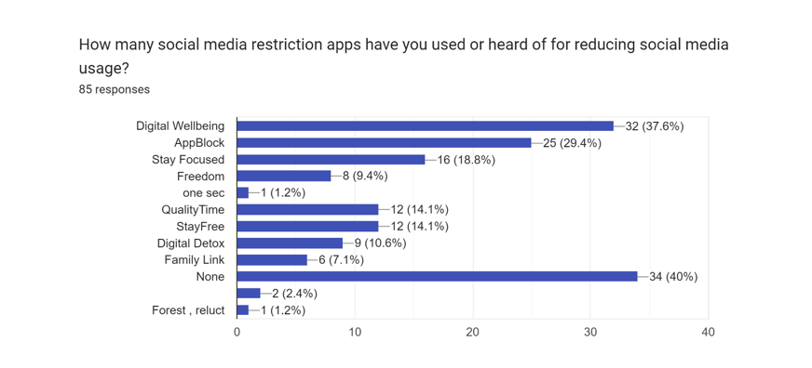
Regarding the social media restriction app 40% people disagreed that they are not aware about such apps, 37.6% know about ‘digital wellbeing’ and 29.4% respondent said that they are aware about the ‘Applock’ , 18.8% said that they knew about ‘Stayfocused’, 9.4% voted for ‘Freedom’, 1.2% respondend for ‘one sec’ , 14.1% claimed that they are aware about ‘Quality Time’ and ‘StayFree’ , 10.6% have heard or used ‘Digital Detox’ and 7.1% are aware about ‘Family Link’ furthermore 2.4% and 1.2% voted that they are aware about ‘Forest’ and ‘Reluct’ applications.
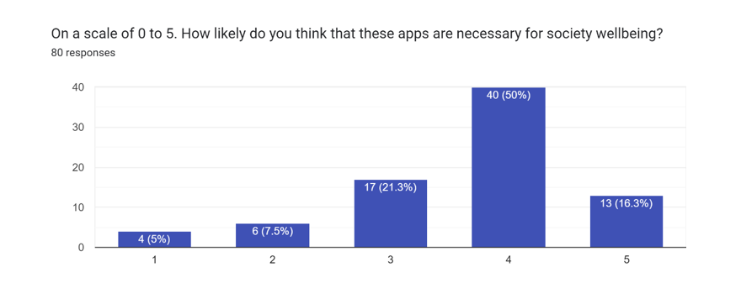
When surved about the necessity of these apps for society wellbeing on the scale of 0 to 5, 50% of respondent voted 4 , 16.3% said 5 out of 5, 21.3% of them responded 3 whereas 7.5% and 5% of them voted for 2 and 1 on a scale of 5.

DISCUSSION
To give a far reaching conversation of an research paper on the guideline of portable utilization, it is vital to initially grasp the primary targets and discoveries of the paper.
The paper might investigate different parts of mobile phone utilization, remembering the effect of extreme use for people's physical and psychological well-being, social connections, and efficiency. It might likewise analyze the viability of various administrative methodologies, for example, schooling efforts, regulations and guidelines, and mechanical mediations.
In light of the discoveries, the paper might recommend various systems for directing mobile phone utilization, including the significance of individual obligation, self-checking, and self-guideline. It might likewise suggest the requirement for strategy and administrative mediations, for example, drawing certain lines on utilization time, limiting admittance to specific substance, and advancing the utilization of options like up close and personal correspondence.
Generally, the paper might add to the continuous discussion around the guideline of cell phone utilization, which has become progressively significant in the present advanced age. It might help policymakers, scientists, and the overall population to more readily comprehend the dangers and advantages related with cell phone use, and to distinguish viable methodologies for advancing sound and capable use.
As far as likely restrictions, the research paper might confront difficulties in laying out a causal connection between unnecessary cell phone use and adverse results, as there might be different variables impacting everything. It might likewise battle to represent individual contrasts in mobile phone utilization designs, as well as social and cultural standards that might impact mentalities and ways of behaving connected with mobile phone use.
Generally, an exploration paper on the guideline of cell phone use can possibly add to a developing group of writing on this significant point, giving bits of knowledge into the dangers and advantages of mobile phone use and recognizing viable systems for advancing dependable use.

CONCLUSION
In conclusion, the regulation of mobile phone use is an undeniably significant issue in the present advanced age, with possible effects on people's physical and psychological wellness, social connections, and efficiency. The research paper on this point can help policymakers, specialists, and the overall population to all the more likely comprehend the dangers and advantages related with cell phone utilization and distinguish successful techniques for advancing mindful use.
The paper might recommend different administrative methodologies, for example, training efforts, regulations and guidelines, and mechanical intercessions. It might likewise feature the significance of individual obligation, self-checking, and self-guideline in advancing sound and dependable mobile phone use.

References

- G. Eason, B. Noble, and I. N. Sneddon, “On certain integrals of Lipschitz-Hankel type involving products of Bessel functions,” Phil. Trans. Roy. Soc. London, vol. A247, pp. 529–551, April 1955. (references)
- J. Clerk Maxwell, A Treatise on Electricity and Magnetism, 3rd ed., vol. 2. Oxford: Clarendon, 1892, pp.68–73.
- I. S. Jacobs and C. P. Bean, “Fine particles, thin films and exchange anisotropy,” in Magnetism, vol. III, G. T. Rado and H. Suhl, Eds. New York: Academic, 1963, pp. 271–350.
- K. Elissa, “Title of paper if known,” unpublished.
- R. Nicole, “Title of paper with only first word capitalized,” J. Name Stand. Abbrev., in press.
- Y. Yorozu, M. Hirano, K. Oka, and Y. Tagawa, “Electron spectroscopy studies on magneto-optical media and plastic substrate interface,” IEEE Transl. J. Magn. Japan, vol. 2, pp. 740–741, August 1987 [Digests 9th Annual Conf. Magnetics Japan, p. 301, 1982].
- M. Young, The Technical Writer’s Handbook. Mill Valley, CA: University Science, 1989.

