A
Project Report
on
SOIL CEMENT COLUMN ANALYSIS WITH INDUSTRIAL WASTE MATERIAL ON PLAXIS 2D
submitted as partial fulfillment for the award of
BACHELOR OF TECHNOLOGY
DEGREE
SESSION 2022-23
in
Civil Engineering
By

Yashita Mishra 1905250000113
Vivek Gupta 1905250000112
Rohit Yadav 1905250000084
Khushboo Singh 2005250009011

Under the supervision of
Baijnath Nishad
(Assistant Professor)



Buddha Institute of Technology, Gorakhpur
Affiliated to
Dr. A.P.J. Abdul Kalam Technical University, Lucknow,
Uttar Pradesh
May, 2023

DECLARATION
I hereby declare that this submission is my own work and that, to the best of my knowledge and belief, it contains no material previously published or written by another person nor material which to a substantial extent has been accepted for the award of any other degree or diploma of the university or other institute of higher learning, except where due acknowledgment has been made in the text.

Yashita Mishra 1905250000113
Vivek Gupta 1905250000112
Rohit Yadav 1905250000084
Khushboo Singh 2005250009011

Date:________________
Department of Civil Engineering

CERTIFICATE

This is to certify that Project Report entitled “SOIL CEMENT COLUMN ANALYSIS USING INDUSTRIAL WASTE MATERIAL ON PLAXIS 2D” which is submitted by Yashita Mishra, Vivek Gupta, Rohit Yadav, Khushboo Singh in partial fulfillment of the requirement for the award of degree B. Tech. in Department of Civil Engineering of Dr. A.P.J. Abdul Kalam Technical University, Lucknow is a record of the candidates own work carried out by them under my supervision. The matter embodied in this report is original and has not been submitted for the award of any other degree.

Date:

(Mr. Vijay Kumar Srivastava) (Mr. Baijnath nishad)
Head of Department Assistant Professor
(Civil Engineering Department) (Civil Engineering Department)
Buddha Institute of Technology, Buddha Institute of Technology,
GIDA, Gorakhpur GIDA, Gorakhpur

ACKNOWLEDGEMENT

It gives us a great sense of pleasure to present the report of the B. Tech Project undertaken during B. Tech. Final Year. We owe special debt of gratitude to Baijnath Nishad, Department of Civil Engineering, Buddha Institute of Technology, Gorakhpur for his constant support and guidance throughout the course of my work. His sincerity, thoroughness and perseverance have been a constant source of inspiration for me.
I also take the opportunity to acknowledge the contribution of Mr. Vijay Kumar Srivastav, Head of the Department of Civil Engineering, Buddha Institute of Technology, Gorakhpur, for his full support and assistance during the development of the project. I also do not like to miss the opportunity to acknowledge the contribution of all the faculty members of the department for their kind assistance and cooperation during the development of my project. I also do not like to miss the opportunity to acknowledge the contribution of all faculty members, especially faculty/industry person/any person, of the department for their kind assistance and cooperation during the development of my project. Last but not the least, I acknowledge my friends for their contribution in the completion of the project.
Yashita Mishra 1905250000113
Vivek Gupta 1905250000112
Rohit Yadav 1905250000084
Khushboo Singh 2005250009011

Date:-

ABSTRACT

Deep stabilization in form of stabilized soil columns is a well-known method often used in infrastructure projects. The use of stabilized soil columns as a deep stabilization method is, however, rarely used in building foundations. Instead various prefabricated or in-situ casted concrete piles are conventionally used. The greatest difficulty with the stabilized soil columns are the lack of standardized calculation methods using stabilized soil columns as deep stabilization. Enhancing in soil strength was measured, by conducting experimental program by preparing and testing samples for unconfined compressive test for stabilized soil with various binder amounts 1%,2%,4% and 7% of soil dry mass and for 7,14,28,60 and 90 days curing time. From the compression test effect of initial loading on soil strength during curing time was evaluated The parameters evaluated from the compression test together with previously performed soil test performed on the used clay material is then underlying the calculations performed by hand as well as for the finite element method modelling with PLAXIS 2D.The difference in strength per weight-percent is higher between 4% and 7% than for the lower binder contents.The stabilized soil columns can, however, not carry as high load as the concrete piles. Therefore, a tighter column pattern is used for the columns than for the piles. Each column can carry a load of 607,6kN while each concrete pile can carry 950,5kN.

Key word: PLAXIS 2D, Deep Stabilization, Bearing Capacity, Prefabrication, Settlement. Etc.

Table of Contents Page No.

DECLARATION ii
CERTIFICATE iii
ACKNOWLEDGEMENT iv
ABSTRACT v
LIST OF FIGURES viii
LIST OF TABLES i
CHAPTER 1 INTRODUCTION 1
1.1 GENERAL 1
1.2 WHAT IS GIT? 2
1.3 USING GIT FOR TRANSPORTATION 4
1.4 INDUSTRIAL WASTE MATERIAL 4
1.5 GOAL AND OBJECTIVE 5
CHAPTER 2 LITERATURE REVIEW 6
2.1 DATA SOURCE 8
2.2 NUMERICAL STIMULATION 9
2.3 DATA COLLECTION 9
CHAPTER 3 METHODLOGY 9
3.1 GENERAL 9
CHAPTER 4 RESULT AND SCOPE 19
4.1 GENERAL………………………………………………………………………………………. 19
4.2 SOFTWARE ANALYSIS 24
4.3 ROLE IN RESEARCH………………….......…………………………………………………... 26
4.4 SAMPLE PROCEDURE 27
CHAPTER 5 CONCLUSION 28
5.1 GENERAL 28
5.2 SOFTWARE ANALYSIS 28
APPENDIX 31
LIST OF PUBLICATIONS……………………………………………...............……...…...…....……34
REFERENCE 35

LIST OF FIGURES

Figure No. | Description | Page No.
1.1(a) | Installation of the soil cement column | 9
1.1(b) | Arrangement of the soil cement column | 10
1.2 | Specific Gravity Test | 14
1.3 | Hydrometer Test | 16
1.4 | UCS Test | 21
3.1 | Mesh Diagram | 23
3.2 | Active Pore Pressure | 23
3.3 | Effective Stresses | 24
3.4 | Deformed Mesh | 24
3.5 | Vertical displacement | 25
3.6 | Time vs Displacement Graph | 25

Table. No | Description | Page No.
2.1 | Basic Test Analysis | 13
2.2 | Specific Gravity (Kaolin Soil) | 14
2.3 | Specific Gravity (Slag) | 14
2.4 | Grain Size Analysis | 15
2.5 | Vane Shear Test | 17
2.6 | Atterberg limit test | 17
2.7 | UCS Test | 18

CHAPTER 1

INTRODUCTION

1.1 GENERAL
Columnar inclusion is one of the effective and widely used methods for improving engineering properties of soft clay ground. This article investigates the consolidation behavior of composite soft clay ground using physical model tests under an axial-symmetry condition and finite element simulations by PLAXIS 2D program. It is found out that the final settlement and the rate of consolidation of the composite ground depend on the stress state. For an applied stress much lower than the failure stress, the final settlement of the ground is insignificant and the consolidation is fast. When the soil-cement column fails, the stress on column suddenly decreases (due to strain-softening) meanwhile the stress on soil increases to maintain the force equilibrium. Consequently, the excess pore pressure in the surrounding clay increases immediately. The cracked soil-cement column acts as a drain, accelerating the dissipation of the excess pore pressure. The consolidation of the composite ground is mainly in vertical direction and controlled by the area ratio, the ratio of diameter of industrial waste material soil-cement column to the diameter of composite ground. The stress on column is low for the composite ground with high value of resulting in less settlement and fast consolidation. For a long soil-cement column, the excess pore pressures in the surrounding clay and the column are practically the same at the same consolidation time for the whole improvement depth.

1.2 WHAT IS GROUND IMPROVEMENT TECHNIQUES (GIT)?
The ground can be improved by adapting certain ground improvement techniques. Vibro-compaction increases the density of the soil by using powerful depth vibrators. Vacuum consolidation is used for improving soft soils by using a vacuum pump. Preloading method is used to remove pore water over time. Heating is used to form a crystalline or glass product by electric current. Ground freezing converts pore water to ice to increase their combined strength and make them impervious. Vibro-replacement stone columns improve the bearing capacity of soil whereas Vibro displacement method displaces the soil. Electro osmosis makes water flow through fine grained soils. Electro kinetic stabilization is the application of electro osmosis. Reinforced soil steel is used for retaining structures, sloping walls, dams etc. seismic loading is suited for construction in seismically active regions. Mechanically stabilized earth structures create a reinforced soil mass. The geo methods like Geosynthetics, Geogrid etc. are discussed. Soil nailing increases the shear strength of the in-situ soil and restrains its displacement. Micro pile gives the structural support and used for repair/replacement of existing foundations. Grouting is injection of pump able materials to increase its rigidity. The jet grouting is quite advanced in speed as well as techniques when compared with the general grouting.

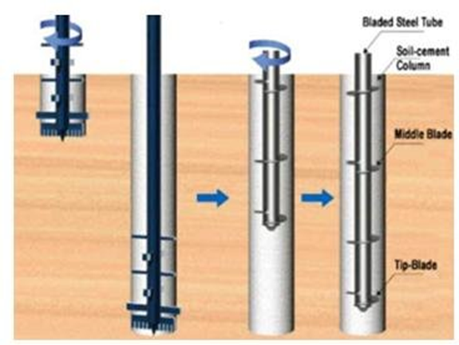
Figure 1.1 (a)

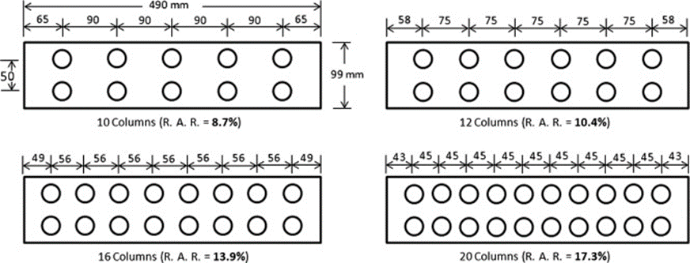
Figure 1.1 (b)

1.3 USING GIT FOR TRANSPORTATION
The use of ground improvement in transportation projects is studied through its application to the four main systems of transportation: surface, underground, marine and air. The ground improvement methods applied involve densification, consolidation, weight reduction, reinforcement, chemical treatment, thermal stabilization and biotechnical stabilization. Improvement of the weak soils provided increased bearing capacity, settlement control, lateral stability, environmental control and liquefaction resistance. Included in the paper are visions of ancient builders as well as modern innovative applications of a variety of ground improvement techniques.
1.4 INDUSTRIAL WASTE MATERIAL

Blast furnace slag is a by-product resulting from the smelting of iron ore into pig iron, in a process carried out in industrial units called blast furnaces, where the oxides contained in iron minerals are reduced and the impurities that accompany them are separated. Slag is formed by the melting of impurities from iron ore after the addition of molten materials such as limestone and dolomite and coke ash.

1.5 GOAL AND ACHIEVMENT
This project aims to produce a superior overall understanding of ground improvement with the help of PLAXIS 2D. In this project, we used the practical method of analysis of column as well as the software method. The use of PLAXIS 2D is the modern method for the analysis of column with different waste material like combination of different percentage of fly ash, slag and dolomite.
Another aim is to contribute to a greater understanding of the weight of the factors (fly ash, slag, dolomite, NaOH etc.) influencing the strengthening parameters during such curing.

CHAPTER 2

LITERATURE REVIEW
2.1 GENERAL
Soil cement columns is difficult to be constructed on loose soil like kaolin soil, who’s physical and chemical property is not acceptable. To increase the properties of the soil we are using waste industrial material with properties which enhances the property of the soft clay.
The industrial waste materials used in our project are Fly ash, Slag and Dolomite etc. In addition of the industrial waste material we also used NaOH for better result. The data of the test result before and after test is provided. The clay was composed of 11% sand, 17% silt and 72% clay. The natural water content was 80% and the specific gravity was 2.68. The liquid and plastic limits were 6 81% and 34%, respectively. Based on the Unified Soil Classification System (USCS), the clay was classified as high plasticity (CH). The soil-cement column was installed in the middle of mold. This physical model test is to simulate a composite foundation where soil-cement columns are installed vertically in a triangular or square pattern at the same spacing into a horizontal clay layer and are subjected to uniform vertical fill loading over an extensive area. The consolidation around a soil-cement column was approximately axis symmetrical with an equivalent diameter, at the boundary of which lateral displacement were not permitted. The vertical load on the model ground was applied by dead weights on a level hanger. The remolded clay slurry was transferred to the cylindrical stainless mold having 30 mm sand at the base and a plastic PVC tube (either 50 mm or 100 mm in diameter) in the middle. The tube had many small holes and covered with thin geotextile to accelerate the consolidation. Because the tube was not directly contact to the surrounding clay, it was easily removed after consolidation. During transferring clay slurry, the mold was vibrated to remove air bubble. A 8 mm thick acrylic plate was placed on the top of the model composite ground to apply a vertical consolidation stress of 20 kPa. The plate had a hole (either diameter of 52 or 102 mm) in the middle. During the consolidation process, the settlement was measured to ensure the end of consolidation. The final height of the clay after consolidation was about 200 mm with a water content of about 60%. The unconfined 7 compressive strength of this reconstituted clay was 25 kPa and the compression and recompression indexes obtained from odometer test were 0.498 and 0.186, respectively. The effective strength parameters in compression were c′ =1 kPa and φ′ = ° 21 . The model soil-cement column was made up by mixing Portland cement with cement slurry at cement contents, C, of 20 and 40%. The clay-cement paste was mixed thoroughly in a soil mixer for 10 min. The paste was poured into a cylindrical plastic PVC tube with internal diameters of 50 and 100 mm and height of 200 mm. After 24 hours, the model columns were dismantled and wrapped in vinyl bags. They were cured in a humidity room of constant temperature (20±2°C) for 28 days. The water contents of the model columns after curing were 80 and 70% for C = 20 and 40%, respectively. The unconfined compressive strengths were 500 and 1200 kPa for C = 20 and 40%, respectively. The effective strength parameters were c′ = 200 kPa and φ′ = ° 25 for C = 20% and c′ = 500 kPa and φ′ = ° 27 for C = 40%. After finishing the consolidation of the reconstituted clay, the PVC tube and geotextile were removed and the soil-cement column was inserted into the hole in the middle of the reconstituted model ground to form the composite model. Six miniature pore water pressure transducers (PPTs) were installed at certain positions and used to measure the pore water pressure in the surrounding clay. All PPTs were penetrated into the surrounding clay through pre-drilled holes of the cylindrical mold. PPT 1 and PTT 2 were fixed on the bottom, PPT 3 and PTT 4 were on the middle and PPT 5 and PTT 6 were on the top of the surrounding clay ground. One small earth pressure (EPC) (10 mm thick and 50 mm in diameter) was placed on the surface of the surrounding clay and the other was on the top of the soil-cement column. Both EPC were covered with 10 mm sand. In addition, two linear variable differential transformers (LVDTs) were used to measure the settlement of the model composite ground. The drainage was only allowed at the top of the composite ground (single drainage).

CHAPTER 3

METHODLOGY

3.1 GENERAL
From this study, the coefficients of permeability of soil-cement column and surrounding clay are practically the same; therefore, the soil-cement column does not act as the drain. Because the soil-cement column enhances the yield stress and the stiffness to the composite ground, the composite ground is in over-consolidated state under the applied vertical applied stresses. At this state, the rate of consolidation is fast due to high coefficient of consolidation. The soil-cement column acts as the drain only when the soil-cement reaches the failure state. After failure, the stress sustained by the soil-cement column transfers to the surrounding clay, resulting in the decrease in stress concentration, n. Consequently, the average degree of consolidation of the composite ground increases. This situation is impossible in actual projects that the soil-cement columns are generally designed under working state. Because the cement content is mainly controlled unconfined compressive strength and effective strength parameters, the final settlement is insignificantly dependent upon the cement content. The diameters of the soil-cement column and composite ground were 1.0 and 6.0 m (a = 1/6) and the depth of soft clay was 15 m. The values of the model parameters presented in the elastic model of the soil-cement column of 120,000 kPa were used for this simulation. For both drainage conditions, the excess pore pressures in the soil cement column around the drainage dissipate slightly quicker than those in the surrounding clay. The dissipation rate in the other parts of the soil-cement column is practically the same as that of the surrounding clay at the same improvement depth. For the long soil-cement column, which is a typical application, the variation in excess pore pressure around the drainage is insignificant and the excess pore pressures in both soil-cement column and surrounding clay at the same consolidation time are practically the same for the whole depth. The change in excess pore pressure with consolidation time in the surrounding clay for both single and double drainage conditions. For both conditions, the change in excess pore pressure with depth is similar to that of one-dimensional consolidation for both positions close to and far away from the soil-cement column.). In other words, the drainage path controls the rate of consolidation but not the final settlement. The soil-cement column inclusion not only reduces the final settlement and but also enhances the rate of consolidation of the soft clay (increase the coefficient of consolidation). The time at 90% degree of consolidation, t90 of the composite ground is 687 min for single drainage while the t90 of the soft clay (without soil cement column) is 8650 min. It is concluded from this study that the composite ground is in the over-consolidated state under the applied load and hence high coefficient of consolidation.
3.2 NUMERICAL SIMULATION
The performance of composite ground (prior to column failure) was simulated by using the PLAXIS 2D program and the simulations were compared with the test results to understand the consolidation mechanism of composite ground and to understand the role of C on the consolidation behavior. The finite element mesh was comprised of 15-nodes triangular elements. Table 2 shows the model parameters for the surrounding clay and the soil-cement column. Overall, the numerical simulations are comparable with the test results. The composite ground with high a value exhibits low settlement and high rate of consolidation. The cement content does not play any significant role on the final settlement and consolidation time because the elastic modulus, E′ of the column is almost the same for both cement contents tested. The σ soil increases rapidly after applying vertical stress and then decreases with time due to the stress transfer to the soil cement column. The excess pore pressures in the soil-cement column dissipate quicker than those in the surrounding clay only at the top of the composite ground while the excess pore pressures in both the soil-cement column and the surrounding clay at the same consolidation time are practically the same for deeper improvement depth. As the area ratio increases, the rate of consolidation increase.
3.3 DATA COLLECTION
3.3.1 BASIC TEST
A laboratory procedure as listed step by step below, was attempted to be developed for preparing, curing and testing the soil mixed specimen applicable to the wet method of soil mixing. This procedure was similar to that described by Strength.
SPACING | EXPERIMENTAL ANALYSIS | NUMERICAL ANALYSIS
Untreatedsoil | 1.9 | 2.13
2d | 1.0 | 1.24
2.5d | 1.4 | 1.51
3d | 1.66 | 1.83
3.3.2 LABORATORY INVESTIGATION
Soil cement columns is difficult to be constructed on loose soil like kaolin soil, who’s physical and chemical property is not acceptable. To increase the properties of the soil we are using waste industrial material with properties which enhances the property of the soft clay.
The different work and test presented in the laboratory are listed below-
- SPECIFIC GRAVITY
- GRAIN SIZE ANALYSIS
- WET SIEVING AND HYDROMETER TEST
- VANE SHEAR TEST
- ATTERBERG’S LIMIT TES
- COMPACTION PROCTOR TEST
- UNCONFINED COMPRESSION TEST

- SPECIFIC GRAVITY
- KAOLIN SOIL Average =2.47
BOTTLE NO. |  |  | 50ml | 50ml
BOTTLE(W1)gm |  |  | 29 | 28.9
BOTTLE+SOIL(W2)gm |  |  | 49.3 | 48.8
BOTTLE+SOIL+WATER(W3)gm |  |  | 89 | 92
BOTTLE+WATER(W4) gm |  |  | 77 | 80
SPECIFIC GRAVITY (G) |  | 2.42 |  | 2.51

- STEEL SLAG Average=2.48
BOTTLE NO. | 50ML | 50ML
BOTTLE(W1)gm | 684.4 | 684
BOTTLE+SOIL(W2)gm | 734 | 734
BOTTLE+SOIL+WATER(W3)gm | 1593 | 1594
BOTTLE+WATER(W4) gm | 1561 | 1563
SPECIFIC GRAVITY (G) | 2.61 | 2.63

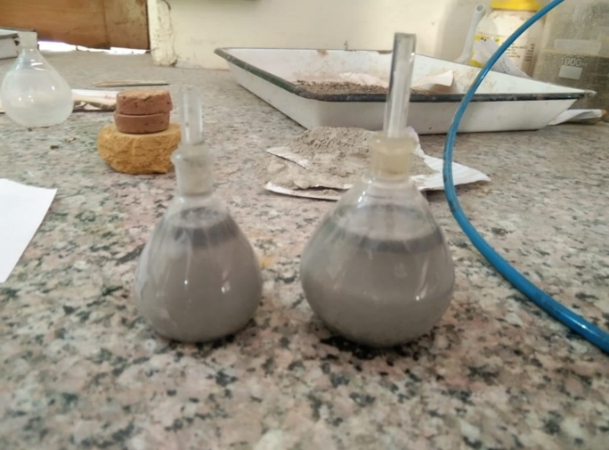
Figure: Specific Gravity test

- GRAIN SIZE ANALYSIS

S No. | Sieve size | Weight retained in sieve | Cumulative weight retained in sieve | % weight retained | %weight passing
1. | 75mm | 8.4 | 0.084 | 0.084 | 99.91
2. | 2.00mm | 33.7 | 0.421 | 0.337 | 99.5
3. | 1.00mm | 86.7 | 1.28 | 0.867 | 98.7
4. | 425 microns | 0 | 1.28 | 0 | 98.7
5. | 212 microns | 58.4 | 1.87 | 0.584 | 98.1
6. | 150 microns | 100.5 | 2.81 | 1.005 | 97.17
7. | 75 microns | 43.4 | 3.31 | 0.434 | 96.6
 | Pan | 65.1 | 3.46 | 0.651 | 96.04
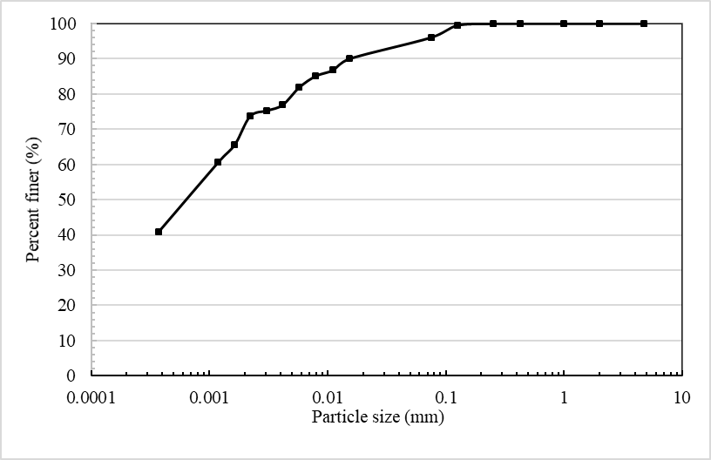
Graph: Particle Size

- WET SIEVING AND HYDROMETER ANALYSIS

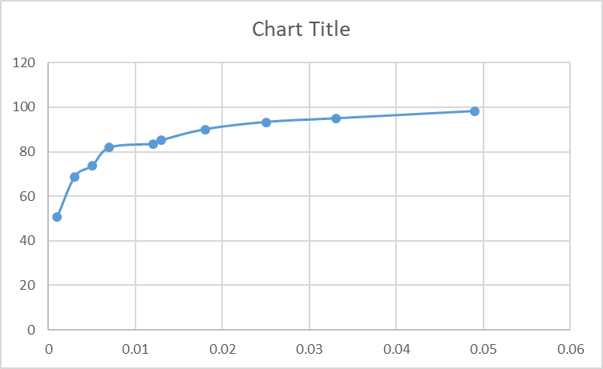
Graph: Hydrometer Graph

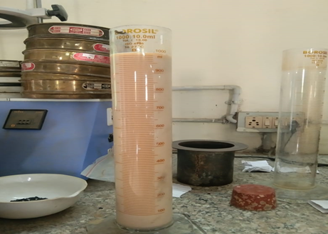
Figure: Hydrometer test
- VANE SHEAR TEST
Initial reading | Final reading | difference | Spring constant | T= diff*spring constant | G | S=T*G | Average S
180 | 73 | 107 | 6 | 3.56 | 0.27 | 0.96 | 0.24
188 | 134 | 54 | 6 | 1.8 | 0.27 | 0.486 | 0.28
183 | 147 | 36 | 6 | 1.2 | 0.27 | 0.324 | 0.31
183 | 158 | 25 | 6 | 0.8 | 0.27 | 0.216 | 0.37
184 | 165 | 19 | 6 | 0.6 | 0.27 | 0.162 | 0.43
183 | 166 | 17 | 6 | 0.5 | 0.27 | 0.135 | 0.52

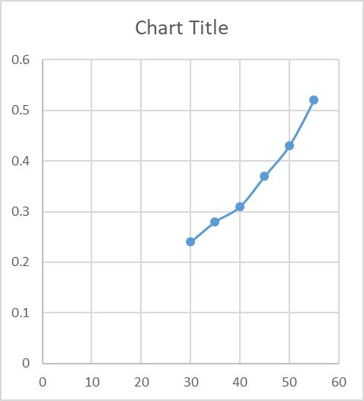

Graph: VANE SHEAR Graph

- ATTERBERG’S LIMIT TEST

LIQUID LIMIT | 43.8
PLASTIC LIMIT | 26.0
SHRINKAGE LIMIT | 25.1

3.4 DATA COLLECTION
3.4.1 TEST RESULT FOR UCS TEST
A laboratory procedure as listed step by step below, was attempted to be developed for preparing, curing and testing the soil mixed specimen applicable to the wet method of soil mixing. This procedure was similar to that described by Strength.
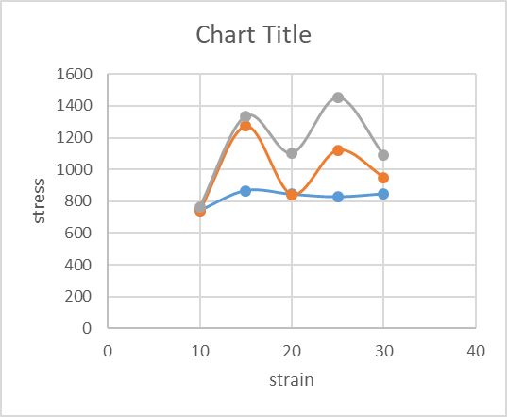
Graph: Unconfined compression test

%slag in soil | strength | 7 days | 14 days
10 | 743.79 | 739.5647 | 763.9714
15 | 866.2743 | 1272.848 | 1335.855
20 | 843.7991 | 841.1023 | 1101.909
25 | 827.8339 | 1121.763 | 1452.357
30 | 847.0941 | 950.4266 | 1089.023
TABLE: UCS TEST

CHAPTER 4

RESULTS AND SCOPE

4.1 GENERAL
4.1.1 EXPERIMENTAL STUDY
Model Test Tank The dimension of model tank was selected based on the dimension of the model footing. The model footing used was a mild steel circular plate of 60mm diameter and thickness 5mm. As per IS1888-1982, the diameter of model tank was fixed as equal to five times the diameter of model footing. Hence, a circular tank of 300mm diameter and depth 150mm was used. Loading Setup A loading frame consisting of proving ring of 20kN capacity and two numbers of LVDTs were placed diagonally opposite was mounted on the plate for settlement observations and is shown in Figure
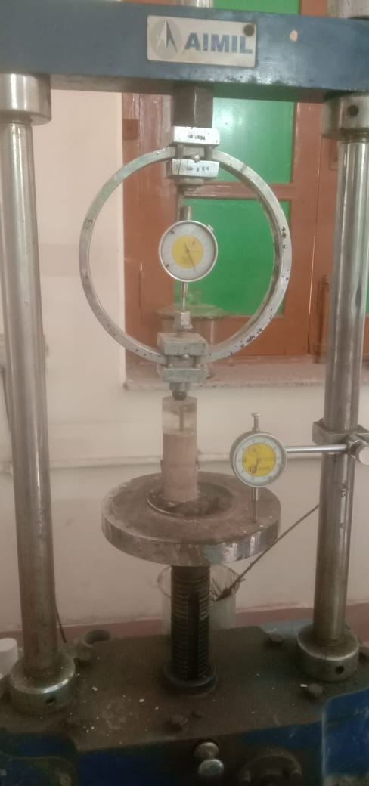
Figure: UCS test
4.1.2 PREPARATION OF SOIL CEMENT COLUMN
Treatment of soil with KOH of 15M strength and Potassium silicate was used as this trial has given the maximum Shear strength among the tested samples. The diameter of waste soil column was 12mm and the length of the column was 75mm. The water content of soil in all the tanks was maintained as 4%, for the ease of making hole in the sandy soil with a PVC pipe of external diameter of 12mm. The density of soil achieved in moist condition is 15.55kN/m3. Totally nine columns were made for 2, 2.5 and 3d spacing, where d is diameter of waste soil column. The waste soil column is placed in equilateral triangular pattern arrangement.

4.2 SOFTWARE ANALYSIS
4.2.1 INTRODUCTION PLAXIS 2D
It is a finite element package intended for the two-dimensional analysis of deformation and stability studies in Geotechnical Engineering as well as Transportation Engineering. Input of soil data in this study Axis symmetry model is used to analysis the load-settlement behavior. Soil hardening model is adopted for the soil medium. Footing is modeled as a plate element. Prescribed load method is used to obtain the ultimate settlement. The soil parameters obtained from the laboratory investigations are used as input in PLAXIS 2D. Other data required are taken as standard values from the program.

PARAMETER | VALUE
Material model | Hardening soil model
Drainage condition | Drained
Material type | Saturated
Material state | Loose condition

4.2.2 ANALYSIS OF PLAXIS 2D
The vertical displacement of footing was taken by considering Axis symmetry is shown in figure 4 & figure 5. In order to analysis the settlement characteristics by using PLAXIS 2D a comparison was made between the settlement of model footing resting on untreated sand and waste material soil column at an ultimate load of 22kN/m2. The corresponding settlement was found to be 2.13mm for footing with untreated sand and 1.24mm for footing with industrial waste material soil column at 2d spacing. This showed that formation of waste material soil cement column improved the bearing capacity with reduction in settlement. capacity is shown in Figs 4 and 5. PLAXIS model was made to validate the experimental results. Among the Selected spacing 2 D spacing was found to be effective in terms of ultimate load and Bearing capacity.
PLAXIS 2D is intended to provide a tool for practical analysis to be used by geotechnical engineers who are not necessarily numerical specialists. Quite often practicing engineers consider non-linear finite element computations cumbersome and time-consuming.
The steps for the analysis of the column on PLAXIS 2D IS provided below-
- Draw the design of column with all the surrounding structure in AUTOCAD. If necessary, we can also draw the design directly on PLAXIS 2D.
- Import the file in (*geo) file type so that it is easy to open in PLAXIS 2D.
- With the help of arrow select the material for the surrounding. The materials are-
- EMBANKMENT
- PEAT
- SAND
- SOIL CEMENT COLUMN
- Select the correct parameters for the above materials for the structure to be perfect. The structure should be as shown.

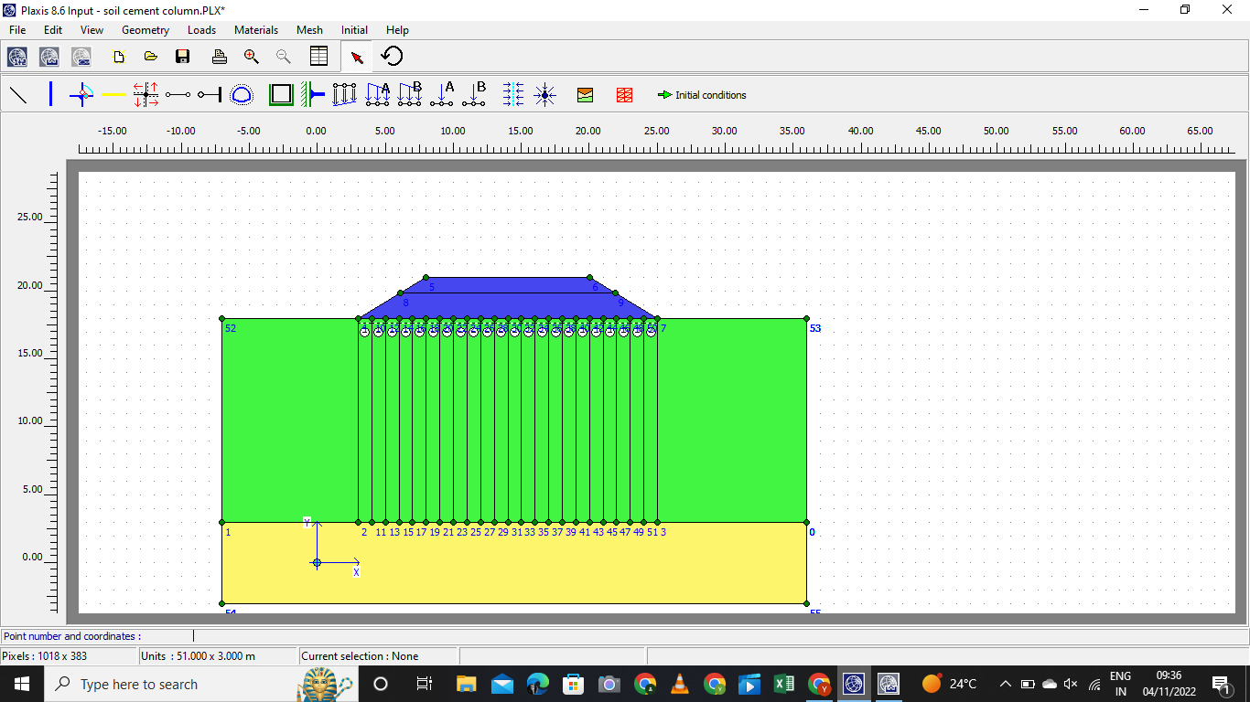
Figure: Mesh Diagram
- Select the mesh which is the most important part of the analysis by which the further step will be proceeded.
- After the general mesh is created select the initial condition and check for the active pore pressure, consolidation, settlement.
- Check the stress which will be effective normal stress, shear stress.
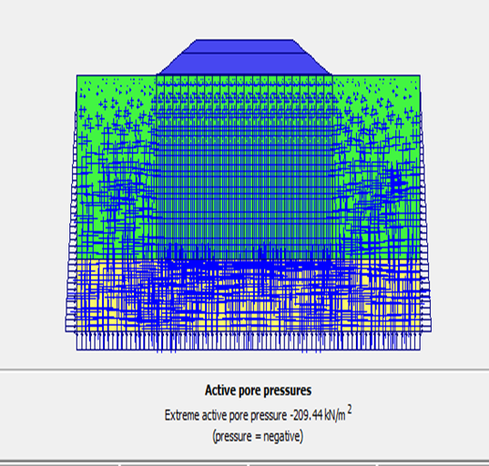

- Vertical deformation will check the phase deformation.
- Now for the last step click calculation on the bar and the calculation will take place for the below phases-
- Consolidation (15years)
- Duration (5days)
- Settlement
- Vertical displacement.
- For the calculation is done correctly the graph will be curved for the displacement with duration(time).

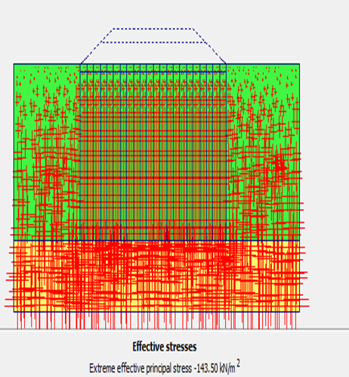
- SOFTWARE ANALYSIS
- DEFORMED MESH

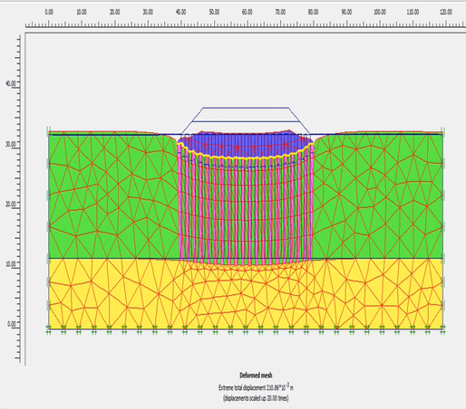

- VERTICAL DISPLACEMENT

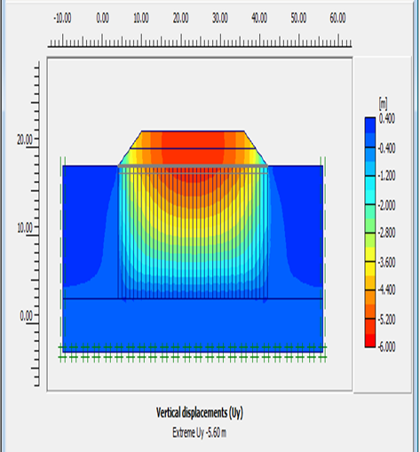

RESULT FOR THE SOFTWARE ANALYSIS
The result shown is the displacement happen with duration when the soil cement column will be constructed on soft clay or any other soil with low bearing capacity soil like kaolin with low parameters are suitable example for this thesis work and if I further describe the example this thesis is totally performed with KAOLIN SOIL, FLYASH, SLAG, DOLOMIT. The graph represented is between
- time (X axis)
- Displacement (Y axis)
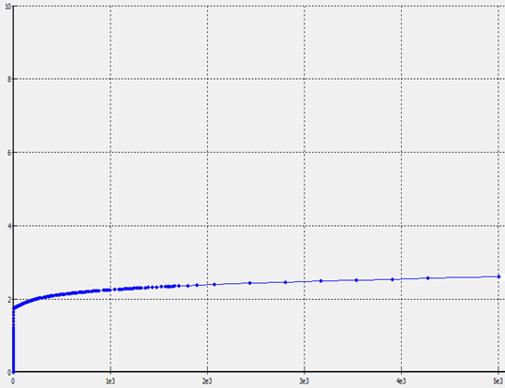
Graph:2 Time and Displacement graph.

In order to achieve the above goals, the following objectives were designed.
- The goal of this Master thesis work is to answer the defined problems.
- The purpose of this work is to perform a well-done recess of the application areas of cement-clay columns as ground improvement with the addition industrial waste material.
- Further, a purpose with this work is to highlight the concept of using in-situ material at the widest possible extent in each project in order to reduce project cost.
- If I talk about civil engineering everybody knows it as only construction but civil engineering is a lot more then construction and site.

4.3 ROLE IN RESEARCH
The PLAXIS 2D software is a well-known geotechnical engineering tool that numerically analyses soil and simulates experimental work in terms of curve matching and outcomes. Furthermore, an analysis of variables was conducted. The soil-cement column is a ground improvement technique formed by the deep mixing method. In coastal areas, the soil-cement columns can deteriorate due to the attack of sulfate present in sea water.

4.4 SAMPLING PROCEDURE
MIXING OF THE SOFT CLAY WITH FLYASH, SLAG, NaOH, DOLOMITE WITH DIFFERENT PERCENTAGE .

SAMPLES MADE ARE CURED FOR 7,14,28 DAYS FOR BETTER STRENGTH DETECTION FOR UCS TEST.

DATA ANALYSIS AND TEST RESULT DETECTION BY SOFTWARE DRAFT.

COMPARATION BETWEEN THE EXPERIMENTAL RESULT AND THE SOFTWARE DRAFT.

CHAPTER 5

CONCLUSION

5.1 General
In this chapter, the findings of the research work carried out this thesis are summarized and the conclusion emerging from the study presented.
5.2 Summary
- This paper presents both the laboratory study and numerical simulation of the consolidation behavior of composite ground. The consolidation mechanism of the composite ground is revealed and the effect of the area ratio and cement content on the consolidation characteristics is presented. The following conclusions can be advanced from this study.
- The soil-cement column inclusion enhances the yield stress and stiffness to the composite ground. The consolidation behavior is dependent upon the stress state. The settlement is less and consolidation is fast when the applied vertical stress is far below the yield (failure) stress. When the applied vertical stress is close to the yield stress, the settlement and consolidation time increase.
- After applying the vertical stress on the composite ground, both the stresses on the soil-cement column and the surrounding clay increase suddenly. After that the stress on the surrounding clay decreases (stress transfer to the column) and hence the stress on the column increases with consolidation time. The decrease in stress on the surrounding clay is associated with the decrease in excess pore pressure.
- At failure state of the composite ground, the stress on the soil-cement column decreases immediately whereas the stress in surrounding clay increases to maintain the force equilibrium. This results in the sharp increase in excess pore pressure. This is attributed to strain softening caused by the crushing of soil- 15 cementation structure. With time, the excess pore pressure decreases toward the cracked soil-cement column, which acts as the drain.
- The area ratio, a, significantly affects the consolidation behavior of the composite ground whereas the cement content is usually insignificant. The composite ground with high a value, has a high load capacity and carries low stress. As such, the settlement is low and consolidation is fast.
- Both the physical model test results and numerical simulations show that for a long soil-cement column, which is a typical field application, the variation in excess pore pressure around the drainage is insignificant and the excess pore pressures in both the soil-cement column and the surrounding clay are practically the same at the same consolidation time for the whole depth.
- During working condition, the soil-cement column does not act as a drain and the consolidation is mainly in the vertical direction. Assuming that the soil-cement column and surrounding clay form a new compressible ground with high coefficient of consolidation, the consolidation settlement with time can thus be predicted simply from the composite coefficient of consolidation obtained from the physical model tests. It was seen that the predicted consolidation settlements by using the composite coefficient of consolidation and that by using the finite element method are comparable within an acceptable error. A stepwise procedure for predicting consolidation settlement is finally presented and the proposed method is useful for geotechnical engineers.

APPENDIX
A. Types of soil foundation needing treatment
1. Evaluation by soil composition
- Soft clay;
- Peat: organic content > 13%;
- Quick sand;
- Soil with the content of soluble impurity of chloride salt greater than 5%, of
- Sulphate salt or chloride sulphate greater than 10% in terms of weight.
- Alluvial soil, muddy soil, loamy soil (with low bearing capacity).
2. Evaluation by forming origin
- Types of mineral origin, can be mixed with organic matters during the
- deposition (organic content up to 10 - 12%);
- Soft soil can also be formed in the form of silt, fine silt in the valleys (void
- ratio e > 1.0, degree of saturation G > 0.8);
- Types of organic origin which usually formed in the mudflats;
- Soft soil in mudflats with peat.
3. Evaluation by testing results
- For non-cohesive soil: Compactness D<0.66, number of hammering in the
- dynamic penetration test N < 30.
- For cohesive soil, the values of viscosity criterion IL are as follows:
- Clayey sandy soil: IL ≥ 0.
- Sandy clayey soil and clay: IL > 0,25
4. Requirements of the determination of physio-mechanical properties of soft soil.
1. Method of shearing-resistant criterion testing.
- Dangerous case for dike stability is that when the phreatic level drops
suddenly while completely saturated. Therefore, the non-consolidated, rapid-shearing.
- and non-drainage diagram (UU diagram) should be chosen for the completely saturated prepared samples;
- In case of embankment on the natural foundation: tri-axial compression test
UU determining (cuu and piecu) by the non-consolidated, non-drainage testing diagram;
- In case of embankment on reinforced foundation: using the rapid-shearing,
consolidated and non-drainage testing diagram c, ;
- In case of chronological embankment: Tri-axial compression test CU
determining (ccu and piecu) by consolidated, non-drainage diagram, measuring pore water pressure.
B. In order to measure the deformation of filling soil, the test determining the settling compression criteria a, modulus of deformation E and lateral (horizontal) swelling factor need to be conducted.

LIST OF PUBLICATION

Soil Cement Column Analysis with industrial waste material on PLAXIS 2D in “EquinOCS Springer IACESD-2023-949”
(Accepted)
Abstract
Deep stabilization in form of stabilized soil columns is a well-known method often used in infrastructure projects. Stabilizing the in-situ material with binder such as cement and lime saves time, money and the need of transports. The stabilized soil columns aim to add bearing capacity to the areas of soft soils and reduce settlements allowing the area to be loaded. The use of stabilized soil columns as a deep stabilization method is, however, rarely used in building foundations. Instead various prefabricated or in-situ casted concrete piles are conventionally used. The greatest difficulty with the stabilized soil columns are the lack of standardized calculation methods using stabilized soil columns as deep stabilization. Enhancing in soil strength was measured, by conducting experimental program by preparing and testing samples for unconfined compressive test for stabilized soil with various binder amounts 1%,2%,4% and 7% of soil dry mass and for 7,14,28,60 and 90 days curing time. From the compression test effect of initial loading on soil strength during curing time was evaluated The parameters evaluated from the compression test together with previously performed soil test performed on the used clay material is then underlying the calculations performed by hand as well as for the finite element method modelling with PLAXIS 2D.

REFERENCES
- https://research.iitgn.ac.in/stl/#
- CONSOLIDATION BEHAVIOR OF SOIL-CEMENT COLUMNS IMPROVED GROUND Suksun Horpibulsuk, B.Eng. (Hons), M.Eng., Ph.D. Professor and Chair of School of Civil Engineering, Suranaree University of Technology, 111 University Avenue, Muang District, Nakhon Ratchasima 30000, THAILAND
- Ground improvement using soil–cement columns: Experimental investigation Ahmed Farouk *, Marawan M. Shahien Structural Engineering Department, Faculty of Engineering, Tanta University, Egypt Received 28 February 2013; revised 1 May 2013; accepted 29 August 2013
- TH-03 BEHAVIOURIAL STUDY ON GEOPOLYMER COLUMN IN SOIL M.Somu alias Ramya, .S.P.Jeyapriya PG scholar, Government College of Technolgy, Coimbatore, ramyagcecivil@gmail.com Assistant Professor, Government College of Technolgy, Coimbatore
- NUMERICAL ANALYSIS OF GEOSYNTHETIC ENCASED FLY ASH COLUMN IN EXPANSIVE SOIL 1Ritakshi Ayare, 2Shraddha Kokate, 3Pranali Hubale, 4Rohan Deshmukh, 5PriyankaSalunkhe, 1,2,3 BE final year student, 4Assistant Professor, 5Associate Professor 1Department of Civil Engineering, 1Terna Engineering College, Nerul, Navi Mumbai 400706, Maharashtra, India.
- Deep stabilization with cement stabilized soil columns -A laboratory study Djupstabilisering med cementkolumner - En laborativ studies.
- M. Bouassida, A. Porbaha, Ultimate bearing capacity of soft clays reinforced by a group of columns-application to a deep mixing technique, Soils and Foundations 44 (3) (2004) 91–101.
- G. Cortellazzo, S. Cola, Geotechnical characteristics of two Italian peats stabilized with binders, in: Proc. Intl. Conference on Dry Mix Methods for Deep Soil Stabilization. Stockholm, Sweden, A. Balkema, Rotterdam, 1999, pp. 93–100.
- Altabbaa, C. Evans, Deep soil mixing in the UK: geoenvironmental research and recent applications, Land Contamination & Reclamation 11 (1) (2003).
- Tchobanoglous, G. (1993). Integrated Solid Waste Management: engineering principles and management issues. New York : McGraw, cop. 1993
- Geiser, K. (2001). Materials matter: toward a sustainable materials policy / Ken Geiser. Cambridge, Mass. : MIT Press, cop. 2001
- Baumann, H. (2004). The hitchhiker’s guide to LCA : an orientation in life cycle assessment methodology and application / Henrikke Baumann & Anne-Marie Tillman. Lund : Studentlitteratur, 2004
- Leander, J.; Rytterstedt, M.; Säfvestad, H. (2007). Insamling och förbehandling av hushållsavfall i Borås kommun: Konsekvensbeskrivning av tre alternativ
- Johansson, A.; Olofsson, M.; Wikström, E.-L.; Ekvall, A.; Gustavsson, L.; Tullin, C.; Jarlsvik, T.; Assarsson, A.; Andersson, B.-Å.; Peters, G.; (2006). Waste Refinery in the Municipality of Borås
- Johansson, A; Olofsson, M.; Wikström, E.-L.; Ekvall, A.; Gustavsson, L.; Tullin, C.; Jarlsvik, T.; Assarsson, A.; Andersson, B.-Å.; Peters, G.; (2006). The Performance of a 20 MWth Energy-from-Waste Boiler
- Golder Associates AB, (2003). Teknisk beskriving Sobacken Avfallsanläggning.
- Miljookonsult B Goldstein, (December 2006). Miljövinster med att minska totala avfallsmängder
- http://www.sintef.no/content/page1____1239.aspx
- Eriksson, O.; Carlsson Reich, M.; Frostell, B.; Bjo¨rklund, A.; Assefa, G.; Sundqvist, J.-O.; Granath, J.; Baky, A.; Thyselius, L.; Municipal solid waste management from a systems perspective. Journal of Cleaner Production 13 (2005) 241–252.
- Holiwast (2006). Report on waste treatment option. Holistic Assessment of Waste Management Technology (2006).
- Anna Björklund, Göran Finnveden, Recycling revisited-Life cycle comparison of global warming impact and total energy use of waste management strategy. Resource Conservation and Recycling 44 (2005) 309-317

