BIOFUELS: A MODERN DAY NEED

Dr. ManjushaPouranik
Associate Professor
Mata GujriMahilaMahavidyalaya,
Jabalpur, (M.P), India
Biofuel is a type of fuel that is mostly produced or got from organic materials, such as plants, animal waste and algae. It is categorized as renewable and alternative liquid or gas fuel that can be used in place of or in addition to diesel, gasoline. Biofuels are environmentally friendly and can be used in vehicle, powergeneration and heating purposes .The concept of biofuels is very old. Rudolf Diesel, first time used vegetable oil as engine's fuel. In a similar manner, Henry Ford gave the idea that the ethanol produced from corn influenced his Model T. In the past decade mankind was blessed with ample amounts of petroleum reserves, available at a reasonable price so biofuels were mostly ignored. However, in the present scenario biofuels play a significant role for several reasons.
BIOFUELS: an overview
The following regions have a need for biofuels:
- Environmentally Friendly: Biofuels produce less CO2, as a result reduce global warming thus maintain the environment and control pollution.
- Energy Security: Biofuels are the product of renewable sources hence it reduces dependency on fossil fuels and enhances energy security.
- Alteration of Energy Sources: Biofuels reducing reliance on a single energy source (fossil fuels)
- Sustainable Husbandry: Biofuel feed stalk production promotes good agricultural practices and prevents deforestation.
- Technology Progression: Advancement in technology improves biofuel production efficiently and cost effectively.
It is very important to know that only 3% biofuel use in the global road biofuel. Biofuels are divided under different categories on the basis of generation.

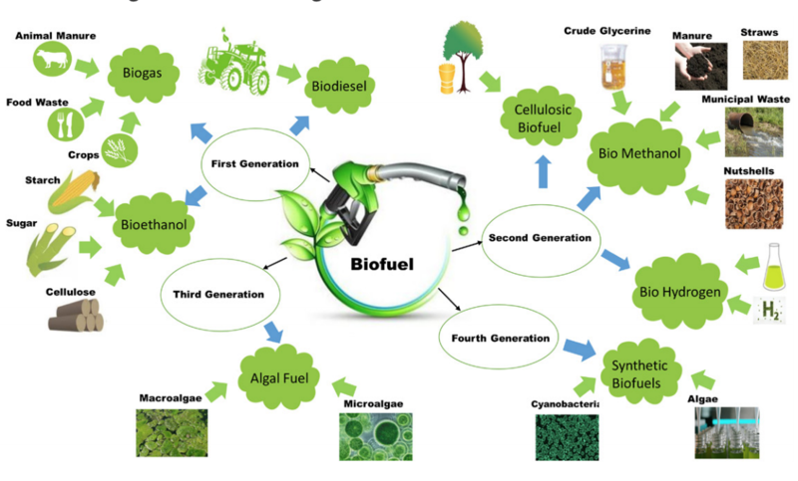

Fig No. 1: Overview of Biofuels types
Source: https://www.researchgate.net/profile/Muhammad-Junaid-Bilal/publication/337925810/figure/fig1/AS:835724198813696@1576263584280/A-schematic-representation-of-the-types-and-generation-of-biofuels.png

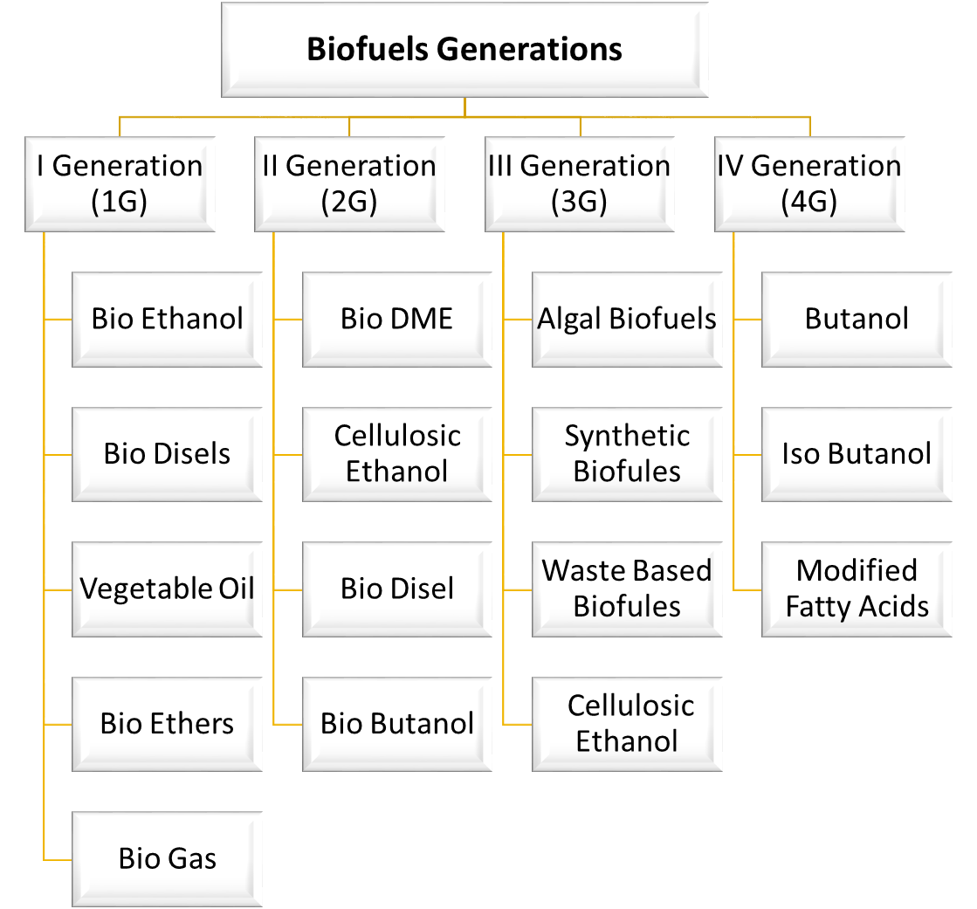
Fig No. 2: Biofuels Generations with examples

FIRST GENERATION (1G) BIOFUELS
These are produced using standard or proven technology from food crops such as corn, sugarcane and soybean, starch, animalfats. These biofuels are known as first generation fuel because they are derived from edible plant materials. Examples of Istgeneration biofuels are ethanol and biodiesel. The first generation of biofuel is not regarded as a good option when taking into account environmental concerns and food security.
SECOND GENERATION (2G) BIOFUELS
Second Generation biofuels are advanced and produced from non-food types such as agricultural leftovers or waste biomass such as wheat stalks and straw, rice straw, maize stalks, and other biomass wastes.

Here is some key points of second Generation Biofuels:
- Feedstocks Lignocellulosic biomass is the major source of 2G and is found as the most abundant plant material on the planet. Agriculture residues, woody material municipal solid waste (MSW), industrial and urban residues, wastes, non-food energy crops (e.g. switchgrass) are the major sources of 2G biofuels. Land unsuitable for crop cultivation can be used as feedstocks production.
- Production Process:It is a complex process including biochemical and thermochemical conversion methods. The conversion process includes enzymatic hydrolysis pyrolysis and gentrification.
- Potential of Higher Energy: As compared to first generation second generation biofuels produces more energy .Ash, plant oils, proteins, and other substances make up the remainder of the lignocellulosic biomass structure (Charles E. Wyman, 1994).
Examples of 2G biofuels are cellulosic ethanol, bioethanol and renewable diesel.
LIMITATIONS OF SECOND-GENERATION (2G) BIOFUELS
The second generation biofuels are expensive in terms of cost, technology complexity and scalability. As a result, these second-generation biofuels are still more expensive than the current first-generation biofuels production pathway for the same return on investment.
BIOFUELS OF THE THIRD GENERATION (3G)
Compared to first and second generation biofuel, third generation fuels are more advanced. They come from non-food feedstock, which lessens rivalry with food crops and increases energy yields. The following are a few examples of third generation biofuels.
- Algal-derived biofuels: These algae can be grown in wastewater and non-arable land, which lessens competition for agricultural fields. Due to their high growth rates and capacity for nearly constant collection, algae are an important source of substitute energy for biofuel.
- Cellulosic ethanol: This kind of biofuel is produced from switchgrass and other agricultural waste products like wood chips. Sugar that has been fattened using plant cellulose and hemicellulose is used to produce cellulose ethanol.
- Waste-based biofuels: These biofuels are made from food waste, sewage sludge, and municipal solid waste.
- Aquatic plants biofuel:Water hyacinths and duckweed are the aquatic plants that can be grown for production of biofuel. Water hyacinth can be utilized to produce biofuel due to high growth rate and low lignin content.
LIMITATIONS OF THIRD-GENERATION (3G) BIOFUELS
These biofuels are unable to fully replace fossil fuels due to their limitations. These are:
- High production costs: It can be costly to generate third-generation biofuels on a large scale, including algae-based biofuels. Algae or other advanced feedstocks might be difficult to commercialize because of the high expenses of growing, harvesting, and processing them.
- Technical difficulties: The manufacturing of third-generation biofuel frequently calls for cutting-edge technology and knowledge. Technically difficult tasks including creating effective growing methods, adjusting the lipid or biomass content, and separating the desired biofuels from the feedstock might necessitate continuous research and development.
- Scale-Up Obstacles:A big problem is making the switch from small-scale laboratory production to large-scale commercial production. It can be challenging to scale up biofuel production methods while keeping them effective and affordable.
- Environmental Issues:Third-generation biofuels are frequently thought of as being more environmentally friendly than prior generations, although there may still be environmental issues. For instance, improper management of large-scale algae farming could possibly impact regional ecosystems.
- Energy Intensity: Some third-generation biofuel production technologies may be energy-intensive, which may restrict the overall environmental advantages of the biofuels and lower the net energy gain from them.
- Third-generation biofuels are up against other renewable energy sources like hydrogen and electric cars, which are becoming more popular in the transportation industry.
- Technological Uncertainty:Third-generation biofuel research and development are proceeding, but there may be doubts about how well such technologies can scale and how affordable they will be.
BIOFUELS OF THE FOURTH GENERATION (4G)
In comparison to earlier generations of biofuels, such as first-generation (corn ethanol and vegetable oil-based biodiesel) and second-generation (cellulosic ethanol and algae-based biodiesel), fourth-generation biofuels, also referred to as advanced or next-generation biofuels, represent a significant advancement in biofuel technology. Fourth-generation biofuels are distinguished by their capacity to address a number of the drawbacks and sustainability issues related to earlier generations of biofuels. These fuels have the potential to provide greater energy efficiency and lessen their negative effects on the environment because they are often made from non-food feedstocks. An introduction to fourth-generation biofuels is provided below:
- Feedstock Diversity: A variety of feedstocks, including lignocellulosic biomass (such as agricultural leftovers, forestry waste, and energy crops), algae, and specific types of microorganisms, are used to make fourth-generation biofuels.
- New Technologies for Conversion: Fourth-generation biofuels frequently use cutting-edge conversion techniques including gasification, pyrolysis, and biochemical procedures (such fermentation and enzymatic hydrolysis). Compared to earlier generations, these techniques are more effective and can extract more energy from biomass.
- Reduced Greenhouse Gas Emissions: Compared to fossil fuels, fourth-generation biofuels are made to produce lower greenhouse gas emissions. Some cutting-edge biofuel production techniques, like growing algae, can even capture and use carbon dioxide, lowering net emissions even more.
- Better Energy Density: These biofuels have the potential for greater energy density, which entails that they can fit more energy into a given volume, making them more effective for transportation.
- Reduced Land and Water Footprint: The production of fourth-generation biofuels may use less land and water since some feedstocks, such as algae, may be cultivated on non-arable land and in brackish or wastewater.
- Biochemical and biotechnological developments: The creation of fourth-generation biofuels is greatly aided by developments in biotechnology, genetic engineering, and synthetic biology. Scientists are modifying bacteria and algae to more effectively make biofuels. Examples of 4th generation biofuels are Algae-based biodiesel, lignocellulosic ethanol, and microbial biofuels made from genetically modified bacteria or yeast.
LIMITATIONS OF FOURTH GENERATION BIOFUELS
While fourth-generation biofuels hold promise in addressing many of the limitations of earlier biofuel generations, they also have their own set of challenges and limitations. Some of the key limitations of fourth-generation biofuels include:
- High Production Costs: Many fourth-generation biofuel production processes are currently expensive and not cost-competitive with fossil fuels. Research and development are needed to optimize these processes and reduce production costs.
- Scalability: Scaling up production of fourth-generation biofuels to meet global energy demands is a significant challenge. Algae-based biofuels, for example, require large-scale cultivation systems that are not yet widely deployed.
- Resource Requirements: Some fourth-generation biofuels, particularly those derived from algae, require substantial resources, including water and nutrients. The sustainable sourcing of these resources can be a limitation.
- Land Use and Environmental Impact: While non-food feedstocks like algae and lignocellulosic biomass are less likely to compete with food crops, the cultivation of these feedstocks can still have environmental impacts, such as land use change and water usage. Ensuring sustainable practices is crucial.
- Technological Hurdles: Advanced conversion technologies used in fourth-generation biofuels, such as enzymatic hydrolysis and genetic engineering, are still evolving. Technical challenges related to efficiency and reliability need to be overcome.
- Regulatory and Policy Hurdles: Developing regulatory frameworks and policies that encourage the production and use of fourth-generation biofuels while addressing environmental and social concerns is a complex task.
- Environmental Concerns: Although fourth-generation biofuels aim to reduce greenhouse gas emissions, the environmental impact of large-scale cultivation and production must be carefully managed to avoid unintended negative consequences.
In conclusion, fourth-generation biofuels represent a promising step towards more sustainable and environmentally friendly alternatives to fossil fuels. However, addressing these limitations will require ongoing research, innovation, and investment to ensure that these biofuels can become a viable and competitive option for the future of renewable energy.
NATIONAL POLICY ON BIOFUELS, 2018
Salient Features of the Policy:
- The Policy categorizes biofuels as “Basic Biofuels” viz. First Generation (1G) bio-ethanol & biodiesel and “Advanced Bio-fuels” – Second Generation (2G) ethanol, Municipal Solid Waste (“MSW”) to drop in fuels. Third Generation (3G) bio-fuels, bio-CNG etc. to enable extension of appropriate financial and fiscal incentives under each category.
- The Policy expands the scope of raw material for ethanol production by allowing use of Sugarcane Juice, Sugar containing materials like sugar beet, sweet sorghum, starch containing materials like corn, cassava, damaged food grains like wheat, broken rice, and rotten potatoes, unfit for human consumption for ethanol production.
- Farmers are at risk of not getting an appropriate price for their produce during the surplus production phase. Taking this into account, the Policy allows use of surplus food grains for production of ethanol for blending with petrol with the approval of National Biofuel Coordination Committee.
- With a thrust on Advanced Biofuels, the Policy indicates a viability gap funding scheme for 2G ethanol Bio refineries of Rs.5000 crore in 6 years in addition to additional tax incentives.
- The Policy encourages setting up of supply chain mechanisms from preferably non-edible oilseeds, used cooking oil and short gestation crops are used for production.
- Roles and responsibilities of all the concerned Ministries/Departments with respect to Biofuels have been captured in the Policy document, efforts should be taken by all ministries and all departments should be in tune for their responsibility.
NEW VEHICLE TECHNOLOGY STRATEGIES
The utilization of biofuels is inextricably related to current and future engine technologies. To replace conventional engine designs based on mineral oil, two alternative techniques are currently being investigated (short and long term approach). The philosophy of the engines is where these concepts diverge the most.
In the medium run, the notion is built on improvements to today's combustion engines and the usage of biofuels. This is currently the most promising strategy. It is efficient and sustainable because no additional infrastructure or fundamentally different engine technology is required.
The long-term strategy favors the transition to electric engines powered by fuel cells and high-efficiency batteries that operate without emitting pollutants during vehicle operation.
CONCLUSION
As a transitional energy source to a future that is more sustainable and environmentally benign, biofuels show promise. Their advantages and disadvantages, however, are nuanced and situation-specific. Priority should be given to sustainable biofuel production, which reduces negative environmental effects and solves issues like food security and land use.
In order to attain a more sustainable energy future, biofuels should also be taken into account as a component of a larger strategy that also includes increased energy efficiency, renewable energy sources, and a move towards a circular economy. The place of biofuels in our energy system will be heavily influenced by public policies, technological advancements, and continuous research.
REFERENCES

AFDC (2019). Alternative Fuels Data Center, Biodiesel Production andDistributionhttps://afdc.energy.gov/fuels/biodiesel_production.html.

BP Statistical Review of world energy June 2018" (PDF). Retrieved 6 January 2019.

Choi, J.H., Woo, H.C., and Suh, D.J. (2014). Pyrolysis of seaweeds for bio oil and biochar production. Chem. Eng. Trans. 37, 121–126.

CSS (2018). Center for Sustainable Systems, University of Michigan.“Biofuels Factsheet.” Pub. No. CSS08-09.http://css.umich.edu/sites/default/files/Biofuels_Factsheet_CSS08-09_e2018.pdf.

Dutta K, DavereyA, Lin JG. Evolution retrospective for alternative fuels: Firstto the fourth generation. Renew Energy 2014; 69:114–22.

Eggert, H., &Greaker, M. (2014). Promoting second generation biofuels: does the first generation pave the road?.Energies, 7(7), 4430-4445.

Kim, G.V., Choi, W.Y., Kang, D.H., Lee, S.Y., and Lee, H.Y. (2014). Enhancement of biodiesel production from a marine alga, Scenedesmussp.Through in situ transesterification process associated with acidic catalyst. Bio Med. Res. Int. 2014:391542.

