Lipid based Vesicles: Formulation and loading of Antihypertensive drug Atenolol
^{1*}Rachana Sharma, ²Uma Sharma
^{1,2}School of Studies in Chemistry and Biochemistry, Vikram University, Ujjain, M.P., India, 456010
^{1*}Parul Institute of Applied Sciences, Parul University, Vadodara, Gujarat, India, 391760
e-mail id.- sharmarachana385@gmail.com
Abstract: The term ‘vesicles’ is used to define circular or ellipsoidal single or multicompartment, closed double layered structures irrespective of their chemical structure. Liposomes are microscopic, tiny synthetic vesicles of sphere-shape that can be formed from cholesterol and natural phospholipids in water as solvent causing closed bilayer structures to form. In present work, lipid-based vesicles were synthesized (by soy lecithin and cholesterol) and loaded with antihypertensive model drug Atenolol by using Rotatory-evaporator. The synthesized liposomes were further evaluated by Fourier Transform Infra-red spectroscopic analysis, particle size distribution, zeta potential and Scanning Electron Microscopic (SEM) analysis. Mean particle size obtained was 121.6nm by Dynamic Light Scattering (DLS), Zeta potential value is found to be -40.98 mV with well-defined multilamellar vesicular morphology by SEM analysis.

Key Words: Vesicles, Liposomes, Lipid-based vesicles, Antihypertensive drug, Atenolol

Corresponding Author*
Dr. Rachana Sharma Malwiya*
School of Studies in Chemistry and Biochemistry, Vikram University, Ujjain, M.P., India, 456010
Parul Institute of Applied Sciences, Parul University, Vadodara, Gujarat, India, 391760
e-mail id.- sharmarachana385@gmail.com

I. Introduction: Vesicles made up of naturally occurring or artificial phospholipids are called liposomes. However, vesicles formed completely from synthetic polymers surfactants are called surfactant vesicles¹and those formed from amphiphilic polymers are called polymerosomes²⁻³. The basic structure of the vesicle (as shown in Fig.1) generally consists of a hollow sphere containing water in the core enclosed by a double layered membrane called lamellae⁴. Such structural morphology with an aqueous core is suitable for insertion of therapeutic molecules such as proteins, drugs, DNA, peptides, etc.; where the membrane can easily surround water loving i.e. hydrophobic drugs. The afforesaid structural features of liposomes offer great possibilities of loading both hydrophilic as well as hydrophobic drugs and thus are in more demand for therapeutic applications ⁵.
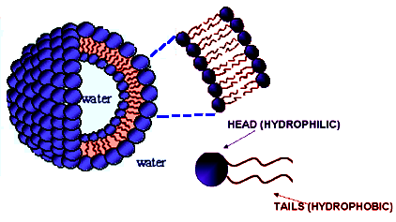
Fig. 1 Schematic of lipid-based vesicles (Liposomes) with a hydrophilic head and a hydrophobic tail (buried within the bilayer)
(A) Historical Perspective of Vesicles:. The formation of multilamellar structures called “myelin figures” upon swelling of dried phospholipids in water was firstly reported by Stoeckenius in 1959⁶. Further Bangham and his co-workers showed that phospholipids in presence of appropriate solvents result bilayered structures to form either multilamellar or unilamellar vesicles capable of entrapping ions in their aqueous interiors and through his membrane model Bangham gained popularity⁷⁻⁸. Properties of liposomes were further investigated by diverse analytical techniques such as electron micrography ⁹, nuclear magnetic resonance (NMR) ¹⁰, electron paramagnetic resonance (EPR) ¹¹ by IR and Raman spectroscopy¹²⁻¹³.
Today liposomes are being explored for their use in various fields such as mathematics and theoretical physics, biophysics for studying characteristics of cell membranes, as catalysts, photosynthesis, colloid science, and biology¹⁴. Ambisome TM, (amphotericin B) liposome for injection was first introduced followed by several other products which are either under therapeutic investigations or are already available commercially. Some of them are enlisted in the following Table-1.
Table-1 Various Marketed Formulations of Lipid-based Vesicles (Liposomes) ¹⁵
S.No. | Product | Drug | Manufacturing Company
 | AmbisomeTM | Amphotericin B | NeXstar Pharmaceuticals, Inc., CO
 | DaunoXomeTM | Daunorubicin | NeXstar Pharmaceuticals, Inc., CO
 | AmphocilTM | Amphotericin B | Sequus Pharmaceuticals, Inc., C.A.  .
 | DoxilTM | Doxorubicin | Sequus Pharmaceuticals, Inc., C.A.  .
 | EpaxelTM | Hepatitis- A Vac. | SSI (Swiss Serum Institute), Switzerland

(B) Mechanism of Vesicle formation: Formation of Lipid-based vesicles or liposome, closed bilayered structures formed after self-assembly is a natural process that requires some input of vital force in the form of heat, physical shaking, ultra sonication, etc. The thermodynamic phase property and self-assembly characteristics of amphipathic phospholipids promote entropically facilitated segregation of hydrophobic areas into sphere-shaped bilayers which prevents unfavourable interactions between solvent (water) and long fatty acid hydrocarbon chains leading to a state of lower energy and thus more stability¹⁶. Additionally to attain a most stable state, these bilayer sheets start folding leading to formation of closed bilayered vesicles adjoining main aqueous core as illustrated in the Fig. 2.
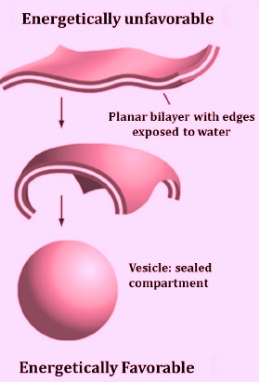
Fig. 2 Mechanism of Vesicle Formation
(C) Classification of Vesicles: Vesicles are mostly classified based on their dimensions and number of bilayers (lamella) Unilamellar vesicles consists of a single bilayer. Based on their mean diameter, they are divided into (a) small unilamellar, large unilamellar, and (c) giant unilamellar vesicles respectively (Fig.3). Multilamellar vesicles (MLVs) possess a membrane composed of several bilayer shells and multivesicular vesicles (MVVs) are large vesicles which encapsulate smaller vesicles inside¹.
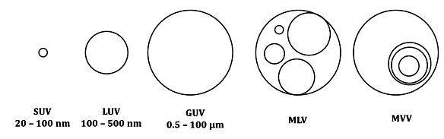
Fig.3 Structural classes of vesicles- Small Unilamellar Vesicles (SUV), Large Unilamellar Vesicles (LUV), Giant Unilamellar Vesicles (GUV), Multilamellar Vesicles (MLV), and Multivesicular Vesicles (MVV) ¹

(D) Structural Components of Lipid-based Vesicles or Liposomes:
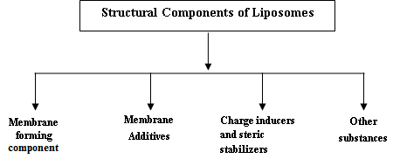
(D.1) Membrane forming components - Phospholipids: The bilayer formers
Phospholipids are the basic components of the biotic membranes are considered as the constructing blocks of liposomes. The phospholipids show tube-like structure with two acyl chains linked to a polar head which on hydration forms a double layered membrane. Two types of phospholipids viz. phosphodiglycerides and sphingolipids along with their identical hydrolysis products are used¹⁷.
Classification of Phospholipids: Negatively charged phospholipids- e.g. Dipalmitoyl phosphatidylcholine (DPPC), Dipalmitoyl phosphatidyl acid, Distearoyl phosphatidyl choline , Dioleoyl phosphatidyl choline, etc. Neutral phospholipids e.g. Sphingomyeline, Phosphatidyl-ethanolamine, and Phosphatidylcholine (Soy lecithin and some positively charged phospholipids.
(D.2) Membrane Additives or Sterols: Cholesterol is the most common sterol (Fig.4), occupies empty spaces present between the phospholipid molecules, situating them more strongly into the structure ¹⁸, a molecule having both hydrophobic and hydrophilic parts which inserts itself into the membrane with its hydroxyl groups arranged towards the aqueous phase and aliphatic chain oriented equivalent to acyl chain of the phospholipid molecules. Cholesterol makes the membrane more ordered and thus increases the transition temperature of the system resulting in both physical and biological stability¹⁹.
Fig.4 Chemical Structure of Cholesterol
(D.3) Steric Stabilizers and Charge inducers: Dicetylphosphate, diacylglycerol, stearylamine, solulan C-24 (a lanolin derivative), etc. are generally most common to provide either a positive or a negative surface charge, and are also beneficial in reducing aggregation as neutral liposomes undergo aggregation very easily.
(D.4) Other substances: When the drugs are fragile and easily undergo oxidation then antioxidants such as Vitamin-E also known as alpha-tocopherol, butylated hydroxyl toluene and stabilizers are used, and sometimes preservatives are added to increase the shelf-life of liposomal formulations²⁰.

(E) Methods of preparation of liposomes⁴ can be summarized with the help of following chart.
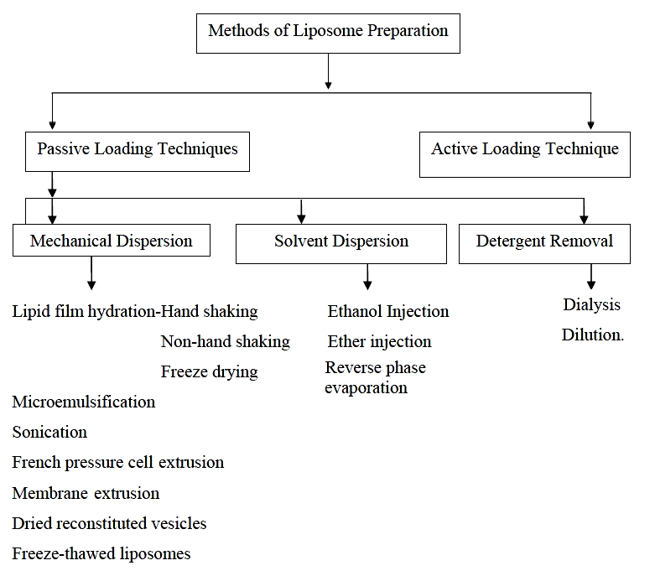
(F) Advantages of Lipid-based vesicles or liposomes⁴:
- Offer selective apathetic (passive) targeting to tumor tissue e.g. Liposomal Doxorubicin.
- Enhance effectiveness and therapeutic ratio of the drug (Actinomycin-D).
- Enclosed structure provides liposomes an extra stability.
- Possess biocompatibility, biodegradability, non-toxicity, flexibility, and non-immunogenicity for systemic and non-systemic administrations
- Cause reduction in toxicity of the encapsulated agent (Amphotericin B, Taxol).
- Protect sensitive tissues from exposure of toxic drugs.
- Provide flexibility to couple with site-specific ligands in achieving active targeting²⁰⁵.
(G) Disadvantages of Lipid-based vesicles or Liposome ⁴
- High manufacture cost
- May cause leak or fusion of encapsulated drug/molecule
- Phospholipids may experience hydrolysis and oxidation like reaction
- Short half-life
- Low solubility
Sir James Black in 1958 for the first time reported Beta blockers and confirmed that by blocking the beta-adrenoceptor, these agents could cause inhibition of the functioning of the SA node (sinus node, chronotropic effect), AV node (Atrioventricular node, dromotropic effect), and myocardial contractility (inotropic effect) ^{21,22}.
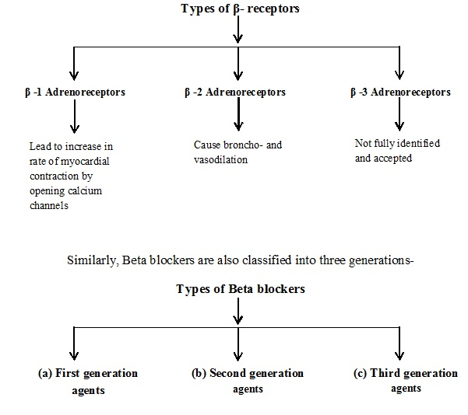
(H) First-generation agents such as Propranolol (or beta-propanolol), Sotalol, Timolol, and Nadolol non-selectively block β -1 and β -2 receptors causing effects on heart rate, conduction, and contractility and tend to cause smooth muscle contraction.
(I) Second-generation agents or Cardioselective agents–Atenolol, Bisoprolol, Celiprolol, and Metoprolol lie under this category. These agents block β -1 receptors in low doses and β -2 receptors in higher doses. Such selective approach of these agents becomes necessary in persons with chronic lung diseases²³ or those requiring insulin under diabetes mellitus. Among all these Bisoprolol is a highly cardio selective agent.
(J) Third generation agents cause dilation of blood vessels especially the arteries. Their actions may be both selective (nebivolol) or non-selective (carvidolol and labetolol).

Beta-blockers are used extensively for the treatment of high blood pressure, angina, cardiac infarction tachycardia, and congestive heart failure ²⁴. All currently available beta-blockers, as a common structural feature, possess an amino-alkanol or isopropylaminopropoxy side chain which act as a major component for their pharmacological and therapeutic activity along with an aromatic group which varies for different drugs, e.g., phenyl group for bisoprolol, atenolol and metoprolol and naphthyl group in the case of propanolol. This aromatic group, known as the modulator of the pharmacological activity also regulates the pharmacokinetic properties of these drugs. The amino-alkanol side chain contains a chiral carbon atom, resulting in the existence of a d- and l-enantiomers²⁵.

Out of the above mentioned beta-blockers we have used selective beta-blocker atenolol as model drug. It has been already reported that atenolol²⁶and propanolol exhibit low bioavailability and shorter half-life relative to bisoprolol²⁷.
Atenolol (Brand name-Tenormin®), IUPAC name - 2-[4-[2-hydroxy-3-(propan-2-ylamino) propoxy] phenyl] acetamide, is a cardioselective β-1 adrenoceptor blocker (Fig.5). This is utmost important to maintain a constant plasma level of a cardiovascular drug for attaining desired therapeutic response. As Atenolol possess a shorter half-life (approximately 6–7 h), many doses are required to keep a constant plasma concentration for a better therapeutic response which results a number of side effects including severe hypotension with shock, congestive heart failure (CHF), low blood sugar, etc. In addition to this, depression and confusion, nightmares, hair loss, runny or blocked nose, indigestion, constipation, and dry mouth effects are also observed²⁸⁻²⁹.

(K) Properties:
- Atenolol is a relatively polar, lipid-soluble hydrophilic drug and is excreted by the kidney only and exhibits low brain permebility³⁰.
- For the treatment of cardiovascular illnesses viz. - angina, hypertension, acute myocardial infarction, dysrhythmias, coronary heart diseases etc., ^{26, 31} Atenolol is mainly prescribed.
- It has a pKa value equals to 9.6, leading to its ionization in the stomach besides intestine and hence possess a poor bioavailability (~55%) of the given dose and that too not increased even after the administration of the drug in liquid form ^{26, 32}.
- Atenolol is generally unaffected by metabolism in liver, and thus is eliminated by renal excretion which makes it different from propanolol or metoprolol.

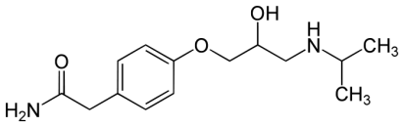

Fig.5 Chemical Structure of Atenolol

II. Experimental Section
(A) Materials and Method:
Materials: Chemicals used for the experimental work were of A.R. grade. Soy lecithin (Phosphatidylcholine, Sigma Aldrich), Cholesterol (Sigma Aldrich), Atenolol drug as gift sample.
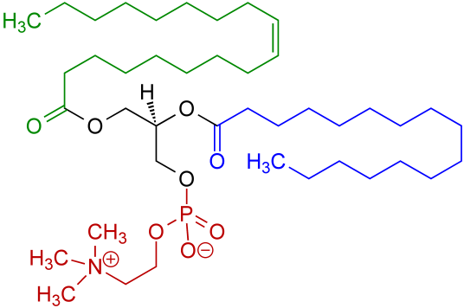
Fig.6 Chemical structure of Soy lecithin
Preparation of Atenolol-loaded Vesicles (Lipid-based) Method: The preparation of atenolol-loaded vesicles is explained as below-
(B) Preparation of Antihypertensive drug Atenolol-loaded Vesicles (Lipid-based): For the preparation of vesicles loaded with atenolol drug, firstly vesicles (lipid-based) were prepared by using rotatory evaporator under following two steps-

Step I: 35 mg Phosphatidylcholine (Soy lecithin or soya PC) and 15 mg cholesterol were dissolved in 5ml chloroform and flask was rotated to form thin lipid film on the inner wall of a rotatory flask kept in vacuum to remove the solvent completely.
Step II: 2 ml aqueous solution of atenolol (2.5 mg/mL, w/v) was added to hydrate and disperse the lipid layer by reverse rotation of flask. The obtained solution containing vesicles (lipid-based) was kept overnight under lyophilisation and were characterized further.
The synthesis of vesicles (lipid-based) was done using a rotatory evaporator and in order to confirm their formation following characterization techniques were employed in support of synthesis.

III. Physicochemical Characterization of prepared vesicles
The physicochemical characterization of prepared lipid based vesicles was done using FT-IR Spectroscopy, Zeta Potential and Particle size measurement, and SEM Analysis.

(A) FT-IR analysis: FT-IR spectra of drug and drug-loaded vesicles were determined by using Potassium bromide (KBr) pellets on FT-IR –Jasco FT/IR-4600 in the range of 4000-200 cm-¹, at ITL Labs Pvt. Ltd., Indore (M.P.). Results are shown in Table-2 and Fig. 7-8.

(B) Zeta Potential and Particle size measurement: Particle size and zeta potential of drug-loaded vesicles were investigated by Malvern Zeta Sizer Nano ZS and Nano Plus at Parul Institute of Pharmacy, Vadodara, Gujarat and UGC-DAE Consortium of Scientific Research, Indore,(M.P.) respectively. The measurements were carried out using a suspension of nanoparticles in deionized water and the results are shown in Fig. 9-10.

(C) Determination of Surface Morphology by SEM: The study of morphology of drug-loaded vesicles was performed by Scanning Electron Microscopy(SEM) at UGC-DAE Consortium of Scientific Research, Indore (SEM- JEOL-JSM-5600 ) and Central University, Gandhinagar, Gujarat (Model –EVO 18, Carl Zeiss, UK) at an acceleration voltage of 20 kV and 6.0 kV respectively. The prepared dried nanoparticles were mounted on a metal stub. Results are shown in Fig. 11.

In order to confirm the formation of lipid-based vesicles, the above characterization techniques were employed and the results were obtained in terms of size, shape, and morphology, etc. The detailed interpretation is given in the following results and discussion section.
IV. Results and Discussion:
Physicochemical Characterization of nanoparticles: The physicochemical characterization of liposomes loaded with atenolol has been performed by FT-IR, DLS (particles size measurement), Zeta potential, and SEM analysis.
(A) FT-IR analysis: IR spectral analysis of atenolol and vesicles loaded with atenolol were performed to determine the interactions between drug and lipid and their characteristic peaks are shown in Table-2. The FT-IR spectrum of Atenolol drug³³⁻³⁷ (Fig.7) shows peaks in the region between 3300-3100cm⁻¹ indicating O-H and N-H stretching ,at region between 2900-2800 cm⁻¹ shows C-CH₃ stretching, at regions between 1750-1500cm⁻¹ C=C aromatic stretching, C=O stretching, and O=C-NH₂ stretching respectively³⁷⁻³⁸. The changes in the frequency of characteristic peaks indicate the interactions between polymer and drug. FT-IR spectrum of atenolol-loaded vesicles (Fig.8) displays distinctive peaks of polymer and drug. It is observed from the FT-IR spectrum of atenolol-loaded vesicles, a change in frequency in peak of atenolol (attributed to O-H stretching) towards higher side is observed. It is assumed that electrostatic interaction/Hydrogen bonding between the amine group present on the drug and the Phosphoric group available on soy lecithin is responsible for frequency shift. Similarly, a small shift in C=O stretching is also observed from 1637.27 cm⁻¹ to 1658.48 cm⁻¹.
(B) Zeta Potential and Particle size measurement: Particle size and zeta potential are two important properties of drugs/drug products. The Polydispersity index (PDI) and Zeta potential of nano-dispersions are indicative of distribution of size and stability of the systems. The average particle size of atenolol loaded vesicles is found to be 121.6 nm. In this study, polydispersity index <0.5 i.e., 0.28 indicates that lipid-based vesicles show narrow size distribution.
The value of zeta potential provides notable evidences about the strength of the prepared nanoparticle (nano sized liposome) solution and is greatly influenced by the surface charge of particle. The zeta potential values more towards negative or positive side is indicative of high stability of the colloidal solution of interest, and thus due to high surface charge, the particles repel each other resulting in reduction of particle aggregation³⁹. Zeta potential value is found to be -40.98 mV revealing high stability. A negative value of zeta potential may be because of the presence of remaining phosphate crowds of soy lecithin and free hydroxyl groups present on the surface of the drug.

(C) Determination of Surface Morphology by SEM: Well-defined multilamellar vesicular morphology of drug-loaded vesicles is observed through SEM analysis indicating that the hydrophilic drug has been successfully entrapped inside the polymer matrix. The SEM micrographs reveal the presence of well-identified multilamellar vesicles that consists of concentric phospholipid bilayers.
V. Conclusion
The studies in present work reveals that lipid-based vesicles can be successfully employed as a nano drug carrier and can become a good candidate in the field of drug delivery. The zeta potential results are also indicative of maximum stability and compatibility of the drug with the polymer along with IR studies which show some interactivities between the drug and polymer. SEM results are also confirming the synthesis and successful loading of the Atenolol drug on the vesicles.
Acknowledgement: Authors are highly thankful to the Teachers and Professors of School of Studies in Chemistry and Biochemistry, Vikram University, Ujjain (M.P.) for their never-ending guidance and support, Parul University, Vadodara (Gujarat) for providing analytical facility. Dr.G.S.Okram and Dr. Phase, Mr. Vinay Ahire (SEM), UGC-DAE CSR, Indore (M.P.), for providing lab facilities and Central University, Gandhinagar (Gujarat) for SEM analysis.

Figures and Tables

Table-2 Characteristic IR frequencies of Atenolol drug and SLC-ATE vesicles
Samples | Characteristic IR Peaks in cm⁻¹
Samples | O-H and  N-H Stretching | O=C-NH₂ stretching
Atenolol Drug | 3352.82 | 1635.32
SLC-ATE Vesicles/Liposomes | 3383.5 | 1658.48

Table-3 Zeta potential and Particle Size measurement

S.No. | Sample name | Dynamic Light Scattering  Particle size  (in nm) | Polydispersity Index | Zeta potential  (in mV)
1 | SLC-ATE Vesicles | 121.6 | 0.287 | -40.98

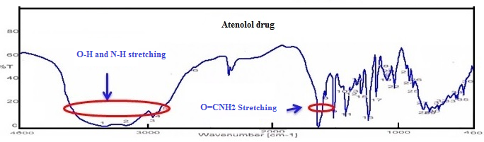

Fig.7 FT- IR Spectrum of Atenolol drug³³⁻³⁴

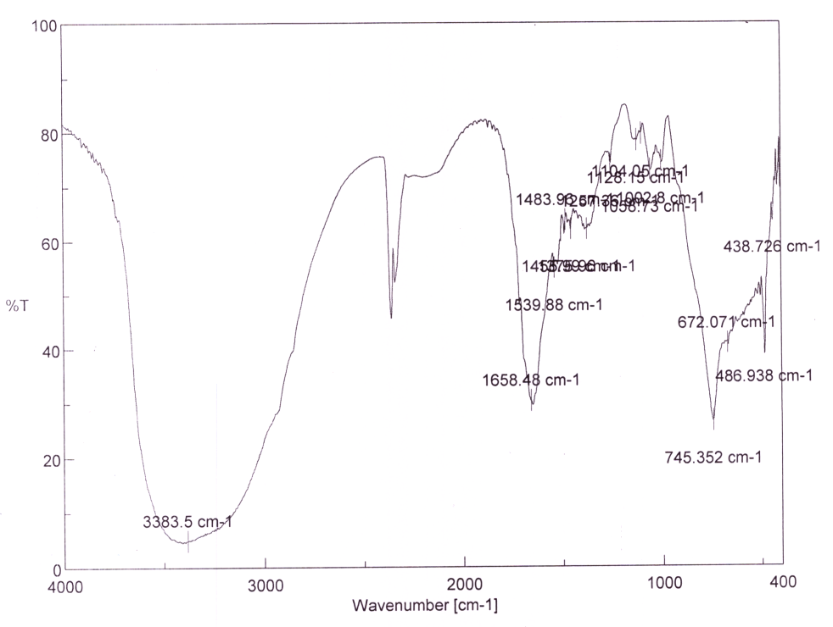
Fig.8 FT-IR Spectrum of Atenolol- loaded Vesicles

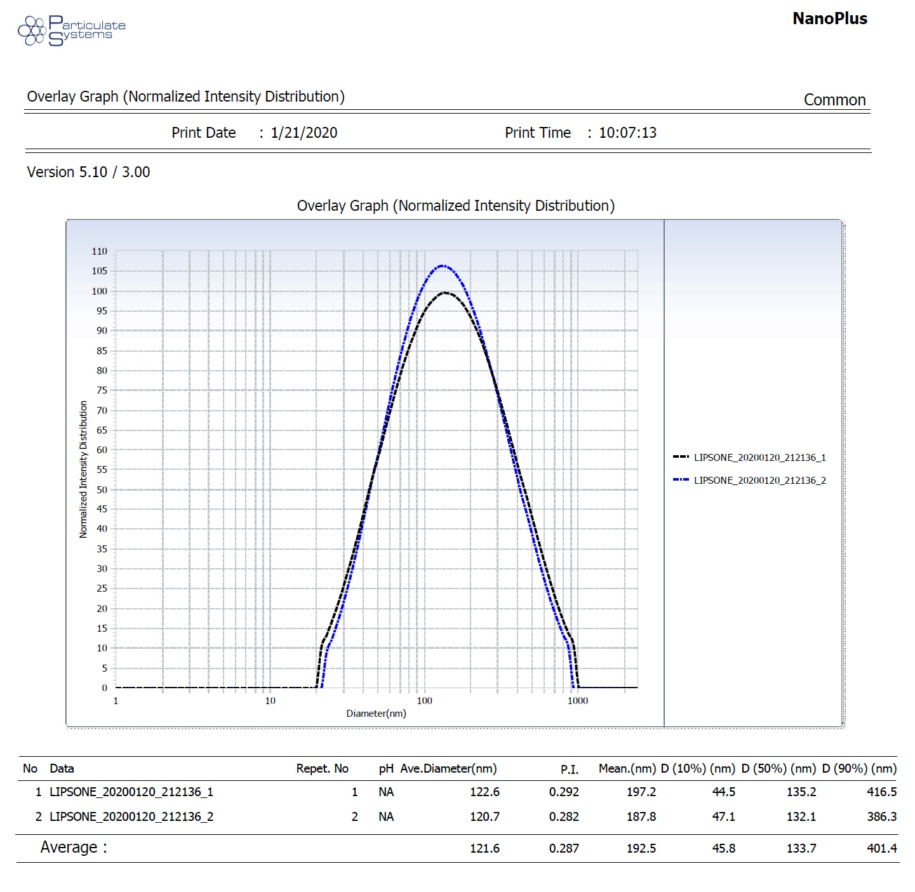
Fig. 9 Particle size of SLC-ATE Vesicles by DLS
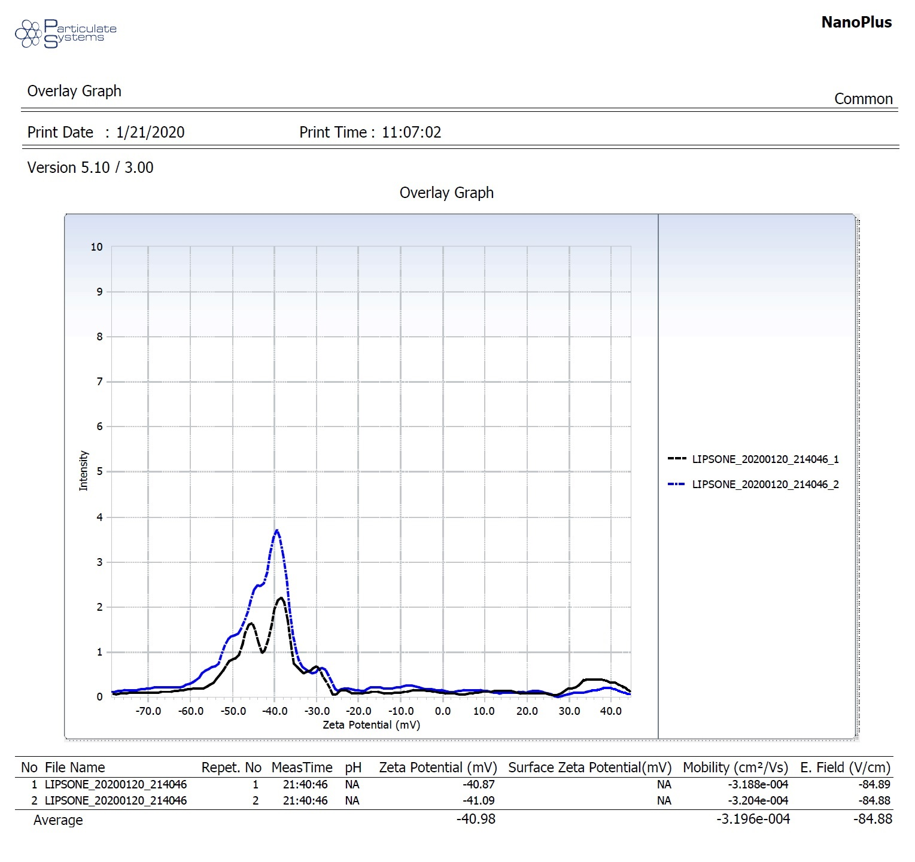
Fig.10 Zeta potential of SLC-ATE Vesicles

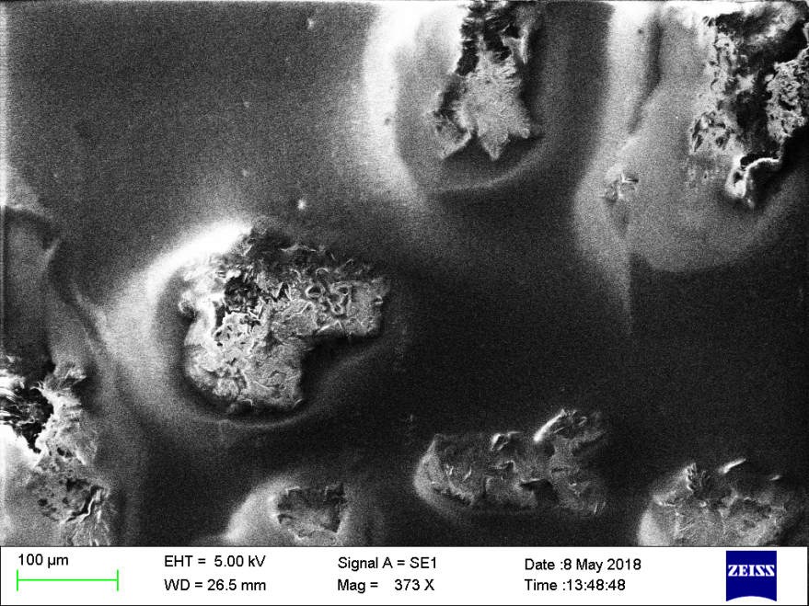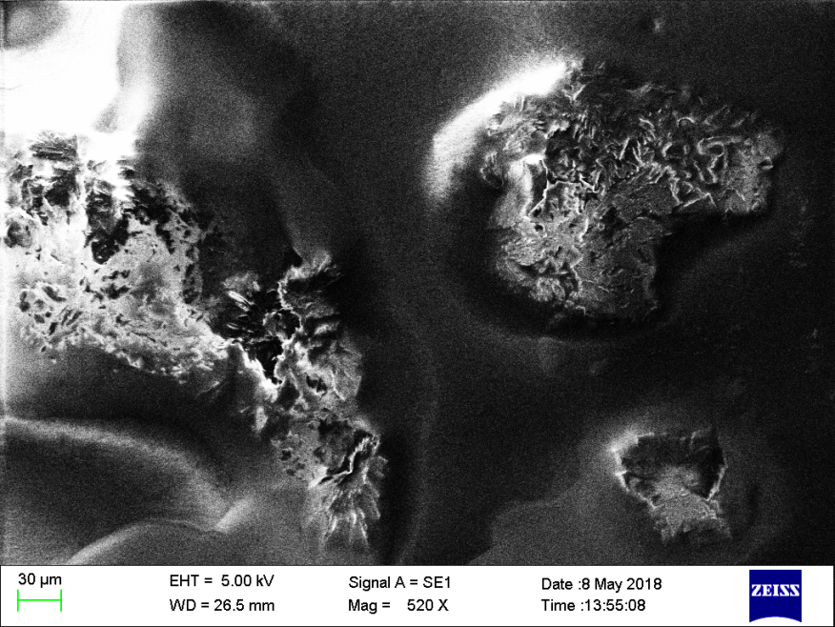
- (b)

Fig. 11 (a ) and (b) SEM images of SLC-ATE vesicles

VI. References

- Khaleel B.S., Syed M.M., Dhandayuthabani R., Sugantha K.V., Mater. Today Proc., (2020), 36(2), 357-363.
- Vinson J.A., Al Kharrat H., Andreoli L., Phytomedicine, (2005), 12(10), 760–765.
- Chen W., Lu Z., Viljoen A., Hamman J., Planta Med.,(2009), 75(6), 587-95.
- Fendler J.H., Acc. Chem. Res. (1980 a), 13, 7-13.
- Helfrich W., J. Phys. Condens. Matter (1994), 6(23A), A79.
- Battaglia G., Ryan A., Nature Mater., (2005), 4(11), 869–876.
- Akbarzadeh A., Rezaei-Sadabady R., Davaran S. et al., Nanoscale Res. Lett., (2013), 8,102.
- Discher D. E., Eisenberg A., Science, (2002), 297, 967-973.
- Stoeckenius W., J. Biophys. Biochem. Cytol.,(1959), 5, 491-505.
- Bangham A.D., Standish M.M., Watkins J.C., J. Mol. Biol., (1965), 13, 238-252.
- Bangham A.D., Prog. Biophy.Mol. Biol., (1968), 18, 25-29.
- Zingsheim H.P.,Plattner H., Electron microscopic methods in membrane biology. Methods Membr. Biol., (1976), 7,111-114.
- Petersen N.O., Chan S.I., Biochemistry, (1977), 16, 2657-2667.
- Hubbell W.L., McConnell H.M., J. Am.Chem. Soc., (1971), 93,334-326.
- Wallach D.F.H., Verma S.P., Fooksen J., Biochim Biophys Acta, (1979), 559, 153-208.
- Pink D.A., Green T.J., Chapman D., Biochemistry, (1980), 19, 349-356.
- Sharma V. K., Mishra D., Sharma A., Srivastava B., Int. J. Curr. Pharm. Rev. Res., (2010), 1, 6–16.
- Lasic D.D., Tibitech, (1998), 16, 307-321.
- Chrai S.S., Murari R., Ahmad I., Bio. Pharm., (2001), 11, 10-14.
- Eibl H., Chem. Phys. Lipids., (1980), 26(4), 405-429.
- Weiner N., Martin F., Riaz M., Drug Develop. Ind. Pharm., (1989), 15, 1523-1554.
- Szoka F., Papahadjopoulos D., Annu. Rev. Biophys. Bioeng., (1980), 9, 467-508.
- Mezei M., Liposomes and the skin. In: Gregoriadis G., Florence A.T., Patel H.M., (Eds.), Liposomes in Drug Delivery, Harwood Academic Publishers, (1993), 125-135.
- Albouaini K., Andron M., Alahmar A., Egred M., Int. J. Chron. Obstruct. Pulmon. Dis., (2007), 2(4), 535-540.
- Kalinowski L., Dobruchi L.W., Szczepanska-Konkel M. et al., Circulation, (2003), 107, 2747–2752.
- Wellstein A., Palm D., Belz G. et al., Eur. Heart J., (1987), 8(Suppl. M), 3–8.
- Packer M., Coats A.J., Fowler M.B., et al. N. Engl. J. Med., (2001), 344(22), 1651-1658.
- Wilson A.G., Brooke O.G., Lloyd H.J., Robinson B.F., Br. Med. J., (1969), 4(5680), 399-401.
- Mcainsh J., Simpson W.T., Holmes B.F., Young J., Ellis S.H., Biopharm. Drug. Dispos. (1980), 1(6), 323-332.
- McDevitt D.G., Eur. Heart J. Suppl M, (1987), 9-14.
- Mehvar R., Brocks D.R., J. Pharm. Pharm. Sci., (2001), 4,185-200.
- Gunjal P.T., Shinde M.B., Gharge V.S., Pimple S.V., Gurjar M.K., Shah M.N., Indian J Pharm Sci., (2015), 77(5),563-572.
- Sharma R., Sharma U. Indian J. Pharm. Sci.,(2021),83(1):60-68
- Sharma R, Sharma U.,Paswan S.K., Indian J Pharm Sci., (2023),85(3):632-643
- Dehdashti B., Amin M.M., Gholizadeh A. et al., J. Environ. Health. Sci. Engineer. (2019), 17, 281–293
- Melander A., Stenberg P., Liedholm H., et al., Eur. J. Clin. Pharmacol., (1979), 16, 327-330.
- Chourasiya V., Bohrey S., Pandey A., Mater. Discover., (2016), 5, 1–13.
- Bhowmik A., Ahmed T., Sultana S. et al., J. App. Pharm. Sci., (2013), 3 (09),103-108.
- Axelos M.A.V., Thibault J.F. The chemistry of low-methoxyl pectin gelation, In: Walter, R.H. (Ed.), The Chemistry and Technology of Pectin, Academic Press, New York, (1991), 109–117.

List of Abbreviations

S.No. | Abbreviation | Meaning
1 | SLC | Soy lecithin
2 | ATE | Atenolol
3 | SLC-ATE | Atenolol loaded Soy lecithin vesicles

