**Chapter Title: Unveiling the Future: Emerging Trends in IoT**

T.Geetha

AP/CSE

[geetha@vmkvec.edu.in](mailto:umamageswari6@gmail.com)

9952262419

Annapoorana Engineering College, Salem

R.Umamaheswari

AP/CSE

[umamageswari6@gmail.com](mailto:umamageswari6@gmail.com)

9629298728

Annapoorana Engineering College, Salem

R. Sujitha

AP/CSE

[aecsujitha@gmail.com](mailto:aecsujitha@gmail.com)

9500551910

Annapoorana Engineerng

College, Salem

**INTRODUCTION:**

The Internet of Things (IoT) has revolutionized the way we interact with technology, connecting devices, sensors, and systems to enable seamless communication and data exchange. As we delve into the future, the potential of IoT expands beyond imagination, shaping a world of interconnected devices, smart environments, and intelligent systems. This chapter explores the futuristic trends on IoT, shedding light on the transformative technologies and innovations that will reshape our lives.

**History :**The history of the Internet of Things (IoT) can be traced back to the early days of computing, when scientists and engineers began to explore ways to connect devices and systems together. One of the earliest examples of an IoT device was a Coca-Cola vending machine that was modified in the 1980s to track its contents remotely.

The term "Internet of Things" was first coined in 1999 by Kevin Ashton, a British technologist. Ashton was working at Procter & Gamble at the time, and he proposed using RFID tags to track products through the supply chain.

In the early 2000s, the IoT began to gain traction as the cost of sensors and wireless networking technology decreased. By the mid-2000s, there were already millions of IoT devices in use around the world.

The IoT has continued to grow rapidly in recent years, and it is now estimated that there are over 50 billion IoT devices in use worldwide. The IoT is being used in a wide variety of industries, including manufacturing, healthcare, transportation, and retail.

The future of the IoT is very bright. As the technology continues to develop, we can expect to see even more innovative and transformative IoT applications in the years to come.

Here are some of the key milestones in the history of IoT:

1982: A Coca-Cola vending machine at Carnegie Mellon University is modified to track its contents remotely.

1999: Kevin Ashton coins the term "Internet of Things."

2000: The first smart home devices are introduced.

2004: The first RFID-enabled toll road opens in Texas.

2007: The first iPhone is released, which helps to popularize mobile IoT devices.

2010: The first connected car is released.

2015: The number of IoT devices in use worldwide exceeds 10 billion.

2020: The number of IoT devices in use worldwide exceeds 50 billion.

The IoT is still a relatively new technology, but it has the potential to revolutionize many industries and improve our lives in a number of ways. We can expect to see even more innovative and transformative IoT applications in the years to come.

**CURRENT STATE OF IOT:**

The Internet of Things (IoT) is a rapidly growing technology that is having a major impact on many industries. The current state of IoT is characterized by:

* Massive growth: The number of IoT devices in use worldwide is estimated to be over 50 billion, and it is expected to grow to over 100 billion by 2025.
* Widespread adoption: IoT is being used in a wide variety of industries, including manufacturing, healthcare, transportation, and retail.
* Innovative applications: IoT is being used to create innovative new applications, such as smart homes, connected cars, and predictive maintenance.
* Challenges: The IoT also faces some challenges, such as security, privacy, and interoperability.

Overall, the current state of IoT is very promising. The technology is growing rapidly, it is being adopted by a wide variety of industries, and it is being used to create innovative new applications. However, there are also some challenges that need to be addressed before IoT can reach its full potential.

**EMERGING TRENDS IN IOT:**

**Artificial Intelligence and IoT Synergy:** In the future, the fusion of Artificial Intelligence (AI) and IoT will be a game-changer. AI will enhance the capabilities of IoT devices by enabling them to analyze, interpret, and respond to vast amounts of data in real-time. This synergy will empower IoT systems to make intelligent decisions, automate processes, and optimize resource utilization. AI can be used to analyze the data collected by IoT devices, identify patterns, and make predictions. This can be used to improve the efficiency of operations, optimize resources, and prevent problems. For example, AI can be used to analyze data from smart sensors in a factory to identify potential problems with equipment before they cause a breakdown. This can help to prevent costly downtime and improve productivity.

AI can also be used to personalize experiences for users. For example, AI can be used to analyze data from wearable devices to track a user's fitness goals and provide personalized coaching. This can help users to stay motivated and achieve their goals.

**Here are some examples of how AI and IoT are being used together:**

* Smart homes: AI and IoT are being used to create smart homes that can automatically adjust lighting, temperature, and other settings to optimize comfort and energy efficiency.
* Connected cars: AI and IoT are being used to create connected cars that can collect data about driving conditions and provide drivers with real-time alerts. This can help to prevent accidents and improve fuel efficiency.
* Healthcare: AI and IoT are being used to create connected medical devices that can collect data about patient health and provide personalized care plans. This can help to improve patient outcomes and reduce costs.

The synergy between AI and IoT is still in its early stages, but it has the potential to revolutionize many industries. As these technologies continue to develop, we can expect to see even more innovative and transformative applications in the years to come.

**Edge Computing:** Empowering IoT at the Edge: Edge computing will take center stage as IoT devices become more powerful and sophisticated. By processing data closer to the source, edge computing reduces latency, enhances security, and enables real-time analytics. In the future, edge computing will empower IoT devices to operate autonomously, improving efficiency and enabling rapid decision-making.

**Examples of edge computing:**

Smart city applications: Edge computing can be used to power smart city applications, such as traffic management, pollution monitoring, and public safety. For example, edge computing can be used to analyze data from traffic sensors to optimize traffic flow and reduce congestion.

Industrial automation: Edge computing can be used to power industrial automation applications, such as predictive maintenance and machine learning. For example, edge computing can be used to analyze data from sensors on industrial equipment to predict when equipment is likely to fail.

Healthcare: Edge computing can be used to power healthcare applications, such as remote patient monitoring and medical imaging. For example, edge computing can be used to analyze data from wearable devices to monitor a patient's health remotely.

Retail: Edge computing can be used to power retail applications, such as shelf inventory monitoring and customer analytics. For example, edge computing can be used to analyze data from sensors on store shelves to track inventory levels and optimize product placement.

**5G Connectivity:** Enabling a Hyperconnected World: The advent of 5G technology will fuel the growth of IoT by providing faster and more reliable connectivity. With its low latency and high bandwidth, 5G will enable a hyperconnected world where billions of devices seamlessly communicate and share data. This trend will unlock new possibilities for smart cities, autonomous vehicles, remote healthcare, and industrial automation.

**Examples of 5G Connectivity:**

* Smart cities: 5G can be used to power smart city applications, such as traffic management, pollution monitoring, and public safety. For example, 5G can be used to connect a network of sensors to monitor traffic flow and optimize traffic signals.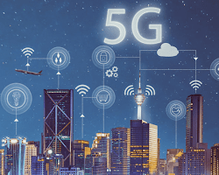

Smart cities 5G connectivity

* Industrial automation: 5G can be used to power industrial automation applications, such as predictive maintenance and machine learning. For example, 5G can be used to connect a network of sensors to monitor industrial equipment and predict when equipment is likely to fail.

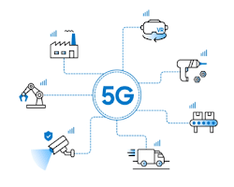

Industrial automation 5G connectivity

* Healthcare: 5G can be used to power healthcare applications, such as remote patient monitoring and medical imaging. For example, 5G can be used to connect a network of wearable devices to monitor a patient's health remotely.



* Entertainment: 5G can be used to power entertainment applications, such as virtual reality and augmented reality. For example, 5G can be used to stream high-definition VR content to users without any lag or buffering.
* Gaming: 5G can be used to power gaming applications, such as online multiplayer gaming and cloud gaming. For example, 5G can be used to provide gamers with a lag-free gaming experience.

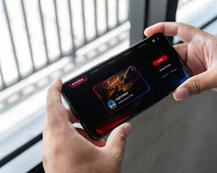

Gaming 5G connectivity

These are just a few examples of 5G connectivity. As the technology continues to develop, we can expect to see even more innovative and transformative applications in the years to come.

Here are some of the benefits of 5G connectivity:

* Faster speeds: 5G can provide speeds that are up to 100 times faster than 4G. This means that users can download files, stream videos, and play games much faster.

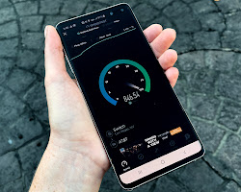

Faster speeds 5G connectivity

* Lower latency: 5G has lower latency than 4G. This means that there is less delay between when a user sends a request and when the network responds. This is important for applications that require real-time communication, such as online gaming and remote surgery.

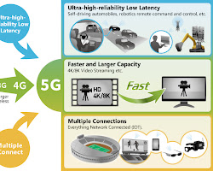

Lower latency 5G connectivity

**Blockchain:** Enhancing Security and Trust: Blockchain technology will play a crucial role in securing IoT ecosystems. By decentralizing data storage and establishing transparent, tamper-proof records, blockchain will enhance the security and trustworthiness of IoT networks. In the future, blockchain will enable secure device-to-device communication, establish provenance in supply chains, and facilitate peer-to-peer transactions.

**Examples**

* Bitcoin: Bitcoin is the most well-known example of blockchain. It is a cryptocurrency that uses blockchain technology to track transactions.

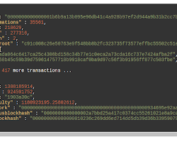

Bitcoin blockchain example

* Ethereum: Ethereum is a blockchain platform that allows developers to create decentralized applications.

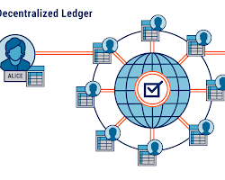

* Supply chain management: Blockchain can be used to track the movement of goods through a supply chain. This can help to ensure that goods are authentic and that they have not been tampered with.

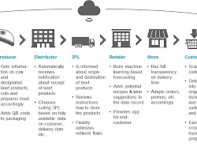

Supply chain management blockchain example

* Healthcare: Blockchain can be used to store medical records in a secure and tamper-proof way. This can help to improve the quality of care and protect patient privacy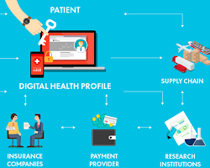

Healthcare blockchain example

* Voting: Blockchain can be used to create a secure and transparent voting system. This can help to prevent voter fraud and ensure that the votes are counted correctly.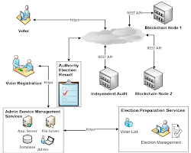

Voting blockchain example

**Human-Machine Interface and Wearable IoT:** Advancements in human-machine interfaces and wearable IoT devices will reshape how we interact with technology. From brain-computer interfaces to augmented reality glasses, these futuristic interfaces will enable seamless integration between humans and IoT systems. Gesture-based controls, voice commands, and biometric sensors will become commonplace, enhancing user experiences and improving accessibility.

**Examples**

Smartwatches: Smartwatches are wearable devices that can be used to interact with a variety of IoT applications. For example, smartwatches can be used to control smart home devices, track fitness goals, and receive notifications.

**Virtual reality (VR) headsets:** VR headsets can be used to create immersive experiences that can be used for training, entertainment, and education. For example, VR headsets can be used to train surgeons on how to perform surgery, provide entertainment, and educate students about different subjects.

**Wearable sensors:** Wearable sensors can be used to collect data about the wearer's physical activity, heart rate, and other biometric data. This data can be used to track fitness goals, monitor health, and provide personalized healthcare recommendations

**Sustainability and Green IoT:** The future of IoT will be strongly influenced by sustainability and environmental concerns. Green IoT initiatives will emerge, focusing on energy-efficient devices, renewable energy integration, and responsible manufacturing practices. IoT systems will play a crucial role in optimizing resource utilization, reducing waste, and promoting sustainable living.

**Examples:**

**Smart agriculture:** IoT sensors can be used to monitor soil moisture, temperature, and other environmental conditions in agricultural fields. This data can be used to optimize irrigation, fertilization, and other agricultural practices, which can help to reduce water usage and improve crop yields.

**Smart buildings:** IoT sensors can be used to monitor energy usage in buildings. This data can be used to identify areas where energy can be saved, such as by turning off lights in unoccupied rooms or adjusting the temperature of the building based on occupancy.

**Green IoT devices:** There are a number of IoT devices that are specifically designed to be more energy-efficient and environmentally friendly. For example, there are smart thermostats that can automatically adjust the temperature of a home based on occupancy, and there are smart light bulbs that can dim or turn off when they are not in use.

**IoT in Healthcare: Revolutionizing Patient Care:** IoT will revolutionize the healthcare industry by enabling remote patient monitoring, personalized treatment plans, and preventive care. In the future, wearable health trackers, smart medical devices, and real-time data analytics will empower healthcare professionals to deliver proactive and efficient care, improving patient outcomes and reducing healthcare costs.

**Remote patient monitoring:** IoT devices can be used to monitor patients' vital signs and other health data remotely. This can help to identify potential problems early on and provide timely intervention. For example, patients with chronic conditions such as diabetes or heart disease can use wearable devices to track their blood sugar levels or heart rate. This data can be sent to healthcare providers, who can then monitor the patient's condition and make adjustments to their treatment plan as needed.

**Wearable devices:** Wearable devices such as smartwatches and fitness trackers can be used to collect data about a patient's physical activity, sleep patterns, and other health-related metrics. This data can be used to track progress towards fitness goals, identify areas where lifestyle changes could be made, and monitor for potential health problems

**Conclusion:** The future of IoT is filled with transformative possibilities that will reshape industries, improve our daily lives, and address pressing global challenges. As AI, edge computing, 5G connectivity, blockchain, human-machine interfaces, sustainability, and healthcare applications converge, the potential of IoT becomes limitless. Embracing these futuristic trends will require collaboration, innovation, and a commitment to ethical and responsible IoT deployment. By harnessing the power of IoT, we can create a connected world that enhances efficiency, sustainability, and the overall well-being of humanity.