Three Axial Articulated Robots for an Industrial Purpose –its Design and Evolution.
Jayashri V. Chopade¹
Dr. Kanchan. D. Ganvir ²
1, Assistant Prof. Mechanical Engineering Department, Pimpri Chinchwad College of Engineering and Research Pune , India
2, Assistant Prof. Mechanical Engineering Department, Priyadarshini Bhagwati College Of Engineering , Nagpur, India
Email: kanchan.ganvir100@gmail.com
Abstract
The proposed research work focuses on Design of a robotic arm. Robots arrive in a wide variety of structures, including articulated robots. One need to mastery and experience to create and work on these types of robots effectively. This study depicts how to make and deal with a 3 Degree of freedom articulated robot with a 1 Degree of freedom gripper. Here an automated arm can get and situate things of various kinds, it can pick and position the different items accordingly. Pneumatic circuits were utilized in the research for configuration, construction and programming the robot. By bringing down the labour and the required time, automation is very fast accelerating its production in the industrial sector today. Our research centres around the unsafe course of shearing, which includes physically getting a sheet and putting it on the belt. In this, the main work is to develop pick and place gadget,that can be able to take a sheet of material from a stack and feed it into a shearing machine. Numerous study has been done , including various review articles to determine how modern and sophisticated areas employ technology for the same reason. In the wake of leading the fundamental exploration, we fostered a three-joint mechanical arm plan with a proper base and joints that can move in every one of the four directions that is in clockwise direction counter-clockwise direction , in an upward direction, and in downward direction . Further in the project the sheet is lifted with a particular measure of power and the end effectors is expected to lift the sheet utilizing suction cups.
1. Introduction
Figure : 1
Robots with articulation are frequently utilised in industrial settings. Robots with articulation are designed to take the place of humans in hazardous or repetitive occupations. The majority of industrial robots have an articulated design. Pick and place robots are frequently used in production lines that have repetitive operations. Humans are inefficient and prone to mental disturbance while performing the same work repeatedly because it becomes monotonous and boring. Robots do not get sick and do not require time off from work for recuperation. Robots are an excellent alternative to human labour. Robotic communication is difficult since they can't be as natural as it is for humans. Robots can resemble humans if a suitable programme is built that considers all plausible scenarios. Machines used in industry include industrial robots, which are often automatically operated and programmable. They are adaptable and capable of carrying out a variety of tasks since they can be utilised in three or more axes. Industrial robots are frequently employed in pick-and-place operations, welding, painting, and assembling. SCARA, which stands for articulated and Cartesian coordinate robots, is the most often used robot setup. Small robots are widely utilised in laboratories and other non-industrial settings. An articulated robot is designed and put into use in this project. The project entails both the design and construction of the articulated robot as well as its electronic control system. The creation and control of an articulated robot was the primary goal of this project. The robot's weight requirements and cylinder specs guided the design of the machine. Inverse kinematics provides the angles of the revolute joints so that the end effector canmove to a certain location, while forward kinematics provides the robot's current configuration. Since there are an unlimited number of ways to get to a particular place, inverse kinematics is occasionally employed for path planning.
2. Literature Review:
In this chapter, we looked at the research articles on robotic systems that have been published so far, as well as the various factors that affect and contribute to the system. In addition to all of this, we have also looked at a variety of products that are offered in the market thanks to practical study that was conducted in various market yards.
1. Sharath Surati et al, 2021
Title: Pick and Place Robotic Arm: A Review Paper.
This essay analyses the pick-and-place robotic arm and makes recommendations for its development. This review study analyses multiple productive research studies and lists the various benefits of deploying robotic arms in industrial settings. Robotic arms can work in dangerous environments, which are risky for people to perform, and this is one of their main advantages. We have cited a number of studies that have undergone experimental testing to examine the various controller types in use and the various approaches taken by various authors to establish the degrees of freedom of the manipulator used to choose an object and position it in a certain location. Designing a robotic arm will be simpler after reading all of these papers in today's society, when humans and robots collaborate to fulfil their given duties. An autonomous robot that can complete duties on its own is referred to as an assistance robot. These robots are utilised in a variety of industries, including as the medical field, military, and industrial. People may be in danger while performing hot or dangerous tasks. This implies that dangerous tasks that would be too risky for humans to perform can be performed by robots.

2. By Bence Tipary et al, 2021
Title: Genetic development methodology for flexible robotic pick-and-place work cells based on Digital twin.
The development process for flexible robotic pick-and-place work cells can be facilitated by the generic development methodology presented in this study. The process is founded on the idea of a "Digital Twin," which enables us to iteratively improve the work cell in both a virtual and physical environment. The commissioning (or reconfiguration) procedure will be accelerated, and work in the physical work cell will be reduced. To sustain twin intimacy, it is vital to digitise and automate the development process, and to guarantee that there is enough contact between team members. With such, the actual work cell can accurately materialise the digital model. Through a task, the process is explained in a form that is simple to understand. It is carried out in a reconfigurable experimental robotic work cell for added flexibility. In order to produce precise and realistic applications, a detailed general development technique for robotic pick-and-place scenarios was presented in this work. The plan, which aims to streamline the development process and lessen on-site workload, is based on the Digital Twin (DT) concept. The method for standardising, making easier, and directing the creation of robotic work cells from conception through commissioning, as well as during adjustment, maintenance, and reconfiguration, is presented in this paper. The method aims to synchronise the development and verification processes using the robotic work cell DT. The suggested iterative development procedure rigorously examines the digital and physical work cells to maintain the usefulness of the prepared system.To properly implement the operation in the physical work cell, geometry and tolerance-related variance between the digital and physical counterparts are also handled in each cycle. This difference is referred described as having "twin closeness." The methodology is designed for applications where autonomous online planning and offline planning using digital models are necessary but local, intuitive robot programming techniques are inefficient. These include complex processes that call for offline planning or optimization, routinely updated conventional or flexible cells, and flexible pick-and-place cell design or re-design. To demonstrate the methodology, a semi-structured pick-and-place task was created and implemented in an experimental work cell. A further study will draw comparisons to industrial practises in the construction of robotic work cells and other use cases to demonstrate the workflow's applicability. A pick-and-place specific tolerance model is one of the modules that will be added to the current technique in the future to fill in the gaps that are currently present.

3. Patrik Fager, Robin Hanson et al, 2021
Title: Vision-guided robotic bin selection application for mixed-model assembly using supervised and unsupervised learning.
Although picking is frequently done by hand, using robotics for bin picking has the potential to increase quality while consuming fewer labour hours. Robots can learn how to do tasks with the use of vision systems. Examining the distinctions between supervised and unsupervised learning is the goal of this research. Engineering preparation time (EPT) and reaction quality (RQ) are the subjects of an experiment. In the paper, an experiment using two different learning algorithms for a vision-system in a robotic bin-picking application was reported. It examined engineering preparation time and recognition accuracy. Because it affects the ability of automated activities to be reconfigured, this is significant in industry. A 3D scanner and robot-vision software were two specific pieces of technology and equipment used in the experiment. Three component kinds with varied properties were also taken into consideration. To create a comprehensive and generalizable picture of how learning approaches affect reconfigurability, it is important for future research to additionally take into account various variations of the technology and equipment.
4. By Fenguchun Li et al, 2020:
Title: Design of a robot end effector with measurement system for precise pick-and -place of square objects.
This study suggests a design for an end effector (EF) and its accompanying measuring technique for manipulating square-shaped target objects (TOs) precisely by robots. A middle measurement frame (referred to as "Frame" for short) that was also mounted with CCD sensors was designed to establish a middle coordinate system (CS) to describe the pose deviation of the EF and of the TO separately, transferring the pose deviation of the TO to the pose being described in the CS of the EF. This was done in order to acquire the pose deviation of the TO in the coordinate system (CS) of the EF. Additionally, the geometric model of the design was examined, and the pose deviation of the 16 CCD displacement sensors readings were used to calculate TO. The cost of the calibration process can be decreased because, in contrast to the conventional existing method, the proposed measurement method uses relative values of the instruments to calculate the pose of the TO. This eliminates the need to precisely determine the initial position of the instruments. It is anticipated that this approach will better balance cost and accuracy. An ABB irb4600 robot was used in a verification exercise to test the proposed design's ability to correct the discrepancy between the EF and its grasped TO. Findings indicate that the typical position mistake may be cut in half, going from 5.34 millimetres to 0.73 millimetres, and the average angular error can be cut in half, going from 0.685 degrees to 0.104 degrees. The total compensation rate is about 85%. Future work will involve developing the robot's stiffness model to account for gravity distortion and upgrading the geometry models of the EF and the Frame to account for able errors, per the investigation of the origins of the experiment's residual errors. The pick-and-place task will increasingly be performed by robots in production in the future. The posture discrepancy between the robot's EF and its modified TO is one of the key mistake factors that lowers the task's final accuracy. The accurate pick-and-place of the square TOs was designed in this paper using an end effectors and its associated measurement system, which can measure the relative pose deviation between the TO and the EF. To transfer the posture of the TO to the expression in the coordinate system of the EF by simultaneously describing the pose of the EF and the TO in the additional measurement frame equipped with CCD laser displacement sensors distinct CS for each frame. It was also determined how the 16 CCD displacement sensors' readings would affect the geometric model of the whole design, which expressed the pose deviation of the TO as a function of those data. An experiment was conducted on an ABB irb4600 robot to compensate for the error between the EF and it's grasped TO in a pick-and-place. operation in order to confirm the efficiency of the design and the accuracy of the geometric model. Results indicate that the average mistakes can be decreased by about 85%
5. By Ahmed Khairadeen Ali et al, 2020
Title: Generic design aided robotically façade pick and place in construction site dataset.
This technique uses generative design to optimise the placement of the robot arm and the facade during the facade assembly activity. Graphical algorithm editors are offered with a collection of generative algorithms. The dataset is split into three sets, each set in charge of a crucial component of facade assembly at the job site. The dataset is known as (iFOBOT) and consists of the following sub datasets: Quantity take-off generating algorithm, Generative algorithm aided robot spatial placement optimizer, and Tool for facade population on building envelop (iFOBOTL). This dataset includes a sample project together with its script and outcome findings to show readers how to use the tool. The placement of robot arms and facade modules exclusively is the subject of this dataset. By minimising robot collision with its body and surrounding objects, reducing reachability rates, and minimising robot time travel during operation, this dataset can produce an optimised location for the robot arm workstation on the jobsite. As a result, risk during facade assembly is minimised, and productivity is increased. By virtue of its parametric format, this dataset can be reused along with all of its historical data by following the instructions in this replicating guide. In the Robot-based Facade Spatial Assembly Optimization paper, more information is provided on how to reuse this dataset and developed technology in building sites. This dataset can be useful to architects, construction engineers, and robot specialists throughout the planning and building phases of construction projects. Parametric designers who concentrate on the fabrication aspect of design modules might also gain from this from the methods and strategies offered in this dataset to prevent fabrication issues during robotically manufactured modules.
6. Fabio Sgarbossa et al, 2020
Title: Robot picker solution in order picking system: an ergo-zoning approach.
Such a robot picker is described in this study, along with a strategy for dividing the warehouse into two zones: one for robot pickers and one for human pickers. The zoning technique was developed using a Non-dominated Sorting Genetic Algorithm II (NSGA-II), which reduced human workload and increased the similarity of product categories within each zone. The approach for dividing products into two warehouse zones—one for robot pickers and one for human pickers—was devised in this study along with a robot picker. This paper is the first to present a technique to assist warehouse managers in selecting the extent of this new technology's application. Additionally, managers will be able to utilise a more sustainable strategy that takes into account both the efficiency of warehouse operations and the wellness of order pickers. The method's inability to directly assess the prices of various options is one of its drawbacks. Lower costs are achieved by maximising each of the goal functions, but once the zone assignment method has produced its results, it is necessary to assess the trade-offs case-by-case. Future studies should focus on including the costs associated with ergonomics, lifting-related illnesses such MSDs, and the overall costs of the supermarket supply chain.Since warehouses compromise performance to reduce overall supply chain costs, the entire supply chain must be considered. The approach also disregards the size of the consolidation area between the zones. When determining this, future studies should take into account the various working hours of people and robots.
7. Albert S. Olesen, 2020
Title: A Collaborative Robot Cell for Random Bin -picking based on Deep Learning policies and a Multi -gripper Switching Strategy.
This paper presents the details of a collaborative robot cell assembled with off-the-shelf components designed for random bin-picking and robotic assembly applications. The proposed work investigates the benefits of combining an advanced RGB-D vision system and deep learning policies with a collaborative robot for the assembly of a mobile phone. In order to overcome the difficulties of grasping the various components of the mobile phone, a multi-gripper switching strategy is implemented using suction and multiple fingertips. An improved version of YOLO is used to detect the arbitrarily placed components of the mobile phone on the working space. Last but not least, the preliminary tests carried out with the suggested robot cell show that the enhanced learning capabilities of the robot achieve high performance in identifying the specific components of the mobile phone, accurately grasping them, and effectively completing the final assembly. This study describes a Table-Picking method that uses a UR5 collaborative robot manipulator to pick up mockup phone components and put them together into a mockup phone. The system uses a version of YOLOv3 in order to detect and locate the different parts and another CNN to fine tune the orientation of the part in order to assemble the phone.In order to identify and find the various pieces and to fine-tune their orientation before being assembled into the phone, the system makes use of a YOLOv3 variant. The study offers a design for a multi-purpose gripper that can pick up non-porous flat surfaces, fuses, and bigger things like phone covers via suction. By simply rotating the end-effector to pick up the required object, the robot is able to easily switch tools. The prototype demonstrated in this study performs well in each of its separate subsystems, but several failed efforts at assembly left the system's overall success rate at just 47% for the tests that were run. Although this quantity seems high Low, which is brought on by the knowledge that even little mistakes on one component during the assembly process will probably prevent the remainder of the phone from being put together. Since not all components performed equally, the system's overall performance was based on the lowest common denominator. Improvements for better success rates for the separate parts, as discussed in the discussion, can be made to potentially reach a 99+ percent success rate.

8. Ya Xiong et al, 2020
Title: An Obstacle separation method for robotic picking of fruits in clusters.
Complex fruit clusters can now be gathered with a better success rate than before thanks to this technique. By combining push and drag actions, the active obstacle separation technique presented in this study is more advanced than the linear pushing policy we previously suggested. The suggested active obstacle separation method, in contrast to conventional obstacle avoidance systems, could actively separate obstacles from the target based on 3D visual perception. We demonstrate the separation rules, computation techniques, and image processing pipeline needed to apply the strategy to a recently created robot. To separate the obstacles underneath and concurrently with the old single linear push, a zig-zag push operation made up of numerous linear pushes was developed. height of the target, which thanks to the multi-directional pushes can manage denser impediments. Additionally, the resulting side-to-side motion can reduce the static contact force between obstacles and the target, making it simpler for the gripper to grasp the target. The gripper drags the target to a location with less obstacles before pushing back to push the obstacles aside for further separation in order to address the issue of mis-capturing obstructions positioned above the target. The operation involves carefully avoiding obstacles as well as pushing them aside An image processing pipeline was created that uses 3D colour thresholding to eliminate noise points from the background, 2D object detection based on deep learning to locate and identify the target, and 3D point cloud operation to identify obstacles in order to implement the suggested method on a harvesting robot. Field experiments revealed that the suggested strategy can significantly boost picking performance. Incorporating a closed loop vision guided manipulation system may significantly enhance performance.

9. Yuhang Li a et al, 2018Title: An approach for smooth trajectory planning of high-speed pick-and-place parallel robots using quintic B-splines.
This work introduces a novel, very efficient method for parallel high-speed pick-and-place robots' smooth trajectory planning. In order to achieve C4-continuity, the pick-and-place path is divided into two orthogonal coordinate axes in Cartesian space. Quintic B-spline curves are then employed to construct the motion profile along each axis. The proposed motion profile is essentially dominated by two key factors, which represent the ratios of the time intervals for the end-effector to move from the initial point to the adjacent virtual and/or via-points on the path. This is done by using the symmetrical properties of the geometric path defined. Then, these two variables can be calculated by maximising the weighted sum of two single-objective normalised functions, which can then be expressed as functions of width/height via curve fitting .ratio of the pick-and-place path, making it possible to store them in a look-up table and apply the algorithm in real time. The residual vibration of the end-effector can be significantly decreased, according to experimental results on a parallel robot of the 4-DOF SCARA type. This is made possible by the highly smooth and continuous joint torques attained. In this study, a novel method for smooth trajectory planning utilising fifth-order B-splines for parallel high-speed pick-and-place robots is proposed. It proposes a motion profile that is primarily dominated by by taking advantage of the symmetric features of the path described in a local frame parameters for two-time ratios. They can be calculated off-line by maximising the product of two single-objective functions that are weighted together and expressed as a function of the pick-and-place path's width to height in Cartesian space. This therefore enables the look-up table-based online creation of the smooth joint trajectories. Both simulation and experimental results on a 4-DOF SCARA type parallel robot show that the time profiles of the joint torque are relatively small and very continuous and smooth, with residual vibration of the end-effector being significantly reduced. These results are compared with two existing trajectories planned in the Cartesian space.

10. Pratiksha Andhare and Sayali Rawat
Title: Pick and Place Industrial Robot Controller with Computer Vision.
Nowadays, the majority of robots work in predetermined cycles that, at best, wait for a few input sensors before moving on. When compared to how a person performs the identical task, we have far more flexibility because the path that our hand should travel during each cycle is determined by the environment that the robot is operating in. This essay provides information on how to determine an object's x and y coordinates. This is discovered by using 2D transformation to translate pixel coordinate into real-world coordinate. Depending on the position and orientation of the object, we add a robotic arm controller. The primary challenge in this task is to select and position the things vision sensor underneath The visual discernment component of computer vision is a passionate drive to imitate human insight and provide robots smarter behaviour. The majority of techniques for grabbing objects visually employ a robot-mounted camera. In this experiment, the camera is positioned freely above the region of interest rather than on a robot. It is necessary to convert camera coordinate into world coordinate for that purpose. Projective geometry and 2D transformation features like scaling, rotation, and translation are crucial when performing this transformation. The object's location is nothing but the centroid's X and Y coordinates. We have given this coordinate to the controller through socket communication, and it will act to direct the appropriate servo motors to pick up the object and position it in the designated location. The application to industry problems is the primary goal.

1.2 Present scenario and Problem identification.
Although there may be advantages to be had, the current hand shearing method is risky for the entire industry. The employee gathers the raw material and manually feeds it into the shearing device. The operation is complete after the sheet has been entirely torn into pieces. The procedure is extremely risky for those performing it. In comparison to human execution, there is a good likelihood that automating this operation will increase the rate of work. It is recommended that the entire shearing process be automated in order to overcome the drawbacks of hand shearing. A pick and place device is used in this project to lift the raw material sheets one at a time to the shearing device.
3. Engineering Objectives
1).To reduce man power and losses caused due to misplacement of components.
2).To increase speed and efficiency of work.
3).Designing of the pick and place mechanism.
4).To avoid the accidents at work place.
5).To handle the repetitive tasks.

Figure : 3
Figure : 4 Prototype of robotic arm

4. Methodology
The research entails the design, construction, and pneumatic circuitry of a 3-DOF robot. Using Creo software, a link design for the robot was completed as the first stage of this research. It can be seen below.

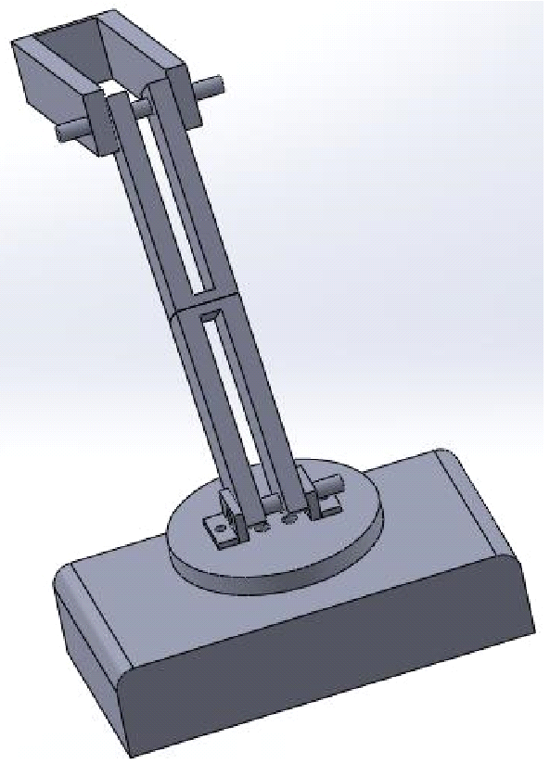

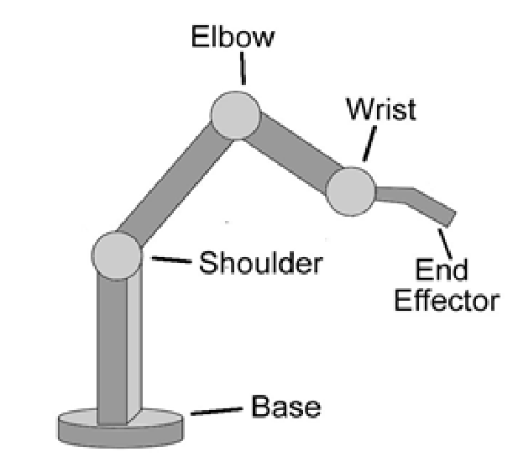

Proposed figure of Mechanism.

This design served as the inspiration for the robot's fundamental mechanics. Following pneumatic cylinder selection, the required link, lengths were determined and made using carbon steel bars. The final design of the robot is as follows. The design of the robot underwent significant changes throughout assembly.

5. Engineering Design.
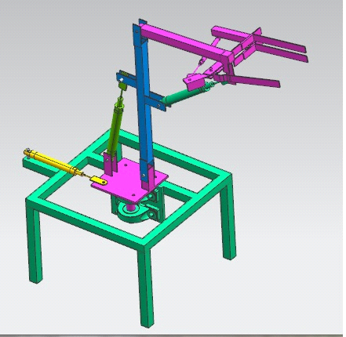
The design and analysis of following parts is done:
Base frame (Mild Steel)
Swivel Base (Mild steel)
Link-1 (Mild steel)
Link-2 (Mild steel).

Base Frame details.
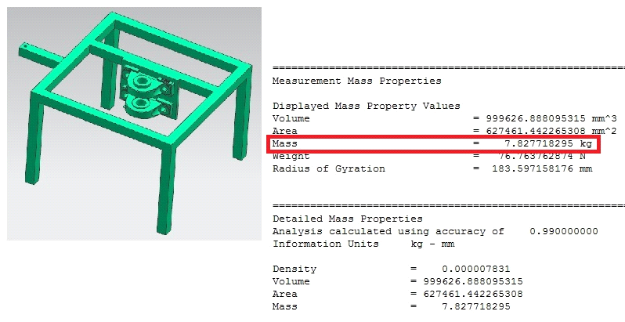

The self-weight of base frame is 7.823 kg
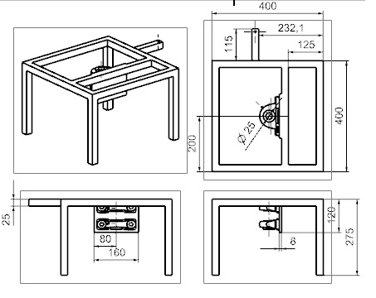

Swivel Base details:

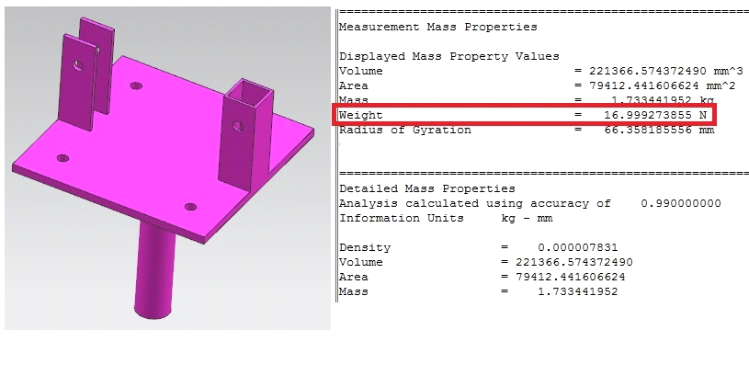

The self-weight of swivel base is 17.3 kg

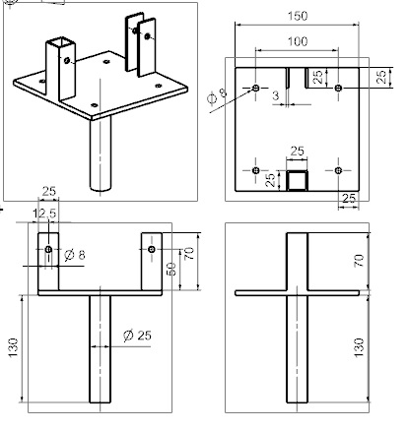
Link-1 details:
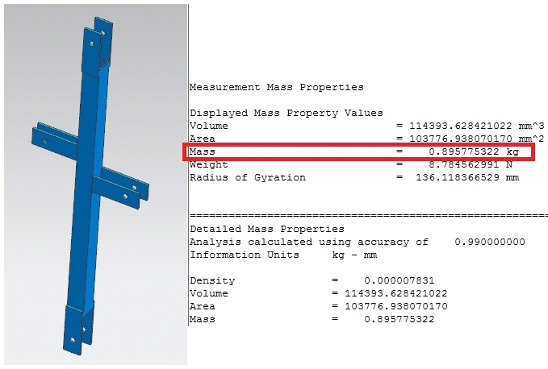

The self-weight of link-1 is 0.89 kg

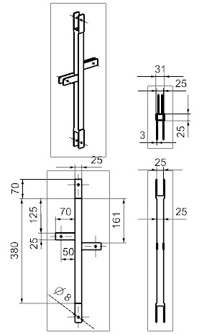
Link-2 details

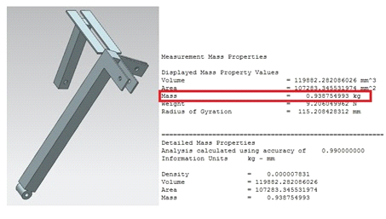

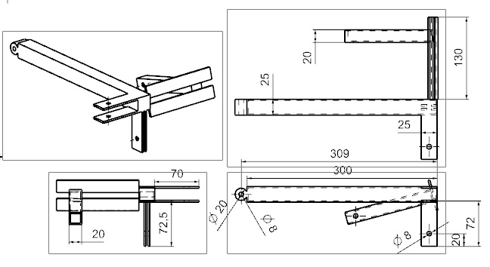

Cylinder details :
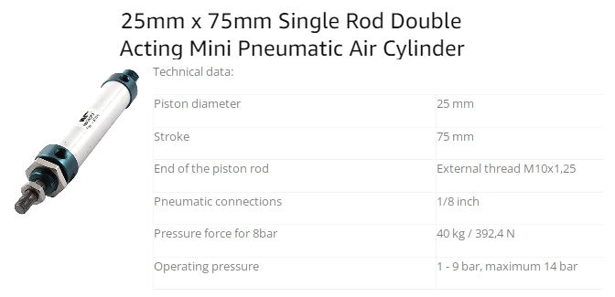

Maximum force exerted by cylinder = 392.4 N
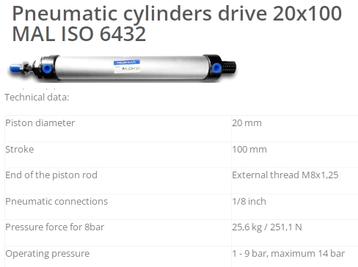

Maximum force exerted by cylinder = 251.1 N

Analysis of Link-2:

Force analysis of the link-2

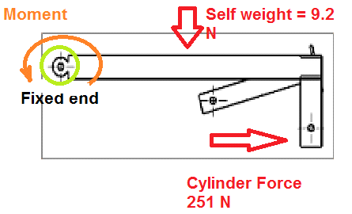

MATERIAL SELECTION: -Ref: - PSG (1.10 & 1.12) + (1.17)

DESIGNATION | ULTIMATE TENSILE STRENGTH N/mm² | YEILD STRENGTH N/mm²
Mild Steel | 600 | 880

fs allowable = 0.18 x UTS = 108N/mm²

Geometry was developed using Unigraphics Nx-8 software and the step file was used as input to Ansys

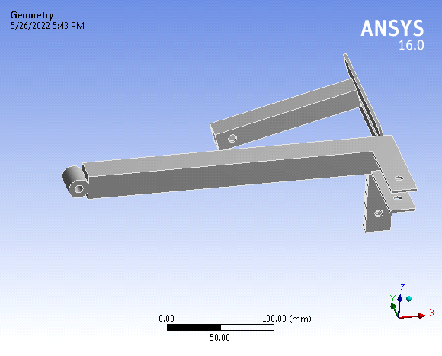

6. Working
Pneumatic air is the primary source for the working operation for project. The project's power pack, which consists of 4 no. of 5/2 hand controlled valves; will receive its primary air supply from this source. All links assembly will be rotated toward the first cylinder's stroke length if the first 5/2 valve is provided for rotation of all links. The second 5/2 valve, which is located a distance from the centre arm that is vertical, is provided for measuring moments against the central pivot point. The third 5/2 valve is used to apply a longitudinal moment to an inclined surface that is not perfectly horizontal. Third 5/2 Valve provided for using fork.

7. Operations Can be Performed are as follows:
1. Cutting: Sawing machines are frequently used to cut materials like metal and wood. Similar cutting specifications apply to all methods of processing metal, including metal sawing. Sawing is employed due to its advantages in terms of speed of cutting, little material waste, high-quality dimensional precision and low power consumption. In sawing operations, a saw is a multipoint cutting tool. In this process, a lot of teeth cut into the work piece, each one deepening the cut created by the one before it. Either the saw or the work piece receives feed. Controlling the feed motion's direction allows for the cutting of either straight or curved profiles. The majority of stock materials arrive in their typical size and shape. In order to feed the stock material to the machine tool for further processing, it must first be cut to a manageable length. In addition to cutting the bar stock in length, we may need to do so very frequently in order to approximately shape and size it. This could speed up processing significantly. The power-driven metal cutting saws are now all but necessary due to these needs and economic factors. One of the most crucial parts of a sewing machine is the saw or saw blade. Saws can be identified by their size, material, tooth form, tooth set, and tooth spacing. Excellent metal cutting High-speed or high-carbon steel are used to make saws.
2. Arc welding is a sort of joining technique that uses an electric arc to generate heat and melt metals. Direct (DC) or alternating (AC) currents from a power source generate an electric arc between a consumable or non-consumable electrode and the base material. Metals are joined using the fusion welding technique known as arc welding. Intense heat of about 6500°F is produced by an electric arc from an AC or DC power source, melting the metal at the joint between two work components. Either a manual or automatic arc The electrode either conducts the current only or conducts the current and melts into the weld pool at the same time to give filler metal to the join. The electrode is mechanically moved along the line of the join. A protective shielding gas or slag is employed to minimise the contact of the molten metal with the air because the metals react chemically to oxygen and nitrogen in the air when heated to high temperatures by the arc. The molten metal’s solidify to create a metallurgical link once they have cooled.
3. GRINDING: Hard materials can be ground down to size or tools can be sharpened using this procedure, which is usually done in stages. After crushing, grinding is done to generate finished goods with the specified fineness. The final fineness, for instance, relies on how finely the desired mineral is dispersed when the mineral ore is crushed to a given size and then ground to a powder. Depending on the material, grinding can be done wet or drytechnique in use, although the materials may first need to be dried in cylindrical, rotary dryers for dry grinding. For grinding, there are numerous machines. Very precise measurements and very fine finishes are possible with grinding. In comparison to "normal" machining, it is typically better suited to the milling of exceptionally hard materials.

d) DRILLING: A drilling machine is defined as a device that creates circular holes, a tool that drills holes of various sizes, and other associated drill bit actions. The drilling machine is among the most crucial pieces of equipment in a workshop. It is second only to lathe machines in terms of importance. The Egyptians used bow drills to create holes some 3000 years ago, in 1200 B.C. The forerunner of today's metal-cutting drilling equipment is the bow drill. Drilling machine holes allows for quick and inexpensive drilling. The drill, a spinning cutting edge instrument that exerts a lot of force on the work, creates the hole ranked on the desk. The device is generally referred to as a "drill press" since it creates holes by applying vertical pressure.
Robots that can pick and place objects accurately are equipped with wide reaches, slender arms, constant repeatability, and precision tooling. They are a suitable fit for pick and place applications because of their high accuracy capabilities.
2. Flexible Pick and Place: Flexibility is one of the key benefits of robotics. Programming pick-and-place robots is simple. They can adapt to numerous variations in product type and shape. Robots also offer a high degree of movement versatility.
3. Pick and Place Robot Systems Can Improve Product Quality And Cycle Time. Pick and Place Robot Systems Can Improve Product Quality And Cycle Time Robotic movements are controlled, therefore the outcomes are constant. This uniformity leads to an improvement in quality. Furthermore, the procedures might happen because of the consistency.
4. Robots Save Space: Pick and place robots are perfect if you want to save floor space because they are built with compact bases. Robots can be designed to operate within predetermined work envelope parameters, resulting in even better space utilisation.
5. Robots Maximize Safety: Physically taxing pick-and-place tasks can be handled by robots. They require a lot of work and are boring and repetitive. Moving a part from one place to another may be difficult work depending on its weight and size. Robots that choose and position objects are unaffected by the demands of the task. They can work uninterrupted and without making blunders.
8. Result of Design Analysis
- The force applied by Pneumatic Cylinder on Arm is 251.32 N.
- Link-1: The analytical stress is 37.127 MPa and the maximum deformation is 0.609 mm.
- Link-2: The analytical stress is 28.82 MPa and the maximum deformation is 0.32661 mm.
- Swivel base: The analytical stress is 31.341 MPa and the maximum deformation is 0.14185 mm.
- Base Frame: The analytical stress is 7.1785 MPa and the maximum deformation is 0.019 mm.
9. Conclusion: The Robot is designed in such a way that it can performed many operations like, cutting , arc welding , grinding ,drilling , flexible pick and place , additionally it is flexibility to pick and place is one of the benefit , serving good service and designed with requirement of less space.
References
1. Nishigandha Patel1, Vaibhav Ahuja1, Shaunak Hedaoo1, Tushar Rotti1, A Review Paper on the Pick and Place Robotic Arm, IRJET Volume 08|02, February 2021.
2. Gabor Erdos, Bence Tipary, Digital twin-based genetic development process for adaptable robotic pick-and-place workcells, ScienceDirect 2021
3. Sven Ekered, Robin Hanson, Asa Fasth-Berglund, and Patrik Fager Vision-guided robotic bin selection application for mixed-model assembly using supervised and unsupervised learning, ScienceDirect 2021.
4. Yixiao Feng, Shuqing Chen, Tiemin Li, Fenguchun Li, ScienceDirect 2020: Design of a robot end effector with measurement system for accurate pick-and-place of square objects.
5. Hayub Song, One Jae Lee, and Ahmed Khairadeen Ali ScienceDirect 2020's generic design dataset includes robotic façade pick and place on construction sites.
6. Torbjorn Krogen, Finn H. Johnson, Anita Romdal, Fabio Sgarbossa An ergo-zoning strategy as a robot picker solution in an order picking system, ScienceDirect 2020.
7. Dimitrios Chrysostomou, Benedek B. Gergaly, Emil A. Ryberg, Mads R. Thomsen, Albert S. Olesen, Based on Deep Learning principles and a Multi-gripper Switching Strategy, a Collaborative Robot Cell for Random Bin-picking, ScienceDirect 2020.
8. Ya Xiong, Pal Johan, Yuanyue Ge A robotic approach for harvesting clusters of fruits using obstacles, ScienceDirect 2020.
9. An technique for smooth trajectory planning of high-speed pick-and-place parallel robots using quintic B-splines, Yuhang Li, Tian Huang, and Derek G. Chetwynd, ScienceDirect 2018,
10. Pick and Place Industrial Robot Controller using Computer Vision by Pratiksha Andhare and Sayali Rawat, 2016.
11. Roshni N and Dr. Sunil Kumar T K, "Pick and Place Robot Using Moving Object Center of Gravity Value," IEEE 2017.
12. DETERIORATION & NON-DETERIORATION WASTES SEPARATION USING PICK & PLACE ROBOT, IEEE 2018; K. Dhayalini and R. Mukesh
13. Pick and Place ABB Working with a Liner Follower Robot by Nwokomah Wilson Gosim, Tarig Faisal, HMAAAl- Assadi, and Mahumud Iwan, ScienceDirect 2012.
14. Validating an object placement planner for robotic pick-and-place tasks: Kensuke Harada, Tokuo Tsuji, Kazuyuki Nagata, Nasuki Yamanobe, and Hiromu Onda, ScienceDirect 2014.
15. Msc. Valdrin Krasniqi, Dr. Shaban Buza, Dr. Arbnor Pajaziti, and Dr. Fehmi Krasniqi, "Control Algorithm of a Pick and Place Three Dimensional Robots," 16th IFAC Symposium on Automation in Mining, Mineral and Metal processing, August 25-28, 2013, USA
16. Automatic Elliptical Trajectory Planning Algorithm For Pick and Place Operation, Wenguang Li, Yongfei Xiao, Shuhui Bi, and Guangyue Du, IEEE 2013
17. Simulation of Pick and Place Robotics System Using Solidworks Softmotion by Rosidah Sam, Kamarul Arrifin, and Norlida Buniyamin, ResearchGate 2012.
18. Carlos F. Aguilar-Ibanez, Jose de Jesus Rubio, Javier Serrano, Maricela Figueroa Dynamic model for an articulated robotic arm with sensors and actuators, Neural Computing and Applications 26 October 2012
19. Takashi Uno, Nobuhiro Nanda, Yoshilkazu Hayakawa, Toshiyuki Kondo, Shinji Sawada, 5th IFAC Symposium on Mechatronic Systems Marriott Boston Cmabridge September 13–15, 2010: Synthesis of Stable Grasp by Four Fingered Robot Hand for Pick-and-Place of Assembling Parts.
20. Development of Semi-Automatic Pick and Place Robot for Material Handling Systems by Aravind, Rajparthiban, and Tiffany, 5th International CSPA 2009.

