DEEP EUTECTIC SOLVENTS GLUCOSE – MALONIC ACID (DESs) AND THEIR NANO SYNTHESIS OF ZINC CHLORIDE

K.Prabhakaran¹, T. Mohana Priya², S.Sathishkumar³ and K.Gayathri⁴

^{1,3,4} Centre for research, Department of Chemistry, Kongu Engineering College (Autonomous), Perundurai, Erode-638060, Tamilnadu, India.

²Associate Professor, Department of Chemistry, Erode Arts and Science College, Erode-638009, Tamilnadu, India

Corresponding Author Details

T. Mohana Priya

Associate Professor, Department of Chemistry, Erode Arts and Science College, Erode-638009, Tamilnadu, India,

E-mail: mohanapriyachem@gmail.com, Mobile: +91 89737 77592

1. INTRODUCTION
During the past two decades, room temperature ionic liquids (ILs) have considerable impact especially in the fields of catalysis, electrochemistry, material chemistry, and recently in the pre-treatment of biomass.^{[1-3]} At the beginning of these research, scientists mainly focused on the formation of ionic liquids by mixing metal salts, mostly zinc, aluminium, tin and iron chlorides, with quaternary ammonium salts. Though both the salts have very high melting points, their proper mixing yielded the formation of a liquid phase known as eutectic mixtures are usually characterized by large depression of freezing point, mostly higher than 150°C. After the introduction of the idea of green chemistry in the early 1990’s, the search for metal-free ionic liquids (ILs) has become of growing interest.^{[4]}
In this context, numerous works were carried to the development of ionic liquids by mixing an organic cation (usually imidazolium-based cations) with a large kind of anions, the most common ones being Cl, BF_{4,} PF₆. From that point of time, ionic liquids have emerged as new types of promising solvents. The possibility to chemically modify the cationic moiety in combination with a large choice of anions offers chemists a wide range of ionic liquids showing varied physical properties such as melting point, solubility, viscosity, density, conductivity, and refractivity. For example, Seddon and co-workers have reported that 1018 different ionic liquids can be theoretically produced in 2009. Among them 250 ionic liquids being already commercialized ^{[5]}. Due to their low vapour pressure and high boiling point, they are recyclable and thus ionic liquids (ILs) were qualified as green solvents.
In fact, many reports mentioned the hazardous toxicity and the poor biodegradability of most ILs ^{[6]}. ILs with very high purity are required, since impurities even in trace amounts affect their physical properties. In addition, their synthesis is fair to be eco-friendly since it generally requires a large amount of salts and solvents in order to exchange the anions completely. Unfortunately, these drawbacks altogether with the high price of common ILs, slow down their industrial materialization. Thus, new concepts are now strongly desired in order to utilize these systems in a more rational way.
To overcome the high price and toxicity of ILs, a new generation of solvent, named Deep Eutectic Solvents (DES) ^{[7]}, has emerged at the beginning of this century. Formation of these DESs can be obtained by simple mixing of two safe components (cheap, renewable and biodegradable), which are capable of forming a eutectic mixture. One of the most widespread components used for the formation of these DESs is choline chloride (ChCl). Choline chloride is a very cheap, biodegradable and non-toxic quaternary ammonium salt which can be either extracted from biomass or readily synthesized from fossil reserves (million metric tons) through a very high atom economy process. In combination with safe hydrogen bond donors such as urea, renewable carboxylic acids (e.g. oxalic, citric, succinic or amino acids) or renewable polyols (e.g. glycerol, carbohydrates), ChCl is capable of rapidly forming a DES. Although most of DESs are made from ChCl as an ionic species, DESs cannot be considered as ILs due to two reasons. Firstly, DESs are not entirely composed of ionic species and secondly, can also be obtained from non-ionic species.
As compared to the conventional ionic liquids, deep eutectic solvents obtained from ChCl draw together many advantages as listed below.
1. Low price
2. Chemical inertness with water (i.e. easy storage)
3. Easy to prepare since DESs are obtained by simply mixing two components, thus overcoming all problems of purification and waste disposal generally encountered with ILs.
4. Most of them are biodegradable ^{[8]}, biocompatible ^{[9]} and non-toxic ^{[10]}, reinforceing the greenness of these media ^{[11]}.
Physico-chemical properties of DESs (density, viscosity, refractive index, conductivity, surface tension, chemical inertness, etc.) are very close to those of common ILs. For this reason, DESs derived from ChCl are named “biocompatible” or “biorenewable” ionic liquids in a few studies. Due to their low ecological path and attractive price, DESs have now become of growing interest both at academic and industrial levels. The number of publications committed to the use of DESs is now swiftly increasing in the current literature and further indicating the magnetism of these media.

1.1. Deep Eutectic Solvents - Definition
A Deep Eutectic Solvent is generally composed of two or three inexpensive and harmless components which are capable of associating with each other, through hydrogen bond interactions, to form a eutectic mixture. The ensuing DES is characterized by a melting point lower than that of each individual component. Generally, DESs are characterized by a very large depression of freezing point and are liquid at temperatures lower than 150°C. The most of them are liquids between room temperature and 70°C. In the majority cases, a DES is obtained by mixing a quaternary ammonium salt with metal salts or a hydrogen bond donor (HBD) that has the capacity to form a complex with the halide anion of the quaternary ammonium salt. Scheme1 summarizes the different quaternary ammonium salts that are widely used in combination with various HBDs in the formation of DESs.
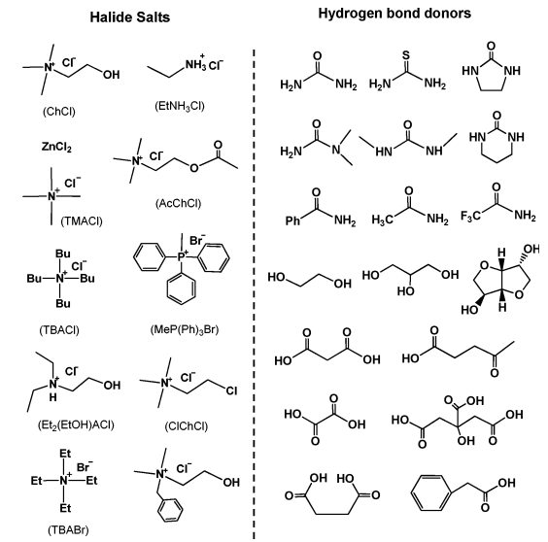
Scheme 1: Typical structures of the halide salts and hydrogen bond donors used for DES syntheses
In 2007, Abbott and co-workers defined DESs using the general formula R₁ R₂ R₃ R₄ N⁺ X – Y^{-[12]}.
Type1: DES Y=MCl_{x}, M=Zn, Sn, Fe, Al, Ga,
Type2: DES Y=MCl_{x}. _{y}H₂O, M=Cr, Co, Cu, Ni, Fe
Type3: DESY= RZwith Z=-CONH₂, -COOH, -OH
Note that the same group also defined a fourth type of DES which is composed of metal chlorides (e.g, ZnCl₂ mixed with different HBDs such as urea, ethylene glycol, acetamide or hexanediol (type IV DES).

Due to its low cost, biodegradability and low toxicity, ChCl was broadly used as an organic salt to fabricate eutectic mixtures commonly with inexpensive and harmless HBDs such as urea, glycerol, carbohydrate-derived polyols or renewably sourced carboxylic acids. These DESs are smart since they exhibit similar physico-chemical properties to usual imidazoliumbased ILs and thus can beneficially replace them in many applications.
As compared to traditional organic solvents, DESs are not considered as volatile organic solvents and not flammable, making their storage convenient. From the vision of green chemistry, these DESs are even more attractive since some of them have been proven to be biodegradable and compatible with enzymes further increasing their interest. Additionally, synthesis of DESs is 100 % atom economic, easy to handle and no purification is required, thus making their large-scale use reasonable.

1.2. Properties of Deep Eutectic Solvents
DESs are chemically tailorable solvents since they can be planned by properly combining various quaternary ammonium salts (e.g. ChCl) with different hydrogen bond donors (HBD). Hence, task-specific DESs with different physicochemical properties such as freezing point, viscosity, conductivity, and pH, among others, can be prepared. Due to their promising applications, many efforts have been committed to the physicochemical characterization of DESs.
1.2.1 Freezing point (T_{f})
As we know DESs are produced by mixing two solids capable of generating a new liquid phase by self-association via hydrogen bonds. This new phase is usually characterized by a lower freezing point than that of individual components. For example, when ChCl and urea are mixed together in a molar ratio 1:2, the freezing point of the eutectic is 12°C, which is significantly lower that of ChCl and urea (melting point of ChCl and urea are 302 and 133°C, respectively). The considerable depression of the freezing point stems from an interaction between the halide anion and the hydrogen bond donor component, here urea. For all reported DESs, their freezing points are below 150°C. In general, DESs with a freezing point lower than50°C are more attractive since they can be used as cheap and safe solvents in many fields.
1.2.2. Density
The density is one of the most essential physical properties for solvents. In general densities of DESs are measured by means of a specific gravity meter. Most of DESs show higher densities than water. For instance, type IV ZnCl₂-HBD eutectic mixtures have densities high than 1.3 g cm⁻³. Among them, density of ZnCl₂-urea (1:3.5) and ZnCl₂-acetamide (1:4) were reported as 1.63 and 1.36 g cm⁻³, respectively. This remarkable difference of density might be attributed to a different molecular organization or packing of the DES. Note that densities of the both DESs are higher than those of pure HBDs (acetamide: 1.16 and urea: 1.32 g cm⁻³). This phenomenon may be explained by the hole theory. Similar to imidazolium-based ILs, DESs are composed of holes or empty vacancies. When ZnCl₂ was mixed with urea for instance, the average hole radius was decreases, resulting in a slight increase of the DES density as compared to that of pure urea^{[12]}.
1.2.3 Viscosity
Similar to most of the ILs, viscosity of DESs is an important issue that needs to be concerned. Except for Glucose Malonic Acid eutectic mixture, most of the DESs exhibit relatively high viscosities (˃100cP) at room temperature. The high viscosity of DESs is often recognized to the presence of an extensive hydrogen bond network between each component, which results in a lower mobility of free species within the DES. The large ion size and very small void volume of most DESs but also other forces such as electrostatic or vander Waals interaction may contribute to the high viscosity of DES.
Owing to their potential applications as green media, the development of DESs with low viscosities is highly desirable. In general, viscosities of eutectic mixtures are mainly affected by the chemical nature of the DES components (type of the ammonium salts and HBDs, organic salt/HBD molar ratio, etc.), the temperature, and the water content. As discussed above, viscosity of DES is also dependent on the free volume. Hence, the hole theory can also be used to design DESs with low viscosities. For instance, use of small cations or fluorinated hydrogen-bond donars can lead to the formation of DES with low viscosity ^{[13]}.

1.2.4 Polarity
Generally, Polarity of a solvent can be evaluated by its polarity scale, E_{T}(30), which is the electronic transition energy of a probe dye (e.g. Reichardt’s Dye 30, E_{T}(30) in a solvent. By means UV-Vis technology and using Reichardt’s Dye 30, E_{T}(30) can be calculated using the following equation.
E_{T}(30)( kcal mol⁻¹) = h_{CU}maxN_{A}= (2.8591×10⁻³) U_{max}(cm⁻¹) = 28591/ λ_{max}
1.2.5 Ionic conductivity
Due to their relatively high viscosities, most of DESs exhibit poor ionic conductivities (lower than 2 mS cm⁻¹ at room temperature). Conductivities of DESs generally increase considerably as the temperature increases due to a decrease of the DES viscosity. Hence, Arrehenius-like equation can also be used to predict the conductivity behavior of a DES. Taking into account that changes of the organic salt/HBD molar ratio considerably impact the viscosities of DES, it is clear that this parameter also dramatically influences the conductivities of DESs ^{[14]}. The conductivity of DES increases with increasing the ChCl content ^{[15]}. When the molar fraction of ChCl is increased to 25 mol %, the conductivity of the ChCl-glycerol DES is 0.85 mS cm⁻¹. At higher salt concentrations, these ChCl / glycerol-based DESs exhibit a viscosity of (< 400 cP) and conductivity of (>1 mS cm⁻¹) comparable to those of an IL.
1.2.6 Acidity or Alkalinity
The Hammett function has been widely used to evaluate the acidity and basicity of non-aqueous solvents by determining the ionization ratio of indicators in a system. For a basic solution, the Hammett function measures the tendency of the solution to capture protons. When weak acids are chosen as indicators, the Hammett function H_ is defined by the following equation.
H_ = pK(HI)+log([I⁻]/[HI])
Where pK (HI) is the thermodynamic ionization constant of the indicator in water, [I⁻] and [HI] represent the molar concentrations of anionic and neutral forms of the indicator, respectively. A medium with large H_ value strong basicity. When 4-nitrobenzylcyanide was used as indicator, the H_ value of the ChCl/urea (1:2) DES was 10.86, suggesting that this DES is weakly basic ^{[16]}. Note that when the system contains 1-3wt% of water, the H_ values decreases slightly (from 10.77 to 10.65) due to a partial solvation of basic sites.

1.2.7 Surface tension
Up to now, studies to the surface tension of DESs have been very scarce. Abbott et al. reported some data about the surface tension of ChCl-based and ZnCl₂-based DESs. Surface tensions of ChCl/malonic acid [1:1] and ChCl/phenylacetic acid [1:2] DESs were about 65 .68 and 41.86 mN m⁻¹, respectively ^{[14]}. Additionally, surface tensions of ChCl-ethylene glycol (1:3), ChCl-glycerol (1:3) and ChCl-1, 4-butanediol (1:3) eutectic mixtures were 45.4, 0.8, and 47.6 mN m⁻¹ at 20°C respectively. Surface tension of ZnCl₂/urea (1:3.5) DES was 72mN m⁻¹while the ZnCl₂/acetamide (1:4) DES has a smaller surface tension (53mNm⁻¹25°C). The ZnCl₂/ethylene glycol (1:4) and ZnCl₂/1, 6 hexanediol (1:3) DESs have a surface tension of 56.9 and 49mN m⁻¹ at 25°C respectively. All these values were than the surface tensions of most of molecular solvents and comparable to those of imidizolium-based ILs and high temperature molten salts, e.g. 1- butyl- 3- methylimidizoliumtetrafluroborate ([BMIM] BF₄, 38.4 mN m⁻¹ at 63°C) and KBr (77.3mNm⁻¹ at 900°C).
Surface tension is also expected to follow a similar trend to viscosity since it strictly depends on the strength of intermolecular interaction that governs the formations of DESs. In particular, the surface tensions of various ChCl/glycerol DESs showed a linear correlation with temperature ^{[17]}. Additionally, surface tension of the ChCl/glycerol DES decreases as the ChCl concentration increases, supporting that addition of ChCl to glycerol disrupts the extensive hydrogen bond network of glycerol.

1.3 Applications of DES
1.3.1 Hydrophilic DES and Applications.
Some of the underexplored fields of DES include biomass processing and liquid–liquid extractions or extractive distillation ^{[17a]}.NADES were introduced when cellular constituents like fructose, glucose, citric acid, proline, and other metabolites formed a viscous liquid at defined molar ratios ^{[17b]}.looked into the evolution of NADES from ionic liquids and DES, and further expanded on the applications of NADES in pharmaceuticals, cosmetics, food, and agricultural settings. NADES can be used as solubilization agents for macromolecules and as media for enzymatic reactions ^{[17c]}.Developmental research is currently ongoing to develop THE DES which will be effective for drug delivery. Compared to water, choline chloride-urea and choline chloride-malonic acid DES improved their solubility with benzoic acid, danazol, griseofulvin, AMG517, and itraconazole by 5 to 22,000 folds ^{[17d]}.This notable feature of DES makes them promising for pharmaceutical applications and in drug delivery. In view of this, developing HDES is eminent not only for liquid–liquid extraction but also as vehicles for drug solubilization.

1.3.2 Challenges, Opportunities, and Perspectives
Despite the numerous advantages of HDES in extraction, some of the notable limitations of these solvents are high viscosity, cloudiness, and difficulty in phase separation during liquid–liquid extraction ^{[17e]}. Since the viscosity of DES depends on the hydrogen bond strength of the solvent, understanding the charge transfer and the molecular interaction between HBD and HBA occurring in HDES is an invaluable opportunity for future research. An investigation into HDES polarity by using solvatochromic molecular probes to measure hydrogen bonding acidity, hydrogen bonding basicity, and dipolarity/polarizability should also be encouraged to curtail phase separation problems. Due to the ever-increasing applications of HDES, in silico models for predicting extraction efficiencies would be vital for future applications.Although HDES are considered as ‘green’ solvents, little has been done to monitor their toxicity, vapor pressure, or bioavailability. Moreover, since the hydrophobicity of HDES is relative, the distinction between hydrophilic and hydrophobic DES is sometimes confusing and hence a comprehensive guideline for calling DES hydrophobic should be established.
1.3.3 Preparation of Materials in DES
Conventional preparation of inorganic materials often takes place in water or organic solvents using in many cases the thermal step for crystallization and structure formation. The “solvothermal synthesis” then consists in growing single crystals from a non-aqueous solution, by thermal treatment under pressure. Recently, the ionothermal synthesis, a new synthetic strategy involving predominantly ILs or deep eutectic solvents (DESs) as solvent, has been developed. In these syntheses, ILs or DESs can be used as both solvent and template (also called structure-directing agents). In solvothermal reactions where solvents are predominantly volatile molecules, the high temperature required for crystallization or pore structure formation needs the use of autoclaves. Contrarily, ionothermal synthesis can be readily conducted in a low-pressure environment (e.g, under ambient pressure) due to the low volatility of ILs or DESs. The use of such solvents there by reduces all security risks arising from the use of low boiling point solvents and simplifies the syntheses process. More importantly, the possibility to tune the ionic nature of DESs provides modulating reaction environments under which novel materials with useful structures (surface properties and porosity) may be produced.
Nowadays, the ionothermal synthesis is gaining considerable attention. In this context, a newly emerging trend of this field consists in the replacement of ILs by cheap and safe DESs. For example, DESs based on ChCl/urea or ChCl/renewable carboxylic acids have been used as an alternative medium to ILs in the ionothermal strategy. As mentioned above, compared to ILs, DESs have notable advantages including low toxicity, biodegradability and low cost. Additionally, the presence of neutral components with high boiling point such as urea, carbohydrates or carboxylic acids also provide new and complementary environments to ILs that are completely ionic. In addition, DESs can play multiple roles during synthesis, including the classical role of solvent, templating agent, reactant, etc. Thanks to these [properties, DESs are now receiving considerable attentions for the ionothermalsysnthesis of materials and the design of novel structures.
Till now several inorganic materials with appreciated properties and structures, including zeolite-type materials, metal–organic frameworks (MOFs), metal oxides, nano-materials, carbon materials, etc., have been produced using the ionothermal synthesis strategy. Even though a few reviews converging on the preparation of inorganic materials using ILs were found in the recent literature ^{[18 - 21]} a complete review related to the use of DESs in the ionothermal synthesis of promising materials for various applications including gas separation, hydrogen storage, catalysis, versatile role played by DESs during the material synthesis were given by Qinghua Zhang et al ^{[7]}.
1.3.4 Glucose Based DES
A novel natural deep eutectic solvent of Choline chloride with sugars such as glucose, fructose and sucrose were prepared by Young Hae Choi et al ^{[22]}. A novel fructose-based DES of choline chloride (2-hydroxyethyl-trimethylammonium) has been synthesized at different molar ratios by AdeebHayyan et al ^{[23]}. The physical properties such as density, viscosity, surface tension, refractive index and pH were measured and analyzed as function of various temperatures (25–85 °C).
The analysis of these physical properties revealed that these new DESs have the potential to be utilized for possible industrial applications involving processing and separation of food constituents. The suggested DESs have many desirable characteristics, e.g. they have low vapor pressure, inflammable, biodegradable, and made from renewable resources. The use of these DESs will positively affect the environment and make use of available renewable resources.

1.4 Reducing agent in the Preparation of Metal / Metal Oxide /
Metal Sulphide Nano Particles
Sodium borohydride is acting as a reducing agent, which is useful in organic chemistry for reducing the aldehydes and ketones to the corresponding alcohols. This compound is also used as a reducing agent in the preparation of metal / metal oxide /metal sulphide nano particles. Copper nano particles were prepared by chemical reduction method using NaBH₄ as reducing agent by Hina Khalid et al ^{[24]}.
Min-Joo Kim et al ^{[25]} prepared Au-Ag and Au-Cu alloy nanoparticles in CHCl₃ using NaBH₄ as the reducing agent. In the preparation of iron, platinum, cadmium, palladium, silver, copper, nickel and gold nano particles in water in oil microemulsions by I. Capek ^{[26]} hydroxyl amine, hydrazine and sodium borohydride were used as reducing agents. NaBH₄ was used as reducing agent by Md. Abdulla-Al-Mamun et al et al ^{[27]} for the synthesis of Cu nano particles in mixed solvent of water and acetonitrile.
1.4.1 Z n / Zn Sulphide Nanoparticles
Metal oxide nanoparticles have a significantly big portion in nano-science applications, especially in sensors. Among oxide forms of transition metals, manganese has many different oxide states, namely; ZnO and ZnS. Alpha manganese sesquioxide is a cubic, and considered as the most popular transition metal oxide ^{[28]}. Some studies reported that mesoporous ZnO particularly exhibits higher catalytic performance and lithium storage properties compared to the corresponding bulk ZnO due to its high surface area as well as the number of active sites ^{[29-31]}. Moreover, non-toxic manganese oxide nanoparticles have a wide range of
applications such as an oxygen storage component (OSC) for a 3-way catalyst systems ^{[32]},
catalyst for removing carbon monoxide and nitrogen oxide from waste gases ^{[33]}, high density magnetic storage media ^{[34]}, molecular adsorption ^{[35]}, ion exchange ^{[36l]}, electrochemical supercapacitor ^{[37]}, biosensors ^{[38]} and as an adsorbent in water treatment ^{[39]}. Manganese oxide nanoparticle can be producible via thermal decomposition ^{[40,41]}, thermochemical ^{[42]}, hydrothermal ^{[43]}, arc evaporation ^{[44]} techniques.

2. AIM AND SCOPE OF THE WORK
In this work, a deep eutectic solvent between Glucose and Malonic acid was prepared and this solvent had been used for the preparation of Mn or MnO oxide nanoparticles. Young Hae Choi et al ^{[22]} prepared the DES of ChCl with Fructose and water in the ratio of 1:1:1 called as “natural deep eutectic solvents” (NADES). These NADES may play a role in all kinds of cellular processes, explaining mechanisms and phenomena that are otherwise difficult to understand, such as the biosynthesis of small molecules and macromolecules, which are soluble other than water.
The physical properties of ChCl and Fructose were measured by Y. Dai et al ^{[45]}. They measured the density, viscosity, decomposition temperature (T_{decomp}) and glass transition temperature (Tg) of 2:5:5 Frucose-ChCl-Water as 1.2075 g cm⁻³, 280.8 mm² s⁻¹, 160 ºC and - 84.58 ºC respectively. Thermophysical properties and rice straw dissolution using DES based on fructose and other carbohydrates were studied by C. Florindo et al ^{[46]}.
Deep eutectic solvents (DESs) have recently received a great interest in diverse fields including nanotechnology due to their unique properties as new green solvents, efficient dispersants and as large-scale media for chemical and electrochemical synthesis of advanced functional nanomaterials. DESs have also an active role in improving the size and morphology of nanomaterials during synthesis stage. Moreover, DESs confined in nano-size pores or tubes show distinct behavior from those in the same types but in
larger scales. Therefore, a numerous study sprung up to expose the importance of the synergy between DESs and nanomaterials.
The first combination of nanotechnology and ILs was published in 2001 ^{[47]}, however, the one related to DES was reported as late as 2008 introducing the use of the DES a solvent for the chemical synthesizing of gold nanoparticles. The DES of ChCl – Urea was found to be play a role of nanostructure sensor ^{[48]}, media for nanoparticle production ^{[49,50]}, electrolyte for nanoparticle deposition ^{[51 - 61]}, media for chemical synthesis of nanoparticles, etc^{[62 – 75]}.
Thus, the up-to-date review of studies employing DESs in diverse nanotechnology areas revealed their unique properties of DESs offer them some advantages over the ILs. DESs have been used as dispersants, exfoliating agents and templates for nanomaterials. Their application as media to synthesize nanoparticles chemically, physically, physicochemically or electrochemically resembles those for ILs. The positive features of DES over ILs such as their easy preparation and being much eco-friendlier. DESs like ILs can be obtained in nano-size with many fascinating features, but these investigations are still inadequate compared to ILs that have great utilization in the field of nano-environment.
Due to these reasons studied from the literatures we tried to explore the utility of DES in the preparation of metal / metal oxide nanoparticles. In this present study we prepared MnO nanoparticles using the DESs of Glucoseand Malonic acid in presence of sodium borohydride and hydrazine hydrate mixture as the reduce.

3. EXPERIMENTAL METHODS
MATERIALS
Commercially available reagent grade chemicals Glucose (GLU), Malonic Acid (MA), Zinc (II) Chloride Sodium borohydride and hydrazine hydratewere purchased from E.Merck and used as received without further purification for these preparations. The details of materials used in this study are given in table 1. The water used was purified through a Milliporesystem.
Components | Molecular Formula | Molar Mass g/mol | Melting  Point ºC | Structure
Glucose | C₆H₁₂O₆ | 180.156 | 146 | 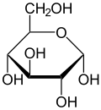
Malonic Acid | C₃H₄O₄ | 104.061 | 135 - 137 | 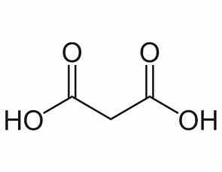
Zinc Chloride |  | 136.29 | 290 anhydrous | cl----Zn-----cl
Sodium Borohydride | NaBH₄ | 37.83 |  | 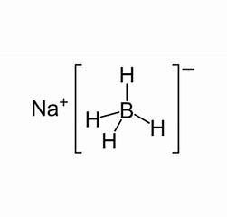
Hydrazine Hydrate | N₂H₄.H₂O | 50.061 | -52 | 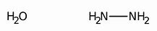

Table 1: Chemicals Used for this study

3.1. Preparation of Glucose – Malonic Acid based DES
A deep eutectic solvent using glucose and malonic acid was prepared by taking in the mole ratio of 1:1 by evaporation methods ^{[76]}. In this method 18 g of glucose and 10.4 g of malonic acid were dissolved in 20 ml of deionized water to form a clear liquid. Then excess of water was evaporated off from this homogenous liquid by gentle heating and the mixture was weighed from time to time until a constant weight was obtained. Then the clear liquid obtained was kept in a dessicator containing anhydrous CaCl₂ for 14 days. As no turbidity or precipitate was seen in the liquid, the deep eutectic solvent formed between glucose and malonic acid was tested for its pH, conductivity, density, viscosity.

3.2. Physical Characterization of DES
The conductivity of the DES was measured using Systronics Conductivity Meter 304 at room temperature. The density of the DES was measured at room temperature using a standard Pycno meter. The viscosity of the DES was measured using digital display rotational viscometer, ofLabman WENSAR make model LMDV 60 by following the standard procedure at room temperature. The pH of this ChCl-U, DES was measured using digital pH meter of ELICO make model no LI120 using the combined electrode CL-51B. These physical parameters of GLU-MA, DES were compared with the literature values.
3.3. Preparation of Zn S Nanoparticles
The Zinc Sulphide (ZnS) colloidal nanoparticles were synthesized by reduction method using NaBH₄ and N₂H₄ mixture under atmospheric conditions.The ZnS nanoparticles were synthesized using ZnCl₂, sodium borohydride and hydrazine hydrate in a molar ratio of 6:1:1 using the deep eutectic solvent obtained from glucose and malonic acid.
About 25 mg of ZnCl₂ was dissolved in 10 ml of GLU-MA, DES in a 100 ml of closed beaker. Undervigorous stirring using a magnetic stirrer with hot plate, freshly taken sodium borohydride (6.3 mg) was addedlittle by little into the reaction medium. Then the stirring was continued after the addition of hydrazine hydrate (10 mg) at the temperature of about 70 ºC until the color was changed from pink to black. After the reduction was completed, the solution wascentrifuged and the black colored particles were separated by washing withmethanol and dried in a vacuum.

3.4. Characterization of Zinc Sulphide Nanoparticles
The solubility of the dried ZnS particles were tested in various organic solvents. The UV-Visible spectrum of ZnS NPs were obtained using a double beam spectrophotometer. The FTIR spectrum of the Copper (II) Oxide nanoparticles were recorded using a Shimadzu FTIR-8900 spectrometer. The field emission scanning electron microscope image (SEM) and energy dispersive X-ray analysis (EDAX) were carried out for the ZnS NPs obtained. These data obtained in this study were compared with the data available in the literature for ZnS nanoparticles

4. RESULTS AND DISCUSSIONS

4.1. Physical Properties of Glucose – Malonic Acid DES
The deep eutectic solvent of Glucose and Malonic acid obtained by the evaporation method was examined for its physical properties such as freezing point, conductivity, density, viscosity and pH at room temperature.

4.1.1 Freezing Point
The GLU-MA DES was cooled in a freezing mixture to note its freezing point. The DES exists as a clear liquid until 10 ºC and below this temperature a turbidity was formed.

4.1.2 Conductivity
The literature survey indicates values of electrical conductivities for DES and common ionic liquids in the range of 0.1 - 14 mS cm⁻¹. The electrical conductivity of the DES of GLU- MA obtained here was found to be 0.154 mS cm⁻¹ at 25 ºC.

4.1.3 Density
Density is an important characteristic property of any liquid. Very limited information is known about the densities of ionic liquids and DES. The density of the DES of GLU-MA obtained by us was measured to be 1.1915 g cm⁻³ at 25 ºC.

4.1.4 Viscosity
The viscosity is a parameter influencing the hydrodynamic processes in all applications of ionic liquids for instance in electrolysis cells. Some aspects of transport phenomena in pure molten salts and ionic liquids are simpler than similar phenomena in aqueous solutions. Unfortunately, there are very few data on the viscosity of ionic liquids and DES. The viscosity of the DES obtained from Glucose and Malonic acid was measured to be as 5084.13 mPa. s at 25 ºC.

4.1.5 The pH
Further the pH values of GLU-MA DES obtained by us was measured to be 1.63 at 25 ºC.
The table 2 give the values of freezing point, conductivity, density, viscosity and pH values of 1:1 DES of GLU-MA prepared by us.

Physical Parameters | Measured Values  1:1 DES of GLU-MA
Freezing Point (oC) | ~ 10
Conductivity (mS cm-1) | 0.154
Density (g cm-3) | 1.1915
Viscosity (mPa. S) | 5084.13
pH | 1.63

Table 2: Physical Parameters of GLU-MA DES
  - Characterization of MnO Nanoparticles

4.2.1 The Solubility of ZnS Nanoparticles
The solubility of nanoparticles of Zinc Sulphide prepared by greener method using the deep eutectic solvent of Glucose and Malonic acid was tested in various organic solvents such as water, ethanol, chloroform and dimethyl sulfoxide. The samples are only soluble in chloroform and insoluble in the other solvents given above.

4.2.2 UV-Visible Spectrum of ZnS Nanoparticles
The UV-Visible spectrum of Zinc Sulphide nanoparticles is provided in Figure 1.
The UV–vis spectroscopy of ZnS NPs (Fig. 1) shows the absorption maximum (λmax) at 269 and 296 nm. This is due to n→π* and π→π* transitions ^{[77]}. The absorption bands seen at different places reveal that the MnO nanoparticles were formed with different morphologies with various sizes. The λmax at this wavelength indicates the formation of ZnS NPs.
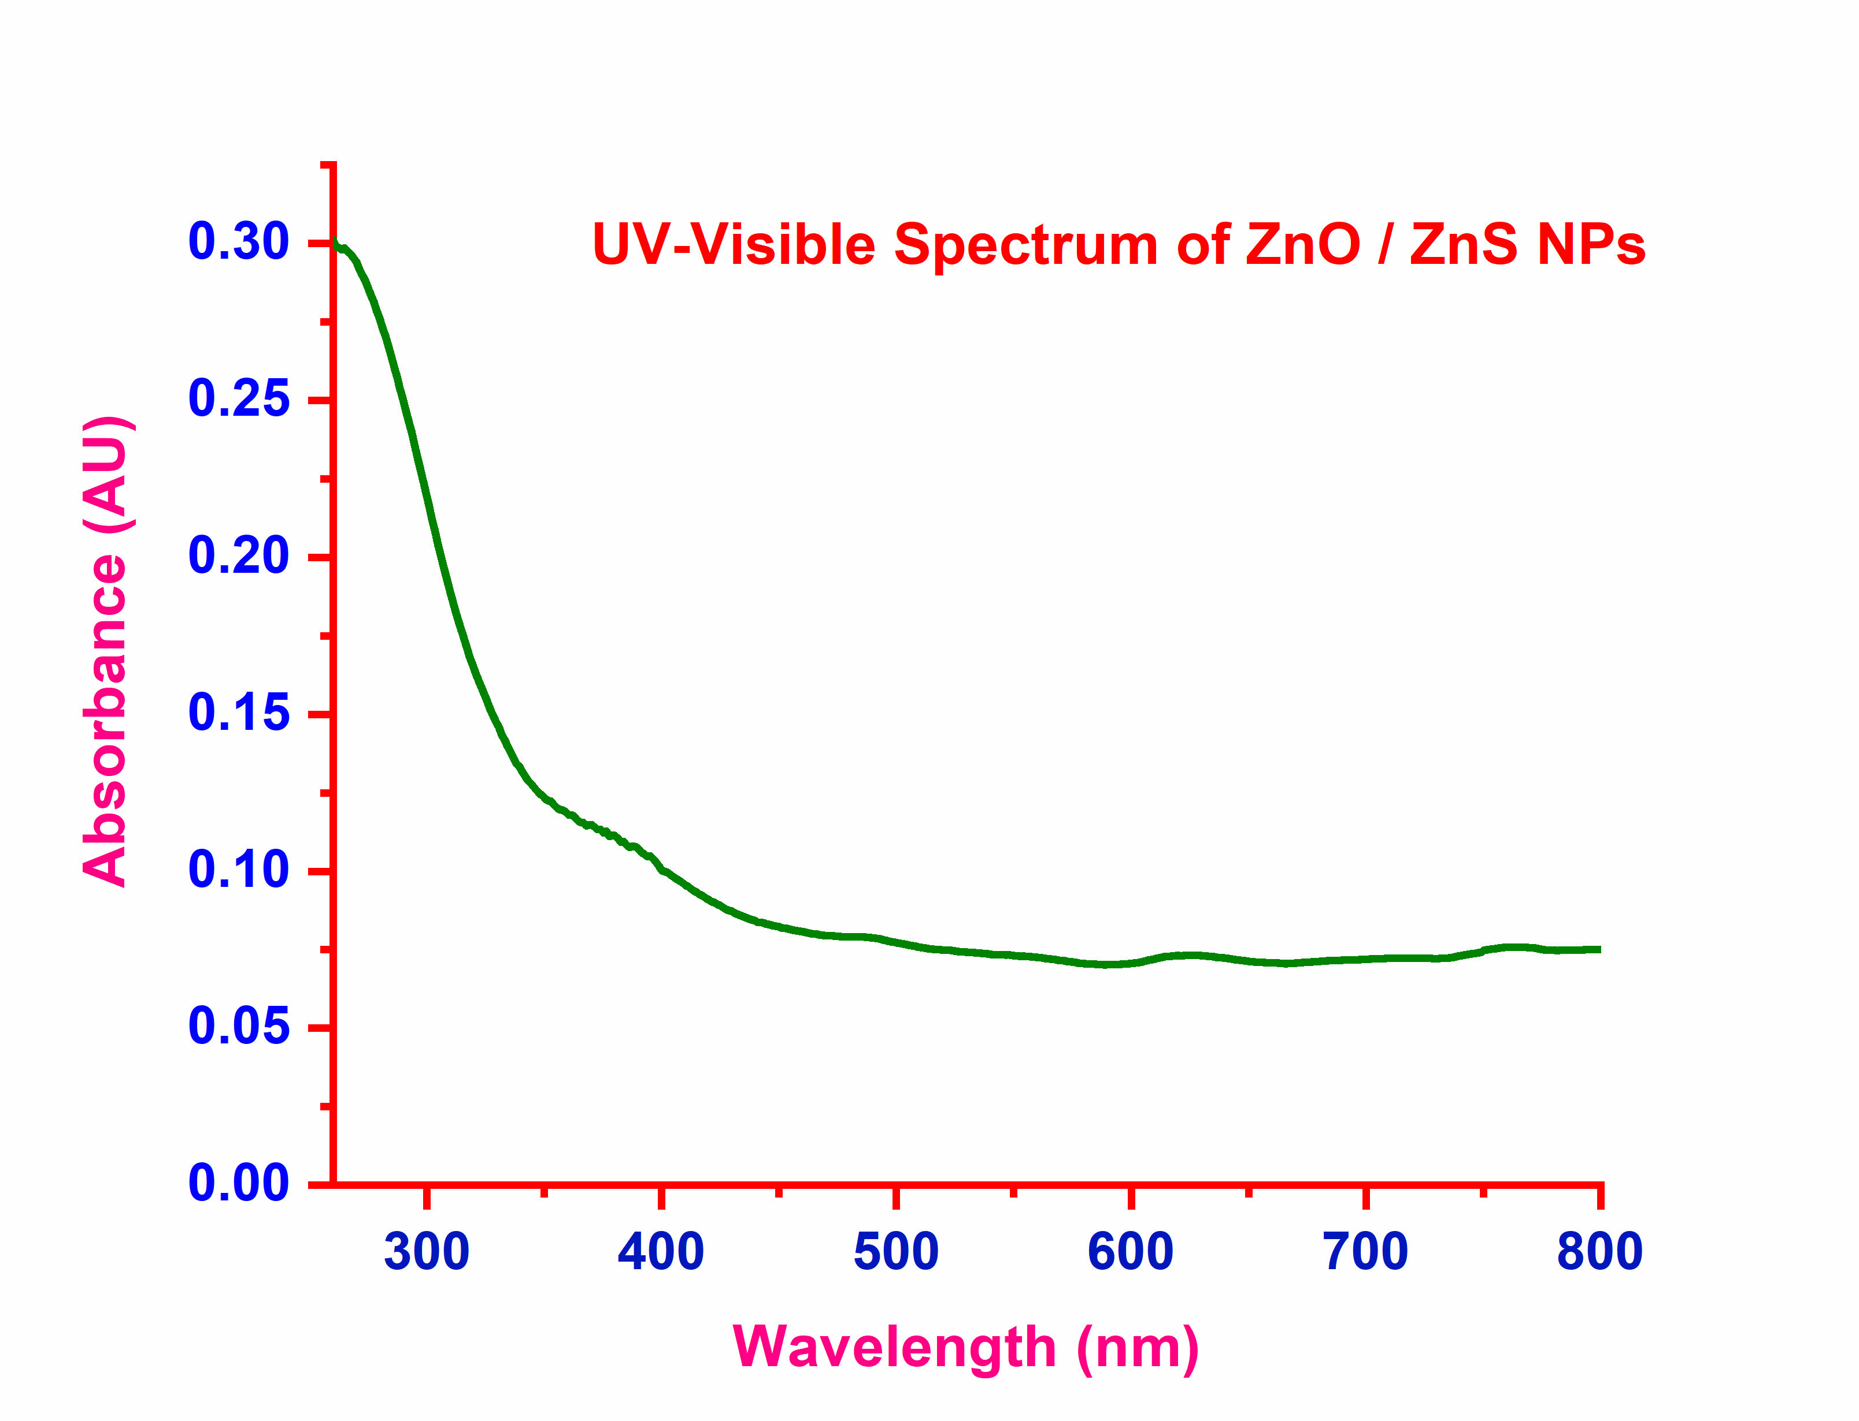
Figure 1. The UV-Visible Spectrum of MnO NPs obtained in GLU-MA DES
4.2.3 FTIR Spectrum of ZnS Nanoparticles
The FTIR spectrum obtained for ZnS nanoparticles was given in Figure 2. FTIR spectroscopy is a convenient tool to know the functionality of any organic molecule. In the present work, we used FTIR spectra to identify whether there are any peaks due to the carbonyl,hydroxyl, aliphatic CH, and CH2 groups of both glucose and malonic acid in the final nanoparticles of MnO, which would confirm the surface capping on the manganese (II) oxide nanoparticles as capping of Cu nanoparticles reported by A. B. S. Sastry et al.
drogen Energy 39 (2014) 10892–10901.
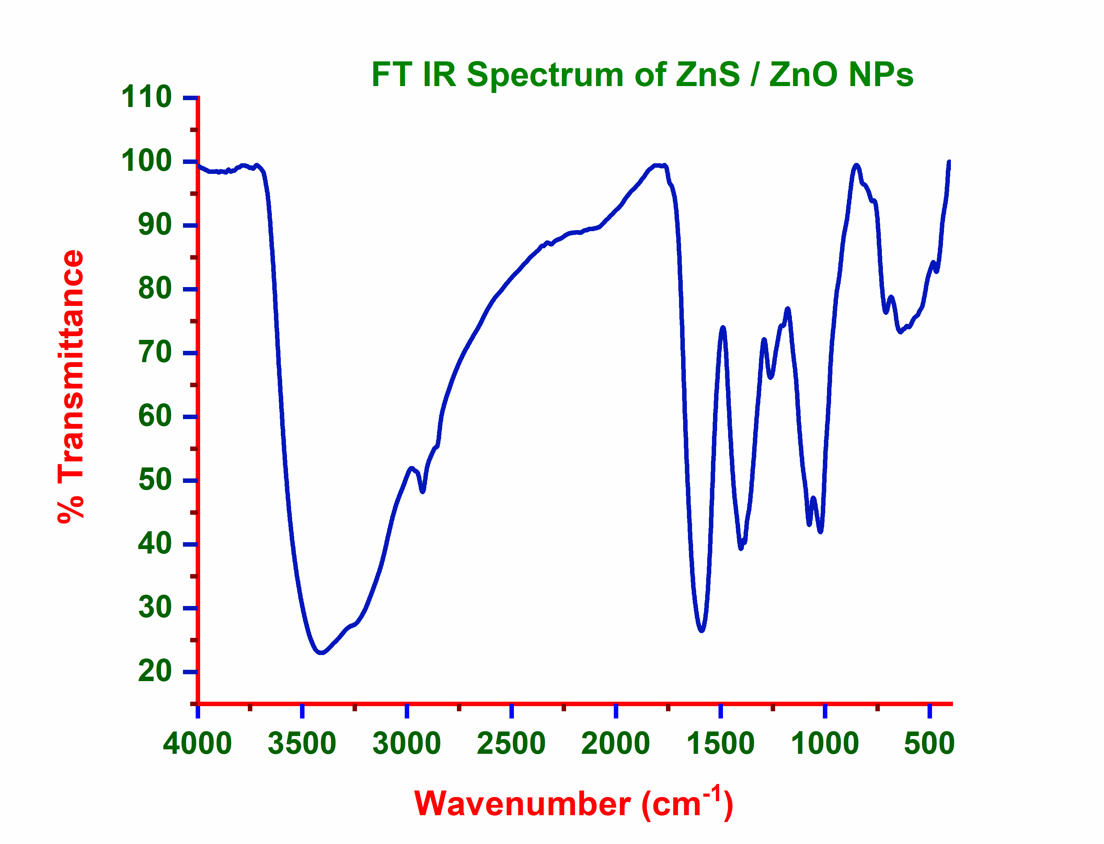
Figure 2. The FTIR Spectrum of ZnS NPs obtained in GLU-MA DES
The FTIR spectrum given in Figure 2 shows several bands between 722.41 and 539.59 cm⁻¹, which can be assigned to the vibrations of M⁺ - O bonds. The sharp peak observed at 722.41 cm⁻¹ in the spectrum MnO nanoparticles is the characteristics of Zn-S bond formation. Usually ZnS shows a strong IR band at ~ 1500 cm⁻¹ according to George Socrates. In agreement with this a strong band noticed at 922.41 cm⁻¹ of figure 2 confirmed the formation of ZnS particles during the reduction of ZnCl₂ using NaBH₄ and N₂H₄ mixture as reducing agent in the DES medium of Glucose and Malonic Acid.
For the ZnS NPs prepared using ZnCl₂ in presence of NaBH₄ and N₂H₄ as reducing agent in the DES medium of Glucose and Malonic acid, the FTIR spectrum obtained do not show any strong and sharp peak due to the C=O stretching frequency of glucose molecule. Hence it is concluded that glucose did not act as a capping agent with ZnS nanoparticles. The weak peaks noticed around 690 cm⁻¹ indicates O – H out of plane bending vibrations of malonic acid. The peak at 970.18 cm⁻¹ reveals the C – C rocking vibrations of malonic acid. The sharp peak at 1080.43 cm⁻¹ and 1177.59 can be assigned to the C – O stretching of malonic acid. Further the peaks observed at 1283.88, 1383.54 and 1446.87 cm⁻¹ indicate various C – H deformations of CH₂ group of malonic acid.
The weak bands seen at 2217.66 and 2541.62 cm⁻¹ can be assigned to O – H stretching of Carboxylic groups of malonic acid. The weak peak at 2918.94 cm⁻¹ can be assigned to the C – H stretching vibrations of aliphatic CH₂ group of malonic acid. The H bonded O – H group of malonic acid with ZnS is confirmed by the broad peak at 3506.39 cm⁻¹. These data are in good agreement with Donald L. Pavia et al ^{[80,} ^{81]}. Thus, it is evident that malonic aicd is acting as a capping agent with ZnS nanoparticles.

4.2.4 FESEM of ZnS Nanoparticles

The field emission scanning electron microscope image of ZMnS nanoparticles prepared by the chemical reduction method using NaBH₄ and N₂H₄ mixture as the reducing agent in the deep eutectic solvent of glucose and malonic acid is given in Figure 3.

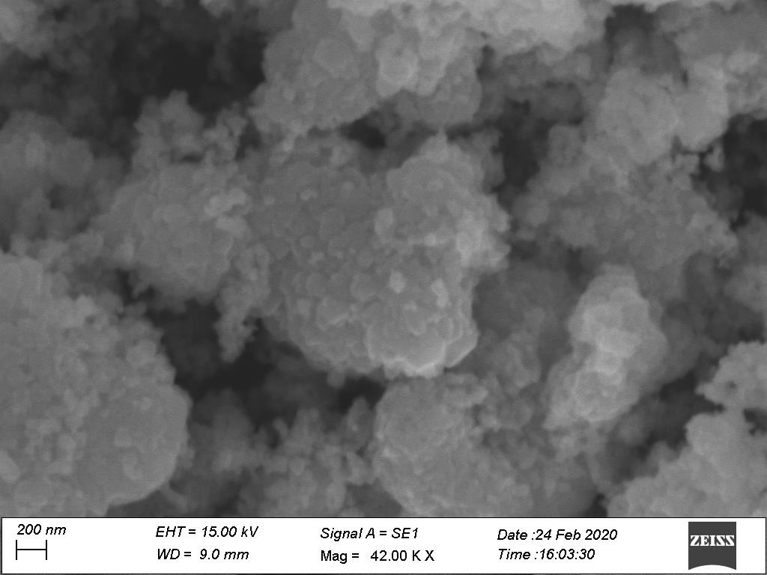

Figure 3. The FESEM of ZnS NPs obtained in GLU-MA DES
The morphological SEM examinations of synthesized ZnS powders reveal that ZnS particles generated from the GLU-MA DES were composed of a large number of uniform scales like particles. The discrete pseudo-particles are clearly visible in the nano scale level, which provides the enough evidence for the formation of ZnS nanoparticles.

4.2.5 EDAX Analysis of ZnS Nanoparticles
The presence of Mn in the prepared samples is confirmed from the selective area EDAX analysis. The weight percent and atom percent of Oxygen and Manganese are given in table 3 below. From this table it was clearly showed that only Oxygen and Manganese are present in the particles prepared from GLU-MA DES.

Element  Line | Weight % | Weight %  Error | Atom %
S K | 60.00 | ± 2.14 | 83.74
Zn K | 40.00 | ± 2.48 | 16.26
Zn L | --- | --- | ---
Total | 100.00 |  | 100.00

Table 3. The element details of EDAX analysis of ZnS Nanoparticles

SUMMARY AND CONCLUSION

A deep eutectic solvent of glucose and malonic acid was prepared by evaporation method. Its freezing point was found to be 10 ºC, which is lower than that of 146 and 135 ºC of glucose and malonic acid respectively. The liquid was clear at room temperature for more than fourteen days. The density, viscosity, conductivity and pH of the DES was measured and the values obtained are comparable with the values reported in the literature.
The GLU-MA DES was used a solvent in the preparation of ZnS nanoparticle by using NaBH4 and N2H4 mixture as reducing agent. The UV-Visible and FTIR spectra were recorded for these particles. Both the UV-Vis and IR data were compared with the various literature values. From this analysis of FTIR data, we expected that ZnS nanoparticles are formed and the malonic was acted as a capping agent during the formation of nanoparticles. The field emission SEM analysis carried out to know the morphology of ZnS nanoparticles showed that uniform sized particles are obtained in the nano scale.

In addition to this, the energy dispersive X-ray analysis of nano particles prepared showed only manganese and oxygen elements are present in it. Therefore, Zn particles are obtained within the nano scale in this DES of glucose and malonic acid. Further analysis of X-ray diffraction studies and Transmission Electron Micrograph are to be carried out to know the particle size accurately for the sample prepared.

[17e]. Van Osch, D.J.; Zubeir, L.F.; van den Bruinhorst, A.; Rocha, M.A.; Kroon, M.C. Green Chem. 2015, 17, 4518–4521.
[18]. D. Freudenmann, S. Wolf, M. Wolff and C. Feldmann, Angew. Chem., Int. Ed., 2011, 50, 11050–11060;
[19]. Z. Ma, J. Yu and S. Dai, Adv. Mater., 2010, 22, 261–285.
[20]. E. R. Parnham and R. E. Morris, Acc. Chem. Res., 2007, 40, 1005–1013
[21]. R. E. Morris, Chem. Commun., 2009, 2990–2998 A. Taubert, Acta Chim. Slov., 2005, 52, 183–186.
[22]. Young Hae Choi, Jaap van Spronsen, Yuntao Dai, Marianne Verberne, Frank Hollmann, Isabel W.C.E. Arends, Geert-Jan Witkamp, and Robert Verpoorte, Plant Physiol. Vol. 156, 2011, 1701-1705.
[23]. Adeeb Hayyan, Farouq S.Mjalli, Inas M.AlNashef, TalalAl-Wahaibi, Yahya M.Al-Wahaibi, Mohd AliHashim, Thermochimica Acta, 541, 10 August 2012, Pages 70-75.
[24]. Hina Khalid, S. Shamaila, N. Zafar, Sci.Int.(Lahore),27(4), 3085-3088, 2015.
[25]. Min-Joo Kim, Heay-Jin Na, Kyoung Chul Lee, Eun Ah Yoob and Minyung Lee, J. Mater. Chem., 2003, 13, 1789–1792.
[26]. I. Capek, Advances in Colloid and Interface Science 110 (2004) 49–74.
[27]. Md. Abdulla-Al-Mamun, Yoshihumi Kusumoto, Manickavachagam Muruganandham, Materials Letters 63 (2009) 2007–2009.
[28]. K. Byrappa T. Adschiri , 2007. Hydrothermal technology for nanotechnology Volume 53, Issue 2, June, Pages 117–166.
[29]. Y. Ren, Z. Ma, L. Qian, S. Dai, H. He, P.G. Bruce, 2009. Catalysis Letters 131 146–154.
[30]. J.N. Park, J.K. Shon, M. Jin, S.H. Hwang, G.O. Park, J.-H. Boo, T.H. Han, J.M. Kim, 2010. Chemistry Letters 39 493–495.
[31]. Hu, L. et al., 2013. Journal of Alloys and Compounds, 576, pp.86–92.
[32]. Salavati-Niasari, M., Esmaeili-Zare, M. & Gholami-Daghian, M., 2014. Advanced Powder Technology, pp.3–8.
[33]. Pugazhvadivu, K.S., Ramachandran, K. & Tamilarasan, K., 2013. Physics Procedia, 49, pp.205–216.
[34]. Han, Y.-F. et al., 2006. Catalysis Communications, 7(10), pp.739–744.
[35]. Gnanam, S. & Rajendran, V., 2013. Journal of Alloys andCompounds, 550, pp.463–470.
[36]. Liu L, Liang H, Yang H, Wei J, Yang Y., 2011. Nanotechnology. 22(1) 015603.
[37]. Zhao, D., Tan, J. S., Ji, Q. Q., Zhang, J. T., Zhao, X. S. and Guo, P. Z., 2010. Chinese Journal of Inorganic Chemistry, Vol 26 No 5
[38]. Soundappan Thiagarajan, Tsung Hsuan Tsai, Shen-Ming Chen, 2011, Int. J. Electrochem. Sci., 6 2235 – 2245.

[39]. Jie Cao QingheMaoa, Yitai Qian, 2012. Journal of Solid State Chemistry 191 10–14.
[40]. Yang, Z. et al., 2006. ChemicalPhysics Letters, 418(1-3), pp.46–49.
[41]. Tokeer A., Kandalam V. R., Samuel E. L., Ashok K. G., 2004J. Mater. Chem., ,14, 3406-341
[42]. Francis, T.M., Lichty, P.R. & Weimer, A.W., 2010. Chemical Engineering Science, 65(12), pp.3709–3717.
[43]. M. Shamshi Hassan, Touseef Amna, Dipendra Raj Pandeya, A. M. Hamza, Yang You Bing, Hyun-ChelKim, Myung-Seob Khil, 2012. Applied Microbiology and Biotechnology,Volume 95, pp 213-222
[44]. Jie Cao, QingheMao, YitaiQian, 2007. Solid State Communications 142 723–726
[45]. Yuntao Dai, Jaap van Spronsen, Geert-Jan Witkamp, Robert Verpoorte, Young Hae Choi, Analytica Chimica Acta 766 (2013) 61–68.
[46]. C. Florindo, M.M. Oliveira, L.C. Branco, I.M. Marrucho, Journal of Molecular Liquids 247, September 2017, DOI: 10.1016/j.molliq.2017.09.026
[47]. R.R. Deshmukh, R. Rajagopal, K.V. Srinivasan, Chem. Commun. (2001) 1544–1545.
[48]. Y. Zheng, L. Ye, L. Yan, Y. Gao, Int. J. Electrochem. Sci. 9 (2014)
[49]. V.S. Raghuwanshi, M. Ochmann, A. Hoell, F. Polzer, K. Rademann, Langmuir 30 (2014) 6038–6046.
[50]. V.S. Raghuwanshi, M. Ochmann, F. Polzer, A. Hoell, K. Rademann, Chem. Commun. 50 (2014) 8693–8696.
[51]. P. Martis, V.S. Dilimon, J. Delhalle, Z. Mekhalif, Electrochim. Acta 55 (2010) 5407–5410.
[52]. S. Fashu, C.D. Gu, X.L. Wang, J.P. Tu, J. Electrochem. Soc. 161 (2014) D3011–D3017.
[53]. X. Guo, S. Wang, J. Gong, J. Guo, L. Peng, W. Ding, Appl. Surf. Sci. 313 (2014) 711–719.
[54]. L. Wei, Y.-J. Fan, H.-H. Wang, N. Tian, Z.-Y. Zhou, S.-G. Sun, Electrochim. Acta 76 (2012) 468 – 474.
[55]. L. Wei, Z.-Y. Zhou, S.-P. Chen, C.-D. Xu, D. Su, M.E. Schuster, S.-G. Sun, Chem. Commun. 49 (2013) 11152–11154.
[56]. L. Wei, Y.-J. Fan, N. Tian, Z.-Y. Zhou, X.-Q. Zhao, B.-W. Mao, S.-G. Sun, J. Phys. Chem. C 116 (2011) 2040–2044.
[57]. R. Böck, G. Lanzinger, R. Freudenberger, T. Mehner, D. Nickel, I. Scharf, T.
Lampke, J. Appl. Electrochem. 43 (2013) 1207–1216.
[58]. A.P. Abbott, K. El Ttaib, G. Frisch, K.J. McKenzie, K.S. Ryder, Phys. Chem. 11 (2009) 4269–4277.
[59]. E. Gomez, E. Valles, P. Cojocaru, A. Raygani, L. Magagnin, ECS Trans.41(2012)3–9.
[60]. J.A. Hammons, T. Muselle, J. Ustarroz, M. Tzedaki, M. Raes, A. Hubin, H.
Terryn, J. Phys. Chem. C 117 (2013) 14381–14389.

[61]. A. Renjith, A. Roy, V. Lakshminarayanan, J. Colloid Interface Sci. 426 (2014)
270–279.
[62]. Y. Zhao, Y. Zhao, H. Feng, J. Shen, J. Mater. Chem. 21 (2011) 8137–8145.
[63]. X. Ge, C.D. Gu, X.L. Wang, J.P. Tu, J. Colloid Interface Sci. 438 (2015) 149–158.
[64]. X. Ge, C.D. Gu, X.L. Wang, J.P. Tu, Chem. Commun. 51 (2015) 1004–1007.
[65]. X. Ge, C.D. Gu, X.L. Wang, J.P. Tu, J. Mater. Chem. A 2 (2014) 17066–17076.
[66]. X. Ge, C.D. Gu, X.L. Wang, J.P. Tu, J. Phys. Chem. C 118 (2013) 911–923.
[67]. Q.Q. Xiong, J.P. Tu, X. Ge, X.L. Wang, C.D. Gu, J. Power Sources. 51 (2015) 1004–1007.
[68]. X.Ge, C.D. Gu, Y.Lu, X.L. Wang, J.P. Tu, J. Mater. Chem. A 1 (2013) 13454–13461.
[69]. F. Chen, S. Xie, J. Zhang, R. Liu, Mater. Lett. 112 (2013) 177–179.
[70]. Y.Huang, F.Shen, J.La, G.Luo, J.Lai, C.Liu, G.Chu, Part.Sci.Technol.31(2012)81–84.
[71]. H.-G. Liao, Y.-X. Jiang, Z.-Y. Zhou, S.-P. Chen, S.-G. Sun, Angew. Chem. Int. Ed. Engl. 47 (2008) 9100–9103.
[72]. H. Zheng, C.-D. Gu, X.-L. Wang, J.-P. Tu, J. Nanopart. Res. 16 (2014) 1–9.
[73]. A. Querejeta-Fernández, J.C. Hernández-Garrido, H. Yang, Y. Zhou, A. Varela,
M. Parras, J.J. Calvino-Gámez, J.M. González-Calbet, P.F. Green, N.A. Kotov, ACS Nano 6 (2012) 3800–3812.
[74]. Y.-H. Lu, W.-H. Lin, C.-Y. Yang, Y.-H. Chiu, Y.-C. Pu, M.-H. Lee, Y.-C. Tseng, Y.-J. Hsu, Nanoscale 6 (2014) 8796 – 8803.
[75]. C.D. Gu, M.L. Huang, X. Ge, H. Zheng, X.L. Wang, J.P. Tu, Int. J. Hydrogen Energy 39 (2014) 10892–10901.
[76]. Koon-Kwee Kow, Kamalish Shirat. Chinese Chemical Letters, 2015,26(10): 1311-1314.

