ISOLATION OF PHYTOCONSTITUENTS FROM Myxopyrum serratulum A.W Hill
T.Sheelarani ¹* and V. Gopal ²
1. Assistant Professor, Sri Ramachandra Faculty of Pharmacy
Sri Ramachandra Institute of Higher Education and Research (DU), Porur, Chennai.
2. Professor, Mother Teresa Post graduate institute of Health sciences, Pondicherry.

ABSTRACT
The current study was undertaken to isolate the phytoconstituents from 70% ethanolic extract of Myxopyrum serratulum using column chromatography. Myxopyrum serratulum A.W Hill is medicinally valuable plant reported to possess number of medicinal values belonging to the family Oleaceae. It is a large woody climbing shrub with quadrangular stems. The roots of the plant are widely used in the treatment of wounds, inflammation, scabies etc. Iridiod glycosides have been isolated from the single leaf of herbarium of Myxopyrum serratulum A.W Hill. Ursolic acid being a pentacyclic terpenoid was isolated and re-crystallized. Characterization of Phytoconstituents was done by sophisticated instruments like UV, IR, NMR, and MASS. HPTLC finger printing was also carried out to determine Rf value of the compound and compared with reference standard.
Keywords - Ursolic acid, UV, IR, NMR, MASS, HPTLC

I. Introduction
Natural products coming from various source materials always have a greater importance as they provide an amazing source of new drugs as well as new drug leads and new chemical entities for further drug development ^{[1]} . Pharmacological action of any plant may be due to the presence of phytoconstituents.
Plants produce an enormous variety of natural products with highly diverse structures. These products are commonly termed “secondary metabolites” in contrast to the “primary metabolites” which are essential for plant growth and development. Secondary metabolites were formerly regarded as “waste products” without physiological function for the plant. With the emergence of the field of chemical ecology about 30 years ago, it became evident, however, that these natural products fulfill important functions in the interaction between plants and their biotic and abiotic environment. They can serve, for example, as defense compounds against herbivores and pathogens, as flower pigments that attract pollinators, or as hormones or signal molecules. In addition to their physiological function in plants, natural products also have a strong impact on human culture and have been used throughout human history as condiments, pigments, and pharmaceuticals ^{[2]}.
Secondary metabolites mainly consist of these following groups: terpenoids, steroids, fatty acid derivatives, alkaloids, phenyl propanoids, non ribozomal polypeptides, enzyme cofactors etc. Chromatography plays an important role in the isolation of secondary metabolites. It is the separation technique of a mixture into individual components using a stationary phase and mobile phase. Column chromatography technique is basically used to purify the individual compound from the mixture. Here the separation of components depends upon the extent of adsorption to stationary phase. The stationary phase is a solid material packed in a vertical column made of glass or metal with a knob at the bottom end. This is preferably a burette shaped cylindrical column without graduations or readings.
Characterization of isolated compound can be carried out using UV, IR, NMR and Mass spectroscopic techniques. UV Spectroscopy is one of the most important technique and widely used because of its sensitivity, accuracy and easy of convenience. It can analyze organic compound containing one or more chromophoric group, because large number of organic compound absorb radiation in ultraviolet and visible region.
In IR, some of the frequencies will be absorbed when infrared light passes through a sample of an organic compound; however, some frequencies will be transmitted through the sample without any absorption occurring. Infrared spectroscopy can essentially be described as a vibrational spectroscopy. Different bonds (C–C, C=C, C≡C, C–O, C=O, O–H and N–H) have diverse vibrational frequencies. If these kinds of bonds are present in an organic molecule, they can be identified by detecting the characteristic frequency absorption band in the infrared spectrum.
NMR is primarily related to the magnetic properties of certain atomic nuclei; notably the nucleus of the hydrogen atom, the proton, the carbon, and an isotope of carbon. NMR spectroscopy has enabled many researchers to study molecules by recording the differences between the various magnetic nuclei and thereby giving a clear picture of what the positions of these nuclei present in the molecule.
Mass Spectroscopy is an analytical tool widely used in research. It is an accurate method to determine the molecular weight of the compound and it also provides abundant information for the structural elucidation of the compounds when tandem mass spectrometry is applied.
HPTLC finger printing is a pattern on TLC plate, which is highly specific enough to become useful characterization identifier for that particular entity. HPTLC is an accurate and sensitive method compared to other chromatographic techniques

II. Materials and Methods
Fresh aerial parts of Myxopyrum serratulum A.W. Hill were collected in September 2012 from Tirunelveli, Tamil Nadu, India following good collection practices. Botanical identification and authentication was done by Botanist Prof. Jayaraman, Director, Plant Anatomical Research Centre, Tambaram, Chennai. A voucher specimen has been deposited in Sri Ramachandra Medical College and Research Institute for further reference.(Voucher specimen number: PARC/2013/3604). The plant materials were shade dried and coarsely powdered (Sieve No 40)
Column chromatography was carried out using silica gel 60-120 mesh (SISCO research, Mumbai) while TLC was carried out using silica gel 60 F₂₅₄ pre coated TLC plates of layer thickness 0.2 mm (E Merck, Mumbai)
Melting points were recorded using Sunbim melting point apparatus. UV spectroscopy was recorded using Perkin Elmer UV spectrophotometer.IR spectra were obtained using KBr discs on Perkin Elmer FTIR spectrophotometer. ¹H and ¹³C NMR spectra were recorded on JEOL spectrometer at 500 and 125 MHz, respectively with DMSO as solvent. Mass spectra were obtained using Agilent MSD VL mass spectrometer.
2.1 Extraction of plant materials
The air dried powder (800 g) was extracted with 70 % ethanol. The resulting extract was concentrated to dryness under reduced pressure and the residue was suspended in water, which was partitioned successively with petroleum ether and ethyl acetate. The presence of terpenoids was identified in ethyl acetate fraction using thin layer chromatography with corresponding spray reagents.

2.2 Isolation of Compound
The stationary phase material is suitably moistened with mobile phase and packed sufficiently in the column with a cotton or asbestos pad at the bottom. The extract material to be separated is placed on the top of packed stationary phase with a second cotton or asbestos pad in between. The mobile phase is poured into the column over the sample. A collecting beaker is placed at the bottom of column near the end to collect the fractions.
Ethyl acetate fraction was subjected to column chromatography on silica gel using chloroform-methanol (10: 8) as the eluting solvent to give thirty five fractions (F₁-F₃₅). Fractions between (F₁₆-F₂₄) contained the major compound with a few minor constituents. The similar fractions were combined and the resulting solid mass was washed with hexane and recrystallized using methanol. The obtained compound was white powder (65 mg) with the melting point of 282-284ºC.
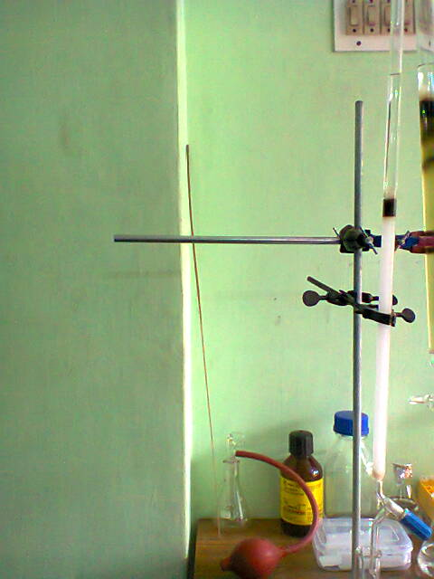
Figure 1 Isolation process using column chromatography
2.3 TLC PROFILE
Sample : 70 % Ethanol extract
Stationary phase : Silica gel 60 mesh
Mobile phase : Toluene: Ethyl acetate: Formic acid (9: 1: 0.5)
R_{f} value : 0.7
Detecting Agent : Vanillin in sulphuric acid
2.4 Chemical Test
- Test for triterpenoids: To 1 ml of compound, tin (one bit) and thionyl chloride were added. Appearance of pink colour indicates the presence of triterpenoids.
- Liebermann Burchard Test: To few mg of substance dissolved in chloroform; acetic anhydride was added followed by sulphuric acid. Appearance of pink colour indicates the presence of terpenoids.

2.5 HPTLC analysis
HPTLC finger printing has been done using the following chromatographic conditions. Chromatography was performed on a 10 x 10 cm pre activated silica gel 60GF 254 plate. Extract were applied to the plate as 6 mm wide band with an automatic TLC applicator Linomat5 with N₂ flow (CAMAG, Switzerland), 8 mm from the bottom. Densitometric scanning was performed on CAMAG scanner III and CAMAG Reprostar 3 photo document was used. The plates were prewashed with methanol and activated at 60°C for 5 minutes prior to chromatography. The slit dimension was kept at 5mm x 0.45mm and 20 mm/s scanning speed was employed. The mobile phase was chosen after running each extract in different mobile phases of varying polarity (Toluene, toluene: ethyl acetate and ethyl acetate: methanol) and 10 ml of mobile phase was used per chromatography. Linear ascending development was carried out in 20 x 10 cm twin glass chamber saturated with the mobile phase at 60°C ^{[3]} and it is given in Table 1.

2.6 Chromatographic Condition

Standard | Ursolic acid (Sigma Aldrich, Chennai)
Stationary phase | Silica gel GF₂₅₄
Mobile phase | Chloroform: Methanol (9.5 : 0.5)
Derivatizing agent | 5 % sulphuric acid in methanol
Scanning wavelength | 510 nm
Sample concentration | Myxopyrum serratulum (50 mg/ml  Isolated compound (2 mg/ml)  Ursolic acid (0.1 mg/ml)
Development mode | Ascending mode
Table 1 Chromatographic condition of HPTLC

III. Results and Discussion
Terpenoids are the most widespread, chemically interesting groups of secondary metabolites with over 30,000 known compounds including steroids ^{[4].} Many terpenes have biological activities and are used for the treatment of human diseases. Among the pharmaceuticals, the anticancer drug Taxol and the antimalarial drug Artemisinin are two of the most renowned terpene-based drugs ^{[5]}

3.1 Examination of Isolated Compound
The 70 % ethanolic extract was subjected to column chromatography. From the pooled fractions, a white powder was isolated and recrystallized.
Description - White powder
Solvent system - Toluene: Ethyl acetate: Formic acid (9:1:0.5)
Detecting Agent - Vanillin-Sulphuric acid
Melting Point - 282-284ºC
R_{f} Value - 0.7

3.2 Characterization of the isolated compound
The isolated compound was characterized using UV, IR, NMR and Mass spectroscopic techniques.
UV spectroscopy
Isolated compound was dissolved in methanol and scanned in the region between 200-400 nm. The UV spectrum of the isolated compound was given in the Figure 2.

Infrared Spectroscopy
The isolated compound showed the following absorption peaks, 3434 cm⁻¹ which corresponds to OH stretching, 2931 & 1694 cm⁻¹ corresponds to carboxylic acid (carbonyl group), 2931 cm⁻¹ corresponds to CH (Str) Superimposed on OH (Str), 1385 cm⁻¹ corresponds to Gem dimethyl group C(CH₃)₂, 1043 cm⁻¹ corresponds to the C-O (Str), 1043 & 998 cm⁻¹ corresponds to C-OH band and 998 & 663 cm⁻¹ corresponds to OH (def) it is represented in Figure 3.

Nuclear Magnetic Resonance Spectroscopy (NMR)
¹H NMR : δ 5.13 (t, J=3.5Hz, 1 H), 4.36 (t, J=5 Hz, 1 H), 4.30 (d, J=5.5 Hz, 1 H), 3.47-3.39 (m, 1 H), 3.02-2.98 (m, 1 H), 2.11 (d, J= 11Hz, 1H), 1.92 (qd, J=13, 4.5Hz, 1H), 1.89-1.77 (m, 3 H), 1.60-1.43 (m, 10 H), 1.34-1.25 (m, 4 H), 1.08-0.99 (m, 5 H), 0.95-0.87 (m, 11 H), 0.82 (d, J=6.5Hz 1 H), 0.75 (s, 3 H), 0.68 (s, 3 H) represented in Figure 4
The ¹H NMR spectrum of the compound showed one proton broad signal at δ 5.12 assigned to Vinylic proton. One proton singlet at δ 2.5 attributed to OH of COOH. One proton doublet at δ 2.1 indicates the presence of hydroxyl group. The signals below indicate the presence of 7 methyl protons in the structure.

¹³C-NMR : δ ppm: 178.99 (C-28); 138.58 (C-13); 125.21 (C-12); 77.31 (C-3); 55.24 (C-5); 52.84 (C-18); 47.48 (C-9); 47.29 (C-17); 42.11 (C-14); 40.47 (C-8); 39.97 (C-20); 39.81 (C-19); 39.64 (C-4); 39.56 (C-1); 38.70 (C-10); 36.99 (C-22); 33.17 (C-15); 30.65 (C-7); 28.72 (C-23); 28.00 (C-21); 2745 (C-2); 24.36 (C-11); 23.73 (C-27); 23.33 (C-16); 21.53 (C-30); 18.47 (C-6); 17.47 (C-29); 17.38 (C-24); 16.54 (C-25); 15.68 (C-26)

In ¹³C-NMR, a peak at δ 178.99 attributed to carboxylic group at the position C-28. The chemical shift value at δ 125.21 and δ 138.58 represented resonance olefinic carbons in C-12 and C-13. The chemical shift value at δ 77.31 represented carbinol carbon in the structure (Figure 5).

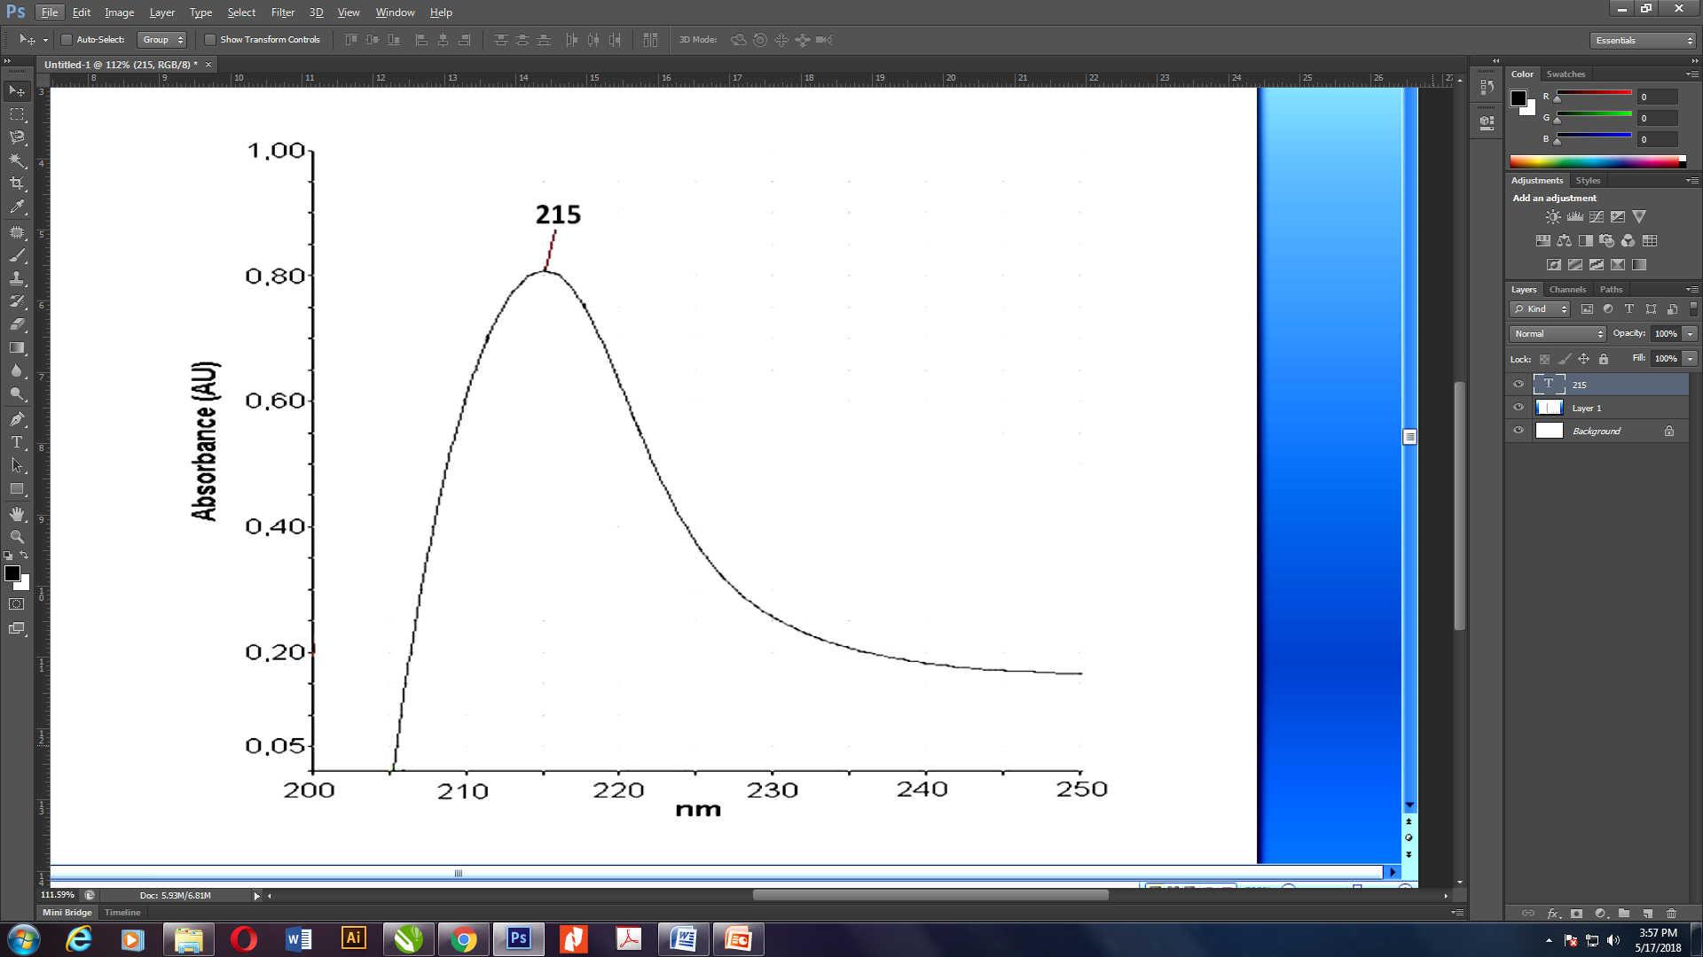
Figure 2 UV Spectra of isolated 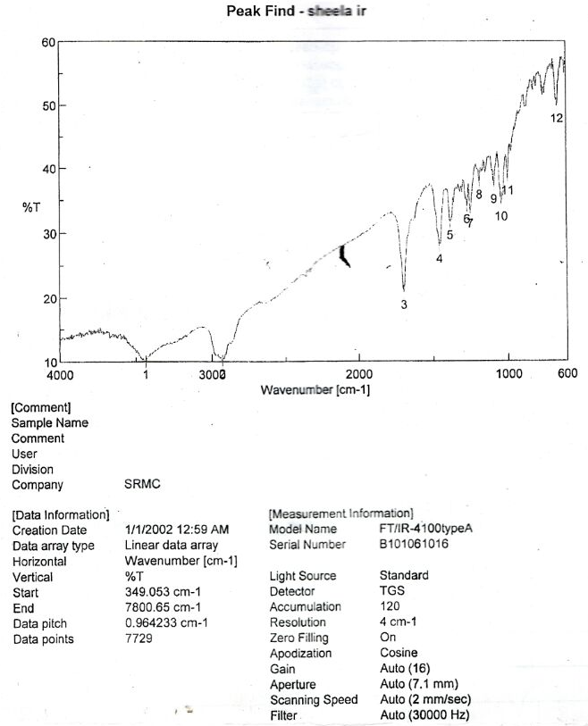
Figure 3 IR Spectra of Isolated Compound

WAVE NUMBER (cm⁻¹) | FUNCTIONAL GROUP
3434 | OH (Str)
2931 & 1694 | Carboxylic acid(carbonyl group)
2931 | CH (Str) Superimposed on OH (Str)
1385 | Gem dimethyl group, C(CH₃)₂
1043 | C-O (Str)
1043 & 998 | C-OH Band
998 & 663 | OH (def)

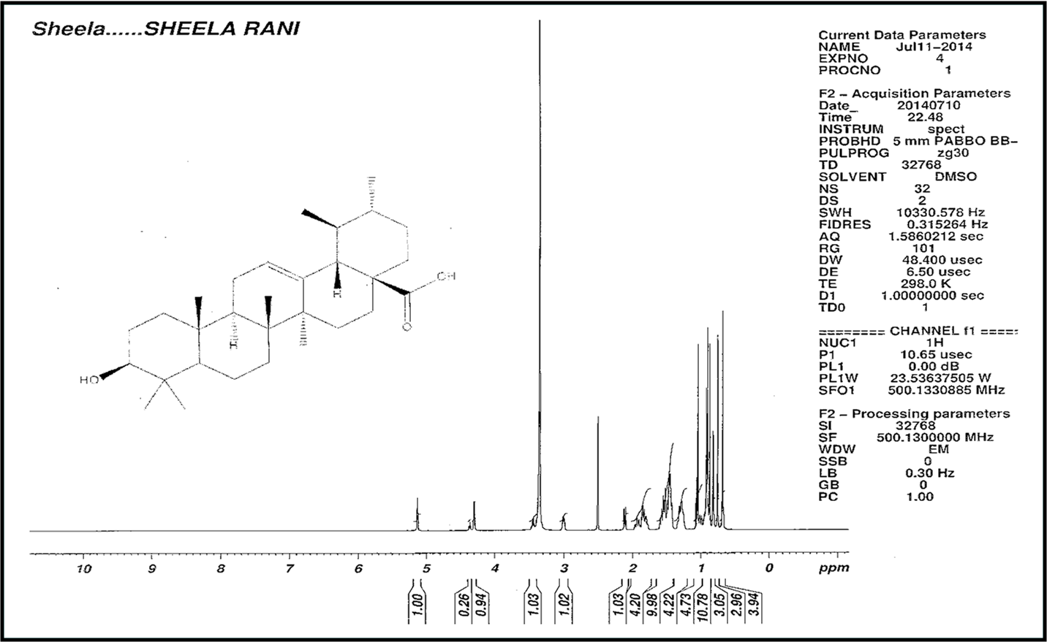
Figure 4 ¹H NMR of Isolated Compound

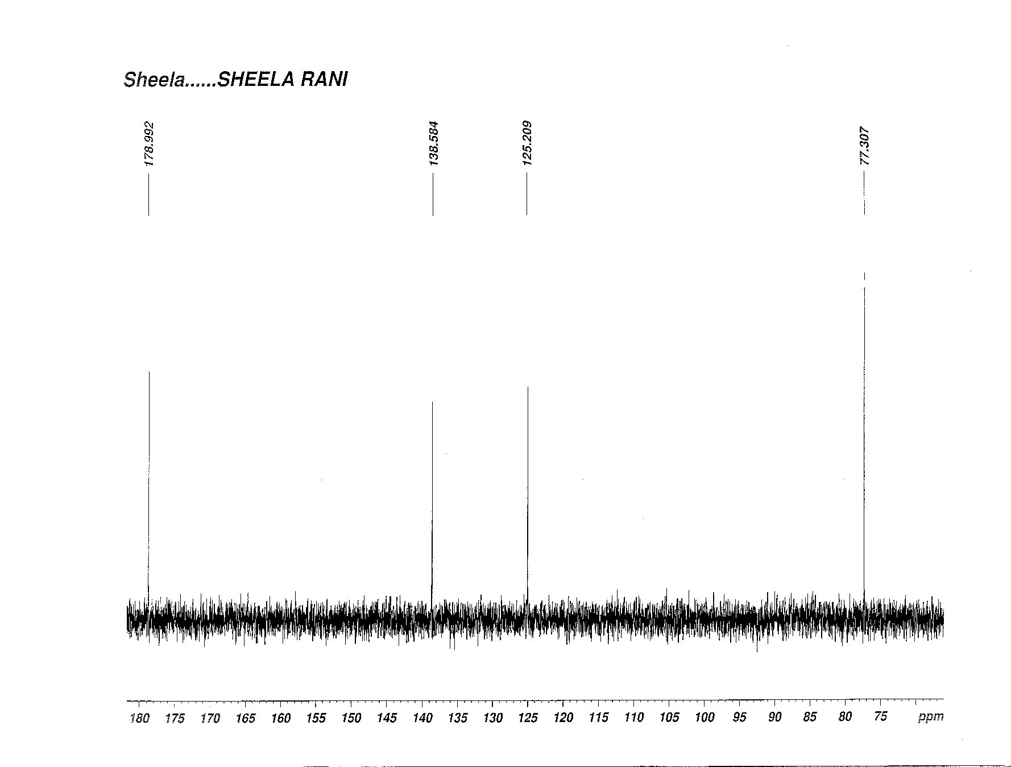
Figure 5 ¹³C NMR of Isolated Compound

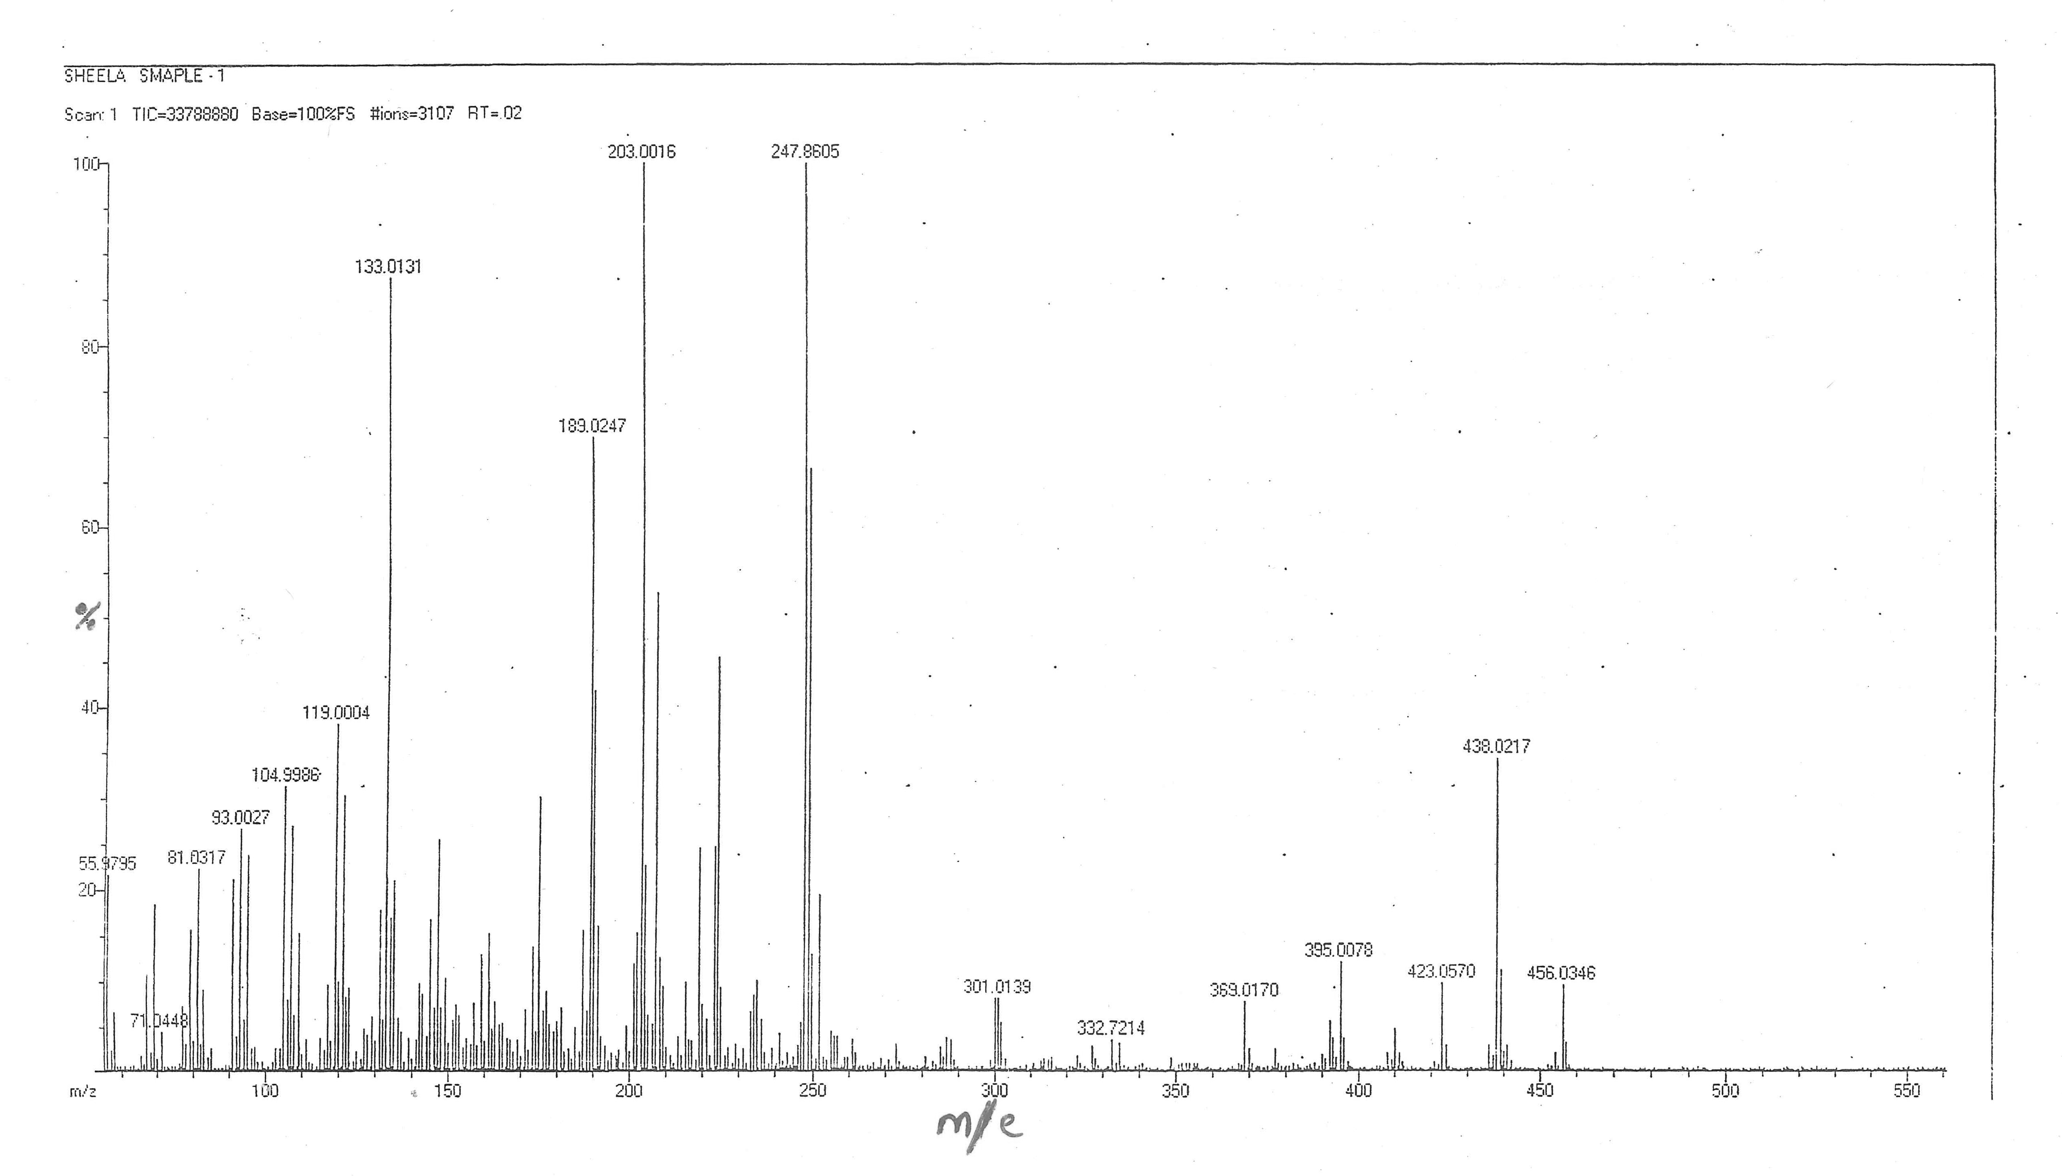
Figure 6 Mass Spectra of Isolated Compound

Mass spectrometry
The EI-MS spectrum of isolated compound was given in Figure 6. The EI-MS spectrum of isolated compound showed the molecular ion peak at m/e 456.03 that corresponds to molecular formula C₃₀H₄₈O₃ and fragmented peaks at 438.02, 423.05, 247.86, 203.00, 189.02 and 133.01.
Structure of isolated compound was identified by spectroscopic techniques like UV, IR, NMR and Mass spectra. The spectral data confirmed that the compound is a pentacyclic triterpenoid, Ursolic acid.

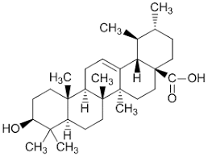
Figure 7 Structure of Isolated Compound -Ursolic acid
Molecular Formula : C₃₀ H₄₈ O₃
IUPAC NAME : 3β-Hydroxy-urs-12-ene-28-oic acid.

HPTLC finger printing of standard, isolated compound and extract
The HPTLC finger print of Ursolic acid was taken and the R_{f} value was found to be 0.4. Similarly the HPTLC finger print of 70 % ethanolic extract and the isolated compound were taken. The chromatogram of 70 % ethanolic extract showed 8 peaks in the range of R_{f} value 0.12 to 0.76. Among the peaks the 6th peak with R_{f} value of 0.4 with percentage area of 69.3 confirms the presence of Ursolic acid in the ethanolic extract.
The HPTLC finger print of isolated compound showed 4 peaks with the range of R_{f} values from 0.16 to 0.77. Among the peaks the 3rd peak at R_{f} value 0.42 corresponds to the standard Ursolic acid (R_{f} value - 0.4) with percentage area of 86.55. It confirmed that the isolated compound is Ursolic acid (Table 2).

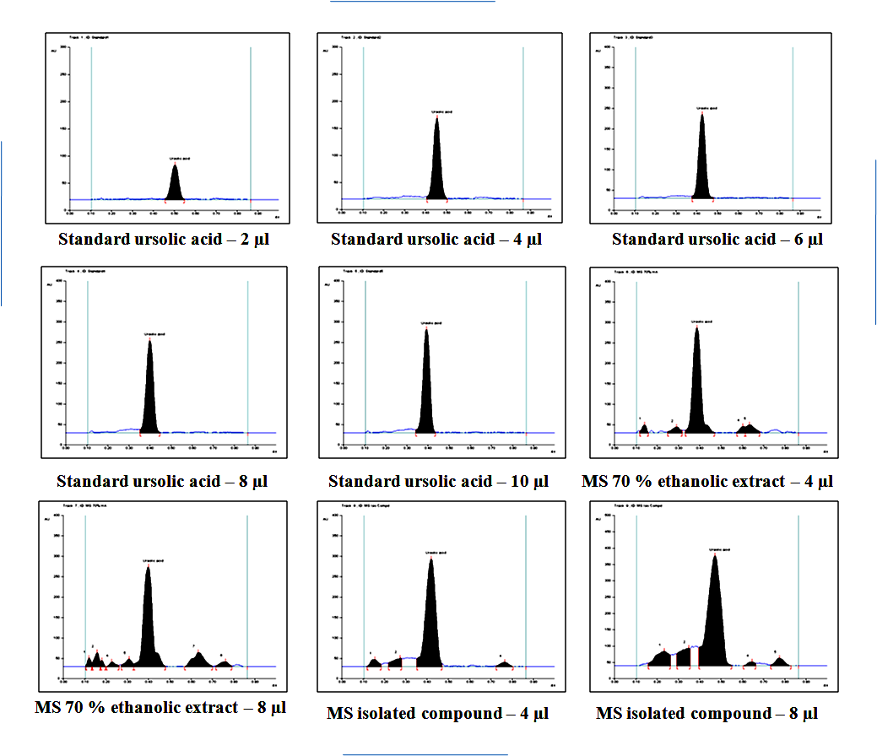

Figure 8 HPTLC chromatogram of standard, isolated compound and extract

Track | Peak | Start  R_{f} | Start  Height | Max R_{f} | Max  Height | Height % | End R_{f} | End  Height | Area | Area %
4 | 1 | 0.35 | 7.9 | 0.4 | 225.1 | 100 | 0.45 | 0.4 | 6770.7 | 100
7 | 6 | 0.33 | 6.5 | 0.4 | 243.9 | 62.5 | 0.48 | 1 | 9322 | 69.3
8 | 3 | 0.35 | 19.6 | 0.42 | 263.7 | 84.5 | 0.47 | 7 | 11087.6 | 86.55

Table 2 HPTLC profile of extract and isolated compound

IV. Conclusion

Ethanolic extract was found to possess significant pharmacological activity when compared to other extracts; hence it was subjected to column chromatography for the isolation of phytoconstituents. The spectral studies confirmed that the isolated compound is Ursolic acid. Ursolic acid is a pentacyclic terpene compound that has diverse pharmacological activities such as anti-inflammatory ^{[6,7]} antitumor ^{[8,9]} antioxidant ^{[10]} hypoglycemic, antiulcer and anti-lipidemic activity.

Ursolic acid was reported to be isolated from various plants including Malus domestica^{[11],} Ocimum sanctum ^{[12],} Diospyros melanoxylon, Vitex negundo^{[13],} Cornus officinalis ^{[14 ]} and Thymus vulgaris ^{[15]}

Isolation of Ursolic acid from Myxopyrum serratulum and characterisation by spectral studies is the significant outcome of this work.

References
[1] McCurdy CR, Scully SS. Analgesic substances derived from natural products (natureceuticals). Life Sciences. 2005 Dec 22;78(5):476-84.
[2] Dayan FE, Duke SO. Biological activity of allelochemicals. Plant-derived natural products: synthesis, function, and application. 2009:361-84.
[3] Rai S, Mukherjee K, Mal M, Wahile A, Saha BP, Mukherjee PK. Determination of 6‐gingerol in ginger (Zingiber officinale) using high‐performance thin‐layer chromatography. Journal of separation science. 2006 Oct;29(15):2292-5
[4] Wang G, Tang W, Bidigare RR. Terpenoids as therapeutic drugs and pharmaceutical agents. Natural products: drug discovery and therapeutic medicine. 2005:197-227.
[5]Çitoğlu GS, Acıkara ÖB. Column chromatography for terpenoids and flavonoids. Chromatography and its applications: INTECH Rijeka. 2012 Mar 16:13-49
[6] Safayhi H, Sailer ER. Anti-inflammatory actions of pentacyclic triterpenes. Planta medica. 1997 Dec;63(06):487-93.
[7] Baricevic D, Sosa S, Della Loggia R, Tubaro A, Simonovska B, Krasna A, Zupancic A. Topical anti-inflammatory activity of Salvia officinalis L. leaves: the relevance of ursolic acid. Journal of ethnopharmacology. 2001 May 1;75(2-3):125-32.
[8] Tu HY, Huang AM, Wei BL, Gan KH, Hour TC, Yang SC, Pu YS, Lin CN. Ursolic acid derivatives induce cell cycle arrest and apoptosis in NTUB1 cells associated with reactive oxygen species. Bioorganic & medicinal chemistry. 2009 Oct 15;17(20):7265-74.
[9] Yamaguchi H, Noshita T, Kidachi Y, Umetsu H, Hayashi M, Komiyama K, Funayama S, Ryoyama K. Isolation of ursolic acid from apple peels and its specific efficacy as a potent antitumor agent. Journal of Health Science. 2008;54(6):654-60.
[10] Saraswat B, Visen PK, Agarwal DP. Ursolic acid isolated from Eucalyptus tereticornis protects against ethanoltoxicity in isolated rat hepatocytes. Phytotherapy Research. 2000 May;14(3):163-6.
[11] Frighetto RT, Welendorf RM, Nigro EN, Frighetto N, Siani AC. Isolation of ursolic acid from apple peels by high speed counter-current chromatography. Food Chemistry. 2008 Jan 15;106(2):767-71.
[12] Vetal MD, Lade VG, Rathod VK. Extraction of ursolic acid from Ocimum sanctum leaves: Kinetics and modeling. Food and bioproducts processing. 2012 Oct 1;90(4):793-8.
[13]Chandramu C, Manohar RD, Krupadanam DG, Dashavantha RV. Isolation, characterization and biological activity of betulinic acid and ursolic acid from Vitex negundo L. Phytotherapy Research: An International Journal Devoted to Pharmacological and Toxicological Evaluation of Natural Product Derivatives. 2003 Feb;17(2):129-34.
[14] Jang SE, Jeong JJ, Hyam SR, Han MJ, Kim DH. Ursolic acid isolated from the seed of Cornus officinalis ameliorates colitis in mice by inhibiting the binding of lipopolysaccharide to Toll-like receptor 4 on macrophages. Journal of agricultural and food chemistry. 2014 Oct 8;62(40):9711-21.
[15] Rowe EJ, Orr JE, Uhl AH, Parks LM. Isolation of oleanolic acid and ursolic acid from Thymus vulgaris, L. Journal of the American Pharmaceutical Association (Scientific ed.)1949 Mar 1;38(3):122-4.

