Challenges and opportunity for higher crop productivity in red-laterite belt of west bengal

Dr. Dhiman Mukherjee
Associate Professor (Agronomy)
Regional Research Station (Red & Laterite Zone)
Bidhan Chandra Krishi Viswavidyalaya
Jhargram -721507, West Bengal, India

- mail : dhiman_mukherjee@yahoo.co.in
Mob : 9474083413

Abstract

Around the world, farmers are constantly seeking solutions for their higher crop productivity with proper insect pest and disease management in response; researchers are striving to come up with promising technologies for crop production in holistic way. Among various soil in India, red and lateritic soils become very problematic and this confined one third part of the soil. These soils cover large areas of potentially arable and pasture land and are widespread in humid to semi-arid tropical climates. Due to anomaly weather conditions, desolate environmental element, and soil ecology related confinement, crop/flora production on these soils has stay on inferior and static. These soils suffer from deficiencies of micro-nutrient such as Ca, S, Zn, B, Mo and N, P, K great extent. The management of this soil should be focused on increasing crop production potential, either by adding amendments to rectify any soil issues, or by adapting appropriate crop-husbandry and cultural practices depending on soil edaphic and local climate condition. Red-laterite belt of west bengal can be manage through more reliance on improve nutrient, water and land use system etc. These can directly overcome the challenges for higher crop productivity with improved livelihood system in long term sustainable basis.

Keywords: Argo-technology, crop, nutrient management, red-laterite, sustainable, water conservation.

- INTRODUCTION
Agribusiness is the leading root-age of livelihood for almost sixty percent population of India. Despite this, corp productivity is far lower than that of many other territorial division and must be increased to produce around 500 million tonnes of food grains in order to satisfy the nutritional needs of the population of 1.8 billion by 2050. Divers climatical modality in India favour the cultivation of different crops in different part of the country (Mukherjee, 2021). Among various state in India, west bengal play vital role in food grain basket of the country. West Bengal (India), an eastern part of the country, has unequalled geographical attribute. It is confined within 21°31′–27°41′N lat. and 85°91′– 89°93′E long. The snowy peaks and Himalayas in the north greatly influence the weather in North Bengal. The Tropic of Cancer cuts through the center of the state. It reaches the southernmost Bay of Bengal (BoB). There is a lot of cloud cover and strong winds from BoB bring early rains and heavy rains in summer to the state. Most of the southern regions are in the equatorial region. The Sunderbans (Bengali for "sundar ban", meaning beautiful forest) is a mangrove region in the southern delta. The state borders Sikkim and Bhutan to the north, Odisha to the south, Jharkhand and Bihar to the west, and Assam to the north. It has an extensive network of rivers, lakes, reservoirs, canals and other water resources.The snowy peaks and Himalayas in the north greatly influence the weather in North Bengal. The Tropic of Cancer cuts through the center of the state. It reaches the southernmost Bay of Bengal (BoB). There is a lot of cloud cover and strong winds from BoB bring early rains and heavy rains in summer to the state. Most of the southern regions are in the equatorial region. The Sunderbans is a mangrove region in the southern delta. The state borders Sikkim and Bhutan to the north, Odisha to the south, Jharkhand and Bihar to the west, and Assam to the north. It has an extensive network of reservoirs, lakes, rivers, canals and other water resources. These state had different type of soil topographical feature. Among various class of soil red-laterite zone has sever problem of various nutrient and water management practice, mainly due to distinct soil characteristics. Red-laterite soils are classified into eight agro-ecological zones of India; AER - 7, 8, 12, 15, 17, 18, 19 and 20 were developed by the National Soil Survey and Land Use Planning Department (Sehgal et al.,1998) and distributed in the states of Tamil Nadu, Kerala, Telangana, Karnatak, AP, Chhattisgarh, MP, Maharashtra, West Bengal, Odisha, Goa, NE region, the Union Territory of Puducherry and Andaman-Nicobar (Figure 1).

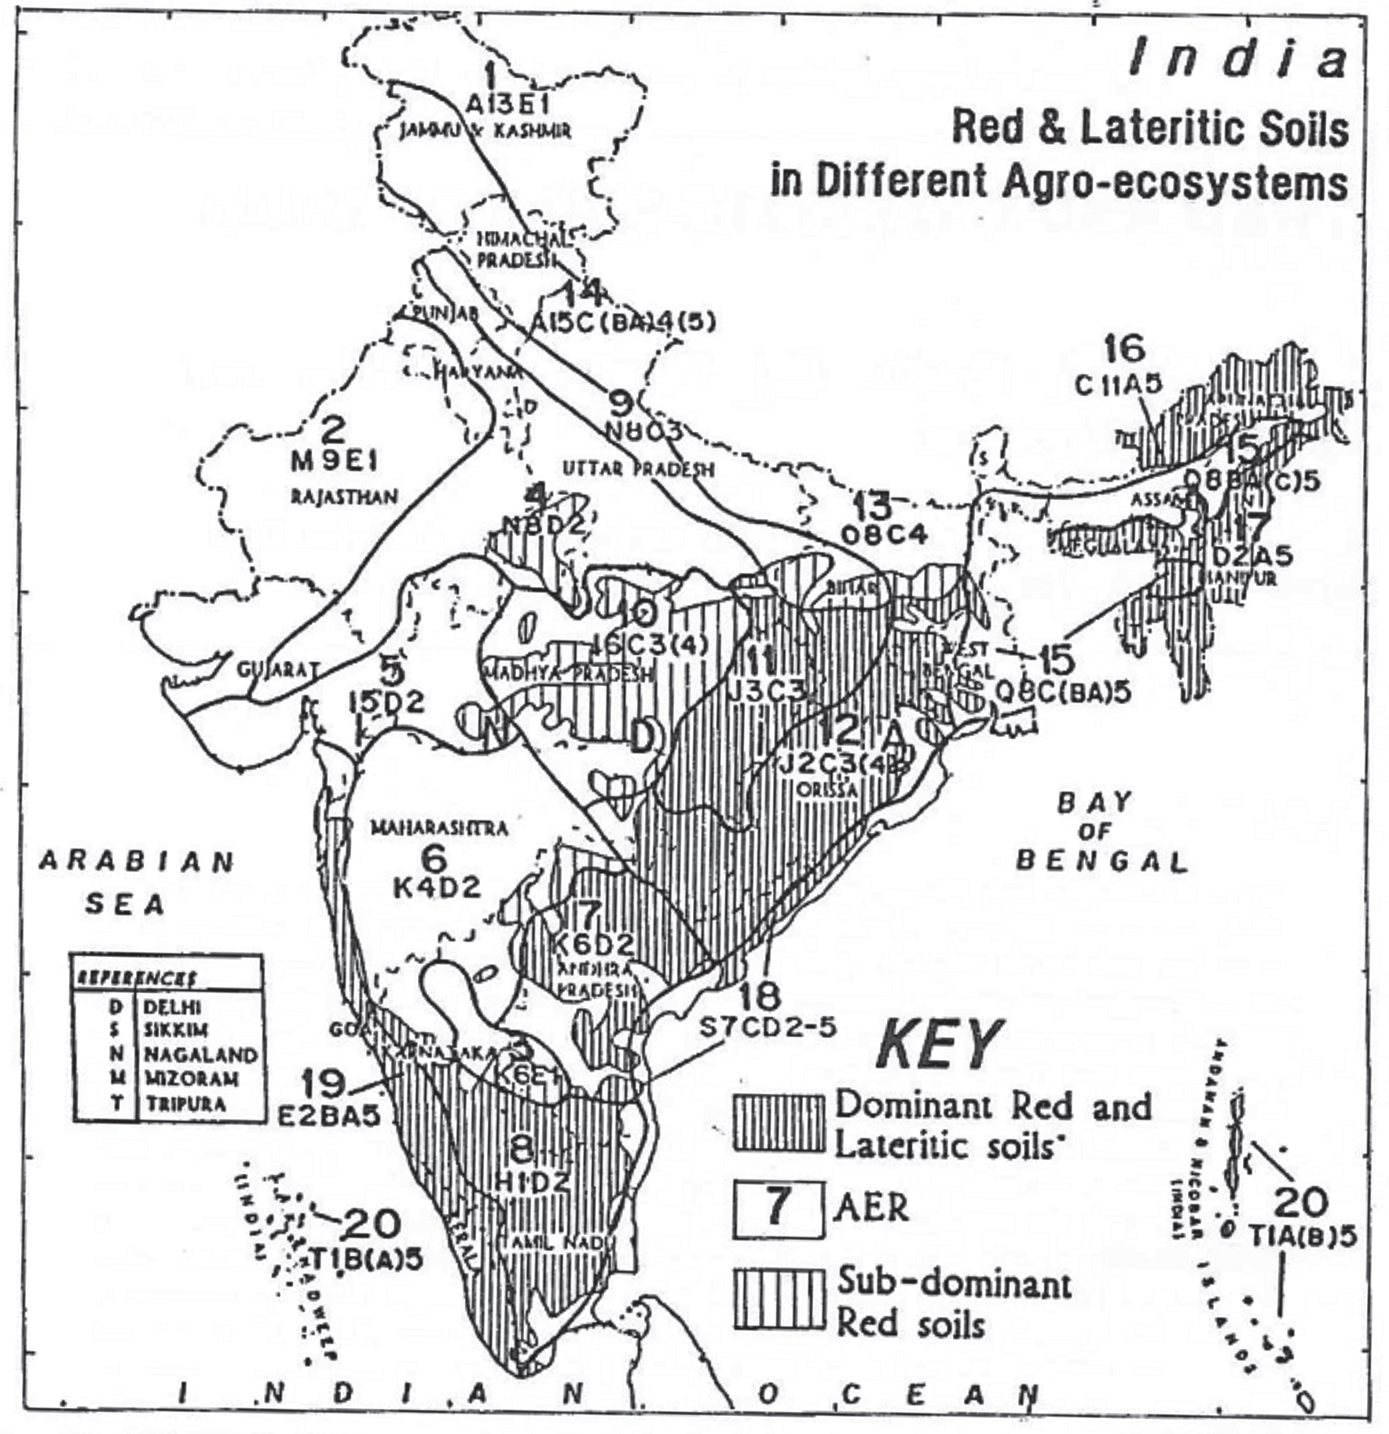
Fig. 1. Red and lateritic soils in different agro-ecosystems of India
Source: Sehgal et al. (1998)

Among the 6 agro - climatic zones of West Bengal, red-late zones account for about 11-14.5 percent of the total cultivated area. The western part of the state consists of large lowland areas with red, undulating soils. This land constitutes about one-third of the cultivated land in Bankura, Paschim Medinipur, Purulent, Jhargram, Birbhum and Bardhaman districts (Chatterjee et al., 2013). The climatic condition is semi-arid with hot summers and cold and dry winters, and the annual rainfall is 1000-1300 mm (Mukherjee, 2023). Like the climate, the soil in this region has some special characteristics, such as rough texture, strong flow, honeycomb metal concentration at a depth of 15 to 30 cm; acidic (pH 5.4 to 6.3); susceptible to erosion; It is poor in organic content, nitrogen, phosphorus other micro- nutrient deficiency in patches and poor water retention capacity (Murmur et al., 2016). Most of the land remains year-round fallow and majority of crops cannot be grown here due to the aberrant soil and climate. People in the region rely on rain-fed agriculture to produce rice, wheat, millet, vegetables etc. We went through different corner of district Jhargram and it’s adjoining belt and observed, farmer’s here severely face tough challenge not only from soil and environment but also by mismanagement of different agronomic option which directly influence crop productivity of this region (Fig. 2).

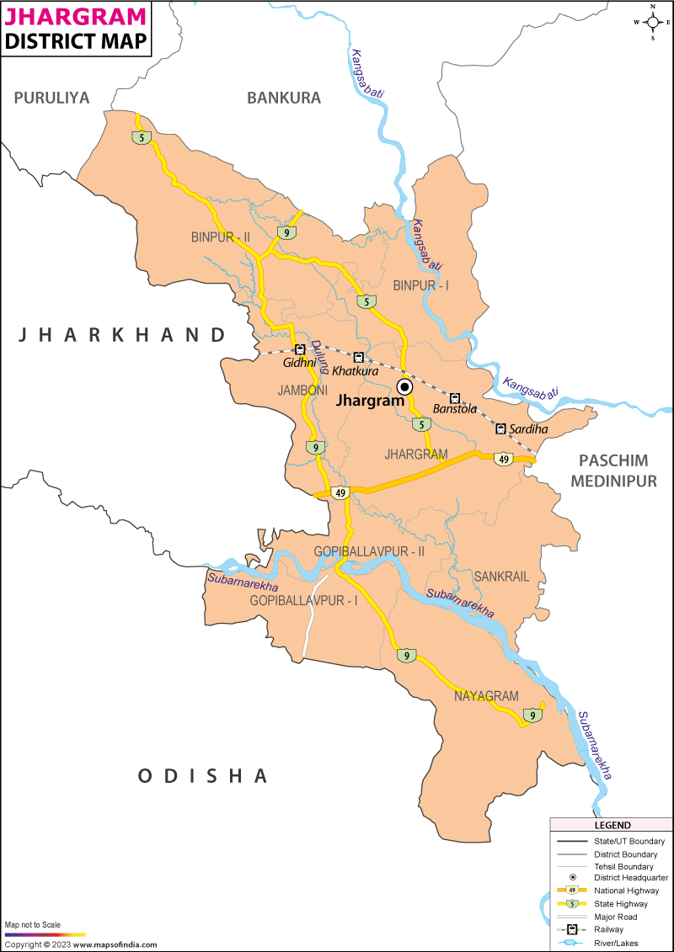

Fig. 2: Red laterite belt of west bengal (Jhargram and it’s adjoining district),
(Source: Internet)

- Challenges and opportunity
The main problems are soil acidification, soil degradation, secondary and micro- nutrient deficiencies, poor soil organic matter, underutilization of ground water and water and soil pollution. Soil structure vary and are susceptible to erosion, crusting, droughtness etc. Constraints can be pointed as :

- Low water and nutrient storage capacity
- Soil has high erosion potential, excess water runoff etc.
- The fertility of the soil is poor in terms of humus, P, N, Zn, S and Ca.
- Year round average rainfall vary from 1000 to 1200 mm, about 74% of which occurs during June - July to September, (monsoon period). Even for short periods of time, precipitation can be distributed unevenly. There is a 25–40% chance of drought or rain disruption throughout the season.
- Some or all of the crops cannot be produced in rainwater so optimum productivity become challenging.
Productivity of the soil can be substantially developed by follow afforestation, soil conservation measures, scientific crop management practices and ‘jhora’ control . In addition to development of horticulture and agriculture, proper care should be paid to the development of plantation crops, orchard management, animal husbandry, landscape and floriculture. Brief-length excessive yielding variety (HYV) of paddy in medium and medium to high lands, and crop variegation in uplands are suggested from rice to groundnut, arhar, sorghum, maize, finger millet and soybean. Short-period pulses and oilseeds are appropriate for developing with residual soil moisture, and wheat and veggies are desired with irrigation in winter. Red soils are made under well drained situation. Illuviation and eluviation of clay, Al, Fe, and bases are the chief dirt forming processes. The chief features of red soils are lighter texture, absence of lime concretions, friable structure and free calcium carbonate and low contents of soluble salts. The soil is slightly alkaline to slightly acidic , with moderate cation exchange capacity. Lateite soils face various degradation problems. They are susceptible to severe water erosion and nutrient loss due to excessive rainfall and seepage. Due to its poor texture and water retention capacity, planting after the rainy season is prohibited and there is no need to irrigate. This kind of soil need proper care with different soil-water management strategy. In addition to this, proper lab to land linkage with local specific problem based training programme become very effective (Mukherjee, 2018). However, experimental evidence shows that with appropriate soil management, these soils have great potential for food production. But to be successful, soil scientists, agroclimatologists, agronomists, and planners must work together to identify elements of environmental circulation and positive interactions between plants.

- MANAGEMENT OPTION FOR HIGHER CROP PRODUCTIVITY

Sustainable agriculture requires careful consideration of soil and climate conditions, soil degradation processes, and soil based agricultural technologies that improve utilization. Management of the red-laterite belt, could be oriented towards increased crop production potential either by manipulating the agronomic practices or addition of ameliorate to correct the soil status depending upon the edaphic and climatic variability. In Jhargram and it’s nearby district face severe problem of intensive leaching, which leads to drastic nutrient loss and imbalance in cost of nitrogen, potassium, phosphorus. zinc and other bases.The release of free iron oxides and aluminium oxides may cause the toxicity of these elements. This soil leads to phosphorus immobilization due to the abundance of hydrous oxides of iron and aluminium and acidification, resulting in phosphorus deficiency. Most of red-lateritic area are acidic in nature and cultivation of crop become very challenging in term of appropriate nutrient and site specific water management. Certain necessary steps should be followed to manage soil acidity are use of lime, acid tolerant zone specific genotype, suitable nutrients and water establishment aspect. Here, I can discuss four major aspect, which we understand after went through various field and lab based study. Major hurdle for higher crop productivity in red-laterite belt of west bengal are :

- Nutrient management

Appropriate in coherence with suitable amount of nutrient application to crop, based on soil test analysis become very challenging because of poor extension and research facility in this area (Mukherjee, 2019). Nutrient management in soil mainly confined the use of manure, soil amendments, technical fertilizers and natural byproduct to agrarian landscapes as a informant of crop nutritive. Nutrient application through 4Rs (right timing, right rate, right placement and right source) become very difficult, as because of variation of soil property and poor availability of local resources for proper agriculture use.
Lateritic soils are deficient from P, K, N and some S, Ca, B, Mo and Zn. Nearly eighteen elements are vital for crop development. Few of these plant nutrients come through water, soil and air naturally. Use of diverse manure component along with chemical nutrients are the natural supplies of resources to enable crops to grow. Fertilizers are very useful, when used correctly by knowing the time of application and the correct doses, but they can become harmful (soil pollutants) if used incorrectly at the wrong time. This become quite often, we can see in Jhargram region, because of poor extension and scientific measures. Surface and ground water are very unsafe to excessive use of heavy dose of chemical fertilizer and pesticides etc. Water and soil ecosystem become quite vulnerable high value resource, and protecting it is an crucial business from different kind of pollutant including irrational use of fertilizer and plant protection chemicals.
Number of crops in red-lateritic belt respond to the use of nitrogen in appropriate dose. Kundu and Pillai (1992) concluded that, use of nitrogen along with FYM increased the economic output and total uptake of K, P and N in paddy-paddy cropping system in lateritic soil of Bhubaneswar and red loam soil of Hyderabad. Appropriate utilization of available resources become very challenging (Mukherjee, 2012). Observation from different field work revealed that, nitrogen productivity could be enhanced by use of different nitrogen sources, method and time of application. Use of karanj cake, sulphur-coated urea and supergranules of urea enhanced the economic yield of rice (Mishra et al., 1994). Usage of neem cake coated along with prilled urea and urea coating with lac in red-lateritic soils also become effective for higher utilization of applied nitrogen fertilizer to crop (increase efficiency of nitrogen utilization by crops). The low available P in red-laterite zone of Jhargram and it’s adjoining region are mainly owing to the phosphorus fixation in soils. Our observation revealed that, due to poor phosphorus efficiency, productivity of principal crop such as rice, wheat, maize etc. was very low (less than 3-4 t/ha) compared to yield potential of 5 to 6 t/ha. Need based application of lime and phosphorus in crop field of acidic red and lateritic belt leads to drastic increase in crop productivity (Sarkar 2013). Fixation of phosphorus in Orissa, Jharkhand, Karnataka, Tripura and West Bengal ranges from 33 to 63% (Ghosh and Sarkar, 1997). Number of crops give positive response to applied phosphors in red-lateritic soils (Ghosh et al. 2003; Pattanayak and Rao. 2014).
Goswami (1975) reported that 1 kg of P₂O₅ fetched 14.4 to 30.8 kg grain of rice on red soils and 11.5 to 17.0 kg grain on red and yellow soils. Relative response of N, P and K in maize and wheat crops in red soils of Ranchi (Jharkhand) over the past 50 years of Permanent Manurial Trial revealed that response of P to crops is higher than N and K; response of P is more in rabi crops than kharif crops over the years; and extent of response of P application in maize was 15 kg grain /kg P while in case of wheat it was 32 kg grain / kg P (Sarkar 2013). Results suggest the need for a focussed attention on the P fertilizer use for mitigating its deficiency in red and lateritic soils for higher crop productivity. This will not only make agriculture more profitable but will also ensure better utilization of resources with adequate food for masses (Mukherjee, 2010). Goswami (1975) reported that 1 kg of phosphatic fertilizer yielded 14.43 to 30.87 kg of rice grain in red soil and 11.53 to 17.02 kg of rice in red and yellow soil. The relative response of maize and rice crops to N, P and K in the red soil of Ranchi (Jharkhand) during the last 50 years of continuous fertilizer experiment showed that P was more sensitive to crops than N and K; the previous year, rabi responded more to phosphorus than to kharif crop. The response to P application was 15 kg grain/kg P for maize and 32 kg grain/kg P for rice (Sarkar 2013). The results show that it is necessary to focus on the use of phosphorus fertilizers in order to subsequently reduce phosphorus deficiency in the soil and increase productivity. This kind of adaptive technology not only make our farming practices more profitable but also help to better utilization of available resources with adequate foodgrain availability for sustainable livelihood (Mukherjee, 2010).
Further, we found sever micro-nutrient availability problem, and might be due to fixation of various major plant nutrient. Deficiency of sulfur, calcium and magnesium become very challenging in lateritic soil (Ghosh et al. 2005; Patra et al. 2012). Moreover, application of different S sources such as SSP (12% S), gypsum (15-18% S), sulphate of potash (18% S), ammonium sulphate (24% S), ammonium phosphate sulphate (15% S) and gromor sulphur bentonite (90% S) become very prominent against S deficient soil of red-lateritic zone of west bengal. These soil are acidic in nature and this can be manage either by application of lime (limestone and dolomite) or use of acid tolerent crop in addition to appropriate nutrient management measures (Mukherjee, 2014 a). Integration of various nutrient along with local available manure, cultural material, vermicompost etc. become very effective for more return per unit of degraded land (Mukherjee, 2016). Various stud revealed that, integrated nutrient use in balance proportion quite effective for higher crop productivity (Pattanayak and Rao, 2014). Nutrient use efficiency can be directly correlate with kind of soil and rainfall pattern of the region (Mukherjee, 2013). The utility of phosphate solubilizing organisms and Rhizobium for pulses and phosphate solubilizing microbes with Azospirillum and Azotobacter and in equal proportion (2-4 kg each in one ha) inoculated to five percent limed vermicompost, multiply for seven days at 30% moisture, use at the day of sowing on sol test basis fertilizer application increase yield of pulses (10-21%), cereals (7-27%) and oilseeds (12-21%) in acid soils (Pattanayak and Rao, 2014). Further under red and lateritic belt iron toxicity become very challenging aspect for higher crop productivity and use of potassic fertilizer in addition to iron tolerant crop cultivar become some extent solve this problem (Dev, 1993).

- Diversification of crops

Crop diversification based on water availability and soil acidity help to overcome limitation of crop cultivation in lateritic soil.

Table 1: Suitable crop choice for cultivation

Ssoil acidity tolerant crops | Optimal pH range
Cereals
Wheat, maize, barley | 6.0-7.5
Millets | 5.0-6.5
Rice | 4.0-6.0
Oats | 5.0-7.7
Legumes
Field beans, soybean, pea, lentil etc. | 5.5-7.0
Groundnut | 5.3-6.6

In addition to above crops, emerging fruit crops in red lateritic zone are mainly Mango (Mangifera indica L.), Citrus, Custard apple (Annona squamosa ), Aonla (Phyllanthus emblica ), Ber (Zyzyphus mauritiana), Cashew (Anacardium occidentale L.), Pumello (Citrus grandis Osbeck), Guava (Psidium guajava ), Waterapple (Syzygium aqueum) and Jamun (Syzygium cuminii L). Mahua (Madhuca latifolia), and Wood apple (Feronia limonea ) etc. (Sau and Datta, 2020).

- Water management

Water is the main basis of the biosphere found on the earth and become important factor for soil reclamation (Mukherjee et al, 2019). Life cannot be imagined without water and water is the priority for its development. Population pressure and environmental imbalance have had the biggest impact on water resources and the red-laterite zone of Jhargram and it’s adjoining district are no exception to it.
There is increasing uncertainty in availability, or site-specific excess of water due to climate change. These call for strategic management of this important natural resource to achieve one of the sustainable development goals set by the United Nations, i.e. ensuring availability and sustainability in water management, and also providing sanitation to all by 2030. Both water scarcity and water excess are intricately associated with the agricultural activities in the state, which demand integrated approach in the management of water resources and their efficient utilization. Since water is the most limiting factor in crop growth, strategies aimed at conserving it and optimizing its use can substantially moderate drought effects. There exist augmenting uncertainty in availability, or site-specific water and environmental crisis. As we know water become limiting factor for crop growth and development, advance tools and technology should aimed at conserving it and optimizing its use. In rainfed and dry land agro-ecosystem, efficient water harvest technology on the basis of water requirement of crop should be develop in patches, depending on climate and suitability in particular location or zone (Mukherjee, 2013a). On the basis of availability of water food growers or farming community can choose their crop (Table 2). Quality and quantity of water availability become very challenging and it ultimately decide the economic yield of a crop (Mukherjee, 2014).
Table 2 - Crop wise seasonal water requirement
Crop | Water requirement of crop (mm/total growing period)
French /faba beans | 350 - 600
Vegetable crops | 600-1300
Orange etc. | 800 - 1000
Maize, millets | 400 - 700
Pulses | 200-500
Groundnut | 300 - 800
Sunflower | 400 - 800
Soybean | 300 - 900

Appropriate watershed planning with more importance on water conservation (rain etc.) is critical input for higher economic yield of crop. Time bound options are available for efficient water procurement with different pertinent technologies related to soil, land and plant management (Mandal et al., 2022).

Following few important measures, for efficient water management in red-laterite zone :
- Recharge of ground water via rain water harvesting in ponds, ditches and dugwells etc. for life saving and supplemental irrigation as per crop requirements.
- Conservation of water and development of canal command area based integrated farming systems (IFS).
- Development of integrated watershed management and afforestation programme under different forest block, which ultimately improve water and soil conservation.
- Conjunctive use of water for irrigation purpose via surface and groundwater resources in different fruit and orchard base planting system.
- Cultivation of vegetables/fodder crops in triabal zone via plastic cover (raising of seed bed) for chilli, tomato, cauliflower, cabbage, brinjal etc. during early occurrence of drought due to late monsoon.
- Wide coverage of crop area under sprinkler and drip irrigation keeping in mind “Per drop more crop” in plantation area of Cashewnut, Jamun, Mango etc.
- Sowing of drought tolerant pulses such as khesari, lentil as paira crop in case of terminal heat stress area.
- Use of various mulches, crop residue, stone mulching etc. become an effective tools for higher productivity of vegetable crops (potato, beans etc. ).
- Broad based ridge and furrow system or paired row planting for groundnut and other crops become quite effective under limiter supply of water.

- Alternate land use systems
Due to different constrains for crop production, some crop cultivated area may be manage in such a way, that it may be range/pasture, ley and tree farming, agro-forestry and rainfed horticulture systems. All these approaches which are secondary to plant production are called as alternate land use systems. This mainly cover inclusion of perennial or long lasting component which can withstand the aberrant weather (drought tolerance), and provide stability to output. Major steps involve in alternate land use systems are as follows :

- Appropriate land use model selection for specific zone and crops.
- Knowing of shrubs/trees which are not adore by livestock 
- Reduce different extent of competition among crop and tree for soil and water to minimal extent. 
- Fruit and orchard cultivation and it’s management as per crop grower’s preference in the context of recent technology. 
- Dig out pit etc. for suitable plantation (improved planting spot) 
- In-situ water harvesting system for higher economic return per unit area.
Soil erosion and degradation can be effectively checked by cultivation of tree, perennial pastures, shrubs etc. either alone or their association (Mukherjee, 2022). Agro-forestry is an alternative land-use system, which combine pastoral or arable crops in combination with woody perennial tree. This may be agri-horticulture, silvipasture and alley cropping. Some other alternate land use system such as tree farming, social forestry and ley farming (rotating legume forages and arable crops).

Future line of research/extension activity

Under the era of modern gadget and ICTs, communication to the farming community become easier (Mukherjee, 2023a). However, this need proper training and lab to land programme. Erosion of soil, deterioration of quality, acidity, low availability of nutrient, poor water holding capacity, low availability of phosphorus (due to high fixation), Mn, Al and Fe toxicity, irratic rainfall patter, poor soil and water conservation measures, are the main limitation of crop cultivation in red-lateritic belt of west bengal, India. Present and future line of research should answer these constraints with the objective of higher productivity in sustainable system of practices. These are mainly confined to :
- Imporve soil organic matter with latest technology to check the problem of nutrient imbalance, soil acidification, enhance water holding capacity and reduce soil moisture and physical stress.
- Developing short duration, location specific crop cultivars, which survive under low water regime.
- As per land topography and configuration, latest technology should be develop.
- Mapping of soil is to be made as per production potential of soil,
- Formulation of water conservation policy and its full implementation.
- Reorientation of research area towards need based technology through efficient nutrient or water management, soil reclamation etc.
- Trained and educate the tribal population in the Jangal Mahal, or other part of the state through different extension programme, regarding proper resource conservation, soil-based nutrient application for higher plant and soil productivity.
- Monitoring natural and human-induced land degradation and climatic changes.
- Proper monitoring and vigilence of technology usefulness to growers, and it’s applicability from lab to land basis.
- Advance research programme for natural and human induced land degradation and weather vulnerability problem.

CONCLUSION
Soil is one of the most important limiting factor of sustainable livelihood system. Soil biota is the biologic natural object which assist the soil in carrying out its utility with the help of surrounding ecosystem. Often soil health can be improve by different remedial measures in problem soil based on soil test for few parameters. There are immense possibilities of improvement lateritic belt in term of water resources, nutrient and crop husbandry practices. Suitable technology with proper extension system this can be feasible by integrated work of agronomist, soil scientist and ago-meteorologist. The process of resource conservation, preservation and promotion has been started keeping in mind the future needs due to the dwindling stock of resources. The end of some resources forever, the pollution of some resources and the lack of consciousness towards existing forest plantation and indigenous system become very challenging, and this should be solved by holistic approach for higher crop and agriculture productivity.

REFERENCES

Chatterjee, S., Ray, M., Halder, P., and Goswami, R. 2013. Economic characterization of predominant farming systems in West Bengal, India. American Journal of Agriculture and Forestry. 1(3): 40-47.
Dev, G. and Rattan, R.K. 1998. Nutrient management issues in red and lateritic soils. In : Red and Lateritic Soils (Vol. 1) Managing Red and Lateritic Soils for Sustainable Agriculture (J. Sehgal, W.E. Blum, and K.S. Gajbhiye, Eds.), pp 321-337, Oxford and IBH Publishing Co. Pvt. Ltd., New Delhi, India.
Ghosh, G.K. and Sarkar, A.K. 1997. Indices of P availability and fixation of P in acid Alfisols of Chotonagpur plateau of Bihar. Journal of the Indian Society of Soil Science 45, 455-460.
Ghosh, G.K., Chattopadhyay, G.N. and Chattopaddhyay, S.2005. Availability and forms of sulphur in red and lateritic soils of Birbhum district of West Bengal. Indian Journal of Agricultural Sciences, 75 : 358-360.
Ghosh, G.K., Mohan, K.S. and Sarkar, A.K. 2003. Efficiency of ammonium polyphosphate as a P source for soybean–wheat sequence in an acid Alfisol. Journal of Research, BAU 15 : 173-178.
Goswami, N.N. 1975. Phosphorus-deficient rice soils of India. Fertiliser News 20, 25.
Kundu, D.K. and Pillai, K.G.K. 1992. Integrated nutrient supply system in rice and rice based cropping systems. Fertiliser News 37 “: 35-41.
Mandal, K.G., Thakur, A.K., Mohanty, R.K., Mishra, A., Sinha, S and Biswas, B. 2022. Policy perspectives on agricultural water management and associated technologies suitable for different agro-climatic zones of West Bengal, India. Current Science, 122 (4) : 386-395.
Mishra, P.C., Sarkar, A.K. and Mishra, B. 1994. Relative efficiency of different nitrogen sources in transplanted rice of Chotanagpur region. Journal of the Indian Society of Soil Science 42, 333-335.
Mukherjee, D. 2010. Productivity, profitability and apparent nutrient balance under different crop sequence in mid hill condition. Indian Journal of Agricultural Sciences, 80 (5) : 420-22.
Mukherjee, D. 2012. Resource conservation through indigenous farming system in hills of West Bengal. Journal of Crop and Weed, 8 (1): 160-64.
Mukherjee, D. 2013. Nutrient use efficiency for maximization of crop productivity. In ::Advances in Plant Physiology - An International Treatise Series -14 (eds. Hemantaranjan, A.). Scientific Publishers, Jodhpur, India. Pp 173-209.
Mukherjee, D. 2013 a. Sustainable uses of water resources and quality with respect to agriculture. In : Advances in Experimental Agriculture (eds. Maloo, S.R and L.L. Somani). Agrotech Publishing Academy, Udaipur, India. Volume 3, Pp 5-48.
Mukherjee, D. 2014. Irrigation water quality in agriculture. In : Advances in Agro-Technology: a Text book, Volume II (eds. Rodriguez, H., Sarkar, N.C., Ramanjaneyulu, R., and Maity, R). Compilation of international research work. Puspa Publishing House, Kolkata, India. Pp 146-166.
Mukherjee, D. 2014 a. Nutrient and its management: Prospect and challenges under the changing environment scenario. In : Advances in Plant Physiology - Vol. 15 (eds. Hemantaranjan, A.). Scientific Publishers, Jodhpur, India. Pp 413-442.
Mukherjee, D. 2016. Integrated nutrient management practices on growth and yield of field pea (Pisum sativum L.) under mid hill condition. International Journal of Agricultural Sciences, 12 (2) : 309-313.
Mukheree, D. 2018. Impact of improved technology for enhancing wheat productivity in West Bengal. Journal of Experimental Biology and Agricultural Sciences, 36 (1): 258-263.
Mukherjee, D., Mahapatra, S and Singh, D.P. 2019. Rainfed wheat production through efficient water management and disease control measures in new alluvial zone. Indian Journal of Ecology, 46 (7) : 11-14.
Mukherjee, D.2019. Enhancement of productivity potential of wheat (Triticum aestivum) under different tillage and nitrogen-management strategies. Indian Journal of Agronomy, 64 (3) : 348-353.
Mukherjee, D. 2021. Food security under the era of climate change threat. Journal of Advanced Agriculture & Horticulture Research. 13:1-4.
Mukherjee, D. 2022. New paradigm for higher crop productivity through climate smart strategies. In : Innovative Approaches for Sustainable Development-Theories and Practices in Agriculture. (eds. Mahdi, S.S. and Singh Rajbir). Springer Publication, page 65-91.
Mukherjee, D. 2023. Soil nutrient management under forest ecosystem for higher crop yield. MFP News letter (RNI No. 61465/93), 32 (1) : 04-10.
Mukherjee, D. 2023 a. Impact of social media on farming community. In : Mobile Apps for Development of Farmers (eds. Arpita Sharma Kandpal). Jaya Publishing House, Delhi, India. Pp 33-51. (ISBN : 978-93-56512-16-0).
Murmu, S., Dhara, P.K. and Roy, D. 2016. "Agroforestry: A sustainable agro-technique for red and laterite zone of west bengal." Journal of Agroecology and Natural Resource Management. 3 (3): 280-283.
Patra, P., Mondal, S and Ghosh, G.K. 2012. Status of available sulphur in surface and sub-surface soils of red and lateritic soils of West Bengal. International Journal of Plant Animal and Environmental Sciences 2, 276-281.
Pattanayak, S.K. and Rao, D.L.N. 2014. Technical bulletin on biofertilizers improve tiribal livelihood in Odisha. All India Net Work Project on Soil Biodiversity Biofertilizers (ICAR), Orissa University of Agriculture and Technology, Bhubaneswar, pp.1-27.
Sarkar, A.K. 2013. Acid soils of Jharkhand. In acid soils their chemistry and management (A.K. Sarkar, Ed.) pp. 165-196, New India Publishing Agency, New Delhi.
Sau, S. and Datta, P. 2020. Establishment of commercial fruit orchards: An approach to bring better livelihood in red lateritic zone of west bengal. Vigyan Varta 1 (1): 26-29.
Sehgal, J.L., Challa O., Thampi, C.J., Maji, A.K. and Bhushana, S.R. 1998. Red and lateritic soils of India. In Red & Lateritic Soils (Vol. 2) Red and Lateritic Soils of the World (J. Sehgal, W.E. Blum and K.S. Gajbhiye, Eds.), Oxford and IBH Publishing Co. Pvt. Ltd., New Delhi, India, pp 113-25.

