A VISION-BASED SYSTEM DESIGN AND IMPLEMENTATION FOR ACCIDENT DETECTION AND ANALYSIS VIA TRAFFIC SURVEILLANCE VIDEO

Ramasamy. K Assistant Professor, SRC, SASTRA, KUMBAKONAM

ABSTRACT
In this work, we aim to investigate the problem of detecting and analyzing traffic accidents automatically and effectively through surveillance videos. First, the technique of motion interaction field (MIF) that has the potential to detect crashes in a video is adopted to locate the crashed vehicles based on the interactions between multiple moving objects. Second, the YOLO v3 model is employed to identify the crashed vehicles within the appropriate location. In order to recover the vehicle trajectories before the collision, a hierarchical clustering approach is used, and the corresponding trajectories are obtained. Third, to facilitate the judgment of traffic police, the trajectory is projected to a vertical view by using a perspective transformation. The vehicle velocity is estimated accordingly with the unbiased finite impulse response (UFIR) approach that does not require statistical knowledge of the external noise. Then, the estimated velocity and the obtained collision angle from the vertical view can be utilized to analyze the traffic accident. Several accident surveillance videos act as the input of the demo board. The accidents are detected successfully, and the corresponding vehicle trajectories are recovered.

SYSTEM ANALYSIS
3.1 EXISTING SYSTEM:
Several models based on deep learning have been presented for automatic traffic accident detection. These methods require training with large amounts of data and use complex neural networks to detect collisions in videos. However, limited by the amount of training data and high computational costs, these frameworks are difficult to be implemented practically. In addition, with the rise in the number of traffic surveillance videos, detecting and analyzing accidents throughout the whole city with a centralized system are difficult. It is necessary to build a distributed architecture consisting of embedded devices deployed in every block of the city. Therefore, a lightweight framework that can be implemented on embedded devices is required.

3.1.1 DISADVANTAGES OF EXISTING SYSTEM:
- However, limited by the amount of training data and high computational costs, these frameworks are difficult to be implemented practically.
- In addition, with the rise in the number of traffic surveillance videos, detecting and analyzing accidents throughout the whole city with a centralized system are difficult.

3.2 Proposed System:
In this article, we propose an accident detection and analysis framework that can be implemented on AI demo boards. Considering quick accident detection, a motion interaction field (MIF) model is adopted to detect and localize traffic accidents. Regarding the analysis of traffic accidents, we use a YOLO v3 model and hierarchical clustering to get the trajectory of the vehicle before the collision. In order to analyze the accident accurately, we employ unbiased finite impulse response (UFIR) filtering and perspective transformation before estimating the speed and collision angle of vehicles in an accident. In addition, regarding the implementation of the designed system, we validate the framework on HiKey970 that is a Huawei AI demo board.

3.2.1 Advantages of proposed system:
- To show the effectiveness and implementation performance of the proposed approach, an experiment is carried out based on a Huawei AI demo board named HiKey970 that is used for coding all the mentioned algorithms.
- Several accident surveillance videos act as the input of the demo board. The accidents are detected successfully, and the corresponding vehicle trajectories are recovered.

3.3 FUNCTIONAL REQUIREMENTS
1.Data Collection
2.Data Preprocessing
3.Training And Testing
4.Modiling
5.Predicting

3.4 NON FUNCTIONAL REQUIREMENTS
NON-FUNCTIONAL REQUIREMENT (NFR) specifies the quality attribute of a software system. They judge the software system based on Responsiveness, Usability, Security, Portability and other non-functional standards that are critical to the success of the software system. Example of nonfunctional requirement, “how fast does the website load?” Failing to meet non-functional requirements can result in systems that fail to satisfy user needs. Non- functional Requirements allows you to impose constraints or restrictions on the design of the system across the various agile backlogs. Example, the site should load in 3 seconds when the number of simultaneous users are > 10000. Description of non-functional requirements is just as critical as a functional requirement.
- Usability requirement
- Serviceability requirement
- Manageability requirement
- Recoverability requirement
- Security requirement
- Data Integrity requirement
- Capacity requirement
- Availability requirement
- Scalability requirement
- Interoperability requirement
- Reliability requirement
- Maintainability requirement
- Regulatory requirement
- Environmental requirement

SYSTEM DESIGN
4.1 SYSTEM ARCHITECTURE:
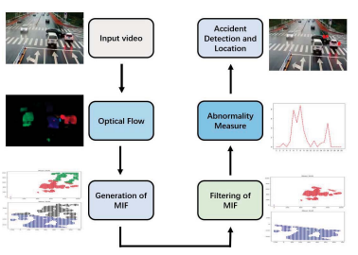

Fig.4.1.1 System architecture
DATA FLOW DIAGRAM:
- The DFD is also called as bubble chart. It is a simple graphical formalism that can be used to represent a system in terms of input data to the system, various processing carried out on this data, and the output data is generated by this system.
- The data flow diagram (DFD) is one of the most important modeling tools. It is used to model the system components.
- DFD shows how the information moves through the system and how it is modified by a series of transformations. It is a graphical technique that depicts information flow and the transformations that are applied as data moves from input to output.

VERIFY

Import libraries
NO PROCESS
Yes NO
Exploring the dataset – Accident detection data

Installing the packages
Data preprocessing

Building the model –YOLOV5

Training the model
Signup & signin

User input
Final outcome
End process

Fig.4.1.2Dataflow diagram
4.2.IMPLEMENTATION
1.Importing the packages
2. exploring the dataset - Accident Detection Data
3. Installing the packages required for yolov5 in Colab
4. Processing the Data based on yolov5 model
5. building the model in colab
- YOLOV5
6. training the model
7. building the model with YOLOv5
8. training the model
9. Flask Framework with Sqlite for signup and signin
10. User gives input as Image or Video
11. the given input preprocessed and with trained model is used for detecting the license plate
12. the segmented each object and put bounding box
13. final outcome is displayed

4.2.1 MODULES AND ALGORITHMS:
- YOLOV5: YOLO an acronym for 'You only look once', is an object detection algorithm that divides images into a grid system. Each cell in the grid is responsible for detecting objects within itself. YOLO is one of the most famous object detection algorithms due to its speed and accuracy.YOLO (You Only Look Once) models are used for Object detection with high performance. YOLO divides an image into a grid system, and each grid detects objects within itself. They can be used for real-time object detection based on the data streams.
Scheme of the YOLOv5 Architecture as Convolutional Neural Network (CNN). Main parts include the BackBone, Neck and Head. In the BackBone, CSPNet is used in order to extract features from the images which are used as input images. The Neck is used for the creation of pyramid feature.

.

4.4. SYSTEM TESTING
4.4.1 TESTING STRATEGIES
UNIT TESTING
Unit testing, a testing technique using which individual modules are tested to determine if there are issues by the developer himself.. it is concerned with functional correctness of the standalone modules. The main aim is to isolate each unit of the system to identify, analyze and fix the defects.
Unit Testing Techniques:
Black Box Testing - Using which the user interface, input and output are tested.
White Box Testing –Used to test each one of those functions behavior is tested.
DATA FLOW TESTING
Data flow testing is a family of testing strategies based on selecting paths through the program’s control flow in order to explore sequence of events related to the status of Variables or data object. Dataflow Testing focuses on the points at which variables receive and the points at which these values are used.
INTEGRATION TESTING
Integration Testing done upon completion of unit testing, the units or modules are to be integrated which gives raise too integration testing. The purpose of integration testing is to verify the functional, performance, and reliability between the modules that are integrated.

BIG BANG INTEGRATION TESTING
Big Bang Integration Testing is an integration testing Strategy wherein all units are linked at once, resulting in a complete system. When this type of testing strategy is adopted, it is difficult to isolate any errors found, because attention is not paid to verifying the interfaces across individual units.
USER INTERFACE TESTING
User interface testing, a testing technique used to identify the presence of defects is a product/software under test by Graphical User interface [GUI].
4.4.2 TEST CASES:
S.NO | INPUT | If available | If not available
1 | User signup | User get registered into the application | There is no process
2 | User signin | User get login into the application | There is no process
3 | Upload image for prediction | Prediction result displayed | There is no process

4.5 SCREENSHOTS
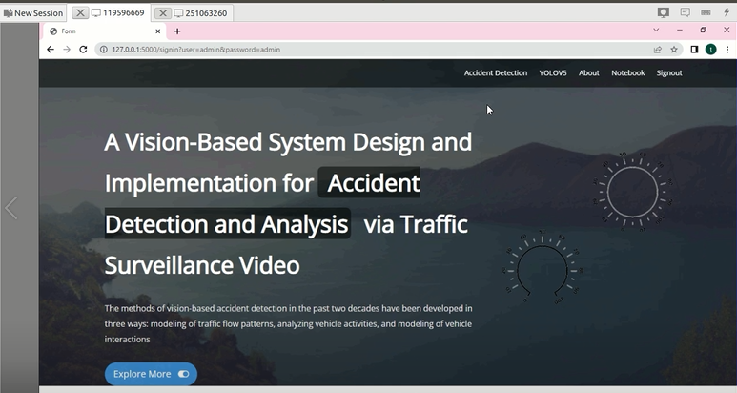
4.5.1 web open page
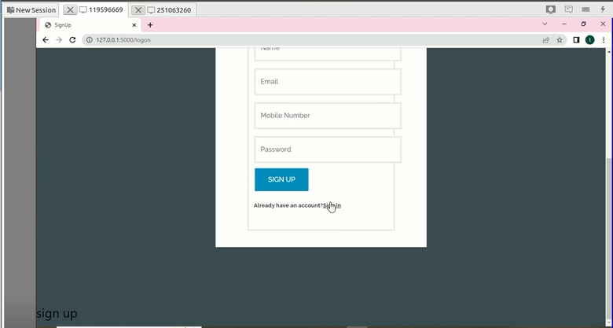
4.5.2 sign up page
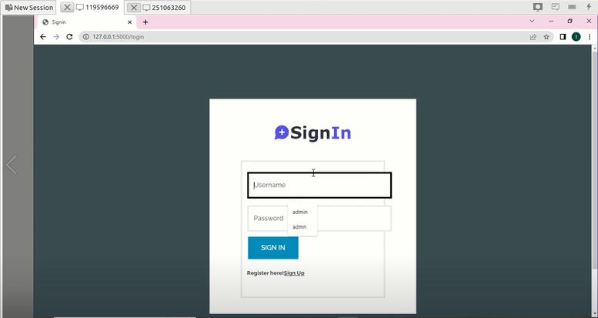
4.5.3 sign in page
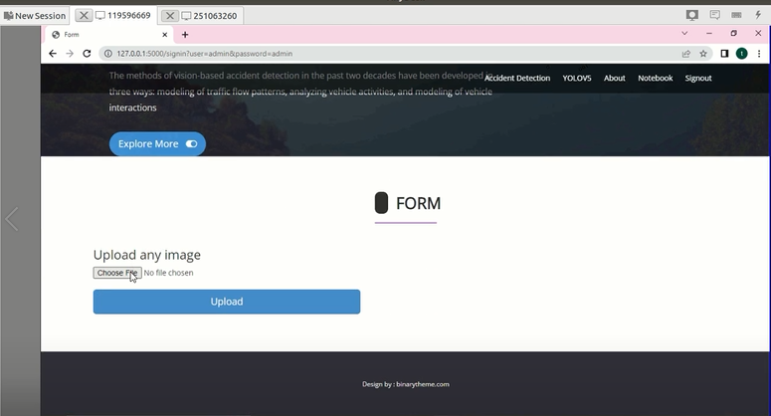
4.5.4 upload an accident image
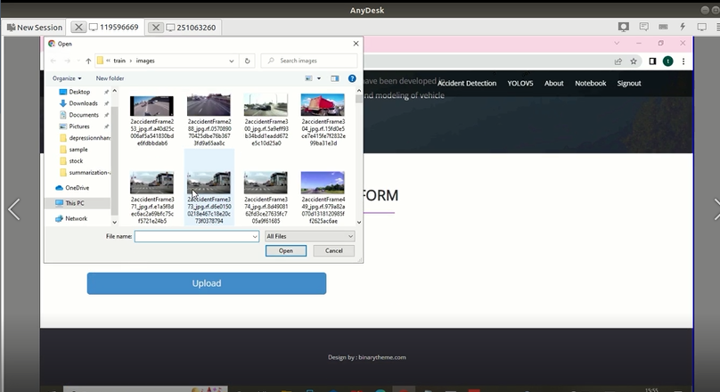
4.5.5 uploading an accident image
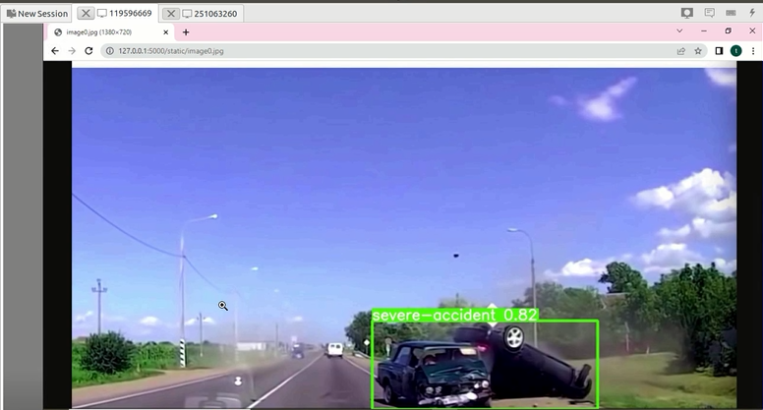

4.5.6 Result of a moderate accident
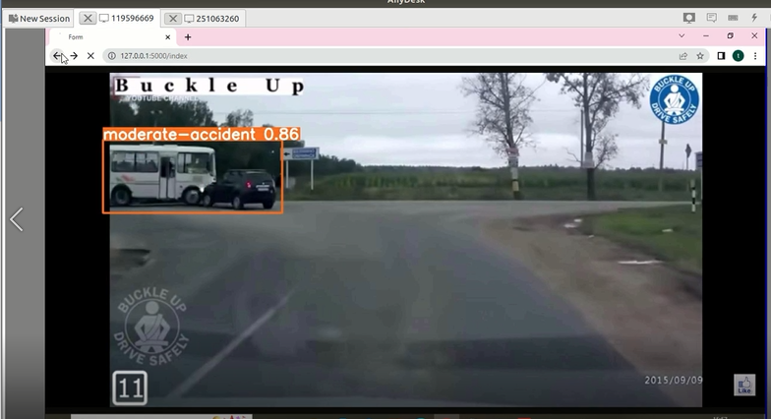
4.5.7 result of a accident with probability of 0.86 seviourness
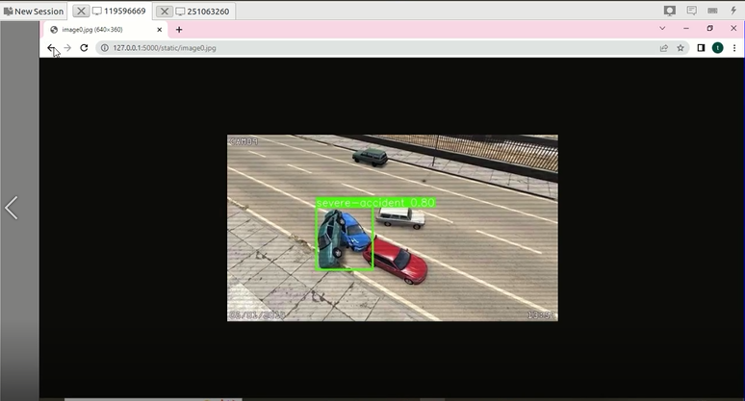

4.5.8 result of the accide

CONCLUSION

In this article, a framework was proposed for detecting and analyzing traffic accidents automatically through surveillance video. First, the technique of the MIF model was utilized to detect and locate crashes in videos. Second, a YOLO v3 model was adopted for the identification of crashed vehicles. Third, the hierarchical clustering algorithm was used to recover the trajectories before the collision. In order to facilitate the judgment of traffic police, the trajectories were projected to a vertical view through perspective transformation. Using UFIR filtering, the trajectories were filtered, and the vehicle velocity was estimated. Then, an accident was analyzed by the estimated velocity and the obtained collision angle from the vertical view. Finally, a hardware practice test had been carried out for coding all the mentioned algorithms on HiKey970, a Huawei AI demo board. An accident surveillance video acted as the input of the demo board. The accident was detected successfully, and the corresponding vehicle trajectories were recovered. The performance of HiKey970 was 28.85%–45.72% of Intel Core i7-9750H CPU @ 2.60-GHz system. However, there are still some problems to be solved in the further. First, another deep learning model can be tried to improve the identification accuracy when the car is blocked. Second, some image enhancement algorithms can be adopted for better performance of accident detection under different climate conditions or if the quality of surveillance videos is low. Third, the number plate of accident vehicles can be recognized for further analysis. In future research, we will focus more on path tracking control and attack detection for autonomous vehicles.

REFERENCES
[1] C. Regazzoni, A. Cavallaro, Y. Wu, J. Konrad, and A. Hampapur, “Video analytics for surveillance: Theory and practice,” IEEE Signal Process. Mag., vol. 27, no. 5, pp. 16–17, Sep. 2010.
[2] X. Zhu, Z. Dai, F. Chen, X. Pan, and M. Xu, “Using the visual intervention influence of pavement marking for rutting mitigation— Part II: Visual intervention timing based on the finite element simulation,” Int. J. Pavement Eng., vol. 20, no. 5, pp. 573–584, May 2019.
[3] C. F. Calvillo, A. Sánchez-Miralles, and J. Villar, “Synergies of electric urban transport systems and distributed energy resources in smart cities,” IEEE Trans. Intell. Transp. Syst., vol. 19, no. 8, pp. 2445–2453, Aug. 2018.
[4] K. Yun, H. Jeong, K. M. Yi, S. W. Kim, and J. Y. Choi, “Motion interaction field for accident detection in traffic surveillance video,” in Proc. 22nd Int. Conf. Pattern Recognit., Aug. 2014, pp. 3062–3067.
[5] J. Varadarajan, R. Emonet, and J. Odobez, “Bridging the past, present and future: Modeling scene activities from event relationships and global rules,” in Proc. IEEE Conf. Comput. Vis. Pattern Recognit., Jun. 2012, pp. 2096–2103.
[6] T. Hospedales, S. Gong, and T. Xiang, “A Markov clustering topic model for mining behaviour in video,” in Proc. IEEE 12th Int. Conf. Comput. Vis., Sep. 2009, pp. 1165–1172. [7] W. Hu, X. Xiao, Z. Fu, D. Xie, T. Tan, and S. Maybank, “A system for learning statistical motion patterns,” IEEE Trans. Pattern Anal. Mach. Intell., vol. 28, no. 9, pp. 1450–1464, Sep. 2006.
[8] S. Sadeky, A. Al-Hamadiy, B. Michaelisy, and U. Sayed, “Real-time automatic traffic accident recognition using HFG,” in Proc. 20th Int. Conf. Pattern Recognit., Aug. 2010, pp. 3348–3351.
[9] Y.-K. Ki, “Accident detection system using image processing and MDR,” Int. J. Comput. Sci. Netw. Secur., vol. 7, no. 3, pp. 35–39, 2007.
[10] D. Zeng, J. Xu, and G. Xu, “Data fusion for traffic incident detector using D-S evidence theory with probabilistic SVMs,” J. Comput., vol. 3, no. 10, pp. 36–43, Oct. 2008.

