Leveraging ERP way for Crafting World class excellence Organizations.

Author 1: Dr. Jaya Yadav
Designation: Professor, Amity Business School
Institutional Address: Amity Business School, F-3 Block, Amity University Campus, Sector-125, Noida-201313, Gautam Budh Nagar, U.P. (India)
e-mail Id: jyadav2@amity.edu

Author 2: Dr. Anshu Singh
Designation: Associate Professor
Institutional Address: Amity Business School, F-3 Block, Amity University Campus, Sector-125, Noida-201313, Gautam Budh Nagar, U.P. (India)
e-mail Id: asingh42@amity.edu

ABSTRACT
Enterprise Resource Planning is among the main high technology tool that reinforces organizations excellence. It supports by integrating the core functional domains of any business enterprise processes. This study aims towards analyzing a conventional, yet smart ERP system, which is critical to a business and also supports a perspective to the skills and benefits of the ERP software. Required data was collected via interviewing the employees to determine their experiences of using ERP which was then analyzed via content analysis to derive SWOT Analysis. The findings revealed that the corporate gain a global recognition with the help of ERP system by strengthening their internal and external environment, hence providing smooth functioning of organization especially during expansions, collaborations and mergers. The benefits of ERP system were found to be both tangible and intangible. Therefore, in a nutshell it can be stated that the ERP has proven to be one of the most effective tools in managing the organizations. It has been found to support all aspects of process management thereby benefitting both organization as well as employee which is evident from its outreach to even public sector firms.

Keywords: Enterprise resource planning, Information and Communication technology, SAP, Software

1. INTRODUCTION
Technology has always been important for the business world. Technology provides us with innumerable benefits which help corporates in making money and satisfy customers’ needs and demands. Regardless of the corporates’ size, technology affects the internal and external environment of a business. In the business world where everyone believes in staying connected to each other, companies have realized the importance of having the ERP system. ERP will primarily help to increase the efficiency of the corporates, and it will simultaneously increase the overall business decisions in the future.

  - SIGNIFICANCE OF THE STUDY:
This study contributes to theoretic information of ERP and highlights the excellent internal and external flow of data in the organizations. The readers will be able to understand why a conventional, yet smart ERP system is important to their business. It also provides an explanation to the skills and benefits of the ERP software- SAP. Specifically, readers can get the insight information about the functioning of the SAP software in leading PSU.

2. LITERATURE REVIEW
Work resource planning was developed in the 1960s, starting with materials planning (MRP). The system has been improved and converted to MRP II (Başoğlu et al., 2007).
The
MRP II system is an effective tool for planning all types of resources in an organization. This knowledge is necessary for planning production processes, but organizations are aware of the need to combine customer satisfaction and profits (Wallace and Kremzar, 2002).
In the early 1980s, governments around the world began experimenting with various government reforms. Many of these efforts have sought to translate strategic management concepts from the private to the public sector (Rosacker & Rosacker, 2010). In its latest form,

ERP systems can manage many business functions, including customer relationship management, human resources, purchasing, finance and operations, accounting, production, ordering, product management, marketing and sales planning (Botta-Genoulaz and Millet), 2006). Due to the benefits of using ERP, the public has started to use this system in their organizations (Rosacker & Rosacker, 2010). For this reason, many organizations have adopted ERP and its use in the service sector has increased rapidly (Acharyulu, 2012).
More and more companies are turning to ERP solutions to better organize their IT resources and manage their legacy systems rather than building their own IT systems (Holland and Light, 1999). Various statistics show that ERP systems were one of the largest IT investments in the 1990s (Chung and Snyder, 1999). The most important aspect of adopting an ERP system is selection, the selection process should be tailored to the organization's requirements as well as be specific to the organization and follow standard controls. (Radut and Codreanu, 2012).

Companies can gain many benefits by transferring non-integrated assets into ERP systems; Shorter lead times, faster data processing, e-commerce support, better information and knowledge management (KM), including improved reporting (Davenport, 2000; Ross and Vitale, 2000).
The ERP system provides business integration by bringing together all functions and offices for data collection, processing, monitoring and reporting with integration and coordination (Dillon, 1999; Davenport, 2000; Al-Mudimigh et al., 2001; Murray and Coffin, 2001).

Rouhani and Mehri (2018) divide ERP benefits into 4 categories including information benefits, communication benefits, developmental and learning benefits, and good benefits. The results show that communication, strategies and knowledge support the results very well. Tasewska et al.
(2014) argue that much of the success of ERP implementation is due to its positive impact on customer satisfaction and perceived quality measures. A successful ERP implementation is also linked to project management, senior management support, teamwork, change planning and integration of the ERP team. Organizational culture, business environment and government policy also pose challenges in implementing ERP systems (Ward & Peppard, 2016).

3. OBJECTIVES
- To evaluate the significant success factors of the ERP system and their implications.
- To identify the supporting factors which lead to the increasing demand of ERP system in the business world.
- To comprehend the overall business performance of SAP, the principal ERP software in the selected Organization.
- To analyze the impact of the functioning of the SAP in the organization’s strategic benefits.

4. RESEARCH METHODOLOGY:
A pilot study was undertaken with a sample size of 30 strategic leaders across domains of a leading PSU, from its various branches across the country. As the research design was descriptive in nature, the primary sources of data collection include the data provided by the concerned officials, survey, personal interview, observations, and descriptive questionnaire.The moderate number of respondents could be attributed due to the constrained time schedule. Content analysis has been be used to infer the conclusion

5. DATA ANALYSIS AND INTERPRETATION:

5.1 Content analysis

Statement 1: ERP covers all departments of an organization

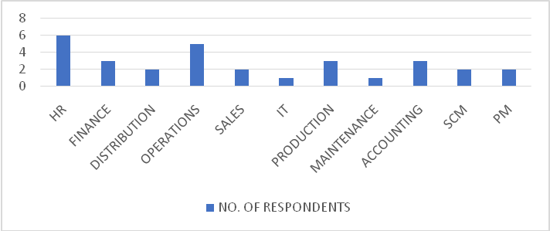
Figure 1: Usage of ERP across departments

Interpretation: The above statement can be analyzed from the responses collected via the questionnaire. The sample population includes employees from various departments of the organization- Oil India Limited. The departments are distribution, finance, human resource, production, operations, maintenance, sales, information technology, accounting, supply chain management, project management etc.

Statement 2: SAP is widely used ERP software

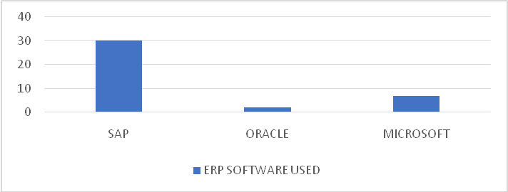
Figure 2: Most used ERP software

Interpretation: Almost all the respondents have used SAP as their ERP software. SAP (Systems, Applications and Products) is enterprise software as well as the name of its company. It was developed in 1972 in Germany by 5 IBM employees namely, Wellenreuther, Hopp, Hector, Plattner and Tschira. It has been recognized as the number one leader with more than 50 percent of the ERP market. Recently, there are over 75,000 customers running the SAP software systems today; this equals to 140,000 successful implementations. Other competitive products of SAP software are Oracle, Microsoft Dynamics, etc.

Statement 3: ERP is effective for corporate related works

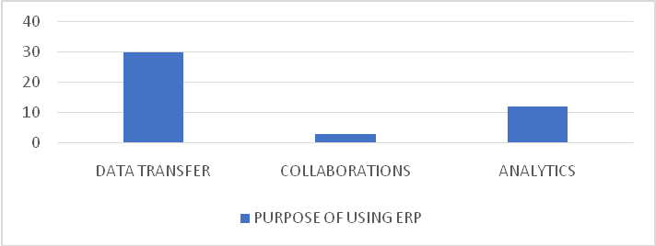
Figure 3: Purposes of using ERP

Interpretation: Almost all the respondents have used ERP during his/her office work. It means for any organizational work ERP is very effective. Apart from the day-to-day data transfer tasks, respondents agreed to use ERP for various collaborations and analytical work. As a whole it can be implemented that there are various purposes of using ERP, regardless of the software used.

Statement 4: ERP system can be customized

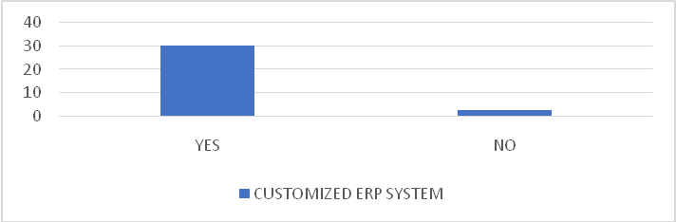
Figure 4: Customized ERP systems

Interpretation: 24 out of 30 respondents have agreed that their ERP systems were customized. The customization can be done to any desired module without making changes to the whole ERP software.

Statement 5: SAP has various modules

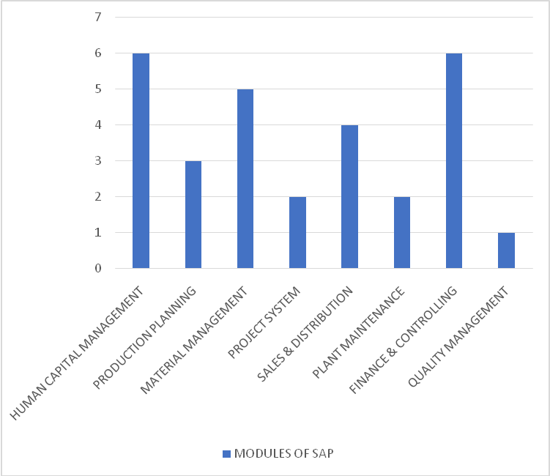
Figure 5: Different types of SAP

Interpretation: The sample population includes respondents specialized in different modules of the SAP software. The term “module” means any business-related process in SAP software. SAP’s 2 types of modules are the functional and technical modules.

Statement 6: ERP users are satisfied with the software

Table 1: Respondents’ Satisfactory Statements About ERP
Respondents | Statements
1 | The ERP database has played an important role in building an organized management .
2 | By using SAP HCM, high demand is experienced.
3 | After using ERP, the work process became smoother.
4 | SAP helps in managing the training cost.
5 | I have been using ERP for 5 years now and the experience is good.
6 | While using the ERP system at office, my workloads have lessened.
7 | I daily use SAP at my workplace, and this has created a connection among all departments.

Interpretation: Some of the statements provided by the respondents are stated above. All the respondents described their experiences of using ERP positively. The respondents have used SAP as the ERP software. They briefly shared their experiences of using the ERP system.

Statement 7: Effective factors of ERP implementation

Table 2: Different Factors for Selecting ERP
Respondents | Factors for Selecting ERP
1 | Flexibility and easy-to-use.
2 | Top-leading software.
3 | The software is robust and cost-efficient.
4 | The software can store a huge amount of data.
5 | The software easily integrates with other components of the organization.
6 | The software is an on-premises system.
7 | The SAP software also comes with a DR site.

Interpretation: Respondents provided various successful factors leading to ERP implementation. The responses mostly incline to the effectiveness of the SAP software. Some given factors are- flexibility, easy-to-use, robust, cost efficient, high storage capacity, on-premise system, top-leading software, easily integrates all components of an organization, smoother functioning, better communication, various analytical features, great enterprise mobility, supports global solutions, etc.

Statement 8: ERP is better than paperwork

Table 3: Statements from Respondents Regarding ERP vs Paperwork
Respondents | Reasons for choosing ERP over paperwork
1 | Save time, reduce paper use.
2 | It makes the recruitment process quicker and easily manageable.
3 | There is complete time and cost efficiency.
4 | Writing everything on paper is time consuming.
5 | ERP helps in communicating with other components of the organization.
6 | The data doesn’t get lost in the ERP unlike in the paperwork.
7 | Urgent data can be easily transferred.

Interpretation: Respondents are in favor of using ERP over traditional paperwork. The reasons are stated as – reduction of paper use, easily manageable, time and cost efficiency, latest trending method, less duplicity, easily accessible, user-friendly, etc.

Statement 9: Failure factors of ERP implementation can be ignored

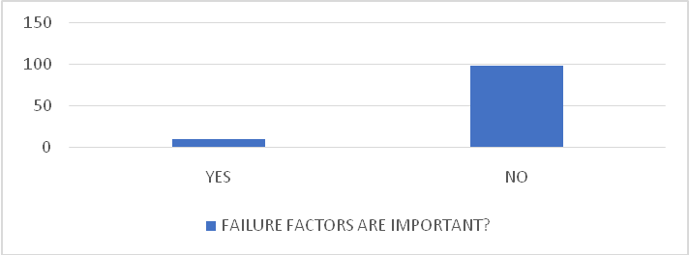
Figure 6: Importance of failure factors for considering ERP implementation

Interpretation: Many respondents agreed to the above statement. The critical factors such as high cost and complex structure of the software can be ignored because there are many advantages of the ERP system. Once the critical factors are handled, the ERP system provides smooth functioning to the organization. Some of the statements provided by the respondents are- “the critical factors are less important in comparison to the profit gained by the ERP implementation”, “too many advantages than disadvantages in the system”, “there are very less critical factors but many successful factors”.

5.2 SWOT analysis

5.2.1 Strengths:
Some of the advantages of SAP are:
• Successfully integrated with organizations, ERP systems, previously only in the private sector, have now become an important part of the public service and government agencies.
• Full transparency in all business processes across departments in the organization.
• SAP has become a software genius when it comes to business innovation. The software has expanded business needs in new areas.
• There is no doubt that SAP is useful software.
But some tools are for professionals only. Therefore, when companies use SAP, it ensures that users are well trained on all the tools they will need for their future work.
• Modules such as Productivity, Order Management Cycle, Cash Management and Online Shipping were developed.

5.2.2 Weaknesses:
Here are some weaknesses that SAP should be aware of:
• SAP cannot integrate companies with different workforces. Admittedly, SAP has been successful in integrating small companies, but has failed miserably at integrating businesses with different cultures.
• If products are not balanced, competitors rise.
• SAP is undoubtedly one of the most effective ERP software, but it still has problems segmenting its products correctly. The software has been extended in several products and should be expanded to more products.

5.2.3 Opportunities:
There are areas where SAP can increase its value. These include:
• Business development that will increase competitors' competitive advantage and enable SAP to increase its competitiveness with other competitors.
• Major investments were made in SAP online and new sales channels were opened.
• Lower Inflation Rate - A lower inflation rate stabilizes the economy, allowing SAP customers to get loans at lower interest rates.
• New technologies give SAP the opportunity to use different pricing strategies in new markets.
Therefore, users will find more satisfaction compared to their competitors.

5.2.4 Threats:
Although SAP is one of the best ERP software, it still faces many threats such as:
• The number of low-cost products similar to SAP has increased. Users want such products due to reduced operating and operating costs.
• In the last two years, the business volume of SAP's competitors has increased, resulting in a decline not only in profits but also in overall sales.
• The company produces a large number of products, but there is a constant supply of new products, resulting in high sales and low sales over time.
• Another threat is the increase in local suppliers in some markets.
Local suppliers eat into SAP's profits.
• High demand for products is seasonal, and anything bad during the season can affect a company's bottom line.
• The company operates in many countries. Therefore, results often change depending on the regulatory environment of the market.
• Changing online shopping behavior may threaten the current supply model driven by physical infrastructure.

6. FINDINGS

As a result of the analysis of the answers found and received in the survey and customer interviews, the following results were obtained:

ERP systems are based on real business needs and support all aspects of the management process. The mission itself is very broad and will include strategic, tactical and operational issues, so there will be many results achieved.
• This study discusses the concept of ERP as a leading, supporting and supporting system that meets the needs of modular businesses and can help increase the efficiency of business process management.
• Research shows that ERP systems can provide many positive and negative benefits. ERP systems are designed to improve all business processes.
• ERP implementation is considered successful if it achieves most of the positive results. These benefits can include reduced account numbers, reduced technology costs, better inventory management, and improved order and cash management.
• One of the most important elements of the ERP system in terms of business development is a policy/strategy that can be implemented as a plan for the success of each association.
• In terms of benefits, there is evidence of labor savings and increased income after ERP implementation. Thanks to the application of the ERP system, the business level of the main enterprise has increased.
There have been significant improvements and some unexpected developments in the field of inventory management. Using the new system, finished products are transferred from the storage area to the storage area.
• Non-financial improvements to the ERP system are probably the most important. The company will then continue to grow and find new ways of collaboration that would not be possible with legacy data processing technology. The company has experience in implementation, integration and data development.
Now he can come up with new ideas and strategies to manage his business with powerful but also ineffective tools.
• In addition to the effectiveness of ERP systems, the quality of SAP software has also been demonstrated by research. Some of the advantages of SAP software are described below.
o The ability of the software to run.
o Gives companies the flexibility to create their own rules in the SAP model.
o Offers a wide range of analytics to meet the needs of complex businesses and government agencies.
o The new version of SAP provides excellent business performance.
o SAP User Groups provide a great opportunity for customers to collaborate and get more out of their software resources.
o SAP supports global solutions with 45 national standards and 8 additional countries.
o SAP is the industry leader and able to retain most of its customers.

7. RECOMMENDATIONS AND SUGGESTIONS:

For an ERP system to work effectively, seven concerns need to be identified: implementation, after-sales, change and management, ERP business and marketing, education and training manual, supply chain management, and the ERP system itself and affect both managers and researchers. Managers can help ERP systems by understanding the various issues that people need to consider when it comes to ERP systems, as well as the issues that need to be addressed and paid for when it comes to ERP systems. Researchers interested in ERP systems can use the conceptual knowledge of ERP to guide their own research and interests, and to build an understanding of ERP's general concepts about research.

8. CONCLUSIONS AND LIMITATIONS:

From this study, some important points can be drawn about the effectiveness of ERP systems. The main purpose of this study is to determine the possible reasons for the increased demand for ERP systems. SAP is the main ERP software in this study. Many advantages of implementing SAP in an organization have already been achieved. Businesses create Internet with the help of ERP system.
In addition to the internal environment, the external environment, such as the expansion, cooperation and integration of the organization, also depends on the effective operation of the ERP system. These companies have gained international recognition with the help of their ERP software. In short, the business management of the organization largely depends on the management tools and ERP has proven to be one of the best tools for managing the organization.

First, the results of this study cannot be generalized because a very large sample was taken. However, the results provide valuable information for managers, researchers, and administrators dealing with ERP systems.
Second, we identified fewer items in eight categories. For more information, more items should be included in the survey to assess the success of ERP systems. Additionally, organizations differ in their initial learning and acquisition capabilities, which may explain the differences in the success of IT implementation. One possible explanation is that businesses must first have some form of learning ability to acquire new knowledge that needs to be used for practice; On the other hand, the result of the use of new IT systems and their integration into the company's business processes also increases the company's knowledge. To leave.

It is also limited to a specific area, but we have no reason to believe that business in this area differentiates ERP implementation from other similar companies.
Another possible explanation for our poor results is that we sampled only one organization that had deeply penetrated and implemented an ERP system. They have an ERP system since 2005 and have successfully implemented it during the ERP implementation. Measuring response prior to ERP implementation can have a greater impact on the organization's future results. It seems that most organizations with "mature" ERP implementations (> 1 year) achieve this to varying degrees, because all the ways to implement ERP and IC sizes are important.

9. SCOPE OF FUTURE RESEARCH
More research is needed to understand the benefits of ERP systems. Further research can be done to gain in-depth knowledge of SAP software.

REFERENCES:
- Alaskari, O., Ahmad, M. M., Dhafr, N., and R. Pinedo-Cuenca (2012). Critical Success Factors (CSFs) for successful implementation of lean tools and ERP systems. In Proceedings of the World Congress on Engineering, Vol III, WCE: London, 1627-1632.
- Alves, M., Matos, S., Alves, M. and S. Matos (2012), ERP Adoption by Public and Private Organizations– A Comparative Analysis of Successful Implementations. Journal of Business Economics and Management, 14(3), 500-19.
- Basoglu, Nuri, Tugrul Daim, and Onur Kerimoglu. 2007. Organizational Adoption of Enterprise Resource Planning Systems: A Conceptual Framework. The Journal of High Technology Management Research 18: 73–97.
- Chung, S.H. and Snyder, C.A. (2000), “ERP adoption: a technological evolution approach”, International Journal of Agile Management Systems, Vol. 2 No. 1, pp. 24-32.
- Elisabeth J. Umble, Ronald R. Haft, M. Michael Umble, (2003). Enterprise resource planning: Implementation procedures and critical success factors. European Journal of Operational Research, 146, 241- 57.
- Farzaneh Amani Adam Fadlalla, (2016). Organizing ERP research: a knowledge-centric approach. Journal of Enterprise Information Management, 29(6), 919- 40.
- Gargeya, V., and C. Brady (2005). Success and failure factors of adopting SAP in ERP system implementation. Business Process Management Journal, 11(5), 501-16.
- Holland, C. R., and B. Light (1999). A critical success factors model for ERP implementation. IEEE Software, 16(3), 30- 36.
- Law, C., Chen, C., and B. Wu (2010). Managing the full ERP lifecycle: Considerations of maintenance and support requirements and IT governance practice as integral elements of the formula for successful ERP adoption. Computers in Industry, 61, 297- 30.
- Mitra, P., & Mishra, S. (2016). Behavioral aspects of ERP implementation: A conceptual review. Interdisciplinary Journal of Information, Knowledge, and Management, 11, 17-30.
- Radut, C. and Codreanu, D-E. (2012) ‘Selection of an organization specific ERP system’, Ideas REPEC Journal, Vol. 18, No. 2, Supplement, pp.384–389.
- Rosacker, K. M., & Rosacker, R. E.,“Information technology project management within public sector organizations”, Journal of Enterprise Information Management, Vol. 23, No. 5, pp. 587-594, 2010.
- Rouhani, Saeed, and Mobin Mehri. 2018. Empowering Benefits of Erp Systems Implementation: Empirical Study of Industrial Firms. Journal of Systems and Information Technology 12: 54–72.
- Tasevska, F., Damij, T., & Damij, N. (2014). Project planning practices based on enterprise resource planning systems in Small and Medium Enterprises — A Case Study From the Republic of Macedonia. International Journal of Project Management, 32(3), 529–539.
- Wallace, Thomas F., and Michael H. Kremzar. 2002. Erp: Making It Happen: The Implementers’ Guide to Success with Enterprise Resource Planning. Hoboken: John Wiley & Sons, vol. 14.
- Ward, John, and Joe Peppard. 2016. The Strategic Management of Information Systems: Building a Digital Strategy. Hoboken: John Wiley & Sons.
- Murray, M.G. & Coffin, G.W. 2001, 'A Case-Study Analysis of Factors for Success in ERP System Implementations', Seventh Americas Conference on Information Systems, pp.l012-IOI8. Retrieved: March 15,2003, from Association for Information System Electronic Library (AISeL) database.

