**IMPACT OF ARTIFICIAL INTELLIGENCE ON THE NEXT GENERATION WORKFORCES**

**Dr. R. Prema**

Associate Professor of Commerce, KPR College of Arts Science and Research, Coimbatore

Email: [rprems6@gmail.com](mailto:rprems6@gmail.com), [prema.r@kprcas.ac.in](mailto:prema.r@kprcas.ac.in)

**Ms. K. S. Hansadvani**

III B.Com, KPR College of Arts Science and Research, Coimbatore

Email: [hansadvani.ks24@gmail.com](mailto:hansadvani.ks24@gmail.com)

**ABSTRACT**

This chapter contains some reflections about artificial intelligence. The main goal of artificial intelligence (AI) is that a machine can have a type of common intelligence comparable to a human’s and is one of the most determined ever proposed by science. In terms of difficulty, it is comparable to other great scientific goals, such as explaining the origin of life or the Universe, or discovering the structure of matter. Leading technological companies are vying with one another to integrate artificial intelligence into our daily lives, which will pave the way for a truly great and exciting artificial intelligence future.

**Keywords**: Artificial Intelligence, Ethical Issue in AI, Human Intelligence.

**INTRODUCTION**

Each and every latest discovery will have both the pros and cons, though it's upon humans to manage this and use the advantages of the discovery to improvise the world. The notable benefits of artificial intelligence are enormous. The essential role humans are supposed to play in preventing the "upsurge of the robots" from getting immensely wild. Others claim that artificial intelligence, if it falls into the wrong hands, has the power to destroy human civilization. No matter how, nevertheless any of the AI applications were built at the level that had the power to exterminate or subjugate humans.

Artificial intelligence has advanced quickly and is no longer simply an idea from sci-fi movies and books, with driverless automobiles and voice automation in houses. The 2054 forecasts made in the acclaimed movie "Minority Report" are coming true faster than expected. In a study conducted by researchers at the University of Oxford, it was found that artificial intelligence will surpass humans in a variety of tasks by the years 2024, 2026, 2031, 2049, 2053, and 2031 in terms of writing essays for school, selling products, and creating popular books. In the imminent years, artificial intelligence (AI) will compass every demeanor of our life and in due course surpasses human intellectual capacity.

Think about using facial recognition technology instead of a key to enter your hotel room. Your facial features will provide your identity, making daily negotiations more straightforward and effective. Prepare for smaller drones to bring your purchases right to your door within minutes of placing an order.

Artificial technology-based virtual assistants are capable of making human-like phone calls to counterfeit an appointment at, say, your local food dentist while taking into the context and subtlety of the intercourse. Be primed to undergo surgery with a robot surgeon. In a few more years, a physical paramedic won't be intrigued in the procedure at all; instead, a robot will do it and assist patients in better understanding their therapy options.

These are only a few instances of the ways artificial intelligence will alter the future. Computerized Intelligence, although technological breakthroughs in the future appear far off, they will arrive faster than we can imagine. Leading technological companies are vying with one another to integrate artificial intelligence into our daily lives, which will pave the way for a truly great and exciting artificial intelligence future.

**AI’S INTERFERENCE IN MODERN PERIOD**

These days, artificial intelligence, or AI, seems to be a hot topic. Although I've been conscious of the outstanding trend in technological advancement for a while, I've noticed that AI is becoming one of the expertise that job seekers are most in search of. Artificial intelligence is a topic that, in its most basic form, combines computer science and substantial datasets to grease the wheels in problem-solving. Moreover, it includes the branches of artificial intelligence known as deep learning and machine learning, which are commonly addressed together. These fields use AI algorithms to build expert systems that make predictions or categorize information based on incoming data. With the data provided the AI makes decisions and choices by themselves according to the environment without the intervention of the external factors.

I'm sure that the phrase "AI" evokes science fiction fantasies or nightmares about machines consuming society for many of us. The way artificial intelligence (AI) has been portrayed in the media has varied widely, and while no one can predict with certainty how it will develop in the future, the present trends and advancements offer a very different picture of how AI will affect our daily lives. Actually, artificial intelligence (AI) is already in use everywhere, influencing everything from our search engine results to our chances of finding love online to the way we purchase. According to data, during the last four years, the application of AI has increased by 270% across numerous corporate sectors.

Advanced web search engines, like Google Search, recommendation systems, understanding human speech, like Siri and Alexa, self-driving cars like Waymo, generative or creative tools, automated decision making, and competing at the highest level in strategy game systems (such as chess and go) are just a few examples of AI applications.

Affect is a phenomenon where tasks that were once thought to require intelligence are now frequently excluded from the concept of AI as computers become more adept. Although it is a common technique, rapid optical character recognition is typically omitted from what is regarded as AI.

Research in AI is divided into a number of subfields, each of which has its own objectives and set of tools. Traditional objectives of AI research include natural language processing, planning, learning, reasoning, knowledge representation, vision, and the ability to move and manipulate objects. One of the field's extended objectives is general intelligence. Artificial neutral networks, formal logic, search and mathematical optimization, method-based statistics, probability, and economics are just a few of the tools that AI researchers have adapted and integrated to address this issue. AI also draws on a variety of other disciplines, including computer science, psychology, linguistics, and philosophy.

Since its establishment as a field of study in 1956, artificial intelligence has gone through multiple waves of optimism, disappointment, and funding loss (dubbed "AI winter"), followed by new strategies, accomplishments, and increased funding. Since its inception, research has experimented with and abandoned a wide range of methodologies, including brain simulation, human problem-solving modelling, formal logic, a sizable store of information, and animal behaviour imitation. Very mathematical statistical machine learning has dominated the discipline in the first decade of the twenty-first century, and this approach has been very effective in assisting with the resolution of many difficult problems in both industry and academics.

**GROWTH OF AI**

1950 sees the release of Computing Machinery and Intelligence by Alan Turing. Turing, who gained notoriety during World War II for cracking the Nazi ENIGMA code, proposes in the paper to address the question, "Can machines think?" and put in place the Turing Test to work out whether a computer can demonstrate the same intelligence (or the outcomes of the same intelligence) as a human. Since then, people have wrangled over the Turing test's usefulness.

1956: John McCarthy introduces the phrase "artificial intelligence" during the inaugural AI conference held at Dartmouth College. The Lisp programming language was created by McCarthy. In the course of that year, Allen Newell, J.C. Shaw, and Herbert Simon developed the Logic Theorist, the first ever operating AI software application.

1967 saw the creation of the Mark 1 Perceptron by Frank Rosenblatt, the first machine to use a neural network that "learned" by making mistakes. Perceptron’s, a book written by Marvin Minsky and Seymour Papert, is published just a year later. It quickly establishes itself as a classic work on neural networks while also serving as, at least temporarily, a counterargument to further research into neural networks.

The 1980s see the widespread adoption of neural networks in AI applications, which train themselves using a backpropagation technique.

1997 saw IBM's Deep Blue surpass former world chess champion Garry Kasparov in a chess match (and rematch).

2011: Ken Jennings and Brad Rutter were defeated by IBM Watson on Jeopardy!

2015: To detect and categorize images with a greater rate of accuracy than the average person, Baidu's Minwa supercomputer employs a unique type of deep neural network called a convolutional neural network.

In a five-game battle in 2016, Lee Sodol, the reigning world champion Go player, was defeated by DeepMind's AlphaGo computer, which is run by a deep neural network. Given that there is a staggering amount of moves that can be made as the game proceeds (more than 14.5 trillion after only four moves!), the victory is noteworthy. In the future, Google reportedly paid $400 million to acquire DeepMind.

**AI ON PAR COMPARISON WITH HUMAN INTELLIGENCE:**

Under the premise that human intelligence can be so exactly characterized that a machine may be created to stimulate it, this field was established. These concerns have previously been investigated by myth, literature, and philosophy since antiquity. This brought up philosophical discussions concerning the mind and the ethical ramifications of constructing artificial beings endowed with human-like intellect. Since then, computer scientists and philosophers have argued that if artificial intelligence (AI) is not guided in using its logical skills for the benefit of society, it may end up becoming an extension of humans.

Human competence is being escalated while age-old human activities are being disrupted by digital life. With ambient information and connectivity, code-driven systems have reached more than half of the world's population, providing opportunities and threats that had never before been possible. Would individuals be in a better position than they are now when new algorithm-driven artificial intelligence (AI) spreads?

Networked artificial intelligence, according to the experts, will increase human performance while simultaneously posing a threat to their autonomy, agency, and skills. They discussed the numerous possibilities, including the possibility that computers might match or even surpass human intelligence and capabilities on tasks like complex decision-making, reasoning, and learning, as well as on other areas like visual acuity, speech recognition, language translation, and sophisticated analytics. They claimed that "smart" systems in cities, cars, buildings and utilities, farms, and business operations would reduce costs, save lives, and provide people the chance to live more individualized futures.

Several of the optimistic comments centered on health care and the numerous potential uses of AI in patient diagnosis and treatment or in assisting in the richer, healthier lives of senior persons. Also, they were excited about the contribution that AI could make to large-scale public-health initiatives based on vast volumes of data that may be gathered in the upcoming years about anything from nutrition to individual genomes. Some of these experts also projected that AI would make possible long- awaited improvements to official and informal education systems.

Yet, the majority of experts, whether they are pessimistic or not, voiced worries about how these new technologies will affect the fundamental aspects of what it means to be a person in the long run. We asked every participant in our non-scientific poll why they thought AI would make people better off or worse off, and they were all asked to provide specifics. Numerous people expressed grave concerns while also offering numerous answers. The table that follows outlines the key threats and solutions that they discussed.

The most voiced out concerns about AI within the future human lifestyle by the experts are

* Human agency: Individuals are experiencing a loss of control over their lives
* Data abuse: Data use and surveillance in complex systems is designed for profit or for exercising power
* Job loss: The AI takeover of jobs will widen economic divides, leading to social upheaval
* Dependence lock-in: Reduction of individuals’ cognitive, social and survival skills
* Mayhem: Autonomous weapons, cybercrime and weaponized information

**AI will probably not make human workers obsolete, at least not for a long time:**

The robots in all likelihood are not coming for your jobs, at least up to a certain point, so you can put some of your perplexity to rest.

Given how artificial intelligence has been presented in the forum, particularly in some of our favourite science concoction films, it is evident that the improvement of this technology has raised solicitude about the prospect that humans could one day become redundant in the workplace. After all, many tasks that were earlier carried out by human hands have become automated as technology has improved. It makes sense to worry that the development of clever computers may interlude the beginning of the end for employment as we know it.

But there is unneeded to be so pessimistic. Artificial intelligence and the future of work was the topic of a recent paper written by the MIT Task Force on the Work of the Future that took a intricate look at these advancements and how they relate to the workplace. The tone of the paper is more upbeat.

The article makes the case that AI won't encourage the demise of human work, but rather that it will continue to fuel huge innovation that will support many current businesses and may even open up a number of new ones for expansion, ultimately leading to the creation of additional jobs.

Nonetheless, humans are capable of "generalized intelligence," which includes the kind of problem-solving, abstract thought, and critical judgment that will remain crucial in the corporate world. Even if human intuition isn't necessary for every work, it is admissible at every level and in every industry.

There are a lot of other things that could stop AI from developing too quickly. AI frequently calls for "learning," which might include enormous volumes of data. This raises concerns about the availability of the proper kind of data, emphasises the need for classification, and draws attention to concerns about privacy and security related to such data. Moreover, calculation and processing capacity have their limits. One high geared language model AI was expected to outlay $4.6 million in electricity alone.

There are still ethical concerns with regard to AI research, development, and application even though we are a long way from the robot-run world in the classic science fiction story. The truth is that there is already technology based on AI in use around the world. It is in charge of analytics, research, and automation in a variety of industries, including manufacturing, transportation, healthcare, and education.

While there is plenty to be optimistic about in terms of development and potential, the quick and successful growth of AI products has shown a diversity and demographic imbalance. Ethical AI cannot be overlooked in the quest to build a world that is increasingly digital and technologically advanced.

**AI’S CURRENT POSITION IN THE WORLD**

Artificial intelligence (AI) technologies are currently used in a wide range of industries, from consumer electronics to customer service software and technological arms races. Both the collection of patient data and the formulation of patient-specific health findings involve their utilization in the healthcare sector. During the COVID-19 pandemic, AI techniques were utilized to monitor people's health behaviours, which has the potential to save lives.

Even in space, AI is assisting astronauts and looking for NASA scientists around the cosmos. It is employed in the creation of autonomous vehicles, in trade and banking, and even in military applications like as training and unmanned weaponry. The boundaries of AI applications are still being explored, and businesses, organisations, and institutions all around the world are integrating AI technology into their operations and advancements.

The existing uses of AI have led to unfairness and ethical concerns, quite apart from the exciting insight into future possibilities they provide. Let's discuss the ethical risks of AI now that we have a fundamental understanding of how it works and where it came from in contemporary culture.

**ETHICAL ISSUE OF AI APPLICATION**

The question of whether a product has reliable AI isn't really the heart of AI ethics. Use AI in healthcare as an example to better grasp the causes of ethical issues and machine bias. An algorithm created to inform hospitals and insurance providers about which patients would benefit from further care was shown to be racially biased, according to a study published in science. The AI programme, which was created to concentrate attention on sicker individuals, favoured white patients over black patients due to the cost discrepancy in the data used to train it. This incident is not unique. Think about the following scenarios where AI could have disastrous results: For instance, racial profiling-prone police departments deploy AI facial recognition technology, or job profiles are trained using gender stereotypes. When AI research and development are not inclusive, ethical issues arise. Ethical considerations must be taken into account as artificial intelligence is integrated into institutions that people rely on for their health, safety, identification, and other needs as well as when it has an impact on real-world systems.

**FUTURE WITH ETHICAL AI**

There are already implemented and in use AI systems. Yet since there isn't much, if any, regulation of AI, it's up to the next generation of artificial intelligence researchers, developers, and leaders to make sure there is as much diversity as possible. As more funds are invested in the creation of AI technology, designers should take proactive steps to remove bias from their creations. The elimination of prejudices and moral conundrums relating to AI can be facilitated by broader expertise and demographic inclusiveness, including variety in cultures, sexual orientations, races, and genders, as well as various backgrounds and knowledge areas. To take part in creating the AI systems that will run our world, you don't need to be a computer or tech expert. In fact, it might be advantageous if you bring diverse viewpoints and skills to the classroom. Your individual experience will be useful in enhancing the machine's "worldview," after all, if training an AI with a holistic perspective is the goal.

**ETHICAL AIS EVOLUTION IN VARIOUS FIELDS OF JOBS**

Artificial intelligence and robots, in my opinion, are not out to steal our jobs or our livelihoods. They are instead there to somehow improve the quality of our lives. The development of robotics and artificial intelligence will present humans with a wide range of opportunities in the future. According to the projection and the study, artificial intelligence is predicted to produce 97 million new jobs by 2025, despite the fact that roughly 1.7 million jobs have been lost to it since 2000, when it comes to the number of employments that have been lost to automation. All of the listed sectors, as well as a number of others, can soon benefit from the technological developments of artificial intelligence. The human element or emotional connection that these sectors demand, however, cannot be duplicated by technologies.

When we approach the digital era, there is a requirement on the part of humans to collaborate with a new world, and of course, we will have to do it with the aid of technology, as the existence of technology in our everyday lives necessitates that we adapt to its presence. Demand is increasing for the advantages AI may offer in the workplace. Nonetheless, this should not alter the fact that the human touch will always be both a necessity and a trend.

Experts predict that artificial intelligence will benefit humanity in many ways. The amount of time that people spend on laborious duties, which are obviously a part of their overall obligations, may be reduced. As a result? The ability of the resource to concentrate on matching initiatives is anticipated. This will enable him to best serve the needs of the resource and the company. Change is a constant in life, it is a fact. Although we must be ready to adjust to them, there is no way to avoid the effects of change. In order to exist, we must learn to accept that things will occasionally change.

A better, more developed world is on the horizon, and we need to pull our socks up because it's time for a great transition. There will be a significant transformation. It is only a matter of time before we stop complaining about it and begin acting on it. There are numerous compromises that must be made in the context of modifications. Not preparing for the future and focusing just on the here and now is utterly unfair and irresponsible. A person's capacity for kindness, compassion, understanding, and love for others will also always be regarded as a strength not just in the here and now but also in the future. There is no substitute for the force of kindness, which will always outweigh all other considerations. It is clear that research in the area of artificial intelligence is developing rapidly. There are several applications being employed in practically every market category. They encompass autonomous vehicles, education, infrastructure, defence, health, social security, cancer detection, and the generation of agricultural yield models in a variety of methods, among other things, in one way or another.

The range of AI research is growing. The use cases range practically every industry, from driverless automobiles to cancer detection models. In the same line, a number of platforms simultaneously offer degrees and certificates in AI, Machine Learning, and Deep Learning. Nevertheless, there are extremely few workers in these fields.

The threat to unskilled occupations will be outweighed by the creation of a clear demarcation between jobs that can be mastered with the right training and instruction. There are still plenty of jobs available if you keep learning and upgrading your skills, despite the fact that artificial intelligence has replaced many of them.

Global poll results from Allegis revealed some extremely intriguing data points. According to the poll, 21% of respondents said they were enthusiastic about AI. According to the findings of a poll completed by 17% of respondents, there is a significant belief among them that within the next ten years, artificial intelligence would disrupt and enable the employment of people. Just 9% of Americans, however, agree that most employment will be replaced by artificial intelligence in the future.

Without a doubt, artificial intelligence will soon be able to carry out tasks that humans undertake, eliminating some jobs that need human characteristics while also opening up new career prospects. There are two sides to this coin: robots and AI will displace some human occupations while also generating new ones. 1.7 million manufacturing jobs have been lost since 2000 as a result of robots and automation technologies. By contrast, it is expected that by 2025, AI would generate 97 million new jobs.

Machine learning engineers, deep learning engineers, artificial intelligence trainers, engineers who specialise in natural language processing, artificial intelligence specialists, deep learning engineers with computer vision skills, as well as a variety of combinations like AI & Deep Learning, Deep Learning & Machine Learning, Deep Learning & Data Scientists, etc., are among the popular job profiles in the years to come.

Although AI can be used in many jobs, there are still those that cannot be replaced by it and can only be aided by human nature. These few occupations include teachers, writers, lawyers, social workers, doctors, therapists, and management experts. According to many adept experts, one of AI's greatest scope is its capacity to free humans from having to carry out monotonous, repetitive tasks that are part of their overall responsibilities. This allows them to concentrate on more complex and advantageous projects or simply take some much-needed time off.

**HOW AI WILL CREATE JOBS**

Several people from all over the world are still working on AI development. Researchers in artificial intelligence (AI) seek to create systems that can learn from smaller quantities of data, according to a New York Times article on the subject. Nonetheless, human labour will always be necessary in the near future.

"The number of people obligated to offer better technologies expands tremendously,". As a result, you switch from being pessimistic about how high technology will affect society to actually contributing to its development. When it comes to AI, there is a constant requirement for training, data, maintenance, and handling all of the exceptions that are occurring. How can we lend an ear to AI? How do we teach it? How can we ensure that AI is not misbehaving? All of those will turn into new positions.

There are some things that AI can complete faster and more efficiently than humans. Nonetheless, this technology will free up human time for other duties rather than completely replacing them.For instance, voice-based AI systems like "Alexa" or "Siri" have evolved into our very own virtual personal assistants.

Based on their capabilities, weak, strong, and super AI are the three major types of AI.

* Weak AI: Intending on a single goal and is unable to go beyond those bounds (common in our daily lives)
* Powerful AI: Competent of learning and comprehending any intellectual work that a person can (researchers are striving to reach strong AI)
* Super AI: Exceeds human intelligence and is superior to humans in all tasks (but is still only a machine)

**ADVANTAGES OF AI:**

* Reduction in Human Error
* Takes risks instead of Humans
* Available 24x7
* Helping in Repetitive Jobs
* Digital Assistance
* Faster Decisions
* Daily Applications
* New Inventions

**DISADVANTAGE OF AI:**

* High Costs of Creation
* Making Humans Lazy
* Unemployment
* No Emotions
* Lacking Out of Box Thinking

**HOW WILL AI CHANGE THE FUTURE?**

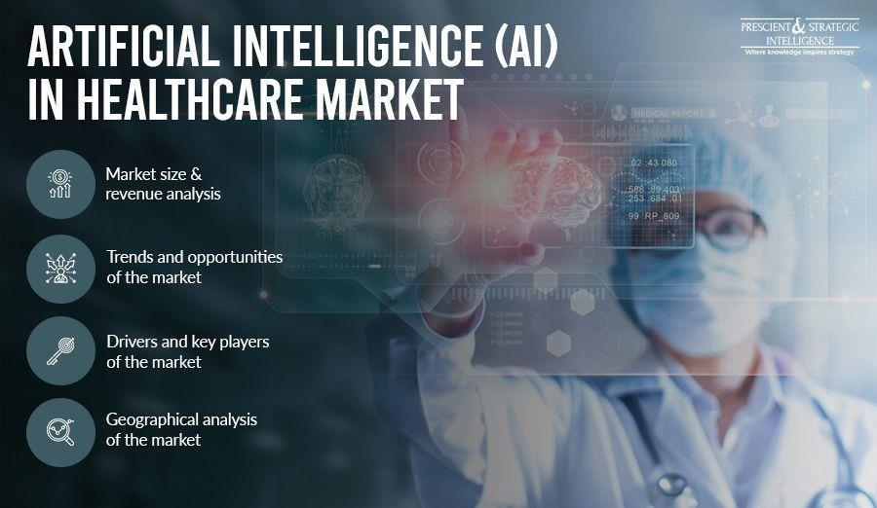**Artificial Intelligence Future in Healthcare**

AI will be essential in helping to prevent about 86% of errors in the healthcare sector. The utilization of AI in healthcare will help democratize the fabrication for the good of both patients and healthcare competent, while also reducing costs and improving accuracy through predictive treatment. Artificial intelligence and predictive analytics can be used to better understand the different elements (birthplace, dietary habits, local air pollution levels, etc.) that affect a person's health. Future medical management systems powered by AI should be able to envision when a person is most likely to develop a chronic illness and offer pre-emptive treatment to stop it before it gets worse.

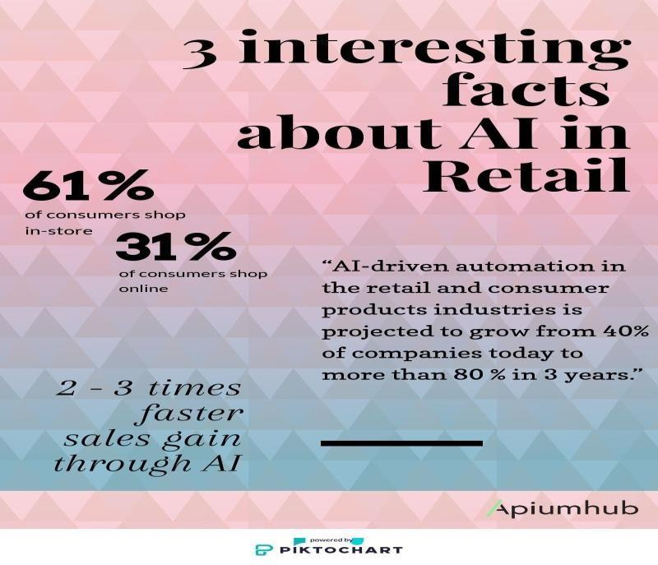**Artificial Intelligence Future in Retail**

By 2022, it is anticipated that the global market for artificial intelligence in retail would increase by over $5 million. Retailers might save over $340 billion by 2022 if they implement AI throughout all of their business operations, according to a Capgemini study on the impact of AI in retail. According to Accenture, investments in artificial intelligence will increase retail sales by 38% by the end of 2002.

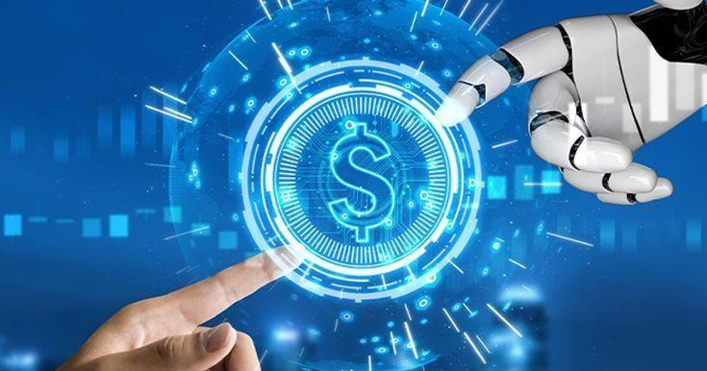**Artificial Intelligence Future in Banking**

By the end of 2030, it is projected that AI in banking will have a $300 billion worldwide economic impact. With lower costs, higher productivity, and better customer experiences, artificial intelligence is poised to dominate sectors like business intelligence and security in the coming ten years. Robo advisors in wealth management will lay out like wildfire and revolutionize the banking industry, saving both consumers and wealth managers a great deal of time. The banks of the future will engage AI to personalize consumer experiences in addition to personalizing their services and goods.

**AI to Open Up Millions of New Job Opportunities** 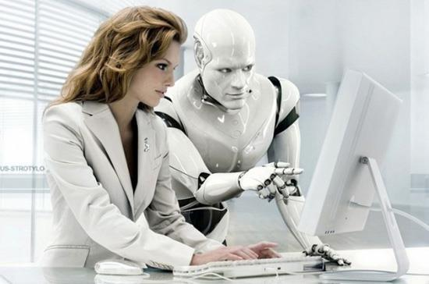

The most pervasive concern about artificial intelligence in the future is that it will oust us from our employment. We may see a more comfortable future for ourselves with artificial intelligence automating all types of work, one that will create new jobs rather than eliminate existing ones. World Economic Forum research on the Future of Employment predicts that by 2022, artificial intelligence will generate 58 million new jobs. By 2030, there is a very good probability that AI will carry out better than humans on the majority of mental tasks, but that does not mean that jobs will be phase out. We are more likely to evolve and coexist with advanced AI in the near future as a result of these AI advancements in society and the workforce. Depending on how we use technology in the future, using AI might either be a blessing or a sin.

**Conclusion**

Generally speaking, artificial intelligence is having a huge effect in spanning the abilities gap in the workforce. Computer based intelligence spans the abilities gap, ensuring equitable access to career advancement. Man-made intelligence controlled learning stages offer customized preparing and up-skilling open doors, independent of one's experience or location. We live in a fast past world, and AI is making a continuous impact on today's workforce. The good news is that AI will enhance jobs that require problem-solving, creativity, and empathy to a new level, which will create new opportunities like never before. The new generation of workers needs to be able to adapt to the recent changes in the workforce. It is essential for people seeking to secure new positions to have an open mind but, more importantly, have a diversified set of skill sets that will drive impact for the company of choice. If workers can transition and develop a strategic set of skills, AI can be seen as an asset and the best thing to boost your career.

**Reference**:

* + - Masayuki, M. O. R. I. K. A. W. A. (2016). The Effects of Artificial Intelligence and Robotics on Business and Employment: Evidence from a survey on Japanese firms. *Res. Inst. Econ. TradeInd*, 16.
    - Kaur, Bhajneet, and Sanskriti Sharma. (2016). Will Artificial Intelligence take over our jobs a human Perspective on Employment Future. *International Journal of Engineering Applied and Management Sciences Paradigms*, 216-218.
    - Frey, Carl Benedikt, and Michael A. Osborne. (2017). The future of employment: How susceptible are jobs to computerization? *Technological forecasting and social change*114,254-280.
    - Fossen, Frank M., and Alina Sorgner. (2018) The effects of digitalization on employment and entrepreneurship. *Conference proceeding paper, IZA–Institute of Labour Economics*.
    - Jarrahi,M.H. (2018). Artificial intelligence and the future of work: Human-AI symbiosis in organizational decision making. *Business horizons*, *61*(4), 577-586.
    - Frank, Morgan R., etal (2019).Toward understanding the impact of artificial intelligence on labor. *Proceedings of the National Academy of Sciences* 116.14,6531-6539.
    - Muro, Mark, Robert Maxim, and Jacob Whiton. (2019). Automation and artificial intelligence: How machines are affecting people and places.
    - Ernst, Ekkehardt, Rossana Merola, and Daniel Samaan. (2019) Economics of artificial intelligence: Implications for the future of work*. IZA Journal of Labor Policy* 9.1
    - Mrowinski, Benjamin, David Brougham, and David Tappin.(2019) Managers' perceptions of Artificial Intelligence and Automation: Insights into the future of work. *New Zealand Journal of Employment Relations* 44.3, 76-91.
    - Singh, Dheeraj, and Geetali Tilak. (2019) Employment Transformation through Artificial Intelligence in India.
    - Furman, Jason, and Robert Seamans. (2019) AI and the Economy. *Innovation policy and the economy*19.1, 161-191.
    - Daron Acemoglu, Pascual Restrepo March, (2020) The wrong kind of AI? Artificial intelligence and the future of labour demand, *Cambridge Journal of Regions, Economy and Society*, Volume13, Issue.
    - Jameel, Kiran, et al. (2020) Current and future impact of artificial intelligence: an employment perspective based on case studies. *PalArch's Journal of Archaeology of Egypt/Egyptology* 17.9, 660-675.
    - Yang, Yu. (2020) Analysis of the impact of artificial intelligence development on employment. *2020 International Conference on Computer Engineering and Application (ICCEA)*.
    - Graglia, Marcelo Augusto Vieira, and Patricia Giannoccaro Von Huelsen.(2020) The sixth wave of innovation: Artificial intelligence and the impacts on employment. *Journal on Innovation and Sustainability RISUS* 11.1,3-17.
    - Benbya, Hind, Thomas H. Davenport, and Stella Pachidi. (2020) Artificial intelligence in organizations: Current state and future opportunities. *MIS Quarterly Executive* 19.4.
    - Wang, Fenglian, Mingqing Hu, and Min Zhu. (2020) Threat or Opportunity– Analysis of the Impact of Artificial Intelligence on Future Employment. *Digital Human Modeling and Applications in Health, Safety, Ergonomics and Risk Management. Human Communication, Organizationand Work: 11th International Conference, DHM 2020, Heldas Part of the 22nd HCI International Conference, HCII 2020, Copenhagen, Denmark, July19–24, 2020, Proceedings, Part II 22*. Springer International Publishing.
    - Moradi,P.,& Levy,K. (2020). The future of work in the age of AI: Displacement or Risk-Shifting?
    - Shaukat, K., et al. (2020) The impact of artificial intelligence and robotics on the future employment opportunities. *Trends Comput. Sci. Inf. Technol* 5,50- 54.
    - Rauf, Muhammad Abdul, et al. (2021). A comparative study on the impact of artificial intelligence on employment opportunities for university graduates in Germany and the Netherlands: AI opportunities and risks. *International Journal of Environment, Workplace and Employment* 6.3, 185-204.
    - Boyd, Ross. (2021) Work, employment and unemployment after AI 1. *The Routledge social science handbook of AI*. Routledge, 74-900.
    - Anagnoste, Sorin, et al. (2021) The role of chat bots in end-to-end intelligent automation and future employment dynamics. *Business Revolution in a Digital Era: 14th International Conference on Business Excellence, ICBE 2020, Bucharest, Romania*. Springer International Publishing.
    - Ekaningrum, Nurul Efri, Muhammad Syahrul Hidayat and FaridaYuliati.(2023) Exploring the Future of Work: Impact of Automation and Artificial Intelligence on Employment. *Endless: International journal of future studies* 6.1125-136.