Enhancing technological transfer among National Agricultural Research Institutes (NARIs) for Agricultural Productivity and Sustainability in Nigeria: A Suggested Participatory Sustainable Development Communication Paradigm

Adetola, A. S.¹, Akintayo, J. B. (PhD) ², Olomojobi, O. T. (PhD) ²

¹National Agricultural Extension Research and Liaison Services,
Ahmadu Bello University, Zaria, Nigeria
²Mass Communication Department, Babcock University, Ilishan Remo, Ogun State, Nigeria Correspondence: adetoladesegun@ymail.com: 08085963771.

Abstract
This paper proposes a participatory sustainable development communication paradigm for enhancing technological transfer among National Agricultural Research Institutes (NARIs) in Nigeria to improve agricultural productivity and sustainability. It emphasizes the need for NARIs to engage in technological transfer that aligns with Nigeria's sustainable development goals. To illustrate this proposed paradigm, an integrated approach that includes various communication strategies with an all-inclusive research planning mechanism, linkages, and feedback with end users in conjunction with a public-private partnership (PPP) that could sufficiently deal with the “blind spots” in the earlier suggested models and, most importantly, align with the current economic realities on the funding of government-owned research institutes in Nigeria is proposed. It is hoped that this proposed model will support NARIs in developing effective strategies for efficient technological transfer that will help improve agricultural productivity and sustainability in Nigeria.

Keywords: agricultural productivity, agricultural research institutes, development communication, participatory communication, technological transfer

Introduction
Development is a subject of interest to any nation, be it developed or emerging. He maintained that development is critical to the sustenance and growth of any nation, as it is associated with modernization, material advancement, industrialization, scientific and technological progress, socio-cultural transformation, mass literacy, vertical and horizontal mobility, employment opportunities and the emergence of specialized and independent occupational roles (Obor & Okafor, 2020). Furthermore, developments can be seen as the outcome of a shift from circumstances that are no longer deemed sufficient to meet a society's goals and interests to those that are most likely to do so. Development could also refer to a shift in social behaviours that allows people to gain a better understanding of human values and more control over themselves (Oluyi, 2019).
According to Haq (1999), Moemeka (1989) and Nussbaum (2011), cited in Oluyi and Adetola (2019), “development is the ‘individual situated in felt needs’ and ‘human development’, meaning achievement with respect to a wide range of well-seasoned values, not only those measured in money, and advancement of people’s ability to achieve such well-seasoned values” (p. 137). The goal of development communication is to inform, raise awareness, educate, and enlighten people so that they can improve their lives in every way. The theory is that meaningful and lasting growth is unlikely to occur without a proper two-way flow of information and interaction between the periphery and the center (Onagwa, 2016).
Sokoya (2014) cited in Adeyemo (2020), described farmers’ information literacy as the “farmer’s ability to critically think and determine the extent of information needed and be able to access available information effectively and efficiently” (p. 557). Laseinde (2015); Olajide and Oresanya (2016) and Vidanapathirana (2012) cited in Omisope (2020) reported that:

Information is one of the priorities for achieving food security and a crucial tool for agricultural and rural development. Agricultural information within the hemisphere of the farmers means empowerment with which they can have control over their resources and decision-making processes. This assertion makes it very clear that when farmers and other agricultural stakeholders are bestowed with information, they become empowered and are able to make positive changes in their farming and agro-allied activities. An effective and efficient delivery system of essential information and technology services to farmers will facilitate their critical role in decision-making towards improved agricultural production, processing, trading, and marketing (p. 2).
Hence, “it is important for farmers to have access to information, and more importantly, have the necessary skills to be able to make efficient use of the best agricultural practices and the market needs of consumers” (Adeyemo, 2020, p.557). Therefore, agricultural information should be made available to all potential users (literate and non-literate farmers) in order to increase their production such that the communication channels will be diversified, since extension communication is a complex form of social action because it goes beyond merely information delivery.

Agricultural extension plays a crucial role in encouraging farmers to accept new technology and innovations for sustainable development and improved quality of life (Ogunsumi, 2017). Agricultural extension, by its nature, according to Jamilah et al. (2010) cited in Ogunremi (2013), entails using a number of communication methods to disseminate knowledge and increase farmer capability. The encoding-decoding process determines whether a communication effort succeeds or fails (Ogunremi, 2013). Agricultural extension programmes are frequently structured on the belief that the goal of gathering and sharing new research-based information is to guarantee that it is used properly.

Dissemination is a difficult process with challenges in dealing with implementation phases and ensuring that recipients have the skills, attitudes, and knowledge levels required to benefit from research findings (Onagwa, 2016). Effective and planned communication is critical in the production, testing, adaption, and delivery of agricultural services, whether physical technologies or management methods. A well-defined and implemented strategy based on an awareness of the communication context in which services are to be offered is required for successful communication (Undiandeye et al., 2014).

Improved farming techniques require effective communication between change agents and researchers in order to increase agricultural production. Ogunremi (2013) posited that “extension workers carefully tailor communication techniques and channels to the unique circumstances of each location” (p. 15). Researchers in research institutes, departments, and faculties of agriculture across the country perform careful experiments to generate innovations. These agencies and institutions were established by the government to generate and disseminate innovations required for enhanced output (Ifeanyieze et al., 2017; Joans, 2013). Presently, there are 23 research institutes in Nigeria, each with a specific mandate in crop, animal, or other commodities and fields. There are also 28 faculties of agriculture across Nigerian universities that have been the traditional partners of the Agricultural Research Council of Nigeria (ARCN) in the past and five international agricultural research institutes (Babu et al., 2017).

Out of these, Nigeria has 17 commodity-based research institutes, a specialized national agricultural extension institute, three specialized universities of agriculture, 37 agricultural development projects (ADPs), and one international agricultural research centre, Nigeria has the largest national agricultural research and extension system in Sub-Saharan Africa (SSA). Their research efforts give rise to a body of knowledge, technologies, practices, and systems that form the basis for agricultural innovations. Despite this, however, the country remains food deficient and food insecure. A major task in agricultural development is the transfer of improved technologies to farmers (Ayansina, 2013; Kolawole, 2011; Onagwa, 2016; Onagwa et al., 2017).

In keeping more closely with the spirit of earlier authors of participatory communication models, this study is inspired to design an alternative model that could sufficiently deals with the “blind spots” in the selected proposed and suggested models by different authors - Babaleye (2022), Ilevbaoje and Ogungbameru (2001), and Onagwa (2016) - whose similar works in this area aroused the interest of this in this study, and most importantly, aligning with the current economic realities on funding of government owned research institutes and the zero hunger policy of the Sustainable Development Goal agenda.

Though, our present farmers are not yet prepared financially to pay for the services of private extension; except large and medium scale farmers. However, based on the Research-Extension-Farmer-Inputs-Linkage-System (REFILS) perspective, treating the private partners or middlemen (agro inputs dealers, agricultural based financial institutions, etc.) as equally critical to the technology development and deployment chain has become mandatory. This is to align with the proposal of the Draft Policy on e-extension, which advocates public extension system that is complimented with private extension.
Meanwhile, present reality check however shows that since 2015, there have been dwindling allocations to research institutes by the federal government, hence, lamentations of paucity of funds by the government established research institutes in carrying out new technological research or even dissemination of the already made and proven technologies to the appropriate farmers due to the issue of low and falling research budget (Babu et al., 2017), hence, resulting to abandonment of such technologies on the shelves. Hence, the need for an all-inclusive communication strategy approach that will ensure that the technology transfer and adoption processes are not abandoned or/and truncated abruptly, but well planned and articulated for sustainable development.
Objective of the Study
The broad objective of this paper is geared towards the development of a participatory sustainable development communication strategy model for planning, executing, monitoring and evaluating agricultural communication strategies for increased and sustained agricultural productivity of smallholder farmers through the agricultural research institutes in Nigeria, in conjunction with the agro – inputs stakeholders in the private sectors. This is to ensure that the technology transfer and adoption processes are not abandoned or/and truncated abruptly, but well planned and articulated for sustainable development. The specific objectives are to review selected ‘homegrown’ models of participatory communication strategy and propose a communication strategy framework for National Agricultural Research Institutes (NARIs) in Nigeria.
Significance of the Study
The significance of this study as relates to this proposed design of participatory sustainable development communication strategy are to ensure that:
1. The dissemination plan of the NARIs is responsive to changing needs of farmers in Nigeria.
2. Client-based partnerships with smallholder farmers and other stakeholders are established, to enable agricultural technologies and innovations deliver on outcomes at scale through public extension system that is complimented with private extension.
3. Public Private Partnership (PPP) collaboration from the research technology development (RTD) to transfer of technology (TOT) is inevitability, so as to improve communication linkages and consultations among communication stakeholders, especially the government-owned and funded research institutes and farmers on one hand; and the agro – inputs stakeholders in the private sector on the other hand.
4. Innovative farmer communication systems are promoted by strengthening and scaling up proven dissemination pathways, such as participatory media and information and communications technology (ICT).

Literature Review
Models were used to represent early communication theories. A model, according to Mortenson (1972), cited in Onagwa (2016), is "a systematic portrayal of an item or event in idealized and abstract form". A model of communication, according to Mortenson, is a "still picture" of a moving process (p. 123). As a result, models or techniques are helpful in defining the fundamental components of the communication process and how they interact. A model is useful as an image that directs man's ability to imagine notions of interest in terms of one another with regard to clarifying complex processes; it is helpful in conceptualizing processes of interest and in generating questions for richer forms of a theory.

Since communication is associated with dissemination, it is therefore fundamental to extension services. Farmers' behaviour and the value of communication in extension cannot be quantified. With varying degrees of effectiveness, development planners have utilized communication to support and promote agricultural development policies and programmes in a variety of contexts and conditions (Gadzama & Akinola, 2013). Communication experts all across the world have advised development-support communication to link all organizations involved in planned agricultural development programmes (FAO, 2012; Onagwa, 2016; UNICEF, 2008). The communication path envisioned here is both vertical and horizontal — in other words, between institutions and individuals involved in agricultural growth.

According to Ayange (2009), as cited in Onagwa (2016), agricultural communication or agricultural extension "is development-support communication in the context of agricultural development planning and implementation, in which adequate action is taken of human behavioral factors in the design of development projects and their objectives" (p. 32). Communication for innovation can take numerous forms, not only in terms of the methods and tactics used but also in terms of the overall intervention goals. For example, if a field problem is characterized as a lack of adequate technology, a conflict over common resources, or a lack of organizational capacity, the practice of communication for innovation must differ. Meanwhile, feedback is important in encouraging social engagement between farmers and extension workers because it provides the foundation on which all other communication models are built.

In the context of this research, the goal of the communication strategy is to increase technology adoption. The strategy is intended as a tool to help organize NARIs' communication efforts in ways that encourage and facilitate high-level participation for all its communication stakeholders, especially farmers (Cook et al., 2012; George, 2010; FAO, 2004). Looking at the issues at hand dispassionately from the scientific research point of view, it is clear that Nigeria does not lack appropriate technologies to support rural farmers. However, from the communication and information definition angle, “what is lacking is the networking process and procedure of bringing all the agriculture stakeholders together to make success of the agricultural technology/innovation transfer and uptake” (Babaleye, 2022, p. 49).

Empirical Review
Research impacts on development, however, its impact can only be sustained by the ability to develop innovative ideas bringing about the quality of research itself. The essence of research is to identify a problem and make conscientious efforts to proffer solutions to the identified problem (Obor & Okafor, 2020). Although, the challenge of low technology acceptance in agriculture has been frequently debated, and various research on innovation adoption in Nigeria has been done. However, such research has not been done in a systematic way (Phillip et al., 2009).
Thus, trends in the adoption of relevant technologies are difficult to describe. Only a few of such studies (Ifeanyieze et al., 2017; Onagwa, 2016) provided an empirical basis for in-depth inferences on the enhancement of agricultural productivity in the country, using the communication activities of such agricultural research institutions. In general, most of these studies (Agbamu, 1995; Aweke et al., 2021; Awotide et al., 2016; Lambert & Ozioma, 2011) have focused on factors influencing innovation adoption and sources of farm information.
There have also been studies on agricultural innovation adoption to communication channels, with the findings indicating that certain socioeconomic and institutional factors have a significant impact on adoption rates and levels, and that different communication channels have different impacts on innovation adoption. Radio, television, and print media, including extension guides, bulletins, pamphlets, and posters, have all been utilized to promote innovation adoption and as information sources among Nigerian farmers over the years, either separately or in combination (Kayode-Adedeji et al., 2017; Mairiga et al., 2019; Ogunremi, 2013; Onagwa, 2016; Onagwa et al., 2017; Onwubuya et al., 2015; Omisope, 2020).
Nevertheless, there has not been much work detailing the inherent and extraneous barriers in communication activities, and how these affect farmers’ uptake of innovations. Barely very few (Babaleye, 2022; Ilevbaoje & Ogungbameru, 2001; Onagwa, 2016) have attempted a detailed and systematic analysis of communication approaches in order to develop more effective dissemination strategies as institutional frameworks for enhancing productivity. This study will therefore, descriptively examine the connection between development communication and the adoption of agricultural research innovations in the light of the research institutes’ efforts to influence the agricultural technology uptake of farmers in Nigeria by cross-examining different established designed participatory communication strategy development process with the goal of strengthening them towards evolving a people-oriented, farmer-centred delivery system for enhancing farmers’ productivity.
Hence, against the backdrop, this paper shall be looking at three different participatory agricultural communication models in order to find a common ground for an acceptable sustainable development communication strategy that will enhance technology adoption uptake and accelerate effective food production and distribution. This premise is based on existing work by researchers in this ﬁeld.

Review of Selected Models
First to be considered is a design approach that was prescribed by Babaleye (2012). The establishment of Community Based Organizations (CBOs) was the bedrock of the Babaleye’s (2012) concept of “Participatory Agricultural Communication (PAComm)” with farmers in rural areas. Borne out of his belief that it is expedient to look for ways of bringing the local farming families together to form CBOs with support from the key players (middlemen) in the agricultural sector as progressive partners where everyone contributes to national food self-sufficiency and food security (Babaleye, 2022).
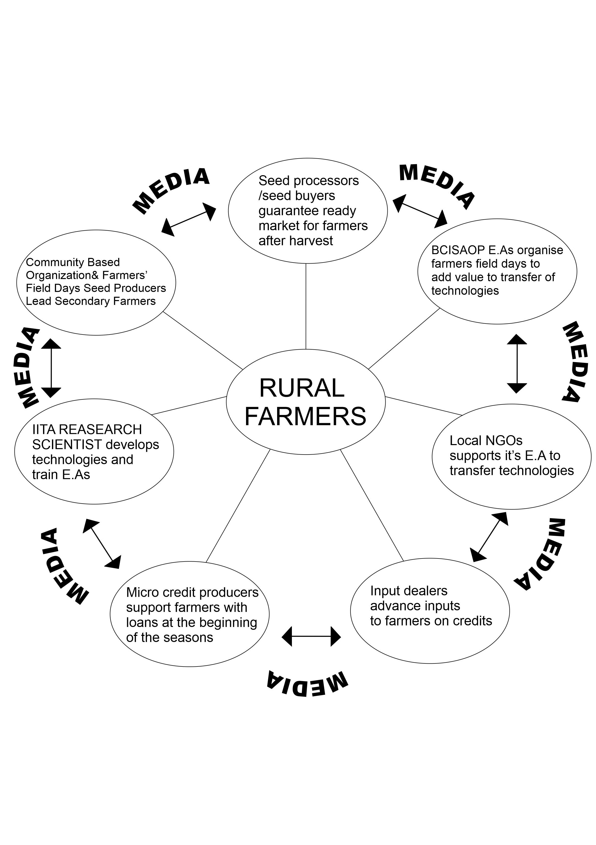
Figure 1: Model of Agricultural Participatory Communication with Rural Farmers (Babaleye, 2012 cited in Babaleye, 2022, p. 54)

PAComm model of participatory communication hung perfectly on the premise of the Brazilian education theorist, Paulo Freire, who propounded his theory in his work titled, “The Pedagogy of the Oppressed”, first published in Portuguese in 1968, and translated into English 1970. The theory stipulated that the so-called development communication of the Western world promoted a top-down, ethnocentric and paternalistic view of development. Freire criticized what he called the “banking” concept of education, whereby the student was viewed as an empty account to be filled with “knowledge” by the teacher. According to Babaleye, this still happens today in Nigeria where the Extension Agents “impose” new ideas and technologies on farmers without the active participation of the farmers in the choice of such ideas and technologies being imposed on them (Babaleye, 2012).

Babaleye believed that the farmers’ Community Based Organizations (CBOs) are crucial in order to avoid falling into the trap of inconsistent agricultural policies which has been the bane of Nigeria’s agricultural development since 1960. In this regard, he maintained that to ensure a durable and steady food production system, the responsibility should not be left with the farmers alone. All that is required is effective planning of the technologies with the farmers, right from the beginning. The meeting with the rural farmers must include the following key players in the food production sector: Farmers Community Based Organizations (CBO), Input dealers, Agricultural Extension Agents, Micro-finance providers, Seed buyers, Marketers, Food processors, Tractor hiring company representatives, Agricultural research scientists, Ministry of Agriculture representatives, Communication specialists and journalists (Babaleye, 2012).

Besides the objective of PAComm to ensure effective communication and knowledge sharing among all key players in the food production chain and stimulating farmers to adopt improved technologies to enhance their productivity, a major fallout of the model is that the so-called middle men who were being criticized in the past for standing between the farmers and abundant food supply to urban centres, are the ones funding agricultural development in Nigeria today. They provide all what the farmers need to support them in their business. In conclusion, the success story of PAComm model of participatory communication is not only applicable to the Nigerian situation but also to other sub-Saharan African countries where the researcher’s employers, IITA operated, which include parts of Burkina Faso, Mali and Niger Republic (Babaleye, 2022).

In the meantime, while Babaleye (2022) encouraged farmers’ inclusiveness in his participatory communication model, as against the top-down attitude of extension agents and managers towards farmers’ groups involved in food production which has made it an insidious problem, this model, however, did little in breaking down how the farmers are carried along in their selected media platforms used in disseminating the information on technology transfer, which is the core focus of this paper. Against this background, Ilevbaoje and Ogungbameru’s (2001) suggested AETA paradigm which addresses the inherent weaknesses in the traditional view that specifies the process as consisting of five successive steps. The suggested paradigm slightly alters the linearity approach, deletes the interest stage, introduces the conviction stage (now, dichotomized into positive and negative) and emphasizes the iterative nature of the adoption process, as depicted in Figure 2.
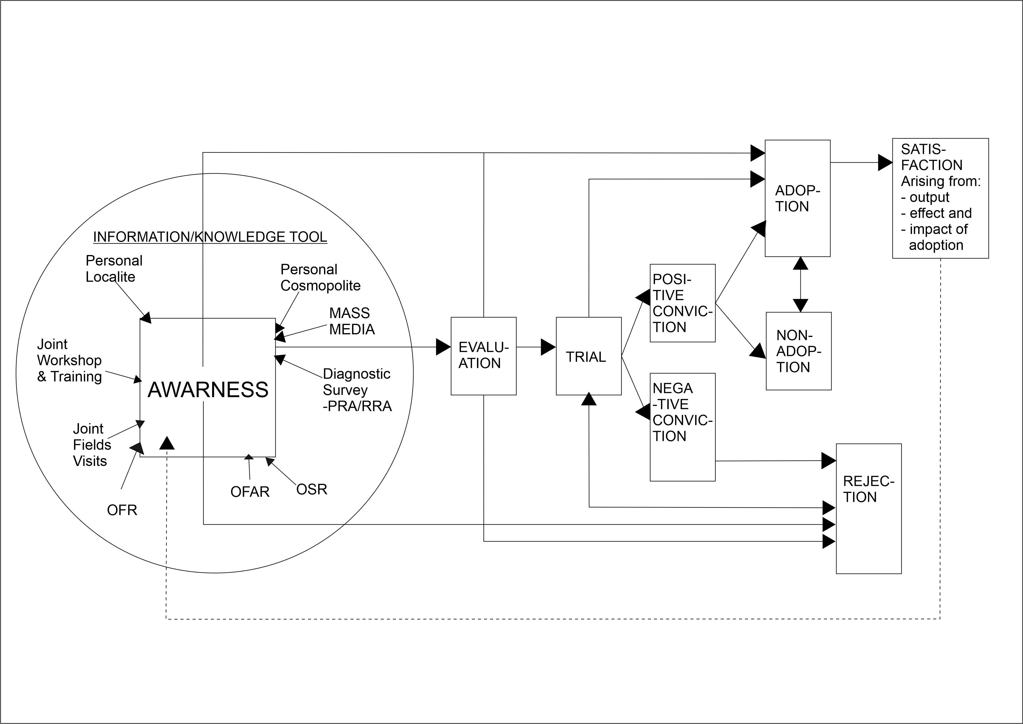
Figure 2: Ilevbaoje and Ogungbameru’s (2001) suggested AETA paradigm.
The suggested AETA model begins with awareness which is completely immersed in information/knowledge pool. Information comes from various sources, namely, personal locality, personal cosmopolite and mass media sources. This mass mediated channel of communication is capitalized in recognition that at the awareness stage, information source is the most crucial. The point raised by Hassinger (in AIETA model) that the farmer is made a passive agent is sufficiently addressed in this new paradigm. The farmer is integrated through participation in diagnostic surveys (using the participatory rural appraisal or rapid rural appraisal) and the resulting on-station research, on-farm adaptive research and on-farm research. The joint field visits, joint workshops and training serve as other avenues of integrating the farmers.
The interest stage is deleted in this model on grounds that interest is vital in all the other steps. Interest will spur farmers to become aware of a new technology. A simultaneous occurrence of awareness and interest manifests, for example, when a farmer is suddenly confronted with a severe farm problem, such as an outbreak of “crazy tops” of maize or aphid attack on cowpea. Moreover, interest is vital in the evaluation stage and it is interest that will drive farmers to make the first attempt of trying one innovation, at least, on a small portion of their farms. According to the authors, it will therefore be illogical to assign interest a distinct stage as its influence pervades all other steps in the adoption process.
The trial stage leads to two conditions – the positive and negative conviction. A poorly conducted trial that evokes negative conviction will result in outright rejection due to the non-manifestation of the effects of the innovation at hand. Adequate persuasion (not coercion) by change agents, can influence farmers who initially rejected the innovation on the basis of poor trial to rework the trial stage. This epitomizes the iterative nature of the suggested paradigm. The positive conviction may lead to either adoption or non-adoption. Farmers who adopt new technologies derive satisfaction in which increased output, effects and impact (higher income and improved living standard) are critical. The satisfaction so derived prompts the farmer to seek more information on emerging technologies to commence another round of the process. This is indicated by the broken line. However, farmers who initially adopted the particular technology may discontinue for reasons similar to those who rejected the technology. Additionally, they may discontinue the use of the technology if the technology is no longer able to address the problems for which it was designed.
This model recognizes the fact that farmers, particularly those classified as innovators may short circuit steps and move straight from awareness to adoption. The early adopters may move rapidly from evaluation and trial stages to the adoption stage. The model also recognizes that some farmers can move from the awareness and evaluation steps for the rejection stage. All things considered, the suggested AETA model has a number of merits. First, the model is comprehensive and integrates appreciable factors and variables not considered in the previous models. It also emphasizes the dynamics of the adoption process. Secondly, the linear approach is altered making the adoption process less mechanic and stressing the relationships between steps, adoption becomes a timeless process.
Third, farmers are not rendered passive but are well integrated in the adoption process. This is assured and guaranteed by their participation in the diagnostic surveys and the resulting trials. Fourth, the paradigm emphasizes the iterative attribute of the process of adoption. This ensures that the process is not truncated but certain steps could be reworked. Finally, the model presents a significant departure from the traditional normative decision-making process which is no longer considered to provide adequate explanation of the way people make decisions.
Meanwhile, Onagwa (2016) expanded Food and Agriculture Organization, FAO’s model designed participatory communication strategy, adapting the recommendations of FAO (2004), will also be considered because of its relevance to the current study to buoy up a homegrown participatory communication strategy for meeting the felt needs of the study population. Onagwa (2016) designed participatory communication strategy development process involved “participation from all the agricultural stakeholders (farmers, extension agents, media package producers, management of NARI (NAERLS), as well as the coordinator of Agricultural Extension Transformation Agenda (AETA), the project of the Federal Ministry of Agriculture and Rural Development” (p. 171). The components of the strategy is illustrated below:

Dissemination

Final Packaging

Postproduction
Testing
Monitoring and
Preliminary Evaluation
Packaging

Media Selection

Refining of
Message

Developing Discussion
Themes and Testing

Preliminary
Message Design

Filed Assessment

Figure 3: The Designed Participatory Communication Strategy adapting the recommendations of FAO, 2004 (Onagwa, 2016, p. 173)

The Suggested Participatory Sustainable Development Communication (PS DevComm) Strategy for NARIs

Communication is a critical component for the effectiveness of NARIs in transferring research technologies to users. The major challenges for dissemination, uptake, adoption, and commercialization of useful technologies for driving agricultural development in Nigeria are: the lack of an all-inclusive approach in the research planning mechanism; poor linkages and feedback with end users; end users’ weak capacity to articulate technological demands; and weak links among all the agricultural stakeholders (Babu et al., 2017). A revitalized communication strategy to improve the delivery and adoption of research technologies and knowledge products by farmers and industry will go a long way in Nigeria.

The objective of the communication strategy is to effectively deliver agricultural research to farmers. The idea is to ensure research meets the needs of farmers and significantly increases technology adoption. For this, institutional barriers, individual habits, and attitudes that determine the relationships between science, knowledge, innovation or research technology and the communities they serve need to be systematically addressed; and institutional arrangements, capabilities, and behaviors to effectively manage these technological changes need to be developed.

In line with this submission, the inspiration behind this proposed design came from the inherent weaknesses and spate of criticisms leveled against the different communication strategies employed by the NARIs in disseminating technology transfer to farmers due to the absence of a definite strategic communication policy for agricultural extension in Nigeria and the issue of financial constraints on the part of the NARIs, which prevent them from performing optimally in research, training, and extension and effectively partnering with international research institutions and development partners (Babu et al., 2017).

In keeping more closely with the spirits of Babaleye (2022), Ilevbaoje and Ogungbameru (2001), and Onagwa (2016) whose similar works in this area aroused the interest of this paper, the researchers are inspired to design an alternative model that could sufficiently deals with the “blind spots” in the earlier proposed and suggested models by different authors, and most importantly, aligning with the current economic realities on funding of government owned research institutes. Hence, a consideration for slight modifications so as to align with the proposal of the Draft Policy on e-extension, which advocates public extension system that is complimented with private extension in Nigeria. This is to ensure that the process is not truncated but certain steps reworked for sustainable development.

The goal of the communication strategy is to increase technology adoption and, therefore, enhance agricultural productivity among smallholder farmers in Nigeria. The strategy is intended as a tool to help organize NARIs communication efforts in ways that encourage and facilitate high-level participation for all its communication stakeholders, especially farmers and the agro – inputs stakeholders in the private sector. The components of the strategy is illustrated and discussed later in this paper.

Strategic Aim
The strategy is geared towards the development of a participatory model for planning, executing, monitoring and evaluating agricultural communication campaigns for increased and sustained agricultural productivity of smallholder farmers in adopted villages and, by extension, in Nigeria, in conjunction with the agro – inputs stakeholders in the private sectors. This is to ensure that the technology transfer and adoption processes are not abandoned or/and truncated abruptly, but well planned and articulated for sustainable development.
Strategic Objectives
The objectives of this communication strategy are to ensure that:
1. The dissemination plan of the NARIs is responsive to changing needs of farmers in the adopted villages.
2. Client-based partnerships with smallholder farmers and other stakeholders are established, to enable agricultural technologies and innovations deliver on outcomes at scale through public extension system that is complimented with private extension.
3. Public Private Partnership (PPP) collaboration from the research technology development (RTD) to transfer of technology (TOT) is inevitability, so as to improve communication linkages and consultations among communication stakeholders, especially the government-owned and funded research institutes and farmers in the adopted villages on one hand; and the agro – inputs stakeholders in the private sector on the other hand.
4. Innovative farmer communication systems are promoted by strengthening and scaling up proven dissemination pathways, such as participatory media and information and communications technology (ICT).
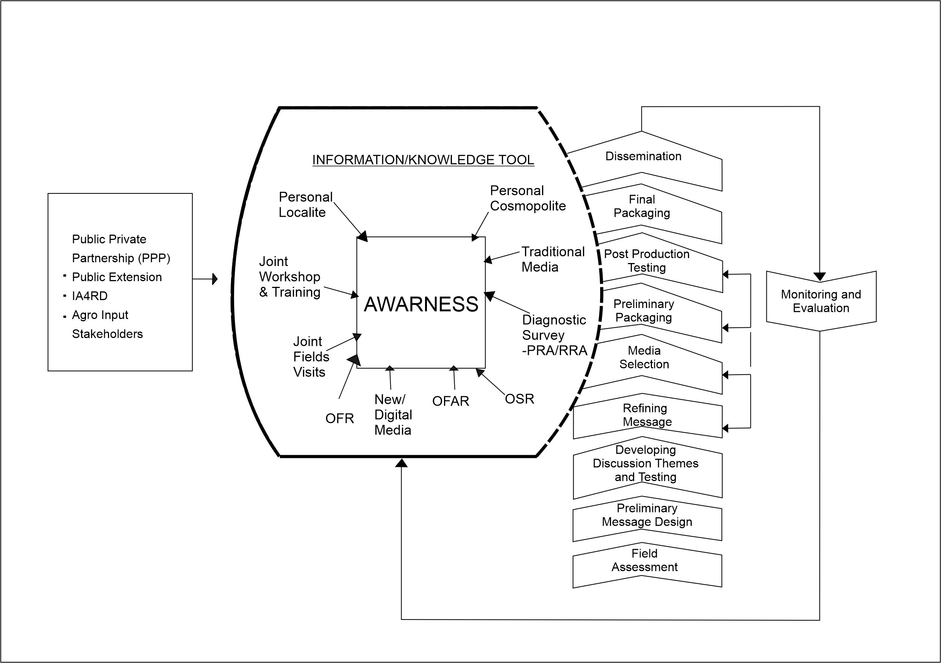
Figure 4: The Suggested Participatory Sustainable Development Communication (PS DevComm) Strategy Paradigm for NARIs. Designed by researchers adapting the recommendations of Babaleye (2022); Ilevbaoje and Ogungbameru (2001) and Onagwa (2016)

The Components of the Suggested Participatory Sustainable Development Communication (PS DevComm) Strategy
The suggested PS DevComm Strategy begins with sharing of research ideas and innovation concepts between the internal and external publics which are primarily involved in the technology transfer process. These publics includes NARIs’ team of researchers, the agro – inputs dealers, NGOs, financial institutions, and other related agricultural stakeholders. These publics are integrated from the initial stage of the communication strategy because of the several earlier identified inherent factors that have made NARIs not to meet up with their mandates, going by the current global economic realities, which now made many past and present research outcomes botched or/and abandoned on the shelves. Worthy of note however, is the issue of financial constraints on the part of the NARIs, which prevent them from performing optimally in research, training, and extension and effectively partnering with international research institutions and development partners (Babu et al., 2017). Hence, the advocacy by the agricultural stakeholders for public extension system that is complimented with private extension, in form of the Integrated Agricultural Research for Development (IAR4D) approach, so as to encourage sustainability of transfer and adoption of technologies.

IAR4D is an innovation-based approach involving many stakeholders and partnerships (multi-institutional and multi-stakeholder framework). IAR4D integrates the perspectives, knowledge, and actions of different stakeholders around a common theme or “entry point,” as well as the learning that stakeholders gain from working together. It brings together analysis, action, and change across the different dimensions of development (such as environmental, socioeconomic). And finally, it integrates analysis, action, and change at different levels of spatial, economic, and social organization (Babu et al., 2017).

Actualizing IAR4D revolves around the successful establishment of innovation platforms that link different groups of actors in different segments along the value chain to feed information, knowledge, and technologies to the value chains. The platforms include the extension system with participation from NGOs and farmer or community groups like cooperatives, community organizations, and farmers’ associations. The linkage allows for more communication between supply and demand of inputs and products, and lower transaction costs. Building these platforms will be an important step in strengthening NARIs’ internal linkages. It should be noted that although the strategy and its initial application were directed at the NARIs under study, its wider applicability, (if successful), could extend to all adopted village projects and farm settlements in Nigeria.

Though, our present farmers are not yet prepared financially to pay for the services of private extension; except large and medium scale farmers, however, based on the Research-Extension-Farmer-Inputs-Linkage-System (REFILS) perspective, treating the private partners or middlemen (agro inputs dealers, agricultural based financial institutions, etc.) as equally critical to the technology development and deployment chain has become mandatory. Thus, all key players in the food production chain should be incorporated to encourage transfer and adoption of improved technologies to enhance agricultural productivity.
This is to corroborate a major fallout of the Babaleye’s (2012) model cited in Babaleye (2022), that the so-called middle men who were being criticized in the past for standing between the farmers and abundant food supply to urban centres, are the ones funding agricultural development in Nigeria today. They provide all what the farmers need to support them in their business. Hence, in order to avoid falling into the trap of inconsistent agricultural policies which has been the bane of Nigeria’s agricultural development since 1960 (Babaleye, 2022), the responsibility to ensure a durable and steady food production system should not be left with the government, research institutes and farmers alone.
Awareness, which is completely immersed in information/knowledge pool comes from various sources, namely, personal locality, personal cosmopolite and mass media sources. This mass mediated channel of communication is capitalized in recognition that at the awareness stage, information source is the most crucial. The point raised by Hassinger, cited by Ilevbaoje and Ogungbameru (2001) in AIETA model, that the farmer is made a passive agent is sufficiently addressed in this new paradigm. The farmer is integrated through participation in diagnostic surveys (using the participatory rural appraisal or rapid rural appraisal) and the resulting on-station research, on-farm adaptive research and on-farm research. The joint field visits, joint workshops and training serve as other avenues of integrating the farmers.

Furthermore, in achieving a mutually beneficial communication process, we cannot rely on the mass media, despite the advantages they offer (cost effectiveness, immediacy, and for radio and television, the ability to transcend literacy barriers and their attractiveness and popularity), we must realize the limitations of the media as tool for technology adoption and find means of how we can enhance their potentials. This, in essence means that the mass media must be complimented with other means of communication as illustrated in the model. Information management encompasses information generation/acquisition, processing and storage, and dissemination. All NARIs are acutely aware of the importance of information management in the process of research planning, priority setting, training and extension, and adoption. However, information management requires a lot of financial and other resources, which are inadequate in the institutes (Babu et al., 2017). All that is required is effective planning of the communication strategies with all the agricultural stakeholders, right from the beginning.
Meanwhile, packaging all the knowledge and information into a particular suitable and relevant media format requires a lot of input from different communication specialists and farmers, hence, the intervention of the intervening variables as enumerated by Onagwa (2016) and reflected in PS DevComm paradigm. These include field assessment, preliminary message design and implementation plan, developing discussion themes and testing with farmers, refining the message (based on the outcomes of field testing), media/channel selection, preliminary package production, postproduction testing, final production, dissemination, monitoring and evaluation.

This process among other things involves putting together of all the rushes, audio clips, or other information gathered into one package (copy), such as a jingle, poster, or radio episode; or a set of packages (copies, such as jingles, assorted posters, or episodes of a programme) in line with the production budget. If broadcast channels were selected, for example, this stage includes using a given format (e.g., jingle, documentary, vox-pop, panel discussion, interview, etc.), studio production (putting different rushes or audio clips together as a single story), editing, addition of special effects, recording in one single tape or burning into a CD or DVD, etc. If interpersonal media (say, training) was selected, this stage includes drawing up training contents, training schedule in collaboration with resource persons (specialists), etc. The fact of it however is that the media package should be ready for pretesting with all the stakeholders that formed the publics.

Conclusion
All things considered, the suggested model, PS DevComm strategy for NARIs has a number of merits. First, the model is comprehensive and integrates appreciable factors and variables not considered in the previous models, most importantly, the Public Private Partnership. It also emphasizes the dynamics of the technology transfer and adoption process. Second, the linear approach is altered making the adoption process less mechanistic and stressing the relationships between steps, adoption becomes a timeless process. Third, farmers are not rendered passive but are well integrated in the adoption process. This is assured and guaranteed by their participation in the diagnostic surveys and the resulting trials. Fourth, the paradigm emphasizes the iterative attribute of the process of adoption. This ensures that the process is not truncated but certain steps could be reworked. Finally, the communication model presents a significant departure from the traditional normative decision-making process which is no longer considered to provide adequate explanation of the way people make decisions.
Acknowledgments
I appreciate immensely the entire lecturers of Mass Communication Department, Babcock University, Ilishan Remo, Ogun State and the Executive Director of National Agricultural Extension Research and Liaison Services, Professor E. I. Ikani, and the entire National Agricultural Extension Research and Liaison Services, Agricultural Media Unit, Zaria, Nigeria.

References
Adeyemo, O. O. (2020). Information literacy among Nigerian women: A tool for national development. In J. O. Ayodele, A. I. Akinyemi, O. A. Ajani, & A. L. Adisa (Eds.), Social sciences and national development perspectives in contemporary Nigeria society. 2020 Festschrift in Honour of Professor Olakunle Abiona Ogunbameru (pp. 543 – 564).
Agbamu, J. U. (1995). Analysis of farmers' characteristics in relation to adoption of soil management practices in the Ikorodu area of Nigeria. Jpn. J. Trop. Agr., 39 (4), 213-222. https://www.jstage.jst.go.jp/article/jsta1957/39/4/39_4_213/_pdf
Aweke, C. S., Hassen, J. Y., Wordofa, M. G., Moges, D. K., Endris, G. S., & Rorisa, D. T. (2021). Impact assessment of agricultural technologies on household food consumption and dietary diversity in eastern Ethiopia. Journal of Agriculture and Food Research, 4(100141), 1-9. www.journals.elsevier.com/journal-of-agriculture-and-food-research/
Awotide, B. A., Karimov A. A. & Diagne, A. (2016). Agricultural technology adoption, commercialization and smallholder rice farmers’ welfare in rural Nigeria. Agricultural and Food Economics, 4(3), 1-24. https://doi.org/ 10.1186/s40100-016-0047-8
Ayansina, C. (2015, December 13). Nigeria‘s investment in agriculture alarming — ActionAid. Vanguard, p. 25.
Babaleye, S. T. (2022, May 26). Participatory agricultural communication with rural farmers: Potentials and panacea for food self-sufficiency and food security in Nigeria [Paper presentation]. 14th Inaugural Lecture, Lead City University, Ibadan, Nigeria.
Babu, S. C. Oyedipe, E. O. Ajakaiye, O. and Ajoni, K. (2017, May). Strategies for restructuring the Agricultural Research Council of Nigeria: Process, Opportunities, and Lessons (Working Paper 41). Washington DC: International Food Policy Research Institute. https://ebrary.ifpri.org/digital/api/collection/p15738coll2/id/131230/download
Cook M., Lally, C., McCarthy, M. & Mischler, K. (2012). Guidelines for the development of a communication strategy. United Kingdom: New Horizon Centre.
Food and Agriculture Organization. (2012). Guide to extension training: The extension agent (Revised edition). Corporate document repository of FAO. www.fao.org/documents.
Gadzama, I. U. & Akinola, M. O. (2013). Adoption and diffusion of ICTs in extension services: Implication for the agricultural transformation programme in Nigeria. Proceedings, 18th Annual National Conference AESON, 113-121.
George, M. O. (2010). The lean six sigma guide to doing more with less. London: John Wiley & Sons.
Ifeanyieze, F. O., Nwarieji, F. E. & Aneke, C. U. (2017, June). Linkages of research agencies in technology transfer for sustainable agricultural development in south east Nigeria. African Journal of Agricultural Research, 12(24), 2063-2069. https://doi.org/10.5897/AJAR2016.11816
Ilevbaoje E., I. and Ogungbameru, B. O. (2001). Stages in the adoption process: A suggested paradigm. Nigerian Journal of Agricultural Extension, 13(2), 22-28.
Joans, R (2013). Incorporating technological change in diffusion models. Am. J. Agric. Econ., 73, 724-733.
Kayode-Adedeji, T., Oyero, O. & Aririguzoh, S. (2017). Communication strategies for agricultural development. New trends and issues. Proceedings on Humanities and Social Sciences. [Online]. 4(10), 434-441. www.prosoc.eu
Kolawole, O. D. (2011). Local knowledge utilization and sustainable rural development in the 21st century. Indigenous Knowledge and Development Monitor, 9(3), 13-15.
Lambert, O. & Ozioma, A. F. (2011): Adoption of improved agroforestry technologies among contact farmers in Imo State, Nigeria. Asian Economic and Social Society, 2(1), 1-9.
https://www.researchgate.net/publication/241752157_Adoption_of_Improved_Agroforestry_Technologies_among_Contact_Farmers_in_Imo_State_Nigeria
Mairiga, J., Momodu, H., Orji, P. O, Halima, M., & Roseline, P. O. (2019, December). Communication strategies for enhancing women participation in sustainable agriculture development in Nigeria: A critical review. South Asian Research Journal of Agriculture and Fisheries, 1(4), 137-142. https://doi.org/10.36346/SARJAF.2019.v01i04.002
Obor, D. O. & Okafor, E. E. (2020). Challenges of researching in social sciences for national development in Nigeria. In J. O. Ayodele, A. I. Akinyemi, O. A. Ajani, & A. L. Adisa (Eds.), Social sciences and national development perspectives in contemporary Nigeria society. 2020 Festschrift in Honour of Professor Olakunle Abiona Ogunbameru (pp. 1 – 36).
Ogunremi, J. B. (2013). Assessment of extension agents’ use of communication methods and its impact on aquaculture linkage activities in Lagos state, Nigeria. Journal of Agriculture and Social Research, 13(1), 15-20.
Ogunsumi, L. O. (2017, April). Integrated farming systems’ model for sustainable agricultural productivity in Nigeria [Paper presentation]. 2017 Annual In-House Review Exercise, Institute of Agricultural Research and Training, Obafemi Awolowo University, Ibadan, Nigeria.
Oluyi, I. A. (2019). A comparative study of electronic banking service delivery in First Bank of Nigeria Plc. and Guaranty Trust Bank Plc. (Unpublished master’s thesis). Lead City University, Ibadan, Nigeria.
Oluyi I. A. & Adetola S. A. (2019). Introduction of automated teller machine in Nigeria and its ethical challenges in development communication. Journal of Communication and Media Technology, 2(1).
Omisope, E. T. (2020, March). Content analysis of National Agricultural Extension and Research Liaisons Services (NAERLS) bulletins and message utilization in selected adopted villages. (Unpublished thesis). Department of Agricultural Extension and Rural Development, College of Agricultural Management and Rural Development, Federal University of Agriculture, Abeokuta Ogun State, Nigeria.
Onagwa, G. I. (2016, May). Appraisal of the Communication Strategies of the National Agricultural Extension and Research Liaison Services, Zaria, Kaduna State (Doctoral dissertation). Department of Theatre and Performing Arts, Faculty of Arts, Ahmadu Bello University, Zaria, Nigeria. https://projectng.com/topic/th11020/appraisal-communication-strategies-national-agricultural
Onagwa, G. I., Abah, S. & Jegede E. (2017, September). Communication barriers to uptake of agricultural innovations among farmers in NAERLS adopted villages, Nigeria. Nigerian Journal of Agricultural Extension, 18(3), pp. 76-84. https://orr.naerls.gov.ng/read/communication-barriers-to-uptake-of-agricultural-innovations-among-farmers-in-naerls-adopted-villages-nigeria/file.pdf
Onwubuya, E. A., Nenna, M. G. & Ugbaja, M. O. (2015, March). Educational and communication strategies used by extension workers in Onitsha agricultural zone of Anambra State, Nigeria. African Journal of Agricultural Research, 10(12), 1421-1426. https://doi.org/10.5897(AJAR09.042)
Phillip, D., Nkonya, E., Pender, J., & Oni, O. A. (2009, September). Constraints to increasing agricultural productivity in Nigeria: A Review (Background Paper No. NSSP 006). Abuja: IFPRI. https://media.africaportal.org/documents/NSSP_Background_Paper_6.pdf
UNICEF (2008). Writing a communication strategy for development programmes. Guideline for development managers and communication officers. Bangladesh: Author.

