In a Cloud Computing Environment, a Secure Multi-Tier Authentication System

Abstract- Due to its secure service, people are embracing remote storage systems day by day. But, it's probable that at some point, people will learn about the security measures implemented on the server side. As a result, the cloud is experiencing new security threats and attacks. As a result, an upgraded and more secure authentication mechanism is required. Single-tier authentication is insufficient for any cloud service where personal or sensitive information is transferred. Multi-tier authentication is significantly more secure than single-tier authentication in the aforementioned scenario. There are many multi-tier authentication techniques used in computing environments, but they do not offer protection from insider threats or virtualization threats. The entire authentication control in a cloud environment is on the server side. So, in a cloud system, it is difficult to trust a third party server. For gaining access to cloud services, this study suggests a more secure and sophisticated multi-tier authentication approach.
Keywords—Cloud Computing, Insider Attacks, Authentication
Scheme, Multi-tier Authentication

I. INTRODUCTION

Many organisations and people have embraced cloud computing [1] technology in recent years since it has gained significant acceptability as a model in various fields like business and academia. These systems offer virtual on-demand services with a great quantity of shared resources, including network, server, storage, etc. They are also very scalable. This computing technology has been evolving quickly day by day. The system must be upgraded in order to achieve a big virtual capacity and high computational power as a result of advancements in computing technology [1]. The development of Internet technology has been rapid in recent years. Individuals conduct business, talk, gather information, play games, and perform other tasks online. All of this online activity calls for some sort of identification to confirm that the person is who they claimed to be. More security information, such as personal data and other account-related information, is required for financial transactions.
The authentication strategy [2] uses a number of different mechanisms, including username-password authentication, biometric facial recognition, Kerberos authentication, Public Key Infrastructure authentication [3] [4], Hybrid Text Image Based authentication, and Symmetric Key Based authentication. An authentication scheme is a technique used to confirm the accuracy of the people taking part in communication.
The username-password technique is the most popular authentication scheme. This method carries a number of security risks connected to the exposure of sensitive user data in the event that the server is compromised. Because of this, users never have full confidence in that third-party server. Dictionary attacks, Man-in-the-Middle attacks, and other security flaws affect password-based authentication as well [5, 6].
A third party is in charge of supplying storage space, computer power, etc. in a cloud computing environment [7]. This makes the authenticating process quite challenging. Users save their data in the cloud [8], which is owned and maintained by a cloud storage provider. People don't want to put their data in this kind of cloud database, thus. Any user who wants to use cloud resources must first present proof of identity that verifies their legitimacy and gives them permission to do so.
In order to access the services, this article suggests a multi-tier authentication strategy since single-tier authentication is insufficient. There are two steps in the authentication procedure (two-level). The user supplies a straightforward username and password in the first stage. The user follows a predetermined series or sequence in the second stage. This two-tier authentication approach has the benefit of not requiring any additional hardware or software.
In this paper, a secure multi-tier authentication strategy for cloud computing is designed and put into practise. Literature review is discussed in the following section. The limits of various authentication strategies are covered in Part III. Section IV provides a description of the proposed authentication mechanism. Finally, it draws the article to a close and discusses the work's future potential. It also summarises what the proposed scheme's outcome is.
II. LIRERATURE REVIEW

This section discusses some authentication mechanisms which are used by various web applications. It also introduces advantages and disadvantages of every authentication scheme. Most of the application use username-password methods [9] for authentication. There are various password cracking tools, which are available free online. Hence attacker takes few minutes for cracking the password [10]. For keeping safety from this type of attacks National Institute for Standards and Technology (NIST) and Federal Financial Institutions Examination

Council (FFIEC) gives some instruction to carry out
financial transactions [11].
Some of the works found in paper [11] [12] [13] about two- tier authentication or two factor authentication mechanisms. The paper [12] [13] states that one-tier login password is not enough for access services and applications use more than one-tier authentication methods. First is the login-password and second is the secret code which is sent to their mobile phone. Disadvantage of this scheme is user always required a mobile phone and SIM for accessing the services.
For accessing various Internet Based Financial Services [11] [12] there exist some standard guidelines which focus on security risk and attacks management. Since 2001, protection of the customer information, reducing fraud and safety of identity are taken as higher priority in the guidelines. This guidelines also provide some step that is useful to increase authentication technology.
When customer accesses a financial service, financial institutions can use various methods for authentication like customer password, Personal Identification Number (PINs), Digital Certificates, Public Key Infrastructure(PKI) [14], Smartcards, One Time Password (OTP), some security tokens, Profile Scripts, and Biometric Identification.
Various multi-factor authentication schemes found in [11]
which includes:

1) Shared Secrets: Shared secrets are the information element (Key) that is shared between both the customer and the trusted third party [15].
2) Tokens: Token is a digital information across the net- work, constructed by XML and signed by an authority containing one or more claims [16] [17].
3) Biometrics: Biometric technology provides authenticity of a person on the basis of physical characteristic of that person [18] [19].
4) Non-Hardware-Based One-Time Password: In this technique, customer is given a scratch card. In the scratch card, a particular number presents at particular place, acts as one-time password.
5) Hardware-Based One-Time Password: In this technique, user is authenticated by two-tier authentication method, first user enters the username and password, then enters secret password which is sent to their mobile phone.
6) Internet Protocol Address (IPA) Location and Geo- Location: In this technique services provider checks the physical presents of the user by identifying his geographical position. For example, if the customer is living in India and made his first transaction in India then his next transaction would be performed in that country (India) only.

The paper [20] provides a technique based on single sign-on (SSO). The single sign-on mechanism helps to authenticate a cloud service customer by a security broker in multiple cloud service environments, which will persist while the cloud service consumer accesses other cloud services. As the result, the cloud service consumers need not to be re- authenticated itself with every subsequent request, which is the advantage of SSO. The security broker of SSO mechanism is mainly useful when a cloud service consumer needs to access cloud services residing on different clouds.
Disadvantage of SSO is that if once SSO server is hacked then entire cloud environment is hacked.
The paper [21] provides a method for authentication based on multiple levels. In the first level, it generates password and concatenates the generated password at subsequent levels. At each level, the user inputs the password to access the cloud services. Advantage of this technique is that user
enters different password again and again at each level. So,
it is difficult to break multilevel security. Disadvantage of this technique is that at each level different password used, so it is hard to remember.
When user keeps her data on the third party cloud, there is a problem. The problem is that how client will rely on the claims [22] of security capabilities of the third party provider. Solution of this problem is that user keeps one secure private cloud and its security capabilities. This private cloud will check the security capabilities with third party security capabilities [23]. If it has the compatibility of data with private cloud policy then access will be granted otherwise not. Advantage of this technique is that user adds own security policy in the private cloud. Disadvantage of this methodology is that overhead is increased, hard to maintain and initial cost of private cloud is increased.
The paper [24] [25] focus on a framework, in which a session key is established between user and cloud server, provide identity management and mutual authentication. This scheme verifies user authenticity using two-tier verification, which is based on OTP, smartcard or other methods. The advantage of this scheme provides more security and control towards client side to resist from attacks. Disadvantage of this methodology is that user requires additional hardware and software for accessing the services.
The Paper [18] [19] [26] propose other method for authentication by using either bio-metric or by using some other physical characteristics of the user. The advantage of this scheme is that it uses multi-tier authentication, but for authentication user requires some extra hardware.

III. LIMITATIONS OF EXISTING TECHNIQUES

In the literature review section, we discuss various authentication techniques along with their advantages and disadvantages. The disadvantages of these techniques can be divided into four parameters namely security from insider attacks, presence of authentication control towards client or server, extra software and hardware needed and number of security tiers required. Table I shows the comparison of various techniques based upon the above parameters [27].
A brief summary of the comparison based upon these parameters is presented below:

1) Security From Insider Attacks: This parameter is based on the assumption that it is easy for an insider to gain access to first-tier login and password. This is not adoptable. So, multi-tier authentication is also required.
2) Presence of Authentication Control towards Client or Server: In cloud computing environment, people store their data on the remote storage cloud (third party storage) and this data is controlled and maintained by third party service

provider. So, there should be some technique for authentication of user at client side.
3) Extra Software and Hardware Needed: In some authentication technique people requires some extra
TABLE I: Comparison of Various Authentication Scheme

Scheme/ Parameter | Securit  y from insider attacks | Presence of authentica tion control towards | Additional hardware and software needed | No. of secu rity tiers
Authentica  tion using  Single  Sign-on | No | Server | No | 1
Multi-level  Authentica tion technique | Yes | Server | No | More  than one
Two-tier | No | Client/Serv  er | No | 2
Strong user authenticat  ion | Yes | Server | No | 2
PAS | No | Server | Yes | 2
AQP | No | Server | Yes | 2
Architectu  re based on proactive model | No | Client/Serv  er | Yes | 1
SOA | No | Server | No | 2
Multi-tier  authenticat ion | Yes | Client/Serv  er | No | 2

hardware and software. This reduces the performance of the system and increases overhead to the system. If additional hardware fails then the whole system fails.
4) Number of Security Tiers Required: Multi-tier authentication scheme is much more secured than one-tier scheme. Paper [12] [13] states that single-tier can’t protest against insider attacks. So, multi-tier authentication is required.

IV. PROPOSED SCHEME: TWO-TIER AUTHENTICATION

In the previous section, we discuss various authentication scheme and their limitations. In this section, we proposed a more efficient and advanced multi-tier authentication technique. Using this technique, we may reduce limitation of existing scheme which is discussed in previous section. The advantage of proposed scheme is that, there is no requirement of extra hardware and software, aspect of
security it is more secured and second-tier authentication is done at client side.
The proposed authentication scheme is based on multi-tier authentication. This scheme is divided into two-tier. In the first-tier, user enters the username and password which follows simple authentication scheme. The second-tier
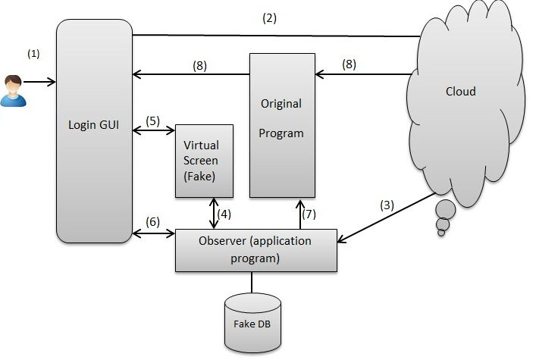

Fig. 1: Architecture of proposed authentication scheme

authentication is based on a sequence of predetermined activity on the virtual screen. This sequence must be same as user has performed during registration time. This virtual screen is loaded by an observer (This is application program run at client side).
The following steps explained the overall process that is shown in fig.1:
Step 1: User enters the URL of the cloud application site in the browser. A login GUI screen is loaded on the browser.

Step 2: User enters the username and password (first-tier) credentials). These credentials go to the cloud server for validation as shown in fig.1.

Step 3: Cloud server checks the username and password. If both credentials are correct then cloud server sends validation reply to an observer, this is an application program runs at client side.

Step 4: After receiving the validation reply from cloud server, the observer fetches the data from fake database and initiates the code to load fake screen.

Step 5: When data fetch process is done, the fake screen is loaded in the browser at client side.

Step 6: In this step, second-tier authentication starts. User enters registered predetermined sequence. Observer continuously checks the activity on the fake screen.

Step 7: If the user activity is correct and enter registered sequence, then in the browser original screen is loaded.

Step 8: After successful completion of previous step, it establishes a direct communication between client and cloud server.

Fig. 2: Probability of breaking multi-tier authentication scheme [27]

These second-tier authentication activities in above scheme could be any among the following three:

1) Menu Activity: After successful completion of first-tier registration, user registers a sequence of click on the menu items. This sequence stored in the fake database. At the time of second-tier authentication, user performs same sequence of click. If the sequence of click is correct, then original screen is loaded, otherwise it fails and not shown in the original screen.

2) Text Field Activity: When user registers on the cloud server, cloud server asks some security question to the user. User enters the answer of these questions, which is stored in the fake database. At the login time, if user enters correct answer of this question, then original screen is loaded in the browser otherwise user is not valid and original screen is not loaded.

3) Mouse Activity: User clicks the mouse at particular coordinates during registration time, this is known as mouse event. It also includes dragging of mouse from one coordinate to another coordinate. Observer stores the activity of mouse event and number of clicks at particular coordinates in the fake database. At login time, if mouse event is correct, then second-tier authenticated is validated.
V. PERFORMANCE EVALUATION

In the previous section, we discuss proposed efficient multi- tier authentication scheme. This scheme has been implemented using Google App Engine [33] and Eclipse Integrated Development Environment (IDE). The paper [29] [30] gives various necessary details for developing a cloud application using Google App Engine. Developing a cloud

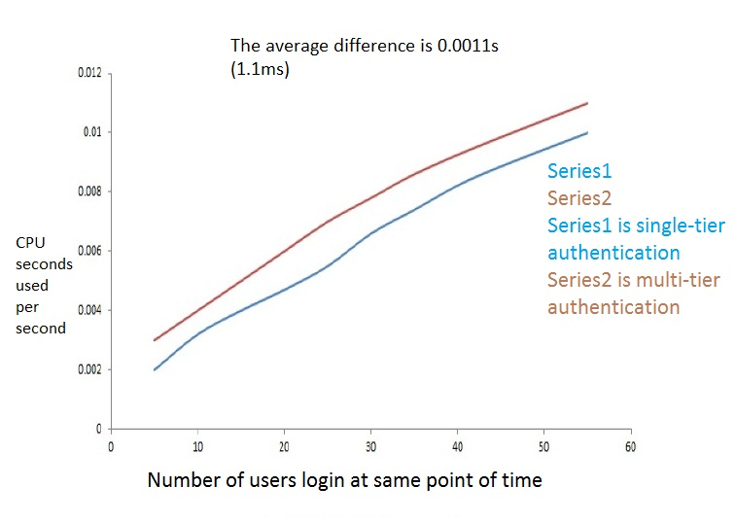
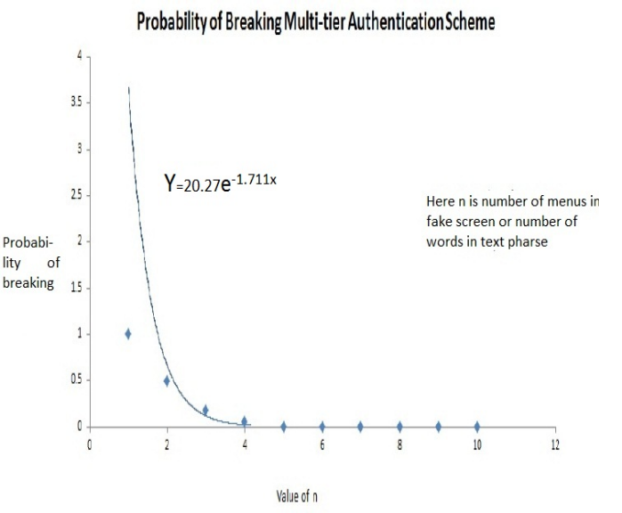

Fig. 3: Performance of the system [27]

application on the cloud server has been made using Eclipse IDE by installing Google App Engine plug in package [33] [34]. Using Remote Procedure Call (RPC) [31] [32] the communication between user and cloud server is established. On the Google Dashboard [28] screen, we analyze various parameters of the results.
There are some parameters which are considered as important when we analyze the performance of the system:

• Security of the System: The main drawbacks of previous authentication scheme are that it is not safe from insider attacks. So, in proposed scheme we are also concerned about this type of attacks. Data is stored in the cloud storage server in the form of hashed data. So, possibility of insider attacks is very less. In proposed scheme, there are two steps for authentication. Let we care the two outcomes of the authentication as success and failure be S and F respectively. The outcomes of two tiers are {SS, SF, FF, and FS}. The total number of event n(S) =4. If P is the success at each level, then probability of success (SS) of breaking
multilevel authentication, denoted by P(E)=P2.
Failure of successful authentication at any level denoted by 1-P(E)=1-P2. Let we assume that probability of

successateachlevelis0.1thenprobabilityofbreaking multilevel authentication is P2=0.001. In the first- tier if the length of key (Password) is 128 bits then there are 2128 different combination of keys. So, security of key also increases.
In the proposed scheme, we mainly deal second- tier authentication strength as follows:

o Menu Activity: Suppose in the menu n menu items are present, then there are n!different combination for menus. If user gives only one chance at a time for authentication, then probability of success is 1/n!.
o Text Field Activity: This is based on number of character in the answer field. If answer has k character, then there is k! different combination of answers, so probability of success is 1/k!.
o Mouse Event: In this method, user chooses any number of clicks at any coordinates with some sequence. Users have only one chance for authentication. So, it is very hard for hacker to determine that sequence of clicks. It also provides a very high level of security.

Probability of success of the second factor security is 1/(n! or k!). If the value of variable (n or k) is increased by small value, probability of success will decreased accordingly. For example, let value of n=5, then n!=120. Now probability of success (breaking second factor) is 1/n!=1/120=0.0083. Now take the value of n becomes 6, then n!=720, the probability of breaking second factor becomes
1/720=0.0019. For n=10, the value is
1/3628800=0.00000028. The above result and probability of success is shown by using graph that is clear that in fig.2.

• Performance of the System: The performance of the system is evaluated in terms of CPU processing time. The CPU processing time is very important parameter for evaluating performance of proposed multi-tier authentication scheme. To evaluate performance, we need both single-tier and multi- tier authentication scheme. During the testing time, both techniques need equal number of successful login attempts. The experimental values of login attempts versus CPU seconds used per second shown by using graph in fig.3.
The above graph (fig.3) clearly shows that multi- tier uses only 0.0011 sec more than single-tier. The whole scheme is made up in cloud computing environment. We know that the cloud computing
provides us unlimited scalable resource. So, this is a negligible difference. Hence according to result it can say that proposed multi-tier authentication scheme takes slight more processing time than single-tier scheme. But, this extra processing time does not decrease system performance.
• Space Requirement: This parameter is also very important to evaluate how effective is this proposed multi-tier authentication scheme in terms of extra storage space. To calculate extra storage space first
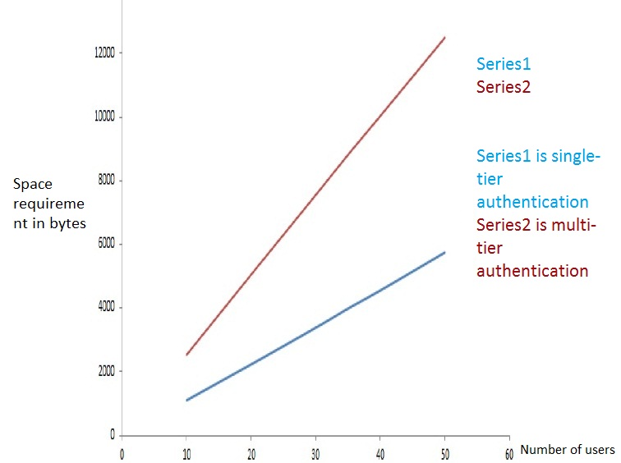

Fig. 4: Additional space for multi-tier authentication scheme

we need to calculate storage space for single-tier authentication. The results were taken for both techniques and the resulting graph clearly shows that both in linear functions of data entered, which means that if data entries (users) are increased in multi-tier authentication scheme, the space requirement also increased linearly. Single-tier authentication scheme requires 114 bytes for storing one user’s credential and multi-tier authentication requires 253 bytes for store one user’s credential. If any time 1000000 users registered then system would need 1000000*(253-
114)=139000000(139 MB approx.) bytes extra storage space. It is not a big issue in cloud computing environment for more security.The above discussion is shown in fig.4.

VI. CONCLUSIONS

It is very much evident that the strength of any authentication technique depends on the fact that whether the technique can be broken or not. The proposed scheme

provides better security through two level authentications. Proposed multi-tier authentication in cloud computing enjoy the benefits of two level authentication while offering user privacy preservation. Multi-tier configuration has several advantages such as no additional hardware and software requirements and second level authentication is entirely done at client side. The proposed scheme provides a balanced solution between the security and performance. Furthermore, our work is based on the components of the cloud computing, where the tasks are distributed in a great manner to avoid the weakness of previous schemes.

VII. FUTURE IMPROVEMENTS

Although the proposed scheme has some advantage in case of additional hardware and software requirements, but it has some drawbacks too. Changing the username and password in both the tiers do not possible. This is major concern and has to be taken care of in future. The other possible ways of recovering the passwords in multi-tier environment are the possible future improvements.

REFERENCES

[1] Peter Mell and Tim Grace,“The NIST definition ofcloud computing”, NIST Special Publication 800-145 (SP800-145), National Institute of Standards and Technology, Gaithersburg, January 2011, pp. 1-52.

[2] White paper for authentication and authorization, “http://www.cryptocard.com/images/stories/pdfs/Authentication WP.PDF”.

[3] B. Goswani, and D. S. Singh, “Enhancing Security in Cloud computing using Public Key Cryptography with Matrices”, International Journal of Engineering Research and Applications, vol. 2, no. 4, pp. 339-344, 2012.

[4] M. K. Boyarsky,“Public-key Cryptography and Password Protocols: The Multi-User Case”, Proc. of the 6th ACM Conference Computer and Communication Security (CCS99), Singapore, Nov. 1999, pp.63-72.

[5] U. Oktay and O.K. Sahingoz, “Attack Types and Intrusion Detection Systems in Cloud Computing”, 6th International information Security & Cryptology Conference, pp. 71-76, 20-21
September 2013.

[6] Yashpalsinh Jadeja, Kirit Modi, “Cloud Computing- Concepts, Architecture and Challenges”, 2012 International Conference on Computing, Electronics and Electrical Technologies [ICCEET].

[7] M. Armbrust, A. Fox, R. Griffith, A. D. Joseph, R. Katz, A.
Konwinski, G. Lee, D. Patterson, A. Rabkin, I. Stoica, and M. Zaharia, “A view of cloud computing”, Communication of the ACM, vol.7, No.4, Apr. 2010, pp. 50-58.

[8]Gurudatt Kulkarni, Rani Waghmare, Rajnikant Palwe, Vidya Waykule, Hemant Bankar, and Kundlik Koli “Cloud Storage Architecture”, 2012 7th International Conference On
Telecommunication Systems, Services, And Applications
(TSSA).

[9]S. Bellovin and M. Merritt,“Encrypted Key Exchange: Password- Based Protocols Secure against Dictionary Attacks”, Proc. of the IEEE Sym- posium on Research in Security and Privacy (SRSP92)), May 1992, Oakland, CA, USA, pp.72-84.

[10]Chun-I Fan, Pei-HsiuHo, and Ruei-Hau Hsu, “Provably Secure Nested One-Time Secret Mechanisms for Fast Mutual Authentication and Key Exchange in Mobile Communications”, IEEE/ACM Transactions on Networking, Vol. 18, No. 3, JUNE
2010.

[11]“Authentication in an Internet Banking Environment”, Federal
Financial Institutions Examination Council, Government of USA,
2005.

[12]David Chou,“Strong User Authentication on theWeb”, Microsoft Corporation, August 2008 Available at: http://msdn.microsoft.com/en- us/library/cc838351.aspx

[13]Prof. More V.N, “Authentication and Authorization Models”, International Journal of Computer Science and Security (IJCSS), Volume 5, Issue 1, 2011.

[14] Y. Zheng, “Public Key Cryptography for Mobile Cloud”, Information Security and Privacy, Lecture Notes in Computer Science C. Boyd and L. Simpson, eds., pp. 435- 435: Springer Berlin Heidelberg, 2013.

[15]Prashant et al.,“An Architecture Based on Proactive model for Security in Cloud”, International Conference on Recent Trends in IT, IEEE, 3-5 June 2011, pp. 661-666.

[16]Claimstypes:http://blogs.msdn.com/vbertocci/archive/2008/05/05/
claimtypes-a-coarsetaxonomy.aspx

[17]Security Assertion Markup Language, A Brief Introduction to
SAML, Tom Scavo, NCSA.

[18] S. Jeon , H. S. Kim, and M. S. Kim,“Enhanced Biometrics-based Remote User Authentication Scheme Using Smart Cards”, J. of Security Engineering, Vol.8, No.2, Apr. 2011, pp.237-254.

[19] J. Wayman, A. Jain, D. Maltoni, and D. Maio,“An Introduction to Bio-metric Authentication Systems”, Biometric systems Technology, Design and Performance Evaluation, Springer, London, 2005, pp.1-20.

[20] Pashalidis, A., Mitchell, C., “A taxonomy of single sign-on systems”, Proceedings, volume 2727 of Lecture Notes in Computer Science, Springer-Verlag, Berlin, July 2003, pp.249-
264.

[21]Dinesha et al.,“Multi-level Authentication Technique for Accessing Cloud Services”, International Conference on Computing, Communication and Applications (ICCCA), IEEE,
22-24 February 2012, pp. 1-4.

[22] Dominick Baier, Vittorio Bertocci, Keith Brown, Scott Densmore, Eugenio Pace, Matias Woloski, “A GUIDE TO CLAIMS-BASED IDENTITY AND ACCESS CONTROL”, Authentication and Authorization for Services and the Web, 2nd ed. http://msdn.microsoft.com/enin/ library/ff423674.aspx.

[23] Syam Kumar P, Subramanian R, “An Efficient and Secure Protocol for Ensuring Data Storage Security in Cloud Computing”, IJCSI International Journal of Computer Science Issues, Vol. 8, Issue 6, No 1, November 2011 ISSN (Online):1694-0814.

[24] K. Gunjan, G. Sahoo, and R. Tiwari, “Identity Management in Cloud Computing A Review”, International Journal of Engineering Research & Technology, vol. 1, no. 4, pp. 1-5, June
2012.

[25]Claims-Based Identity For Windows http://download.microsoft.com/

[26] Mohammed RazaKanjee, KalyaniDivi, and Hong Liu,“A Physiological Authentication Scheme in Secure Healthcare Sensor Networks”, Proceedings of IEEE Secon, 2010.

[27] Maninder Singh and Sarbjeet Singh, “Design and Implementation of Multi-tier Authentication Scheme in Cloud”, IJCSI International Journal of Computer Science Issues, Vol. 9, Issue 5, No 2, September 2012 ISSN (Online): 1694-0814.

[28] Google App Engine, http://appengine.google.com/

[29] Daniel Guermeur and Amy Unruh,“Google App Engine Java and GWT Application Development”, Packt Publication, Chapter 1, November 2010.

[30] Daniel Guermeur and Amy Unruh, “Google App Engine Java and GWT Application Development”, Packt Publication, Chapter
2, November 2010, pp 24-29.

[31] “Benefits of Using RPC over HTTP”, Available at:http://technet.microsoft.com/enus/library/aa997284(v=exchg.6
5).aspx

[32] “Making Remote Procedure Calls”, Available at:
https://developers.google.com/webtoolkit/doc/latest/tutorial/RPC

[33] “Google Plugin for Eclipse 3.7 Installation Instructions”, Available at: https://developers.google.com/eclipse/docs/install-
eclipse-3.7

[34] Google Account Recovery, methods available at https://accounts.google.com/RecoverAccount

