**Next-Generation Wireless Standards: 6G and Beyond**

Monica Gupta, Assistant Professor, Department of ECE, Bharati Vidyapeeth’s College of Engineering, New Delhi

V.Gayathri, Student, Department of ECE, Bharati Vidyapeeth’s College of Engineering, New Delhi

Monica Bhutani, Assistant Professor, Department of ECE, Bharati Vidyapeeth’s College of Engineering, New Delhi

**Abstract:**

6G, the future­ mobile system, is designed to overcome the issues seen in the former networks. It is intended for use in applications like Virtual Reality, Brain Computer-Wireless Interference Actions and Autonomous Driving Vehicles that require high data speed and minimal delay. The chapter highlights the overview of previously developed networks, system requirements and applications of the 6G network. The shift from 5G to 6G is described, with a focus on cooperation efforts, social impact and ethical considerations. Global connectivity, which reveals the role of 6G in shaping the future, is also discussed. Amidst advancing 6G research, it underlines challenges posed by smart devices and multimedia programs, spotlighting technology like (sub) THz verbal exchange, AI integration, and reconfigurable wise surfaces. The technological progress that has been achieved to define wireless communication, to create a 6G community with exceptional capacity and reduced latency, is assessed in this chapter in a concise but profound way, setting the stage for the future of connectivity.

***Keywords:*** 6G technology, Wireless communication, Wireless standards, Next-generation technology, 5G technology.

**Introduction to Wireless Evolution:**

6G, the emanation of the next-generation wireless standard, is the outcome of the persistent advancement of cellular networks due to the disclosure of inherent constraints in the former generations. 5G technology has the potential to transform communications and enable advanced applications such as remote surgery and self-driving cars. 6G is expected to outperform 5G in performance and network connectivity to overcome these limitations. Virtual reality, augmented reality and the Internet of Things will be able to reach their full potential thanks to the faster speeds, lower latency and more reliable connections of 6G. It is the expectation that 6G would enhance the advantages that 5G offers in terms of network connectivity. In addition to addressing the shortcomings of its predecessors, 6G aims to transform data transmission in smart cities with unmatched efficiency, lower latency, and seamless integration of bandwidth-intensive applications (autonomous vehicles, wireless brain-computer interactions, and extended reality). In the end, 6G will contribute to the integration of the digital, biological, and physical realms. It will create a sustainable, networked physical environment that is not just digital and programmable but also supported by intelligent machines and the Internet of Senses.

This chapter analyzes 6G cellular networks, including their potential uses, problems and societal effects, given the evolution of telecommunications technologies. New use cases such as virtual reality, augmented reality, advanced medical systems, and automation are expected to be enabled by 6G, enabling faster and more reliable communications. Collaboration research with an ethical and socially responsible approach will be needed to realise the full potential of 6G. As the research progresses, it will consider issues of ethics like safety, privacy, societal dynamics and how globalization is leading to defining next-generation network standards. Knowledge from researchers, industrial companies and common organisations will be needed to develop a road map for the 6G.

As wireless communication has seen vast development, the number of users also has been increasing by 50% per year since 1984. The need to increase the capacity of today's mobile networks to cope with the increasing demand for smart devices and multimedia applications is thus recognised in this chapter.

Overall, this chapter provides a comprehensive view of the 6G mobile systems and contains concise information on services, applications, research as well as technology developments.

1. **Overview of Previous Wireless Generations:**

Wireless communications have seen outstanding advances, where each of the generations brings transformative changes in connectivity, speed and capacity. This trip spans from the early days of 1G to the anticipated advances of 6G and beyond.

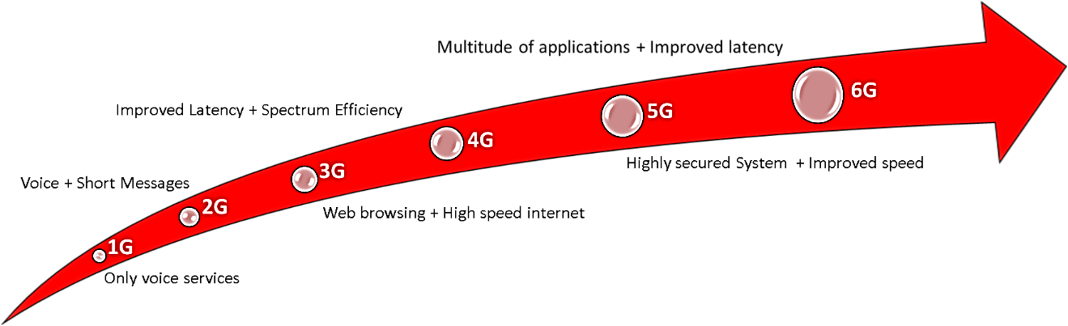

*Fig 1. Evolution from 1G to 6G: Network services*

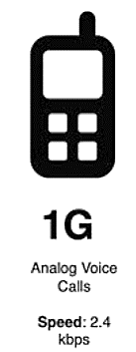**1G Pioneers:** The advent of wireless communications commenced with 1G, which marked a revolutionary transition from traditional wireline telephony to the mobile telecommunications era. In the early 1980s, 1G, or the first generation of mobile networks, revolutionized traditional wireline telephony and paved the way for the age of mobile telecommunications. The main goal of 1G was to enable wireless voice calls, freeing users from the limitations of landline connections. Despite the fact that mobile devices during that time were bulkier and heavier than today's sleek and compact devices, 1G served as a foundation for subsequent advancements in wireless communications technology.

*Fig 2. 1G Network services*

Despite the restrictions of mobility and the fundamental nature of voice communication, 1G laid the foundation for subsequent advances in wireless communications technology, shaping the landscape for generations of complex more and more featurerich later. The extensive use of 1G set the phase for the development of 2G, 3G, 4G, and presently 5G, which have facilitated a whole ecosystem of connected devices, services, and applications.

**2G The Digital Revolution:** A Notable Development in Wireless Communication: The introduction of 2G in the 1990s allowed for the transition from analogue to digital technologies, which offered higher voice quality and mobility. Greater access to a variety of services has been made possible by this paradigm shift. Text messaging was one of the main improvements in 2G, completely changing how people communicated outside of voice calls. Additionally, refinements in voice quality made the interactions more reliable and transparent. Furthermore, the optimal use of the wireless spectrum was greatly aided by 2G. More users can now share the available bandwidth at once thanks to the significant improvement in communication channel efficiency brought about by the use of digital transmission techniques. The foundation for later wireless technology generations was created by this increase in spectral efficiency.  In summary, the development of subsequent generations of mobile networks—which are more sophisticated and feature rich—was made possible by 2G. It has also expanded the services it offers for mobile communication, adding text messaging among them.

*Fig 3. 2G Network services*

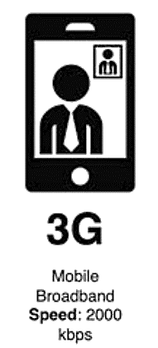**3G Mobile Internet Emerges:** In the early 2000s, the emergence of 3rd generation network marked a transformative phase in mobile communication. It transformed the network into convoluted hubs for the exchange of data and multimedia through sophisticated connectivity and mobile Internet capabilities. The beginning of 3G mobile communication was observed by drastically increased data transmission and new applications and services. The shift from 2.4Kbps to 2Mbps improved the voice quality and enabled users to video call with good quality streaming. The development of 3g allowed use1rs to browse the web, write emails, and view entertainment content. This change brought the transition from primarily voice-centric services to a data-centric approach.

*Fig 4. 3G Network services*

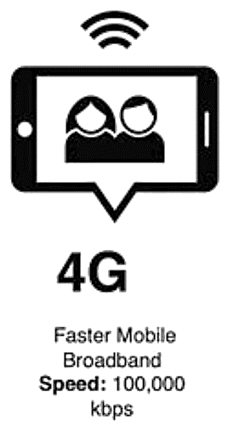**4G Broadband Connectivity:** The 4th generation of wireless communication was the significant advancement in 3G around 2009.  In order to boost the reliability and performance of these devices over cellular broadband, it has made considerable advances in data transfer speeds up to 100Mbps. The faster data transfer ensured an expedited and seamless user experience (high-definition video streaming and online gaming).

The salient feature also includes reduced latency, enabling users’ real-time communication such as video conferencing.  The low latency provided users with a reduced delay and a more responsive and engaging experience. In industries such as finance and healthcare where time sensitive transactions are carried out, this strategic reduction of latency would have a significant impact.

*Fig 5. 4G Network services*

 With robust and high-speed connections, 4G has also played an important role in the expansion of the Internet of Things. It came with refinement in the accuracy and speed of location-based services, ensuring sophisticated navigation applications and seamless integration of geotagging features.

The emergence of the fourth generation has given rise to 5G technologies, which consequently have an understandable impact on strategic planning for their development and deployment.

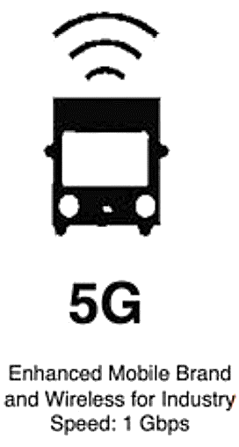**5G The Era of Connectivity:** 5G, introduced in 2019 commercially, represents a significant forward leap in wireless communication. It is marked by exponentially faster data transmission compared to predecessor technologies. The speed from Mbps shifted to around 1Gbps, facilitating quicker downloads, consistent streaming and more rapid data uploads. Ultralow latency was brought about by 5G, which aided in vital real-time applications including driverless vehicles, augmented reality, and virtual reality. With smart grids, 5G has been addressing the support for managing machinery and connectivity to a variety of applications outside of industry, including agriculture, construction, and energy. Real-time Internet of Things (IoT) access is also made available. 5G supports a high density of devices per square kilometre in applications with a large number of interconnected devices. It follows the concept of network slicing, which leads to virtualized and independent networks, allocating each slice according to the use case. A large number of devices are supported due to the mMTC (Massive Machine Type Communication) design of 5G, which enables simultaneous connections. This design is important for the expansion of the IoT field.

*Fig 6. 5G Network services*

In order to ensure that users have an unprecedented experience of bandwidth intensive applications, it is equipped with a very improved broadband capability from previous technologies. The increased data transfer speed, bandwidth capability, and highly reduced latency make 5G a more energy-efficient technology. Thus, the 5G technology is a superior technology that allows multiple users to access the network with the best quality services and enhanced security to safeguard the communication process.

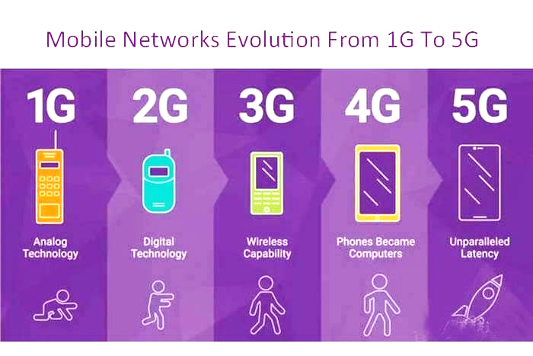

*Fig 7. Mobile network from 1G to 5G.*

**6G Anticipating the Future:** 6G is the sixth generation. The goal of 5G is to enable millions of devices with extremely low latency. The secret to learning how to remotely control machines is resilience coupled with low latency, which enables people and machines to collaborate in the same real-virtual environment. Whether it is smart cities, farms, factories, or robotics, 6G will elevate everything with regard to network connectivity and make it better for the end user. It offers increased functionality, increased efficiency, and a better user experience. Thanks to the extensive deployment of sensors, real-time synchronous updates, digital twin models, artificial intelligence, and machine learning (AI/ML), 6G will link the physical and digital worlds.

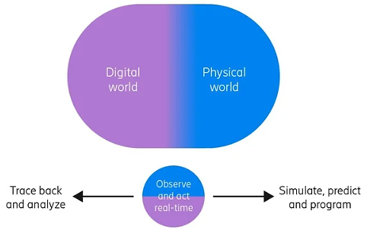These digital twin models are important because they let us analyse what's happening in the real world, foresee needs, model potential consequences, and take constructive action in the real world. In the 6G era, mobile phones will still be essential devices, but new interfaces between humans and machines will facilitate the management and consumption of information. 6G will combine the digital, physical, and human realms. This will build a network that moves us from information to knowledge, efficiency to purpose, and connectivity to unification. It is intended to create a digitally and programmably connected and sustainable physical environment where intelligent machines and the Internet of Senses support humankind.

*Fig 8. Interconnection of Digital and physical world.*

**Beyond 6G Imagining the Uncharted:** 6G and beyond will provide universal wireless connectivity for everyone, meeting the needs of a fully connected world. It is anticipated that transformative developments will propel the push to support an ever-increasing quantity of intelligent devices and services. The following significant technology advancements have been made in order to meet 6G's connection goals:

1. TERAHERTZ COMMUNICATION ADVANCEMENTS - 6G connectivity will function over a broad range of frequency bands, from the millimetre wave and mid-band region of 3.5 to 6 GHz to terahertz. These sub-THz frequencies will often only be used in situations when there is an urgent need for extremely high data rates or very low latency in specific locations.  The potential to deliver faster and more efficient communications at unprecedented bandwidth.  With improved data capabilities, applications like Augmented Reality and Virtual Reality can be used.
2. ROLE OF ARTIFICIAL INTELLIGENCE (AI) - Artificial intelligence has a key role to play as regards the development of air interfaces after the 6G era. The intelligence systems adapt to the communications environment and optimise their performance at a rapid pace. The efficiency, reliability and security of wireless networks will be enhanced by machine learning, neural network techniques or artificial intelligence.
3. HEALTHCARE TRANSFORMATION - It allows for the provision of personalized and progressive health care. To facilitate effective exchange of ideas and timely sharing of patient information between healthcare professionals around the world, rapid decisions in case of emergency need to be taken using 6G for better communication and cooperation. Health applications include holographic communication for in-person, personalised treatment plans through rapid analysis of a wide range of health data, advanced imaging to detect early cancer detection, accelerated drug discovery and improved prosthetics offering strong links with the user's nervous system towards enhanced control and quality of life.
4. IMMERSIVE EDUCATION - To increase knowledge transfer, virtual reality experiences will be provided through 6G in the field of education. There will be an exponential increase in the boundaries of learning. 6G allows students and teachers from all over the world to communicate and collaborate in an easy, high-quality way. Virtual classrooms, where students from different locations can collaborate on projects, share knowledge and participate in joint learning experiences, are becoming immersive spaces.

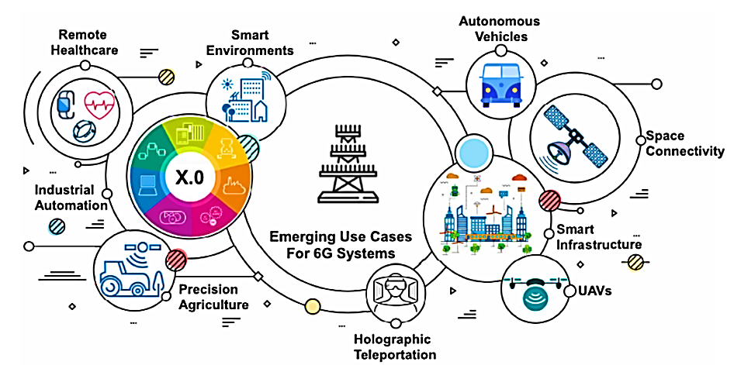

*Fig 10. Use cases of 6G.*

1. UBIQUITOUS CONNECTIVITY - Semantic interoperability interfaces support a collaborative network that facilitates the integration of computer entities, private networks, smart cities, macro networks, and potential intermediaries.
2. REMOTE AREA ACCESSIBILITY - specific coverage needs, the utilisation of extra-terrestrial systems, Dynamic weather monitoring and warning systems, digital replicas to facilitate remote surgery, and remote medical support for people and farm animals.
3. AUTOMATED TRANSPORTATION - Enable guided automated road transport systems to enhance security, alleviate traffic, and boost intercity travel times.
4. IMMERSIVE INTERACTIVE EXPERIENCE - VR, AR, and mixed reality (MR) experiences targeted at the manufacturing, education, scientific, and entertainment sectors.
5. INDUSTRIAL INTERNET - Ultralow end-to-end communication latencies and Hyper-reliability.
6. SUPPLY CHAIN AND LOGISTICS - incredibly low indoor/outdoor positioning latencies for real-time tracking.
7. SURVEILLANCE FOR INDUSTRIES AND CIVIC CRIME CONTROL - Controlling crowds and preventing crime via AI/ML.
8. NATIVE AI/ML IN NETWORKS - AI for the network, AI in the network, AI at the device, and AI in the cloud with use cases including network self-management, security, and personalisation.
9. **Motivations for 6G Development:**

Due to the inherent limitations of previous wireless technologies, which have led to 6G's development, there is a need for a paradigm shift to meet an evolving Digital Age demand. The need for a more advanced and capable network has reinforced by the emergence of congestion, such as bandwidth constraints, latency problems or inability to support applications that run on high bandwidth. The proliferation of applications of 6G networks, such as extended reality, wireless brain-computer interaction, and autonomous vehicles, which require significant bandwidth. The limitations of the former technology will be overcomed by 6G by integrating seamlessly and accommodating the necessities of bandwidth-intensive applications. Therefore, 6G aims to give better data rates along with a more dependable and low quiescence transmission network that will lay the road for a future of a more intelligent, technologically advanced society.

1. **System Requirements and Technological Landscape:**

6G wireless technologies, with their evolving technical landscape, encompass a set of fundamental system requirements that contribute to their evolution. It is essential to include the high-end rates and advances in the sixth-generation (6G) technological environment. The vital components are the millimetre wave bands, Massive Multiple Input Multiple Output (MIMO) technology, dense deployment of microcellular units, effective decoding techniques such as filters for OLF multiplexing and advances in virtualization and computing technologies.

The objective of the Next Generation Standard is to provide essential characteristics that are significantly more advanced than existing technologies. High reliability, low latency, increased data rates and support for a wide range of bandwidth applications are among the key characteristics of 6G. Therefore, the combination of such requisites from various systems and advanced conditions of technologies makes 6G wireless communication the most advanced technology.

1. **Potential Applications of 6G:**

6G is a concept that entails a great variety of applications, which can be regarded as the final step forward to the development of new scientific opportunities and that reflects the unique nature of the changes taking place in the digital age. Among the key motivators of 6G development, one of the main driving forces is the uniform utilization of bandwidth-intensive applications.

The application areas of 6G are expected to be wide-ranging, opening up revolutionary developments to meet the dynamics of the digital world. These include, however not restricted to, extended reality (XR), wireless brain-computer interactions, and autonomous vehicles. The increased rates of data in 6G with powerful ultra-reliable and low-latency communications and an expansive bandwidth will promote high-quality XR experience going beyond the world of lives, holographic communication, and digital twinning. Additionally, the technology is set to revolutionize wireless brain-computer interactivity as a technological paradigm of human-machine connectivity. The implementation of 6G will prove to be finally the missing link in the evolution of autopilot vehicles through effective real-time communication, which will enhance safety as well as productivity. The emergent applications are highlighted by the transformative nature of 6G that is realised in diverse sectors thereby exhibiting a future of connectivity supersedes the current limits.

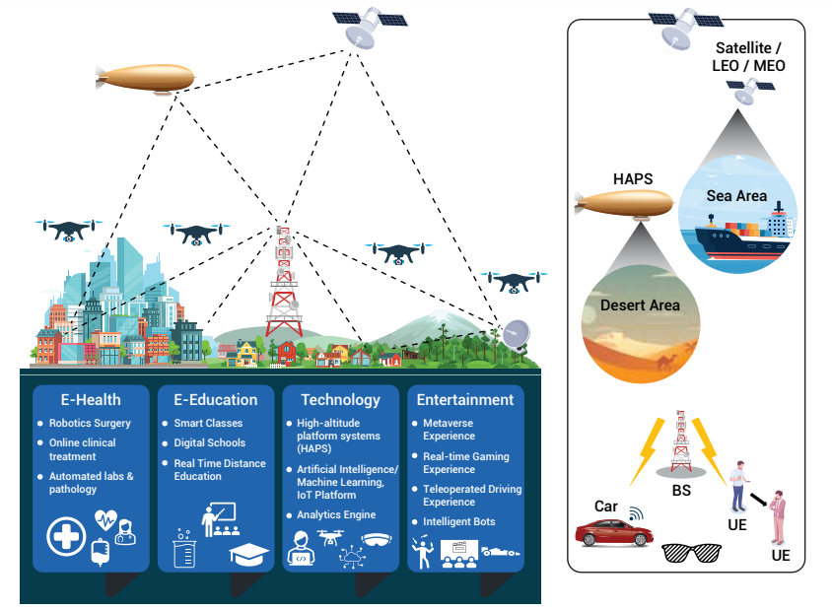

*Fig 11. Applications of 6G.*

1. **Challenges in Transition from 5G to 6G:**

The shifting from 5G to 6G comes along with some challenges to be addressed reflecting the way towards the development and evolution of the wireless standard. There is one prominent challenge associated with the seamless integration of 6G’s new abilities without compromising the capabilities of 5G, which the current equipment supports. This entails not only moving through this confusing world of distinct technologies and services intertwined in a network. Further, the predicted problems include the creation and normalization of new technologies and responding to the issues connected with the spectrum allocation and regulatory institutions. The transition also has to deal with the nuances of ethical issues that are inseparable from innovative wireless technologies, including privacy, security, and social engineering. Ethical responsibility, innovation, and finding a reasonable middle ground between the two are not easy to balance one. In the process of this evolutionary shift in the wireless ecosystem, collaborative projects, research efforts, as well as industry cooperation, will be essential to meet the challenge of evolving from 5G to 6G.

1. **Ethical Considerations in Advanced Wireless Technologies:**

Advanced wireless technologies necessitate significant moral considerations because we are stepping into the world of high-end connectivity. However, the implementation of technologies such as 6G that promise a paradigm shift in communication creates ethical issues of privacy, security and other social dynamics that are overlooked.  These technologies and their impact on our daily lives in terms of use, monitoring or surveillance need to be assessed from a general ethical point of view as they are implemented into intensive work and everyday life. The importance of balancing technological development with ethical principles to promote responsibility and sustainable growth cannot be underestimated in a time of new wireless technologies.

1. **Roadmap to 6G:**

The roadmap to 6G opens up as a dynamic voyage that narrates the course from current wireless standards to the projected metamorphosis. Through this path, there are interactive efforts that the key players in the industry, standardization bodies, and researchers. The technology, the services, and the applications are connected through the road map to conceptualize the 6G cellular system intricately. It deals with the definition of system requirements, analysing trends in technology and identifying challenges. The transformational aspects of the next-generation wireless standards and their defining features, as well as the promotion of milestones and collaborative initiatives that will lead to 6G and future generations, are highlighted.

*Fig 12. Roadmap to 6G.*

1. **Technological Advancements and Research Progress:**

The world of 6G is characterised by many technological innovations and ongoing research advancements that influence the wireless communication of the future. For which, researchers are constantly making endeavours to look for innovative approaches to address the inbuilt restrictions of existing networks given fulfilling the growing demands on bandwidth-intensive applications.

The conducted progress in 6G research refers to various directions, such as a variety of system requirements, possible development opportunities, and advanced technologies. State-of-art development includes communication, sensing, and localization, which all contribute to an enlightened revolution as the present state-of-art that is adaptable to the new frontiers in the environment.

1. **6G's Transformative Role in Global Connectivity:**

As the next generation of wireless communication, 6G awaits the next forefront, assuming revolutionary characteristics in the development of international infrastructures. 6G aims to provide such communication capacity and performance beyond the capabilities and levels of the previous systems and systems that characterised the end of the era. The introduction of this new standard is set to reduce the level of uncertainty while facilitating the inception of an unprecedented level of efficacy, significantly more significant capacity as well as greatly reduced latency. However, the potential for transformation is in its ability to include stateoftheart technologies from extended reality to wireless brain computers’ interactions and autonomous rides are completely blended into one technology package. With smart cities in the 6G future consuming massive amounts of data with negligible latency, it is one of the vital forces that define our interconnected world of the global society. In this chapter, then, the transformative nature of 6G as it pertains to the evolution of global connectivity in the asymmetry that global connectivity can change the course of wireless standards of living is laid bare.

*Fig 13. Global connectivity of 6G.*

**Conclusion and Future Perspectives:**

From 1G to the oncoming 6G, Communications technology continuously improves as capabilities have been unfolded. The very first step to bring voice calls to life was with 1G in 1971 and with each iteration moving forward had capabilities unleashed. Now, the 5G is not just moving it forward but the ultimate goal of 6G is not just an improvement over the current version, it wants to explore completely new roles and act as an enabler for Physical Life, Biological Life, and also Digital Life. 6G could certainly bring new ways in connecting applications, like Reality (Immersive Reality & Extended Reality) and also improve the quality of life by bringing better communication, better connectivity, and ultimately reducing delay and eventually saving bandwidth and energy consumption. To cruise with 6G, innovation, respectful to infrastructure existing, and also integrating capabilities and keeping ethics related to privacy and security as a primary target are all the main goals to be chased.

Governments, industries, international standardisation bodies and the research community have worked together to provide a roadmap to 6G implementation. The impact of 6G on smart learning, health care, autonomy and others will continue to grow over the coming years. Essentially, by reinforcing our information society to imagine a better world with connectivity, 6G is the end of evolution's evolutionary journey and will eventually bring us closer to connected, smart and environmentally friendly future.

**References:**

1. [H. Hafi](https://ieeexplore.ieee.org/author/37086263232), [B. Brik](https://ieeexplore.ieee.org/author/37073369200), [P.A. Frangoudis](https://ieeexplore.ieee.org/author/37079088100), [A. Ksentini](https://ieeexplore.ieee.org/author/37284835700), [M. Bagaa](https://ieeexplore.ieee.org/author/37945137900), “Split Federated Learning for 6G EnabledNetworks: Requirements, Challenges, and Future Directions”, IEEE Access, vol.12, pp. 98909930, January 2024, doi: [10.1109/ACCESS.2024.3351600](https://doi.org/10.1109/ACCESS.2024.3351600).
2. [X. Mu](https://ieeexplore.ieee.org/author/37088218516), [J. Xu](https://ieeexplore.ieee.org/author/37088654930), [Y. Liu](https://ieeexplore.ieee.org/author/37085363947), [L. Hanzo](https://ieeexplore.ieee.org/author/37276255400), “Reconfigurable Intelligent SurfaceAided NearField Communications for 6G: Opportunities and Challenges”, [IEEE Vehicular Technology Magazine](https://ieeexplore.ieee.org/xpl/RecentIssue.jsp?punumber=10209), pp. 211, January 2024, doi: [10.1109/MVT.2023.3345608](https://doi.org/10.1109/MVT.2023.3345608).
3. H. Li, S. Li, G. Min, “Lightweight privacypreserving predictive maintenance in 6G enabled IIoT”, Journal of Industrial Information Integration, January 2024, doi: 10.1016/j.jii.2023.100548.
4. M. Banafaa, I. Shayea, J. Din, M.H. Azmi, A. Alashbi, Y.I. Daradkeh, A. Alhammadi, “6G Mobile Communication Technology: Requirements, Targets, Applications, Challenges, Advantages, and Opportunities”, [Alexandria Engineering Journal](https://www.sciencedirect.com/journal/alexandria-engineering-journal), vol. 64, pp.245274, February 2023, doi: 10.1016/j.aej.2022.08.017.
5. Wang, Zhe, Zhang, Jiayi, Du, Hongyang, Niyato, Dusit, Cui, Shuguang, Ai, Bo, Debbah, Mérouane, Letaief, B. Khaled, Poor, H. Vincent, “A Tutorial on Extremely LargeScale MIMO for 6G: Fundamentals, Signal Processing, and Applications”, IEEE Communications Surveys & Tutorials, pp. 11, January 2024, doi: [10.1109/COMST.2023.3349276](https://doi.org/10.1109/COMST.2023.3349276).
6. Z. Qadir, K.N. Le, N. Saeed, H.S. Munawar, “Towards 6G Internet of Things: Recent advances, use cases, and open challenges”, ICT Express, vol. 9, no. 3, pp. 296312, June 2023, [doi: 10.1016/j.icte.2022.06.006](https://doi.org/10.1016/j.icte.2022.06.006).
7. [S. Mahboob](https://ieeexplore.ieee.org/author/37086616159), [L. Liu](https://ieeexplore.ieee.org/author/37293117400), “Revolutionizing Future Connectivity: A Contemporary Survey On AIEmpowered SatelliteBased NonTerrestrial Networks in 6G”, IEEE Communications Surveys & Tutorials, pp.11, January 2024, doi: 10.1109/COMST.2023.3347145.
8. B. Zhai, Y. Zhu, A. Tang and X. Wang, "THz Prism: FrequencyBased Beam Spreading for Terahertz Communication Systems," in IEEE Wireless Communications Letters, vol. 9, no. 6, pp. 897900, June 2020, doi: 10.1109/LWC.2020.2974468.
9. A. S. Cacciapuoti, M. Caleffi, F. Tafuri, F. S. Cataliotti, S. Gherardini and G. Bianchi, "Quantum Internet: Networking Challenges in Distributed Quantum Computing," in IEEE Network, vol. 34, no. 1, pp. 137143, January/February 2020, doi: 10.1109/MNET.001.1900092.
10. Z. Qin, H. Ye, G. Y. Li and B. H. F. Juang, "Deep Learning in Physical Layer Communications," in IEEE Wireless Communications, vol. 26, no. 2, pp. 9399, April 2019, doi: 10.1109/MWC.2019.1800601.
11. C. Liaskos, S. Nie, A. Tsioliaridou, A. Pitsillides, S. Ioannidis and I. Akyildiz, "A New Wireless Communication Paradigm through SoftwareControlled Meta surfaces," in IEEE Communications Magazine, vol. 56, no. 9, pp. 162169, Sept. 2018, doi: 10.1109/MCOM.2018.1700659.
12. C. Huang, G. C. Alexandropoulos, A. Zappone, M. Debbah and C. Yuen, "Energy Efficient MultiUser MISO Communication Using Low Resolution Large Intelligent Surfaces," 2018 IEEE Globecom Workshops (GC Wkshps), Abu Dhabi, United Arab Emirates, 2018, pp. 16, doi: 10.1109/GLOCOMW.2018.8644519.
13. C. Han, J. M. Jornet and I. Akyildiz, "UltraMassive MIMO Channel Modeling for GrapheneEnabled TerahertzBand Communications," 2018 IEEE 87th Vehicular Technology Conference (VTC Spring), Porto, Portugal, 2018, pp. 15, doi: 10.1109/VTCSpring.2018.8417893.
14. N. Kato et al., "The Deep Learning Vision for Heterogeneous Network Traffic Control: Proposal, Challenges, and Future Perspective," in IEEE Wireless Communications, vol. 24, no. 3, pp. 146153, June 2017, doi: 10.1109/MWC.2016.1600317WC.
15. S. Wang and C. Ran, "Rethinking cellular network planning and optimization," in IEEE Wireless Communications, vol. 23, no. 2, pp. 118125, April 2016, doi: 10.1109/MWC.2016.7462493.
16. F. Akyildiz, M. Pierobon, S. Balasubramaniam and Y. Koucheryavy, "The internet of BioNano things," in IEEE Communications Magazine, vol. 53, no. 3, pp. 3240, March 2015, doi: 10.1109/MCOM.2015. 7060516..
17. J. M. Jornet and I. F. Akyildiz, "Graphenebased Plasmonic NanoAntenna for Terahertz Band Communication in Nanonetworks," in IEEE Journal on Selected Areas in Communications, vol. 31, no. 12, pp. 685694, December 2013, doi: 10.1109/JSAC.2013.SUP2.1213001.
18. R. G. CidFuentes, J. M. Jornet, I. F. Akyildiz and E. Alarcón, "A receiver architecture for pulsebased electromagnetic nanonetworks in the Terahertz Band," 2012 IEEE International Conference on Communications (ICC), Ottawa, ON, Canada, 2012, pp. 49374942, doi: 10.1109/ICC.2012.6364476.
19. O. Momeni and E. Afshari, "A Broadband MmWave and Terahertz TravelingWave Frequency Multiplier on CMOS," in IEEE Journal of SolidState Circuits, vol. 46, no. 12, pp. 29662976, Dec. 2011, doi: 10.1109/JSSC.2011.2162469.
20. T. L. Marzetta, "Noncooperative Cellular Wireless with Unlimited Numbers of Base Station Antennas," in IEEE Transactions on Wireless Communications, vol. 9, no. 11, pp. 35903600, November 2010, doi: 10.1109/TWC.2010.092810.091092.
21. S. Venkatesan, A. Lozano and R. Valenzuela, "Network MIMO: Overcoming Intercell Interference in Indoor Wireless Systems," 2007 Conference Record of the FortyFirst Asilomar Conference on Signals, Systems and Computers, Pacific Grove, CA, USA, 2007, pp. 8387, doi: 10.1109/ACSSC.2007.4487170.
22. S. Collonge, G. Zaharia and G. E. Zein, "Influence of the human activity on wideband characteristics of the 60 GHz indoor radio channel," in IEEE Transactions on Wireless Communications, vol. 3, no. 6, pp. 23962406, Nov. 2004, doi: 10.1109/TWC.2004.837276.