Nanopesticides: A Promising Tool in Insect Pest Management

Ramesh M Maradi^{1*}, Ashwini A² , Keerthana A³, Sahana M⁴ and Durga G⁵
1 , 2, & 4 Ph.D. Research Scholars, Department of Agriculture Entomology, University of Agricultural Sciences, Dharwad, Karnataka, India- 580005
3 M.Sc. Department of Entomology, Agricultural College, Vijayapura, Karnataka, India
5 Ph.D. Research Scholars, Dept. of Agril. Entomology, UAHS, Shivamogga
Email- maradiramesh2011@gmail.com Ph. No- 7411805515

Abstract
Nanotechnology emerges as a promising alternative to conventional pest management, specifically addressing the drawbacks associated with chemical pesticides. Integrated pest management and traditional pesticides often lead to environmental harm, resistance issues and non-target organism toxicity. Nanotechnology offers benefits like heightened pest efficiency, reduced harm to non-targets and a sustainable approach to pest control. The controlled release of nanomaterials minimizes environmental impact, making it an appealing choice for eco-friendly agriculture. Ongoing research is crucial to refine nanotechnology's development, evaluation, and regulation, ensuring a more effective and environmentally conscious strategy for insect control.
Keywords: Nanotechnology, Nano-pesticides, Formulation, Insect pest management
Introduction
Nanopesticides, or nano plant protection products, represent a cutting-edge technological advancement with the potential to revolutionize pesticide use by offering various advantages, including heightened efficacy, increased durability and a reduction in required active ingredient amounts. Formulation options encompass nanoemulsions, nanocapsules employing polymers, and products featuring engineered nanoparticles like metals, metal oxides, and nanoclays. The term 'nano' originates from Greek, meaning dwarf, emphasizing the significant size reduction. The primary goal in developing nano-pesticides is to mitigate the environmental impact of pesticide active ingredients by enhancing their chemical efficiency, leveraging the benefits of extremely small particle sizes ranging from 1 to 100 nanometers. These nanoparticles enhance solubility, formulation stability, slow release of active ingredients, and mobility due to their smaller size and larger surface area. The anticipated improvement in the mode of action against target pests distinguishes nanoparticles from bulk materials. Additionally, nano-formulations offer systemic properties, uniform leaf coverage, and improved soil characteristics, making them valuable for sustainable agricultural practices and addressing the threats posed to non-target organisms and the environment by synthetic pesticides (Savary et al., 2006).
Pesticides are indispensable in agriculture to increase crop yield. More than 90 percent of used insecticides are lost due to drift, leaching in the soil, degradation process (photolysis, hydrolysis). Only a small amount of pesticides reach the target site (1%), which requires repeated application of pesticides and has led to increased costs and pollution of the ecosystem. Farmers in the United States have spent $200 billion on pollination every year because the indiscriminate use of neonicotinoids has caused bee colony collapse disorder. In India, 28 percent of available pesticides are emulsifiable concentrates and oil-in-water emulsions, which are poorly soluble in water due to their non-polar nature. To increase their solubility, higher amounts of organic material such as xylene and surfactant are added. But organic solution/solvents are expensive, flammable and dermally toxic, and heavy metals present in surfactants accumulate in soil, creating abiotic stress in plants (Rice et al., 2001).
Repeated use of certain pesticides, such as Malathion, has produced genotoxicity in humans. Almost 20,000 human deaths are counted each year due to the consumption of pesticides through food. Pesticides interact with the microbiome present in the human gastrointestinal tract and cause digestive problems, lung cancer and hormonal imbalance. Premature degradation of the a.i (active ingredient) in pesticide formulations by soil bacteria also reduces pesticide efficacy (Anderson et al., 2016).
Nanotechnology stands on the brink of transforming various industries, encompassing agriculture, food, pharmaceuticals, aerospace, medicine, and construction. The expansive applications and benefits of nanotechnology extend to diverse fields such as electronics, cosmetics, coatings, packaging, biotechnology, materials science and more (Khatoon et al., 2017). In agriculture, nanomaterials play a pivotal role, particularly in the development of nano-encapsulated conventional fertilizers, pesticides and herbicides.
These nano-formulations enable a controlled and gradual release of nutrients and agrochemicals, ensuring precise dosing to plants. Nanofertilizers, characterized by nanoparticle-sized nutrients or artificial metal oxide and carbon-based nanomaterials, along with nanopesticides, offer targeted release of agrochemicals, maximizing biological efficacy without the risk of overdosing. Additionally, nanomaterials contribute to environmental protection by facilitating the detection and removal of contaminants through innovative techniques like nanosensors and nanoremediation methods. The versatile applications of nanotechnology underscore its potential to revolutionize and enhance various aspects of modern industries (Lavicoli et al., 2017).
The application of modern tools and techniques rooted in nanotechnology holds the potential to address various challenges associated with conventional insect pest management, presenting a potential revolution in the field (Duhan et al., 2017). The encouraging outcomes have paved the way for significant advancements in insect pest control. Nanoparticles emerge as promising agents for managing and controlling insect pests. These applications encompass safeguarding against pests through nanomaterial-based formulations of pesticides and insecticides, utilizing nanoparticles for gene or DNA transfer into plants to develop insect-resistant varieties, and enhancing agricultural productivity via slow nutrient release using nanoparticle encapsulation. Traditional agricultural approaches, such as integrated pest management and the use of synthetic pesticides like dichlorodiphenyltrichloroethane (DDT), fenthion, and malathion, exhibit adverse effects on both animals and humans, contributing to soil fertility decline. To surmount these challenges, active research has been directed toward developing new pesticides rooted in nanotechnology, commonly referred to as "Nanopesticides."

Need of Nano-Formulation:
- Meet the demands of efficacy
- Increase water solubility. •
- Suitability to the mode of application •
- Minimizing the damage to the environment

Formulations of nano-pesticides
The development of nano-pesticides involves various formulations designed for crop protection, including nanoinsecticides, nanoherbicides, nanofungicides, and nanonematicides. These formulations aim to enhance solubility, ensure slow release of active ingredients, and prevent degradation. Diverse modifications in the chemical carrier molecule have led to classifications such as organic polymers, lipids, nanoparticles, metals and metal oxides, and clay-based nanomaterials. Notable nanoformulations include (Dimetry and Hussein, 2016):
Nano-emulsions: These are oil-in-water emulsions where the active chemical is dispersed as nanoparticles in water. They can be thermodynamically stable or kinetically stable, with examples like neem oil nanoemulsions developed for insect control.
Nano-suspensions: Also known as nanodispersions, these involve dispersing solid pesticide nanoparticles in an aqueous medium. Examples include aqueous dispersions of nano-permethin, Novaluran, and β-cypermethrin.
Nanogel: Hydrogel nanoparticles are also known. These are formulated by cross-linking polymer particles with hydrophilic groups so they absorb more water, e.g; Chitosan nanogel. ▪
Nano-fibres: Nanofibers are developed using electrospinning, a thermally induced phase separation. Researchers have developed electrospun nanofibers loaded with the chemical, (Z)-9-dodecenyl acetate, a pheromone component that embeds itself into a polymer matrix to control many insect pests of the order Lepidoptera. ▪
Polymer-based nano-particles: Mainly used for slow and controlled release, these carriers improve dispersion in aqueous media. Examples include nanoencapsulation, nanospheres (e.g., bifenthrin nanoparticles), nanogels (e.g., chitosan nanogel), and nanofibers developed through electrospinning.
Nano Encapsulation: This involves packaging an active ingredient on a nanoscale into a protective shell. For instance, controlled-release nanoformulations of neonicotinoid insecticides like acetamipirid and imidacloprid have been developed.
These diverse nanoformulations showcase the versatility of nanotechnology in addressing challenges in insect pest management, offering improved efficacy and targeted delivery for more sustainable agricultural practices.

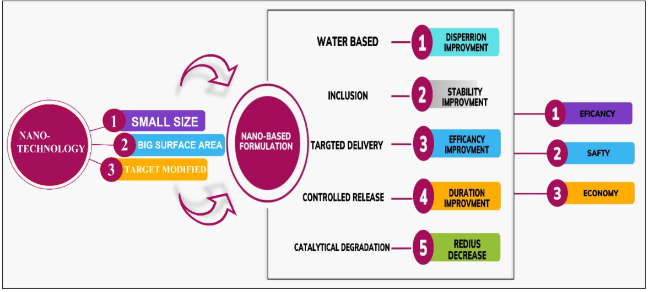
Fig 1: Beneficial enhancements of nano-pesticide formulations (Urkude, 2019)

Nanotechnology Applications in Agriculture:
- Precision Pest Management: Nanomaterials enable the development of precise, effective, and safer pesticides, herbicides, and fertilizers, allowing controlled release (Kuzma and VerHage, 2006).
- Molecular Biology Tools: Nanotechnology introduces new instruments for molecular biology, aiding in the identification of plant disease microorganisms
- Revolutionizing Disease Detection: Nanotechnology offers tools for disease detection, targeted treatment, and enhances plants' ability to resist pests and withstand environmental pressures.
- Postharvest Product Management: Nanotechnology addresses challenges in managing postharvest products, contributing to improved quality through rational selection and processing of raw materials (Rickmann et al., 2003).
- Productivity Enhancements: Applications include non-porous zeolites for efficient water and fertilizer dosing, nanocapsules for precise herbicide delivery, and nanosensors for pest detection.
- Smart Sensors and Transport Systems: Nanotechnology aids in the development of intelligent sensors and transport systems to combat infections and other crop pathogens, enhancing overall crop health.
- Environmental Sustainability: Nanotechnology contributes to environmental sustainability by offering renewable energy sources and strategies for pollution reduction and cleanup.
- Reduced Chemical Usage: Nanomaterials in agriculture reduce chemical spray usage through smart delivery systems, minimizing nutrient loss during treatments and increasing yields.
- Advancements in Genetic Modification: Nanotechnology is explored for its potential contributions to plant breeding and genetic modification (Tomey et al., 2007).
- Bio-Nanocomposites: Agriculture holds promise for bio-nanocomposites with improved physico-mechanical properties, utilizing materials like wheat straw and soybeans for bio-industrial purposes (Alamdar and Sain, 2008).

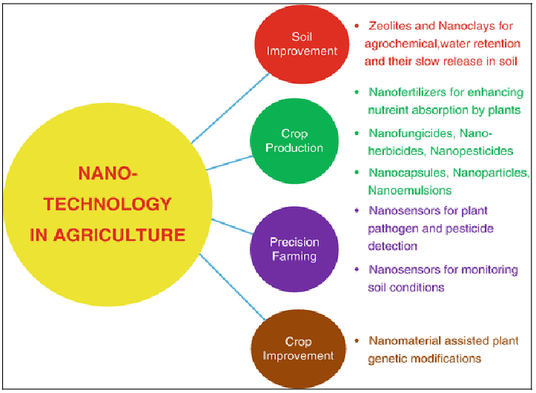
Fig 2: Nanotechnology in agriculture (Kaushal and Wani, 2017)

NPs in plant protections
Plant protection against insects and pests has benefited from nanotechnology. The nanoparticles could be useful in the formulating new pesticides, insecticides, and insect repellent compositions. The broad application of nanotechnology in the agri-sector as nanofungicides, nanoherbicides, nanoinsecticides, nanofertilizers, nanomicronutrients, nanobiopesticides, and nanobiosensors.
Nanoinsecticides
The potential use of nanoparticle in pest management has been successfully documented (Bhattacharyya et al. 2010). In the control of polyphagous pest, Helicoverpa armigera, notable application of nanoparticles has been reported (Vinutha et al. 2013). Synthesized Ag NPs reveal excellent mosquito larvicidal and antilice activity (Jayaseelan et al. 2011). Nanoencapsulation helps to promote the gradual release of chemical compounds for a distinct host for the management of insect by releasing some of the activities such as diffusion, biodegradation and osmotic pressure (Vidyalakshmi et al. 2009). The acceptable application of amorphous nanosilica as a pesticide has been found in several agricultural findings (Barik et al. 2008). Nanocopper is a modified nanoparticle which is suspended in water and used in a known compound, Bouisol, as fungicide for some grape varieties and other fruit crops. Because of mutagenesis, viral capsids could be changed to achieve several elements like the production of some enzymes and nucleic acids to act against parasites (Perez-de-Luque and Rubiales 2009). Nanoparticles with silver at 100 mg/kg restrain growth of mycelium and germination of conidia on cucurbits and inhibit the growth rate of powdery mildew in pumpkins (Lamsal et al. 2011). As one of the elite nanopesticides, silver nanoparticles show a significant application in agriculture practices (Afrasiabi et al. 2012). Treatment of mulberry leaves affected by grasserie disease is done by application of the ethanolic suspension of hydrophobic alumina-silicate nanoparticles, which has remarkably minimized the viral load (Goswami et al. 2010). DNA-tagged Au NPs are powerful for Spodoptera litura and hence they taken as a functional element for integrated pest management (Chakravarthy et al. 2012).
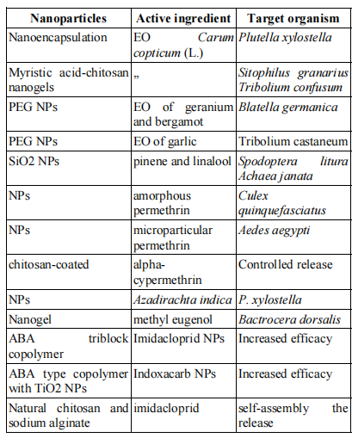
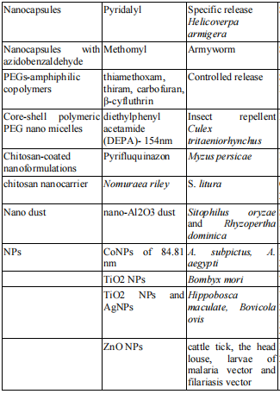
Table 1: Nanopesticides and their effect on target organisms (Parvez et al., 2019)
The Mode of action/entry of nanoparticles in insect:
Nanoparticles penetrate insects through physical contact, ingestion and inhalation. Upon physical contact, the nanoparticles penetrate the exoskeleton; bind the nanomaterials to sulfur from protein or phosphorus from DNA in the intracellular space, leading to organelle and enzyme denaturation, leading to cellular fraction and cell death (Abd-Elsalam et al., 2018). Dust nanoparticles are commonly used to control stored grain pests and the mechanism relies on physical disruption. The nanoparticles dehydrate the insect's body by attaching to their waxy cuticle layer. Nanoclay, nanoalumina, and nanosilica are attached to the insect's cuticle and absorb water from the insect's body. The hydrophobic behavior of nanosilver particles causes cracks and scratches on the insect body, changes membrane properties, resulting in changes in cell permeability and respiration, damages DNA and releases toxic Ag+ ions. Ag nanoparticles interfere with melanin synthesis. Inhalation of nanoparticles leads to internalization in cells via phagocytosis, which causes deterioration of the midgut and alters the activity of metabolic genes and decreases lipid, protein and glucose levels. Inhalation also changed the activity of nervous system enzymes and membrane potential e.g. Zn NPS and Tio2 NPS bind to acetylcholine esterase and β carboxyl esterase and affect their activity. The mode of action of these nanoparticles is same as that of organphosphorus and carbamate insecticides. Ag nanoparticles affect the enzyme Glutathione S transferase. In Spodoptera litura, Ag nanoparticles act as an amylase inhibitor. The reactive oxygen species is considered as the most cellular effects induced by nanoparticles and the excessive generation of free radicals induces DNA damage through inflammatory processes.
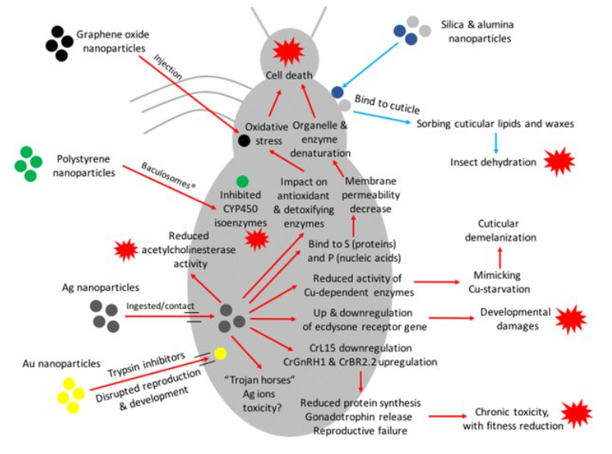

Fig 3: Mode of entry of nanopesticides/nanoparticles in insect (Rafiq et al., 2022)

Synthesis of nanomaterial
Synthesis of nanomaterials is to produce a material that consists properties of nanometer range (1-100 nm). The synthesis methods are appropriate that controls the size in this range so that one feature or another can be achieved. The methods are two types: bottom-up and top-down (Parvez et al., 2019).
- Top-Down Method: Involves breaking down solid materials into small pieces through the application of external force. Utilizes various physical, chemical, and thermal techniques to provide the necessary energy for nanoparticle formation.
- Bottom-Up Approach: Involves gathering and combining gas or liquid atoms or molecules to create nanoparticles. This approach contrasts with the top-down method and has its own set of advantages and disadvantages.
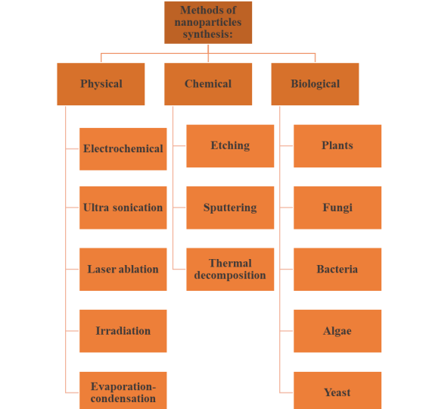
Methods of nanoparticle synthesis
Fig 4: Methods of nanoparticle synthesis (Parvez et al., 2019).
Green synthesis of nanoparticles
Green synthesis serves as a crucial tool to mitigate the negative impacts associated with traditional nanoparticle synthesis methods commonly used in both laboratory and industrial settings. This approach employs natural extracts, derived from diverse sources, to facilitate the synthesis of metal and metal oxide nanoparticles, including gold, silver, copper oxide, and zinc oxide. Key biological components, such as essential phytochemicals (e.g., flavonoids, alkaloids, terpenoids, amides, and aldehydes), play a dual role as reducing agents and contributors to solvent systems (Singh et al., 2018).
The adoption of green synthesis principles in material and nanomaterial production directly enhances environmental friendliness. This includes the regulation, control, clean-up, and remediation processes, which collectively contribute to the sustainability of nanoparticle production. The fundamental tenets of green synthesis emphasize waste prevention or minimization, reduction of derivatives and pollution, utilization of safer and non-toxic solvents and auxiliaries, as well as the incorporation of renewable feedstock. By adhering to these principles, green synthesis not only ensures eco-friendly material creation but also aligns with sustainable practices, reducing the ecological footprint associated with conventional synthesis methods and promoting a more environmentally conscious approach to nanomaterial production (Nadaroğlu et al., 2017).

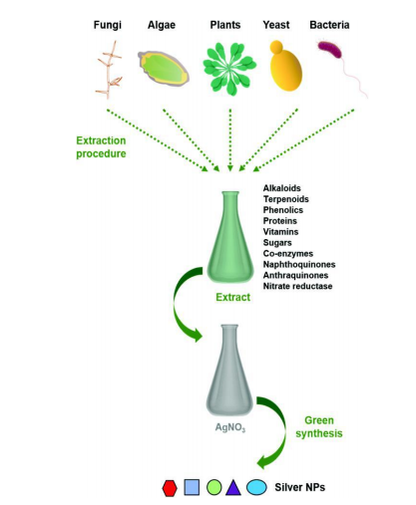

Fig.5: Diagrammatic representation of the green synthesis of AgNPs (Roy et al., 2019)

The major advantages of use of nano-pesticides over conventional pesticides are:
- Target Specificity: Nanotechnology enables the development of highly target-specific nano-pesticide formulations.
- Controlled Release: Nano-pesticides facilitate targeted delivery and controlled release mechanisms, improving pesticide utilization and minimizing residues and pollution.
- Nano-Microcapsule Formulations: Utilizing light-sensitive, thermo-sensitive, humidity-sensitive, enzyme-sensitive, and soil pH-sensitive high polymer materials, nano-microcapsule formulations ensure slow release and protection of pesticides.
- Improved Adhesion: Nano-pesticide formulations enhance droplet adhesion on plant surfaces, reducing drift losses and improving the dispersion and bio-activity of pesticide molecules.
- Efficacy Over Conventional Formulations: Nano-pesticides demonstrate higher efficacy compared to conventional formulations (D-Dust, G-Granule, P-Pellet, etc.) due to their small size, improved droplet ductility, wettability, and target adsorption during field application.
- Increased Apparent Solubility: Nanopesticides increase the apparent solubility of poorly soluble active ingredients, protecting them against environmental degradation and ensuring slow/targeted release.
- Reduction in Environmental Contamination: Nano-pesticides contribute to reduced environmental contamination by minimizing the reuse of conventional pesticides and reducing losses.
- Cost and Safety Benefits: The use of nanopesticides reduces costs, human mucosal irritation, phytotoxicity, and damage to non-target organisms, providing safer and more environmentally friendly alternatives.
- Increased Delivery System Efficacy: Nanopesticide delivery systems exhibit increased efficacy and higher toxicity, resulting in a reduced amount of pesticide used, thereby lowering pollution loads and input costs.
- Safety from an Environmental Perspective: Nano-pesticides offer safer alternatives from an environmental standpoint, aligning with sustainable and eco-friendly practices.

Dis-advantages of use of nano-pesticides
- Contamination Risks: Nanopesticides may introduce new soil and water contamination issues due to their prolonged persistence, increased transport, and higher toxicity. Some nanoparticles, such as silver nanoparticles (AgNps), pose risks by exhibiting higher toxic effects than their conventional counterparts, with the ability to penetrate biological barriers like cell membranes.
- Specific Risks of Nanoparticles: Silver nanoparticles (AgNps) contribute to increased toxicity compared to silver nitrate and can cause liver toxicity (bile duct hyperplasia) upon inhalation and oral ingestion. Alumina nanoparticles impede root growth in various plant species, including cucumber, cabbage, carrot, corn, and soybean.
- Phytotoxicity Concerns: Nanopesticides have the potential to be phytotoxic, impacting plants, animals, and the environment, depending on the type of nanomaterial used. Adverse effects on root elongation and seed germination percentage are observed at different growth stages, particularly with higher concentrations and specific types of nanomaterials.
- Nanosilver Toxicity: Approximately 100 pesticides containing silver (Ag) are used for antimicrobial properties, but the main concern lies in the toxicity of nanosilver to ecosystems and humans.
- Challenges and Considerations for Future Research: Unpredictability in Plant Responses: The response of nanomaterials in different plants can be unpredictable, necessitating further investigation.
- Phytotoxicity at Higher Concentrations: Higher concentrations of nanomaterials may lead to phytotoxic effects.
- Reduced Plant Uptake and Photosynthesis: Larger nanomaterials may hinder plant uptake and photosynthesis, requiring attention in future research on nanomaterials for plant germination and growth.

Conclusions and Future Perspectives
Nanotechnology is rapidly becoming a game-changer in agriculture, with a focus on elevating crop production and ensuring environmental sustainability, particularly in the realm of soil protection. Among the various technologies emerging in this field, nanobiotechnology stands out for its potential to deliver environmentally efficient outcomes across energy production, consumer goods, agricultural crops, and information technologies. This burgeoning innovation not only holds promise for addressing pressing environmental concerns but also provides adaptive solutions to cope with changing environmental conditions, such as those arising from the impact of climate change.
Ongoing research endeavors in agricultural nanotechnology are geared towards finding effective solutions to prevalent environmental and agricultural challenges. Nanomaterials, distinguished by their minute size and unique physical, chemical, and biological properties, are regarded as compelling and safe tools for revolutionizing agricultural practices. These nanomaterials demonstrate remarkable efficacy in diverse agricultural applications, serving as intelligent delivery systems for nutrients, indicators of soil and plant health, and chelators capable of removing toxic substances from the soil. Despite their substantial potential, the transition of nanomaterial-based products to the market faces hurdles like significant initial investments, regulatory complexities, and public apprehensions concerning their nanoscale characteristics and potential biological risks. Addressing these challenges is paramount for ensuring the continued development and widespread adoption of nanotechnology in agriculture.

References:
- Abd-Elsalam KA, Prasad R. 2018. Nanobiotechnology applications in plant protection. Springer. 23: 42-61.
- Afrasiabi Z, Eivazi F, Popham H, Stanley D, Upendran A, Kannan R. 2012. Silver nanoparticles as pesticides. In: Capacity building grants program project director’s meeting. National Institute of Food and Agriculture, Huntsville. September, 16-19.
- Alemdar A, Sain A. 2008. Mesoporous silica nanoparticles deliver DNA and chemicals into plants. Technologies. 99:1664-1671.
- Anderson JA, Harrigan GG, Rice P, Kleter G. 2016. Challenges and opportunities in supporting sustainable agriculture and food security. Overview of the 13th IUPAC, International Congress of Pesticide, 21-23.
- Barik TK, Sahu B, Swain V. 2008. Nanosilica- from medicine to pest control. Parasitol Research. 103(2): 253-258.
- Bhattacharyya A, Bhaumik A, Rani PU, Mandal S, Epidi TT. 2010. Nanoparticles- a recent approach to insect pest control. African Journal of Biotechnology. 9(24): 3489-3493.
- Chakravarthy AK, Chandrashekharaiah KSB, Bhattacharya A, Dhanabala K, Gurunatha K, Ramesh P. 2012. Bio efficacy of inorganic nanoparticles CdS, Nano-Ag and Nano-TiO2 against Spodoptera litura (Fabricius) (Lepidoptera: Noctuidae). Current Biotica. 6(3): 271-281
- Dimetry N, Hussein H. 2016. Role of Nanotechnology in agriculture with special reference to pest control. International Journal of Pharm Tech Research. 9(10): 121-144.
- Duhana JS, Kumara R, Kumara N, Kaura P, Nehra K, Duhan S. 2017. Nanotechnology: The new perspective in precision agriculture. Biotechnology Reports. 15: 11-23.
- Goswami A, Roy I, Sengupta S, Debnath N. 2010. Novel applications of solid and liquid formulations of nanoparticles against insect pests and pathogens. Thin Solid Films. 519(3): 1252-1257.
- Jayaseelan C, Rahuman AA, Rajakumar G, Vishnu Kirthi A, Santhoshkumar T, Marimuthu S, Bagavan A, Kamaraj C, Zahir AA, Elango G. 2011. Synthesis of pediculocidal and larvicidal silver nanoparticles by leaf extract from heart leaf moon seed plant, Tinospora cordifolia Miers. Parasitol Research. 109(1): 185-194.
- Kaushal M, Wani SP. 2017. Nanosensors: frontiers in precision agriculture. In nanotechnology. Springer. 7(8): 279-291.
- Khatoon N, Mazumder AJ, Sardar M. 2017. Biotechnological applications of green synthesized silver nanoparticles. Journal of Nanosciences.18:24-31.
- Kuzma JR, VerHage P. 2006. Nanotechnology in agriculture and food production: anticipated applications. Project on emerging nanotechnologies. One Woodrow Wilson Plaza 1300 Pennsylvania Avenue, N.W. Washington, DC 2004-3027, 2006.
- Lamsal K, Kim SW, Jung JH, Kim YS, Kim KS, Lee YS. 2011. Inhibition effects of silver nanoparticles against powdery mildews on cucumber and pumpkin. Mycobiology. 39(1): 26-32.
- Lavicoli I, Leso V, Beezhold DH, Shvedova AA. 2017. Nanotechnology in agriculture: Opportunities, toxicological implications and occupational risks. Toxicology and Applied Pharmacology. 329: 96111.
- Nadaroğlu H, Güngör AA, Ince S. 2017. Synthesis of nanoparticles by green synthesis method. International Journal of Innovative Research and Reviews.1(1): 6-9.
- Parvez QR, Surendra Singh Shekhawat, Irsad and Mohd Shahid Anwar Ansari. 2019. Nanotechnology in Insect Pest Management. Springer. 1(2): 125-160.
- Perez-de-Luque A, Rubiales D. 2009. Nanotechnology for parasitic plant control. Pest Management Science. 65(5): 540-545.
- Rafiq S, MA Mantoo, TH Askary, Rehana Akbar, Ulfat Jan, Amreena Akhter and Surendra Singh Bhadu. 2022. Nanopesticides: An emerging tool for pest management. The Pharma Innovation Journal. 11(10): 1659-1666.
- Rice PJ, Connell LL, Heighton LP, Sadeghi AM, Isensee AR, Teasdale JR. 2001. Runoff loss of pesticides and soil: a comparison between vegetative mulch and plastic mulch in vegetable production systems. Journal of Environment Quality. 30(5): 1808-1821.
- Rickman D, Luvall J, Shaw J, Mask P, Kissel D, Sullivan D. 2003. Precision agriculture: changing the face of farming. Geotimes. 48(11): 28-33.
- Roy A, Bulut O, Some S, Mandal AK, Yilmaz MD. 2019. Green synthesis of silver nanoparticles: Biomolecule-nanoparticle organizations targeting antimicrobial activity. RSC Advances. 9(5): 2673-2702.
- Savary S, Teng PS, Willocquet L and Nutter FW. 2006. Quantification and modeling ofcrop losses: A review of purposes. Annual Review of Phytopathology. 44: 89-12.
- Singh J, Dutta T, Kim KH, Rawat M, Samddar P, Kumar P. 2018. Green’synthesis of metals and their oxide nanoparticles: Applications for environmental remediation. Journal of nanobiotechnology. 16(1): 84.
- Tomey F, Trenyn BG, Lin VSY, Long K. 2007. Natural Nanotechnology. Pest Management Science. 2: 295-300.
- Urkude R. 2019. Application of nanotechnology in insect pest management. International Research Jornal of Science & Engineering. 7(6):151-156.
- Vidyalakshmi R, Bhakyaraj R, Subhasree RS. 2009. Encapsulation the future of probiotics- A review. Advance Biological Research. 3(3-4): 96–103.
- Vinutha JS, Bhagat D, Bakthavatsalam N. 2013. Nanotechnology in the management of polyphagous pest Helicoverpa armigera. Journal of Academics and Indian Reseach. 1(10): 606-608.

