**High-Yielding Variety of Rabi paddy - Tripura Chikon Dhan to Replace Long-Duration Local Varieties Suitable for North East India**

**Introduction:**

In terms of area and productivity, rice is second among the world's major food crops. In Asia, where 90% of the world's rice is farmed and consumed, it is a staple food for about 50% of the population. Irrigated rice fields, which produce more than 75% of all rice in Asia, are crucial to the continent's food security ((Virk *et al*. 2004)).

One of the seven states in the North Eastern Hill Region, Tripura, is mostly an agricultural state where rice is farmed both in the hills and valleys. The hilly region uses jhum, or shifting cultivation, whereas the plains use established farming. Aush, Amon, and Boro are the three seasons in which rice is farmed. In order to increase the state's overall rice yield, jhum is also used to grow rice. In valley regions, irrigation from canals is the main source of rice production, but in hill regions, rain is a major factor.

Paddy is the stable food in Tripura and grown almost throughout the year in different parts of the State. Out of 4.87 lakh ha gross cropped area, Paddy alone accounts for 54% (2.64 lakh ha) area.

Rice-based cropping system has been promoted in last few decades for attaining self-sufficiency in food grains production.

In Tripura, 78.1% of the land is cultivated, with the main rice growing seasons being from April to June (Aush), July to November (Aman), and December to February and March (Boro).

Because of eating patterns and agro-climatic conditions, farmers in the state only plant rice, which is entirely dependent on food security. Rice productivity must increase in the coming days if we are to achieve self-sufficiency in food grains. The state Department of Agriculture, on the other hand, has begun to push the SRI method of rice growing to achieve self-sufficiency in food grains due to demographic pressure and a decline in the cultivable area, particularly rice. The State Agricultural Research Station of the Department of Agriculture started evaluating SRI during the boro season of 1999–2000. From 1999 to 2002, five seasons including both the aman and boro seasons were used to examine Tripura's adaptability to various agro-climatic conditions.

The state has relatively limited access to agricultural inputs, including as irrigation systems, and only 35% of its entire cropland is grossly irrigated, which is a significant cause for concern. Between the consumption and required amounts of food grains, there is currently a shortfall of 0.19 lakh tonnes. Agriculture in the state is under threat from both a growing population and a shrinking amount of farmland. The distribution of resources in these conditions is crucial for increasing rice production. Due to the state's small and marginal rice growers' limited access to production resources, it is imperative that these resources be used effectively for increased rice yields.

Farmers must increase their output beyond subsistence levels to maintain the sustainability of their food security within highly constrained land spaces as rural population increases and agricultural lands become more scarce. The circumstance requires

Using integrated soil fertility management, ecological pest management, and the use of diverse sustainable farming technologies would significantly increase the farmer's agricultural knowledge system in the production of food. The "System of Rice Intensification" can be used to successfully handle the aforementioned issues (SRI).

The SRI method is now used in 8 districts of Tripura, mostly to address rice cultivation's water deficit. The SRI technique of paddy farming has a number of advantages over the conventional method, including fewer seed and water requirements, a decreased incidence of pests and illnesses, and a significantly higher yield (Dass *et al*., 2017)

**Problem diagnosed:**

Lack of availability of HYV varieties in the State. The practice of a single variety of paddy for many years. Continual use of traditional varieties as a result of the shortage of seeds and farmers' ignorance about high-yielding kinds (Upland, rainfed lowland and deep water areas).

Weeds are one of the major problems. Weeds can grow in dry areas of rice fields because of insufficient water availability, inappropriate water levels, and uneven field levels. Additionally, weed growth in rice fields might be brought on by poor soil quality, a lack of weeding due to a lack of time or farmer health difficulties, or both.

Rice has abiotic stress issues. Rice can be farmed in a wide range of ecologies, but abiotic conditions including heat stress, cold stress, salinity, flood, and drought have a significant negative impact on its growth and output.

The majority of rice-growing areas are centered in the North Eastern region, which practically yearly sees severe flooding and excessive rainfall. The rice harvest has suffered a very significant degree of loss. Moreover, the crop suffers in upland locations due to either dryness or heavy rainfall. Also, it has been noted that some types of soils do not respond to the balanced application of N.P.K. fertilizers with the appropriate yield response. The main causes of this lack of responsiveness to balanced fertilizer application are linked to specific natural characteristics of the soil.

Rice crops frequently experience soil moisture stress as a result of irregular and insufficient rainfall. Farmers cannot retain soil moisture in upland soils because rainwater runs off quickly. Moreover, there is inadequate infrastructure for life-saving irrigation, especially in highland and drought-prone rainfed lowland areas.

Continual use of traditional varieties as a result of the shortage of seeds and farmers' ignorance about high-yielding kinds (Upland, rainfed lowland and deep water areas).

Poor soil fertility as a result of soil erosion, which causes nutrient and moisture loss in plants

Particularly in the North-Eastern and Eastern States, fertilisers are used inefficiently and in an unbalanced manner.

High weed growth and insect/pest infestation, such as blast and brown spot, and inadequate attention to prompt control (upland and rainfed lowland).

Uneven germination due to poor crop plant population in the event of spread sowing (upland and direct seeded lowlands). Delay in monsoon arrival frequently causes delayed and prolonged transplanting and unfavourable plant populations (Mostly in rainfed lowlands).

Due to farmers' poor economic standing, improved agricultural production technology has not been widely adopted (upland and lowlands).

Upland rainfed rice is cultivated under rainfed conditions, and its growth is mostly influenced by the whims of the monsoon. The crop fails due to drought in years with insufficient or uneven rainfall, while in years with abundant rain, especially during flowering, there is poor grain setting and the ripened grains also germinate on the panicles.

Due to the upland location and loose soil texture in the heavy rainfall zone, rainwater is lost quickly through deep percolation. These soils can quickly lose the plant nutrients added by fertilisers, making the purchase of fertilisers risky.

In addition, the soil's poor ability to retain water due to its high permeability immediately creates a moisture stress state once rain stops.

The crop suffers from an iron and zinc deficit in some soils in low-rainfall areas, while Helminthosporium outbreaks are more common in high-rainfall areas, probably as a result of an uneven nutrient availability in the soils.

Upland rice crops typically mature earlier in the season, although rats and birds do significant damage.

**Brief about the technology:**

* Technology developed by ICAR, ICAR Research Complex for NEH Region, Tripura Centre, Lembucherra, 2013 and notified by Central Sub-Committee on Crop Standards, 2018.
* Suitable for rainfed shallow lowland and irrigated land in Kharif season, medium slender grain with very good cooking quality, completely free from chalkiness.
* This rice variety is suitable to be grown in Rabi (125‐10 days).
* Fine grain variety and preferred by the consumer and high value in the market.
* Seed rate- 6 to 10 kg/ha (SRI)
* In nursery beds that have been prepared by mixing soil, cow dung or FYM, rice hulls, and burned husks into a layer that is 1.5 to 2 cm thick, rice seed is sparingly sowed. The speed of a maximum of 20 gm per sqm of seeding should be used. As soon as the sprouting seeds are sown, a thin layer of the soil mixture made by combining soil, cow dung, and rice hulls or burned husk should be placed over the seed beds.
* To keep nursery beds moist and protect the seeds from birds and the direct heat of raindrops caused by rapid downpour, nursery beds should be covered with paddy straw for at least two days. The straw needs to be removed once the seedlings emerge from the bed. Keeping a straw cover for longer than two to three days may encourage the spread of disease.

**Main field bed preparation in paddy variety Gomati**

* Generally, 8 to 10 days after seeding, the seedlings are prepared for transplanting.
* The season designates the cultivation of the rice variety which are planted in November-December.
* When only the first two leaves have sprouted from the first tiller or stalk, or when they are between 8 and 15 days old, rice seedlings are transplanted. In a nursery where the earth is kept damp but not inundated, seedlings should be grown. When transplanting seedlings, use a trowel to carefully remove them from the nursery bed and keep them moist. Do not allow them to dry out. Since the seed sac is a crucial source of energy for the early seedling, it should be kept affixed to the baby root. After being taken out of the nursery, seedlings should be transplanted as quickly as possible—ideally within 15 minutes and no later than 30 minutes. By putting seedlings in the ground,
* Instead of planting seedlings in groups of two, three, or more, individuals are used instead. Individual plants can therefore expand out and put down roots. They do not face as much competition from other rice plants for soil nutrients, sunlight, or available space. When plants are spread out individually and the subsequent method is used, their root systems completely diverge.

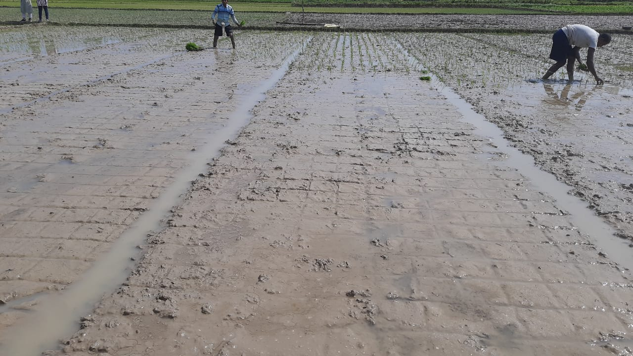

* Spacing: 25cm x 25cm
* Seedlings are planted in a square layout with lots of space between them in all directions rather than in closely spaced rows. Typically, they are separated by at least 25 cm by 25 cm. Feel free to experiment with the spacing since it relies on the soil's structure, nutrients, temperature, moisture, and other factors to produce the greatest number of fruitful tillers per square meter. Plants should have enough of space to grow, as a general rule. Seldom will the ideal spacing be closer than 20 cm × 20 cm if you also utilise the other techniques suggested here. In healthy soil with a 50 x 50 cm spacing and only four plants per square metre, the highest yields have been recorded.
* Sticks along the field's perimeter at suitable intervals (for example, every 25 cm) can be made prepared, then stretch threads between them to carefully position the plants (which makes weeding easier). You should label the strings at equal intervals so that you can plant in a square pattern. Maintaining ample space between each plant allows the roots to expand and increases the exposure of the plants to sunshine, air, and nutrients. The end outcome is increased tillering and increased root growth, which improves nutrient intake. Weeding is made easier by the square layout.

**View of paddy after Transplanting**

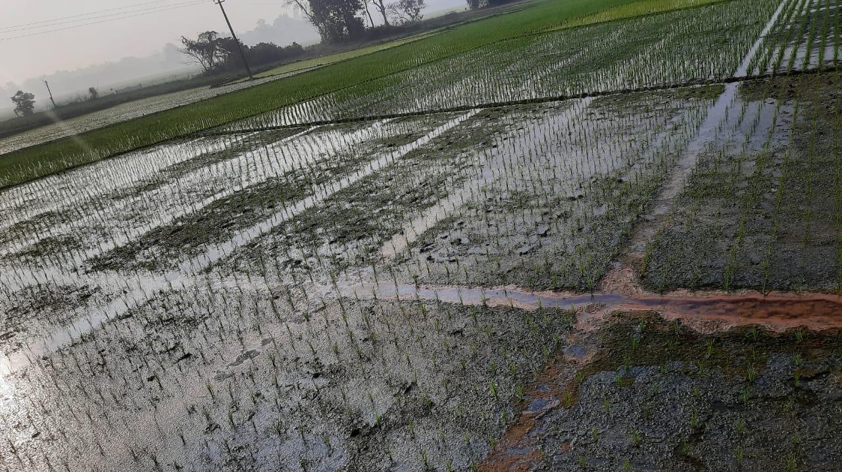

* The use of a mechanical weeder makes weeding operations easier and reduces the need for labour.
* In the past, rice was typically grown underwater in water. It is obvious that rice can withstand standing water. Although it doesn't seem optimal, standing water causes the soil to become hypoxic (lacking in oxygen) for the roots. It has been demonstrated that rice roots deteriorate in flooded areas, losing 3/4 of their roots by the time the plants are in the flowering stage. Senescence, a term that suggests it is a natural process, has been used to describe the die-back of roots that occurs when they are submerged. But in reality, it symbolises suffocation, which prevents plants from growing and functioning normally.
* Chemical fertiliser is not necessary for growing rice. Yet, SRI performs better when using organic sources of fertiliser. We advise applying organic fertiliser, such as FYM, Bio-fertilizers, green manure, leaf manure, etc., to acquire the greatest results after experiencing this result. For farmers in some regions of the world, however, access to organic fertiliser may be a challenge. Given this issue, we suggested a nutrient management programme that combined chemical and organic fertilisers. In general, we would advise combining 15-20 kg of basal (soil) application of bio-fertilizer (microbial fertiliser - N-fixing, PSB, etc.) per hectare with 25% of the chemical fertiliser (N: P: K / Ha) of a specific location / area.
* Nutrient Management- Recommended N:P:K -80:40:40, Bio fertilizer (*Azosprillium* @ 4 Kg/ ha, *Azotobactor* @ 4 Kg/ ha, *Phosphate Solubilizing Bacteria* @ 4 Kg/ ha,
* Zinc – 15 kg/ha,
* FYM – 10 MT/ha or Soil test based application.
* Any biomass (such as rice straw, plant clippings, and other plant waste) can be used to create compost, and animal manure can be added if it is available. Cuttings from leguminous shrubs can add more nitrogen and potassium, and other plants like Tithonia and Afromomum angustifolium may be high in phosphorus. Compost gradually replenishes the soil with nutrients and helps improve the soil's structure. If chemical fertiliser is not provided, it would seem rather obvious that some type of nutrient input would be required on poor soils. Given the massive rice harvests, the soil needs to receive something back.

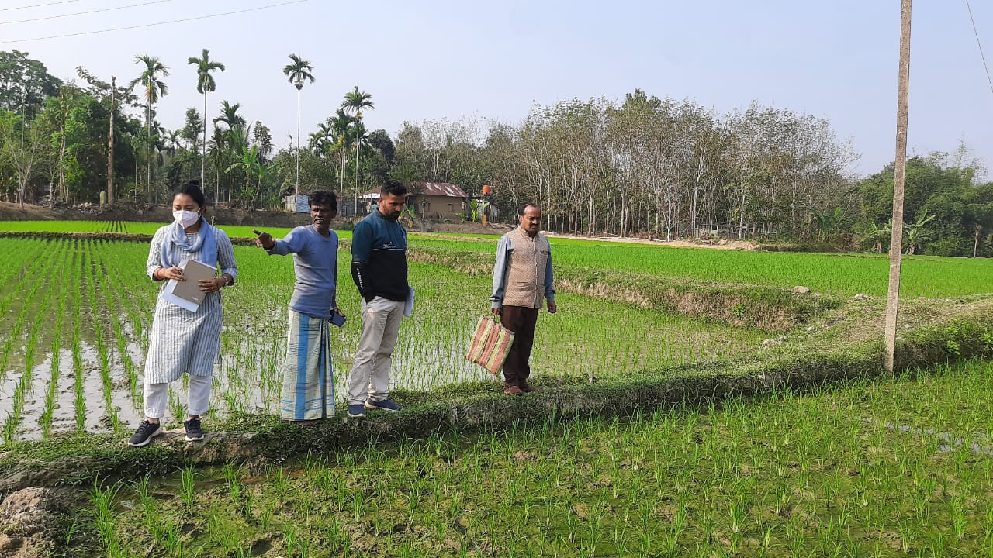

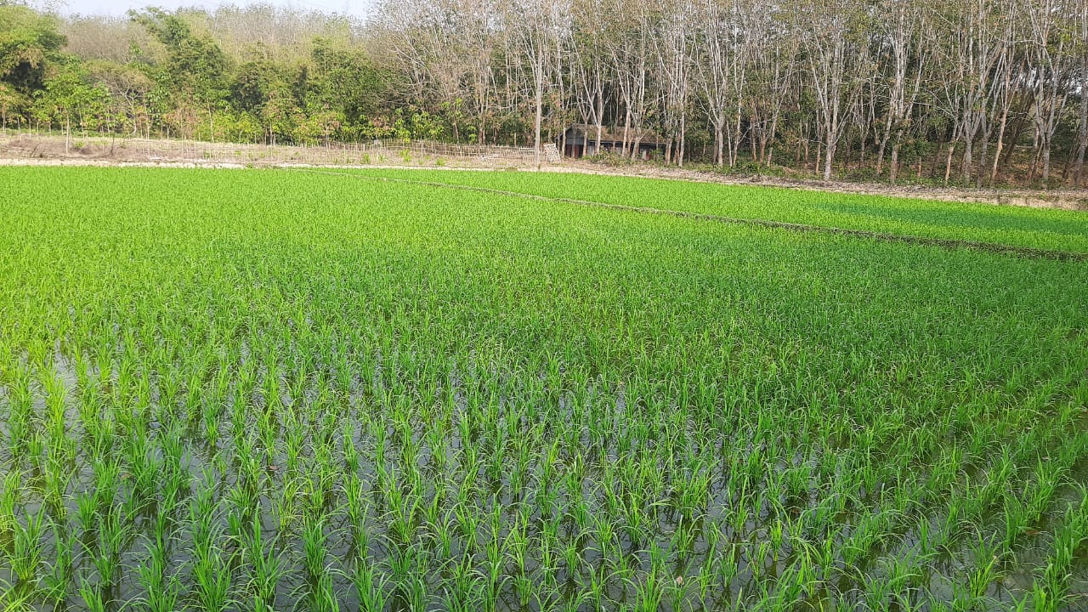

**Growth stage of the crop in farmers field**

**Field inspection**

* Weeding: Either by hand or with a basic mechanical tool, this is possible. Using a mechanised hand weeder created by the International Rice Research Institute in the 1960s is beneficial to farmers in Madagascar since it reduces labour costs while boosting output. The earth is stirred up when the weeder is pushed down and across the alleyways created by the square planting pattern by vertical revolving toothed wheels. Although weeding requires a lot of labor—up to 25 days of effort are required to weed one hectare—the increased yield ensures that the work is more than worthwhile.
* Ten to twelve days after transplanting, the first weeding should be completed, and twelve to fourteen days later, the second weeding should be finished. Similar to the second weeding, the third weeding is also carried out, if necessary, 12 to 14 days later. It is advised to do at least two or three weedings, but an additional one or two can add one to two tonnes per hectare to the harvest. This method of churning the soil appears to improve soil structure and boost aeration of the soil, which is probably more significant than weed removal.

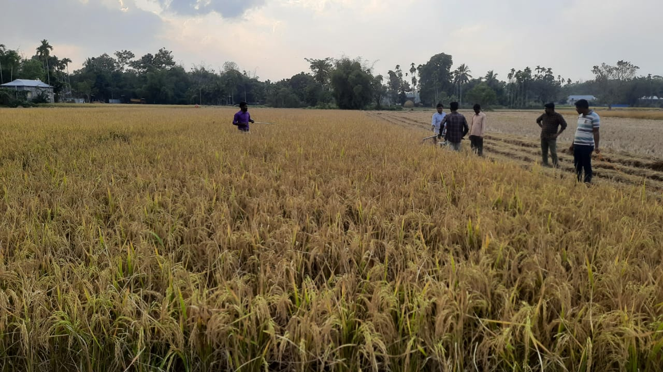

**Crop at mature stage before harvesting**

|  |  |
| --- | --- |
|  |  |

**Crop cut experiment to justify the yield of the paddy variety Gomati**

* production of 5.8 - 6 MT/ha

|  |  |
| --- | --- |
|  |  |

**Harvested bunch of Paddy**

**References:**

* Virk PS, Khush GS, Peng S (2004). Breeding to enhance yield potential of rice at IRRI: The Idiotype Approach, IRRI, p. 5-9.
* Dass, A., Chandra, S., Upoff, N., Choudhary, A.K., Bhattacharyya, R. and Rana K.S. (2017). Agronomic fortification of rice grains with secondary and micronutrients under differing crop management and soil moisture regimes in the north Indian Plains. Paddy Water Environ. 15(4): 745-760.