Automated Pond Monitoring System

Madhukumar Patnala1 Assistant Professor, Dept. of ECE, Bapatla Engineering College, Bapatla

**Abstract**

The Technology and innovations are improving day by day in every aspect. IoT plays a keyrole in our daily life. One of the aspect that needs improvement is aqua culture that plays a keyrole in aqua farmers yield. It is very important to support aqua culture to improve farmers standrad of living. Water is the most essential component in aqua culture and it is important to maintain the quality of water. The proposed system consists of sensors that measures the quality of water and sends data to the user mobile Phone for quick access and response. It is a time saving technique where as traditional methods cosume much time as well as they are probabilistic and costly. A traditional scheme need to collect the samples and sends to laboratory for testing and monitoring. The results may be inaccurate sometimes. Our system is equipped with Ph. Sensor and temperature sensor for measurement of pond’s water quality. The values were read by sensors and these values were sent to the user mobile Phone via Blynk Application through NodeMCU. The NodeMCUconverts analog readings in to accurate digital equivalents which can be acquired using internet from remote locations. NodeMCU was coded to acquire, analyze and report to user’s mobile phone using standrad GUI. This GUI was designed using Blynk Application for an android mobile.

**Introduction**

We all know that food is basic need for human being to sustain. The population growth is increasing rapidly scarcity of food also increasing. It means the production of food is not matching population demand. To reduce the food crisis there are different types of food production streams. The main form of food production is Agriculture. there are mainly two types i.e., land and aqua farming. The land farming is far better than the aqua farming and the production is more where as in aqua culture the production is low as well it involves more cost and it is a time taking process. If we could technologically contribute for the aqua farming using IoT the food crisis would decrease and the production gaps can be filled making farming a reliable profession.

Aqua culture is also known as aqua farming. Aqua farming is a practice involving growth for well being of aquatic organisms. It can be done in different waters they are fresh water, barckish water and salt water. The main objective of aqua culture is to produce protein rich, nutritive, palatable and easily digestible food supplies at low or reasonable cost. The proposed work has scope to contribute in this direction. By developing aqua culture and improving the quality and features of water like Ph. and temperature by properly supplying food and oxygen levels to the aquatic organisms the growth would be proper. This would inturn fetch huge profits for the stakeholders.

In traditional method the temperature is identified using laboratory tests and Ph. is measured using Titration method. The proposed model consists of a single wired temperature sensor and an Ph. electrode that detects the potential difference between the actual to the reference Ph. settings. The traditional methods are time consuming and for Ph. detection the titration method takes more than a day to get results. Some times Ph. value can be calculated using Ph. indicator strips, but these strips are not reusable.

IoT means internet of things. It is a 21st century technology. It consists of inter connected devices with embeded electronics. These devices collects, processes and transfers data via internet. It mainly consists of sensors, internet connectivity, dataprocessing and user interface. These sensors senses the changes in the surrondings and transfers data via internet. It is popularly called as machine to machine communication.

**Problem Statement**

In these modern days every one is depending on technology and every one is thinking about smart work rather than hard work , so we got up with an idea to reduce farmers labour i.e., rather than collecting samples of water and submitting to the laboratory and waiting for results he could expect accurate quality parameters instanly in no time using his mobile phone. This would reduce the number of times he need to visit the aqua farm to monitor the activities. The automated system would garentee accuracy and as well saves valuable farmers time.

**Proposed Method**

The model comprises hardware with developed software and the overall system is aimed at tracking the water quality deploying IoT. The system consists of sensors and NodeMCU as a wifi module. The sensors collect the data and sends for further processing via internet. The NodeMCU connects both hardware and software components. It is a wifi module that operates at 3v DC Power supply. The sensors were used to read pond’s Ph. and temperature. In this the Ph. is an analog sensor and temperature sensor is a digital sensor. The temperature and Ph. sensor operates at 3.3v to 5v DC powersupply. The temperature sensor input pin, ground pin and data pin are connected to the NodeMCU. After establisment of connection the sensors starts collecting the physical parameters.NodeMCU has been coded to acquire datum which gets processed and then sent to the user mobile Phone via Blynk application. The block representation is reported in Figure 1.

Smart phone installed with Blynk

Node MCU

ESP8266



Potentiometer

Ph sensor interface circuitry

Voltage Regulator

Temperature sensor

Ph sensor

Power Supply Unit

Figure 1. Block representation of proposed Pond Monitoring System

**Ph. Sensor**

Ph. explains about potential or power of hydrogen. It determines the quality of liquid by determining its chemical properties. Ph. sensor works on potentiometric principle. Ph. sensor was invented by soren sereson in 1909. A normal Ph. scale consists 0-14. In this project we used an analog Ph. sensor. It consists of an measuring system and an reference system. The potential difference between these systems gives the Ph. value.for an acid the Ph. value is less than 7 and for a base it would be greater than 7. If the th Ph. value of a solution is equal to 7 then it is called as neutral. We used an analog Ph. sensor it requries an Ph. sensor interface. It links between the Ph. sensor and NodeMCU. The snapshots of the Ph. Sensor and the interface were reported in Figures 2 & 3 respectively. Table 1 shows the various effects when Ph. value changes.

|  |  |
| --- | --- |
|  |  |
| Figure 2. Ph. sensor | Figure 3. Ph. sensor Interface |

Table 1. Ph. effect on pond culture

|  |  |
| --- | --- |
| **Ph.** | **EFFECT** |
| 4 | Acid death |
| 11 | Alkaline death |
| 6-9 | Better growth |
| 4-5 | No reproduction |
| 5-6 | Slow growth |
| 9-14 | Denaturing cellular membranes |

**Temperature Sensor**

DS18b20 is the temperature sensor we have choosen for the work. It is a single wired sensor that can measure temperature from **-55°C to +125°C with an of accuracy of** ± 0.5°C**. It was a standard programmable digital sensor that operates with DC 3v to 5v. It is a water proof sensor. It consists of three pins i.e., VCC, DATA and GND. The data pin is connected to the NodeMCU and vcc to power supply pin and GND pin to chassis ground. The data pin collects data and transmits to the NodeMCU via buses and the data gets processed.**

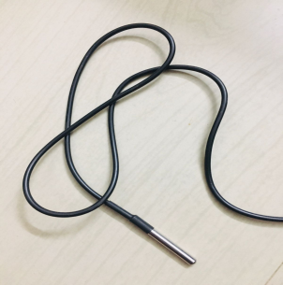

Figure 4. DS18b20 temperature sensor

**NodeMCU**

NodeMCU is a open source IoT platform having both hardware and software. It is a low cost wifi module consists of built-in TCP/IP networking software and a microcontroller operating at 3.3v DC. NodeMCU is programmed using the Arduino IDE with support for vast open source libraries. It is compatible with other languages such as micro python and became cheap and popular in the market. It is powerful and easy to use. It consumes very less power.

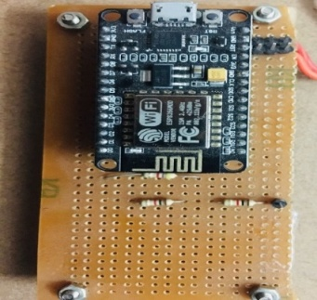

Figure 5. NodeMCU

**Arduino IDE**

We have utilized Arduino for code development. It enables user to compile and run the code and dumps the code in the hardware system.

**Potentiometer and Voltage Regulator**

To get the constant power supply to NodeMCU and Ph.sensor interface regulator and potentiometer has been used to protect from supply variations. Figure 6. And Figure 7. Displays the typical circuitry used in the work.

|  |  |
| --- | --- |
|  |  |
| Figure 6. Voltage regulator | Figure 7. potentiometer |

**Blynk**

The Blynk application is used to get values to the mobile through notifications. It acts as an interface and provide different widgets. It provides communication between hardware and software. We can create project dashboards and arrange graphs, sliders and other widgets on the screen. It offers a flexible way to send messages and provides security. It is an app editor and the projects are sharable. The GUI planned for reporting the pond quality was displayed in Figure 8.

|  |  |  |
| --- | --- | --- |
|  |  |  |

Figure 8. GUI designed using Blynk Application

**Methodology**

The Process flow was shown in Figure 9. The first stage is to connect the temperature sensor and Ph.Sensor with NodeMCU to link up with the internet for acquiring pond quality parameters . The Ph.Sensor is connected to NodeMCU via Ph.sensor interface. For constant power supply to the NodeMCU we have operated it on a regulator. The sensors determine the changes in the pond parameters.

The Blynk app has to be installed on farmer’s mobile from android play store. Assistance is needed to customer to install and create a project with an authentication token. This auth token is used to connect hardware components to software via internet. A couple of Gauge widgets are choosen to reflect the status of temperature and Ph. values.

To establish connection between the user and components one should write the code for NodeMCU and another component’s using Arduino IDE. During the coding we need to code for auth token provided by the Blynk app and user name of the internet and password to establish internet connection for NodeMCU. After the code completion, compile the code in Arduino IDE software if no errors are present then select the appropriate port. Then run the code, during the running operation the Ph. and temperature sensors acquire the data from the pond and the NodeMCU processes the data. An average of ten samples collected from Ph. sensor was represented as a single parameter on Gauge meter. The NodeMCU converts the analog data into its digital equivalent. Processed result is sent to Blynk through Wi-Fi using the same auth token.

**Result**

We have implemented a pond monitoring system which saves time for testing the quality of pond by using IOT devices such as sensors and NodeMCU. At the instance of time the results are sent to user mobile Phone through Blynk application. The snapshot of the interconnected system that has to be installed in the pond premises is shown in Figure 10. Figure 11. Shows the system being tested with different samples -potable hot water, lemon water, alkaline sample and soapy liquid (from left to right). We can watch the ph. value of these samples at room temperature reported on GUI of mobile. The temperature can also be seen on right gauge of GUI.

Initialize sensor and connect to Wi-Fi

Ph sensor

Temperature sensor

Update to Blynk server

Displayed in the gauge widget

Figure 9. Process Flow for implementing proposed pond monitoring system

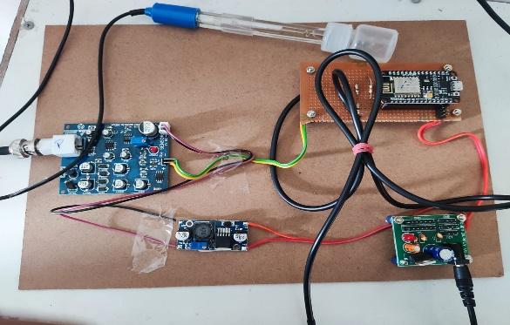

Figure 10. Proposed System at the Pond Premises

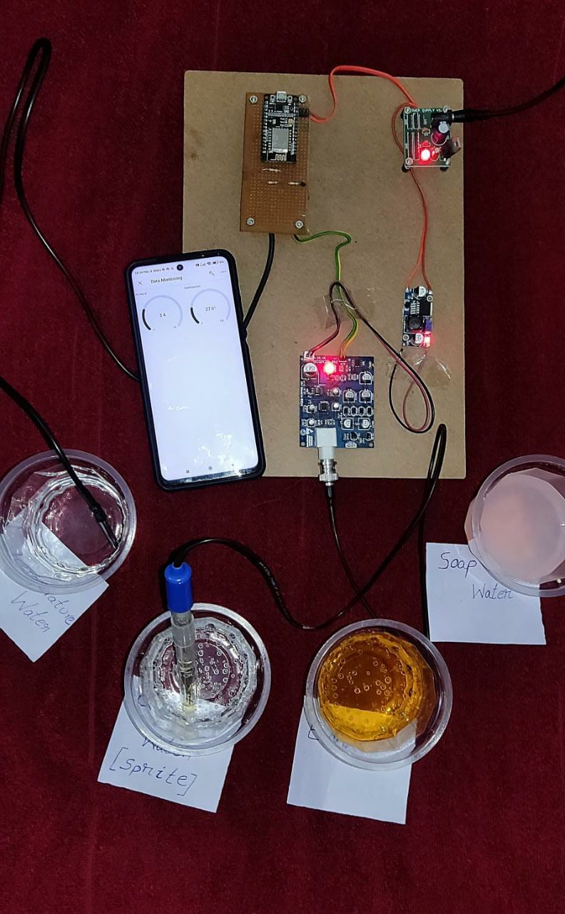

Figure 11. Proposed System with various samples displaying the pond quality on customer android phone

**Conclusion**

Aqua farmers need to be more careful because many factors affect the quality of water and in turn the yield. It is important to observe those changes. With the help of traditional method it requires more than a day during that time many changes may happen in the pond and it may affect the production. For instant results we have designed a pond monitoring system. It is very flexible and helpful system which can increase the production. By using IOT technology it is an economical solution for tracking accurate pond parameters. The system can further be modified to read parameters like turbidity, salinity and dissolved oxygen content using suitable sensors.

**References**

|  |  |
| --- | --- |
| [1]. | Kalpana, M. B., and M. Tech Student. "Online monitoring of water quality using raspberry Pi3 model B." International Journal of Innovative Technology and Research 4.6 (2016): 4790-4795. |
| [2]. | Chandanapalli, Suresh Babu, E. Sreenivasa Reddy, and D. Rajya Lakshmi. "Design and deployment of aqua monitoring system using wireless sensor networks and IARKick." Journal of Aquaculture Research and Development 5.7 (2014). |
| [3]. | Daigavane, Vaishnavi V., and M. A. Gaikwad. "Water quality monitoring system based on IoT." Department Electronics & Telecommunication Engineering, Advances in Wireless and Mobile Communications 10.5 (2017): 1107-1116. |
| [4]. | Kaimal A, Jaison R, Santha V, Anand S, “Smart Aquarium”, National Conference on "Emerging Research Trends in Electrical, Electronics & Instrumentation", (ERTEEI’17). |
| [5]. | Mohd Saad Hamid, Muhammad Amirul Abd Wahab, Rasyidah Abdullah, “Development of Water Quality Monitoring for Smart Aquaculture System”, Journal of Engineering and Applied Science 14 (9); 2840-2847, 2019. |
| [6]. | Pasika, Sathish, and Sai Teja Gandla. "Smart water quality monitoring system with cost-effective using IoT." Heliyon 6.7 (2020): e04096. |
| [7]. | Miry, Abbas Hussien, and Gregor Alexander Aramice. "Water monitoring and analytic based Thing Speak." International Journal of Electrical and Computer Engineering 10.4 (2020): 3588. |
| [8]. | Junaid Khan, Onib-Ur-Rehman, Zafran Jalil1, Sikandar Ali, Abdul Samad Danish, “Implementation of Smart Aquarium System Supporting Remote Monitoring and Controlling of Functions using Internet of Things”, Journal of Multidisciplinary Approaches in Science Volume 9, Issue 1 (2019). |
| [9]. | Madhu Kumar Patnala & Mahesh Babu P, “HARSHA: Intelligent Gesture control Mine Explorer (IGME) Robot”, ScienceQ Journal of Computation in Biosciences and Engineering, Aug. 2014, Vol.1, Issue.03, pp.01-06 |