RECENT ADVANCEMENTS ON MEDICINAL ACTIVITY OF INDOLE DRUGS

1.Dr.R.Radha  Professor,  Department of Pharmaceutical Chemistry  Seven hills college of Pharmacy  Tirupati, India  radharayisree@gmail.com | 2. Dr M.Deepa  Professor  Department of pharmaceutical chemistry  Annamacharya college of pharmacy,  Razampet,Kadapa  venkatdeepa19@gmail.com  9492516158
3.Dr Sibbala Subramanyam  Asscoate professor,  Dept of Biotechnology and pharmaceutical sciences,  vignans foundation for science.technology and Research. Vadlamudi.,Guntur  sibbalaphd@gmail.com  9949877510 | 4. B.Swapna  Assistant professor  Deparment of Pharmaceutical Chemistry,  Krishna Teja pharmacy college, tirupati  Mobile No : 7032040378  email.Id : madhur.swapna2013@gmail.com
5.Ms.S.NaveenTaj  Assistant Professor  Department of Pharmaceutics,  Sri PadmavatiMahilaVisvavidyaylayam,  Tirupati, India  naveentaj33@gmail.com | 6.Mr.G.Mallikarjuna  Associate Professor,  Department of Pharmacology  Seven Hills college of Pharmacy  Tirupati, India  Mail ID: malli.g53@gmail.com

ABSTRACT

Indole is one of the most significant scaffolds for drug discovery. The majority of significant synthetic medicine compounds contain indole scaffolds, which have paved the path for the development of reliable targets. Derivatives of indoles have a distinctive capacity to attach to enzymes reversibly while resembling the structure of peptides. 2-arylindoles tend to be the most promising lead among the molecules in the indole class for potential therapeutic development. The 2-arylindole derivatives possess antimicrobial, antituberculosis, anticancer, antioxidant, anti-inflammatory, anti-diabetic, antiviral, and antiproliferative activity. This provides incredible possibilities for finding novel medications with various mechanisms of action. Novartis developed the medication panobinostat (LBH589), a non-selective histone deacetylate inhibitor, to treat acute myeloid leukaemia and multiple myeloma. The approval of panobinostat in the third line of treatment in combination with bortezomib and dexamethasone was based on its efficaciousness when used in combinatorial regimens. Novartis markets panobinostat under the Farydak brand.

Keywords: Indole, panobinostat, acute myeloid leukaemia, multiple myeloma

- INTRODUCTION
A significant quantity of heterocyclic compounds are used in drugs solely due to their distinctive chemical and biological characteristics, which are essential for an array of physiological processes.One of the most promising and pharmacologically active of these is indole. Indole's chemical reactivity has made it accessible to modification, resulting in a wide range of new lead compounds that have been effectively employed as innovative therapeutic candidates to treat various pharmacological conditions. Among the indole-based compounds used are amedalin, an antidepressant, reserpine, an antihypertensive, and vincristine, an anticancer drug [1].
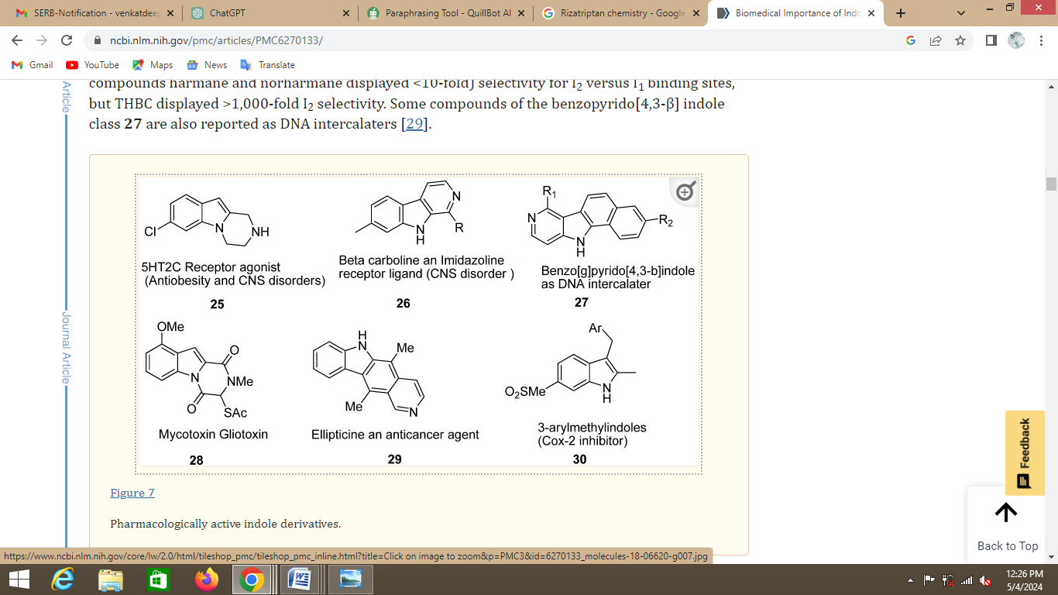

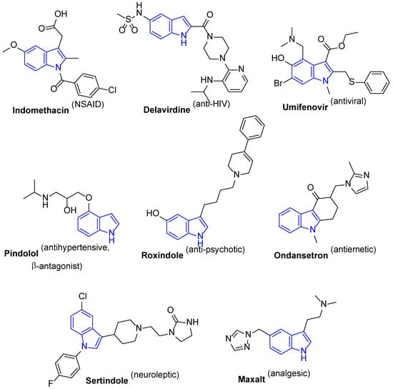
2. HISTORY OF INDOLES:
Indole was found in the nineteenth century. German chemist Adolf von Baeyer created indole in 1866 while researching the composition of dye molecules. By heating ortho-nitrobenzyl to high temperatures when zinc was present, he was able to do this.
Chemical Structure: The structure of indole, which is a benzene ring fused to a pyrrole ring, was clarified by Baeyer's synthesis. Indole's distinct features and biological activities stem from its unusual structure.
Researchers started to understand the biological relevance of indole molecules in the early 1900s. Frederick Gowland Hopkins made the discovery of tryptophan in 1901. It is an important amino acid that acts as a precursor for compounds containing indole.
The discovery of serotonin and the clarification of the tryptophan metabolic pathway provided insight into the biological role of indole containing compounds during the 1940s and 1950s. Drugs intended to treat mood disorders like depression have turned their attention to serotonin, a neurotransmitter that is generated from tryptophan.
Antidepressants and antipsychotics: Drugs containing indole were developed in the middle of the 20th century to treat mental illnesses. One of the earliest antipsychotic drugs was developed in the 1950s and was called chlorpromazine. Subsequently, imipramine, a tricyclic antidepressant with an indole ring, was developed to treat depression.
Oncology: Plant-derived indole alkaloids have demonstrated strong anticancer properties. The Madagascar periwinkle plant yields vincristine and vinblastine, which were first used as chemotherapy drugs in the 1960s to treat a range of malignancies, including lymphoma and leukemia.
Taking everything into account, the history of drugs that contain indole emphasizes how versatile and important indole chemistry is in medicine, with ongoing efforts to optimize their therapeutic potential across a variety of disease domains.
3. CHEMISTRY OF INDOLES
The chemical makeup of indoles is wrecked down as follows:
Due to the presence of both the pyrrole and benzene rings, indole has a high aromaticity. Stability is achieved through the π-electrons' delocalization throughout the molecule, which is facilitated by the benzene ring.
Nature of electron-richness: The pyrrole ring's nitrogen atom is sp2-hybridized, which makes it both electron-rich and able to donate electrons. This characteristic renders indoles adaptable to a wide range of chemical processes.
Reactions of substitution: Indoles have substitution reactions at several points within the ring structure. C2, C3, and C5 are frequently substituted, with the C3 position being the most reactive because of its closeness to the nitrogen atom.
Functionalization: Indoles can be functionalized by a number of chemical processes, such as those catalyzed by transition metals, electrophilic aromatic substitution, and nucleophilic substitution.
Biological significance: Numerous natural compounds, such as certain alkaloids, hormones like melatonin and serotonin, and certain neurotransmitters, contain indoles. Their biological activities are broad and include antibacterial, anticancer, and depressive qualities.
Numerous techniques exist for the synthesis of indoles, such as the Madelung synthesis, the Bischler–Möhlau synthesis, the Fischer synthesis, and the Barton–McCombie deoxygenation. Furthermore, effective synthetic techniques for the production of indole derivatives have been devised, including transition metal-catalyzed processes.
Because of their generally rich and varied chemistry, indoles are useful scaffolds in medicinal chemistry and essential building blocks in organic synthesis.
Several medications with indole moieties were on the market for different therapeutic uses Here are a few instances:
Sumatriptan: Medication known as sumatriptan is used to treat migraines and cluster headaches. It targets the 5-HT1B and 5-HT1D receptors in particular, acting as a selective agonist of serotonin receptors. There are several forms of sumatriptan on the market, such as tablets, nasal sprays, and injections.
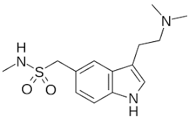
Rizatriptan: Another medicine used to treat migraines is rizatriptan. It is functionally related to N,N-dimethyltryptamine.
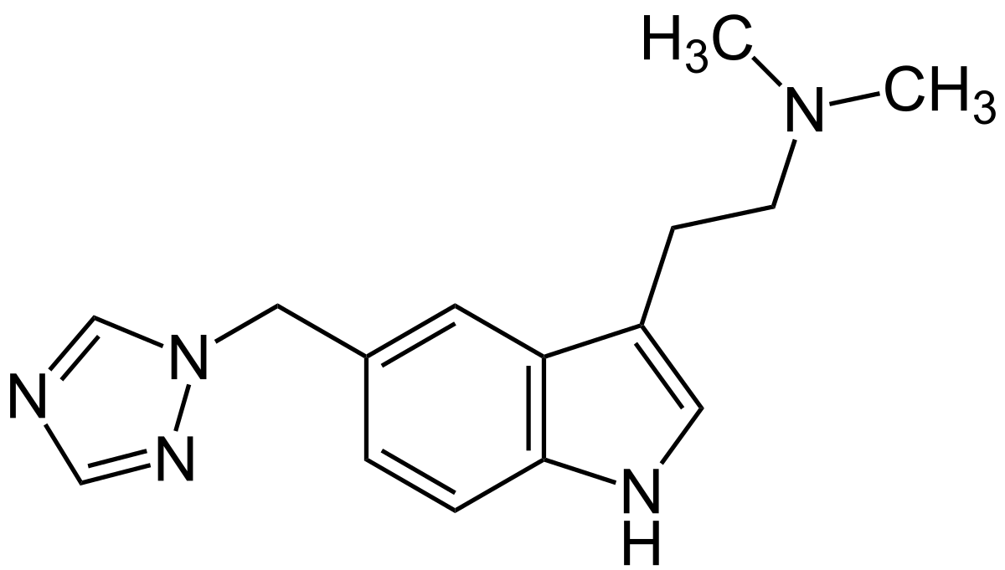
Ondansetron:
Ondansetron is a member of carbazoles. This medication is frequently used to stop nausea and vomiting brought on by radiation, chemotherapy, or surgery. It functions by preventing serotonin from acting at the chemoreceptor trigger zone and gastrointestinal tract 5-HT3 receptors.
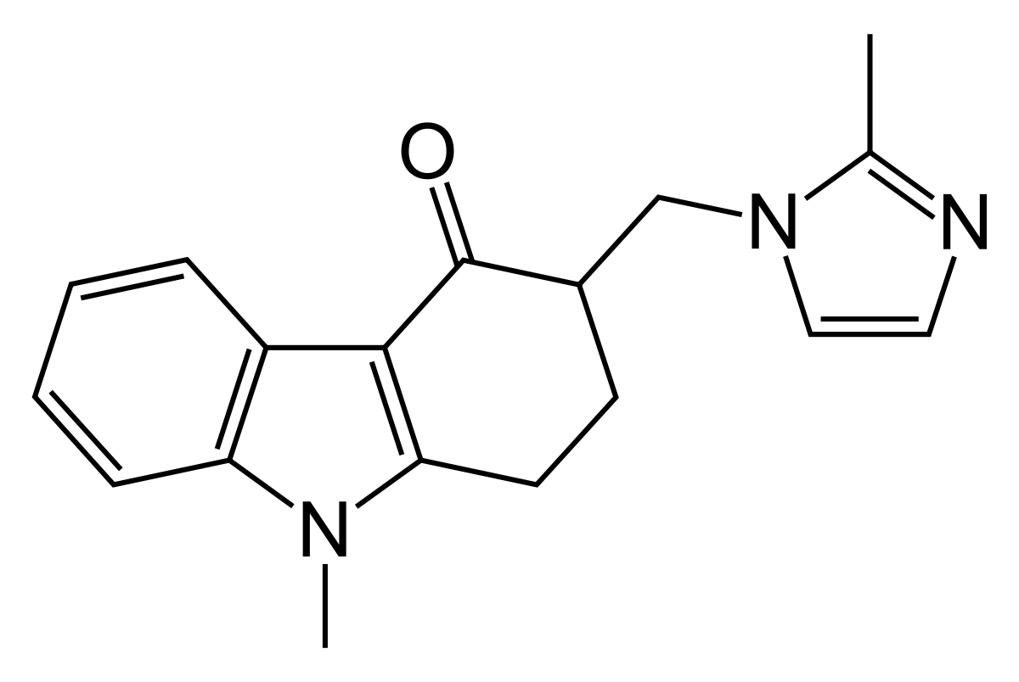

Synthetic Indole Containing Compounds:

Isatins

2-[(Indol-3-yl)thio]acetamides

Indole-Chloropyridine Conjugates

Diindole-Substituted Benzimidazole

3-Alkenyl-2-Oxindoles

Spiroindoles

Indole with Dual Acting Proteases Inhibitor
4. PANOBINOSTAT: A NON-SELECTIVE HISTONE DEACETYLATE INHIBITOR
- Drug Chemistry
Panobinostat is a member of a recently discovered class of drugs known as deacetylase (DAC) inhibitors. Panobinostat is a strong oral nonselective pan-histone deacetylase inhibitor (HDAC). It has been approved by the FDA to treat multiple myeloma in conjunction with dexamethasone and bortezomib. Panobinostat (chemical name: 2-hydroxypropanoic acid, compound with 2-(E)-N-hydroxy-3-[4-[[[2-(2-methyl-1H-indol-3- yl)ethyl]amino]methyl]phenyl]-2-propenamide [1 : 1][2].
Figure 1: Structure of Panobinostat
In all four HDAC classes (Histone Deacetylases), preclinical activity has been demonstrated. It causes apoptosis in multiple myeloma cells that are resistant to traditional treatments at low doses. In myeloma cell lines, it also causes caspase activation and poly-(ADP-ribose) polymerase (PARP) breakage, and it suppresses cell growth [3].
SAR of panobinostat:
Core Indole Structure: The indole nucleus is a key structural component of panobinostat. It provides the scaffold upon which various functional groups are attached or modified to modulate the compound's activity. Indoles substituted at 3-position Compounds having one or both indoles substituted at the 3-position go through probable NH interaction in the hydrophobic pocket. Hydrogen bonds to residues of protein with a free indole NH proton. Hydrophobic pocket binding mechanism is vital to the potency of the compounds.
Substituents on the Indole Ring: The substitution pattern on the indole ring significantly influences the compound's activity. Substituents at different positions (e.g., 5-, 6-, and 7-positions) can affect the compound's potency, selectivity, and metabolic stability. Replacement with indole B with Benzimidazole with benzimidazole or quinoline and substitution with a variety of polar and nonpolar groups. These substitutions allow distinction of shape, charge, hydrophobic contact surface area and polar interactions. These studies were anticipated to the potential of the compounds to form additional hydrogen bonds.
Linker Moieties: The linker moiety connecting the indole core to other functional groups or pharmacophores plays a crucial role in determining the compound's potency and selectivity. Optimizing the linker length and flexibility can enhance binding affinity and biological activity. Many of the isomers were also expected to have improved drug like properties including a lower lipophilicity since the drug has olefinic bond
Functional Groups: Functional groups attached to the indole ring or the linker moiety can interact with specific residues within the histone deacetylase enzyme's active site, influencing the compound's inhibitory activity and specificity.The hydrophobic pocket located on the long groove formed along the NHR effect by escalating vanderwaals contacts by introducing additional hydrophobic substituents.
Hydrogen Bonding and Hydrophobic Interactions: Indole derivatives in panobinostat likely engage in hydrogen bonding and hydrophobic interactions with the target enzyme, contributing to their binding affinity and mechanism of action.
- Mechanism of Action
Since histones were the first identified targets of DACs, panobinostat inhibits a wide variety of DACs, commonly referred to as histone DACs (HDAC).It is understood that DACs control the acetylation of over 1,750 proteins involved in several biological processes, such as chromatin remodelling, gene transcription, cell cycle progression, protein degradation, and cytoskeleton reorganization, in addition to DNA replication and repair [4].Unfavorable findings have been connected to the overexpression of DACs in multiple myeloma [5]. All class I (HDACs 1, 2, 3, and 8), class II (HDACs 4, 5, 6, 7, 9, and 10) and class IV (HDAC 11) HDACs are inhibited by panobinostat, with half maximum inhibitory doses for each class I, II, and IV HDAC in the nanomolar range. When compared to vorinostat, another pan-DAC inhibitor that was studied for the treatment of multiple myeloma, panobinostat's potency was ten times higher for all HDACs. It is now one of the most potent pan-DAC inhibitors in clinical research [6]. It is believed that panobinostat largely exerts its anticancer effects by inhibiting protein metabolism and altering gene expression through epigenetic modifications. By inhibiting signal transducer and activator of transcription 3, Akt, and hypoxia-inducible factor 1α, class I HDACs can alter gene expression and assist reactivate epigenetically silenced tumour suppressor genes. Class I HDACs target histones and transcription factors like p53 [7, 8].
Additionally, it has been demonstrated that panobinostat and PI bortezomib work in concert. The way in which panobinostat affects protein breakdown helps to explain this synergy. High levels of protein turnover make multiple myeloma cells susceptible to PIs, which impede the metabolism and excretion of proteins made inside the cell and, as a result, trigger a proapoptotic signal. On the other hand, if the proteasome is unable to break down these proteins fast enough, the proteins can form aggregates called aggresomes, which are then carried by microtubules to an autophagosome where lysosomes break them down. The transportation of these protein aggregates for breakdown depends on the interaction of HDAC6 with tubulin and the motor protein dynein.Hyperacetylated microtubules and ineffective aggresome mediated breakdown result from HDAC6 inhibition. When bortezomib and panobinostat are administered together, the proteasome and aggresome pathways are simultaneously inhibited, which leads in synergistic cytotoxicity. Bortezomib inhibits the proteasome's ability to degrade protein and stimulates the creation of aggresomes [9].
Furthermore, panobinostat in conjunction with bortezomib plus dexamethasone or the IMiD lenalidomide plus dexamethasone facilitated deregulation of other genes that were not affected by doublet treatment alone, according to in vitro and in vivo models of multiple myeloma [10].

- Pharmacokinetics and Metabolism
20 mg of panobinostat administered orally undergo rapid absorption, reaching the highest possible plasma concentration in one to two hours [11, 12]. Panobinostat's median maximum plasma levels when taken orally ranged from 5.5 to 21.2 ng/ml. When panobinostat was taken orally, its absolute bioavailability was 21%. Food consumption had no discernible impact on the bioavailability or rate of absorption of the drug. With a half-life of thirty-one hours, panobinostat is eliminated almost equally by all patients in the form of urine and faeces [13, 14]. CYP and non-CYP enzymes primarily catalyse the hydrolysis, acidosis, and glucuronidation processes that break down panobinostat. Panobinostat exposure may be greatly increased by CYP3A4 inhibitors, necessitating careful monitoring for medication interactions or possibly lowering panobinostat dosage. Conversely, CYP34 inducers are to be shunned wherever feasible as they have the potential to drastically lower panobinostat exposure. Additionally, panobinostat may inhibit CYPY2D6, thus it's best to stay away from related substrates. QT prolongation has been observed with panobinostat administration, particularly when given intravenously. As a result, concurrent use of medications that lengthen QT should be avoided. Previous research on the administration of panobinostat in patients with haematological or renal impairment has demonstrated that hepatic impairment is linked to decreased drug clearance and increased plasma exposure, whilst renal function had no effect on drug clearance and tolerability [15, 16].
Panobinostat is still a vital treatment option for patients with refractory or relapsed multiple myeloma, even in the face of notable advancements in the disease's therapeutic management. Multiple clinical trials have provided data confirming its continued effectiveness as a therapy, even for individuals who have had extensive pretreatment. When combined with other drugs, HDAC inhibitors like panobinostat have the potential to completely change the way multiple myeloma is treated by extending survival times and improving response quality while posing less toxicity to patients [17].
- REFERENCES
[1] Kumar D, Sharma S, Kalra S, Singh G, Monga V, Kumar B. Medicinal perspective of indole derivatives: recent developments and structure-activity relationship studies. Current drug targets. 2020 Jul 1;21(9):864-91.
[2] Atadja P. Development of the pan-DAC inhibitor panobinostat (LBH589): successes and challenges. Cancer letters. 2009 Aug 8;280(2):233-41.
[3] Kawaguchi Y, Kovacs JJ, McLaurin A, Vance JM, Ito A, Yao TP. The deacetylase HDAC6 regulates aggresome formation and cell viability in response to misfolded protein stress. Cell. 2003 Dec 12;115(6):727-38.
[4] Choudhary C, Kumar C, Gnad F, Nielsen ML, Rehman M, Walther TC, Olsen JV, Mann M. Lysine acetylation targets protein complexes and co-regulates major cellular functions. Science. 2009 Aug 14;325(5942):834-40.
[5] Mithraprabhu S, Kalff A, Chow A, Khong T, Spencer A. Dysregulated Class I histone deacetylases are indicators of poor prognosis in multiple myeloma. Epigenetics. 2014 Nov 2;9(11):1511-20.
[6] Laubach JP, Moreau P, San-Miguel JF, Richardson PG. Panobinostat for the treatment of multiple myeloma. Clinical cancer research. 2015 Nov 1;21(21):4767-73.
[7] Atadja P. Development of the pan-DAC inhibitor panobinostat (LBH589): successes and challenges. Cancer letters. 2009 Aug 8;280(2):233-41.
[8] Kalushkova A, Fryknäs M, Lemaire M, Fristedt C, Agarwal P, Eriksson M, Deleu S, Atadja P, Österborg A, Nilsson K, Vanderkerken K. Polycomb target genes are silenced in multiple myeloma. PloS one. 2010 Jul 9;5(7):e11483.
[9] Catley L, Weisberg E, Kiziltepe T, Tai YT, Hideshima T, Neri P, Tassone P, Atadja P, Chauhan D, Munshi NC, Anderson KC. Aggresome induction by proteasome inhibitor bortezomib and α-tubulin hyperacetylation by tubulin deacetylase (TDAC) inhibitor LBH589 are synergistic in myeloma cells. Blood. 2006 Nov 15;108(10):3441-9.
[10] Ocio EM, Vilanova D, Atadja P, Maiso P, Crusoe E, Fernández-Lázaro D, Garayoa M, San-Segundo L, Hernández-Iglesias T, de Álava E, Shao W. In vitro and in vivo rationale for the triple combination of panobinostat (LBH589) and dexamethasone with either bortezomib or lenalidomide in multiple myeloma. haematologica. 2010 May;95(5):794.
[11] Clive S, Woo MM, Nydam T, Kelly L, Squier M, Kagan M. Characterizing the disposition, metabolism, and excretion of an orally active pan-deacetylase inhibitor, panobinostat, via trace radiolabeled 14 C material in advanced cancer patients. Cancer chemotherapy and pharmacology. 2012 Oct;70:513-22.
[12] Van Veggel M, Westerman E, Hamberg P. Clinical pharmacokinetics and pharmacodynamics of panobinostat. Clinical Pharmacokinetics. 2018 Jan;57(1):21-9.
[13] Srinivas NR. Clinical pharmacokinetics of panobinostat, a novel histone deacetylase (HDAC) inhibitor: review and perspectives. Xenobiotica. 2017 Apr 3;47(4):354-68.
[14] Savelieva M, Woo MM, Schran H, Mu S, Nedelman J, Capdeville R. Population pharmacokinetics of intravenous and oral panobinostat in patients with hematologic and solid tumors. European Journal of Clinical Pharmacology. 2015 Jun;71:663-72.
[15] Sharma S, Witteveen PO, Lolkema MP, Hess D, Gelderblom H, Hussain SA, Porro MG, Waldron E, Valera SZ, Mu S. A phase I, open-label, multicenter study to evaluate the pharmacokinetics and safety of oral panobinostat in patients with advanced solid tumors and varying degrees of renal function. Cancer chemotherapy and pharmacology. 2015 Jan;75:87-95.
[16] Slingerland M, Hess D, Clive S, Sharma S, Sandstrom P, Loman N, Porro MG, Mu S, Waldron E, Valera SZ, Gelderblom H. A phase I, open-label, multicenter study to evaluate the pharmacokinetics and safety of oral panobinostat in patients with advanced solid tumors and various degrees of hepatic function. Cancer chemotherapy and pharmacology. 2014 Nov;74:1089-98.
[17]Eleutherakis-Papaiakovou E, Kanellias N, Kastritis E, Gavriatopoulou M, Terpos E, Dimopoulos MA. Efficacy of panobinostat for the treatment of multiple myeloma. Journal of Oncology. Jan 13;2020.
[18]Zhou G, Sofiyev V, Kaur H, Snyder BA, Mankowski MK, Hogan PA, Ptak RG, Gochin M. Structure-activity relationship studies of indole-based compounds as small molecule HIV-1 fusion inhibitors targeting glycoprotein 41. J Med Chem. 2014 Jun 26;57(12):5270-81. doi: 10.1021/jm500344y. Epub 2014 Jun 6. PMID: 24856833; PMCID: PMC4216203.
[19]Manuela Lemoine,Enrico Derenzini,Daniela Buglio,L. Jeffrey Medeiros,R. Eric Davis,Jiexin Zhang,Yuan Ji,Anas Younes, The pan-deacetylase inhibitor panobinostat induces cell death and synergizes with everolimus in Hodgkin lymphoma cell lines
LIST OF THE ABBREVIATIONS
Abbreviations | Expansion
CYP3A4 | Cytochrome P450 3A4
CYPY2D6 | Cytochrome P450 family 2 subfamily D member 6
5-HT1B | 5-Hydroxytryptamine 1B
HDAC | Histone Deacetylases
Ng | nanograms
ml | Millilitre
PARP | Poly-(ADP-ribose) polymerase

