CHAPTER 4
Lean Manufacturing Techniques in Packaging Solution
Ms.Viny Dave^{*1}, Mr. Sandeep Mukati², Dr. Shikha Jaiswal³, Dr.Sudha Vengurlekar⁴
- Department of Pharmacy, Oriental University, Indore(M.P.).
- Department of Pharmacy, Oriental University,Indore(M.P.).
- Department of Pharmacy, Oriental University,Indore(M.P.).
- Department of Pharmacy, Oriental University,Indore(M.P.)
CONTENT
- Introduction
- Waste Elimination
- Lean Six Sigma
- Lean Technology in Pharmaceutical Industry
- Relationship between Lean practices and Innovation Skills

- Introduction
Lean manufacturing is a systematic approach to identifying and eliminating waste (non-value-added activities) through continuous improvement by flowing the product at the customer’s pull in pursuit of perfection. Lean identified eight wastes in the manufacturing viz. overproduction, waiting, transportation, over-processing or incorrect processing, excess inventory, unnecessary movement, defects, and unused employee creativity. The system focused on identifying significant waste sources and using tools like JIT, production smoothing, and others to eliminate the waste. Lean manufacturing uses various tools like value stream mapping (VSM), 5S, visual management, kanban, Kaizen, line balancing, cellular manufacturing, just in time(JIT), single minute exchange of dies(SMED), standardized work, etc. to eliminate these wastes and achieve better productivity, smooth flow, reduction in cycle time and many benefits. The packaging is one of the critical sectors in any country. Vertical form fill seal machines play a significant role in food packaging. Every industry wants to improve its product and standardize it by removing all the non-value adding processes. Lean manufacturing techniques can be effectively used to remove the waste from the product’s process and improvement. (Mahesh Babu Purushothaman et al.Waste reduction using lean tools in a multicultural environment J. Clean. Product.(2020))
- Waste elimination
Any process in an organization that is not adding value is considered as waste and the goal of Lean is to eliminate wastes (Nicholas, 2010). The adding value or non-adding value processes must be identified through a customer perspective. Ohno’ seven wastes is a simple concept that will be used for identifying the wastes that Lean tries to eliminate in order to improve the chain of values. This seven wastes approach can be applied to many services even though these wastes categories were originally for
manufacturing (Bicheno & Holweg, 2009).
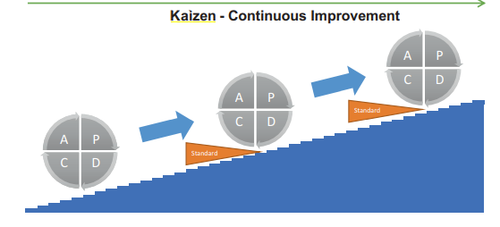

Figure 1 - Kaizen cycle (PDCA) (adapted with permission from Helmold, 2020, p.27).
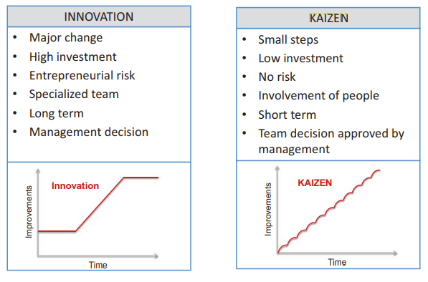

Figure 2 - Innovation vs Kaizen (adapted with permission from Helmold, 2020, p.27).
2.1.The waste of overproduction
While the ideal situation should be to make exactly what is required in terms of quantities, on time and with high quality, overproduction is making too much and too early. A process should not encourage output that is not needed. As a consequence, it leads to excessive lead time and it may also lead to situations where defects are not detected and products are deteriorated 6 (Bicheno & Holweg, 2009). So whatever the reason, making a quantity of products that exceeds the demand is wasteful. Waste from overproduction is also difficult to identified unless the quantity of products sold is compared to the quantity shipped (Nicholas, 2010).
2.2. The waste of waiting
This waste is related to flow and it takes many forms like waiting for materials or orders from preceding processes. It may also occur in automated processes when an operator who turns on a machine after having loaded it, remains in front of the machine and waits for the end of the process (Nicholas, 2010). Waiting is a waste that must be avoided as it results into reduced productivity and efficiency. Indeed, it causes longer lead times and it may also decrease engagement and motivation of employees (Helmold, 2020).
2.3. The waste of unnecessary motions
Unnecessary motions is the excessive movement of material or machines within the work area. It leads to higher cost due to the decrease of productivity. This is due to the fact that unnecessary motions require more time or capacity in operations than actually required in a process where unnecessary movements are eliminated (Helmold, 2020).
2.4. The waste of transporting
Any movement of materials can be considered as a waste because the customer does not pay for having goods moved around. In addition to that, the likelihood of damage increases with the number of operations of material handling and transport (Bicheno & Holweg, 2009). However, this waste cannot be fully eliminated. The supply of goods on a market requires a minimum of transport from the manufacturing to the delivery to the final customer.
2.5. The waste of overprocessing
Overprocessing is related to activities and processes which are more than the customer expects or needs. In other words, adding more value than the customer requires is a waste of overprocessing. Simplification of the activities reduce these wastes (Helmold, 2020). The origin of this waste seems less intuitive. Indeed, why does a company put energy on processes which the customer does not pay for? Some possible reasons could be inappropriate 7 or not capable processes that require additional work in order to meet the expectations of the customer.
2.6. The waste of unnecessary inventory
Inventory can be classified in three types: raw material, work in process (WIP) or semi-finished goods and end items. Their causes of existence and priorities for decrease are quite different.Inventory in raw material may be necessary due to constraints at supplier level while the inventory in end items helps to adapt to market in case of customer demand increase. But in general excessive inventory is a waste as it represents a risk of obsolescence (Bicheno & Holweg, 2009), items are waiting for something to happen which represents a situation where costs are generated and time is lost since no value is being added to them (Nicholas, 2010). In Lean, the reduction of inventory is not an end in itself but it must be considered as an opportunity for exposing wasteful practices as shown in the analogy of a ship on water where
inventory is compared to water depth and where problems like poor scheduling, quality issues, machine breakdown or long changeover are huge boulders into the sea (Nicholas, 2010).
2.7. The waste of defects
Defects impact the quality of products which deviate from the standards of their design or from the customer’s expectation. Defective products must be replaced and require additional work to process it. In some circumstances, it may cause as well loss of customers (Helmold, 2020). Product defects are ideally detected and handled before products are released on the market. However this activity represents also a waste because correcting defects increases production lead times which can lead to other delays in the process (Nicholas, 2010). The results of waste reduction can be measured by efficiency indicators and among the most used metrics are lead time, on-time delivery, Overall Equipment Effectiveness, WIP and many others (Chiarini, 2012). The presentation of the seven wastes ends this introduction about what is Lean. The choice of the TPS house as core concept allows to approach the ultimate aim of Lean through a global view. It describes also Lean as a complex system in which every single element contributes to the whole. Before to discuss the spreading of Lean in Six Sigma philosophy and in the Supply Chain discipline, it is important to present two configurations in which Lean can be deployed: the mechanistic and the organic systems.
- Lean Six Sigma
3.1. What is Six Sigma?
The Six Sigma philosophy works under a structured problem-solving approach whose aim is to eliminate variability, defects, and waste in a process. This structure is called Define– Measure–Analyze–Improve–Control (DMAIC), where
(i) Define is for the definition of the problem that needs to be addressed;
(ii) Measure is for the measurement of the problem and the process from which it was
produced;
(iii) Analyze is for the analysis of the process to identify the root causes of defects and
the opportunities for improvement;
(iv) Improve is for the improvement of the process;
(v) Control is for the implementation and the control of the improvements.

The majority of decision-making tools for Six Sigma are borrowed from statistics
(Muralidharan, 2015). Indeed, Six Sigma has an approach based on facts and data. All the results of the project are validated using ‘sigma level’ around the target. This sigma level can be put in correlation with the number of defects in a process and the cost of poor quality (CPQ) (Chiarini, 2012).
3.2. From Lean to LSS
Similarities can be seen between DMAIC and the Kaizen cycle (PDCA) from Lean. Both problem-solving approaches are made of steps coming one after another with the goal of achieving an improvement of the process. However Kaizen is more dynamic than DMAIC as it is a continuous improvement philosophy while DMAIC is deployed and exists in the context of a well-defined project. 10 As Lean focuses on streamlining a process by identifying and removing wastes, combining Lean and Six Sigma modifies the DMAIC approach by emphasizing speed. Wastes like rework and scrap are often the result of variability in the process. So there is an opportunity for connecting Six Sigma and Lean to form LSS whose the goal is to supply quality products that meet customer requirements as effectively and efficiently as possible (Muralidharan, 2015). But isn’t what Lean seeks to achieve already? Certainly but the use of statistical tools for data analysis and process control brings more accuracy. Six Sigma can also be considered as a prerequisite for Lean that needs process stability to work which is exactly what Six Sigma aims for (Friedli, Mänder & Bellm, 2013).

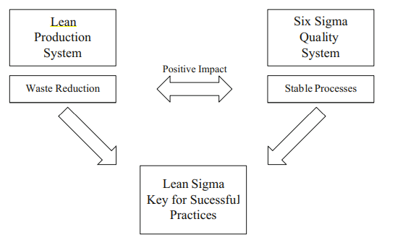

Figure 3: illustrates the interaction between Lean and
Six Sigma.

- Lean Technology in Pharmaceutical Industry
The Pharmaceutical Industry is very complex as it involves challenges to coordination among
multiple actors. According to Shah (2004), there are five categories of players in the
Pharmaceutical Industry, including:
(i) The companies with Research and Development (R&D) activities and
manufacturing sites in many locations;
(ii) The generic manufacturers, who produce out-of-patent products and over-the
counter products;
(iii) Local manufacturing companies operating in their home country, producing both
generic products and branded products under license or contract;
(iv) Contract manufacturing organizations (CMO) who provide outsourcing services for the production of active ingredients (AI) or final products;16
(v) Biotechnology start-up with no significant manufacturing capacity;
4.1 Approach
“Intelligent Optimization of manufacturing” is the principle of the departments “Production Logistics” and “Health Care Logistics” in the Fraunhofer IML. Intelligent optimization means capturing the whole production with respect to the company’s individual capabilities and targets. Many reorganization approaches in the pharmaceutical industry have an isolated focus and hence lack a holistic view. Cost-, time-, and service-benefits can only be achieved by analyzing the whole system of processes, employees and technologies as well as by adjusting the whole system on the customer’s individual needs. The Fraunhofer IML works process- and system-orientated and examines the work flows in an appropriate depth – always in view of the actual market demands. According to the Fraunhofer philosophy we work as a neutral and independent consultant. Individually staffed project teams develop sustainable solutions in manufacturing processes endorsed by your company’s employees.
4.2. Benefits
• Pharma-specific manufacturing concepts precisely tailored to your manufacturing requirements
• Holistic interaction of all your company’s resources
• Effective, flexible and customer orientated manufacturing
• Enhanced competitiveness in global competition
4.3. Analysis of the potential for Lean Pharma
• Examination of your status quo (process-mapping and data-acquisition)
• Drafting of a basic concept
• Appraisal of expected benefits Holistic reorganization concept
• Detailed planning of a lean material flow concept
• Configuration of a production system using
4.4. Lean Manufacturing principles
• Guidance during implementation Simulation
• Validation of performance
• Stochastic simulation to check robustness
• Analysis of future developments
4.6. Our area of consulting
We offer you orientation and a competent guidance during selection and realization of Lean Manufacturing methods. Thus we support long-term corporate success by fitting different methods into a holistic production system.
Thereby we work in the following areas:
4.7. Production of Active Pharmaceutical Ingredients (API)
For manufacturing pharmaceutical companies API production is regularly the first step of value creation in the manufacturing process. Hence this part of the value chain is the first to be affected by changing market conditions. To overcome these obstacles, achieving a greater flexibility by reducing batch-sizes and cycle times is essential. Instead lots of API producers try to buffer fluctuating market demands by boosting their stock levels. Restructuring the prevalent multi-purpose-factories in dedicated and partially dedicated facility networks, according to the Lean Manufacturing principles, allows companies to achieve the needed flexibility with significantly less inventory.
4.8. Drug production
Increasing complexity in production is caused by market differentiation of dosage forms. An increasing number of variations in dosage forms must be handled by existing machinery, which is the reason for smaller batch sizes. This again leads to an increase in time-consuming change-overs. Along with variable routing of work flows and unbalanced capacities of single machines this finally results in a batch-and-queue production. To address this problem a fixed routing and customized lean methods will help raise your production efficiency.
4.9. Packaging
The times of blockbuster production in which high volume packing machines were predominant are long gone. Customer specific packaging for each country leads to a low volume/ high mix production, which is accompanied by an increasing need of small lot sizes. Besides a shift from high performance packaging machines to flexible machines, a reorganization of production concepts is needed. Lean manufacturing methods help by reducing change-over times, standardizing work flows and increasing machine availabilities. Finally, this is essential to achieve operational excellence in packaging, even for very small lot-sizes.
Lean Management in the pharmaceutical industry According to IMS (Intercontinental Marketing Services) the global pharmaceutical industry will be worth US$1.160 billion in 2016 .(IMS Health Market Prognosis, June 2013,http://www.imshealth.com/deployedfiles/imshealth/ Global/Content/Corporate/Press%20Room/Total_World_Pharma_Market_Topline_metrics_2012- 17_regions.pdf)
A number of researchers and organizations have identified the following key developments and issues in the industry:
• Shifts in the growth of pharmerging countries (Figure 1 and 2)
• The expiration of patents of products which were launched during the industry's 'golden era' in the 1990s and the progressive introduction of less expensive generic alternatives
• A common strategy of industrial concentration which has been adopted in order to deal with the growing costs of R&D.

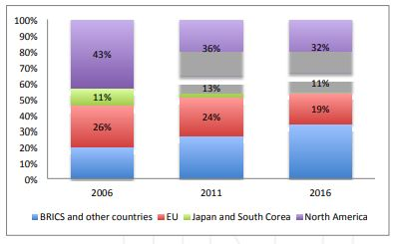
Figure 5: Global pharmaceutical market (% of total size)

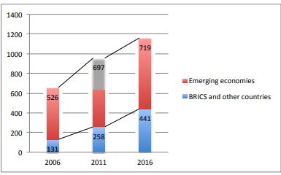
Figure 6: Global pharmaceutical market growth (billions of dollars and average annual growth rate)

4.10. Application of Lean Management

4.10.1. Value = f (Quality, Service, Cost)
4.10.2. Customers
Big C: patients/ doctors/ pharmacists/ health care providers/ regulators
Small c: Internal customers
4.10.3. Quality
Patient safety
Fit for purpose
4.10.4. Quality by Design
- Critical to Quality Parameters
- Factors impacting on variability of process outputs
- Factor range & interaction
- Process design robustness & optimisation
- Parameter design
- Process performance, capability & control
- Risk based management
- Quality at source vs multiple checking
- Uniformity around a target value vs compliance with specifications
4.10.5. Process Understanding Capability & Control
- Robust process design & development
- Robust technology/ process transfer
- DMAIC
- PF/CE/CNX/SOP
- Design of Experiments
- Control Charting: Address causes of OOC symptoms before they become OOS
- Understand sources of variation: Process vs measurement system
- Measurement System Analysis : prospective vs retrospective
- Error proofing
- Standard work
4.10.6. Waste & Variation
- SOP vs standard work
- VA vs NVA activities
- 7 Wastes
- Process RFT
- Testing RFT
- Documentation RFT
- Line/ equipment OEE
4.10.7. Flow
- FIFO vs Laboratory scheduling
- Visual control vs Spreadsheets
- Relationship between Lean practices and Innovation Skills
Most of the studies emphasize that with regard to operations and developments, services businesses are least developed as compare to production especially for pharmaceutical production. Many pharmaceutical organizations are facing improvement and development problems such as the increase of costs, recurring medical errors and the increased efforts to improve efficiency and quality of pharmaceutical product. Hence, implementing lean principles is claimed to be essential for solving such problems and providing a space for innovation (Angelis & Fernandes, 2012; Hoerl & Gardner, 2010). The existing literature indicates that the interest in practicing lean production is growing significantly from 2002 to 2008 where most applications have occurred in the United States of America and public healthcare sector of United Kingdom (Box & Woodall, 2012). This reflects the fact that lean production is becoming a successful approach for improvement of pharmaceutical product. Nat Natarajan (2006) analysed the opportunities and challenges in the healthcare sector for learning and transferring best concepts from other sectors in order to improve and develop the skills of employees and enhance the innovation process. A main challenging issue states that performance measurement and improvement programs within healthcare organizations do not honestly identify the problems, because efforts by outside firms likewise “the Joint Commission on Accreditation of Healthcare Organizations” (JCAHO) may face limitations because of concerns about “legal vulnerabilities or punitive actions”. Rousek (2012) demonstrate how “the implementation of lean and human factors engineering (HFE) initiatives can improve quality and patient safety within diverse healthcare delivery problems”. Lean aims to eliminate waste to create a more efficient workplace while HFE focuses on human capabilities and limitations to enhance performance. The research completed its objectives by reviewing five case studies. Each analysed and improved processes that are negatively affecting quality in healthcare delivery. Al-Balushi et al. (2014) studied the perspectives of process implication and development methods in a complex business of a UK National Health Service Trust. This rich qualitative study encourage “lean thinking” for process developments to enhance the competence and efficiency of the distribution of healthcare facilities. Ultimately, the study demonstrates that lean provides a culture of innovations using fewer resources to improve the capabilities and sustain the improvements. Particularly, McGrath (2007) applied a case study involving two Irish Medical Device industries, whereby in-depth understandings of human behaviour associated with lean are examined. The findings of the study emphasizes that lean manufacturing widely influence innovation, and it is considered as a strategic tool to help the competitive advantage of business, where one of the main benefits is the constant development that results in the sustained value and future business development. Based on the above discussion, it is imperative that each lean organization required a comprehensive, incessant, intellectual and self-reinforcing human capital with high innovative skills. According to Dibia and Onuh (2010), human resources are regarded as the hands of constant development, eyes of actual excellence and face of lean.

