Modeling of Gauss Elimination Method for Linear and Fractional Programming Problem

Sanjay Jain¹ and Adarsh Mangal^{2*}

¹Department of Mathematics, SPC PG Government College, Ajmer.

²Department of Mathematics, Engineering College, Ajmer.

drjainsanjay@gmail.com

dradarshmangal1@gmail.com

Abstract: This chapter deals with the solution of various programming problems viz. Linear Programming Problem (LPP), and Linear Fractional Programming Problem (LFPP) by Gauss elimination method. Gauss elimination method is an important method to solve linear equations in the field of Numerical Analysis. We have applied this method on linear inequalities to achieve an optimal solution of various programming problems. It is quite easy to understand and takes less computation time as compared to existing simplex method.

Keywords: Optimal solution, Linear programming problem, Linear fractional programming problem, Linear inequalities.

1. INTRODUCTION
In a finite dimensional vector space (FDVS), one can find the extrema of functions on sets which is defined by non-linear and linear constraints (equations or / and inequalities) to solve the optimization problems. Such types of optimization problems are encountered in Mathematical Programming; which is an important branch of Operations Research. If an object and all the restrictions involved in an optimization problem can be expressed in mathematical form (function, equation, inequality) then such problem is known as Mathematical Programming Problem (MPP). Every problem has an object. A problem without an object is meaningless. Generally a problem has some restrictions to achieve the desired object / goal. Therefore, the arrangement of the restrictions should be in such a way that the object of the problem can be obtained easily.
Generally, MPP has three main parts:
( a ) Objective Function
( b ) Restrictions
( c ) Non-negative conditions.
Mathematical Programming Problem (MPP) can be classified broadly in two categories:
- Linear Programming Problem (LPP)
- Non-linear Programming Problem (NLPP)
If all the terms involved in the MPP are linear in nature, then the corresponding MPP is termed as Linear Programming Problem (LPP). For example,
Max. Z = 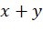
Subject to, 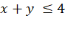
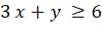
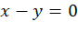
and 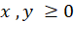
Here two decision variables 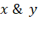 are being used which is involved linearly in objective function, restrictions and non-negative conditions.
On the other hand, if some or all of the terms involved either in objective function or in constraints or in both in the MPP are non-linear in nature, then the corresponding MPP is termed as Non-linear Programming Problem (NLPP). For example,
Max. Z = 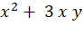
Subject to,
and
Whenever we have a raw data of an optimization problem, we always try first to formulate as like LPP & NLPP. In many real-life problems, an optimization problem may not be adequately described in the form of LPP & NLPP necessarily.
In this chapter, we’ll discuss modeling of Gauss elimination technique for different kinds of Mathematical Programming Problems viz. Linear Programming Problem (LPP) and Linear Fractional Programming Problem (FPP).
2. Gauss Elimination Technique for Mathematical Programming Problem
In this chapter, a numerical technique “Gauss elimination technique for simultaneous linear algebraic equations” has been proposed to solve several mathematical programming problems viz. Linear Programming Problem (Sharma et al 2003), Fractional Programming Problem (Jain et al 2008) and Extended Integer Solution for Fractional Programming Problem (Jain et al 2008). Gauss elimination technique is useful than the earlier methods available in the literature so far because it takes least time and calculations are also simple in nature.

3. Gauss elimination technique for simultaneous linear algebraic equations
In this method, the given system of simultaneous linear algebraic equations can be reduced to an upper triangular system by eliminating the variables successively and the knowns are found by back substitution. For the sake of clarity and simplicity, we consider only the system of three equations.
Let the system be
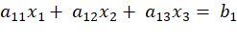
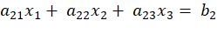
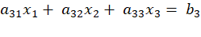
To eliminate from the second equation, multiply the first equation by - and add to the second equation. Similarly to eliminate from the third equation, multiply the first equation by - and add to the third equation. These elements - and - are called the multipliers for the first stage of elimination, assuming 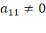.
The first equation is called the pivotal equation and is called the first pivot.
Therefore the second and third equations become
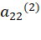 + 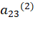 = 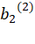
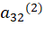 + 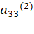 = 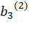
where = -
= -
= -
= -
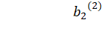= -
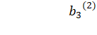= -
In the second stage of elimination, we multiply the fourth equation by - 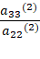 and adding to the fifth equation. We have 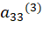 = 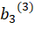
where = - 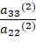
and = - 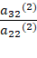
Now collecting the first equation from each stage, we get the system :
+ = ……………………………(A)
=
The above system (A) is known as upper triangular system and can be solved by using back substitution method.
4. Modeling of Gauss elimination technique for inequalities
In Numerical Analysis, the system of simultaneous equations is solved by Gauss elimination technique with the help of elimination of variables one by one and finally reduce to upper triangular system of equations, which can be solved by back substitution. Equation gives only one solution while inequality gives possibility of many solutions in bounded/ region form, out of which we select maximum or minimum value according to the problem to optimize. This is the main theme to apply Gauss elimination technique for inequality in place of equation. It can easily verify that max. / mini. value of linear variables gives, max. / mini. value of objective function of 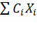 form where all are positive. If some are not positive, then we take mini. / max. value of corresponding linear variables so it gives max. / mini. value of objective function.
Here we apply Gauss elimination technique for a system of inequalities of the same sign i.e., either less or equal to ( or greater than or equal to ( in nature. Here variables are eliminated by combining inequalities in such a way that the inequalities and variables reduced one by one in every iteration i.e., one variable and one inequality reduce in one iteration so at last there remains only one inequality with one variable remains. This last inequality gives value of last variable in bounded form and finally taking the maximum or minimum value of last variable according to objective function of Mathematical Programming Problem. Finally, we get value of other variables by back substitution of value of the last variable.
For the sake of clarity and simplicity, we consider the system of inequalities of n variables and m inequalities:
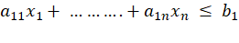
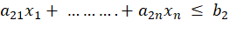
……………………………………
……………………………………
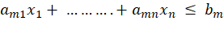
First of all to eliminate the first variable say , multiply the first row by 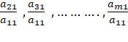 respectively and then subtract them from second, third and so on up to the 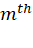 row respectively. Then we get the first iteration as:
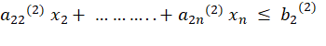
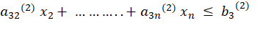
…………………………………………………
…………………………………………………
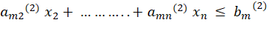
where 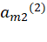 = 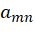 - 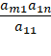
Now after first iteration, we get (n-1) variables and (m-1) inequalities. Repeating this process or after (n-1) iteration we have only one variable remains. Finally, we can get the value of last variable. There may be some redundant constraints present in the system.
5. Algorithm of Gauss elimination technique for Mathematical Programming Problem
In this chapter, main emphasis is given on several programming problems viz. Linear Programming problem, Fractional Programming Problem and Extended Integer Solution for Fractional Programming Problem to find an optimal solution by Gauss elimination technique. The steps to apply Gauss elimination technique on MPP are as follows:
- To apply Gauss elimination technique on Mathematical Programming Problem (MPP), we have to formulate this MPP again by taking objective function as constraints and all constraints of having same sign of inequality.
- Now variables eliminated by combining inequalities in such a way that the inequalities and variables reduced one by one in each iteration. If at any stage we get an absurd inequality like 0 where is a negative number then we conclude that the given MPP has an infeasible solution otherwise MPP has a feasible solution.
- In case of having feasible solution, we form the following pairwise disjoint sets for all the variables like,
=
=
= ; i = 1,2, …….., m and j = 1,2,…..,n
- If at any stage the set or becomes empty for a variable, then the given MPP possess an unbounded solution. Hence, optimal / feasible solution of MPP exists when neither absurd inequality nor empty set of or exist in the system.
6. Problem Formulation for Various Mathematical Programming Problems

- Linear Programming Problem
Max. Z = 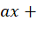α
subject to, 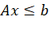
and 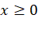
Reduced form of Linear Programming Problem for Gauss elimination technique are as follows:
Max. Z
Z – 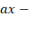α 0
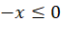
- Fractional Programming Problem
Max. Z = 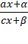
subject to
and
Reduced form of Fractional Programming Problem for Gauss elimination technique are as follows:
Max. Z
(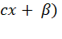Z – 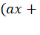α) 0
To explain the procedure of Gauss elimination technique for various mathematical programming problems, the illustrations of Linear Programming Problem, Linear Fractional Programming Problem and Multi-objective Linear Programming Problem are being solved for better understanding to the readers and learners.
7. Illustrations
- Solve the given Linear Programming Problem by Gauss elimination technique:
Max. Z =
Subject to,
and
Solution : Making standard form by treating objective function as constraints and all inequalities of same sign for Gauss elimination technique, we have
Max Z
Z - ≤ 0 ………(1)
………(2)
………(3)
………(4)
………(5)
In the first stage of Gauss elimination, let the variable is selected to be eliminated, then

Since, here non-empty sets of 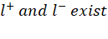, therefore an optimal / feasible solution of above Linear Programming Problem can be obtained by using Gauss elimination technique.
Now, (1) multiplied by - , we have
– 3 - 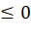 ……….(6)
Adding (6) to (2), we get
+ 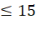 ………(7)
Multiplied (1) by -1, we have
Z – 5 - 3 …………(8)
Adding (8) to (3), we get
Z – 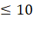 …………(9)
Multiplied (1) by , we have
– – …………..(10)
Subtracting (10) from (4), we get
- + …………..(11)
Hence, after first stage of elimination, we have
Max Z
+ or 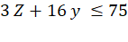 ………………(12)
Z – …………………..(13)
- + or -Z + 3 ………………….(14)
-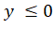 …………………..(15)
In the second stage of Gauss elimination, to eliminate the variable , multiplying (12) by - , we have
+ 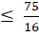 ………………….(16)
Adding (16) to (13), we get
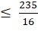 ………………..(17)
Multiplied (12) by , we have
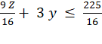 …………………(18)
Subtracting (18) from (14), we get
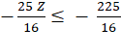 …………………..(19)
Multiplied (12) by - , we have
+ ……………….(20)
Adding (15) to (20), we get
………………(21)
Hence, after second stage of elimination, we have
Max Z
Z 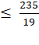
Z 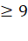
Z 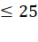
Here, our object is to maximize Z. Hence, we have to select maximum value of Z from the above bounded values of Z which satisfies all the above inequalities. Therefore, Max. Z = 9.
Now putting Z = 9 into the inequalities (12) , we get
16 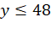 or 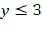
Now putting Z = 9 into the inequalities (13) , we get
-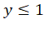 or 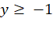
Now putting Z = 9 into the inequalities (14) , we get
3 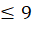 or
Now we observe that on putting Z = 9 into the inequalities (12) to (14), we get different bounded values of 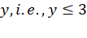, and 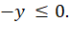 Out of these, 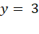 is the only value that satisfies all the inequalities altogether.
Now putting Z = 9 and in the inequality (1), we get
-5 or
Now putting Z = 9 and in the inequality (2), we get
3 or 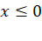
Now putting Z = 9 and in the inequality (3), we get
5 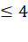 or 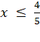
Now we observe that on putting Z = 9 and into the inequalities (1) to (5), we get different bounded values i.e., , and . Out of these, 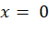 is the only value that satisfies all the above inequalities altogether. Hence, .
Therefore, the optimal solution of above Linear Programming Problem by Gauss elimination technique is, , and Z = 9.

- Solve the given Linear Fractional Programming Problem by Gauss elimination technique:
Max. Z = 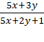
Subject to, 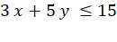
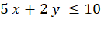
and 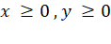
Solution : Making standard form by treating objective function as constraints and all inequalities of same sign for Gauss elimination technique, we have
Max Z
≤ 0 ………(22)
………(23)
………(24)
………(25)
………(26)
Since, we have to find the maximum value of objective function. Let us suppose that
1< z < .
In the first stage of Gauss elimination, let the variable is selected to be eliminated, then
S
Since, here non-empty sets of , therefore an optimal / feasible solution of above Linear Fractional Programming Problem can be obtained by using Gauss elimination technique.
Now, (22) multiplied by 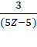 , we have
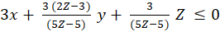 …………………….(27)
On subtracting (27) from (23), we have
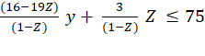 ……........................(28)
Now, (22) multiplied by 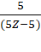 , we have
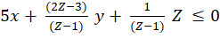 …………………….(29)
On subtracting (29) from (24), we have
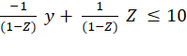 ……........................(30)
Now, (22) multiplied by 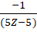 , we have
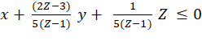 …………………….(31)
Adding (31) and (25), we have
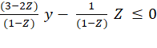 ……........................(32)
Hence after first stage of elimination, we have
Max. Z
……........................(33)
…........................(34)
……........................(35)
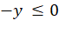 …………………(36)
In the second stage of Gauss elimination, to eliminate the variable , multiplying (33) by -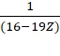 , we have
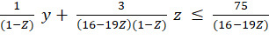 …………………….(37)
Adding (37) and (34), we get
-209 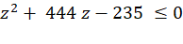 ………………………………(38)
Now, (33) multiplied by 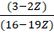, we have
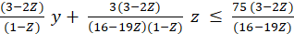 ……………………….(39)
Subtracting (39) from (35), we get
7 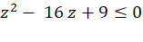 …………………………(40)
Now, multiplied (33) by 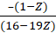 , we have
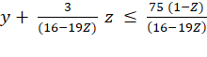 …………………………..(41)
Adding (41) and (36), we get
78 z – 75 ≤ 0 …………………..(42)
Hence, after second stage of elimination, we have
-209 …………………………………(43)
7 …………………………………(44)
78 z – 75 ≤ 0 ………………………..(12.45)
Here we get quadratic inequality in one variable z by (43), (44) and linear inequality by (45). On solving quadratic inequalities (43) and (44), we select only real values of the variable and if no such real value exists for that variable then there does not exist any feasible solution for the fractional programming problem and linear inequality (45) for z, we have bounded values of z by using quadratic root method
( 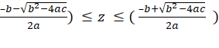 or by graphical method of non-linear programming problem.
Gauss elimination method is a direct method so the amount of computation is fixed, while in an iterative or indirect method the amount of computation depends on the accuracy required.
Here, our object is to maximize z. So, select maximum value of z from the bounded values of z. Values of z from inequalities (43), (44) and (45) are
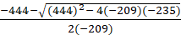 ≤ z ≤ 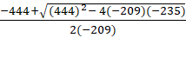
Hence Max. Z = { 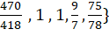 =
Now putting Z = into the inequalities (33) to (36) respectively, we get different bounded values for the variable y as y ≤ 3, y ≤ , y ≥ 3 along with –y ≤ 0. Out of these y = 3 is the only value that satisfies all the inequalities (33) to (36) altogether. Hence y = 3.
Now putting Z = and y = 3 into the inequalities (22) to (26) respectively, we get different bounded values for the variable as ≤ 0, 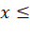 and – ≤ 0. Out of these, 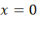is the only value that satisfies all the inequalities (22) to (26) altogether. Hence 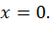
Therefore the optimal solution of the above linear fractional programming problem by Gauss elimination technique is 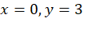and Z = .
References

Chadha, S.S., “A linear fractional program with homogeneous constraints” OPSEARCH 36,390-398 (1999).

Charnes, A. and Cooper, W.W.,“Programming with linear fractional functionals” Naval Research Log. Quart., 9, 181-186 (1962).

Dantzig, G.B., “Linear Programming Methods and Applications” Princeton University Press, Princeton, New Jersey (1963).

Gass, S. I., “Linear Programming Methods and Applications” McGraw- Hill Book Company, New York (1985).

Hirche, J., “A note on programming problems with linear plus linear fractional objective functions” EJOR, 89, 212-214 (1996).

Jain, S. “Modeling of Gauss elimination technique for multi-objective linear programming problem” Journal of Novel Applied Sciences, Vol. 1 Issue 1, pp. 25-29, 2012.

Jain, S., Mangal, A. and Sangeeta, “Modelling of Gauss elimination technique for Quadratic optimization” Advances in Modelling and Analysis AVol. 56 No. 2-4, pp. 31-34, December 2019.

Jain, S., Mangal, A. and Sangeeta, “Modeling of nature inspired modified Fourier elimination technique for quadratic optimization” International Journal of Swarm Intelligence (Inderscience), Vol. 5 No. 2, pp. 182-190, 2020.

Kamboo, N. S., “Mathematical Programming Technique” Affiliated East-West Press Pvt. Ltd., New Delhi (India) (1995).

Kanniappan, P.and Thangavel, K., “Modified Fourier’s method of solving LPP” OPSEARCH 35, 45-56 (1998).

Karmarker, N., “A new polynomial time algorithm for Linear Programming” Combinatorica 4, 141-158 (1984).

Kohler, D.A., “Translation of a report by Fourier on his work on linear inequalities” OPSEARCH 10,38-42 (1973).

Martos, B.,“Nonlinear Programming, Theory and Methods” North-Holland Publishing Company, Amsterdam (1975).

Sastry, S.S., “ Introductory Methods of Numerical Analysis” Prentice-Hall, India (2002).

Sharma, K.C. and Bhargava, S., “Gauss method to solve Linear programming problem” Applied Science Periodical, 3(1), 45-49 (2003).

Swarup, K., “Linear Fractional Functionals Programming” Operations Research, 13, 1029-1036 (1965).

Williams, H.P.,“Fourier’s method of Linear Programming and its Dual” American Mathematical Monthly, 93, 681-695 (1986).

