**Designing Zinc Oxide Nanoparticles (**Hib/nZnO NPs) **synthesized using ‘Green’ methods from *Hibiscus rosa-sinensis* flower extract as fluorescent probe for Dopamine**

Dr. Rimki Bhattacharjyaa ⃰, Rohit Sarmaa

a Department of Chemistry, Pandu College, Guwahati

***Corresponding Author: Assistant Professor, Pandu College***

***(rimki.bhatta@gmail.com)***

**Abstract:**

In this study Zinc Oxide Nanoparticles (Hib/nZnO NPs) are synthesized using green methods from hibiscus rosa sinensis flower. The morphology, microscopic structure and size of the Hib/nZnO NPs were characterized by The SEM analysis which clearly shows the distribution of ZnO nanoparticles prepared with natural surfactant. From the SEM images it can be seen that the particles have sheet like structure with thickness which has the size below 100nm and no aggregation was seen. ZnO nanoparticles are analysed by UV-Visible Spectra and IR Spectra also. The interaction between dopamine and Hib/nZnO NPs solution was verified by fluorescence studies. Upon gradual addition of dopamine to the solution the intensity decreases i,e quenches and the λmax moves towards higher wavelength, i.e., red shift takes place.

**Key Words:** Hibiscus rosa sinensis flower,Zinc Oxide Nanoparticles (Hib/nZnO NPs),UV-Visible Spectra, IR Spectra, SEM, Fluorescence spectroscopy

1. **Introduction:**

A Nanoparticleis usually defined as a particle of matter that is between 1 and 100 nanometer (nm) in size. Green synthesis of metallic nanoparticles has gained an ultimate interest over the last decade due to their distinctive properties that make them applicable in various fields of science and technology. Green synthesis methods involving biological agents like bacteria, fungi, plants and algae are a good alternative to the chemical and physical methods, as they are both environment friendly and economic[1-4]. Among all types of metal nanoparticles preparation, noble-metal based nanoparticle synthesis using various plants extracts has achieved an extensive interest due to its unique advancement of nanoscale activity, selectivity and reusability also it is an environmentally friendly method to reduce the use of harmful chemicalsubstances[5].

Metal nanoparticlesthat are synthesized by using plants have emerged as non-toxic,ecofriendly and of low cost. During this type of synthesis less energy is required.

ZnOnanostructures are the forefront of research due to their unique properties and vast applications. The advantages of using ZnOnanoparticlesis that they have antibacterial properties means strongly inhibit the action of pathogenic microbes when used in small concentration. [6,7].

Dopamine (3,4-dihydroxyphenethylamine), an organic chemical belonging to catecholamine and phenethylamine families, acts as both hormone and neurotransmitter, playing a key role in the metabolism of brain and body. In the human body, dopamine functions majorly in the cardiovascular, central nervous, renal, and hormonal systems, in addition to monitoring human metabolism [8].

Dopamine acts on the sympathetic nervous system when ingested intravenously, producing effects such as increased heart rate and blood pressure [9]. Therefore, monitoring the concentration of dopamine is very important both in vivo and in vitro.

In this study Zinc Oxide Nanoparticles (Hib/nZnO NPs)are synthesized using green methods from hibiscus rosa sinensis flower. The morphology, microscopic structure and size of the Hib/nZnO NPs were characterized by The SEM analysis which clearly shows the distribution of ZnO nanoparticles prepared with natural surfactant. From the SEM images it can be seen that the particles have sheet like structure with thickness which has the size below 100nm and no aggregation was seen.ZnO nanoparticles are analysed by UV-Visible Spectra and IR Spectra also. The interaction between dopamine and Hib/nZnO NPs solution was verified by fluorescence studies. Upon gradual addition of dopamine to the solution the intensity decreases i,e quenches and the λmax moves towards higher wavelength, i.e., red shift takes place.



1. **Required materials**:

* ZnSO4.7H2O
* Sodium Hydroxide (NaOH)
* Dopamine
* HCl
* Ethyl acetate
* Acetone
* Distilled water..etc.

1. **Methods:**
2. **Synthesis of a natural surfactant from *Hibiscus rosa-sinensis* flower:**

Hibiscus petals are collected, cleaned, dried and crushed to powder.The surfactant was extracted from the flower of ***Hibiscus rosa-sinensis,*** the plant material under ambient conditions. During the synthesis, excess of an aqueous NaOH solution (pH-11) was added into the grind plant material of ***Hibiscus rosa-sinensis*** flower. The mixture was then heated on a water bath with continuous stirring for 1 hour and then allowed to stand for 12 to 18 hours. The alkaline extract was filtered, acidified with 10 ml aqueous HCl solution (pH-1), and allowed to stand for diserstion. The disersion was separated by filtration. The residue was washed with distilled water and pre exrtracted with ethyl acetate by refluxing for about 5-6 hour. The pre- extractant that obtained then distilled off and the residue was extracted with acetone. The acetone extra obtained was mixture of natural surfactant which was finally separated and dried.

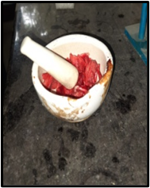

**Fig 1A:** Grinding ***Hibiscusrosa-sinensis***flower

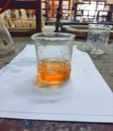

Fig 1B: Hibiscus solution

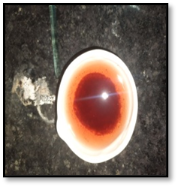

**Fig 1C:**Residue observed afterAcidified with HCL.

1. **Surfactant assisted synthesis of Zinc Oxide Nanoparticles:**

In a reaction flasks 88 ml of 1M aqueous solution containing ZnSO4.7H2O and natural surfactant was mixed with 12 ml aqueous NaOH solution(4M). The resulting mixture in the flask was stirred vigorously under room temperature and then respective reaction flask were exposed to reaction condition by placing them in microwave oven (1 min). The white precipitate were filtered, washed with distilled water and then dried at room temperature.

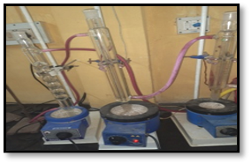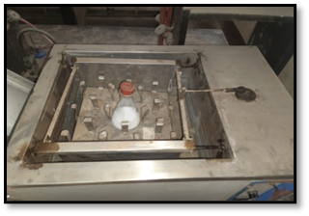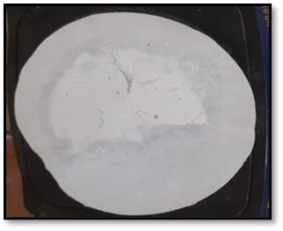

**Fig 2A:** Refluxing

**Fig 2B:** Stirring

**Fig 2C:Zinc Oxide Nanoparticles (**Hib/nZnO NPs)

1. **RESULTS AND DISCUSSION:**
2. **Characterization of prepared Zinc Oxide Nanoparticles (Hib/nZnO NPs):**

The synthesized product thus obtained in our work has been characterized with various analytical techniques.

1. **UV-Visible Analysis:**

**Sample 1:** UV-Visible analysis of **aqueous** extract of ***Hibiscus rosa-sinensis*** flowersolution:

**Fig-3:** UV-Visible spectra of aqueous extract of ***Hibiscus rosa-sinensis*** flower.

**Sample 2**: **UV-Visible analysis of ZnOnanoparticle**s :

In order to observe the UV spectroscopy of synthesized ZnO nanoparticles, they are sonicated in distilled water for about 15 minute and UV spectra were recorded supplementary data Fig-2(A) and Fig-2(B) shows the UV-Visible absorption spectra of ZnO nanoparticles.

**Fig-4 (A) :** UV-Visisble spectra of ZnO nanoparticles at comparatively higher concentration.

**Fig-4 (B) :** UV-Visible spectra of ZnO nanoparticles at comparatively lower concentration.

The UV-Visible absorption characteristic of the aqueous extract of ***Hibiscus rosa-sinensis*** flowers were investigated, and a prominent peak was observed in the range of 295-300 nm as shown in the **Fig-3**.

Subsequently, UV-Visible spectroscopy was employed to analyze the prepared ZnO nanoparticles, using both higher and lower concentration of the prepared solution. The spectra of ZnOnanoparticles is shown in the **Fig -4(A)** and **Fig-4(B)**.

In **Fig-4(A)**, the UV-Visible spectrum of the **higher concentration** demonstrated the characteristic peak of pure ZnO nanoparticles within the range of 360nm -370nm. Notably, this peak coincided with the presence of ***Hibiscus rosa-sinensis*** peak observed in the 295-300 nm range. The concurrent appearance of these peaks indicated the successful synthesis of ZnO nanoparticles, while also suggesting the retention of ***Hibiscus rosa-sinensis*** components in the solution.

Conversely, **Fig-4(B)** exhibited the UV-Visible spectrum of the **lower concentration**, revealing only the distinctive peak of ZnOnanoparticvles at 360nm – 370 nm. Interestingly, the peak corresponding to ***Hibiscus rosa-sinensis*** was absent, implying that its concentration in the solution was negligibly low due to dilution.

This finding clearly shows the successful synthesis of ZnO nano particles**(**Hib/nZnO NPs).

**FT-IR analysis of *Hibiscus rosa- sinensis* flower:**

**Fig-5A** shows the FT-IR spectrum of ***Hibiscusrosa-sinensis*** extract. FT-IR spectra of ***HibiscusRosa Sinensis*** flower exhibited the characteristic bands at 3280 cm-1. Indicating the presence of alcohol and phenol (O-H) groups. The peak at 2916 cm-1 and 2845 cm-1 are ascribed to the stretching vibration of C-H bond of the Methyl or Methylene group. The FT-IR spectrum at 1630 cm-1 indicating the presence of Carbonyl(C=O) group. The peak at 1010 cm-1 is ascribed to the stretching vibration of C-N bond of aliphatic amines.

Synthesized Zinc Oxide nanoparticle were subjected to FT-IR analysis to detect the various characteristic functional group associated with the synthesized nanoparticle. The peaks indicate the characteristic functional group present in the synthesized Zinc Oxide Nanoparticle. It is inferred that the samples have absorption peaks in the range of 3370 cm-1, 1520 cm-1, 1395 cm-1, 1095 cm-1, 735 cm-1, and 500 cm-1 – 697 cm-1. The absorption peak at 500-697 cm-1and 735 cm-1 corresponds to Metal-Oxygen means ZnO stretching vibration mode. The peak at 1095 cm-1 is ascribed to the stretching vibration of C-N bond of the primary amine or to the stretching vibration of the C-O bond of the secondary alcohol. The peak at 1395 cm-1 is ascribed to primary or secondary or phenol or tertiary alcohol in-plane bend or vibration. The peak at 1520 cm-1 is ascribed to the vibration modes of aromatic nitro compound and alkyl. The peaks at 3370 cm-1 are ascribed to the stretching vibration of hydroxyl compound.

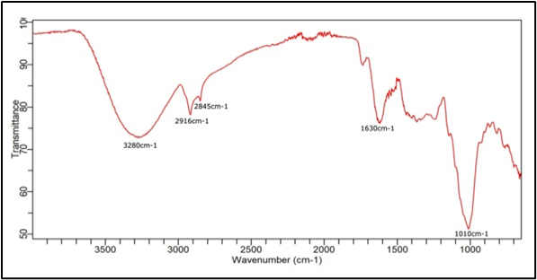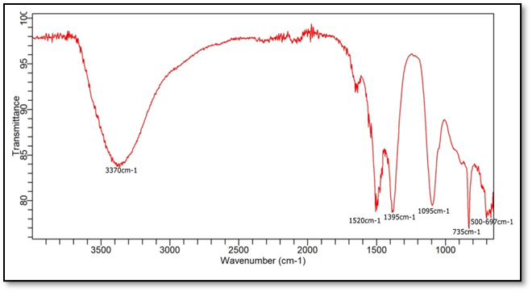

**Fig-5A:** FT-IR Spectra of***Hibiscusrosa -sinensis***flower

**Fig-5B:** FT-IR Spectra of ZnO nanoparticles.

**4: SEM Analysis:**

**Fig 6A: SEM analysis** of the Hib/nZnO NPs

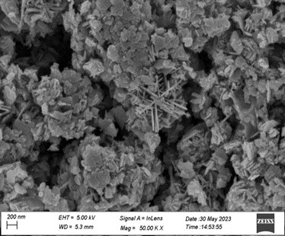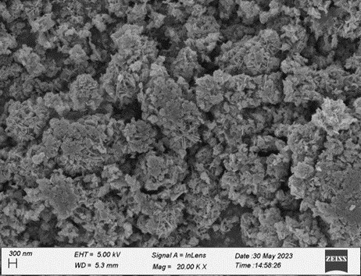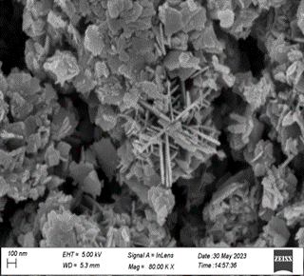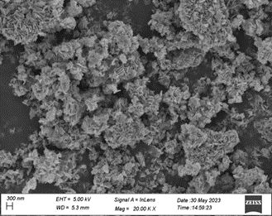

**(a)**

**(b)**

**(c)**

**(d)**

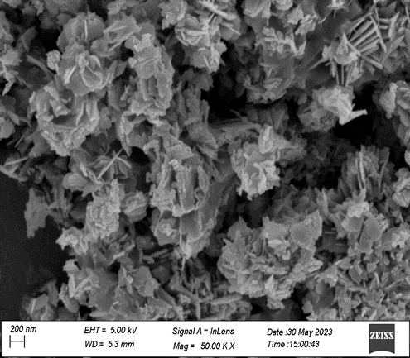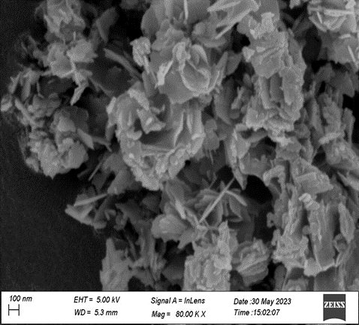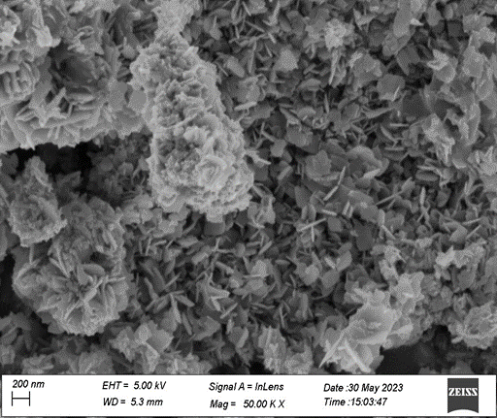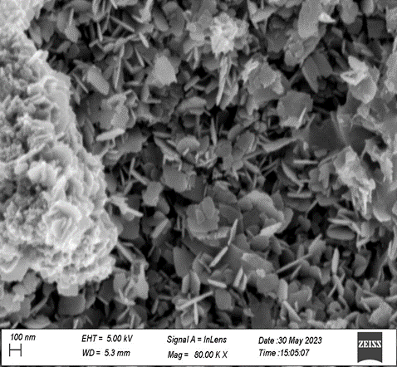

**(e)**

**(g)**

**(f)**

**(h)**

**Fig 6B:** SEM analysis of Hib/nZnO NPs

The morphology, microscopic structure and size of the Hib/nZnO NPs were characterized byThe SEM analysis clearly shows the distribution of ZnO nanoparticles prepared with natural surfactant. From the SEM images it can be seen that the particles have sheet like structure with thickness which has the size below 100nm. It can clearly seen that no aggregation is formed. 3-D structure of prepared ZnO nanoparticle is shown in the Fig-6A and Fig-6B.

**(ii). Flurescence study**

# The interaction between dopamine and Hib/nZnO NPs solution was verified by fluorescence studies. Upon gradual addition of dopamine to the solution the intensity decreasesi,e quenches and the λmaxmoves towards higher wavelength, i.e., red shift takes place.



**Figure 7: Fluorescence emission spectrum of Hib/nZnO NPs solution (black), Hib/nZnO NPs solution and 200 μL dopamine-aqueous solution (dark blue). Red shift occurs on addition of dopamine-aqueous solution**

1. **CONCLUSIONS:**
2. In the present study, ZnO nanoparticles have been synthesized using green and ecofriendly method with the help of surfactant which was isolated from the flower of ***Hibiscusrosa-sinensis*** which is act as a reducing agent.
3. The synthesized ZnO nanoparticle have been characterized using FT-IR , UV-Visible Spectroscopy and SEM.. All these studiesconfirms the successful formation of ZnO nanoparticles.
4. The interaction between dopamine and Hib/nZnO NPs solution was verified by fluorescence studies. Upon gradual addition of dopamine to the solution the intensity decreases i,e quenches and the λmax moves towards higher wavelength, i.e., red shift takes place.

**Acknowledgment**

We acknowledge our institute Pandu College, Guwahati for providing us with all the necessary information and tools required for the completion of the research work. We would like to thankGauhati University, CIF, IIT Guwahati, bearing instrumentation facilities undergone in this research work. We would also like to acknowledge Prof. Diganta Kr. Das, Gauhati University, Guwahati for his valuable advice.

**Conflict of Interest**

We declare no competing conflict of interest

1. **REFERENCES:**
2. Lin, G., Zeng, B., Li, J., Wang, Z., Wang, S., Hu, T. and Zhang, L., 2023. A systematic review of metal organic frameworks materials for heavy metal removal: synthesis, applications and mechanism. *Chemical Engineering Journal*, *460*, p.141710.
3. Agarwal, H., Kumar, S.V. and Rajeshkumar, S., 2017. A review on green synthesis of zinc oxide nanoparticles–An eco-friendly approach. *Resource-Efficient Technologies*, *3*(4), pp.406-413.
4. Saravanan, A., Kumar, P.S., Karishma, S., Vo, D.V.N., Jeevanantham, S., Yaashikaa, P.R. and George, C.S., 2021. A review on biosynthesis of metal nanoparticles and its environmental applications. *Chemosphere*, *264*, p.128580.
5. Vishwanath, R. and Negi, B., 2021. Conventional and green methods of synthesis of silver nanoparticles and their antimicrobial properties. *Current Research in Green and Sustainable Chemistry*, *4*, p.100205.
6. Bhattacharjya R, Saikia H, Kalita Sarojmoni et all, “Green” synthesis and electrochemical studies of B/nZCu-M nanoparticles using LawsoniaInermis, **Results in Chemistry,** 6(2023) 101078.
7. M J Divya, C Sowmia et all, “ Synthesis of zinc oxide nanoparticles from***Hibiscusrosa-sinensis* leaf extract and investigation of its antimicrobial activity, ISSN : 0975-8585**
8. Lin, G., Zeng, B., Li, J., Wang, Z., Wang, S., Hu, T. and Zhang, L., 2023. A systematic review of metal organic frameworks materials for heavy metal removal: synthesis, applications and mechanism. *Chemical Engineering Journal*, *460*, p.141710.
9. Kim Yang, Bong S. et all, “Electrochemical detection of dopamine in the presence of ascorbic acid using grapheme modified electrodes”, Biosensors and Bioelectronics”, ol 25, Issue 10, 15 june, 2366-2369.