Frontiers in Secure Software Defined Networking: A Research Perspective

BV Prasanthi
Research Scholar, Department of Computer Science and Engineering, Jawaharlal Nehru Technological University Anantapur,
Andhra Pradesh, India
prasanthibeera@gmail.com

P. Chenna Reddy
Professor, Department of Computer Science and Engineering, Jawaharlal Nehru Technological University Anantapur, Andhra Pradesh, India

ABSTRACT
In the ever-evolving landscape of network management and architecture, the emergence of Software-Defined Networking (SDN) has become a transformative paradigm shift. SDN redefines the way networks are controlled, introducing a dynamic and programmable approach that departs from traditional, rigid network architectures. At the heart of SDN lies the concept of decoupling the control plane from the data plane, paving the way for centralized control, intelligent decision-making, and unparalleled adaptability. Unraveling the SDN architecture reveals a central orchestrator the SDN controller empowered with the capability to dynamically manage network resources. The controller communicates with network devices through southbound APIs, dictating the forwarding decisions to the simplified and efficient data plane. This separation of concerns empowers network administrators and developers to programmatically shape network behavior, responding swiftly to evolving requirements and application dynamics. In this chapter, we embark on an exploration of the fundamental principles of SDN, dissecting its key components, and unraveling the implications of its programmable nature particularly within the context of robust security measures. Acknowledging the paramount importance of security in contemporary networking, we address the inherent challenges and vulnerabilities that persist in traditional network security models. As we navigate through the intricate layers of SDN, our focus extends to securing this dynamic paradigm. We examine its centralized intelligence, dynamic adaptability, and the open standards underpinning interoperability, all while scrutinizing the security implications inherent in each facet.
Keywords— Software-Defined Networking (SDN);Network Virtualization Security;Role-Based Access Control (RBAC);Intrusion Detection and Prevention Systems (IDPS);Encryption Protocols;Southbound and Northbound API Security

INTRODUCTION

Software-Defined Networking (SDN) is a transformative networking architecture that separates the control plane from the data plane in network devices. Unlike traditional networking, where both control and data plane functionalities are tightly integrated into individual devices, SDN introduces a centralized control plane, which makes global decisions about how traffic should be forwarded across the network. This separation allows for programmability, automation, and greater agility in managing and configuring network resources.
The Key Components of SDN are SDN Controller, Switches and Forwarding Devices, Southbound and Northbound APIs.SDN Controller, it is the central intelligence of an SDN, and the controller manages the network by communicating with switches and other devices. It interprets high-level network policies and translates them into low-level instructions for the switches. Network switches in an SDN environment are responsible for forwarding data packets according to the instructions received from the SDN controller. These switches are simpler as they primarily focus on data forwarding. Southbound APIs facilitates communication between the SDN controller and network devices (e.g., OpenFlow), enabling the controller to instruct switches on how to handle traffic. Northbound APIs allows communication between the SDN controller and applications, enabling external software to program and control the network. The key Concepts of SDN are Decoupling Control and Data Planes, Centralized Intelligence, Programmability and Automation, Open Standards and APIs.SDN separates the decision-making (control plane) from the actual forwarding of data packets (data plane). This decoupling enhances network flexibility and adaptability. The SDN controller acts as a centralized point of intelligence, making global decisions about how traffic should be handled across the network.SDN allows for the programmability of network configurations, enabling dynamic adjustments to network behavior based on changing requirements and conditions.SDN relies on open standards and APIs, fostering interoperability and enabling a diverse ecosystem of applications and services to interact with the network. The Benefits of SDN are Adaptability, Resource Optimization, Innovation.SDN networks can quickly adapt to changing conditions, making them well-suited for dynamic environments, including cloud computing and IoT. Centralized control allows for efficient resource utilization, optimizing network performance. The open nature of SDN encourages innovation by allowing the development of diverse applications and services that can interact with the network. In essence, SDN represents a paradigm shift in networking, offering a more flexible, programmable, and centrally managed approach to network architecture.

SECURITY THREATS IN SDN

In the realm of Software-Defined Networking (SDN), the pursuit of innovation and agility is accompanied by the ever-present specter of security threats. This section provides an overview of potential security threats [1] within SDN environments, shedding light on the vulnerabilities that may compromise the integrity and functionality of the network.

Threat Landscape Overview
Delving into the SDN environment reveals a nuanced threat landscape, encompassing diverse challenges that demand vigilant attention. Security threats in SDN extend beyond conventional network vulnerabilities, requiring a holistic understanding of the risks that may emerge in this dynamic paradigm.

Threats to SDN Controllers, Switches, and Communication Channels
- Controller Vulnerabilities
Examining the security of SDN controllers unveils potential vulnerabilities that could be exploited by malicious actors. Unauthorized access to the controller poses a significant threat, potentially leading to unauthorized manipulation of network policies and configurations.
- Switch Exploitation
SDN switches, as integral components of the data plane, are susceptible to various threats, including malicious commands and tampering. Compromised switches may lead to unauthorized traffic redirection, packet inspection, or denial-of-service attacks.
- Communication Channel Risks
The communication channels between the SDN controller and network devices are critical junctures that demand secure protocols and encryption. Threats such as eavesdropping, man-in-the-middle attacks, and data interception pose risks to the confidentiality and integrity of transmitted information.

Risks Associated with Centralized Control and Programmability
- Single Point of Failure
The centralized control inherent in SDN introduces a potential single point of failure in the form of the controller. Attacks targeting the controller's availability could lead to widespread network disruption.
- Programmability Challenges
The programmable nature of SDN, while enabling flexibility, introduces security challenges related to unauthorized code execution and injection. Ensuring the integrity of programmable elements becomes crucial to prevent the exploitation of vulnerabilities.

SECURITY REQUIREMENTS IN SDN

Security requirements [2] in Software-Defined Networking (SDN) outline the essential criteria and measures necessary to fortify the SDN architecture against potential threats and vulnerabilities. This includes:
- Authentication and Authorization
Ensuring that only authenticated and authorized entities have access to and modification rights within the SDN infrastructure. This involves robust mechanisms to verify user identities and delineate their permissible actions based on predefined roles.
- Encryption of Communication
Securing communication channels between SDN components to prevent eavesdropping, tampering,and unauthorized access. Utilizing encryption protocols ensures the confidentiality and integrity of data in transit within the SDN environment.
- Secure SDN Controller
Implementing security measures to protect the central SDN controller. This encompasses strategies such as access controls, continuous monitoring, and proactive measures to fortify the controller against potential exploits, ensuring the integrity of the entire SDN architecture.
These security requirements collectively form the foundation for building a resilient and secure SDN environment. By adhering to these criteria, SDN practitioners and administrators can establish a robust security posture, mitigating risks and enhancing the overall trustworthiness of the network.

SECURE SDN ARCHITECTURE

A secure Software-Defined Networking (SDN) [3] architecture encompasses a comprehensive framework designed to safeguard the entire SDN ecosystem from potential threats and vulnerabilities. This involves implementing robust security measures across key components
- Controller Security
Employing access controls and continuous monitoring strategies to fortify the central SDN controller, preventing unauthorized access and ensuring vigilant oversight.
- Switch Security
Implementing measures to protect SDN switches, addressing vulnerabilities and unauthorized access to secure the data plane and mitigate the risks of tampering.
- Southbound and Northbound API Security
Ensuring secure communication channels between the SDN controller and network devices by employing encryption, authentication, and validation mechanisms for southbound and northbound APIs.
- Network Virtualization Security
Securing virtualized network functions and overlays by addressing security considerations by using network forensics tools[4] in virtualized environments, including isolating virtual networks and safeguarding overlay configurations.

SECURITY MECHANISMS AND TECHNOLOGIES

In the context of Software-Defined Networking (SDN), security mechanisms [5] and technologies entail a multifaceted arsenal of strategies aimed at fortifying the network against potential threats. This includes:
- Role-Based Access Control (RBAC)
Implementation of RBAC to meticulously control access to SDN resources based on predefined user roles. This ensures that individuals and entities only possess the permissions necessary for their designated responsibilities, minimizing the risk of unauthorized access and potential exploits.
- Encryption and Secure Communication Protocols
Utilization of encryption algorithms and secure communication protocols to safeguard data in transit within the SDN environment. By employing robust encryption methodologies, sensitive information remains confidential, mitigating the risk of eavesdropping and tampering during data transmission.
- Intrusion Detection and Prevention Systems (IDPS)
Deployment of IDPS as a proactive defense mechanism for real-time threat detection and prevention within the SDN architecture. IDPS continuously monitors network activities, identifies anomalies, and takes preemptive measures to thwart potential security breaches, enhancing the overall resilience of the SDN infrastructure.

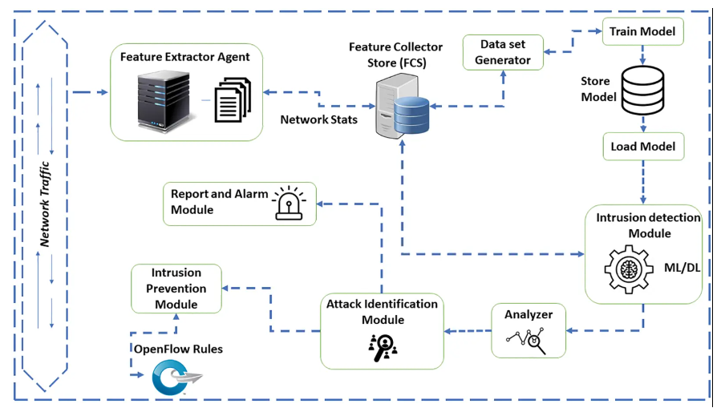
Figure 1: IDPS flow-based architecture.
The above figure depicts the system design [6] for IDPS. The system is made up of seven different components: feature collector store (FCS), feature extractor agents (FEA), intrusion detection module (IDM), attack identification module (AIM), intrusion prevention module (IPM), analyzer module (AM), report and alert module (RAM). Agents submit network traffic statistics to the highlighted collector on a regular basis, and the IDM monitors the statistics for the entire network from there. The IDM keeps track of the typical MQTT traffic generated by IoT devices. The MQTT broker receives data from the IoT devices. The MQTT subscriber, on the other hand, receives data from the broker when needed.
These security mechanisms and technologies collectively form a robust defense framework, reinforcing the SDN environment against unauthorized access, data vulnerabilities, and emerging cyber threats.

CHALLENGES AND FUTURE DIRECTIONS

In the dynamic landscape of Software-Defined Networking (SDN) [7], addressing challenges and charting future directions are essential for the sustained evolution of secure networking environments. This section encompasses:
- Ongoing Challenges in Securing SDN Environments
Identifying and addressing persistent challenges associated with securing SDN. This involves mitigating vulnerabilities, ensuring robust authentication, and adapting security measures to the evolving threat landscape within the dynamic SDN architecture.
- Emerging Threats and Potential Areas for Improvement
Anticipating and preparing for new and evolving threats to SDN. This includes scrutinizing potential areas for improvement in security mechanisms, threat intelligence, and proactive measures to stay ahead of emerging cyber risks within the SDN ecosystem.
- Future Trends and Innovations in Secure SDN
Exploring upcoming trends and innovations that will shape the future of secure SDN. This involves examining advancements in encryption technologies, behavioral analytics, artificial intelligence-driven security, Vulnerabilities and its Countermeasures [8] and other innovative approaches poised to redefine the security landscape of SDN.
By navigating these challenges, identifying emerging threats, and embracing future innovations, the chapter aims to provide a forward-looking perspective on securing SDN environments in an ever-evolving cyber security landscape.

CONCLUSION

In the dynamic realm of Software-Defined Networking (SDN) security, this chapter delved into the transformative paradigm shift brought about by SDN's programmable architecture. We explored the nuanced threat landscape, from vulnerabilities in controllers and switches to risks associated with centralized control. By outlining security requirements, architecting a secure SDN framework, and detailing advanced security mechanisms, the chapter establishes a robust defense against potential threats. As we address ongoing challenges, anticipate emerging threats, and embrace future innovations, the narrative concludes with a forward-looking perspective on securing SDN environments in the ever-evolving cyber security landscape

REFERENCES

- Hossain, S. M. A., A. Alelaiwi, and R. Hussain. "A Survey on Security in Software Defined Networking: Threats and Countermeasures." Journal of Network and Computer Applications, 2016.
- Chowdhury, N. M. Mosharaf Kabir, and Raouf Boutaba. "A Survey of Security in Software Defined Networking." IEEE Communications Surveys & Tutorials, 2014.
- Zaki, Ahmed M., and Al-Sakib Khan Pathan. "Security in Software-Defined Networking: A Review." Journal of Network and Computer Applications, 2016.
- Prasanthi, B. V., Prathyusha Kanakam, and S. Mahaboob Hussain. "Cyber forensic science to diagnose digital crimes-a study." International Journal of Scientific Research in Network Security and communication (IJSRNSC) 50.2 (2017): 107-113.
- Ferrag, Mohamed Amine, Nadjib Aitsaadi, and Raouf Boutaba. "Security in Software Defined Networking: Threats and Mitigation Techniques." IEEE Network, 2016.
- Mazhar, Noman, et al. "R-IDPS: Real time SDN based IDPS system for IoT security." 2021 IEEE 18th International Conference on Smart Communities: Improving Quality of Life Using ICT, IoT and AI (HONET). IEEE, 2021.
- Kreutz, Diego et al. "Software-Defined Networking: A Comprehensive Survey." Proceedings of the IEEE, 2015.
- Chowdhury, M. R., and R. Boutaba. "Security in Software Defined Networking: Issues, Vulnerabilities and Countermeasures." IEEE Network, 2010.

