Synthesis of 1-(1H-Benzo[d]imidazol-2-yl)-2-(3,5-dimethyl-1-phenyl-1H-pyrrol-2-yl)diazenes
Laxminarayana Eppakayala¹, Shashikala Kethireddy¹*
¹ Sreenidhi Institute of Science and Technology (Autonomous) Yamnampet, Ghatkesar, Hyderabad-501301 India
^{1*} Geethanjali College of Engineering and Technology, Keesara, Rangareddy-501301 India
*Email: kala.shashi2010@gmail.com

Abstract
The study aimed to synthesize novel pyrrole and pyrrolo[2,3-d] pyrimidine derivatives with the expectation that these new compounds would have significant chemical and biological relevance. The synthesis of such compounds allows researchers to explore their potential applications in various fields, including medicine, agriculture and materials science.

Keywords Pyrroles, Pyrrolo[2,3-d] pyrimidines, Paal-Knorr Synthesis, 1,4- di carbonyl compounds.

Introduction
The discovery of the pyrrole moiety marked a significant milestone in chemistry, as it is a remarkable heterocyclic compound found abundantly in nature, playing a vital role in the survival of living organisms. The journey of pyrrole’s discovery began in 1834 when Runge noticed a substance in coal tar and bone oil that dyed pine splinters red. He named this substance “pyrrole”, meaning fiery oil, although he did not isolate it at the time. It took another 26 years until 1857 when Anderson successfully converted pyrrole to its potassium salt, and its actual structural formula was established later in 1870.
Pyrrole is a colourless compound but susceptible to air oxidation, readily polymerizing under acidic conditions. Structurally, it consists of a five- membered aromatic ring with the lone pair on nitrogen delocalized throughout the ring. This delocalization gives the pyrrole ring six π electrons satisfying Huckel’s rules for aromaticity. Consequently, the reactivity of the pyrrole ring mirrors that of aromatic molecules.¹
The bond lengths in pyrrole reflect its aromatic nature, with C1-C5 and C3-C4 bonds being shorter than typical single bonds and the C1-C2 double bond being longer than a normal C-C double bond.² The delocalization of the lone pair on nitrogen reduces the basicity of pyrrole, making it significantly less basic than a secondary amine. While the pyrrole ring more electron rich than benzene, nucleophilic aromatic substitution is uncommon, except in the protonated forms of ring. Pyrrole undergoes electrophilic aromatic substitution faster than that of benzene and substitution occurs preferentially at the 2nd position. This is due to the fact that a cationic intermediate at the 3rd position has increased resonance stability than a cation at the 2nd position.
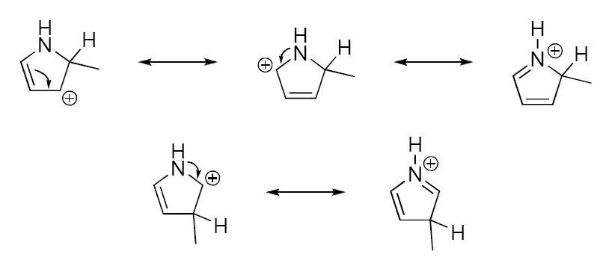
Synthesis of Pyrroles
Pyrrole synthesis has been primarily driven by the demand for specific substitution patterns in the ring, often motivated by the commercial success of pharmaceuticals containing a pyrrole motif. As a result, most pyrrole syntheses are target -oriented rather than focused on developing new methodologies. Numerous resources, including textbooks and extensive reviews are available on the synthesis of various forms of the pyrrole ring, highlighting its significance in pharmaceutical chemistry.
The widespread occurrence of pyrrole in nature indicates the ease with which the pyrrole ring can be formed. This is attributed to the favorable entropy change for the formation of five membered ring and the resulting resonance stability of the pyrrole ring. Given the extensive number of pyrrole syntheses, the following subsections will discuss a few relevant methods.
Paal-Knorr Pyrrole Synthesis
The Paal-Knorr Pyrrole Synthesis, developed over a century ago is perhaps the most renowned method for pyrrole synthesis. It involves an acid catalyzed condensation of a primary amine with a 1,4-dicarbonyl compound.³ This classic reaction has gained popularity due to the simplicity and availability of 1,4- di carbonyl compounds. As a result, it is widely used to prepare substituted pyrroles.
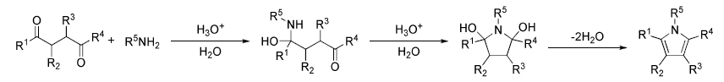
The Paal-Knorr reaction can be applied to various masked or unmasked 1,4-dicarbonyl compounds, enabling the generation of fully substituted pyrroles. Acetic acid has been most commonly used acid catalyst although TiCl₄ has shown effectiveness with more sterically hindered substrates. However, this reaction has proven to be less successful with 1,4-dialdehydes due to their instability. On the other hand, it readily accepts different types of amines, including electron-rich, electron-poor, aryl amines or ammonia.³ Overall, the Paal-Knorr pyrrole synthesis remains the most widely used procedure for generating pyrrole rings.

Knorr Pyrrole Synthesis
Another significant pyrrole synthesis is the Knorr Pyrrole synthesis, which was discovered just two years after the Paal-Knorr reaction. Knorr found that combining an α-amino ketone with another ketone under thermal and acidic conditions leads to the formation of a tetra-substituted N-H pyrrole.⁴
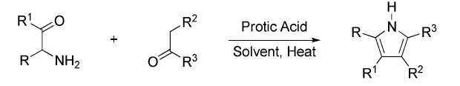
2 3 4

The reaction has been successful under both basic and acidic conditions. However, to prevent self-condensation of α- amino ketones, they are typically generated in-situ from the corresponding nitro compounds. α-nitrogenation can be easily achieved using HNO₂ in the presence of acid; providing a wide range of α-amino ketones for the reaction. This method allows the synthesis of N-substituted pyrroles, leading to fully substituted systems as seen in the Paal-Knorr reaction.¹⁹ In cases where non-symmetrical ketones are employed the reaction shows regioselectivity, favoring the larger substituent (R3) to be located at C4 in the pyrrole ring. Mechanistically, the reaction proceeds in three steps.
- Condensation of the amine with the ketone, forming the corresponding imine.
- Tautomerization yields the enamine, which can then undergo cyclization through nucleophilic attack onto the α-ketone.
- The elimination of water, followed by a final tautomerization step, resulting in the formation of the pyrrole product.⁴

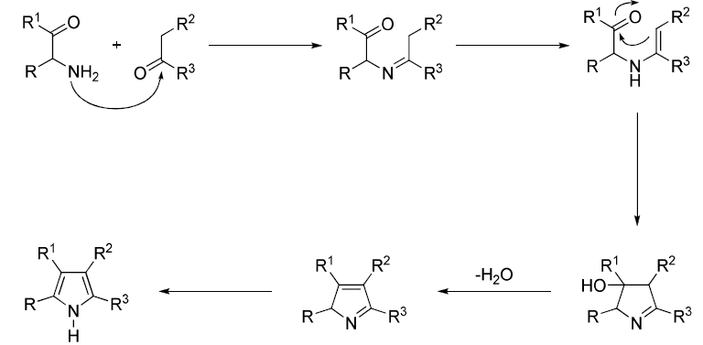

Significance of Pyrroles
Since their discovery is unparalleled, as they are widely found in nature and serve as crucial building blocks in the synthesis of various materials, including pharmaceuticals, polymers, and dyes.
A comprehensive review of different routes to aryl pyrroles covers both classical and contemporary methods, with specific focus on the Trofimov synthesis from aryl ketoximes and acetylenes.⁵ Several useful variations of classical methods have been reported. For instance, the optimal conditions for the preparation of 1-benzylpyrroles from benzylamines and 2,5-dimethoxytetrahydrofuran involve using a mixture of pyridine and acetic acid as solvent.⁶ This synthetic method has also been adapted to create a pathway to 3,4-dialkoxypyrroles.⁷
Additionally, 5-Trifluoromethylpyrroles have been successfully prepared through a modified Hantzsch synthesis, where the use of preformed enamines helps to avoid the side reactions leading to furans.⁸ Organotin enamines, stable enough to be isolated and stored, have also proven effective in yielding pyrroles in high yields.⁹
Furthermore, the products obtained from Knorr-type reductive condensation of 1,3-diketones with oximinocyanoacetate esters depend on whether dry or aqueous acetic acid is used as the solvent.¹⁰ Glyoxal monophenylhydrazone has been employed in Knorr-type condensations with β-keto esters to synthesize 1,2,3,4-tetrasubstituted pyrroles.¹¹ Innovative approaches in pyrrole synthesis have been explored, such as the use of atmospheric nitrogen instead of ammonia in the synthesis of pyrroles from 1,4-dicarbonyl compounds. In this reaction, nitrogen is reduced by a mixture of titanium(IV) chloride, chlorotrimethylsilane and lithium metal.¹²
Gevorgyan et al. reported a new route for the synthesis of pyrroles 13 via copper(I) catalyzed cyclization of alkynyl imines 12 (Scheme 21).¹³ Mechanistic studies revealed that this reaction proceeded via the propargyl-allenyl isomerization of 12 to the allenyl imines and through the nucleophilic attack of the nitrogen atom of imine on the electron deficient carbon as shown in intermediate which forms the copper containing pyrrole ring skeleton.

A novel gold catalyzed cascade cycloisomerization of propargylic derivatives 14 has been discovered, leading to the formation of pyrrole containing heterocycles 15.¹⁴ This cascade transformation involves 1,2-migration of silyl, stannyl and germyl group enabling the efficient synthesis of various C-2 substituted fused pyrrole containing heterocycles. Mechanistically, the process begins with the isomerization of alkyne 14 resulting in the formation of vinylidene species 15. Subsequently nucleophilic attack of the nitrogen lone pair at the vinylidene carbon leads to the formation of zwitterions 16. These zwitterions then undergo a series of 1,2-hydride shifts, ultimately producing the desired product 15Top of Form
The gold(III)-catalyzed sequential amination/annulation reaction of 2-propynyl-1,3-dicarbonyl compounds 18 with primary amines produces 1,2,3,5-substituted pyrroles 19 in moderate to high yields (Scheme 26).¹⁵ The reaction of 18 with primary amines under the reaction conditions generates enaminone intermediate. The cyclization of intermediate through 5-exo-dig pathway followed by protonolysis of the resulting C-Au bond and subsequent isomerization reaction afford the pyrroles 19.
A convenient and general one-pot synthesis of substituted pyrroles from propargylic acetates, silyl enol ethers, and primary amines was catalyzed by indium trichloride. High yields of various pyrrole derivatives were obtained.¹⁶
A fast, mild, and environmentally benign domino reaction enables an efficient reaction of (E)-β-bromonitrostyrenes with enaminones in water to afford pyrroles in excellent yields.¹⁷
A cationic N-heterocyclic carbene-gold(I) complex catalyzes the formation of tri- and tetrasubstituted pyrroles from N-propargyl β-enaminone derivatives via an amino-Claisen rearrangement to yield α-allenyl β-enaminones and subsequent cyclization of these intermediates.¹⁸
A simple, efficient, cost-effective, and metal-free four-component coupling reaction of aldehydes, amines, dialkyl acetylene dicarboxylates, and nitromethane furnished the corresponding 1,2,3,4-tetrasubstituted pyrroles under reflux in the presence of molecular iodine as a catalyst in high yields within 8 hours.¹⁹
A tandem reaction involving cross metathesis followed by concomitant cyclisation enables the synthesis of substituted pyrroles. Various protected electron-deficient N-allylamines reacted with α,β-unsaturated carbonyl compounds in the presence of Lewis acids under the cross metathesis conditions using a 2nd generation Hoveyda catalyst in order to form pyrroles.²⁰
Over the course of several decades, there has been a keen interest in pyrrole derivatives as antimicrobial agents leading to the synthesis and evaluation of such molecules. For instance, monodeoxypyoluteorin and 2-(2'-hydroxybenzoyl) pyrrole bromine derivatives have shown significant antimicrobial activity against Staphylococcus aureus, Bacillus subtilis and Escherichia coli. Moreover, they have demonstrated interesting antifungal activity against Candida albicans.^{21, 22} Other compounds like 3,4,5,3,5-Pentabromo- -2-(2-hydroxybenzoyl)pyrrole, which is a synthetic antibacterial compound related to pyrrolomycins, exhibited significant activity against Staphylococcus epidermidis and Staphylococcus aureus.²³ 2-Methyl-1,3,5-trisubstituted pyrroles have significant activity against Mycobacterium tuberculosis^{.24,25} Diguanidino-1-methyl-2,5-diaryl-1H-pyrrole derivatives have antifungal activity against Candida species, as reported by Jana et al.²⁶ Tubercidin, toyocamycin and sangivamycin are naturally occurring pyrrolo[2,3-d]pyrimidine antibiotics having significant activity against Mycobacterium tuberculosis, Candida albicans and Streptococcus neoformans, which was shown in many reports.²⁷⁻²⁹ 2,4-Diamino-5-methyl-6-substituted-pyrrolo[2,3-d]pyrimidines are potent and selective dihydrofolate reductase (DHFR) inhibitors against Pneumocystis carinii, Toxoplasma gondii and Mycobacterium avium, as reported by Gangjee et l.³⁰

Scheme

EXPERIMENTAL:
1-(1H-benzo[d]imidazol-2-yl)-2-( pentan-2,4-dione -2-ylidene)hydrazine (27)
A mixture of acetyl acetone (0.01mole)and sodium acetate (0.01mole) in absolute ethanol (25ml) was added drop wise to a solution of diazonium derivative of 3H-imidazo[4,5-b]pyridin-2-amine (26) and stirred for 30 min. Then the reaction mixture was left about 2hrs. at room temp. and red solid product was then collected.
IR: 3333 cm⁻¹(N-H), 2979 cm⁻¹(C-H aromatic), 1715 cm⁻¹(C=O), 1514 cm⁻¹(C=N).
¹H NMR (DMSO-d₆) : =2.21 (s, 6H), 7.35 (t, 1H), 7.85(d, 1H), 8.25 (d, 1H), 10.52 (brs, 1H), 13.01 (brs, 1H).
Mass: m/z 245 (M+H).
1-(1H-benzo[d]imidazol-2-yl)-2-(3,5-dimethyl-1H-pyrrol-2-yl)diazene (28)
A mixture of compound (27) (0.01mole) and hydrazine hydrate (0.02mole) was heated under reflux in acetic acid (25ml) for 10-12hrs, cooled and poured onto crushed ice and the achieved solid product was filtered off.
IR: 3333 cm⁻¹(N-H), 2985 cm⁻¹(C-H aromatic), 1766 cm⁻¹(C=O), 1514 cm⁻¹(C=N).
¹H NMR (DMSO-d₆) : =2.21 (s, 3H), 2.41 (s, 3H), 6.14 (brs, 1H), 6.98 (t, 1H), 7.21 (t, 2H), 7.63 (dd, 1H), 7.81 (d, 1H), 7.94 (d, 2H), 8.12 (d, 1H), 13.02 (brs, 1H).
Mass: m/z 240 (M+H).
1-(1H-benzo[d]imidazol-2-yl)-2-(3,5-dimethyl-1-phenyl-1H-pyrrol-2-yl)diazene (29)
A mixture of compound (27) (0.01mole) and phenyl hydrazine hydrate (0.02mole) was heated under reflux in acetic acid (25ml) for 10-12 hrs, cooled and poured onto crushed ice and the obtained solid product was filtered off.
IR: 3333 cm⁻¹(N-H), 2932 cm⁻¹(C-H aromatic), 1715 cm⁻¹(C=O), 1514 cm⁻¹(C=N).
¹H NMR (DMSO-d₆) : = 2.02 (s, 3H), 2.42 (s, 3H), 5.01 (brs, 1H), 7.25(t, 1H), 7.65(d, 1H), 7.98(d, 1H), 13.02(brs, 1H).
Mass: m/z 316 (M+H).
Conclusion
The synthesis of novel 1-(1H-benzo[d]imidazol-2-yl)-2-(3,5-dimethyl-1-phenyl-1H-pyrrol-2-yl)diazenes presented in this study provides new avenues for exploring their chemical and biological properties. These compounds hold promise as potential candidates for further investigation in pharmaceutical and agricultural applications, thereby contributing to the advancement of science and technology.

References
- Corwin, A. H., Heterocyclic Compounds Vol I, Wiley, 1950.
- Jackson, A. H., Reactivity of the 1H-Pyrrole Ring System, Interscience, 1990,295.
- Kurti, L.; Czako, B. Strategic Applications of Named Reactions in Organic Synthesis, Elsevier, 2005, 326.
- Kurti, L.; Czako, B. Strategic Applications of Named Reactions in Organic Synthesis, Elsevier, 2005, 244.
- Korostova S. E., Mikhaleva A. I., Vasiltsov A. M. and Trofimov B. A., Russ. J. Org. Chem. (Engl. Transl.), 1998, 34, 967.
- Silva C. D. and Walker D. A., J. Org. Chem., 1998, 63, 6715.
- A. Merz and T. Meyer, Synthesis, 1999, 94.
- Kameswaran V. and Jiang B., Synthesis, 1997, 530.
- Yasuda M., Morimoto J., Shibata I. and Baba A., Tetrahedron Lett., 1997, 38, 3265.
- Cheng L. J. and Lightner D. A., Synthesis, 1999, 46.
- Jolivet-Fouchet S., Hamelin J., Texier-Boullet F., Toupet L. and Jacquault P., Tetrahedron, 1998, 54, 4561.
- M. Mori, K. Hori, M. Akashi, M. Hori, Y. Sato and M. Nishida, Angew. Chem., Int. Ed., 1998, 37, 636.
- Kelin, A. V.; Sromek, A. W.; Gevorgyan, V. J. Am. Chem. Soc. 2001, 123, 2074.
- Seregin, I. V.; Gevorgyan, V. J. Am. Chem. Soc. 2006, 128, 12050.
- Arcadi, A.; Giuseppe, S. D.; Marinelli, F.; Rossi, E. Adv. Synth. Catal. 2001, 343, 443.
- Lin M., Hao L., Ma R.-d., Zhan Z.-p., Synlett, 2010, 2345.
- Rueping, M. Parra A., Org. Lett., 2010, 12, 5281.
- Saito A., Konishi O., Hanzawa Y., Org. Lett., 2010, 12, 372.
- Das B., Bhunia N., Lingaiah M., Synthesis, 2011, 3471.
- Shafi S., Kędziorek M., Grela K., Synlett, 2011, 124.
- Petruso S., Bonanno S., Caronna S., Ciofalo M., Maggio B.and Schillaci D., J. Heterocyclic Chem. 31, 1994, 941.
- Raimondi, Cascioferro, Schillaci and Petruso, Eur. J. Med. Chem. 41, 2006, 1439.
- Schillaci, Petruso and Sciortino, Int. J. Antimicrob. Ag. 25, 2005, 338.
- M. Biava, R. Fioravanti, G. C. Porretta, D. Deidda, C. Maullu and R. Pompei, Bioorg. Med. Chem. Lett. 9, 1999, 2983.
- M. Biava, G. C. Porretta, D. Deidda, R. Pompei, A. Tafi and F. Manetti, Bioorg. Med. Chem. 11, 2003, 515.
- G. H. Jana, S. Jain, S. K. Arora and N. Sinha, Bioorg. Med. Chem. Lett. 15, 2005, 3592.
- Y. Misumo, M. J. Ikehara, K. A. Watanabe, S. Suzuki and T. Itoh, J. Org. Chem. 28, 1969, 3329.
- Q. Dang and J. E. Gomez-Galeno, J. Org.Chem. 67, 2002, 8703.
- K. V. Rao, J. Med. Chem. 11, 1968, 939.
- A. Gangjee, X. Lin and S. F. Queener, J.Med. Chem. 47, 2004, 3689.

