**Reducing Traffic Congestion with AI-Powered Solutions**

Ms. Kruti Shah, Mr. Yogesh Kumar Sharma, Ms. Neha Sharma, Mr. Pranveer Singh Tomar

Institute of Technology and Management, Gwalior

kruti.shah@itmgoi.in

**Abstract:**Traffic control in major cities is especially challenging. To lower the expense of traffic congestion, some governments throughout the world have created Intelligent Transportation Systems (ITS). This paper looks at the application of Machine_Learning (ML) and Artificial_Neural_Network (ANN) techniques, as well as implementation issues, in traffic flow prediction. Other techniques, such as machine learning and artificial neural networks, have been discussed. Implementing AI-powered technologies to reduce traffic congestion.Using the power of big_data, real-time analytics, and machine learning, the study investigates novel approaches to alleviate congestion, reduce travel times, and improve overall transportation efficiency. This research seeks to contribute to the development of smarter and more adaptable traffic management strategies by analyzing and integrating huge data sets generated by modern transportation systems. As urbanization increases, the challenges of controlling traffic congestion become more apparent.These algorithms, which analyze historical data and learn from real-time inputs, may predict congestion hotspots, recommend appropriate traffic signal timings, and react to changing road conditions. The research investigates the use of adaptive traffic signal control systems that dynamically modify signal timings in response to real-time traffic circumstances.The study highlights the worth of collecting real-time data from many sources. Traffic cameras, sensor embedded in road infrastructure, and data from vehicles with connectivity all contribute to an extensive collection of data that reflects the dynamic nature of urban traffic. The application of big data analytics is central to the research. Patterns, trends, and anomalies in traffic patterns can be identified by processing large amounts of data using advanced analytics techniques.

Keywords: ITS, Machine_Learning, Artificial_Neural_Network, Big_data, real_time analytics

**Introduction**

Congestion not only hinders commuters on a regular basis, but it also incurs crucial economic and environmental costs. In today's urban landscape, rising population densities and increasing vehicle volumes have created unexpected obstacles to efficiently managing traffic flow.This article digs into the revolutionary possibilities of leveraging data analytics for improved traffic flow, illustrating an abrupt change in how we approach and oversee urban transportation.

1. **Growing Urbanization and Traffic Challеngеs**: As cities around the world suffer rising levels of urbanization, the consequent rise in vehicle traffic has become a common challenge. Traditional traffic management approaches, which are frequently static and rule-based, are finding it difficult to maintain up with the dynamic and complex nature of contemporary traffic dynamics. This necessitates innovative ways for leveraging the wealth of data generated by advanced transportation systems.
2. **Effectiveness of Data Analytics in Traffic Optimization:** The fundamental contribution of data analytics to the revolution of traffic flow management lies at the core of this study. Using accurate information from a complex network of sensors, traffic devices, and connected vehicles, accurate decision-making is made possible. using the utilization of big data analytics, citizens can obtain valuable insights regarding traffic patterns, trends, and anomalies that are otherwise impossible to detect using conventional methods.
3. **Instantaneous information, predictive modeling and enormous amounts of data:** The paper acknowledges the significance of large amounts of information analytics in processing large datasets quickly and effectively. Instantaneous information derived from this data enable strategies that are adaptable and dynamically respond to changing traffic conditions. Learning from data algorithms are essential for anticipating traffic patterns, learning from past data, and streamlining traffic in ways that conventional systems are unable to.
4. **Systems for Predictive Transportation Light Monitoring:**The investigation of adaptive traffic signal control systems is a key focus of this study. These systems minimize delays and streamline traffic flow by dynamically modifying signal timings based on real-time data. This aligns traffic signals with actual demand. An era where traffic signals are responsive and precisely adjusted to the ebb and flow of urban mobility is anticipated thanks to the adaptivе approach.
5. **The purposes and relevance of the analysis:** This study uses a combination of simulation modeling and field experiments to validate the effectiveness of data analytics_driven traffic flow optimization. In addition to reducing traffic and travel times, the goal is to give policymakers, transportation authorities, and urban planners useful information. The significance lies in the possibility of making urban transportation a more intelligent, flexible, and efficient network.
6. **Outline of the Working Article:** This paper will go into the key components of analytics for data in transportation efficiency, the experimental approach used, and the expected results and implications in the following sections. We hope to add valuable knowledge to the discussion on developing data_driven, resilient, and efficient transportation systems for the future urban environments by the end of the paper.

**ITS Overviw:** ITS is the general term for the use of transit systems with information, communication, and transportation technology. ITS's primary objectives are efficiency and traffic safety. One of the benefits of an intelligent transportation system is a)Decrease in junction stops and delays b) Enhancement and regulation of speed c) Enhancement of travel time d) Managing of demand and e) Handling of occurrences

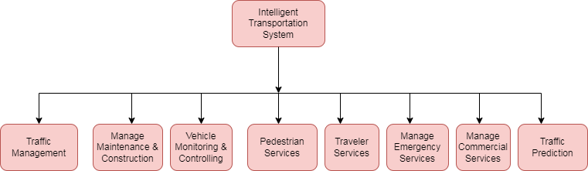

**Machine learning predictions in ITS:** With tasks that may be divided into predicting traffic flow, journey duration, vehicle behavior, user behavior, and road occupancy, machine learning approaches have demonstrated exceptional performance on ITS prediction difficulties.

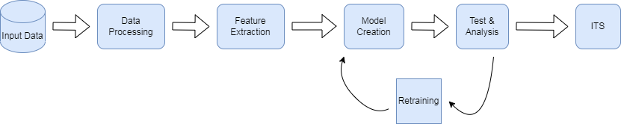

|  |  |
| --- | --- |
| **ML_Pipelining** | **Detail_Description** |
| **Data_Preprocessing** | Preprocessing and data cleaning usually have necessary for raw data. |
| **Feature_Extraction** | Two methods exist for feature_extraction: a) Manual-Handcraft extraction using human specialists b) Making use of Machine_Learning, which is better at continually acquiring complex characteristics. |
| **Model Creation and Training** | In terms of training models, machine learning has become extremely popular. Regression., clustering., classification., and decision-making that can be applied to ITS can all be done with the trained machine learning model. |
| **Test_analysis** | In machine_learning, model testing is the process of assessing how well a fully trained model performs on a testing set. Two statistical measures that can be used to assess test results are receiver function curves and mean_squared deviations. |

**Machine learning's function in forecasting traffic flow:** Traffic forecasting is the process of estimating the amount and frequency of traffic flow to manage transportation, ease-congestion, and design the best (least time or energy_consuming) route. Traffic forecasting is crucial for two types of businesses:

1. **National/local authorities:** In the past ten to twenty years, ITS has been adopted by numerous cities to help with the management and development of urban transportation networks. By alerting users to current road conditions and making adjustments to road infrastructure, these systems leverage real-time traffic data and forecasts to improve transportation efficiency and safety. This approach reduces the likelihood of accidents and improves road safety by providing the public with greater information on traffic flow and weather conditions on the roads.
2. **Logistics companies:** Another area of application is the logistics industry. Transportation, delivery, and field service are just a few of the businesses that depend on precise scheduling and efficient route planning. When it comes to travel, the future is frequently just as important as the present. Accurate traffic and road condition estimations are essential to the planning and profitability of businesses such as these.

Traffic bottlenecks are caused by a number of factors that interact intricately. variances in traffic volume are caused by a number of factors, including weather, accidents, maintenance activities, and traffic variances. Environmental factors, such as weather, changes in road structure, or construction or maintenance work, cannot be precisely forecast even with today's techniques. A more precise forecast system must be built in order to lessen traffic congestion. This study's main objective is to determine how to use machine learning approaches to accurately predict traffic flow in urban road situations by incorporating more of the fundamental causes of traffic congestion as forecasting input.

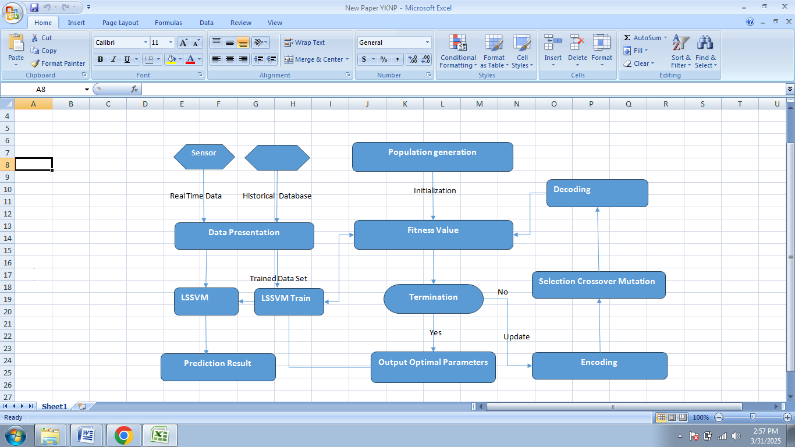

**Forecasts of traffic flow and unresolved issues:**

1. **Short-term forecasts:** Most current solutions require a lot of data. However, data gathering is challenging due to the fact that abnormal events (bad weather, transitory traffic management, etc.) are often not recurrent, which makes learning more challenging and the training sample size smaller than under normal traffic conditions. Additionally, many cities struggle with inadequate data because different cities have varying levels of development.
2. **Long-term forecasts:** Few research have been conducted on long-term forecasting, and the majority of traffic prediction systems now in use are focused on short- to medium-term projections. Long-term prediction techniques might not be as affected by historical knowledge, and more supplementary data might be needed.
3. **Learning network integration:** Multi-source, massively trafficked big data conceals knowledge related to the transportation area. A large_scale mobility information network. construction, learning., and deep_knowledge search can enhance prediction performance by penetrating closer into traffic information with semantics.
4. **Instantaneous forecasting:** Processing data and evaluating traffic conditions quickly are the objectives of real-time traffic prediction. However, the model size, parameters, and data volume all grew. One major problem is designing a lightweight neural network that works well to speed up networks and reduce processing. The problem of developing a more interpretable deep learning model for traffic prediction has not been fully explored and is yet open.
5. **Translation and structures:** Because of their sophisticated structure, high number of parameters, and restricted method transparency, neural networks are widely recognized to be dependable. A lack of interpretability in traffic projections might lead to problems. The problem of developing a more interpretable deep learning model for traffic prediction has not been fully explored and is yet open.
6. **Transportation forecasting evaluation:** As the subject develops, new models are put forth, usually in comparable fashions. It is now difficult to compare new traffic prediction algorithms since there is no established benchmark with reliable experimental conditions and large datasets. Additionally, model design is getting more complex. It is unknown how each element enhances the algorithm, despite the fact that the majority of approaches have ablation research. Therefore, it is essential to develop a reproducible benchmarking framework using a shared dataset.
7. **Forecasting under disruption:** The accuracy of the model's forecast will be impacted by contaminated data. Current methods often separate model prediction from data processing. It is critical to design a robust and efficient traffic forecast model in the face of errors and data noise.
8. **The best option for network architecture:**

Not much study has been done on how to choose the optimal network design for a given traffic prediction task In a variety of works, traffic data can be represented using a road network graph. In-depth study on deep learning has not yet been given the attention it merits. It's also necessary to research better prediction performance with a network architecture.

**Predictive characteristics for traffic flow:**

We present a multi-parameters prediction strategy that considers traffic patterns in multiple ways to predict traffic flow.

a) **Stream:** A stream of traffic is the volume of traffic that moves through a specific location on the road in a specified period of time.

b) **Rate:** A vehicle's rate is determined by the distance it travels in a given amount of time. Any car on the road will typically go at a different speed than others around it due to a variety of factors, including the driver's personal circumstances, driving time, traffic conditions, and geographic region.

c) **Workday:** Monday through Sunday may be the day.

d) **Type day:** This type day is primarily defined as a weekend, public holiday, and working day.

e) **Calendar time:** The standard unit of time is a 24-hour period (1–24), which can be broken down into hours.

f) **Climate:** Conditions like sunshine and rain can be used for training and competition.

**Research Gap:**

Use of technology in the traffic flow forecast system has not received enough attention. Both the approaches' accuracy and simplicity must be increased. Researchers have been inspired to use different machine learning techniques to anticipate traffic flow as a result of recent advancements in ITS. When it comes to implementing the complexity of traffic flow prediction systems, several of the algorithms in machine_ learning techniques face certain challenges. Enhancing the technology that deals with these issues is one approach to guarantee that traffic flow prediction systems accomplish their goals in real-world scenarios. It was discovered throughout the review that a number of traffic flow forecast system components do not adequately use statistical techniques. The research gaps listed below are identified by this survey, along with suggestions for addressing them: Machine_Learning Algorithm., User_Interface Design., Availability of Data_Set repositories., New algorithm. for traffic_flow prediction.

**Research_Agendas:**   
  
1. To learn about the many open-source tools and datasets for traffic flow prediction that are available.

2. Which machine learning methods or algorithms are best suited for developing short-term traffic prediction models in an urban setting that have a low false-positive score, a high prediction rate, and high accuracy?

3. Which technologies, aside from machine learning algorithms, are being investigated to automate the TFP process in an ITS?

4. How far along is the study of deep learning and machine learning for predicting traffic flow?

5. What are the features and shortcomings of the current models for predicting traffic jams?

6. Comparative analysis of various methods that include ANN., ML., and deep_learning that are appropriate for TFP.?

7. Designing an appropriate user interface.

**Examining Research_Agendas:**

In order to determine the technique's effectiveness, materials must be identified. To build an intelligent TFP system that generates the intended result, data can be gathered and processed using a variety of approaches and procedures. We ought to select the most effective approach that works with every component of the external contact. It is best to use the best available hardware and software to build the framework for integrating machine learning algorithms. To enhance the results of smart traffic flow prediction systems, it should be mandatory to scan and evaluate novel machine learning systems.

**Advantages and Disadvantages:**

|  |  |
| --- | --- |
| **Advantages.** | **Disadvantages.** |
| * It is very helpful to drivers all around the world. | * The quality of the supplied data has a significant impact on forecast accuracy. |
| * Future traffic jams in a metropolitan area can be predicted with the use of a traffic forecasting system. | * Managing unorganized data is one of the most challenging tasks in data management. |
| * People, companies, and authorities could utilize this traffic prediction data to make well-informed decisions regarding traffic patterns. | * There is no set format to follow when gathering information. |
| * It could improve the caliber of the decisions drivers make about their routes. | * The reliability and preciseness of information must be confirmed. |
| * Improves traffic operations, reduces carbon_emissions, lessens traffic congestion, and speeds up vehicles. | * Regular analysis is required to thoroughly analyze traffic forecasting information. |

**Conclusion:**

In summary, the study of data_analytics based traffic flow optimization has revealed a promising avenue for revolutionizing urban transportation systems. The integration of real-time data, advanced analytics, and adaptive traffic_signal management has shown tangible and transformative results in improving the efficiency of traffic flow. The key findings and insights gleaned from this research have significant ramifications for policymakers, transportation authorities, and urban planners looking for creative ways to address the problems of congestion and enhance overall mobility.

**References:**

[1] Zhang, J., Wang, F. Y., Wang, K., Lin, W. H., Xu, X., & Chen, C. (2011). Data-driven intelligent transportation systems: A survey. *IEEE Transactions on Intelligent Transportation Systems*, *12*(4), 1624-1639.

[2] Kim, Y. J., & Hong, J. S. (2015). Urban traffic flow prediction system using a multifactor pattern recognition model. *IEEE Transactions on Intelligent Transportation Systems*, *16*(5), 2744-2755.

[3] Boukerche, A., & Wang, J. (2020). Machine Learning-based traffic prediction models for Intelligent Transportation Systems. *Computer Networks*, *181*, 1-21.

[4] Qureshi, K. N., & Abdullah, A. H. (2013). A survey on intelligent transportation systems. *Middle-East Journal of Scientific Research*, *15*(5), 629-642.

[5] Thomas, T., Weijermars, W., & Van Berkum, E. (2009). Predictions of urban volumes in single time series. *IEEE Transactions on Intelligent Transportation Systems, 11*(1), 71-80.

[6] Pan, T. L., Sumalee, A., Zhong, R. X., &Indra-Payoong, N. (2013). Short-term traffic state prediction based on temporal-spatial correlation*. IEEE Transactions on Intelligent Transportation Systems, 14*(3), 1242-1254.

[7] Lv, Y., Duan, Y., Kang, W., Li, Z., & Wang, F. Y. (2014). Traffic flow prediction with big data: a deep learning approach. *IEEE Transactions on Intelligent Transportation Systems*, *16*(2), 865-873.

[8] Mirzabeiki, V. (2013). An overview of freight intelligent transportation systems. *International Journal of Logistics Systems and Management, 14*(4), 473-489.

[9] Prabha, R., &Kabadi, M. G. (2016). Overview of data collection methods for intelligent transportation systems. *The International Journal Of Engineering And Science (IJES)*, *5*(3), 16-20.

[10] Sun, P., Aljeri, N., & Boukerche, A. (2020). Machine learning-based models for real-time traffic flow prediction in vehicular networks. *IEEE Network, 34*(3), 178-185.

[11] Li, C., & Xu, P. (2021). Application on traffic flow prediction of machine learning in intelligent transportation*. Neural Computing and Applications, 33*(2), 613-624.

[12] Yuan, T., Da Rocha, W., Rothenberg, C. E., Obraczka, K., Barakat, C., &Turletti, T. (2019). Machine learning for next‐generation intelligent transportation systems: A survey. *Transactions on Emerging Telecommunications Technologies,* e4427.

[13] Essien, A., Petrounias, I., Sampaio, P., & Sampaio, S. (2021). A deep-learning model for urban traffic flow prediction with traffic events mined from twitter. *World Wide Web, 24*(4), 1345-1368.

[14] Tian, Y., Zhang, K., Li, J., Lin, X., & Yang, B. (2018). LSTM-based traffic flow prediction with missing data. *Neurocomputing, 318*, 297-305.

[15] Poonia, P., Jain, V. K., & Kumar, A. (2018). Short term traffic flow prediction methodologies: a review. *Mody University International Journal of Computing and Engineering Research, 2*(1), 37-39.

[16] Z. Huang, Q. Li, F. Li and J. Xia. (2019). A Novel Bus-Dispatching Model Based on Passenger Flow and Arrival Time Prediction, *IEEE Access, 7*(1), 106453-106465.

[17] Mackenzie, J., Roddick, J. F., & Zito, R. (2018). An evaluation of HTM and LSTM for short-term arterial traffic flow prediction. *IEEE Transactions on Intelligent Transportation Systems, 20*(5), 1847-1857.

[18] Chen, Y. H. (2020). Intelligent algorithms for cold chain logistics distribution optimization based on big data cloud computing analysis. *Journal of Cloud Computing, 9*(1), 1-12.

[19] Zheng, Z., Yang, Y., Liu, J., Dai, H. N., & Zhang, Y. (2019). Deep and embedded learning approach for traffic flow prediction in urban informatics. *IEEE Transactions on Intelligent Transportation Systems, 20*(10), 3927-3939.

[20] Zhang, D., &Kabuka, M. R. (2018). Combining weather condition data to predict traffic flow: A GRU-based deep learning approach. *IET Intelligent Transport Systems, 12*(7), 578-585.

[21] Yang, D., Li, S., Peng, Z., Wang, P., Wang, J., & Yang, H. (2019). MF-CNN: traffic flow prediction using convolutional neural network and multi-features fusion*. IEICE TRANSACTIONS on Information and Systems, 102*(8), 1526-1536.

[22] Alsubari, S. N., Deshmukh, S. N., Alqarni, A. A., Alsharif, N. H. T., Aldhyani, T. H., Alsaade, F. W., & Khalaf, O. I. (2022). Data analytics for the identification of fake reviews using supervised learning. *CMC-Comput Mater Continua, 70*(2), 3189-3204.

[23] Fiandrino, C., Zhang, C., Patras, P., Banchs, A., & Widmer, J. (2020). A machine-learning-based framework for optimizing the operation of future networks. *IEEE Communications Magazine, 58*(6), 20-25.

[24] Liu, C., &Ke, L. (2022). Cloud assisted Internet of things intelligent transportation system and the traffic control system in the smart city. *Journal of Control and Decision*, 1-14.

[25] Arora, R., & Kaur, A. (2022). Heterogeneous Fault Prediction Using Feature Selection and Supervised Learning Algorithms. *Vietnam Journal of Computer Science*, 1-24.

[26] Lu, B., Gan, X., Jin, H., Fu, L., Wang, X., & Zhang, H. (2022). Make More Connections: Urban Traffic Flow Forecasting with Spatiotemporal Adaptive Gated Graph Convolution Network. *ACM Transactions on Intelligent Systems and Technology (TIST), 13*(2), 1-25.

[27] Yan, H., Qi, Y., & Yu, D. J. (2022). Short-term traffic flow prediction based on a hybrid optimization algorithm. *Applied Mathematical Modelling, 102*, 385-404.

[28] Dai, G., Ma, C., & Xu, X. (2019). Short-term traffic flow prediction method for urban road sections based on space–time analysis and GRU. IEEE Access, 7, 143025-143035.

[29] Qu, L., Li, W., Li, W., Ma, D., & Wang, Y. (2019). Daily long-term traffic flow forecasting based on a deep neural network. *Expert Systems with applications, 121*, 304-312.

[30] Li, Y., Chai, S., Ma, Z., & Wang, G. (2021). A hybrid deep learning framework for long-term traffic flow prediction. *IEEE Access, 9*, 11264-11271.

[31] Larry, H. K. (1995). Event-based short-term traffic flow prediction model. Transportation Research Record, 1510, 45-52.

[32] Pan, Z., Wang, Z., Wang, W., Yu, Y., Zhang, J., & Zheng, Y. (2019, November). Matrix factorization for spatio-temporal neural networks with applications to urban flow prediction. *In Proceedings of the 28th ACM International Conference on Information and Knowledge Management* pp. 2683-2691.

[33] Lana, I., Del Ser, J., Velez, M., &Vlahogianni, E. I. (2018). Road traffic forecasting: Recent advances and new challenges. *IEEE Intelligent Transportation Systems Magazine, 10*(2), 93-109.

[34] Vlahogianni, E. I., Karlaftis, M. G., &Golias, J. C. (2005). Optimized and meta-optimized neural networks for short-term traffic flow prediction: A genetic approach. *Transportation Research Part C: Emerging Technologies, 13*(3), 211-234.

[35] Liu, Y., James, J. Q., Kang, J., Niyato, D., & Zhang, S. (2020). Privacy-preserving traffic flow prediction: *A federated learning approach. IEEE Internet of Things Journal, 7*(8), 7751-7763.