A Comparative Study of Text and Audio Steganography for Cybersecurity

**K Revathi1, and S. Kaja Mohideen2**

1, 2 Department of Electronics and Communication Engineering.

1, 2 B.S.Abdur Rahman Crescent Institute of Science and Technology, Vandalur, Chennai, Tamil Nadu, India.

1 [revathivigneswaranphd@gmail.com](mailto:revathivigneswaranphd@gmail.com), and 2 [kajamohideen@crescent.education](mailto:kajamohideen@crescent.education).

**ABSTRACT**

Steganography embeds information in digital media for secure communication. This study compares text and audio steganography based on mean squared error and bit error rate to evaluate the better steganography technique for cybersecurity. Experimental results show that audio steganography achieves an average mean squared error of 1.82E-10 and an average bit error rate of 1.22E-02, supporting cybersecure communication. Audio steganography provides improved security and imperceptibility against adversarial analysis compared to text steganography. The higher mean squared error and bit error rate values of 0.022262 in text steganography indicate increased distortion, making the hidden data more detectable. The superior imperceptibility of audio steganography ensures secure communication for cybersecurity applications.

**Keywords:** Audio Steganography; Text Steganography; Cybersecurity; Least Significant Bit (LSB); Mean Squared Error(MSE); Bit Error Rate (BER).

**I. INTRODUCTION**

Advancements in internet technology and the pandemic have increased the demand for a digital world in education, banking, healthcare, government, smart cities, and grid systems. The above highlights the need for secure online information transmission and the role of cybersecurity in protecting data and communications. Therefore, data protection, privacy concerns, reliability, availability, and cybersecurity are key considerations in the digital world. Cybersecurity protects individuals, societies, organizations, systems, and technologies from unauthorized activities. As cybersecurity strengthens, cybercriminals continuously develop more sophisticated attacks to bypass security measures, leading to an ongoing struggle between security and threats [1-3].

Cybercrime involves various illegal activities that use digital devices or information systems as tools, targets, or both. It includes offenses affecting computer data or systems, often categorized as computer crime, electronic crime, e-crime, high-technology crime, or digital crime. Hence, cybersecurity must protect confidentiality, integrity, and availability (CIA) to protect an organization's systems, computer resources, and network security [4].

Integrating information-hiding techniques with cybersecurity strengthens data protection, reducing the impact of cybercrime on secure communication. Data hiding methods include watermarking, steganography, and cryptography, each with advantages and limitations. Effective data hiding should ensure high capacity, robustness, security, payload, and reliability. The choice of method depends on the required security level and the amount of information embedded in multimedia files. Figure 1 illustrates these techniques [5].

Cryptography encrypts plaintext into ciphertext to ensure confidentiality. The plaintext can be a file, financial data, login credentials, or confidential information. Before encryption, the original data is plaintext, while the encrypted version is ciphertext. The fundamental components of cryptography include plaintext, a key, ciphertext, and encryption and decryption algorithms. The encryption algorithm transforms plaintext into ciphertext, while the decryption algorithm reverses the process, restoring the original plaintext. The cryptographic keys are symmetric and public keys. Symmetric key cryptography employs a single key for encryption and decryption. Public key cryptography uses a key pair, with the public key for encryption and the private key for decryption [5].

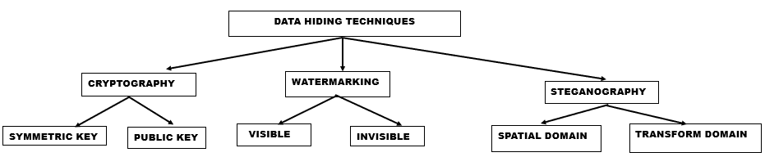

Figure 1: Data hiding techniques

Watermarking is a data security technique for authentication and copyright protection with digital data embedded into multimedia files. It is classified into visible watermarking, which includes logos or text, and invisible watermarking, which remains imperceptible while ensuring protection. This method prevents unauthorized duplication and false ownership claims, enabling users to place an indelible mark on digital content. Watermarking ensures robustness, security, and efficiency in safeguarding intellectual property [5,6].

Steganography embeds confidential data in a cover file such as text, audio, image, or video. It secures messages by concealing data within media, unlike cryptography, which converts data into ciphertext. While cryptography ensures security through encryption, steganography enhances protection by keeping data hidden. In cryptography, security is compromised if the encrypted data is accessed. In contrast, steganography strengthens security by concealing the existence of communication [6]. Steganography is categorized based on the type of cover object used, including image, network, video, audio, and text steganography. Image steganography, the most common method, uses an image as the cover object. Network steganography conceals data within network protocols such as TCP, IP, and UDP. Video steganography embeds secret data within video files, while audio steganography hides information within audio files. Text steganography involves embedding data in a text file, producing a stego text as the output [5]. This study aims to identify the best steganography method between text and audio for cybersecurity communication. The framework is in Figure 2.

The rest of the chapter is structured as follows: Section II briefs about audio and text steganography. Section III discusses the LSB technique. Section IV details the simulated experiments, evaluates the results, and discusses the most suitable steganography approach for cybersecurity. Section V concludes the paper with future scope.

**II. AUDIO AND TEXT STEGANOGRAPHY**

Ideal steganography ensures secure communication without prior key exchange. Secret key steganography involves using a stego key for the secure embedding and extraction of messages.

Public key steganography uses a public key for embedding and a private key for retrieval to enhance security through asymmetric encryption. In all cases, the cover file should be large enough to embed the message for accurate retrieval. The similarity between the cover and stego audio file minimizes distortion with secured communication with a value close to one [7].

Audio Steganography is the process of embedding secret data in the cover audio file. Figure 3[8] illustrates the embedding and extraction process. Embedding data in audio files is more challenging than in images due to the higher sensitivity of the human auditory system. However, the larger size, high redundancy, and high data transmission rate make audio files more suitable as host files [9].

An audio steganographic system should maintain the trade-off between capacity, robustness, and imperceptibility to provide cybersecurity. Capacity is a percentage of hidden messages in cover audio files. Robustness is the strength of audio-steganographic communication resistance to any attacks. The imperceptibility is the similarity in the cover audio file before and after embedding the hidden messages [10].

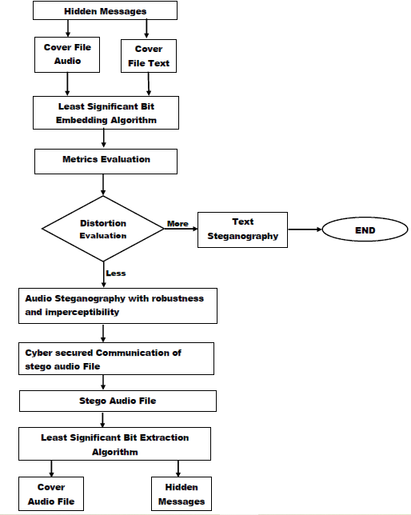

Figure 2: The Framework of the chapter

The least significant is the basic and efficient steganography method for embedding and extracting hidden messages in audio steganography. Figures 5 and 6 [11] illustrate the LSB algorithm in audio steganography. The algorithm’s efficiency resulted in indistinguishable between the cover and stego audio files[11]. Audio steganography is applied in Cybersecurity, Healthcare, Media and Entertainment, Government and Defence, E-commerce, and Intellectual Property Protection for secure communication and data storage. Using the LSB algorithm, audio steganography allows data embedding at 16 Kbps in wide audio files for reliable storage. In the medical domain, it embeds Electronic Health Records (EHRs) and diagnostic data in audio signals to ensure confidentiality. In Government and Defence applications, it enables covert transmission of operational information. In multimedia and industrial applications: production data, control parameters, and copyright information are embedded in audio signals to protect intellectual property and prevent unauthorized access. Steganographic techniques protect the data from cyber threats for information security companies [7,12].

Text Steganography is the natural language steganography that hides the hidden message in the medium of text. The two main groups in natural language steganography are linguistic steganography and text steganography. Linguistic steganography preserves linguistic structure while embedding the hidden message, and text steganography manipulates cover text elements to conceal data. Text steganography hides messages within text by modifying text components such as words, spaces, and lines, making the presence of the message undetectable.

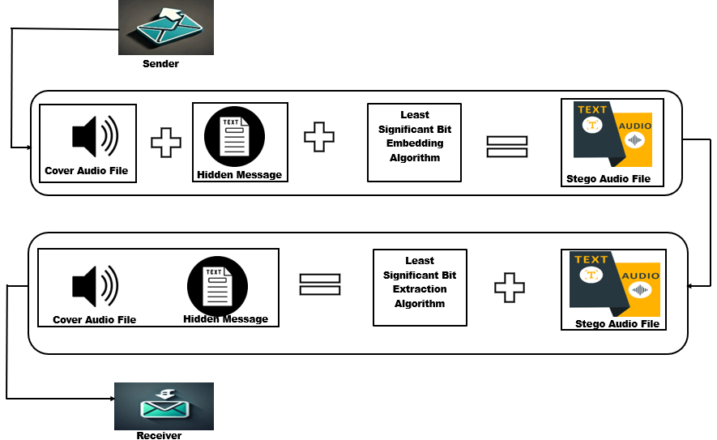

Figure 3: Audio steganographic process

Text steganography methods are further divided into word-rule-based and feature-based approaches. Word-rule-based methods in text steganography embed hidden messages by modifying text alignment. Line-shift coding alters vertical line positions, encoding binary values by shifting lines up or down. Word-shift coding horizontally adjusts word positions within lines to conceal information. Feature-based methods manipulate text features such as letter shape, size, and position to hide data by exploiting the unique structure of the cover text [13].

The text steganography in this study, where both cover and hidden messages are text files, is shown in Figure 4[8]. The cover file with the hidden message is a stego file. The LSB method is a simple steganography technique that embeds hidden messages in cover text files. Figures 5 and 7[11] illustrate the LSB embedding and extraction algorithm in text steganography. The algorithm demonstrates efficiency by increasing the percentage of hidden messages in cover text files, maintaining uniqueness between cover and stego text files, and ensuring undetectable communication of stego files. The main challenge in text steganography is its low hiding capacity due to insufficient redundant data in textual documents compared to digital media such as images, audio, and video files [6].

Text steganography has several technical applications, including hidden communication, network covert channels, and unauthorized access detection. Hidden communication involves embedding secret data within ordinary text files or messages transmitted over public networks such as SMS and social media. Intelligence agencies, journalists, or individuals under strict regulations can use these hidden messages to exchange sensitive information securely. Network covert channels utilize text steganography to establish undetectable communication paths within network protocols. These channels covertly transmit malware or bypass internet restrictions. Additionally, text steganography aids in detecting unauthorized access to sensitive documents by embedding identifiers within confidential files, allowing traceability without the recipient’s awareness [14].

**III. LEAST SIGNIFICANT BIT ALGORITHM**

The least significant bit (LSB) algorithm is one of the earliest methods of information-hiding techniques. In the LSB embedding algorithm, the least significant bits of the cover file are replaced with bits from the hidden message. The 50% probability of the replaced bit remaining unchanged theoretically reduces distortion.

The LSB of a cover file must be modified carefully to preserve its quality, ensuring that the hidden message before steganography and the stego message after steganography retain the same characteristics. In the LSB extraction algorithm, the least significant bits are extracted from the stego file, and eight bits are grouped to reconstruct the hidden message. Figure 5[15] presents the flow chart for the LSB embedding and extraction algorithm.

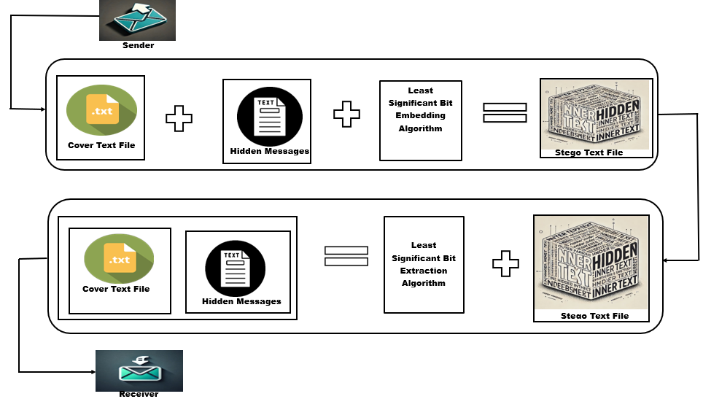

Figure 4: Text Steganography process

The hidden message is a text file (.txt), while the cover file is a text file and an audio file. Embedding a character of one byte requires eight one-byte text characters. Similarly, embedding one byte of a character from a text file into an audio file requires eight one-byte audio samples. The LSB algorithm increases capacity with an embedding rate of 8 kbps in cover audio files at 8 kHz [11].

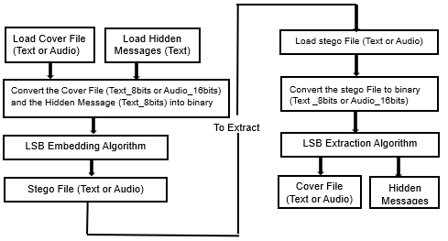

Figure 5: The flowchart of the LSB algorithm

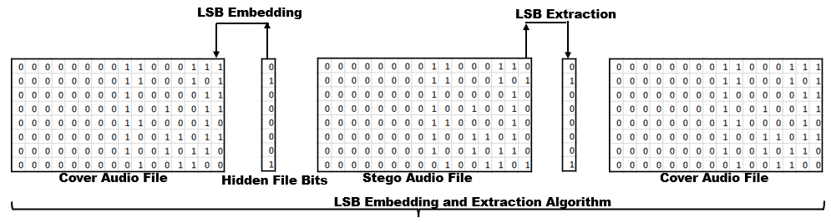

Figure 6: LSB algorithm in cover audio files

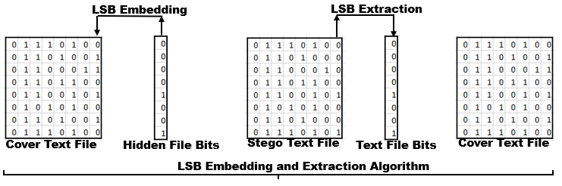

Figure 7: LSB algorithm in cover text files

**IV. RESULTS AND DISCUSSION**

The least significant bit (LSB) algorithm was tested in MATLAB using audio and text files to evaluate its performance. The audio files used in this study are from the Free Spoken Digit Dataset (FSDD) [16], consisting of recordings of spoken digits in WAV files sampled at 8 kHz. The text files (.txt) are from a Question-Answer Dataset containing question-answer pairs generated from 690,000 words of cleaned Wikipedia text. It includes three files (S08, S09, and S10) categorized by student year. Each entry contains the article title, question, answer, difficulty ratings from the questioner and answerer, and the article file name [17]. Table 1 lists the specifications of the cover text and audio files (WAV). Mean Squared Error (MSE) and Bit Error Rate (BER) were used to evaluate the LSB algorithm. These metrics determine the more effective steganography method for cybersecurity communication.

**Table 1.** Specification of Cover Audio and Text Files

|  |  |
| --- | --- |
| Audio Files | |
| Bits per sample | 16 |
| Number of Samples | 3370-5083 |
| Sample Rate | 8000 |
| Channel | 1 |
| Audio Type | Music |
| Duration in Seconds | 0.4-0.6 |
| Text Files | |
| Bits per byte | 8 |
| Length (Bytes) | 3415-5512 |

Equation (1) [18] quantifies the distortion using the average squared difference between the cover and stego files.

BER measures the ratio of incorrect bits after embedding to the total number of embedded bits using equation (2)[18]. Lower MSE and BER values result in higher fidelity with minimal distortion of stego files, ensuring the reliability of the steganographic process.

$MSE=\frac{1}{P} \sum_{k=1}^{L}{{(Q_{k}-R_{k})}^{2} }$ (1)

$Q_{k}$ and $R_{k}$ are the cover and stego files for the kth samples or characters, and P is the total number of samples or characters.

$BER=\frac{S_{error}}{S_{\begin{aligned}bits \\ \end{aligned}}}$ (2)

Serror is the incorrect bits, and Sbits is the total number of bits embedded in the cover file.

**1.** **AUDIO STEGANOGRAPHIC COMMUNICATION FOR CYBERSECURITY**

The objective is to select the most suitable steganography method for communicating hidden messages with cybersecurity. Eighteen simulations embedded hidden messages in audio and text files. The average MSE for audio and text steganography are 1.82E-10 and 0.022262, respectively. Similarly, the BER for audio and text steganography is 1.22E-02 and 0.022262. Figures 8a, 8b, 9a, and 9b illustrate the MSE and BER for the audio and text steganography. The x-axis in Figures 8a and 8b represents the size of text files (in bytes) hidden within cover audio files (AF1, AF2, and AF3). Similarly, the x-axis in Figures 9a and 9b represents the size of text files (in bytes) hidden within cover text files (TF1, TF2, and TF3). The y-axis in Figures 8a, and 9a represents the mean squared error. In Figures 8b and 9b, the y-axis represents the bit error rate. Based on these metrics, it concluded that audio steganography provides a more secure means of transmitting hidden messages. Audio signals have more redundancy and variability, making embedded data more secure against detection and modification. These factors improve the overall effectiveness and robustness of audio steganography. Cybersecurity applies to various fields, such as smart grid, vehicular communication, smart city, and smart eHealth system [1]. Using audio files as cover media enhances cybersecurity compared to embedding in text files.

In contrast, text steganography is less effective due to the lack of redundancy in text files. The average MSE and BER values of 0.022262 indicate higher distortion and error rates, facilitating the detection of hidden messages during communication. Even a slight modification in the stego text file, such as a single-bit change, alters the corresponding character, disrupting the text flow. This disruption makes the stego text more susceptible to steganalysis attacks, reducing its robustness. Encrypting hidden messages before embedding them in text files enhances the security of text steganography.

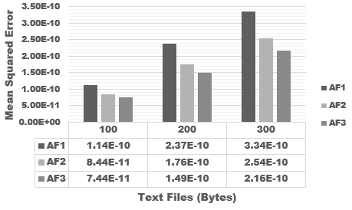 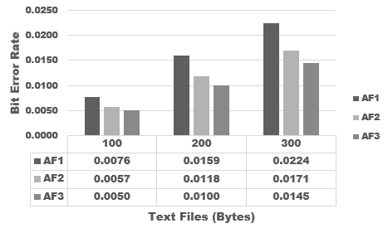

Figure 8: Results of (a) MSE and (b) BER for 300bytes of hidden messages embedded in audio files

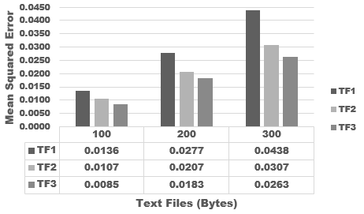 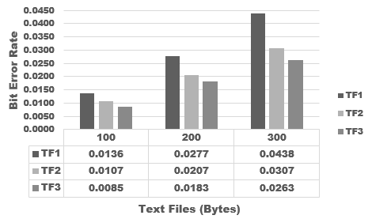

Figure 9: Results of (a) MSE and (b) BER for 300bytes of hidden messages embedded in textfiles

**V. CONCLUSION**

This chapter compared text and audio steganography for cyber-secure communication. Text messages are embedded in cover audio and text files using the LSB algorithm. The average MSE of 1.82E-10 measured the distortion level in audio steganography, while the average BER of 1.22E-02 determined the number of incorrect bits in the stego audio files. These metric values indicated reduced distortion and strong communication of hidden messages, enhancing cybersecurity. In comparison, text steganography, with an average MSE and BER of 0.022262, was less effective in resisting steganalysis. In the future, the traditional LSB approach can be modified by embedding hidden messages in higher bits to increase the payload capacity.

**References:**

[1] Wasyihun Sema Admass, Yirga Yayeh Munaye, and Abebe Abeshu Diro ,” Cyber security: State of the art, challenges and future directions”, Cyber Security and Applications,2(2024),100031, <https://doi.org/10.1016/j.csa.2023.100031>.

[2]Farhan Ullah, Hamad Naeem, Sohail Jabbar, Shehzad Khalid, Muhammad Ahsan Latif, Fadi Al-Turjman, and Leonardo Mostarda,” Cyber Security Threats detection in Internet of Things using Deep Learning approach, IEEE Access, https://doi.10.1109/ACCESS.2019.2937347.

[3] Jagpreet Kaur, and K .R. Ramkumar,” The recent trends in cyber security: A review”, Journal of King Saud University – Computer and Information Sciences,34 (2022) 5766 –5781,https://doi.org/10.1016/j.jksuci.2021.01.018.

[4] Regner Sabillon, Jeimy Cano, Victor Cavaller, and Jordi Serra,Cybercrime and Cybercriminals: A Comprehensive Study, International Journal of Computer Networks and Communications Security, 4(6), 2016, pp.165–176

[5] A. Rasmi, and M. Mohanapriya,” An Extensive Survey of Data Hiding Techniques “,

Indian Journal of Science and Technology,9(28),2016https://doi.org/10.17485/ijst/2016/v9i28/90457.

[6] Mohammed Abdul Majeed, Rossilawati Sulaiman, Zarina Shukur and Mohammad Kamrul Hasan

,” A Review on Text Steganography Techniques”, Mathematics, 2021, 9, 2829. <https://doi.org/10.3390/math9212829>

[7] S. Katzenbeisser and F. Petitolas, "Information Hiding Techniques for Steganography and Digital Watermarking", vol. 28, no. 6. London: Artech House computing library, 2000.

[8] Danish Shehzad and Tamer Dag,” A Novel Image Steganography Technique based on

Similarity of Bits Pairs”,2017 IEEE 8th Control and System Graduate Research Colloquium (ICSGRC 2017), 2017.

[9]Sushma Bahuguna and Sandeep Jain, “A Review of LSB-Based Audio Steganography Techniques “, International Journal of Computer Engineering and Technology (IJCET)

12(3), 2021, pp. 1-7, https://doi.org/10.34218/IJCET.12.3.2021.001.

[10] Ifra Bilal, Mahendra Singh Roj, Rajiv Kumar and P K Mishra, “Recent Advancement in Audio Steganography”,2014 International Conference on Parallel, Distributed and Grid Computing, IEEE, pp 402-405.

[11] Dingwei Tan, Yuliang Lu, Xuehu Yan, and Xiaoping Wang,” A Simple Review of Audio Steganography”,2019 IEEE 3rd Information Technology, Networking, Electronic and Automation Control Conference (ITNEC 2019), IEEE, pp.1409-1413

[12] Thi-Kien Dao and Trong-The Nguyen,” Recent Information Hiding Techniques in Digital

Systems: A Review, Journal of Information Hiding and Multimedia Signal Processing, (15),1, 2024 pp.10-20.

[13] Mohd Hilal Muhammad, Hanizan Shaker Hussain, Roshidi Din, Hafiza Samad, and Sunariya Utama,” Review on feature-based method performance in text steganography’, Bulletin of Electrical Engineering and Informatics,10(1),2021, pp. 427-433, <https://doi.10.11591/eei.v10i1.2508>.

[14] Milad Taleby Ahvanooey, Qianmu Li, Jun Hou, Ahmed Raza Rajput and Yini Chen,” Modern Text Hiding, Text Steganalysis, and Applications: A Comparative Analysis”, Entropy, 2019, 21, 355, <https://doi:10.3390/e21040355>.

[15] May Alanzy, Razan Alomrani, Bashayer Alqarni, and Saad Almutairi,” Image Steganography Using LSB and Hybrid Encryption Algorithms “, Applied Sciences. 2023, 13, 11771. https://doi.org/10.3390/app132111771.

[16] Z. Jackson, Spoken digit, https://github.com/Jakobovski/free-spoken-digit-dataset, 2016.

[17] Smith, N. A., Heilman, M., & Hwa, R. (2008, September). Question generation as a competitive undergraduate course project. In Proceedings of the NSF Workshop on the Question Generation Shared Task and Evaluation Challenge.

[18] M. M. Mahmoud and H. T. Elshoush, “Enhancing LSB Using Binary Message Size Encoding for high capacity, Transparent and Secure Audio Steganography-An Innovative Approach,” *IEEE Access*, 10, pp. 29954–29971, 2022, doi: 10.1109/ACCESS.2022.3155146.