Robotics in Hospitality

Akshita Gupta

Bachelor of Technology Scholar from Arya College of Engineering and Information Technology,

Department of Computer Science Engineering

gakshita622@gmail.com

## Abstract

This is a real-time monitoring system, where people communicate with robots through touch. This is a great help to people who are a big challenge for them to travel. There is a need for theory-based interaction over speech recognition as it has failed to authorize robots due to fluctuations and fluctuations in frequency. The launch is achieved by navigating the robot by touching a variety of objects. As a result of this project, the lives of people with physical disabilities become more difficult. It will benefit a variety of areas including applying for basic infrastructure and security. The touch control robot has two parts: image capture and data extraction. Items are accessed using a webcam. Another feature of this project is to control the Indian economy by controlling street lighting.

**Keywords** — Robot, Touch, Web Camera, Object Discovery

## Introduction

Many robot parameters are designed according to need. There are various ways to control robotic arm such as Voice Controlled, Keypad Control, Gesture Control, etc. The system used consists of transmitter & receiver. Transmitter is nothing but a human hand with flexible sensors & the receiver is a robot manipulator. The Motion of transmitter is wirelessly transmitted to the receiver via an X-bee module. The receptive Robotic arm is nothing but a multi-component repair system and the end and the functions such as mean gripper movement of these fingers or gripper can be done using stepper motor or servo motor when the user performs hand movements of any application on the side -transmitter The same movement is copied by the receiver as in the transmitter there are flexible sensors attached to the glove transmitter that change its resistance depending on the movement of the user. In the research team of intelligent robots, one of the biggest problems is driving a robot on its own.

The entire program consists of two modules.

1. Control the robot using hand gestures.
2. Object detection using a webcam.

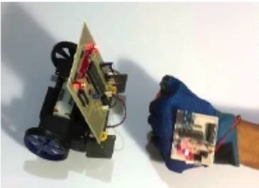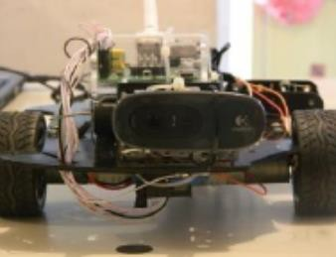

Fig (1) Touch control robot (2) Object detection using a webcam

Applications for the proposed program:

* + Wireless controlled robots are very useful for many applications such as remote monitoring, military etc.
  + A hand-controlled robot can be used to physically challenge wheelchairs.
  + With the use of touch detection, a hand-held remote control of various machines is possible. Benefits of the proposed system:
  + Improving the system will save electricity and benefit the Indian economy.
  + It will save lives in dangerous areas.
  + Remote objects can easily be seen with a webcam.
  + A hand-held robot can be used by wheelchairs.

# LITERATURE REVIEW

## In this section we have identified and discussed existing activities related to touch control, robot and object acquisition using a webcam.

A hand-held visual interface for navigating the robot. The robot can be controlled by the user using the touch of his hand. A 3-axis accelerometer was adopted to record user handwriting. Trajectory data is wirelessly transmitted via an RF module to a computer. The detected trajectories are divided into six commands to control the navigation of the robot. The separator adopts a dynamic time warping algorithm to separate hand trajectories. Existing work is limited to the fact that the simulation results show that the class divider can only get a fair rate of 92.2%.

The control strategy allows us to generate the dynamic motion of a robot that is less actuated or subject to external interference. This control strategy is based on two phases. The first uses a set of pragmatic rules to generate a sequence of active and inactive phases that allow us to perform flexible robot movements. In the second phase, we use these neural networks to generate trajectories learned during the first phase. The current function of this project is problematic while working with barriers to avoid using neural networking.

Tracking and detection of an object are two important functions in the surveillance of multiple cameras. This paper proposes a framework to accomplish these tasks in a network of multiple non-portable cameras. A new algorithm for finding an object that uses mean shift separation, is introduced, and closed objects are further segregated with the help of in-depth information based on stereo view. The current job has a problem while seeing the performance of non-training materials.

The object is the most important factor in the widespread use of computer vision. There are many changes in the process made over the years in the efforts of coding and datasets, it is very important to improve the library and measure the state of the art. After reviewing the latest developments to track something online, large-scale testing with various test conditions to understand how these algorithms work can be done. The sequence of the test image is defined by the various attributes of performance testing and analysis. By analysing quantitative results, we identify effective methods for strong tracking and provide potential future research guidelines in this field.

Electrical electronics, machinery, grids, and markets with telecommunications technologies are a variety of smart technologies of grid connection power that lead to disciplinary action, in a multi-domain system.

Simulation packages that test the integration of system components often include a single subdomain. Collaborative simulation overcomes this by integrating sub-domain models defined and resolved in their area, using specialized solutions and certified libraries. This article discusses the state of the art and illustrates the great challenge of imitating intelligent energy systems.

# PROBLEM STATEMENT

The aim of this project is to build a robotic system that can be controlled by manual touch but not by old buttons. We just need to wear a small transfer device in your hand mounted on an accelerometer. This will transmit the correct command to the robot so that it can do whatever we want. The robot will detect objects and name them using a webcam and will control street lighting. Setting up an automatic segmentation system and tracking moving objects in video camera scenes, which can serve as the basis for advanced thinking tasks and applications. Making significant improvements to widely used algorithms. Finally, the purpose is to show the detection and tracking based on the motion of moving objects in the video from a still camera. Specification of the existing system gap.

Looking back, there were a few problems that could have been handled differently. First, the correct choice of chassis can be made correctly and eliminate the need to replace it. The biggest problem that arose during this time was not a separate launch, but a waste of time trying to figure out why the car is not moving at a slower speed. One thinks that he will probably be choosing a different language to build a control channel, because Unity has one major limit and that it does not support live video streaming within the system and that the project has to work with a saved window using another video game application.

On this existing device there is no webcam to detect and invent an object with a gesture control car robot system. There were several systems that could turn on and off the street light whenever it was dark but there was no regulation in the use of electricity in connection with the detection of an object on the road. Radio frequency transmission is used instead of infrared transmission as RF can travel a long distance which improves the range of application, RF can also apply to the barrier between remote and vehicle. Transfers happen up to 10 Kbps. After studying books, it is found that finding a video sequence and tracing an object is a real challenge. Object tracking can be a time-consuming process due to the amount of data contained in the video.

# ARCHITECTURE DIAGRAM

It contains a flexible sensor and transmits accelerometer data via Bluetooth or Wi-Fi, where values are combined and processed simultaneously. At the same time the flex sensor does its job by sending a range of hand movements to the Arduino. The transfer device incorporates an IC Comparator to provide the appropriate levels of input power from the accelerometer and encoder used to enter data and will be transmitted via the RF Transmitter module.

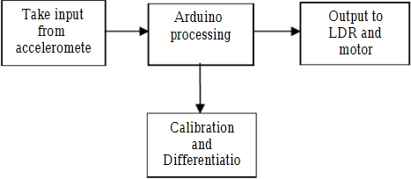

Figure 4. Touch control modeling

At the end of receiving the RF module it will receive the recorded data and record it using the decoder. This data is then processed by a small controller and passed to the driver of the vehicle to rotate the motors in a special way so that the robot can move in the same direction as the hand. The webcam focuses on a robot, where a video object is built into MATLAB and connected to a camera or webcam. It helps to see things.

The traffic light sensor operates on the microcontroller only when the vehicle or pedestrians enter the receiving circuit and activate the light sensor. The light sensor is activated when accessible light is available below the set limit of the switch off, some is OFF. Sensors (LDR & PIR) hear data, collect information and send it to a microcontroller. Microcontroller controls the signal and uses software to analyze the system.

Visible hand-based control interface for car robot control. Depending on the interface, a user with a 3-axis accelerometer module attached to his wrist can use direct hand movement to navigate the car-robot. The 3- axis accelerometer module detects hand trajectories and transmits wireless to a PC via RF module. After that the hand-sensing module uses a DTW algorithm to detect trajectories. Next, it sends a wireless control command to the robot's reception module. The robot then roams according to the command you received.

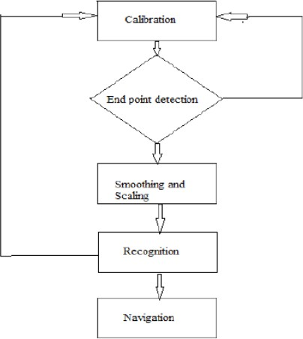

Fig . Block diagram for Gesture sensor robot

A. The awareness process involves 5 steps as follows:

Step 1. Measurement: The way the tri-axes accelerometer module is attached to the user's wrist varies from person to person. In addition, it may vary from time to time during the same user control process. For example, a user may wear a module with a certain angle of inclination. Without any hand movement, the accelerator already has a certain amount of g sensing. Therefore, the module should be measured for each user at the beginning of the control process. To measure the speed module, we first measure the angles of rotation and rotation.

Step 2. Final Score Detection: Before we used the DTW algorithm to separate the recorded trajectories, the final scores of the obtained trajectories were first detected. The final points mark the beginning and end of the sample trajectory data. The acceleration signal changes accordingly as the acceleration module moves. Therefore, the number of acceleration variables (AAC) can be used to obtain end points. When the AAC exceeds the aforementioned limit, it signifies that the first place of movement is found. The final point is obtained when the AAC falls below the 0.5-second limit. The performance of the final acquisition points depends on the amount of the aforementioned limit. If the threshold is set too low, a small vibration motion will be detected as a new direction. Conversely, if the threshold is set too high, the slower trajectory will not be detected. From our many tests, 0.1g would be a good limit.

Step 3. Stabilization and Measurement: After obtaining the final points, we expand the data to reduce the impact of noise. In our system, we use a second-party management filter to stream data. After the slide, we need to measure the smooth data to the limit [0, 1]. Apart from the measurement process,trajectories from the same action may vary. Step 4. Attention: The DTW algorithm is a flexible algorithm for detecting location sequences. It works like this. First, in each class, one or more sequences are kept as a sequence of templates. Thereafter the test sequence is compared to the pre-stored template sequence, and the average similarity (or distance) of each template is calculated. An important step in this comparison is to align the

test sequence over time with each successive template due to the variance in sequence length. In our recognition module, for each hand gesture, we randomly select a single trajectory as the trajectory of the corresponding touch template. The test result was then compared with the sequence of each hand touch template. The two trajectories to be compared are aligned with time and the resulting alignment method for high similarity is calculated electronically. Finally, the test route is said to be a class with very similarities.

Step 5. Navigation: After the trajectories are separated, the corresponding command is then transmitted to the robot. The generated signal is stored in a file in the Wi-Fi protection station on the robot accessing this file to transmit signals from the control station to the robot. As soon as the Wi-Fi shield receives a command from the control station, it is transferred to an Arduino microcontroller. Arduino takes this signal as an input from Wi-Fi protection and produces some outgoing signals transmitted to the driver of the vehicle. This output of output output depends on touch input, for all four possible input signals, a separate output signal is generated. The driver of the car is used to drive DC robot motors. It takes digital signals as input from Arduino and provides these signals as output to DC motors. Once the robot has been given a command signal, it continues to move toward that location until the next command is given or any obstacle arises along the way.

# CONCLUSION

The results of the proposed program are as follows. The proposed system, where the user can navigate a wireless robot in an area that uses various touch commands. The ultimate goal is to provide a reliable and natural way for a user to navigate a wireless robot in an environment that uses touch. The proposed system will provide a smart system that can be controlled by hand touch, operating on an accelerometer device equipped with a receiver. A developing robot will discover objects and name them using a webcam. Object detection and tracking can be used to control the movement of the robot outside the wire. Object detection was achieved by color detection and image classification. The robot will detect the object and automatically control the electricity of the traffic light. Each sensor controls OPEN or OPEN the lighting column. The street lights are successfully controlled by the Arduino microcontroller. At the command from the controller the lights will illuminate the movement areas in the dark.

# REFERENCES

1. Taipei, Taiwan.: The 2010 IEEE/RSJ International Conference on Intelligent Robots and Systems October 1822, 2010.
2. Kun and W. T. Miller.: Adaptive dynamic balance of abiped robotusing neural networks, IEEE Conference on Robotics and Automation,pp. 240-

245, 1996.

1. Shuai Zhang, Member, IEEE, Chong Wang, Member, IEEE, Shing-Chow Chan, Member, IEEE, Xiguang Wei, and Check-HeiHo.: IEEE SENSORS

JOURNAL, VOL. 15, NO. 5, MAY 2015.

1. Y. Wu, J. Lim, and M.-H. Yang, A benchmark,in Proc. IEEE Conf. Comput. Vis. Pattern Recognit.: Online object tracking Jun. 2013, pp. 2411–2418.
2. Paul Flikkema.: Dept. Electrical Engineering and Computer Science Northern Arizona University Flagstaff, Arizona,2014.
3. G. Zhabelova, and V. Vyatkin.: Multiagent Smart Grid Automation Architecture Based on IEC 61850/61499 Intelligent Logical Nodes, IEEE Trans.

on Industrial Electronics, vol.59 no.5, pp. 2351- 2362.