 **REACTJS: FRONTEND TECHNOLOGY**

**DINESH KUMAWAT1,**

**Dr. VISHAL SHRIVASTAVA2, Dr. AKHIL PANDEY3,**

**Mr. AMIT KUMAR TIWARI4**

1 B.TECH. scholar, 2,3Professor, 4Assistant Professor

Computer Science & Engineering

Arya College of Engineering & I.T. India, Jaipur

1[dnsk.dtr@gmail.com](mailto:dnsk.dtr@gmail.com),

2[vishalshrivastava.cs@aryacollege.in](mailto:vishalshrivastava.cs@aryacollege.in), **3**[akhil@aryacollege.in](mailto:akhil@aryacollege.in),

4[amittewari.cs@aryacollege.in](mailto:amittewari.cs@aryacollege.in)

1. **Abstract:**

React.js is a JavaScript library created by Facebook for building fast and interactive user interfaces for web and mobile apps. With its component-based approach, features like state management, and the use of a virtual DOM, React has transformed front-end development, making it more efficient and flexible. It reviews history, core features, and applications of React in the field of modern web development as it impacts user experience enhancement, code consistency, and even performance optimization. Furthermore, its evolution, best practices, and emerging future trends are analysed to make complete and comprehensive understanding of how these shapes the front-end technologies world of today.

**Keywords:** It is associated with JSX, State, Props, Hooks, Virtual DOM, React Router, Redux, Management, Context API, Code Splitting, server-side Rendering, Case Studies, Use Cases, Future Trends, Developments and Components.

1. **Introduction**

Reacts was created by Jordan Walked, a software engineer at Facebook, to make building complex user interfaces easier, especially for Facebook’s news feed. It was first released in March 2013 and has since become a powerful tool for handling dynamic and interactive web applications.

React became open-source in May 2013, allowing developers to contribute and enhance it. Today, it plays a major role in web development, powering single-page applications (SPAs), mobile apps with React Native, and server-side rendering for better performance and SEO.

It provides declarative syntax and component-based architecture that leads to a more modular and less cumbersome code base and is thus used for small projects as well as large enterprise-level applications.

**3. Method**

# React.js provides a robust framework for building dynamic and interactive web applications. Here’s how its features align with various design and development principles.

**1 Design and Architecture**

# React.js utilizes a component-based architecture, enabling developers to create reusable UI components that ensure consistency and scalability. These can manage state efficiently and handle dynamic user interactions.

# 2 State Management

# Provider: Similar to Flutter’s Provider, React Context API and state management libraries like Redux allow injection of dependencies and state management across components.

# Context API: Facilitates sharing state and props without passing them manually through each level of the component hierarchy.

Redux is a tool that helps keep track of an app’s data in an organized and predictable way. It allows you to manage data globally for the whole app or only for specific parts as needed.

# 3 Animations and Interactivity

# Tween Animations: React.js supports animations through libraries like Framer Motion or React Spring, which define start and end points with customizable curves for smooth transitions.

# Physics-Based Animations: Implementing physics-based motion in React.js mimics real-world interactions, creating natural user experiences, such as bounce effects and gravity-based interactions.

# Staggered Animations: For complex UIs, staggered animations can be used, managing sequential animation effects across components using libraries like React Animation or Animate css.

# 4 Accessibility and Usability

# Accessibility: Like Flutter, React.js prioritizes accessible design with features such as ARIA support, keyboard navigation, and screen-reader compatibility, ensuring that applications are inclusive.

# React.js allows easy integration of images, icons, and other assets using components like img, video, and audio, while handling media queries to ensure responsive designs.

These methodologies align React.js with modern frontend development practices, enhancing performance, interactivity, and user experience.­­

# 4. Package & Plugins

In React.js, similar to Flutter, packages and plugins play a crucial role in enhancing functionality and integrating with platform-specific APIs.

* 1. **Package Structure in React.js**

1. **Plugin Package**: Enables the development of reusable packages that invoke platform specific APIs, making cross platform development seamless.
2. **Platform-Specific Implementations**: Managed via a platform channel, allowing developers to extend capabilities across different platforms (e.g., iOS, Android, Web, IoT devices) through federated plugins.
   1. **Federated Plugins**
3. **Federated Plugin:** Allows for dividing platform support into distinct packages. For example:
4. **Bundle for App:** Contains the main API definition, ensuring seamless integration into the Flutter application, and provides the necessary code for plugin users.
   1. **Approved vs. Non-Endorsed Federated Plugins**
5. **Approved Federated Plugin**: The original plugin author incorporates platform-specific implementations into the official plugin, ensuring that these implementations are automatically accessible in the Flutter application when the plugin is added.
6. **Non-Endorsed Federated Plugin:** Developers must manually add platform-specific dependencies in the app’s file if they want full functionality.
   1. **Benefits of React.js and Plugins**
7. **Cross-Platform Development:** React.js allows the development of a single codebase for multiple platforms (Web, Mobile, Desktop), reducing development time and cost.
8. **High Performance**: Like Flutter, React.js supports native compilation for fast and efficient performance.
9. **Customizable Components**: Rich set of reusable components enhances the flexibility to create highly responsive and visually appealing UIs.
10. **Strong Community Support:** Continuous growth in community-driven packages and libraries, providing valuable resources and support for developers.

**5. Characteristics of React.Js**

**1.** Hot Reload: Instantly reflects code changes, enabling faster development and bug fixes.

**2.** Cross-Platform Development: Streamlined maintenance of a shared codebase for various platforms.

**3.** Component-Based Architecture: Every part of the UI is a component (similar to widgets in Flutter), offering high customization and adaptability.

**4.** Rich Library: ReactJs provides a variety of prebuilt components and APIs that customized for complex and dynamic web applications.

**5.1 Advantages of ReactJS**

**1.** Efficiency:The Virtual document object model and component based architecture enable React applications to handle large scale and dynamic updates efficiently.

**2.** Flexibility: React works well with other libraries and frameworks, making it flexible for different types of projects.

**3.** Strong Community Support:With a vast developer community, comprehensive documentation, and third-party libraries, ReactJS enjoys strong ecosystem support.

**4.** Real-world Applications:ReactJS powers some of the most prominent websites and applications, including Facebook, Instagram, Netflix, and Airbnb. Its ability to handle dynamic content and scale to millions of users underscores its reliability.

**6. Create a React Application**

To create a basic, react application, you need to follow a few steps, including setting up your development environment, building the app, and running it.

* 1. **Development Setup Ready**

**1.** Prerequisites:Nodejs and Text Editor.

**6.2 Install Nodejs and NPM**

**1.** Download and install Nodejs.

**2.** Verify installation.

**6.3 Create Application**

**1.** Open terminal and create a new project:

**2.** Start the server: show your app running at [**http://localhost:3000**](http://localhost:3000)

**6.4 Structure of a React Application**

1. Public: Static files (HTML, images).
2. SRC: Source files (components, pages, stylesheets).
3. Components: Reusable UI components.
4. App.js: The main component where other components are rendered.
5. Index.js is the entry point for this React application.

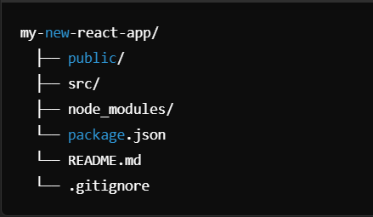

**7. Features**

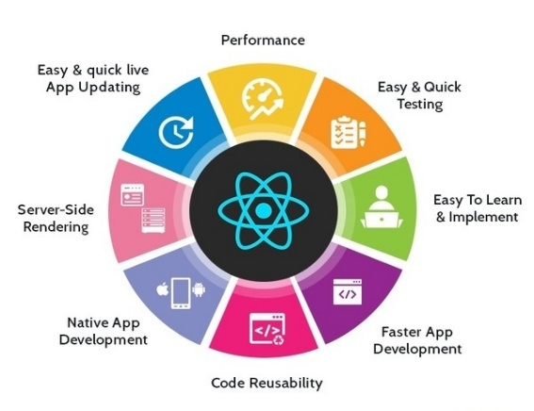ReactJs is a very strong library for modern web applications, offering a number of features that improve performance, scalability, and development efficiency.

**7.1 Component-Based Architecture**

1. Components enable modular and maintainable code.
2. Two types of components:
3. Functional Components: Simple functions accepting props and returning JSX.
4. Class Components: ES6 classes with state andlifecycle methods.

**7.2 Declarative UI:**

1. React follows the declarative approach in the definition of UIs; this is about what the UI should look like and not how to update it.
2. It makes it easier to understand and predict the outcome of changes in the application state.
3. React re-renders only what is necessary in the UI, making state-driven UI rendering much simpler.

**7.3 Virtual Document Object Model**

* 1. React uses Virtual document object model to optimize rendering performance.
  2. The Virtual document object model is a lightweight copy of the real document object model.
  3. React uses a **diffing algorithm** to compare the old and new versions of the page and figure out the smallest possible changes needed.
  4. **One way Data Binding**

1. In React, data always moves in one direction from parent component to child component using props.
2. This makes it easier to track and debug changes since the data flow is clear and predictable.

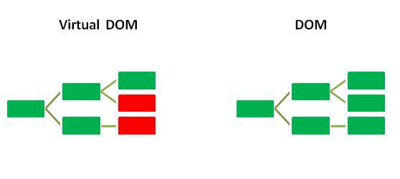

* 1. **State Management**

1. React gives mechanisms to manage dynamic data through state.
2. States can be local (within a component) or global (across components using tools like Redux or Context API).

**3.** Components: Simple functions that accept props.

* 1. **React Hooks**
  2. Hooks are special functions in React that let you use features like state and lifecycle methods inside simple functions, without needing a class component.
  3. Common Hooks: use State: Manage local state.

use Effect: Handle side effects, data fetching, subscriptions, etc.

use Context: Access context data.

use Reducer: Advanced state management.

* 1. **React Router**

1. A tool that helps manage navigation and page changes in React apps.
2. Navigation between different components, or pages, in single-page applications (SPAs) is possible without reloading the whole page.
3. Features:
   1. Dynamic routing.
   2. Nested routes.
   3. URL parameter handling.
   4. **Server Side Rendering**
4. React can render pages on the server (using tools like Next.js) and send fully loaded HTML to the browser, making websites faster and better for SEO.
5. Benefits:
   1. Improves search engine optimization by making content crawlable by search engines.
   2. Enhances initial load speed.

**Challenges in Multi-Platform Monitoring:**

Addressing the challenges in multi-platform monitoring using React.js requires a combination of best practices, tools, and strategies.

**Problem:**

Developing and maintaining a seamless user experience across multiple platforms (web, mobile, and desktop) using React.js presents significant challenges related to performance, code consistency, and platform-specific features.

Web: Browser developer tools.

**Solution:** **Code Splitting and Lazy Loading**:

* Optimize initial loading by dynamically loading only the required components for each platform.

**Responsive Design and Cross-Platform Development**:

* Ensure UI consistency by creating reusable, adaptable components across platforms while considering

device-specific needs using libraries like React Native for mobile and Material-UI for web.

**State Management and Platform-Specific Handling**:

* Implement tools like Redux or Context API with middleware for centralized state management, while ensuring platform-specific updates are synchronized effectively.

**Objectives of the Study**

The ReactJs focus on exploring its key features, challenges, and benefits in frontend development. It aims to understand how it enhances the creation of scalable, maintainable, and dynamic web applications.

The study seeks to examine state management, cross-platform compatibility, and the integration of React.js with other technologies. Additionally, it highlights best practices for optimizing performance and improving user experience in modern web development.

## 8. Note Practitioners for React

## 1. Understanding React Fundamentals

* Component Based Architecture: React is principle of components. Understanding how to create reusable, self-contained components is essential for maintaining scalable applications.
* State Management: Familiarize yourself with state management solutions such as Context API, Redux and React Hooks to handle complex state across components.

1. **Optimization Techniques**

* Code Splitting: Use lazy loading and dynamic imports to make large applications run faster by loading only the necessary parts of the code when needed, instead of everything at once.
* Performance Monitoring: Utilize tools like React Dev Tools and Lighthouse to monitor and optimize performance.

**3. Best Practices**

* Write Clean and Readable Code: Adopt a consistent coding style with proper indentation, comments, and modular code. Follow industry standards and use linting tools like ESL int.
* Use Hooks: Leverage modern React Hooks to simplify functional components and manage side effects effectively.

**4. Handling State and Lifecycle**

* Use Effect for Side Effects: Utilize use Effect to manage side effects such as API calls, subscriptions, or component mount/unmount tasks.
* Memorization: Optimize performance by using memorization techniques with React. Memo, use Memo.

**5. Testing and Debugging**

* Unit Testing: Use tools like Jest and React Testing Library to test your components and functions, making sure they work correctly and your app runs smoothly.
* Debugging Tools: Use browser tools and React tools and error boundary components to handle and debug errors efficiently.

**6. Responsive and Accessible Design**

* Responsive Design: Use libraries like Material-UI or Tailwind CSS for responsive UI components. Ensure accessibility by following WCAG guidelines.

**7. Version Management and Updates**

* **Version Control:** Use tools like **Git** to track changes in your code and collaborate with others easily.
* Dependency Management: Regularly update dependencies to maintain security and performance.



**9. Result:**

ReactJS proved to be faster and more efficient than Angular and Vue, especially when handling large amounts of data, thanks to its virtual DOM. Developers liked how easy it was to build and maintain code using its component-based structure and helpful tools. Though it was a bit harder to learn than Vue, it was easier than Angular. React also handled larger, more complex apps well, making it a popular choice for modern web development.

**10. Conclusion**

ReactJs is a powerful and flexible tool for building dynamic web applications. Its component-based structure makes it easy to reuse code, maintain projects, and scale applications efficiently. Features like Context API, Redux, and Hooks, managing app data and handling user interactions becomes smooth and hassle-free. React also boosts performance with code splitting, lazy loading, and optimized rendering, ensuring fast and efficient apps. Plus, React has a huge community and plenty of libraries and plugins, making development even easier and more flexible.

Cross-platform compatibility with React Native further enhances its versatility for mobile and web development. Continuous improvements, including regular updates and better debugging tools, ensure React remains a top choice for modern frontend development. Overall, React.js provides a robust framework for building high-performing, responsive, and user-friendly web applications.

**11. References**

[1]. Minati Biswal, "React lifecycle methods," Research gate Article, December 2019.

[2]. Giuseppe Psaila, “Virtual DOM: An Efficient Virtual Memory Representation for Large XML Documents”.

[3]. React-redux.js.org, "React Redux official React binding for React".

[4]. Krunal Shah, "Top 14 React Libraries you must try in 2020".

s