**CHAPTER**

**FORENSIC SCIENCEC**

The term forensic is derived from the latin word ,forensic meaning of a forum ,place of assembly. In modern use,the term forensics is often used in place of forensic science ,The word science is derived from the latin word for knowledge and is today closely tied to the scientific method a systematic way of acquiring knowledge taken together ,forensic science means the use of scientific methods and processes for crime solving

Forensic science is also known as criminalistics ,is the application of science ,principles and methods to support legal decision making in matters of criminal and civil law .A relevant modern definition of forensic is relating to used in or suitable to a court of law. Any science used for the purposes of the law is a forensic science.

The forensic sciences are used around the world to resolve civil disputes ,to justify enforce criminal laws and grant regulations ,and to protect public health.Forensic scientists may be involved any time on objective scientific analysis is needed to find the truth and to seek justice in a legal proceedings.

Forensic science comprises a diverse array of disciplines,from fingerprint and DNA analysis to anthropology and wild life forensics ,Though they represent varied disciplines,all forensic scientists face a common set of challenges.

During criminal investigation in particular, it is governed by the legal standards of admissible evidence and criminal procedure.It is a broad field utilizing numerous practices such as the analysis of DNA fingerprints blood stain patterns ,firearms ,ballistics ,toxicology and fire debris analysis.

Forensic scientists collect ,preserve and analyze evidence during the course of an investigation .While some forensic scientists travel to the scene of the crime to collect the evidence themselves ,Others occupy a laboratory role ,performing analysis on objects brought to them by other individuals.Others are involved in analysis of financial crime investigation ,and can be employed as consultants from promote firms,academia ,or as grant employees. In addition to their laboratory role forensic scientists testify as expert witness in both criminal and civil cases and can work for either the prosecution or the defense.While any field could technically be forensic ,certain sections have developed over time to encompass the majority of forensically related cases.

The word forensic originates from the latin word forum,which refers to the law,and science,which is the application of the various disciplines of science to the law.The American academy of forensic science,established in 1948 ,is the oldest and most influencial professional organization of forensic scientists throughout the world,with a current membership of 5,000.

**Forensic science is a combination of knowledge:**

1.Weapons identification

2.Fingerprinting

3.Questioned document analysis

4.Chemical identification

5. Trace analysis of hair,fiber,or soil

6.Deoxyribonucleic acid (DNA) analysis

7. Investigation of explosives

8.Criminal justice system

9.Crime scene photography

10. Terrorism

11. Disaster response

(a) Caused by humans

(b)Natural

(c) Nuclear

12. Cybercrime

13.Human rights violations: International and regional

(a) Genocide

(b) Torture: sexual and psychological

(c) Human trafficking

(d) Mass executions

(e) Child labor

(f) Slavery

14.Human response to stress

**History of forensic science:** Forensic science history can be traced to the ancient Egyptians,who developed a system of law and a judicial system that was adapted in to later Greek and Roman laws. Egyptians law was based on a sense of right and wrong and that everyone should be viewed as equal under the law ;The one exception to this was the slave. Criminal offences were investigated prior to rendering a final judgement.Religious beliefs would not allow an autopsy to be performed for the purpose of establishing cause and manner of death .written records of the trial proceedings and judgement were used as a precedent when similar legal issues arose.

The ancient Greeks relied on the principle of reason,taught by Aristotle ,to resolve issues of self, politics ,developing strategies of war,understanding religion ,and the individuals relationship to the Gods. The Greeks created a court system A council was appointed officials whose only job was to write laws.The Greeks developed procedural laws that were the guidelines for judges on how to use the laws the Greeks created laws that dictated how public services were to be provided and family laws that regulated the behavior of men and woman. The Greeks identified homicide as a tort law. The Roman empire developed a sophisticated process of criminal investigation and punishment the first people to make law in to a science wrote the first legal code for roman law,the law of the twelve tables ,which provided the foundation for all western civil and criminal law.

**Technology and Forensic science techniques**

**A.**After the late 17th century,technology,the development of instruments such as the microscope and photography ,the use of x-ray, and the introduction of new laboratory equipment and tests such as blood typing and application of the principles to ballistic trajectories all made the science of criminal investigation more accurate

**.B.**Locard’s exchange principle became the cornerstone of forensic science: Human contact with any person, place or thing ,will result in an exchange of physical materials or evidence.

1.Fibers from a sofa you sat on will become part of you ,your clothing ,or any object placed on the sofa in addition physical material (trace material from your skin ,hair fingernails ,clothes) will remain on the sofa.If collected and preserved properly ,the materials left by you on the sofa will provide information regarding your activities that day,several days prior to the time you sat on the sofa,and if another individual wore your clothes.Stains left on the sofa can be identified by type of stain ,who was responsible for producing the stain occurred.

2.Dirt on shoes can identify the location of crime; microscopic materials in the dirt may provide information to a specific location and may also assist in determining the weather conditions at the time the shoes stepped in the dirt

.3.The shoe will also contain the individuals skin cells from either the feet or the fingers that tied the shoelaces ,including any additional material left from the hands such as dirt,food,hair, sweat and any other materials that the hand and fingers may have been in contact with prior to tying the shoelaces.

**LOCARD’S EXCHANGE PRINCIPLE**

“You touch it ,it’s yours.”

In 1932,the U.S. Federal Bureau of investigation (FBI),under Director J.Edgar Hoover ,designated the organization of a national laboratory with the main purpose to offer forensic science services to all law enforcement agencies throughout the country.Currently ,the FBI laboratory is the largest forensic laboratory in the world.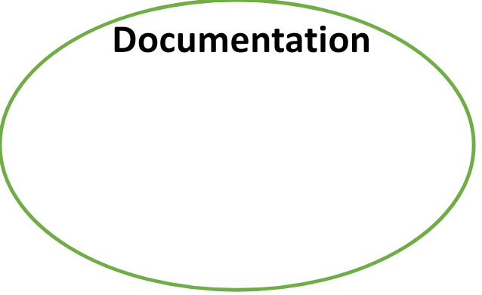

**Basics of forensic science:**

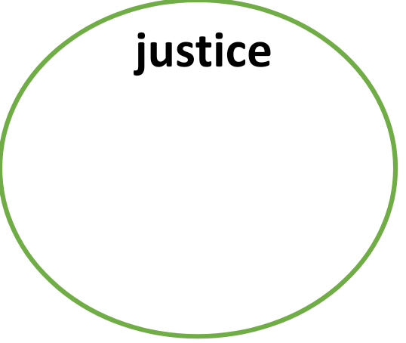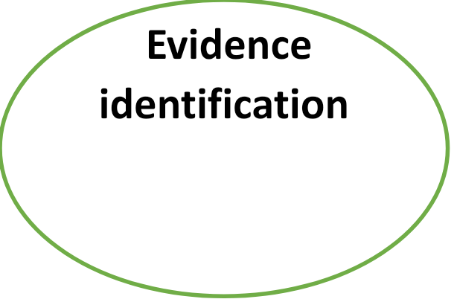



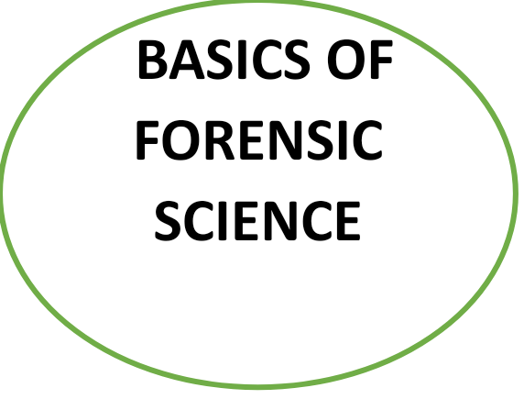

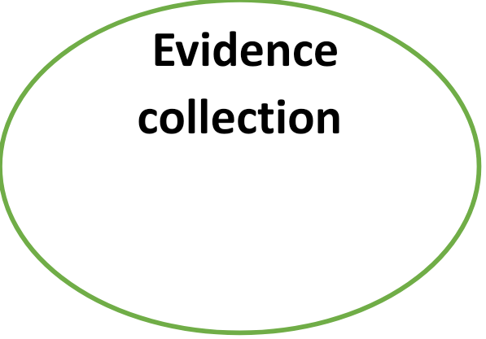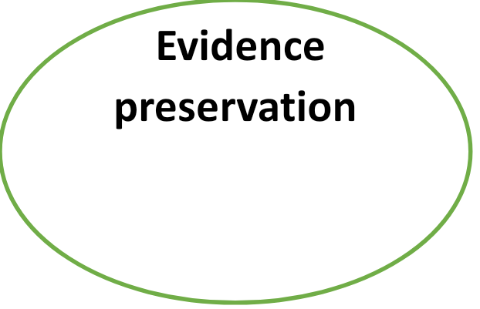

**Functions of a forensic scientist:**

1. Identification ,collection ,and preservation of physical and biological evidence
2. Analysis of physical evidence provide expert witness testimony
3. Prove the existence of a crime or identify connection to the crime
4. Provide skilled documentation related to chain of custody and precise record maintenance.
5. Work as a member within an investigative team ,including
6. Police officers
7. Sheriff deputies both prosecuting and defense attorneys
8. Federal agencies such as the FBI
9. Central intelligence agency (CIA)
10. Immigration officials
11. Other professionals involved in the investigation(e.g forensic psychiatrist or psychologist ,forensic pathologist forensic nurse or other scientific or legal specialists assisting with the investigation process)
12. Provide death notification
13. Determine the who ,what ,where ,when ,and why of a crime

**Forensic science specialty areas:**

A.As Classified by the American Academy of Forensic science (AAFS) 2008,specialty areas involve the following

**Criminalistics:** Application of physical sciences to criminal investigation **Jurisprudence:** Application of the philosophy or science of law

**Digital and multimedia sciences:** Application of the science of computer data processes and media recording to the legal investigation of possible criminal activity

**Questioned documents:** Use of forensic science methods to determine the authenticity or origin of a document

**Toxicology:** Study of drugs and poisons that may have legal applications

**Pathology or forensic medicine:** Specialty of medicine and subspecialty of pathology that deals with investigating the cause,manner and mechanism of death(2008)

**Forensic medicine:** Subspecialty of medicine with application to the investigation ,diagnosis ,care and treatment of the living and the dead

**Taphonomy:** Study of the postmortem process and its relationship to the environment.

**Psychiatry and behavioural science:** Application of the principles of human psychology to the law and legal process ;including criminal profiling.

**Developing specialty areas in forensic science identified by the AAFS (2008):**

1. Computer imaging of crime scenes
2. Suspect composites
3. Victim characteristics for potential application
4. Tape recordings and digital voice identification
5. Acoustic and speech analysis
6. Accurate detailed identification of financial schemes ,money laundering
7. Internet fraud
8. Forestry and wildlife science
9. veterinary medicine
10. Botany
11. Ecological awareness

**Future forensic science:** Specialties in both the physical and biological sciences will appear as technology and research provide more sophisticated accurate tools for

1.Investigation of crime

2. Developing a more efficient criminal judicial system

3. Working with victims to provide services for long term physical and psychological recovery

4. Continued demand for DNA analysis of evidence obtained from past crime scenes to verify or overturn guilty verdicts

5.Improved laboratory technology to increase the speed of DNA analysis and additional evidence laboratory testing

6. Portable devices capable of DNA analysis

7.The use of digital radiology

8.Ultraviolet and infrared injury photography to detect biological and biochemical changes after an injury has occurred

9. Fingerprint rejuvenation to assist in the identification of deteriorated remains

10.Scene investigation following natural and human-human disasters

11.Ultimate goals care of the victim justice,community safety;punishment or rehabilitation for the perpetrator

12.Improvements in computer technology

**Yasmeen jaan**

**Nsg tutor: Govt B.sc Nsg college Jammu**

**Mob 9797434009**

**Mail: yasmeenjaan120@gmail.com**