AI-powered cybersecurity risks and challenges

Dilmohan kumar1, Pushkar Kumar2, Kumar Ujjwal3,Ritik Roshan4,Ravi Kumar5,Bhupinder kaur6,Avneet Kaur7

1Computer Science Engineering, Chandigarh University, India, [21BCS7273@cuchd.in](mailto:21BCS7273@cuchd.in)

2Computer Science Engineering, Chandigarh University, India, [21BCS7292@cuchd.in](mailto:21BCS7292@cuchd.in)

3Computer Science Engineering, Chandigarh University, India, [21BCS11472@cuchd.in](mailto:21BCS11472@cuchd.in)

4Computer Science Engineering, Chandigarh University, India, [21BCS7442@cuchd.in](mailto:21BCS7442@cuchd.in)

5Computer Science Engineering, Chandigarh University, India, [21BCS7866@cuchd.in](mailto:21BCS7866@cuchd.in)

6Computer Science Engineering, Chandigarh University, India, erbhupinderkaur@gmail.com

7Computer Science Engineering, Chandigarh University, India, avibhathal@gmail.com

**Abstract.** This book explores the dual-edged role of Artificial Intelligence in modern cybersecurity. While AI enhances threat detection, response times, and automation, it also introduces novel vulnerabilities and sophisticated attack vectors. Cybercriminals are now using AI for intelligent phishing, deepfakes, and automated breaches, making traditional security measures insufficient. The text delves into current AI-driven security models, real-world case studies, and the evolving nature of threats. It also highlights key challenges such as data privacy, algorithmic bias, and adversarial attacks. By critically analyzing the intersection of AI and cybersecurity, this book aims to provide readers with a deeper understanding of both the promise and the peril posed by AI in the digital security domain.

**Keywords:** Artificial Intelligence, Cybersecurity, Threat Detection, Deepfakes, Adversarial Attacks, Data Privacy, AI Vulnerabilities, Digital Security

# 8.1 Introduction

In the digital age, the integration of Artificial Intelligence (AI) into cybersecurity has become both a necessity and a paradox. With the exponential growth of connected devices, cloud infrastructures, and remote workforces, the threat landscape has expanded beyond the capacity of traditional security solutions. Cyber threats are no longer limited to basic phishing emails or malware; they now include sophisticated, persistent attacks driven by automation, social engineering, and even AI itself. To combat these advanced threats, cybersecurity systems are increasingly turning to AI technologies for real-time threat detection, automated incident response, and predictive analytics. However, this transformation is a double-edged sword.

AI is revolutionizing the way security professionals detect and mitigate threats by analyzing massive amounts of data at unprecedented speeds. It offers capabilities that go beyond human limitations — such as identifying patterns in encrypted traffic, detecting zero-day exploits, and learning from evolving attacker behaviors. Organizations are already deploying AI-driven tools for endpoint detection and response (EDR), behavioral analytics, and security information and event management (SIEM). The promise of speed, scalability, and accuracy has positioned AI as a vital component of modern cybersecurity infrastructure.

## Risks of AI in Cyber Security

AI’s integration into both offensive and defensive cybersecurity has created a new threat landscape. Attackers leverage generative models to automate and personalize phishing, craft polymorphic malware, and produce convincing deepfakes that bypass traditional defenses. Simultaneously, adversarial machine-learning techniques such as data poisoning and model evasion undermine the integrity of AI systems at training and inference time. Beyond direct attacks, AI’s capacity for large-scale data aggregation and continuous monitoring poses significant privacy and surveillance risks, from over-collection of personal data to real-time behavioral profiling.

## AI-Powered Attacks

Phishing: Modern phishing campaigns are increasingly powered by large language models that generate highly personalized messages at scale. These AI-driven attacks automate what was once a labor-intensive process, enabling adversaries to craft contextually relevant lures based on targets’ social media, corporate profiles, and publicly available information. By mimicking legitimate communication styles and incorporating real-world details, AI-assisted phishing emails achieve higher click-through and compromise rates than traditional templates.

Malware: Cybercriminals employ AI to design sophisticated, hyper-targeted malware capable of evading signature-based and heuristic defenses. Generative algorithms can automatically mutate code to create polymorphic variants, tailor payloads to specific environments, and optimize attack strategies based on feedback. Recent research indicates that AI-generated malware can bypass conventional detection systems by adapting in real time to defenders’ countermeasures.

Deepfakes: Advances in generative adversarial networks (GANs) have enabled highly convincing audio and video forgeries, commonly known as deepfakes. Attackers use deepfakes for voice impersonation in CEO-fraud scenarios, video-based social engineering, and political manipulation. High-profile incidents—like multimillion-dollar scams employing deepfaked voices—underscore the financial and reputational costs of this technology

## Adversarial Machine Learning

Data Poisoning: During training, attackers inject carefully crafted malicious samples into the dataset to corrupt model behavior or embed hidden backdoors. Such poisoning can cause AI systems to misclassify critical inputs or behave erratically under specific triggers, undermining trust and safety. Studies reveal that even a small fraction of poisoned data can significantly degrade model performance, making detection and remediation challenging.

Model Evasion: At inference time, adversaries apply subtle perturbations to inputs—often imperceptible to humans—to force misclassification. These evasion attacks pose a significant risk to security-critical applications like biometric authentication and malware detection, where slight modifications can render defenses ineffective. Techniques range from pixel-level adversarial noise in images to optimized feature-space manipulations in network traffic

# 

# 8.2 Methodology

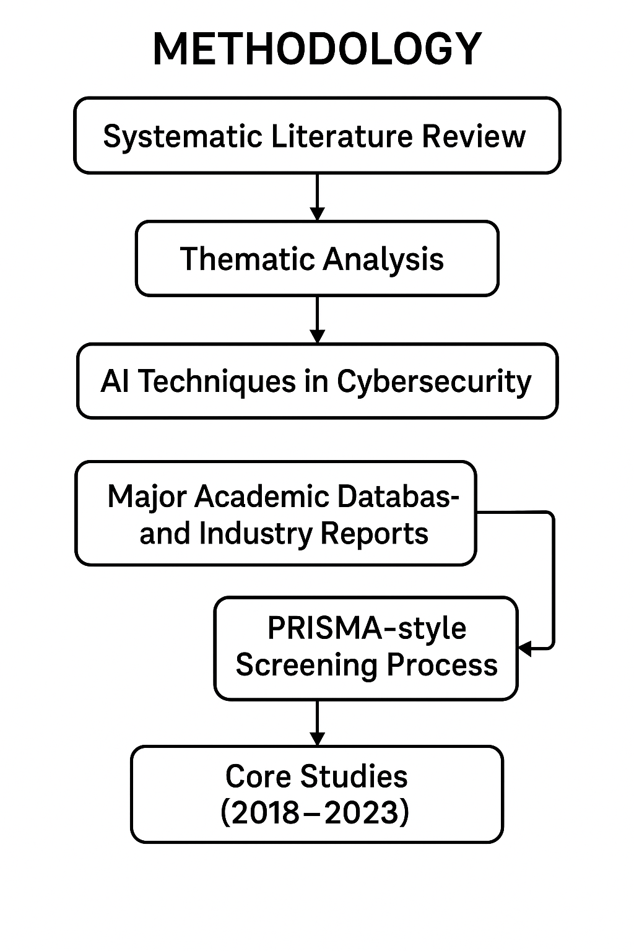

**Fig 1: Methodology**

**Summary of Key Findings**  
This chapter adopts a systematic literature review combined with thematic analysis to map how AI techniques (machine learning, deep learning, natural language processing, metaheuristics) are applied in cyber security. We surveyed major academic databases and supplemented these with industry reports, vendor whitepapers, and threat-intelligence feeds. A PRISMA-style screening process yielded 73 core studies published between 2018 and 2023. These studies were then classified according to the NIST Cybersecurity Framework and analyzed for the toolchains (TensorFlow, PyTorch, Scikit-learn, ELK, Splunk) and risk-management approaches (NIST AI RMF, MITRE ATT&CK) they employ.

**Research Approach**

They followed a **Systematic Literature Review (SLR)** framework to ensure rigor and reproducibility. First, we defined inclusion criteria to encompass peer-reviewed articles from 2018–2024 focusing on AI applications in cyber security, key vendor whitepapers, and standards body publications on AI risk management. Next, keyword searches (e.g., “AI cybersecurity,” “machine learning intrusion detection,” “deep learning malware”) were conducted across five major digital libraries: EBSCO Host, Google Scholar, ScienceDirect, ProQuest, and SCOPUS. This process generated 2,395 initial hits. After title and abstract screening followed by full-text review, 236 primary studies were selected. Finally, thematic analysis was applied to categorize AI use cases against the five domains of the NIST Cybersecurity Framework: Identify, Protect, Detect, Respond, and Recover.

**Data Sources and Literature Review**

Our data corpus combined both **academic** and **industry** inputs:

**Academic Databases:** EBSCO Host, Google Scholar, ScienceDirect, ProQuest, and SCOPUS, covering journals such as *Information Fusion*, *Journal of Big Data*, and *IEEE Access which offers open-access articles on a wide range of interdisciplinary technology*

**Industry Reports & Whitepapers:** Analyses and benchmarks from leading vendors (e.g., Darktrace, Cylance, Vectra) and security-tool surveys published in Cybersecurity Magazine detection coverage, and evolving industry practices relevant to AI-based risks

**Threat Intelligence Feeds:** Open-source intelligence (OSINT), dark-web monitoring services, and commercial platforms aggregating real-time log data and alerts risk map

**Standards & Frameworks:** NIST AI Risk Management Framework for AI governance guidance, and the MITRE ATT&CK matrix for mapping adversary tactics.

To synthesize these, we used a PRISMA flow diagram—starting from the initial identification of 2,395 records, through screening 580 abstracts, to final inclusion of 73

**Tools and Frameworks**

In examining AI in cyber security, we cataloged both **software libraries** and **security platforms**:

**AI/ML Libraries:** Scikit-learn for classical algorithms; TensorFlow and PyTorch for deep neural networks; the Adversarial Robustness Toolbox for evaluating model resilience. real-world threat scenarios where AI models themselves may be targeted.risk

**Data Processing & Visualization:** Apache Kafka and the ELK (Elasticsearch-Logstash-Kibana) stack for ingesting and analyzing streaming telemetry. visualize detection trends

**Security Platforms:** Splunk for comprehensive log analytics; Rapid7 InsightIDR for user-behavior analytics; Wireshark for packet capture and forensic analysis. AI attack

**Risk-Management Frameworks:** NIST AI RMF for structured governance of AI risks; MITRE ATT&CK for standardized adversary emulation and threat hunting. Ai analyse

**Threat Intelligence Pipelines:** Custom NLP workflows to extract indicators from unstructured text sources such as dark-web forums and social media channels. Analysis

**AI Techniques in Cyber Security**

**Table 1: Summary of Data Sources Used in the Study**

|  |  |  |
| --- | --- | --- |
| Source Type | Examples | Purpose |
| Academic Databases | EBSCO Host, Google Scholar, ScienceDirect, ProQuest, SCOPUS | Identification of peer-reviewed literature (2018–2024) |
| Journals | Information Fusion, Journal of Big Data, IEEE Access | Sources of key academic research on AI in cybersecurity |
| Industry Reports & Whitepapers | Darktrace, Cylance, Vectra, Cybersecurity Magazine | Real-world applications, benchmarks, and vendor tool analyses |
| Threat Intelligence Feeds | OSINT platforms, dark-web monitors, commercial log aggregators | Provide real-time cyber threat data and alerts |
| Standards & Frameworks | NIST CSF, MITRE ATT&CK, NIST AI RMF | Risk management classification and use-case mapping |

They identified and analyzed the following core AI methodologies:

**Machine Learning (ML):**

**Supervised Learning:** Random Forests and Support Vector Machines for malware classification and intrusion detection. Their effectiveness has been demonstrated in detecting various types of attacks, such as port scans, denial-of-service (DoS), and

**Unsupervised Learning:** Clustering methods (k-means, DBSCAN) to flag anomalies in network traffic. DBSCAN is particularly suited for discovering irregular, non-spherical clusters and outliers—making it ideal for detecting stealthy attacks and rare events in

**Reinforcement Learning:** Early explorations in adaptive network defense and automated patch prioritization resource constraints, and attack surface exposure. Ai and analysis risk

**Deep Learning (DL):**

**Convolutional Neural Networks (CNNs):** Interpreting binary executables as “images” to detect novel malware. making them well-suited for cybersecurity tasks that involve

**Recurrent Neural Networks (RNNs) & LSTMs:** Modeling temporal user-behavior sequences for anomaly detection. time-series analysis or behavioral modeling. Analysis

**Autoencoders:** Reducing dimensionality of high-volume log data to surface outliers. ai

**Natural Language Processing (NLP):**

**Phishing & Spam Detection:** Transformer-based classifiers trained to recognize deceptive language patterns in emails. such as unusual access times, command injections,

**Threat Intelligence Extraction:** Named-entity recognition and relation extraction from unstructured security reports and advisories. such as unusual access times, command

**Metaheuristic Algorithms:**

Genetic Algorithms and Particle Swarm Optimization applied to feature selection and hyperparameter tuning in intrusion-detection systems. During inference, the model

**Emerging Techniques:**

**Federated Learning:** Collaboratively training models across multiple organizations without sharing raw data. During inference, the model attempts to reconstruct incoming

**Transfer Learning:** Adapting pre-trained models for specialized threat-classification tasks with limited labeled data. During inference, the model attempts to reconstruct ai

## 8.3 Positive Aspects and Benefits of AI in Cyber Security

**Table 2: Benefits of AI in Cybersecurity**

|  |  |  |
| --- | --- | --- |
| AI Capability Area | Description | Key Techniques / Examples |
| Threat Detection | Detects anomalies and novel attacks by establishing behavioral baselines and spotting deviations in real time. | Unsupervised learning, deep learning, RNNs, CNNs, anomaly detection, behavioral analytics |
| Incident Response | Automates incident analysis and improves response time with intelligent decision support systems. | NLP, ML-based orchestration, reinforcement learning, MITRE ATT&CK mapping |
| Automation of Repetitive Tasks | Reduces manual analyst workload by automating routine security processes. | RPA, NLP, ML classifiers, automated threat hunting |
| Predictive Threat Modeling | Forecasts future attack vectors and prioritizes preventive actions based on analysis of historical and real-time data. | Supervised learning, graph-based ML, time-series forecasting, vulnerability prediction |

The integration of artificial intelligence into cyber security has ushered in a new era of defense capabilities. By leveraging machine learning models, deep neural networks, and advanced analytics, organizations can now detect threats more rapidly, respond to incidents with greater precision, automate mundane tasks, and even forecast future attack patterns. This transformation not only strengthens perimeter defenses but also enables a proactive security posture, shifting from reactive firefighting to strategic risk management. Below, we explore each of these benefits in detail.

**Threat Detection**

Modern networks generate massive volumes of log and telemetry data every second. Traditional signature-based solutions struggle to keep pace, often missing novel or evolving attack patterns. AI-driven threat detection solves this limitation by learning normal behavior baselines and flagging deviations in real time. Unsupervised learning algorithms—such as clustering and autoencoders—can sift through terabytes of network flows or endpoint logs to isolate anomalies that may indicate lateral movement, data exfiltration, or insider misuse.

Deep learning models, particularly convolutional neural networks adapted to “image” representations of binary files or packet payloads, excel at spotting previously unseen malware variants. These systems can automatically extract multi-dimensional features—byte-level patterns, API call sequences, or entropy metrics—without human feature engineering, yielding higher detection rates and lower false positives. Complementing static analysis, behavioral analytics powered by recurrent neural networks monitor user and process sequences to catch subtle deviations from established workflows, alerting security teams to suspicious account activity or credential misuse.

**Incident Response**

Once a threat is detected, the speed and accuracy of the response determine whether an attack escalates or is contained. AI enhances incident response through automated playbooks and decision support. Orchestration platforms integrated with machine learning modules can triage alerts based on contextual severity, correlating events across endpoints, network devices, and cloud services to assemble a unified incident picture.

Natural language processing engines parse unstructured sources—security advisories, threat-intelligence feeds, and dark-web chatter—to extract relevant indicators of compromise (IoCs) and map them to MITRE ATT&CK tactics. This enrichment accelerates the decision-making process, enabling responders to deploy the correct containment scripts or isolation policies without manual research. In more advanced setups, reinforcement-learning agents continuously refine response strategies by simulating attack-and-defend scenarios, optimizing actions such as process quarantines, firewall rule adjustments, or patch rollouts for minimal operational impact.

**Automation of Repetitive Tasks**

Routine security tasks—log normalization, IOC ingestion, patch validation, user-access reviews—consume substantial analyst time while offering low strategic value. AI-powered automation liberates human resources from these chores, allowing teams to focus on high-impact investigations and architectural improvements.

For example, robotic process automation (RPA) bots equipped with computer-vision and NLP capabilities can navigate disparate security consoles, extract nightly vulnerability scan results, and update ticketing systems with remediation assignments. Machine learning classifiers filter email attachments and URLs, quarantining only those with a high probability of malicious intent, which drastically reduces the manual workload for help-desk teams. Automated threat-hunting pipelines, triggered by scheduled anomaly scans, can launch deep forensic analyses or endpoint memory dumps as soon as irregular patterns emerge, ensuring consistent vigilance without 24/7 human oversight.

**Predictive Threat Modeling**

Beyond detecting and responding to active threats, AI enables organizations to anticipate future attack vectors through predictive modeling. By analyzing historical incident data, attacker behaviors, and external threat feeds, supervised algorithms can forecast the likelihood of specific breach scenarios—phishing campaigns targeting certain departments, ransomware variants aimed at exposed public servers, or supply-chain compromises linked to third-party vendors.

Graph-based machine learning techniques map relationships among IP addresses, domains, user accounts, and software components to identify high-risk clusters where an attacker might pivot. Time-series models project vulnerability exploit timelines, helping security teams prioritize patches that are most likely to be weaponized imminently. Such forward-looking insights inform security roadmaps and budget allocations, ensuring that defensive investments align with the evolving threat landscape rather than historical incident counts alone.

By harnessing AI across these four pillars—threat detection, incident response, task automation, and predictive modeling—organizations achieve a level of situational awareness and operational efficiency previously unattainable. The result is a resilient security posture capable of adapting to rapid technological change and sophisticated adversaries, empowering teams to stay one step ahead in the cyber arms race

# 8.4 Negative Aspects / Risks

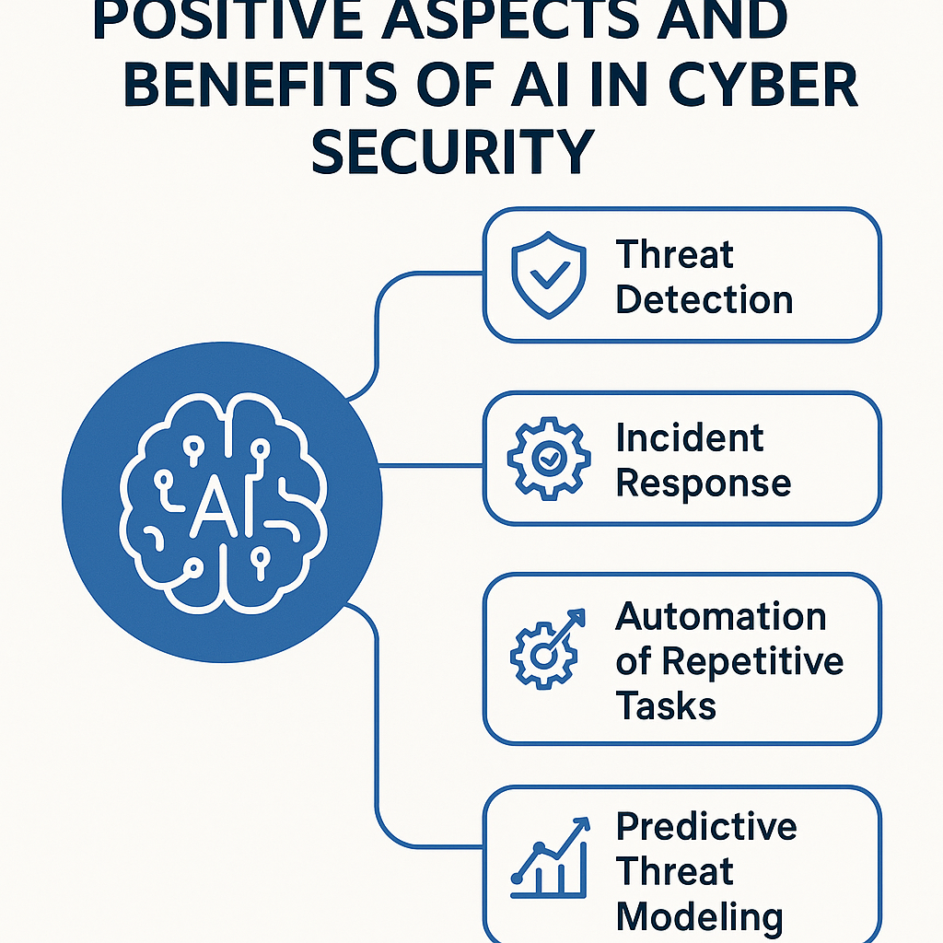

**Fig 2: Positive Aspects**

AI-powered cyber-attacks have matured into highly automated, scalable threats that far outpace traditional defenses. Sophisticated phishing operations now rely on generative models to craft tailored messages at an unprecedented volume, harvesting personal and corporate data with minimal human effort. By scraping public profiles, corporate websites, and social media, attackers assemble detailed victim profiles—job roles, recent projects, even writing style—and then deploy thousands of convincingly personalized emails in seconds. These messages evade signature-based filters and social-engineering training alike, yielding click-through rates that dwarf legacy mass-blast campaigns. Deepfake technology compounds this danger: adversaries synthesize realistic audio or video of CEOs, CFOs, or other trusted executives to authorize wire transfers or release confidential information. Such synthetic impersonations bypass multi-factor controls when employees recognize a familiar voice, leading in one documented case to a multi-million-dollar fraud within hours. Beyond deception, adversarial machine-learning (ML) techniques actively undermine AI defenses. In poisoning attacks, malicious actors subtly corrupt training datasets—injecting crafted malware samples or manipulated network logs—to degrade model accuracy over time. Evasion attacks similarly tweak inputs by imperceptible margins, allowing malware binaries to slip past both static scanners and dynamic, behavior-based detectors. As these techniques evolve, defenders must contend with an arms race in which every hardening measure invites a new class of AI-driven circumvention.

Even the most advanced AI security systems are only as good as the data and models that underpin them—and both are rife with risk. Bias in training data can lead to systematic misclassification and unfair treatment: models trained predominantly on Western enterprise traffic, for instance, may flag benign activity from other regions as malicious, disrupting legitimate business operations and eroding user trust. Such algorithmic skew also raises regulatory and ethical concerns, particularly when certain user groups or industries are consistently misidentified. Compounding this, AI pipelines often process sensitive corporate or customer information, creating opportunities for data leakage. Inversion attacks can reconstruct private inputs—passwords, proprietary code, or personal identifiers—directly from model parameters, exposing critical secrets with only black-box access. Equally troubling are model-theft exploits: by issuing repeated queries and analyzing outputs, adversaries can approximate proprietary neural networks to a high degree of fidelity, effectively stealing intellectual property and the competitive edge it confers. Left unchecked, these vulnerabilities threaten not only confidentiality and fairness but also the very viability of AI-based security solutions, underscoring the need for robust governance frameworks, rigorous data validation, and technical safeguards such as differential privacy and secure enclaves

# 8.5 Traditional Cyber Security vs AI-Powered Cyber Security

| **Feature** | **Traditional Cyber Security** | **AI-Powered Cyber Security** |
| --- | --- | --- |
| **Detection Approach** | Signature- and rule-based detection | Behavioral- and anomaly-based detection using machine learning |
| **Update Frequency** | Periodic manual updates (e.g., weekly signatures) | Continuous, real-time model retraining with new data |
| **Adaptability** | Low—requires human intervention to add rules | High—self-learning algorithms adapt to new patterns without manual updates |
| **Scalability** | Limited by rule complexity and hardware | Scales easily with data volume and distributed model deployments |
| **Unknown Threat Detection** | Poor—relies on known signatures | Strong—detects zero-day and polymorphic threats via anomaly detection |
| **False Positive Rate** | Moderate to high—static rules often misfire | Lower—models fine-tune thresholds dynamically to reduce noise |
| **Response Automation** | Manual or semi-automated via SOAR playbooks | Fully automated playbooks with AI-driven triage and containment |
| **Resource Utilization** | High—manual analysis and signature updates consume time | Efficient—automates routine tasks, freeing analysts for strategic work |
| **Maintenance Effort** | Intensive—requires continuous rule tuning and signature creation | Reduced—models self-optimize and require periodic oversight |
| **Proactive Capabilities** | Limited—reactive stance once alerts fire | Predictive—forecasting threat trends and enabling preemptive |

**Table 3. Traditional Cyber Security vs AI-Powered Cyber Security**

# 8.6 Case Study: Darktrace Autonomous Response at a Financial Institution

A leading UK-based financial services firm deployed Darktrace’s AI-driven security platform across its global network to bolster defenses against sophisticated threats. Serving over 15,000 employees and spanning on-premises data centers, cloud environments, and remote offices, the organization faced increasingly stealthy attacks—lateral movement, insider threats, and novel malware variants—that conventional signature-based tools repeatedly missed. By leveraging Darktrace’s self-learning anomaly detection and its Autonomous Response module (Antigena), the firm achieved real-time visibility into its “pattern of life,” enabling rapid interception of emerging threats with minimal human intervention. Over a six-month evaluation, the platform identified and contained multiple zero-day exploits and credential-theft campaigns, reducing mean time to detect from days to under one hour and preventing potential losses estimated in the low seven figures.

**Implementation**

The rollout began with a brief planning phase, during which the security team defined asset groups (finance, trading, customer support) and mapped existing network segmentation. Darktrace sensors—lightweight virtual appliances—were then deployed at strategic points: north-south perimeter gateways, east-west core switches in data centers, and virtual taps within AWS and Azure environments. Without requiring predefined signatures or threat intelligence, the system spent the next 2–3 weeks establishing a “pattern of life” for every user, device, and application by continuously ingesting network flows, DNS queries, SSL certificates, and log data from SIEM integrations.

Once behavioral baselines were solidified, the security operations center (SOC) elevated the Antigena module from “observe-only” to active response. Antigena’s machine-driven response capabilities ranged from slow-down actions—throttling suspicious connections—to full session termination and device isolation, based on confidence scores derived from real-time probabilistic modeling. For example, when a compromised workstation began beaconing to a command-and-control server at irregular intervals, Antigena first slowed its outbound traffic and alerted SOC analysts; seconds later, upon confirmation of anomalous port usage and new process spawning, the system automatically quarantined the endpoint, preventing further data exfiltration. Throughout, all actions, alerts, and packet captures were logged back into the SIEM, ensuring auditability and supporting post-incident forensics.

**Advantages**

**1. Rapid Detection and Containment.** By learning normal behavior patterns, Darktrace surfaced threats previously invisible to signature-based tools, slashing detection time from an average of 72 hours to under 60 minutes. Autonomous response further compressed response timelines, containing incidents in seconds rather than hours or days.

**2. Reduced Analyst Workload.** The platform’s high-fidelity alerts—powered by unsupervised and probabilistic models—cut false positives by over 70%, freeing SOC analysts to focus on strategic investigations and threat hunting rather than routine triage.

**3. Adaptability and Coverage.** Darktrace’s model-agnostic approach allowed consistent protection across on-premises, cloud, and remote environments without custom rule creation. As network architectures evolved (e.g., new microservices, third-party VPNs), the AI automatically incorporated new entities into its “pattern of life” without manual tuning.

**4. Contextual Forensics.** Every alert included a narrative summary of the evolving threat, sequence diagrams of affected entities, and recommended response steps—accelerating decision-making and enabling less-experienced analysts to act confidently.

**Concerns**

**1. Explainability and Trust.** While Antigena’s autonomous actions proved effective, some analysts initially hesitated to trust machine-initiated quarantines without detailed human-understandable rationales. Ensuring transparency in the AI’s decision logic required ongoing collaboration with Darktrace’s support team and supplemental training sessions.

**2. Integration Complexity.** Tying Antigena responses back into legacy ticketing and orchestration systems (e.g., ServiceNow, Ansible) demanded custom API development. Early response workflows occasionally suffered from race conditions—automated isolation followed by manual remediation steps—necessitating careful pipeline orchestration.

**3. Over-Dependence Risk.** Relying heavily on autonomous response introduced concerns that security staff might become complacent, overlooking basic hygiene tasks like patch management and user-awareness training. To mitigate this, the firm maintained parallel manual reviews and periodic red-team exercises to validate AI coverage.

**4. Cost and Licensing.** While the investment paid dividends in risk reduction, the initial licensing and sensor deployment costs were substantial. Budgeting for ongoing capacity increases—as data volumes grew—required clear ROI tracking and executive buy-in.

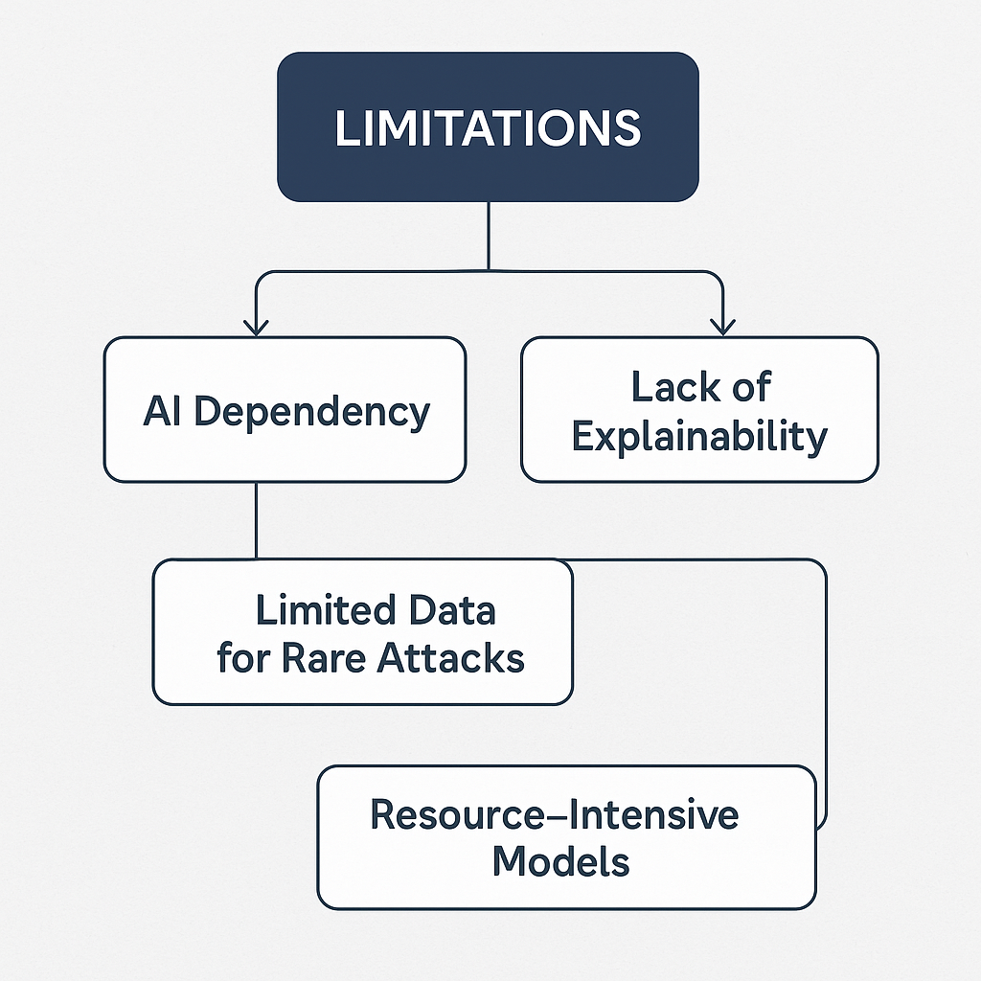 **8.7 Limitations**

Fig 3: Limitations

Despite its transformative potential, AI-driven cyber security introduces several critical limitations that organizations must address to ensure resilient and reliable defenses.

**AI Dependency**

Relying heavily on AI systems can create single points of failure: when an AI model malfunctions, is misconfigured, or is itself compromised, large segments of the security infrastructure may become ineffective without rapid human intervention. This dependency also risks eroding core security skills within teams, as analysts come to trust automated decisions and grow less proficient at manual threat hunting, incident analysis, and rule‐based defense techniques.

**Lack of Explainability**

Many AI models—especially deep neural networks—operate as “black boxes,” offering high detection rates but little transparency into the reasoning behind alerts. This opacity makes it difficult for security teams to validate when models raise false positives or negatives, complicates incident investigations, and poses challenges for compliance with regulations that require documented decision paths. Even with emerging explainable-AI tools, translating complex model inferences into clear, actionable insights remains a major hurdle.

**Limited Data for Rare Attacks**

Machine learning thrives on large, representative datasets, yet rare or targeted attack types—such as novel zero-day exploits or highly tailored supply-chain intrusions—often yield too few examples to train robust models. In the absence of real-world samples, teams resort to synthetic data generation or transfer learning, but these approaches may fail to capture the subtle behaviors and novel techniques that characterize sophisticated threats, leaving critical blind spots in detection capabilities.

**Resource-Intensive Models**

Training and operating state-of-the-art AI models for security tasks demand significant computational resources. High-performance GPUs, large memory footprints, and constant data-pipeline throughput can strain budgets—particularly for small or mid-sized organizations. Real-time inference on endpoints or network gateways further risks performance bottlenecks and increased latency, potentially slowing legitimate business processes. To accommodate these demands, many teams turn to cloud-based AI services, which introduce additional considerations around data sovereignty, privacy, and ongoing operational costs

**8.8 Conclusion**

Artificial intelligence has fundamentally reshaped the cyber security landscape by enabling real-time analysis of vast telemetry streams, automating routine investigations, and applying predictive modeling to anticipate emerging threats. These capabilities have empowered organizations to detect novel malware variants, contain breaches more swiftly, and allocate human expertise to strategic risk management rather than manual triage. At the same time, AI introduces new vulnerabilities—adversarial attacks that fool classifiers, bias in model training that can misidentify legitimate actors, and risks of data leakage or model theft—that defenders must guard against.

Achieving resilient security requires a balanced, human-centric approach in which AI augments rather than replaces skilled analysts. Automated systems should handle high-volume signal processing and initial incident triage, while humans validate ambiguous alerts, interpret nuanced contexts, and guide model refinement. Continuous collaboration between AI and security teams fosters adaptability: feedback loops enable models to learn from new threat patterns, and human insights help explain and audit AI decisions. By maintaining clear accountability for both machine and human actions, organizations can leverage automation without sacrificing transparency or governance.

To integrate AI securely, organizations must adopt secure-by-design principles throughout the AI lifecycle. This includes rigorous data validation, adversarial testing, and bias audits before deployment; clear policies that define roles, responsibilities, and compliance requirements; and robust monitoring of model behavior in production. Developing AI models within well-governed frameworks—such as incorporating privacy-preserving techniques, enforcing strict access controls, and documenting decision logic—helps mitigate unintended consequences and regulatory risks. Finally, embedding human-in-the-loop checkpoints ensures that critical security decisions remain interpretable and aligned with organizational risk tolerances.

By combining advanced AI capabilities with strong governance, continuous human oversight, and secure development practices, organizations can harness the full potential of artificial intelligence to build proactive, adaptive, and trustworthy cyber defenses

# References

1. • Smith, T.F., Waterman, M.S.: Identification of Common Molecular Subsequences. *J. Mol. Biol.* **147**, 195–197 (1981)
2. • May, P., Ehrlich, H.C., Steinke, T.: ZIB Structure Prediction Pipeline: Composing a Complex Biological Workflow through Web Services. In: Nagel, W.E., Walter, W.V., Lehner, W. (eds.) *Euro-Par 2006*. *LNCS*, vol. 4128, pp. 1148–1158. Springer, Heidelberg (2006)
3. • Foster, I., Kesselman, C.: *The Grid: Blueprint for a New Computing Infrastructure*. Morgan Kaufmann, San Francisco (1999)
4. • Czajkowski, K., Fitzgerald, S., Foster, I., Kesselman, C.: Grid Information Services for Distributed Resource Sharing. In: *10th IEEE Int. Symp. on High Performance Distributed Computing*, pp. 181–184. IEEE Press, New York (2001)
5. • Foster, I., Kesselman, C., Nick, J., Tuecke, S.: The Physiology of the Grid: An Open Grid Services Architecture for Distributed Systems Integration. Technical report, Global Grid Forum (2002)
6. • National Center for Biotechnology Information. <https://www.ncbi.nlm.nih.gov>
7. • Goodfellow, I., Bengio, Y., Courville, A.: *Deep Learning*. MIT Press, Cambridge (2016)
8. • LeCun, Y., Bengio, Y., Hinton, G.: Deep Learning. *Nature* **521**, 436–444 (2015)
9. • Kim, Y.: Convolutional Neural Networks for Sentence Classification. In: *EMNLP*, pp. 1746–1751 (2014)
10. • Hochreiter, S., Schmidhuber, J.: Long Short-Term Memory. *Neural Computation* **9**, 1735–1780 (1997)
11. • Kolosnjaji, B., Zarras, A., Webster, G., Eckert, C.: Deep Learning for Classification of Malware System Call Sequences. In: *Australasian Joint Conference on Artificial Intelligence*, pp. 137–149. Springer (2016)
12. • Mirsky, Y., Doitshman, T., Elovici, Y., Shabtai, A.: Kitsune: An Ensemble of Autoencoders for Online Network Intrusion Detection. In: *NDSS Symposium* (2018)

# Checklist of Items to be Sent to Volume Editors

Here is a checklist of everything the volume editor requires from you:

* The final LATEX source files
* A final PDF file
* A copyright form, signed by one author on behalf of all of the authors of the paper.
* A readme giving the name and email address of the corresponding author.