Climate Change Prediction and Impact Assessment: Understanding the Science and Planning for the Future

**Shilpa Sharma**

Assistant Professor, Department of Computer Science and Engineering, Apex Institute of Technology (AIT-CSE), Chandigarh University

E-Mail: [shilpa.e17638@cumail.in](mailto:shilpa.e17638@cumail.in) , [sharmashilpa365@gmail.com](mailto:sharmashilpa365@gmail.com)

ORCID: <https://orcid.org/0009-0002-1405-5566>

**Abstract**

Long-term variations in temperature, precipitation, wind patterns, and other aspects of the Earth's climate system are referred to as climate change. Because of human activities like burning coal, oil, and gas, clearing forests, and exploiting land in ways that are not sustainable, these changes are occurring more quickly now. Large volumes of greenhouse gasses, including carbon dioxide (CO₂) and methane (CH₄), are released into the atmosphere as a result of these activities. The greenhouse effect is when heat from the sun is trapped by these gases, warming the globe.

Making predictions about future climate change is crucial. Climate models, which are sophisticated computer programs that mimic the Earth's climate system, are used by scientists. These models consider a number of variables, including human emissions, cloud cover, ocean currents, and solar radiation. We can forecast future temperature increases, sea-level changes, and the frequency of extreme weather events like hurricanes, floods, and droughts by executing various scenarios, such as how the climate would change if emissions increase or decrease.

Traditional models are now being combined with new technologies, particularly machine learning (ML) and artificial intelligence (AI), to enhance predictions. Large datasets can be analyzed by AI to find intricate patterns that improve the accuracy and speed of local climate impact forecasting.

Globally, the effects of climate change are already being felt. For instance, increased wildfires, water shortages, and health issues can result from rising temperatures. Cities along the coast are at risk from rising sea levels, and agriculture and food security are negatively impacted by erratic rains. Since many plants and animals find it difficult to adjust to the changing climate, biodiversity is also at jeopardy. Human populations are frequently the most susceptible since they have fewer resources to defend themselves, particularly in impoverished or rural locations.

We require both adaptation and mitigation techniques to lower these dangers. Mitigation entails lowering the causes of climate change, such as preserving forests that absorb CO2, increasing energy efficiency, and moving to renewable energy sources like solar, wind, and hydro. Preparing for the changes that are already occurring, such as strengthening infrastructure, creating crops resistant to drought, and enhancing early warning systems for disasters, is known as adaptation.

Keywords: Climate change, greenhouse gases, global warming, renewable energy, adaptation.

1. **Introduction to Climate Change**

Significant, long-term changes in regional or worldwide climatic patterns, especially those that have arisen from the middle to late 20th century, are referred to as climate change. Human activity is the main cause of this phenomenon, particularly the burning of fossil fuels like coal, oil, and natural gas, which releases significant amounts of greenhouse gases (GHGs) into the atmosphere. The Earth's climate system's natural equilibrium is upset by these gases, which trap heat.

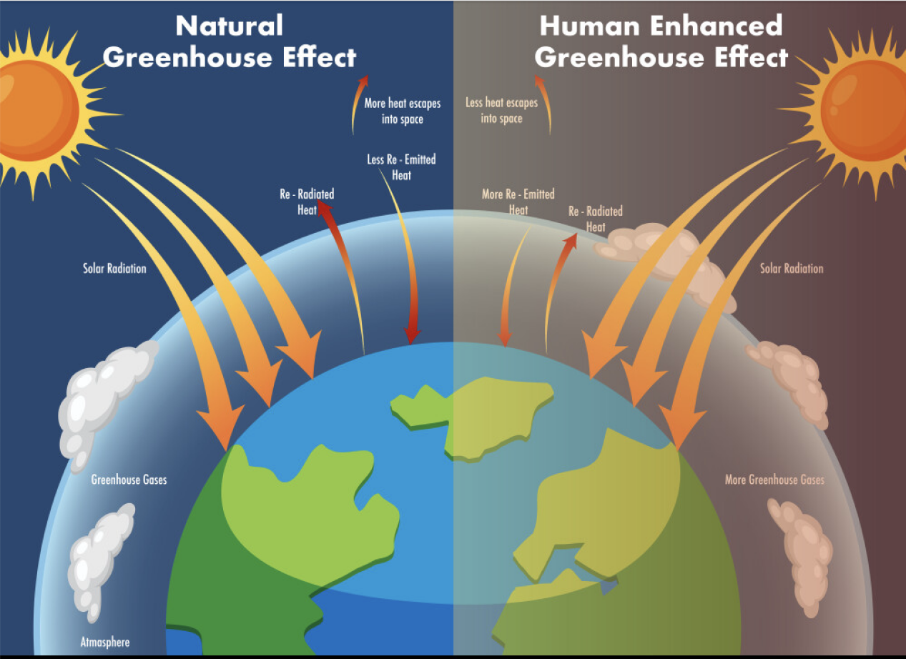

Figure 1: Illustration of the Greenhouse Effect[1]

Source: [www.freepik.com](https://www.freepik.com/)

Natural phenomena including volcanic eruptions, variations in solar radiation, and changes in Earth's orbit have all historically caused changes in the planet's temperature. Nonetheless, the present pace of climate change is unparalleled and closely associated with human-caused factors. A major turning point was the Industrial Revolution, when deforestation, urbanization, and massive energy usage started to alter the atmosphere. It is highly probable that human activity was responsible for over half of the observed rise in the average global surface temperature between 1951 and 2010, according to the Intergovernmental Panel on Climate Change (IPCC).

The consequences of climate change are widespread and multifaceted. Rising global temperatures, changing precipitation patterns, the melting of glaciers and ice caps, and rising numbers of extreme weather events like hurricanes and droughts are all evidence of a warming world.

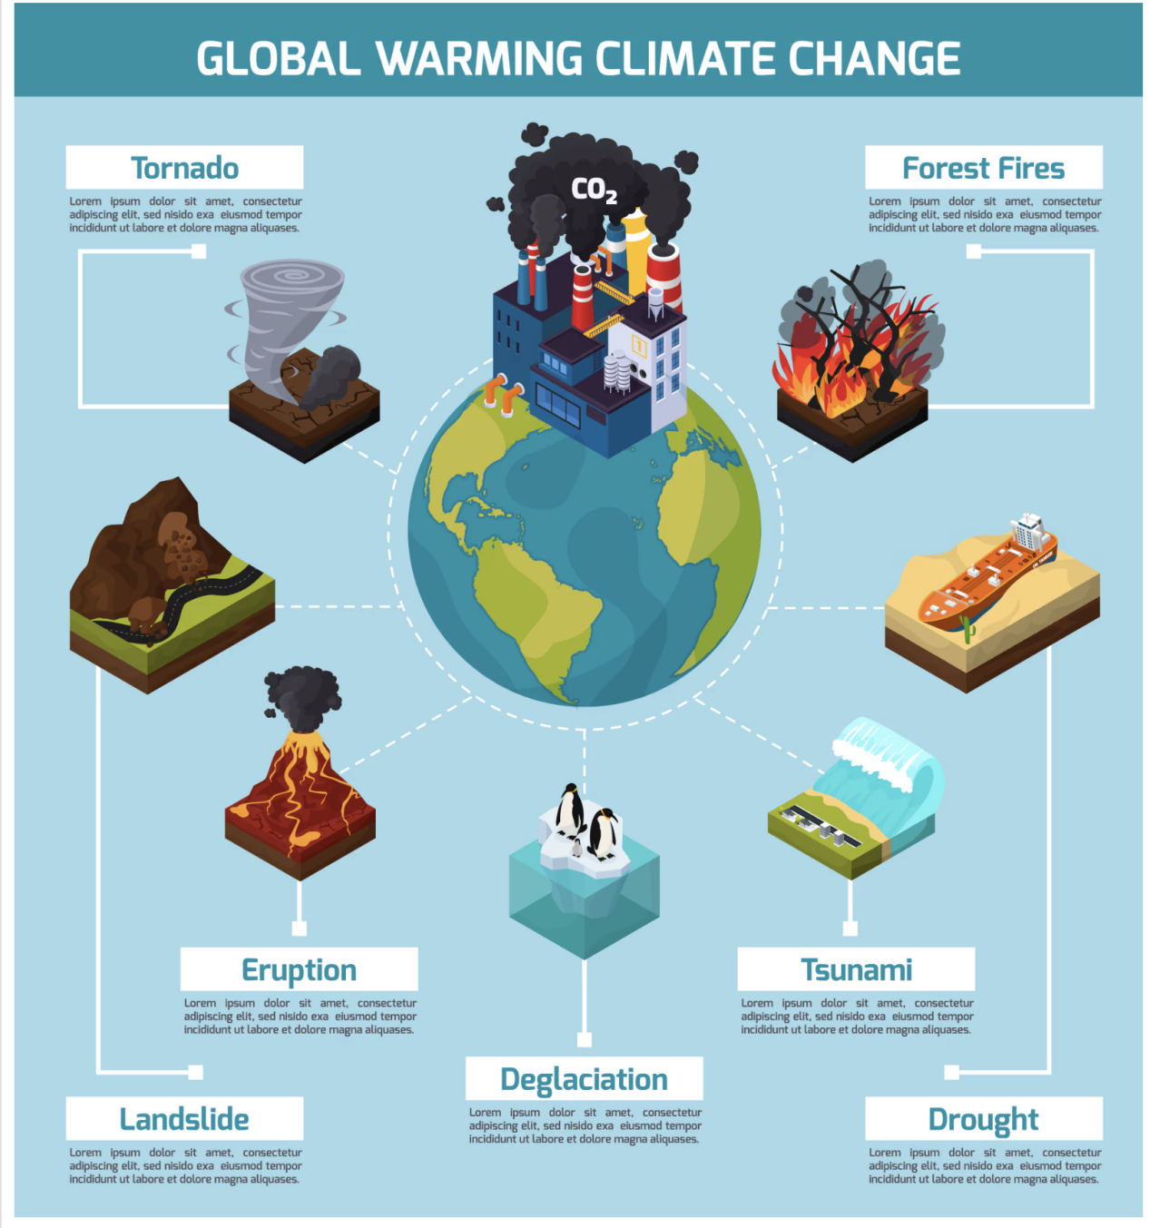

Figure 2: Climate Change Impacts Info-graphic[2]

Source: [www.freepik.com](https://www.freepik.com/)

All these changes pose significant threats to ecosystems, biodiversity, food security, water resources, and human health. Climate change, as a global challenge, requires a concerted international response that encompasses both mitigation and adaptation measures.

Climate change needs to be understood through an interdisciplinary framework that cuts across atmospheric sciences, oceanography, ecology, economics, and social sciences. This chapter will try to examine the causes, predictive models, global effects, and the urgent need for mitigation and adaptation in the context of a changing climate. It will also examine the role of contemporary technologies, such as artificial intelligence and machine learning, in improving our capacity to predict and react to climatic changes.

Within the introductory section above, we established the groundwork to have a clearer discussion on climate change. Subsequent sections shall delve into each mechanism of climate change, predictors and impact determinants, as well as executable actions that governments, communities, and individuals everywhere can undertake.

1. **Materials and Methods**

**Greenhouse Gases and the Greenhouse Effect**

The greenhouse effect is a natural phenomenon that heats the Earth's surface. As the Sun's energy arrives at the Earth, some of it bounces back into space and the rest gets absorbed, heating the planet. The Earth subsequently emits infrared radiation. Greenhouse gases trap infrared radiation and keep the heat within the atmosphere so that it doesn't escape to space. Trapped heat heats the Earth's surface and maintains the planet livable.

The principal greenhouse gases causing this impact are carbon dioxide (CO₂), methane (CH₄), nitrous oxide (N₂O), water vapor, and ozone (O₃). Even though the most plentiful of these greenhouse gases is water vapor, its atmospheric concentration is chiefly regulated by temperature. CO₂, CH₄, and N₂O, however, are human-activity-influenced directly. All of these gases have different global warming potentials (GWP), which is how much they trap heat in the atmosphere during a given period, typically 100 years.

The most prominent greenhouse gas, carbon dioxide, is generated through the combustion of fossil fuels, deforestation, and industrial processes. Methane is emitted through the extraction and transportation of coal, oil, and gas and from livestock and other farming activities. Agricultural activities, industries, the burning of fossil fuels, and biomass release nitrous oxide emissions.

The intensification of the greenhouse effect means the additional heat trapping in the atmosphere caused by the higher levels of greenhouse gases due to human activities. It results in rising global average temperatures, popularly known as global warming. Since the last century, the Earth's mean surface temperature has risen by approximately 1.1°C (2.0°F), and warming has been happening at an ever-increasing pace in recent decades.

The impacts of a strengthened greenhouse effect are extensive. They encompass more frequent and severe heatwaves, altered precipitation patterns, sea level rise, and ecosystem disruption. Polar ice is melting at record levels, adding to sea level rise and putting coastal populations at risk. Changes in temperature and precipitation can also influence the distribution and health of plant and animal species, resulting in altered biodiversity and ecosystem services.

Mitigating the greenhouse effect involves an extensive knowledge of sinks and sources of greenhouse gases. Sinks refer to natural sinks that trap more carbon than they release, for example, oceans, forests, and soil. Conservation and increasing these sinks is essential to maintaining GHG concentration in the atmosphere. Additionally, curbing emissions through the adoption of energy efficiency, renewable energy, and use of sustainable land use management practices is important to reducing the impact of climate change.

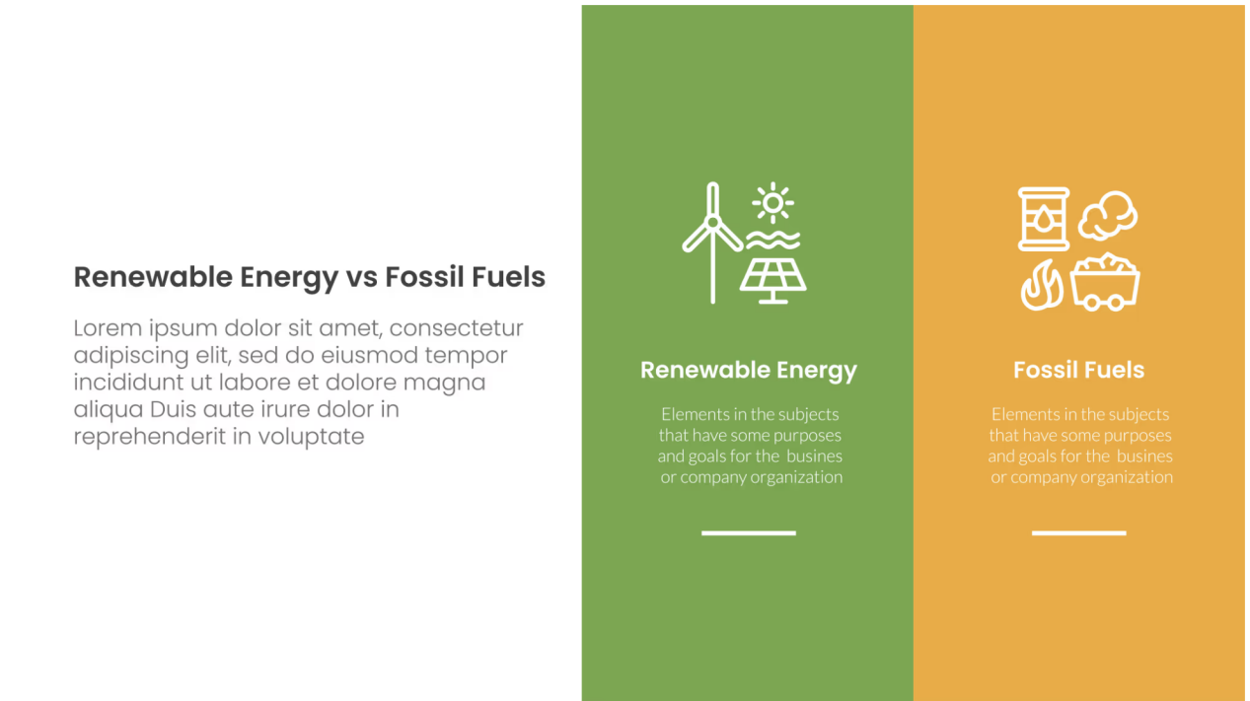

Figure 3: Comparison of Renewable Energy vs Fossil Fuels[3]

Source: [www.freepik.com](https://www.freepik.com/)

**Historical Climate Trends and Evidence of Change**

The climate of the Earth has always changed, but the rate and scale of change now are unparalleled in human history. Past climate trends allow scientists to learn about natural variability and separate natural and anthropogenic changes.

Paleo-climate information derived from ice cores, tree rings, sediment layers, and corals are evidence of past climate. Ice cores, for example, have trapped air bubbles that indicate past CO₂ levels and temperatures. These records indicate that during the last 800,000 years, CO₂ levels never went above 300 ppm—until recently.

Instrumental records over the last 150 years provide accurate measurements of temperature, rainfall, and atmospheric composition. These records reveal a definite increasing trend in global temperatures, particularly since the late 20th century. The past decade has been the warmest decade ever, NASA and the National Oceanic and Atmospheric Administration (NOAA) reported.

Sea level measurements also confirm warming trends. The global sea levels have increased approximately 20 cm since 1900 as a result of thermal expansion of ocean water and glacial melting. Arctic sea ice coverage has decreased significantly, and some estimates propose ice-free summers in the Arctic Ocean by the mid-century.

Biological indicators like advanced flowering of flowers, changes in the migration of animals, and shifts in species distribution also indicate a changing climate. Coral reefs are undergoing widespread bleaching because of increasing ocean temperatures.

Climate models that include only natural forcings (such as volcanic eruptions and sunspots) can explain neither the recent acceleration of warming since the mid-20th century. But models that account for human emissions closely replicate the observed record, building evidence to support the conclusion that human activities are the leading cause of recent climate change.

Understanding historical trends provides valuable context for predicting future climate scenarios and informs adaptation strategies. It also emphasizes the urgency of reducing emissions to prevent irreversible changes.

**Climate Modeling and Simulation Techniques**

Climate modeling is a foundation of climate science. Models mimic the Earth's climate system to project future change based on assumptions. These mathematical devices are constructed using physical principles like thermodynamics, fluid dynamics, and radiation transfer.

General Circulation Models (GCMs) are complete models that depict the interactions between the atmosphere, oceans, land surface, and ice. The models subdivide the Earth into a grid system of three-dimensional cells. Climate variables such as temperature, pressure, humidity, and wind speed are computed for every grid cell with respect to time.

Models are tested for accuracy through hindcasting—comparing their outputs with historical data. If a model can accurately simulate past climate, it is considered reliable for future projections. Multiple models are often used in ensemble simulations to capture a range of possible outcomes and reduce uncertainty.

Scenarios used in climate modeling include Representative Concentration Pathways (RCPs), which describe different greenhouse gas concentration trajectories. For example, RCP2.6 assumes strong mitigation, while RCP8.5 represents a high-emissions future. More recently, Shared Socioeconomic Pathways (SSPs) combine socioeconomic trends with emissions trajectories.

Down scaling techniques enhance model resolution for regional analysis. Dynamic down scaling uses regional climate models nested within GCMs, while statistical down scaling relies on observed data to refine projections. These methods are essential for informing local planning and adaptation.

Models have limitations, including difficulties in simulating cloud dynamics and regional variability. However, advances in computing power, data collection, and machine learning are continuously improving model accuracy.

Climate models inform international climate policy, risk assessment, and infrastructure design. They help identify vulnerable regions, plan for sea-level rise, and assess the effectiveness of mitigation strategies. As tools of both science and policy, climate models are indispensable in the global response to climate change.

**Role of Artificial Intelligence and Machine Learning in Climate Prediction**

Artificial Intelligence (AI) and Machine Learning (ML) are soon becoming indispensable tools in the improvement of climate science. These technologies provide the ability to analyze enormous quantities of data, identify patterns, and produce insights at high speeds and accuracy that conventional techniques can only hope to emulate. AI and ML algorithms have transformed weather forecasting, climate modeling, environmental monitoring, and hazard forecasting.

One major advantage of AI is its ability to analyze large datasets such as satellite imagery, sensor outputs, and historical climate records. Machine learning algorithms, including deep learning networks, can identify trends, classify climatic phenomena, and predict events such as heatwaves, floods, and storms. These predictions can be made faster and sometimes with more localized precision than classical numerical models.

AI assists climate modeling by optimizing the calibration of current models, detecting anomalies, and enhancing parameterization schemes. AI can be employed to create surrogate models that mimic intricate simulations, lowering computation time by a large margin. Further, AI methods can improve data assimilation by merging real-time observations with climate forecasts, making them more reliable.

Some examples of AI applications are Google's Earth Engine, which tracks land-use changes and deforestation through satellite imagery, and IBM's Green Horizons project, which provides air pollution forecasts based on AI. Machine learning is also being used to forecast renewable energy generation by simulating solar radiation and wind patterns.

Despite its potential, the use of AI in climate science presents challenges. AI models require large, high-quality datasets and may lack interpretability compared to physical models. They can also be biased if trained on incomplete or skewed data. Thus, combining AI with domain knowledge and traditional modeling remains essential.

**Global Environmental Impacts of Climate Change**

The environmental consequences of climate change are extensive and multifaceted, affecting ecosystems, natural resources, and the overall health of the planet. Rising temperatures, altered precipitation patterns, and increased frequency of extreme events disrupt the balance of nature and threaten biodiversity.

One of the most dramatic impacts is the melting of glaciers and polar ice caps. This not only contributes to sea-level rise but also affects ocean currents and weather patterns. The loss of Arctic sea ice has profound implications for global climate regulation, as it reduces the Earth’s reflectivity, leading to further warming in a feedback loop.

Ocean acidification is also a huge concern. Oceans are acidifying as they take up additional CO₂ from the air, and pH lowers, the water becomes more acidic. It hurts marine animals, especially animals that form calcium carbonate shells or skeletons, including corals, mollusks, and certain plankton. Coral reefs, these hotspots of biodiversity, are particularly sensitive to this problem.

Terrestrial ecosystems are affected by increasing temperatures and altered precipitation, which stress forests, grasslands, and wetlands. Wildfires with growing frequency and intensity burn habitats and emit vast quantities of CO₂, adding to the causes of climate change. Shifts in species distribution may cause disturbances in ecological interactions and loss of keystone species.

Freshwater environments are impacted as well. Snow melt timing and rainfall shifts decrease water supply in certain areas and create flooding in others. Numerous rivers that rely on glacier melt are experiencing diminishing flows, and this has implications for agriculture, drinking water supply, and electricity generation.

Ecosystems supply essential services—like carbon storage, water filtering, and pollination—that human survival depends upon. As they deteriorate, their capacity to deliver these services declines, which results in growing environmental and social threats.Adaptation measures include ecosystem restoration, afforestation, conservation of wetlands and mangroves, and the implementation of protected areas. These actions not only protect biodiversity but also help buffer human communities from climate impacts.

**Economic and Social Consequences**

Climate change imposes significant economic and social costs worldwide. The increasing frequency and severity of climate-related disasters strain public finances, disrupt supply chains, and displace populations. The costs of inaction are mounting and affect both developed and developing nations.

Agriculture is one of the most exposed sectors. The yields of crops are being decreased by heat stress, altered rainfall, and rising pests and diseases. Livestock suffer from heat-related health problems, and fisheries are impacted by warming and acidification of oceans. This leads to increased food costs and higher food insecurity, especially in poor nations.

Climate change impacts infrastructure too. Roads, bridges, and buildings are not built for the more intense weather of the future. Flooding destroys transport infrastructure, while heat warps rails and runways. Coastal cities are at risk from sea-level rise and storm surges, which can be expensive to adapt to or relocate from.

Public health is also at stake. Higher temperatures increase heat-related illness, worsen respiratory diseases with air pollution, and facilitate the transmission of diseases such as malaria and dengue fever. The most vulnerable populations, the elderly, children, and people with pre-existing illnesses, are especially at risk.

Social inequality is exacerbated by climate change. Affluent communities are able to invest in adaptation and recovery, while the poor bear the brunt. Climate-related displacement, both within and across national borders, exacerbates existing social tensions and potentially results in conflict and instability.

The insurance industry is seeing higher claims due to natural disasters, prompting increases in premiums or withdrawal of coverage in high-risk areas. This poses a threat to financial markets and local economies.

Addressing these economic and social consequences requires investments in climate resilience, social protection programs, public health infrastructure, and inclusive planning. International cooperation is key to supporting vulnerable nations and sharing technology, knowledge, and financial resources.

**Case Study: Climate Vulnerability in Developing Countries**

Developing countries are disproportionately affected by climate change despite contributing the least to global emissions. Their vulnerability stems from high exposure to climate hazards and limited adaptive capacity due to economic, technical, and institutional constraints.

Agriculture is a major source of livelihood in most of these nations and is greatly affected by climate variability. Extended droughts, irregular rainfall, and severe weather conditions such as cyclones and floods result in crop failure, hunger, and economic loss. For instance, East African nations often suffer from droughts that destroy livestock and lower food security.

Urban centers in developing countries usually do not have resilient infrastructure. Sub standardly constructed housing, poor drainage systems, and congestion heighten the vulnerability to disaster. Monsoon flooding frequently displaces millions of people in South Asia, destroying homes and transmitting disease.

Sea-level rise poses an existential threat to small island developing states (SIDS) like the Maldives, Kiribati, and Tuvalu. Even moderate rises can contaminate freshwater supplies, erode coastlines, and force population relocation.

Financial constraints hinder adaptation. Many developing countries rely on international aid and climate finance mechanisms, such as the Green Climate Fund, to implement climate resilience projects. However, access to these funds is often hampered by bureaucratic challenges and lack of technical expertise.

In spite of all these challenges, local communities are stepping up and responding in creative ways. Community-based adaptation (CBA), indigenous knowledge, and participatory planning processes are paying off. Examples include adopting drought-resistant crops, water harvesting strategies, and restoring mangroves.

Equitable global equity calls for developed nations to assist developing countries with equitable climate finance, technology transfer, and capacity development. Without this assistance, it is impossible to meet global climate targets.

**The Role of Oceans and Ice Caps in Climate Regulation**

Oceans and ice caps are essential to the Earth's climate system. They cover more than 70% of the Earth's surface and are a huge heat sink, taking in about 90% of the excess heat due to greenhouse gas emissions. Oceans also take up a large quantity of atmospheric CO₂ and are a key element of the global carbon cycle.

Ocean currents aid in the transfer of heat throughout the world. For instance, the Gulf Stream carries warm tropical water to the North Atlantic and has an effect on weather patterns in Europe and North America. Any disruptions of these currents as a result of melting ice or variations in salinity may contribute to extreme local climate shifts.

Polar ice caps, including the Greenland and Antarctic ice sheets, reflect a large portion of the sun’s energy back into space. This reflectivity, known as albedo, helps regulate global temperatures. As these ice sheets melt, less sunlight is reflected and more is absorbed by the darker ocean surface, accelerating global warming in a feedback loop.

Melting glaciers and ice caps contribute directly to sea-level rise, threatening coastal communities and ecosystems. Additionally, the influx of freshwater from melting ice can disrupt marine ecosystems and ocean currents, potentially leading to further climate disruptions.

Ocean acidification, resulting from the uptake of CO₂, is increasingly becoming a problem. It changes the chemistry of seawater, making it more difficult for marine life such as corals and shellfish to build calcium carbonate shells. Coral reefs, which harbor a quarter of all marine species, are especially at risk.

International cooperation is needed to protect the oceans and polar areas. Marine protected areas, sustainable fishing, and marine pollution reduction are critical measures. In addition, knowledge of the interconnections of ocean and atmospheric systems is critical to anticipating and controlling future climate hazards.

1. **Result and Discussion**

Climate prediction has been highly benefited by both conventional modeling and new AI/ML methods. Conventional models such as General Circulation Models (GCMs) offer a robust physical basis, providing long-term simulations based on known physical principles. They are computationally intensive and tend to be spatially coarse.

Conversely, AI and Machine Learning (ML) methods introduce speed and flexibility. These data-driven models are capable of quickly processing large datasets, enhancing the accuracy of localized climate predictions. Yet, they can at times act as "black boxes," providing limited interpretability and demanding high-quality, diverse data for training.

Hybrid models that integrate AI with traditional techniques are showing promise, combining physical insights with data flexibility. The table below compares five popular techniques:

|  |  |  |  |
| --- | --- | --- | --- |
| **Technique** | **Description** | **Advantages** | **Limitations** |
| General Circulation Models (GCMs) | Physics-based climate simulation models. | Comprehensive, physically grounded, reliable for global trends. | Computationally intensive, low spatial resolution. |
| Downscaling Models | Refine GCM outputs for local/regional scales. | Useful for local planning and climate impact studies. | Dependent on GCM accuracy, may include statistical assumptions. |
| Machine Learning Models | Data-driven models using supervised/unsupervised learning. | Fast, adaptable, can capture complex patterns with high accuracy. | Require large, high-quality datasets; often lack transparency. |
| AI-enhanced Surrogate Models | AI mimics traditional simulations. | Significantly faster computation with reasonable accuracy. | May oversimplify complex climate interactions. |
| Hybrid Models (GCM + AI) | Combine physical modeling with AI post-processing. | Balanced accuracy, improved regional predictions, scalable. | Complex integration; requires careful validation. |

1. **Conclusion and Future Scope**

Climate change is among the most immediate challenges of today. It threatens our environment, health, food security, economies, and societies with long-term risks. The chapter has discussed the science of climate change, the greenhouse gases' role, the history, modeling methods, technological advances such as artificial intelligence, and the general effects on climate change across natural and human systems. Case studies from developed and developing countries show the world nature and multiple facets of the problem.

The effects of climate change are already visible—from rising sea levels and melting ice caps to increased frequency of extreme weather events and disruption of ecosystems. Climate modeling and predictive tools show us a range of possible futures, and it is up to us to shape which path we follow. The urgency of the situation requires not only an understanding of the causes and consequences of climate change but also a commitment to action. Mitigation strategies, such as transitioning to renewable energy, enhancing energy efficiency, and preserving natural carbon sinks, are crucial to reducing emissions. At the same time, adaptation strategies—including climate-smart agriculture, resilient infrastructure, and early warning systems—are necessary to minimize the damage from climate impacts that are already occurring or inevitable.

In the future, a number of areas of innovation hold significant potential for building our resilience and capacity to limit climate change. Ongoing innovation in renewable energy, battery storage, carbon capture, and green materials will power the transition to low-carbon economies. Artificial intelligence, big data, and higher-resolution climate modeling will enhance forecasting, planning, and real-time decision-making. Nature-based solutions like reforestation and wetland restoration can provide cost-effective mitigation with increased biodiversity and ecosystem services. Climate finance, more effective policy frameworks, and global cooperation will be critical in enabling vulnerable populations and making a just transition. In addition, public awareness and societal changes in the direction of sustainable lifestyles will be the key to ultimate success. In conclusion, a sustainable and resilient future is achievable if we act today in a decisive and concerted manner.

**Acknowledgement**

I would like to express my sincere gratitude to my institution, Chandigarh University, for providing the support and resources necessary to complete this work. I am especially thankful to my colleagues and mentors in the AIT-CSE department for their valuable feedback and encouragement throughout the development of this chapter. I also extend my appreciation to the numerous researchers and organizations whose work has informed and enriched this study. Their contributions to the field of climate science have been instrumental in shaping the perspectives presented here.

**References**

<https://www.alamy.com/diagram-showing-the-greenhouse-effect-illustration-image496416808.html>​

<https://depositphotos.com/vector/global-warming-climate-change-infographics-171115242.html>​

<https://www.freepik.com/premium-vector/renewable-energy-vs-fossil-fuels-comparison-concept-infographic-template-banner-with-big-column-banner-right-layout-with-two-point-list-information_403194534.htm>​

Climate Change AI. (2023). Machine learning and climate. Retrieved from [https://www.climatechange.ai](https://www.climatechange.ai/)

Food and Agriculture Organization of the United Nations. (2020). Climate-smart agriculture sourcebook. Rome, Italy: FAO.

Google Earth Engine. (2023). Remote sensing and environmental monitoring. Retrieved from [https://earthengine.google.com](https://earthengine.google.com/)

Green Climate Fund. (2022). About GCF. Retrieved from [https://www.greenclimate.fund](https://www.greenclimate.fund/)  
Intergovernmental Panel on Climate Change. (2021). Climate change 2021: The physical science basis. Contribution of Working Group I to the Sixth Assessment Report of the IPCC. Cambridge University Press.

NASA. (2023). Global climate change: Vital signs of the planet. Retrieved from [https://climate.nasa.gov](https://climate.nasa.gov/)

National Oceanic and Atmospheric Administration. (2023). Climate.gov. Retrieved from [https://www.climate.gov](https://www.climate.gov/)

United Nations Environment Programme. (2021). Emissions gap report 2021. Retrieved from [https://www.unep.org](https://www.unep.org/)

United Nations Framework Convention on Climate Change. (2015). The Paris Agreement. Retrieved from [https://unfccc.int](https://unfccc.int/)

World Bank. (2022). Climate change overview. Retrieved from <https://www.worldbank.org/en/topic/climatechange>