**Augmented Reality in Education, Art, and Culture**

Dr. VISHAL SHRIVASTAVA1, ER.SANGEETA SHARMA2,

1 Professor, Assistant Professor 2

Computer Science and Engineering

Arya College of Engineering & I.T. Jaipur, India

[1vishalshrivastava.cs@aryacollege.in](mailto:1vishalshrivastava.cs@aryacollege.in),[2sangeetayuwansh1](mailto:2sangeetayuwansh1)[@gmail.com](mailto:sangeetayuwansh1@gmail.com)

**Abstract:**

Augmented Reality (AR) merges digital information and virtual objects with a user’s perception of the real environment, creating immersive, interactive experiences. This technology has matured significantly over the past two decades, transforming from a niche field of research into a widely recognized medium with far-reaching implications. This paper provides a comprehensive examination of AR’s role in three key areas: education, art, and cultural heritage. In educational settings, AR enhances traditional pedagogies through immersive simulations, interactive visualizations, and context-aware learning activities. Within the art domain, AR expands the creative landscape, enabling artists to integrate digital layers into physical artworks and encouraging audience participation, remote collaboration, and immersive installations. In the cultural heritage sector, AR contributes to heritage interpretation, preservation, and inclusive engagement by overlaying historical reconstructions, intangible traditions, and scholarly narratives onto physical artifacts and sites. The paper discusses technical frameworks and implementation considerations, including user interface design, scaling strategies, and the use of cloud-based services (e.g., AWS) and modeling tools (e.g., Blender) to streamline AR production. It also addresses challenges such as technical limitations, ethical dilemmas, digital preservation hurdles, and pedagogical alignment. Finally, it projects future directions, emphasizing next-generation hardware, artificial intelligence integration, standards development, and global collaboration. By providing an interdisciplinary perspective, this paper aims to guide educators, artists, cultural professionals, policymakers, and technologists toward responsible, creative, and sustainable AR practices.

**Index Terms**—Augmented Reality, Education, Art, Cultural Heritage, Interactive Learning, Immersive Media, Digital Preservation, Pedagogy, Ethics, UI/UX.

**1. Introduction**

A

ugmented Reality (AR) involves the seamless blending of virtual elements—such as computer-generated graphics, textual information, audio, and haptic feedback—with the user’s immediate physical environment [1]–[3]. Unlike Virtual Reality (VR), which immerses users into entirely simulated settings, AR complements the real world by anchoring digital content onto physical surroundings. This convergence maintains a critical sense of presence in the real environment while enhancing it with additional contextual data. Over the last two decades, AR has seen rapid advancements due to improvements in sensing hardware, computing power, computer vision algorithms, and display technologies. Once confined to research laboratories and specialized

industrial applications, AR now permeates various

sectors including entertainment, marketing, manufacturing, healthcare, and, notably, education, art, and cultural heritage [1], [4], [5].

**Motivation and Significance:**

In the educational landscape, pedagogical methods historically relied heavily on lectures, text-based materials, and static imagery [6], [7]. Although effective in many scenarios, such traditional techniques often struggled to engage learners, especially when dealing with complex concepts requiring spatial understanding or hands-on experimentation. AR offers an alternative by presenting information as dynamic, manipulable objects placed directly into the learner’s field of view, making abstract ideas more tangible and promoting deeper cognitive engagement [8]–[10].

Similarly, in the realm of art, AR challenges conventional definitions of artistic spaces, authorship, and audience interaction. By overlaying multimedia content onto physical artworks, AR installations can invite viewers into participatory narratives and multi-layered interpretations [11]–[13]. Artists can transcend material limits by creating experiences that respond to viewer movement, environmental conditions, or global participation. This new medium supports critical inquiry, emotional resonance, and cultural discourse beyond what static artworks or traditional galleries can achieve.

Cultural heritage—encompassing monuments, artifacts, traditions, and landscapes—benefits from AR’s capacity to bring the past into the present. Museums, archaeological sites, and heritage institutions grapple with how best to convey the relevance of historical objects and narratives to contemporary audiences [14], [17], [19]. AR facilitates virtual reconstructions, contextual animations, intangible heritage representations, and multilingual interpretations, thereby democratizing cultural knowledge. Visitors can engage in active exploration, interact with objects safely, and access cultural content that might be geographically, temporally, or physically inaccessible under normal circumstances.

**Challenges and Limitations:**

Despite AR’s potential, multiple barriers impede its widespread adoption. Technically, AR requires accurate real-time tracking, stable registration of digital content onto physical surfaces, adequate display quality, and user-friendly hardware form factors [1], [4], [22]. Financial and infrastructural factors pose further hurdles, as not all educational institutions, cultural organizations, or artists can afford to develop and maintain high-fidelity AR experiences. Ethical and cultural considerations emerge as well. How does one ensure historical authenticity in AR reconstructions? How to balance artistic freedom with intellectual property rights when overlaying digital content onto physical public spaces? How to preserve digital AR artworks when hardware and software evolve rapidly and formats risk obsolescence? Addressing these questions demands interdisciplinary collaboration among educators, designers, curators, engineers, legal experts, and community stakeholders.

**Objectives and Contributions:**

This paper aims to provide an in-depth, interdisciplinary examination of AR’s impact and applications in education, art, and cultural heritage. It seeks to synthesize theoretical foundations, discuss pedagogical alignments, explore creative methodologies, highlight case studies, and outline technical frameworks. By offering a holistic perspective that spans from implementation guidelines to future outlooks, this work aspires to serve as a reference point for researchers, practitioners, policymakers, and developers interested in leveraging AR’s capabilities responsibly and effectively.

**Structure of the Paper:**

Section II delves into AR’s integration into educational contexts, describing its theoretical grounding, application scenarios, and the challenges involved in curriculum integration. Section III addresses AR’s influence on the art world, detailing conceptual frameworks, interactive installations, virtual galleries, and emergent trends in participatory artistic experiences. Section IV shifts focus to cultural heritage, examining AR-enabled reconstructions, museum-based storytelling, and safeguarding intangible traditions. Section V synthesizes the interdisciplinary insights and discusses the socio-cultural implications of AR’s cross-domain proliferation. Section VI addresses the technical foundations and implementation considerations, including user interface design, hardware-software stacks, cloud integration, and maintenance strategies. Section VII identifies future research directions, emphasizing pedagogical efficacy assessments, inclusive design, ethical frameworks, and standardization efforts. Finally, Section VIII concludes, summarizing the key findings and envisioning a trajectory for AR’s continued evolution in transforming how we learn, create, and preserve culture.

**2. AR in Education**

**2.1 Historical and Theoretical Background**

Educational theory provides a useful lens through which to understand AR’s pedagogical potential. Constructivist approaches posit that knowledge emerges when learners actively construct meaning rather than passively receive information [6], [7]. Traditional textbooks and lectures, though foundational, often leave abstract concepts disconnected from lived experiences. AR, by embedding digital content into physical contexts, naturally aligns with constructivist paradigms. Learners can explore virtual objects as if they are part of their immediate reality, facilitating a more intuitive and inquiry-driven learning process.

Cognitive load theory underlines the importance of designing instructional materials that balance complexity and cognitive capacity [26]. AR can reduce extraneous cognitive load by integrating textual, graphical, and auditory information within the spatial environment where learning occurs. For example, a physics student analyzing projectile motion can see overlays of velocity vectors or parabolic trajectories on an actual playground, directly linking theory to real-world perception. Dual coding theory suggests learners retain information more effectively when it is presented in both verbal and visual forms [9], [10]. AR’s multimodal nature—combining spatial cues, animations, voiceovers, and text—reinforces understanding and recall.

Over time, researchers have also explored Social Constructivism and Distributed Cognition theories in AR contexts. Social Constructivism emphasizes that learning is not an isolated endeavor but often a collaborative one [7]. AR fosters group discussions as multiple learners can view and manipulate the same virtual object from different perspectives, promoting dialogue and negotiation of meaning. Distributed Cognition frameworks consider how cognitive processes extend beyond the individual to tools, devices, and the environment. AR fits into this model by acting as a cognitive scaffold, augmenting learners’ abilities to visualize complex phenomena and access information on-demand within the physical space [8], [9].

**2.2 Applications in Learning**

**2.2.1 Interactive Learning Materials:**

Science, technology, engineering, and mathematics (STEM) disciplines benefit considerably from AR-based visualization. Complex concepts such as molecular structures in chemistry, anatomical systems in biology, planetary orbits in astronomy, and architectural engineering principles can be represented as interactive 3D models integrated into textbooks or laboratory environments [8], [20]. For instance, a chemistry student may scan an image in a textbook with a tablet to reveal a rotating 3D molecule, enlarge specific bonds, and observe reactions triggered by hypothetical temperature changes. Such interactivity mitigates the abstraction barrier and facilitates experiential understanding.

Beyond STEM, AR can also enhance language learning by overlaying vocabulary words onto corresponding real-world objects, encouraging learners to associate abstract linguistic symbols with concrete references. In geography or history classrooms, AR can project historical maps onto desks or school grounds, allowing students to visualize spatial relationships and temporal changes in real-time [10], [27]. These applications do not replace traditional learning materials but enrich them, providing multidimensional insights and catering to diverse learning styles.

**2.2.2 Simulation-Based Learning and Lab Exercises:**  
Simulation plays a central role in vocational training, medical education, and professional development. Medical students historically relied on cadavers and 2D illustrations to learn anatomy and surgical procedures. AR now enables the overlay of digital organs or pathologies onto a patient simulator or even a live volunteer’s body, creating an environment that simulates real patient encounters without risking harm [9], [20]. Students can practice injections, incisions, or diagnostic maneuvers in a dynamic, feedback-rich setting. In engineering education, AR-assisted simulations allow students to experiment with mechanical systems, fluid dynamics, or circuit layouts projected onto real components, bridging theoretical knowledge with hands-on practice.

In advanced manufacturing training, AR can guide trainees step-by-step through assembly procedures by overlaying instructions directly onto the machinery. Similarly, in environmental science courses, learners can visualize ecosystem processes—such as pollination, water cycles, or soil nutrient distributions—through AR overlays on a school garden or greenhouse. Simulation-based learning thus becomes more accessible, intuitive, and contextualized, fostering higher-order thinking and problem-solving abilities.

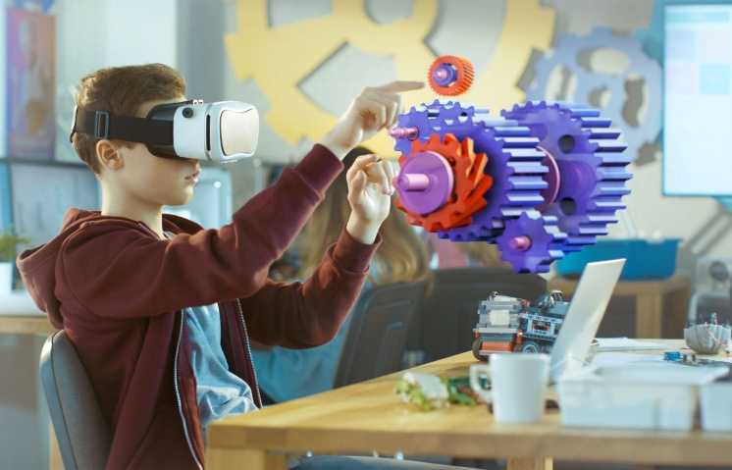

Fig1: Ar Simulation Based Learning

**2.2.3 Gamification and Game-Based Learning:**

Educational theorists recognize that well-designed games can captivate learners, sustaining their motivation and encouraging repeated engagement. AR-based educational games leverage the immersive quality of AR to create “situated learning” scenarios. For example, a math teacher might design a scavenger hunt where students must solve geometric puzzles by finding and scanning markers placed around the school. The AR interface then displays hints, feedback, and real-time progress tracking. In language learning, a student might roam the classroom searching for AR-embedded words placed on physical objects, building vocabulary through direct association [27].

Gamification strategies include leaderboards, badges, and narrative structures that reward learners for their achievements. AR can integrate these elements seamlessly into the physical world. By melding play and learning, AR fosters positive attitudes towards difficult subjects, reduces anxiety, and encourages persistence. Studies have shown that AR-based educational games can improve knowledge retention, creativity, and collaborative skills, ultimately shaping more confident and autonomous learners [9], [10].

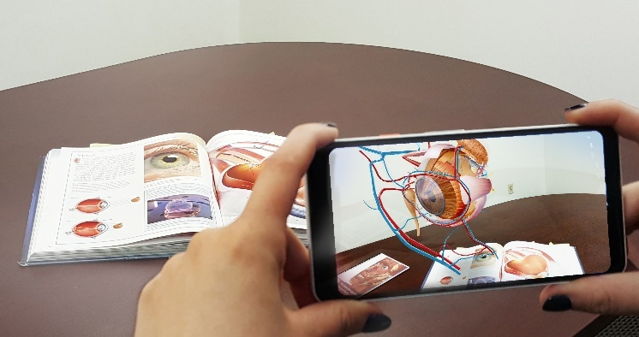

Fig2: AR based Learning

**2.3 Benefits of AR in Education**

One of AR’s most significant pedagogical advantages is its ability to heighten student engagement. The novelty and interactivity of AR experiences draw learners into active exploration. Instead of passively reading about planetary motion, for instance, a student can manipulate a digital planet and watch orbital changes occur. This kind of embodied interaction leads to longer-lasting motivation and curiosity [6], [8], [9].

Research consistently demonstrates that AR enhances concept retention and understanding [8], [9], [26]. By bridging concrete sensory experiences with abstract knowledge, AR helps learners build robust mental models. Students who interact with AR-based biology simulations, for example, are more likely to recall anatomical details months later than peers who studied solely through text and diagrams.

Additionally, AR fosters adaptability and accessibility. AR materials can be designed for learners with diverse needs. For visually impaired students, AR can provide auditory descriptions of objects in their environment, enabling them to navigate and learn in new ways. For students who prefer visual or kinesthetic learning modalities, AR’s multisensory input offers a more aligned educational approach [8], [10]. Remote learners in underserved regions can also access AR-based materials that would otherwise be unavailable physically, ensuring more equitable learning opportunities.

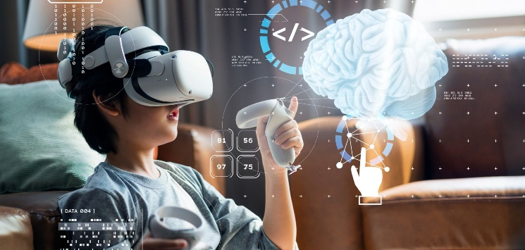

Fig3: AR interactive Learning

**2.4 Challenges and Limitations in AR for Education**

**2.4.1 Technical and Financial Constraints:**

While smartphone-based AR has gained traction, high-quality AR often demands specialized head-mounted displays, accurate spatial tracking systems, and powerful computing resources [1], [22]. Such hardware can be expensive, and not all educational institutions have the budgets or technical support infrastructure to implement these technologies widely. Even seemingly simple applications require software development expertise, ongoing maintenance, and content updates. As technologies evolve, schools must continuously invest in upgrades and teacher training to prevent obsolescence and ensure that AR offerings remain pedagogically relevant.

**2.4.2 Usability and Interface Design:**  
Not all learners or instructors are tech-savvy. Poorly designed AR interfaces can cause confusion, frustration, or cognitive overload, negating the educational benefits [6], [23]. Achieving intuitive interfaces—where learners naturally understand how to interact with virtual objects, navigate menus, or request help—remains an active research and design challenge. Multimodal interfaces that blend voice commands, gesture recognition, and haptic feedback show promise but also complicate development and require user testing to refine.

**2.4.3 Pedagogical Integration and Teacher Preparedness:**  
Implementing AR effectively requires more than just providing the tools. Educators must thoughtfully integrate AR activities into lesson plans, ensuring they align with learning objectives, assessment strategies, and student readiness. Many educators require professional development to understand AR’s affordances, troubleshoot technical issues, and guide students through immersive experiences [6], [7], [23]. Without teacher buy-in and adequate support, AR risks becoming a novelty rather than a transformative pedagogical instrument.

**2.5 Emerging Trends and Future Directions in AR for Education**

As AR hardware miniaturizes, the next wave of educational AR will likely lean towards wearable devices, such as lightweight smart glasses or retinal projection systems [20]. Freed from holding tablets or phones, learners can immerse themselves more fully in AR content, using gaze, gestures, or voice commands for interaction. Advances in artificial intelligence may enable adaptive AR tutoring systems that monitor learner progress and dynamically adjust content difficulty, pacing, and language levels, thereby personalizing instruction to individual needs.

Cloud-based architectures and 5G connectivity promise more fluid AR experiences, as content can be streamed and processed remotely, reducing the hardware burden on end-user devices. This shift could lower entry costs for institutions, as they might rely on cloud services to power high-fidelity AR simulations. Integration with large-scale learning analytics platforms will allow educators and researchers to study user interactions, identify learning bottlenecks, and refine best practices. Over time, international collaborations, standardized authoring tools, and open educational resources could further democratize access to AR-enhanced learning.

**3. AR in Art**

**3.1 Conceptual Foundations of AR-based Art**

Art has long been a domain that embraces and adapts to new media, from photography in the 19th century to digital installations in the 20th and 21st centuries. AR represents the next phase in this evolution. Traditional artworks, whether paintings, sculptures, or performances, exist primarily in physical space. AR allows artists to transcend these spatial and material constraints by superimposing digital elements—animations, videos, holographic sculptures, textual commentary—onto physical contexts [11], [12], [13]. This blending results in a “mixed reality” environment where viewers engage with layered meanings and multi-sensory experiences.

Artistic exploration through AR often references conceptual frameworks from media studies, semiotics, and phenomenology. By overlaying digital signifiers onto tangible objects, AR art can challenge conventional perceptions of authenticity, presence, and materiality. In some cases, it reflects on the tension between digital ephemerality and the tangible durability of physical artworks. In others, it leverages interactivity and responsiveness to involve viewers as co-creators, thus dispersing traditional notions of a singular artist’s voice [13], [15].

The early AR-based art experiments of the 2000s used marker-based tracking, requiring users to hold printed markers in front of webcams to trigger digital overlays [12]. As computer vision improved, markerless AR and object recognition enabled more seamless experiences. Artists now design site-specific AR installations that activate based on geolocation data, time of day, or viewer biometrics. This context-awareness introduces a dynamic quality: the artwork evolves based on external variables, making each encounter unique.

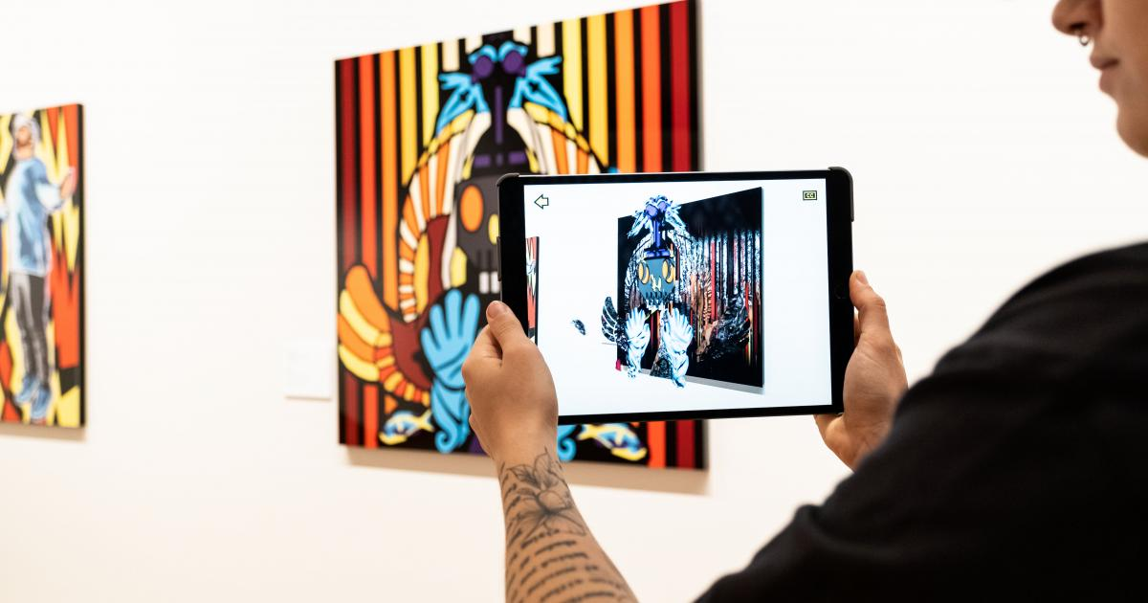

Fig4: AR in ART

**3.2 Applications in Art**

**3.2.1 Digital Installations and Mixed-Reality Environments:**  
Exhibitions increasingly integrate AR projections that react to viewer movements. For example, approaching a sculpture might trigger virtual animations that swirl around it, change color, or produce soundscapes. The physical sculpture provides a stable anchor, while the digital overlay enriches interpretation, offering narrative layers that cannot exist in static form [11], [13]. Such installations can use multiple sensory inputs—visual, auditory, and haptic feedback—blurring boundaries between viewer and artwork. This immersiveness encourages contemplation, emotional engagement, and sustained interest.

**3.2.2 Virtual Galleries and Extended Exhibitions:**  
AR addresses the spatial and logistical limitations of traditional art displays. Museums with limited floor space can present entire virtual collections that appear when a visitor points a smartphone at a blank wall. Historical artworks that have been lost, damaged, or scattered across different institutions can be digitally “reunited” in a single AR-assisted exhibition [14]. Visitors can zoom in to examine brushstrokes, watch contextual interviews with the artist, or explore cross-sections of sculptures. AR thus transforms passive viewing into active, research-like exploration, deepening cultural literacy.

Online AR galleries grant remote audiences access to world-class artworks without traveling. These virtual exhibitions can integrate social media features, enabling visitors from different countries to share reactions, leave comments, or even collectively manipulate AR elements. The digitization of art through AR can also facilitate educational outreach, inviting schools to access AR-enhanced artworks that illustrate historical art movements, techniques, or cultural influences.

**3.2.3 Collaborative and Participatory Art:**  
AR platforms can support shared creative endeavors. Multiple artists scattered around the globe can co-author an AR installation by uploading their 3D models or video loops to a common platform. The composite artwork emerges as a layered tapestry of styles and ideas. Audiences too can participate, adding their own AR content on-site, modifying existing elements, or voting on the artwork’s direction [12]. This collaborative model upends the hierarchical relationship between artist and spectator, reflecting broader shifts toward participatory culture and user-generated content.

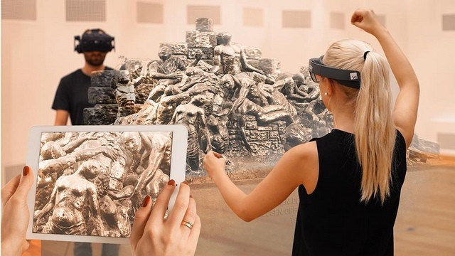

Fig5: Art Interaction though AR

Public art projects have also harnessed AR to engage communities. By overlaying digital murals onto city walls, artists invite residents to discover hidden stories about local history, social issues, or cultural practices [15]. Citizens can contribute their own imagery or narratives, co-creating evolving AR-based murals that reflect collective experiences. This inclusive, dialogical form of art breaks down elitist barriers, making art more accessible and responsive to community voices.

**3.3 Case Studies in AR-based Art**

Early pioneering projects like “Augmented Letter Soup” demonstrated how AR could bring static letters on a page to life as interactive 3D objects, inviting users to play with typography as sculptural forms [12]. Another seminal project, “Out of the Blue,” created an immersive audio-visual AR environment where floating ellipsoids responded to user movements, blending form, motion, and sound into a holistic sensory composition [13].

Street-based AR festivals and exhibits have multiplied. For instance, an AR installation in a heritage district might overlay historical photographs of the same street onto the current scene, revealing transformations over time and connecting past and present urban narratives. During a cultural festival, visitors might encounter virtual dancers, mythological creatures, or poetic verses triggered by scanning specific markers placed along a walking route. These real-world implementations highlight AR’s capacity to fuse performance art, historical archives, and public space interventions.

**3.4 Benefits and Opportunities in AR-based Art**

AR-based art expands the creative arsenal of artists, allowing them to integrate multimedia elements and interactive functionality without the logistical burdens of complex physical setups. Artists who might lack the funds to produce large sculptures or ship artworks internationally can distribute their creations digitally, making them accessible to global audiences [5], [11]. Curators and gallery owners can offer richer contextualization, linking artworks with behind-the-scenes interviews, artist sketches, or complementary scholarly essays. Viewers benefit from an enriched aesthetic experience that transcends the static nature of traditional media.

Moreover, AR encourages multi-literacy—viewers learn to “read” both physical and digital semiotic layers, developing critical thinking and interpretive skills. By confronting viewers with evolving narratives, layered interpretations, and participation-driven content, AR-based art fosters active cultural engagement. Museums and institutions can also reach younger, tech-savvy demographics who may find traditional art galleries less engaging.

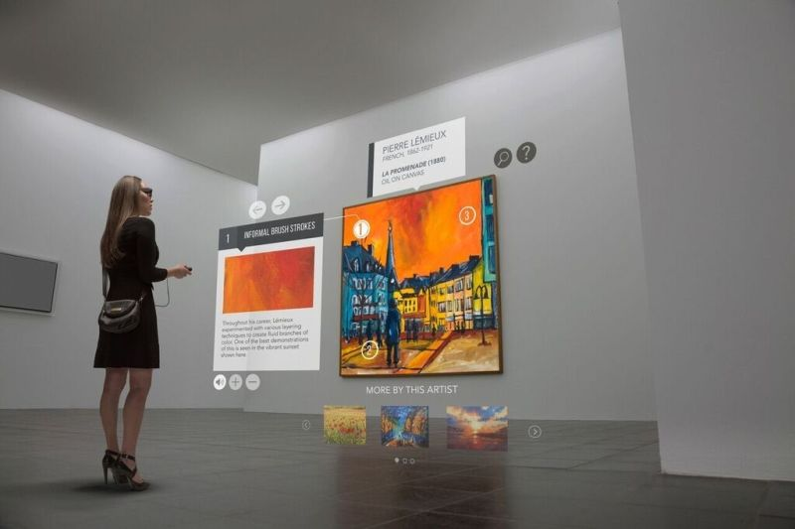

Fig6: AR Art in selection

**3.5 Challenges in AR-based Art**

**3.5.1 Accessibility and Costs:**

High-fidelity AR artworks may require advanced hardware (e.g., HMDs, motion tracking sensors) and customized software development. Artists and small galleries with limited budgets may struggle to create stable AR experiences. Although smartphone-based AR is more accessible, quality and interactivity may be limited [11], [13]. Additionally, ensuring that AR content runs smoothly across diverse devices, operating systems, and display technologies remains a substantial challenge, potentially excluding certain audience segments.

**3.5.2 Preservation and Authenticity:**

Digital artworks pose long-term preservation concerns. File formats, software dependencies, and hardware interfaces evolve rapidly, risking the loss of artworks if they are not continuously maintained, migrated, or emulated [24]. Ensuring that future audiences can experience today’s AR artworks as intended demands robust archiving strategies. Museums and cultural institutions must collaborate with digital preservation experts to develop frameworks for capturing AR states, source code, and metadata. Authenticity becomes ambiguous: Is the “real” artwork the code, the concept, the digital assets, or the integrated experience as displayed through certain hardware at a given time?

**3.5.3 Ethical and Intellectual Property Considerations:**  
AR artworks that overlay public spaces raise questions about permissions, privacy, and cultural sensitivity. Digitally augmenting a culturally significant landmark with controversial imagery may spark public outcry. Similarly, when artists use copyrighted images or trademarks as overlays, intellectual property rights come into play [25]. As AR platforms facilitate user-generated content, curators must vet contributions for hate speech, disinformation, or culturally insensitive material. Balancing artistic freedom with community values, legal frameworks, and ethical norms is a delicate endeavor.

**3.6 Emerging Trends and Future Directions in AR-based Art**

The future of AR-based art will likely see greater use of advanced AI techniques. Machine learning algorithms can generate responsive AR elements that adapt to viewer mood, gaze patterns, or facial expressions [28]. Such personalization could yield artworks that respond uniquely to each spectator, offering intimate, emotionally resonant encounters. As AR hardware becomes more discreet—potentially integrated into everyday eyewear—AR art may merge seamlessly into daily life, turning streets, parks, and homes into evolving art stages.

Holographic projectors and spatial computing platforms might allow artists to create large-scale AR installations that are persistent, accessible to anyone passing by, and context-aware. Global collaborations could produce transnational AR art exhibits that link different cultures and perspectives. Interoperable content standards and open-source AR frameworks would lower barriers to entry, encouraging a more diverse range of artists to explore this medium. In sum, AR-based art promises a future where creativity transcends material bounds, forging an ongoing dialogue between tangible reality and the digital imaginary.

**4. AR in Cultural Heritage**

**4.1 Context and Rationale**

Cultural heritage comprises the physical artifacts, monuments, landscapes, and intangible traditions passed down through generations. Museums, archaeological sites, and cultural institutions face the challenge of preserving, interpreting, and disseminating this heritage to a global, increasingly digital audience. Traditional exhibit methods—displaying objects behind glass with static plaques—often fail to convey the full context of how artifacts were created, used, or understood historically [14], [17], [19].

AR addresses these limitations by overlaying interpretive layers, historical reconstructions, multimedia narratives, and interactive simulations onto heritage objects or sites. Instead of reading about an ancient temple in a guidebook, visitors can stand within its ruins and see its original architecture superimposed through AR. They can witness simulated inhabitants engaging in daily activities or consult digital annotations explaining symbolic motifs. This approach enriches the visitor’s experience, making heritage interpretation more immersive, educational, and emotionally engaging.

**4.2 Applications in Cultural Heritage**

**4.2.1 Virtual Reconstructions of Historical Sites and Artifacts:**

One of AR’s most compelling applications in heritage is the digital restoration of destroyed or partially eroded structures. For example, at an archaeological site, a visitor can use a smartphone or AR headset to view a 3D reconstruction of a ruined temple as it once stood—complete with original colors, decorations, and furnishings [17]. Historical photographs, architectural plans, and archaeological research inform these reconstructions, ensuring scholarly accuracy. The result is a bridge between past and present, enabling visitors to grasp the site’s former splendor and cultural significance.

This technique extends to individual artifacts. Fragile pottery fragments or faded frescoes can be displayed alongside AR overlays that restore missing sections, highlight patterns invisible to the naked eye, or compare multiple hypotheses of how the artifact originally looked. Researchers can use AR as a communication tool to present competing interpretations side-by-side, engaging audiences in the scientific inquiry process.

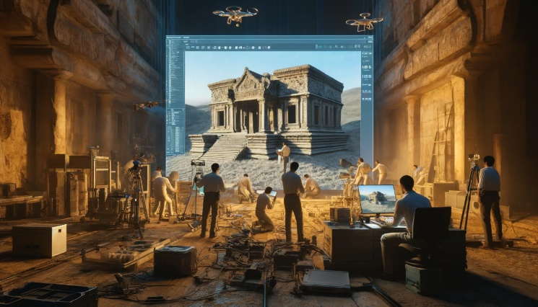

Fig7: Virtual Reconstruction of Historical sites

**4.2.2 Interactive Museum Tours and Education:**  
Museums employ AR to enhance guided tours by making exhibits more dynamic and learner-driven. Visitors can scan markers on a museum label to trigger an AR sequence showing how an artifact was used, traded, or crafted [3], [10]. For instance, an Egyptian mummy might be virtually “unwrapped” to reveal its linen layers, amulets, and skeletal structure, providing a level of insight that would be impossible or unethical with the actual artifact.

Gamification elements can turn museum visits into quests, where participants solve historical puzzles, collect virtual clues hidden in AR overlays, and piece together narratives. Language accessibility is improved, as AR interfaces can offer instant translations, sign language interpretations, or audio guides tailored to the visitor’s preferences. Augmented tours thus cater to a diverse, global audience, making heritage more approachable and inclusive.

**4.2.3 Cultural Storytelling and Intangible Heritage:**  
Not all heritage is tangible. Songs, dances, oral histories, and traditional crafts are often passed down through practice and memory rather than physical objects. AR can capture these intangible forms by embedding recorded performances, interviews with cultural practitioners, or animated demonstrations into relevant physical settings [19], [21]. At a historical marketplace, visitors might see AR overlays of artisans weaving baskets, performing traditional music, or telling local legends. Such experiences convey the living nature of culture and encourage empathy, understanding, and respect for cultural diversity.

In environments where intangible heritage risks disappearing due to globalization, urbanization, or generational gaps, AR can serve as a preservation and transmission tool. Younger audiences can interact with AR content that teaches traditional dances step-by-step, set in the original cultural context, ensuring that practices remain accessible and appreciated.

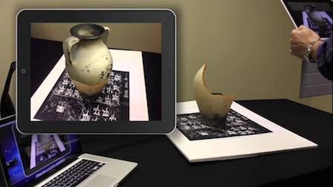

Fig8: AR used to rebuild broken structure

**4.3 Case Studies in AR for Cultural Heritage**

Multiple projects have showcased the power of AR in heritage settings. The Escher Museum in The Hague, for example, integrated AR installations that animated M.C. Escher’s prints, allowing visitors to experience his impossible geometries as interactive 3D illusions [12], [13]. Another pioneering initiative, “Sgraffito in 3D,” visually reconstructed medieval pottery patterns faded over time, guiding visitors to understand intricate details otherwise invisible to the unaided eye [13], [24].

Archaeological sites and historical districts worldwide have experimented with AR interpretive layers. In ancient Roman ruins, visitors might use AR to visualize the original street layout, commercial stalls, and daily activities of the inhabitants. In a Holocaust memorial, AR could provide documentary footage, survivor testimonies, and archival letters overlaid onto the physical memorial landscape, deepening visitors’ emotional and intellectual engagement with the site’s history.

**4.4 Benefits of AR in Cultural Heritage**

AR democratizes access to heritage, reaching beyond museum walls. Remote audiences can explore AR scenes from their homes, enabling diaspora communities or students in distant regions to engage with cultural material otherwise out of reach [3], [9], [10]. By providing rich, contextual information, AR also addresses the notorious “three-second glance” problem in museums, where visitors rapidly move past static exhibits. With AR, they are more likely to spend time investigating, discussing, and reflecting.

From a conservation perspective, AR reduces the need for handling delicate objects or exposing them to harmful lighting conditions. High-quality AR replicas can satisfy visitors’ curiosity while preserving originals under optimal conditions. Heritage professionals can also use AR to present multiple interpretive layers, acknowledging scholarly debates or uncertainties rather than promoting a single, simplified narrative. This transparency fosters critical thinking and appreciation for the complexity of historical understanding.

**4.5 Challenges in AR for Cultural Heritage**

**4.5.1 Historical Accuracy and Ethical Considerations:**  
Reconstructing the past inevitably involves interpretation and hypothesis. If AR reconstructions simplify, romanticize, or distort historical realities, visitors may walk away with misconceptions. Cultural biases, incomplete research, or the desire to create a visually appealing experience can compromise fidelity. Institutions must collaborate with historians, archaeologists, cultural custodians, and community representatives to ensure factual accuracy and cultural sensitivity [17], [19], [24]. Incorporating disclaimers, citing sources, and offering multiple viewpoints can mitigate the risk of misinformation.

**4.5.2 Technical Dependence and Digital Divide:**  
High-quality AR experiences in heritage contexts often rely on stable Wi-Fi, powerful mobile devices, or specialized AR headsets. Museums and heritage sites in regions with limited internet connectivity or low-income communities may struggle to implement such solutions, exacerbating the digital divide. Low-cost, offline-capable AR applications or simplified marker-based systems that run on older smartphones can increase accessibility [22], [23].

**4.5.3 Longevity of Digital Assets:**  
As with AR art, preserving AR heritage content is challenging. File formats, 3D models, AR software frameworks, and device hardware evolve rapidly. An AR tour that works perfectly today may fail in a few years if visitors use newer devices or the original app is not updated. Heritage institutions must invest in digital preservation strategies, archiving source code, 3D models, metadata, and user experience documentation. Partnerships with archivists, libraries, and standardization bodies can help ensure AR heritage projects remain accessible to future generations [24], [25].

**4.6 Emerging Trends and Future Directions in AR for Cultural Heritage**

Integrating AI into AR heritage applications could produce adaptive storytelling experiences. The system might tailor explanations based on a visitor’s background, interests, or learning style, offering simpler explanations to novices and in-depth scholarly discussions to experts. Advanced sensor integration might include environmental cues—like changes in temperature, lighting, or humidity—triggering different AR narratives.

Wearable AR devices could deliver continuous, hands-free heritage exploration. Instead of scanning QR codes, visitors could simply look at an artifact to receive context-sensitive overlays. Community-driven AR content creation would allow local groups to add their own oral histories, family photographs, or interpretations to heritage databases, promoting inclusive representation. With robust ethical and scholarly guidelines in place, AR could facilitate a pluralistic, dynamic presentation of cultural memory, encouraging ongoing dialogue and understanding.

**5. Synthesis of AR’s Impact Across Domains**

**5.1 Interdisciplinary Perspectives**

Although this paper examined AR’s role in education, art, and cultural heritage separately, these domains share common goals and face similar challenges. All three fields aim to convey information, stimulate thought, evoke emotions, and create meaningful experiences. AR’s capacity to blend physical and digital realms aligns well with these objectives by making learning more engaging, art more interactive, and heritage more accessible.

In education, AR fosters active, inquiry-based learning; in art, it encourages participatory creativity and context-rich interpretation; in heritage, it deepens understanding of cultural legacies. These outcomes overlap in multidisciplinary projects. For example, a museum could use AR to teach students about Renaissance art techniques while simultaneously offering them virtual galleries where they can manipulate and remix artworks. A cultural festival might combine AR heritage narratives with artistic installations, inviting attendees to learn history through creative, immersive storytelling.

**5.2 Socio-Cultural Implications**

AR’s democratization could reshape cultural consumption and production. By lowering barriers to entry, AR allows a wider range of voices—emerging artists, grassroots educators, local communities—to create and share content. This inclusivity can enhance cultural diversity, cross-cultural dialogue, and educational equity. Learners in remote areas can access AR-based STEM lessons, art enthusiasts can virtually visit global exhibitions, and diaspora communities can connect with heritage sites back home.

However, AR’s widespread adoption raises new socio-cultural challenges. Overreliance on AR content may foster complacency, where users accept digital overlays as truth without critical inquiry. Cultural biases introduced by developers or institutions could skew narratives. Intellectual property disputes could arise as AR blurs boundaries between public space, private art, and communal resources. Policymakers, educators, artists, and cultural stewards must collaborate to establish norms, ethical guidelines, and equitable practices that protect cultural integrity and human rights.

**5.3 Ethical and Policy Considerations**

Regulatory frameworks must adapt to AR’s unique properties. In education, privacy policies should govern how student data—collected through AR analytics—is stored, shared, and used. For art, copyright and licensing rules must clarify what constitutes permissible digital augmentation. In heritage, laws should address authenticity claims, ensuring that AR reconstructions are identified as interpretations rather than undisputed facts.

These legal and ethical frameworks could be guided by professional organizations, UNESCO guidelines, or consortiums of AR developers and cultural institutions. Balancing innovation and freedom of expression with responsible stewardship of knowledge and culture is an ongoing challenge.

**6. Technical Foundations and Implementation Considerations**

**6.1 Key Technologies and Components**

AR systems rely on a combination of hardware and software. On the hardware side, cameras, depth sensors, inertial measurement units (IMUs), and occasionally specialized devices like Microsoft HoloLens or Magic Leap headsets provide positional tracking and environmental mapping [1], [4]. Mobile devices—smartphones and tablets—are popular due to their ubiquity, though they offer limited field of view and may cause arm fatigue. Head-mounted displays free the user’s hands and often provide a more seamless experience but at a higher cost.

Software components include AR software development kits (SDKs) such as ARKit (iOS), ARCore (Android), Vuforia, or Unity-based AR frameworks. These tools manage computer vision algorithms, simultaneous localization and mapping (SLAM), and rendering pipelines. 3D modeling tools like Blender or Maya help create virtual objects and scenes [5]. Cloud-based infrastructures, for example on AWS, can host large 3D asset libraries, handle server-side rendering for complex simulations, and provide scalable user analytics.

Real-time computer vision algorithms identify and track environmental features, detecting planes, surfaces, or specific objects. Marker-based AR uses predefined images or patterns as anchors for digital overlays, while markerless AR leverages feature points in the environment. Advancements in machine learning have improved object recognition and scene understanding, enabling more accurate and stable overlays.

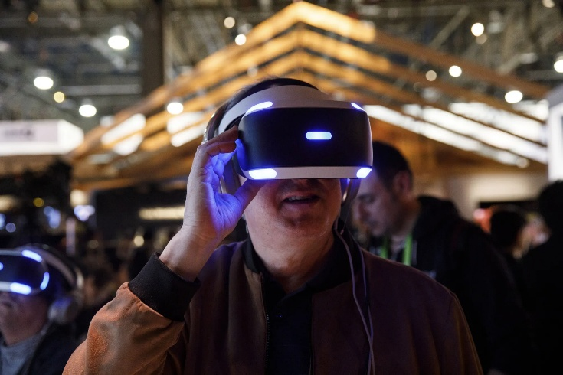

Fig8: AR technology

**6.2 User Interface and Experience Design**

User interface (UI) and user experience (UX) design are critical for ensuring that AR enhances rather than distracts. The interface should minimize cognitive load. Clear instructions on how to interact with digital elements—through tapping, gestures, or voice commands—are essential. Icons, highlight effects, and visual cues can guide users to relevant content. In educational AR apps, designing progressive disclosure of information allows learners to control their depth of exploration, preventing them from feeling overwhelmed.

Haptic feedback and spatial audio can enrich AR experiences. Spatial audio, for example, can direct the user’s attention to a point of interest behind them, encouraging them to turn around. Eye-tracking technologies can facilitate gaze-based interactions, letting users select objects simply by looking at them for a moment. Such natural, intuitive interfaces are vital to making AR universally accessible, especially for younger students, non-technical audiences, or users with disabilities.

In cultural heritage settings, UI designers must be sensitive to aesthetics, respecting the mood of historical contexts. In art installations, the interface can be more experimental and playful. Designers should consider user comfort, ensuring that AR usage does not cause fatigue, motion sickness, or visual strain. Tutorials, contextual help menus, and quick calibration procedures can help users adapt to AR environments smoothly.

**6.3 Scalability and Maintenance**

As AR applications grow in complexity, scalability becomes a pressing concern. Educational institutions implementing AR across multiple classrooms require centralized content management systems that let instructors select and customize modules, track student progress, and update materials. Museums hosting AR-enhanced tours must ensure that software updates do not disrupt visitor experiences, and that content remains consistent across devices.

Version control and continuous integration practices help developers maintain AR apps over time. Automated testing frameworks can verify that updates do not break existing features. Metadata standards and open file formats improve the portability of 3D models, ensuring that future platforms can interpret them. Regular maintenance schedules and user feedback loops guide iterative improvements. Without proper maintenance, AR experiences risk becoming outdated or incompatible with new hardware, undermining long-term sustainability.

**6.4 Cloud Integration and Deployment Strategies**

Cloud-based architectures support more advanced AR features by offloading computational tasks—like complex 3D rendering, artificial intelligence inference, or large-scale simulations—to remote servers [5]. Users access lightweight clients, while powerful cloud servers handle graphics processing and database queries. This approach reduces the need for expensive local hardware and enables real-time updates, data analytics, and collaborative features.

For educational AR, cloud platforms can store extensive digital libraries, ensuring instant access to learning modules anytime, anywhere. Teachers can monitor student activity remotely, analyze performance data, and adjust assignments dynamically. In cultural heritage projects, cloud services enable remote experts to contribute new layers of interpretation, historical data, or translations. Art curators can update virtual galleries with new AR exhibits overnight, offering visitors fresh content each morning.

**6.5 Security and Privacy Considerations**

Collecting and processing user data in AR environments raises privacy and security concerns. For example, AR educational apps may record user interactions, locations, or learning progress. Sensitive information must be encrypted, and access strictly controlled, particularly in settings involving children’s data. Compliance with data protection laws (e.g., GDPR in the European Union) is necessary to avoid legal pitfalls and build user trust.

In public art scenarios, AR might capture images of passersby or identify landmarks, raising questions about surveillance. Designers can implement opt-in permissions, anonymize data, and provide transparent explanations of what is collected and why. Cultural institutions should ensure that digital heritage reconstructions respect community rights and do not infringe upon sacred sites or indigenous knowledge without proper consent.

**7. Future Research Directions**

**7.1 Pedagogical Efficacy and Assessment in AR Education**

While numerous case studies and pilot projects suggest AR’s educational benefits, more rigorous, large-scale research is needed to quantify its impact. Longitudinal studies could follow cohorts of students over multiple semesters, comparing AR-enhanced instruction to traditional teaching methods. Controlled experiments, randomized trials, and mixed-methods analyses can isolate AR’s contribution to learning outcomes. Researchers should measure not only knowledge retention but also critical thinking, problem-solving, creativity, and motivation.

Assessment frameworks should consider that AR changes the learning context. Traditional paper-and-pencil tests may not capture the depth of understanding gained through immersive exploration. Augmented assessments might involve performance-based tasks within AR environments, peer evaluation of collaborative AR projects, or portfolios documenting learner interactions. By refining assessment methodologies, educators and policymakers can confidently invest in AR knowing its pedagogical value.

**7.2 Inclusive and Accessible AR Design**

Ensuring that AR is accessible to all learners and audiences is paramount. Future research should focus on interface modalities for individuals with visual, auditory, or motor impairments. For instance, developers could integrate haptic feedback for navigation, audio descriptions of visual elements, or eye-tracking input for users who cannot operate touchscreen interfaces [8], [10]. Cultural localization is also necessary: AR content should accommodate multiple languages, scripts, and cultural references to resonate with global audiences.

In cultural heritage, inclusive AR design might offer simplified tours for younger children or cognitively accessible interpretations for visitors with varying levels of background knowledge. Art installations could provide adjustable complexity modes, allowing viewers to choose between minimalistic overlays or richly layered content. By prioritizing universal design principles, future AR applications can ensure that no one is excluded from immersive learning, artistic appreciation, or cultural understanding.

**7.3 Cross-Cultural Collaboration and Ethical Frameworks**

As AR emerges globally, cross-cultural collaborations can promote best practices, resource sharing, and mutual learning. Educators from different countries can compare how AR affects learning styles shaped by cultural norms. Artists can exchange techniques, jointly creating transnational AR exhibitions. Heritage professionals can develop consensus-based standards for authenticity, transparency, and community involvement in AR reconstructions.

Ethical frameworks must evolve to address cultural sensitivity, intellectual property disputes, and representation of marginalized groups. Researchers can create guidelines to avoid cultural appropriation, ensure respectful portrayal of sacred traditions, and involve local stakeholders in content creation. Such frameworks would encourage responsible innovation, foster trust, and maintain AR’s credibility as a culturally enriching medium.

**7.4 Emerging Technologies and Integration**

The future of AR may involve integration with other emerging technologies. AI-driven chatbots integrated into AR environments could act as virtual tutors, answering questions, adapting to user needs, and pointing out relevant features in real-time. The Internet of Things (IoT) could allow AR applications to respond dynamically to environmental sensors—altering the AR scene if temperature, noise level, or light conditions change.

Brain-computer interfaces might one day enable mentally triggered interactions, while advanced haptics could simulate textures, weights, and other tactile properties of digital objects. Such developments would push AR beyond visual overlays into fully multisensory experiences. Research will need to explore user acceptance, ethical implications, and health considerations of these novel modalities.

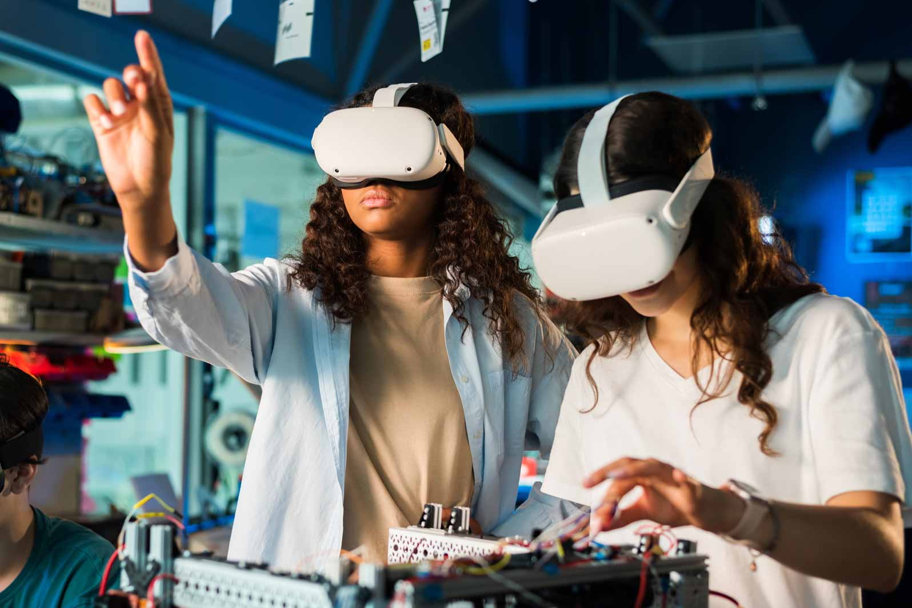

Fig9: AR emerging technologies

**7.5 Standardization and Preservation**

Long-term sustainability of AR content demands standardization. Without stable file formats, consistent metadata schemas, or interoperability guidelines, AR experiences risk fragmentation. Users might face compatibility issues when switching devices or platforms. Researchers can collaborate with standards bodies and industry consortia to develop common protocols for exchanging AR assets, ensuring that future platforms can interpret legacy content.

Preservation research must address how to store AR scenes, code, and datasets. Emulation techniques, migration strategies, and open archiving platforms will keep AR heritage alive for future scholars. Capturing user experience data—such as transcripts of AR-based museum tours—could provide valuable historical records of how cultural interpretation evolved over time. By planning for preservation from the outset, AR creators safeguard their work’s cultural and intellectual value.

**8. Conclusion**

Augmented Reality is not merely a technological tool but a transformative medium that reshapes how people learn, experience art, and engage with cultural heritage. In education, AR elevates student-centered, inquiry-driven learning, making complex subjects accessible and engaging. In art, AR extends creativity beyond physical constraints, allowing artists and audiences to co-create dynamic, participatory installations. In cultural heritage, AR enriches interpretation, offering empathetic, context-rich encounters with the past.

However, AR’s full potential is contingent on addressing critical challenges. Technical barriers—such as tracking accuracy, hardware costs, and interface complexity—must be lowered. Ethical and cultural considerations require careful curation, inclusive design, and respect for authenticity. Preservation efforts must ensure that AR artworks, educational modules, and heritage reconstructions do not vanish as technology evolves. Rigorous research, cross-sector collaboration, and principled policymaking are essential to guiding AR’s maturation.

Looking ahead, AR may seamlessly integrate into everyday life. Miniaturized, affordable devices and advanced AI could deliver personalized experiences that adapt to each user’s interests, knowledge level, and cultural background. The future may witness fully context-aware AR that merges with environmental cues, social media streams, and global networks of co-creators. If wielded thoughtfully and ethically, AR can help build a more inclusive, informed, and inspired society—one in which knowledge acquisition, artistic expression, and cultural appreciation transcend traditional limitations.

**References**

[1] R. T. Azuma, “A survey of augmented reality,” *Presence: Teleoperators and Virtual Environments*, vol. 6, no. 4, pp. 355–385, 1997.

[2] P. Milgram and F. Kishino, “A taxonomy of mixed reality visual displays,” *IEICE Trans. Inf. Syst.*, vol. 77, no. 12, pp. 1321–1329, 1994.

[3] J. Carmigniani, B. Furht, M. Anisetti, P. Ceravolo, E. Damiani, and M. Ivkovic, “Augmented reality technologies, systems and applications,” *Multimedia Tools and Applications*, vol. 51, pp. 341–377, 2011.

[4] T. Höllerer and S. Feiner, “Mobile augmented reality,” in *Telegeoinformatics: Location-Based Computing and Services*, H. Karimi and A. Hammad, Eds. Boca Raton, FL: CRC Press, 2004, pp. 221–260.

[5] B. Furht, Ed., *Handbook of Augmented Reality*. New York, NY: Springer, 2011.

[6] M. Billinghurst and A. Duenser, “Augmented reality in the classroom,” *Computer*, vol. 45, no. 7, pp. 56–63, July 2012.

[7] C. Kirner and E. R. Zorzal, “Educational applications of augmented reality,” in *Proc. ACM SIGGRAPH Int. Conf. Virtual-Reality Continuum and Its Applications in Industry*, 2005, pp. 289–292.

[8] J. Bacca, S. Baldiris, R. Fabregat, S. Graf, and Kinshuk, “Augmented reality trends in education: A systematic review of research and applications,” *Educ. Technol. & Society*, vol. 17, no. 4, pp. 133–149, 2014.

[9] I. Radu, “Augmented reality in education: A meta-review and cross-media analysis,” *Pers. Ubiquitous Comput.*, vol. 18, no. 6, pp. 1533–1543, 2014.

[10] K. Chang, C. Chang, and J. Shih, “Motivational strategies in a mobile inquiry-based language learning setting,” *System*, vol. 51, pp. 117–128, 2015.

[11] B. Perry, “Building an ARt experience: A framework for augmented reality art projects,” *Leonardo*, vol. 48, no. 5, pp. 485–486, 2015.

[12] Y. Kolstee and W. van Eck, *Interactive Visualization Techniques for Art and Design*. Royal Academy of Art, The Hague, 2007.

[13] P. Jonker, I. Garcia, and M. Gutiérrez, “Augmented reality for art, design, and cultural heritage,” *EURASIP J. Image Video Process.*, 2009(1), p. 716160, 2009.

[14] Y. L. Chang, P. Morreale, and P. Medicherla, “Applications of augmented reality systems in education,” in *Proc. World Conf. Educ. Multimedia, Hypermedia and Telecommun.*, 2010, pp. 4881–4888.

[15] H.-L. Chi, S.-C. Kang, and X. Wang, “Research trends and opportunities of augmented reality applications in architecture, engineering, and construction,” *Automation in Construction*, vol. 33, pp. 116–122, 2013.

[16] N. Chung, H. Han, and Y. Joun, “Tourists’ intention to visit a destination: The role of augmented reality (AR) application for a heritage site,” *Comput. Human Behav.*, vol. 101, pp. 409–420, 2019.

[17] L. Pujol and E. Champion, “Evaluating presence in cultural heritage projects,” *Int. J. Heritage Stud.*, vol. 18, no. 1, pp. 83–102, 2012.

[18] C. Ardito, P. Buono, M. F. Costabile, R. Lanzilotti, and A. Piccinno, “Enriching archaeology museums with augmented reality,” *Int. Arch. Photogramm. Remote Sens. Spatial Inf. Sci.*, vol. 44, pp. 55–62, 2020.

[19] S. Perry, M. Roussou, M. Economou, H. Young, and L. Pujol, “Moving beyond the virtual museum: Engaging visitors emotionally,” in *Proc. 23rd Int. Conf. Virtual System & Multimedia (VSMM)*, 2017, pp. 1–8.

[20] M. Ma, L. C. Jain, and P. Anderson, Eds., *Virtual, Augmented Reality and Serious Games for Healthcare 1*. Berlin, Germany: Springer-Verlag, 2020.

[21] T. R. Eduardo, P. L. Rita, S. D. J. Barbosa, and M. G. Paula, “A systematic literature review on augmenting cultural heritage with 3D virtual environments, serious games and storytelling,” *Multimedia Tools Appl.*, vol. 80, pp. 19137–19174, 2021.

[22] A. Dünser, R. Grasset, and M. Billinghurst, “A survey of evaluation techniques used in augmented reality studies,” Human Interface Technology Laboratory, Univ. of Canterbury, New Zealand, 2008.

[23] S. K. Ong and A. Y. C. Nee, “A brief introduction of augmented reality systems,” in *Virtual and Augmented Reality Applications in Manufacturing*, S. K. Ong and A. Y. C. Nee, Eds. London, U.K.: Springer, 2004, pp. 1–12.

[24] S. Perry, R. Roussou, L. Pujol, M. Economou, H. Young, and P. F. Lister, “Crafting knowledge with (digital) visual media in archaeology,” in *Material Evidence: Learning from Archaeological Practice*, R. Chapman and A. Wylie, Eds. London, U.K.: Routledge, 2015, pp. 189–212.

[25] L. Szablya, T. Hollett, and R. Hall, “Investigating everyday AR: Case studies of learner interactions with augmented reality in informal settings,” in *Int. Soc. Learning Sci.*, 2017, pp. 1–8.

[26] R. E. Mayer and R. Moreno, “Nine ways to reduce cognitive load in multimedia learning,” *Educ. Psychol.*, vol. 38, no. 1, pp. 43–52, 2003.

[27] E. Klopfer and K. Squire, “Environmental detectives—the development of an augmented reality platform for environmental simulations,” *Educ. Technol. Res. Dev.*, vol. 56, no. 2, pp. 203–228, 2008.

[28] W. Wei, R. Qi, and L. Zhang, “Effects of virtual reality and augmented reality on induced emotion and presence in experiences,” *IEEE Access*, vol. 7, pp. 130379–130392, 2019.