**Strategy Formulation**

**Ms. Jyoti Manral**

Asst. Professor

Deptt. of Management

Uttarakhand Open University

Haldwani, Uttarakhand

**Introduction to Strategy Formulation**

Strategy formulation is a critical process in strategic management that involves defining the direction an organization should take to achieve its long-term goals and maintain a competitive edge. It serves as a blueprint for decision-making and resource allocation, guiding the organization toward its vision and mission. The process involves analyzing internal capabilities, assessing external market conditions, and identifying opportunities and threats that influence business success. By crafting an effective strategy, businesses can create a sustainable advantage, adapt to changing environments, and enhance overall performance.

The strategy formulation process begins with a clear understanding of corporate planning, which includes defining objectives, setting priorities, and aligning resources to achieve desired outcomes. It involves various types of planning, such as operational, tactical, and strategic planning, each serving a distinct purpose within the organization. Strategic decision-making plays a vital role in this process, ensuring that key stakeholders consider multiple perspectives and assess potential risks before implementing strategies. A well-defined vision, mission, and purpose help shape the overall strategic direction and create a sense of purpose within the organization.

Moreover, strategy formulation requires businesses to select the most appropriate type of strategy based on their industry dynamics, competition, and market trends. Companies can pursue growth strategies, competitive strategies, or diversification strategies to achieve their objectives. Crafting successful business strategies involves setting realistic goals, leveraging core competencies, and continuously evaluating performance to ensure long-term sustainability. By following a structured approach, organizations can position themselves for success and navigate challenges effectively in an increasingly complex business environment.

**Corporate Planning**

Corporate planning is a comprehensive process that outlines an organization’s long-term goals and the strategies required to achieve them. It provides a structured framework for decision-making, ensuring that resources are allocated efficiently and business activities are aligned with the company’s vision and mission. Corporate planning involves assessing both internal and external factors that influence business operations, including financial resources, market trends, competitive landscape, and regulatory requirements. By integrating these elements, organizations can develop a roadmap for sustainable growth and long-term success.

The corporate planning process typically consists of multiple stages, starting with defining the company’s objectives, setting measurable targets, and identifying potential risks. Organizations conduct thorough environmental scanning, such as SWOT (Strengths, Weaknesses, Opportunities, and Threats) analysis or PESTEL (Political, Economic, Social, Technological, Environmental, and Legal) analysis, to gain insights into market dynamics. Based on this assessment, businesses formulate strategic plans that outline specific initiatives, resource requirements, and timelines for execution. Effective corporate planning ensures that the company remains proactive in responding to industry changes and capitalizing on new opportunities.

A well-structured corporate planning approach enhances coordination across different departments and ensures that every unit works toward common goals. It also facilitates strategic decision-making by providing a clear direction for business expansion, mergers, acquisitions, and diversification strategies. Moreover, corporate planning fosters a culture of continuous improvement, encouraging businesses to regularly evaluate their performance and adjust strategies as needed. By prioritizing long-term planning over short-term gains, organizations can build resilience, maintain competitiveness, and achieve sustainable growth in an ever-evolving business landscape.

**Concept of Planning**

Planning is a fundamental management function that involves setting objectives and determining the most effective course of action to achieve them. It entails analyzing the current situation, forecasting future conditions, and establishing clear goals that align with the organization's vision and mission. By mapping out the steps needed to reach these goals, planning provides a structured approach to resource allocation, risk management, and decision-making, thereby reducing uncertainty and paving the way for coordinated efforts across all levels of the organization.

At its core, planning is about creating a roadmap for success. It not only outlines what needs to be done, but also identifies the methods, timelines, and responsibilities for executing the strategy. This systematic process helps organizations anticipate challenges, seize opportunities, and respond adaptively to a dynamic business environment. By fostering a proactive mindset, planning ensures that organizations remain focused on their long-term objectives while being agile enough to adjust to short-term fluctuations and external pressures.

**Planning Process**

The planning process consists of several steps:

The planning process generally involves a series of steps that help individuals, teams, and organizations define their goals and determine the best course of action to achieve them. While the specifics can vary depending on the context, here's a common breakdown of the planning process steps:

**1. Define Objectives/Goals:**

* **Identify the purpose:** What do you want to achieve?
* **Make them SMART:** Ensure goals are Specific, Measurable, Achievable, Relevant, and Time-bound.
* **Prioritize:** Determine which goals are most important.

**2. Analyze the Current Situation:**

* **Gather information:** Collect relevant data and information about the current state.
* **Identify strengths and weaknesses:** Conduct a SWOT analysis (Strengths, Weaknesses, Opportunities, Threats).
* **Assess resources:** Determine what resources are available (financial, human, technological, etc.).
* **Environmental scanning:** Look at the external factors that could impact your plan.

**3. Develop Alternatives/Options:**

* **Brainstorm:** Generate a range of potential strategies and approaches.
* **Evaluate feasibility:** Assess the practicality and viability of each option.
* **Consider risks and benefits:** Weigh the potential advantages and disadvantages of each alternative.

**4. Evaluate Alternatives:**

* **Analyze potential outcomes:** Predict the likely results of each option.
* **Compare alternatives:** Evaluate the options based on defined criteria.
* **Select the best option:** Choose the most suitable course of action.

**5. Create a Plan:**

* **Develop a detailed action plan:** Outline the specific steps, tasks, and timelines.
* **Assign responsibilities:** Determine who is responsible for each task.
* **Allocate resources:** Assign the necessary resources to each task.
* **Establish a timeline:** Set deadlines and milestones.
* **Create a budget:** If needed, determine the financial resources required.

**6. Implement the Plan:**

* **Put the plan into action:** Execute the steps outlined in the plan.
* **Communicate effectively:** Ensure all stakeholders are informed and involved.
* **Provide necessary training and support:** Equip individuals with the necessary skills and resources.

**7. Monitor and Control:**

* **Track progress:** Regularly monitor the implementation of the plan.
* **Measure performance:** Evaluate the results against the established goals.
* **Identify deviations:** Determine if there are any discrepancies between planned and actual results.
* **Take corrective action:** Make adjustments to the plan as needed.

**8. Evaluate and Review:**

* **Assess the overall effectiveness:** Determine if the plan achieved its objectives.
* **Identify lessons learned:** Analyze what worked well and what could be improved.
* **Make adjustments for future planning:** Use the insights gained to improve future planning processes.

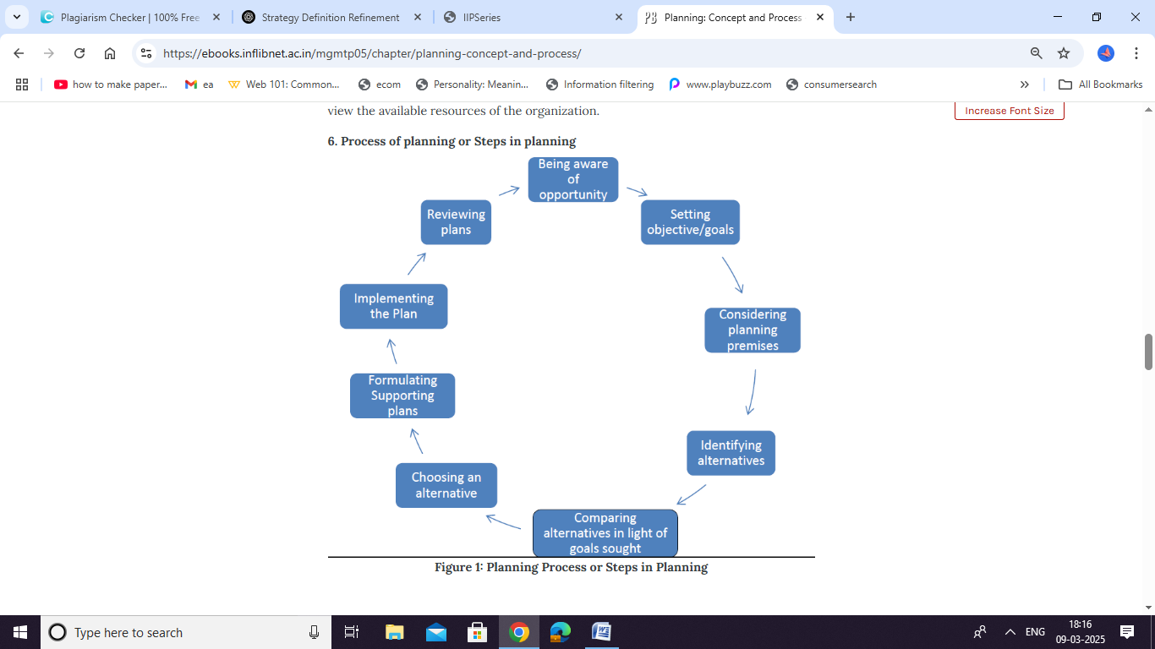

**Types of Planning**

Organizations engage in different types of planning, including:

* **Strategic Planning**: Long-term planning focused on overall business direction.
* **Tactical Planning**: Mid-term planning that translates strategic goals into actionable initiatives.
* **Operational Planning**: Short-term, day-to-day planning that ensures efficient business operations.
* **Contingency Planning**: Preparing for potential risks and uncertainties.

**Strategic Planning**

Strategic planning involves defining an organization’s strategy or direction and making decisions on resource allocation to achieve competitive advantage. It ensures businesses remain adaptable to changing environments and sustain growth over time.

**Tools for Strategic Formulation**

Strategic formulation relies on a range of analytical tools to assess both the internal capabilities of an organization and the external competitive landscape. Foundational tools such as SWOT Analysis and PESTEL Analysis help organizations systematically identify their Strengths, Weaknesses, Opportunities, and Threats while examining Political, Economic, Social, Technological, Environmental, and Legal factors. These tools enable decision-makers to build a comprehensive picture of the market environment and pinpoint areas that require strategic focus.

In addition to these environmental assessments, competitive analysis tools like Porter's Five Forces provide critical insights into industry dynamics by evaluating the bargaining power of suppliers and buyers, the threat of new entrants, the threat of substitute products, and the intensity of competitive rivalry. Meanwhile, Value Chain Analysis allows organizations to break down their internal processes to identify opportunities for operational improvements and cost advantages. Together, these tools create a robust framework for understanding where an organization stands relative to its competitors and what strategic moves are needed.

Other strategic instruments, such as scenario planning and benchmarking, further enhance the formulation process by preparing organizations for multiple future outcomes and comparing performance against industry standards or best practices. Scenario planning fosters agility by exploring different future scenarios, while benchmarking drives continuous improvement by highlighting gaps in performance. By integrating these strategic tools into the planning process, organizations can develop informed, flexible strategies that align with their vision, mission, and long-term objectives, ultimately creating sustainable competitive advantages.

**Strategic Decision-Making**

Strategic decision-making involves choosing the best course of action among alternatives to achieve long-term business goals. It requires analyzing market trends, competitive positioning, financial considerations, and stakeholder expectations.

**Vision, Mission, and Purpose**

**Vision Statement**

A vision statement defines what an organization aspires to become in the future. It serves as a guiding light for strategic planning and decision-making.

**Example:** “To be the world’s most customer-centric company.”

**Mission Statement**

A mission statement outlines the organization’s purpose, its primary business activities, and its impact on stakeholders.

**Example:** “To provide innovative and sustainable energy solutions for a greener tomorrow.”

**Purpose of a Business Organization**

The purpose of a business organization defines why it exists beyond profit-making. It encompasses delivering value to customers, employees, and society while maintaining ethical and sustainable practices.

**Objectives and Goals of a Business Organization**

**Objectives**

Business objectives are specific, measurable outcomes that organizations aim to achieve. They can be classified into:

* **Financial Objectives**: Revenue growth, profitability, cost reduction.
* **Market Objectives**: Market share expansion, customer acquisition.
* **Operational Objectives**: Efficiency improvements, technological advancements.
* **Social Objectives**: Corporate social responsibility, environmental sustainability.

**Goals**

Goals are broader aspirations that drive the organization’s long-term success. They provide direction and inspiration for business strategies.

**Types of Strategies**

Organizations adopt various strategies based on their market position, resources, and objectives. Some key strategies include:

**Corporate-Level Strategies**

Directional strategies are overarching plans that guide an organization's general direction and growth trajectory. They encompass decisions related to the organization's vision, mission, and core objectives, setting the foundation for more specific strategic actions. These strategies typically address the fundamental questions of what the organization aims to achieve and the primary methods it will employ to reach those goals.

There are several types of directional strategies:

1. **Growth Strategies**: These focus on expanding the organization's operations, market reach, or product lines. Methods can include market penetration, market development, product development, and diversification.
2. **Stability Strategies**: Aimed at maintaining the current status of the organization, these strategies are employed when the company is performing well and seeks to sustain its position without significant growth or contraction.
3. **Retrenchment Strategies**: These involve reducing the scale or scope of the organization's operations, often through cost-cutting, divestment, or restructuring, to improve financial stability or refocus on core areas.

Implementing effective directional strategies ensures that all organizational activities are aligned with the desired long-term outcomes, providing a clear roadmap for decision-making and resource allocation.

Business-level strategies are approaches that organizations adopt to gain a competitive edge within their specific markets. According to Michael Porter's framework, there are three primary strategies:

1. **Cost Leadership**: This strategy focuses on becoming the lowest-cost producer in the industry. By achieving cost efficiencies, companies can offer products or services at lower prices, attracting price-sensitive customers and increasing market share.
2. **Differentiation**: Here, businesses aim to offer unique products or services that stand out from competitors. This uniqueness can justify premium pricing and foster brand loyalty among customers.
3. **Focus Strategy**: This involves targeting a specific market segment or niche. Companies can either pursue cost focus, offering lower prices within the niche, or differentiation focus, providing specialized products or services tailored to the unique needs of that segment.

Implementing these strategies effectively requires aligning them with the company's resources, capabilities, and market conditions to achieve sustainable competitive advantage.

**Functional-Level Strategies**

Functional-level strategies are the detailed plans that guide how each department within an organization contributes to overall success. These strategies ensure that every functional area is aligned with the company's broader business goals and effectively supports competitive positioning in the marketplace.

* **Marketing Strategy**: This involves enhancing brand positioning and driving customer engagement through targeted campaigns, market research, and innovative communication. The goal is to build a strong brand identity that resonates with customers and differentiates the company from competitors.
* **Operational Strategy**: Focused on streamlining production processes and optimizing supply chain efficiency, this strategy aims to reduce costs, improve quality, and boost overall productivity. It ensures that resources are used efficiently and operations run smoothly, contributing directly to the company's bottom line.
* **Human Resource Strategy**: This centers on talent acquisition, workforce development, and retention. By recruiting the right talent, providing effective training programs, and fostering an engaging work environment, the organization can maintain a competitive edge and ensure long-term growth.

These functional-level strategies are integral to executing higher-level business and corporate strategies, creating a cohesive and well-coordinated approach across the entire organization.

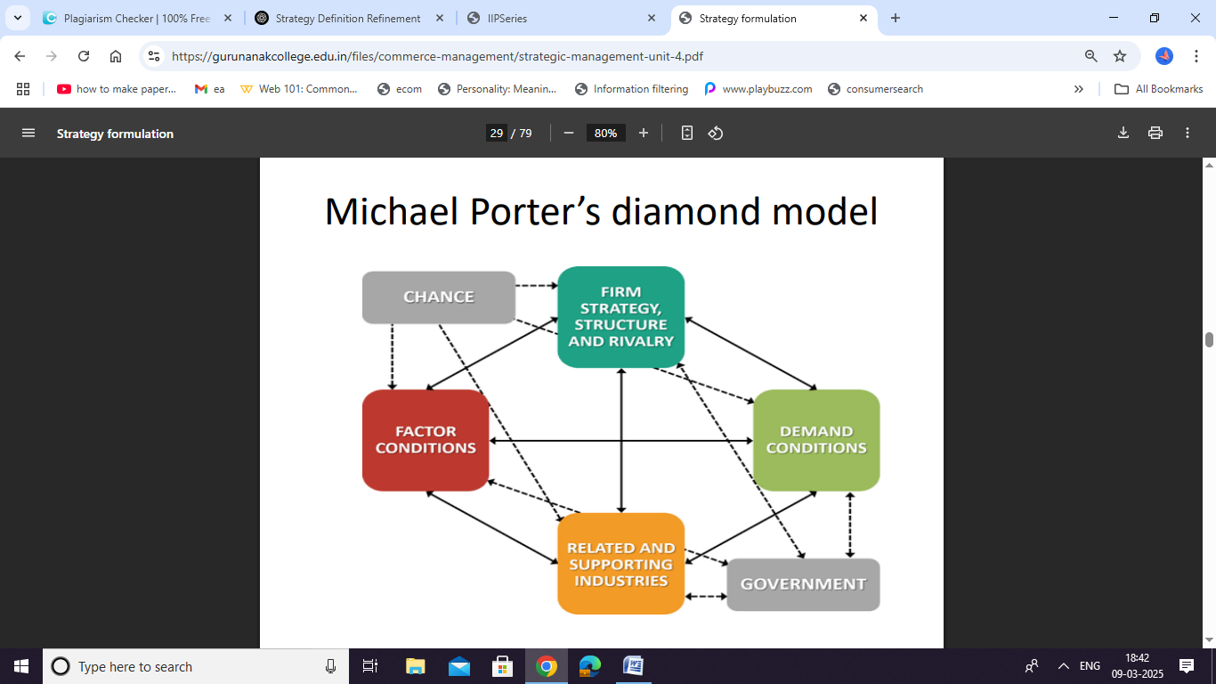

**Guidelines for Crafting Successful Business Strategies**

To develop effective business strategies, organizations should consider the following guidelines:

1. **Align with Vision and Mission**: Ensure strategies support the organization’s long-term aspirations.
2. **Conduct SWOT Analysis**: Identify strengths, weaknesses, opportunities, and threats.
3. **Leverage Competitive Advantage**: Capitalize on unique capabilities to differentiate from competitors.
4. **Ensure Flexibility and Adaptability**: Create strategies that can evolve with changing market conditions.
5. **Focus on Customer Needs**: Prioritize customer satisfaction and engagement.
6. **Integrate Technology and Innovation**: Use digital advancements to enhance business operations.
7. **Establish Clear Performance Metrics**: Define key performance indicators (KPIs) to measure success.
8. **Encourage Cross-Functional Collaboration**: Foster teamwork across different departments.
9. **Regularly Review and Refine Strategies**: Continuously monitor outcomes and adjust strategies as needed.

Strategy formulation is a crucial component of strategic management that helps businesses achieve sustainable growth. By understanding corporate planning, defining clear objectives, and implementing effective strategies, organizations can navigate competitive landscapes and attain long-term success. A well-crafted strategy aligns with the company’s vision, leverages its strengths, and ensures adaptability to changing market dynamics.