Voltage Dip Mitigation Using Shunt-Connected Voltage Source Converter

Niraj Tukaram Dandage1

M.Engg Student Department of Electrical Engineering Shri Sant Gajanan Maharaj College of Engineering, Shegaon, Maharashtra, India

Dr.S.R.Paraskar2 (Prof.)

Department of Electrical Engineering

Shri Sant Gajanan Maharaj College of Engineering, Shegaon, Maharashtra, India

# Abstract:- In this paper, a voltage source converter (VSC) connected in shunt with the grid to mitigate voltage dips for sensitive processes is presented. The VSC maintains the magnitude of the grid voltage at the connection point constant by injecting reactive power to compensate for the voltage dip. This is achieved by using a cascade controller, constituted by an inner vector cur- rent-controller (VCC) and an outer voltage controller, which calculates the current references for the VCC. The paper shows that using an inductor/capacitor/inductor (LCL)-filter instead of the simpler L-filter in between the VSC and the grid yields high performance and robust controller. Furthermore, in order to compensate for unbalanced dips, both positive- and negative-sequence components of the grid voltage must be controlled separately. This is done by using two independent controllers for the two sequences, with the same cascaded structure described above. Simulation results under balanced and unbalanced dips are presented to show the performance. Also, stability analyses are done to determine the robustness of the system against grid parameter variation.

# *Keywords:-* *voltage dips, shunt-connected VSC, reactive power compensation, LCL filters, power quality*

# 1. INTRODUCTION

Voltage quality is crucial in modern industrial environments, where even brief voltage dips can cause significant disruptions to operations. These dips, often resulting from grid faults or load changes, can lead to equipment malfunctions, production losses, and downtime, especially in industries reliant on sensitive electronic systems. Addressing these challenges requires advanced solutions that ensure power stability and reliability.

Voltage Source Converters (VSCs), particularly in shunt configurations, have emerged as a promising approach to mitigate voltage dips. By injecting reactive power into the grid, these converters stabilize voltage levels at the point of common coupling (PCC). Beyond mitigation, shunt-connected VSCs also enhance overall power quality through harmonic filtering and reactive power compensation, making them versatile solutions for industrial applications.

However, the effectiveness of VSCs depends heavily on the design of robust control strategies that perform well under dynamic grid conditions. Factors such as weak grids and unbalanced faults necessitate advanced control systems capable of maintaining stability and performance. This paper reviews a proposed approach for shunt-connected VSC-based voltage dip mitigation, focusing on innovations like cascade controllers, LCL filters, and dual-vector control strategies. The findings, supported by simulations, provide valuable insights into the system’s strengths, limitations, and potential for practical implementation.

**2.** **MODEL OVERVIEW AND FUNCTIONALITY**

**2.1 Key Components and Their Functions**

1. **Three-Phase Source and Grid Integration**  
   The system connects to a three-phase power source, ensuring seamless integration with the grid. It continuously monitors grid voltage to detect and address voltage dips, enabling real-time response to disturbances.
2. **Maximum Power Point Tracking (MPPT)**  
   This component maximizes energy extraction from renewable sources such as solar or wind. By continuously optimizing operating conditions, MPPT enhances overall system efficiency and ensures a consistent energy supply, even under fluctuating input conditions.
3. **Shunt-Connected Voltage Source Converter (VSC)**  
   The VSC serves as the system's backbone, injecting reactive power into the grid to stabilize voltage levels at the Point of Common Coupling (PCC). Its robust design ensures effective compensation for voltage dips, improving grid reliability and power quality.
4. **LC Filter**  
   A vital component for harmonic suppression, the LC filter ensures that the current injected into the grid is smooth and complies with international power quality standards. This guarantees minimal distortion and prevents adverse effects on grid-connected equipment.
5. **Pulse Width Modulation (PWM) Control**  
   PWM control governs the switching operation of the VSC with precision. By generating high-frequency signals, it allows for efficient and accurate voltage regulation while minimizing power losses during operation.
6. **Battery Energy Support**  
   An integrated battery system provides auxiliary energy during voltage dips, ensuring uninterrupted operation. This backup power enhances the system's ability to maintain grid stability and improve overall reliability during extended disturbances.
7. **Control Strategy**  
   The system employs a dual-loop control mechanism. The outer loop regulates voltage at the PCC, while the inner loop manages current injection. This cascade control structure enables fast and accurate responses to grid disturbances, maintaining system stability under varying load and grid conditions.

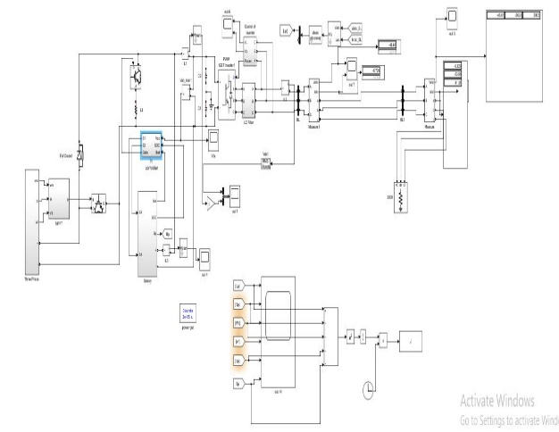

Fig.1 Power System Model for Voltage Stability Enhancement

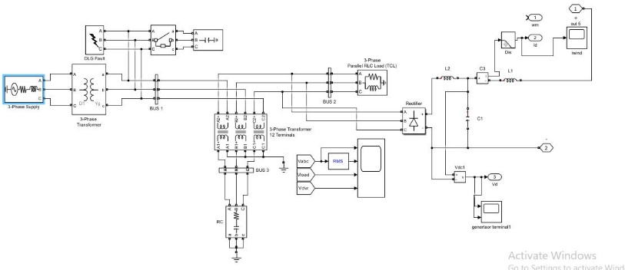

Fig. 2 Three-Phase Power Network Simulation

**2.2 Working Principles**

The operation of the system is strategically designed to ensure efficiency and reliability under varying grid conditions.

1. **Normal Operating Conditions**  
   During normal grid conditions, the VSC remains in a passive state, consuming minimal energy. This ensures the system operates efficiently without unnecessary power draw when no disturbances are present.
2. **Voltage Dip Detection and Response**  
   When a voltage dip occurs, the control system promptly identifies the disturbance through real-time grid monitoring. Upon detection, the VSC is activated to counteract the dip, ensuring rapid response to maintain power quality.
3. **Reactive Power Injection**  
   The VSC injects reactive power at the Point of Common Coupling (PCC) to restore voltage levels and stabilize the grid. Concurrently, the integrated LC filter suppresses harmonic distortions, ensuring the injected current adheres to grid standards and does not compromise power quality.
4. **Unbalanced Voltage Dip Compensation**  
   In the case of unbalanced voltage dips, the system employs a dual-vector control strategy. This advanced approach compensates for both positive and negative sequence components, effectively mitigating asymmetrical disturbances and ensuring stable and balanced voltage at the PCC.

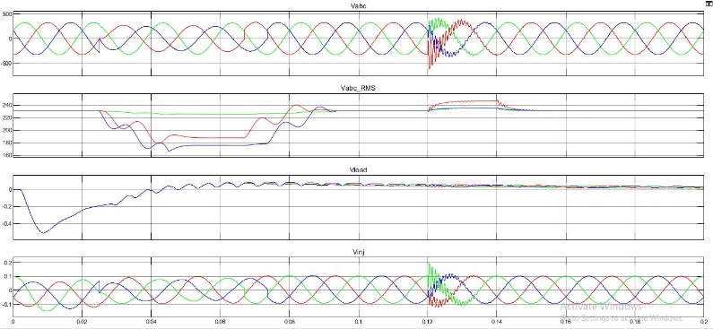

Fig.3 Time-Domain Analysis of Three-Phase Voltages (Vabc), RMS Values,Load Voltage (Vload) and voltage injector

**3. PERFORMANCE ANALYSIS**

**3.1 Balanced Voltage Dips**

The system demonstrates exceptional performance under balanced voltage dip conditions by promptly restoring voltage levels at the Point of Common Coupling (PCC). Through precise reactive power injection, the system stabilizes the grid voltage, ensuring minimal disruption to connected loads. The integrated LC filter effectively suppresses harmonics, maintaining high-quality current that complies with grid standards. Simulation results validate the system's capability to achieve rapid voltage stabilization with minimal overshoot, ensuring reliable operation during such disturbances.

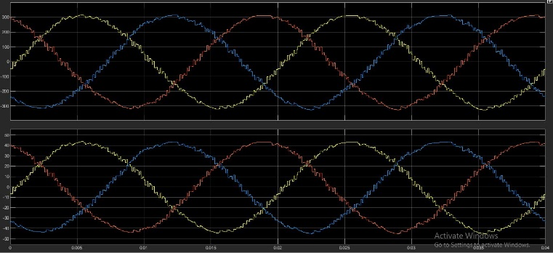

Fig.4 Balanced Voltage Dip Analysis

**3.2 Unbalanced Voltage Dips**

For unbalanced voltage dips, the system employs an advanced dual-vector control strategy that effectively addresses both positive and negative sequence components. This method minimizes oscillations and restores voltage stability even under asymmetrical grid conditions. While the system ensures robust compensation, slight residual effects may still occur, highlighting opportunities for further optimization and fine-tuning of control parameters. Overall, the system's ability to manage unbalanced dips significantly enhances its versatility and reliability.

**3.3 Harmonic Mitigation**

Harmonic distortion is a critical concern in power quality systems, and the LC filter in this design plays a pivotal role in addressing this challenge. By significantly reducing harmonic content, the filter ensures that the injected current meets stringent power quality standards, such as those set by IEEE and IEC. This capability not only enhances the performance of the system but also prevents adverse impacts on grid-connected devices, ensuring smooth and stable operation across all conditions.

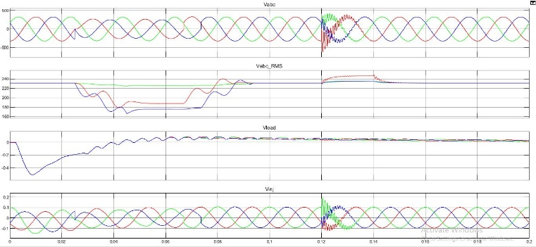

Fig.4 Balanced Voltage, Unbalance Voltage and Harmonics Mitigation

**4. CHALLENGES AND LIMITATIONS**

While the system offers a robust solution for mitigating voltage dips, it is not without its challenges. Key limitations include:

1. **Grid Sensitivity**  
   The effectiveness of the control strategy depends heavily on accurate and real-time detection of grid parameters, such as voltage and current levels. However, these parameters can fluctuate dynamically due to changing grid conditions, making it challenging to maintain consistent performance. Enhancing the system's adaptability to such variations is critical for further improvement.
2. **Battery Constraints**  
   The battery system plays a vital role in providing energy support during voltage dips. However, its capacity and charging speed impose practical limitations, particularly during prolonged or frequent voltage dips. Insufficient battery capacity can hinder the system's ability to sustain operation, highlighting the need for advancements in energy storage technology.
3. **Controller Tuning**  
   Achieving optimal system performance requires precise tuning of control parameters, especially for unbalanced voltage dips. Fine-tuning the controller to handle complex grid disturbances is a time-intensive process and may require advanced algorithms to ensure stability and responsiveness under all conditions.

**5. CONCLUSION**

The proposed model offers a reliable and efficient solution for mitigating voltage dips in industrial and commercial grid environments. By integrating a shunt-connected Voltage Source Converter (VSC) with advanced features such as Maximum Power Point Tracking (MPPT), LC filtering, and Pulse Width Modulation (PWM) control, the system ensures rapid voltage stabilization and improved power quality. Its ability to address both balanced and unbalanced voltage dips demonstrates its versatility and practical applicability.

However, to further enhance the system's scalability and reliability, future research should prioritize hardware optimization, the development of adaptive control strategies for dynamic grid conditions, and seamless integration with renewable energy sources. These advancements will enable the system to meet the evolving demands of modern power grids, ensuring sustainable and uninterrupted power delivery.

**REFERENCES**

**[1]** Bongiorno, M., & Svensson, J. *Voltage Dip Mitigation Using Shunt-Connected Voltage Source Converter.* IEEE Transactions on Power Electronics, 22(5), 1867–1874, 2007.

**[2]** Blaabjerg, F., Teodorescu, R., Liserre, M., & Timbus, A. V. *Overview of Control and Grid Synchronization for Distributed Power Generation Systems.* IEEE Transactions on Industrial Electronics, 53(5), 1398–1409, 2006.

**[3]** Bollen, M. H. *Understanding Power Quality Problems: Voltage Sags and Interruptions.* IEEE Press, 2000.

**[4]** Esram, T., & Chapman, P. L. *Comparison of Photovoltaic Array Maximum Power Point Tracking Techniques.* IEEE Transactions on Energy Conversion, 22(2), 439–449, 2007.

**[5]** Rodriguez, P., Luna, A., Candela, I., Mujal, R., Teodorescu, R., & Blaabjerg, F. *Multiresonant Frequency-Locked Loop for Grid Synchronization of Power Converters Under Distorted Grid Conditions.* IEEE Transactions on Industrial Electronics, 58(1), 127–138, 2009.

**[6]** Teodorescu, R., Liserre, M., & Rodriguez, P. *Grid Converters for Photovoltaic and Wind Power Systems.* Wiley, 2011.

**[7]** Divya, K. C., & Østergaard, J. *Battery Energy Storage Technology for Power Systems—An Overview.* Electric Power Systems Research, 79(4), 511–520, 2009.

**[8]** Hingorani, N. G., & Gyugyi, L. *Understanding FACTS: Concepts and Technology of Flexible AC Transmission Systems.* Wiley-IEEE Press, 2000.

**[9]** Guerrero, J. M., Loh, P. C., Lee, T. L., & Chandorkar, M. *Advanced Control Architectures for Intelligent Microgrids—Part II: Power Quality, Energy Storage, and AC/DC Microgrids.* IEEE Transactions on Industrial Electronics, 60(4), 1263–1270, 2013.

**[10]** IEEE Standard 519-2014. *IEEE Recommended Practices and Requirements for Harmonic Control in Electric Power Systems.* IEEE, 2014.

**[11]** Zhou, K., & Wang, D. *Relationship Between Space-Vector Modulation and Three-Phase Carrier-Based PWM: A Comprehensive Analysis.* IEEE Transactions on Industrial Electronics, 49(1), 186–196, 2002.

**[12]** Akagi, H. *New Trends in Active Filters for Power Conditioning.* IEEE Transactions on Industry Applications, 32(6), 1312–1322, 2001.

**[13]** He, J., & Li, Y. W. *Analysis, Design, and Implementation of Virtual Impedance for Power Electronics Interfaced Distributed Generation.* IEEE Transactions on Industry Applications, 47(6), 2525–2538, 2011.

**[14]** Bose, B. K. *Modern Power Electronics and AC Drives.* Prentice Hall, 2002.

**[15]** Wu, F., Tang, Y., Peng, Z., & Zhang, X. *Modeling and Control of Grid-Connected Voltage-Sourced Converters Under Unbalanced Grid Conditions.* IEEE Transactions on Power Electronics, 25(3), 498–507, 2010.