**Introduction of Intelligent Agents**

Dr. Vimmi pandey Prof. Prashant Kumar Koshta

Department of Computer Science & Engineering Department of Computer Science & Engineering

Gyan Ganga College of Technology Gyan Ganga College of Technology

Jabalpur (MP), India Jabalpur (MP), India

vimmipandey@ggct.co.in prashantkumarkoshta@ggct.co.in

ABSTRACT

Autonomous systems that can see their surroundings, make decisions, and carry out activities to accomplish particular objectives are known as intelligent agents. These agents work in dynamic and unpredictable situations by applying intelligence techniques including reasoning, machine learning, and problem-solving. They are extensively used in many fields, including as autonomous cars, healthcare, robotics, and finance. The basic ideas of intelligent agents are presented in this work together with information on their types, structures, and main development obstacles. It also looks at their function in contemporary AI applications and upcoming developments in the field of intelligent agent research. An extensive introduction to intelligent agents is given in this study, which covers their kinds, structures, and traits. Important characteristics are examined to comprehend how these agents behave in diverse contexts, including autonomy, reactivity, proactiveness, and social competence. The capabilities and uses of several types of intelligent agents—such as model-based agents, simple reflex agents, learning agents learning agents and goal-based agents—are examined.

**Keywords**— Information, Agent, Data Analytics.

# INTRODUCTION

An intelligent agent, as used in machine learning, is a software system that can sense its surroundings, decide what to do, and act on its own initiative to accomplish particular objectives. It frequently learns and adapts by experience. Over the past few decades, video games and computers have steadily generated increasingly complex virtual worlds that give realistic representations of the real world. These days, computer graphics are employed extensively in a variety of fields, including entertainment, education, and the military. Intelligent agents use their knowledge of their surroundings to make decisions and take action on their own, without continual human intervention. They are made to work toward particular goals, such as finishing a task, streamlining a procedure, or reaching a desired result. Agents interact with their surroundings and carry out actions by using actuators and sensors to collect information about it. By using methods like many intelligent agents can gradually improve their tasks and decision-making skills by learning from their experiences.

An entity that perceives its surroundings, acts independently to accomplish objectives, and may enhance its performance through machine knowledge or learning acquisition is referred to as an intelligent agent in artificial intelligence. According to many AI textbooks, artificial intelligence is the "study and design of intelligent agents," with a focus on the fundamental role that goal-directed behavior plays in intelligence. Simple and extremely complex intelligent agents are both possible. A human being, a simple thermostat or control system, or any other system that satisfies the same requirements—like a company, a state, or a biome—is regarded as an intelligent agent. Schematically, intelligent agents are frequently characterized as distinct functional systems that resemble computer programs. Abstract intelligent agents are abstract descriptions of intelligent agents that are used to differentiate between theoretical models and practical implementations. Software agents, which are independent computer programs that perform tasks on behalf of users, are closely related to intelligent agents. Additionally, they are called "rational agents" using a phrase taken from economics as shown in figure-1.

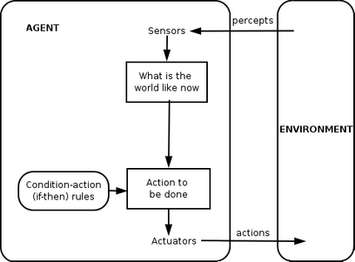

Figure-1 Simple reflex agent diagram

Intelligent agents in ML exhibit key characteristics that distinguish them from traditional software programs:

* **Autonomy** – They operate without direct human intervention, making independent decisions.
* **Perception** – They gather data from the environment using sensors or input mechanisms.
* **Learning and Adaptation** – They improve their performance over time through experience.
* **Goal-Oriented Behavior** – They are designed to achieve specific objectives.
* **Reactivity and Proactiveness** – They respond to environmental changes while also taking proactive actions to optimize results.

An agent could be anything that employs sensors to sense its environment and actuators to act. An agent goes through a cycle of perceiving, thinking, and action. An agent could be:

o **Human-Agent:** A human agent's hands, legs, and vocal tract function as actuators, while their eyes, hearing, and other organs serve as sensors.   
o **Robotic Agent:** A robotic agent may be equipped with cameras, an infrared rangefinder, sensors that use natural language processing, and actuators that use a variety of motors.   
o **Software Agent:** A software agent can act on keystrokes and file contents as sensory inputs, display the results on the screen, and more.

Thus, the thermostat, cell phone, camera, and even ourselves are agents in our environment.   
An intelligent agent is a self-governing creature that uses sensors and actuators to influence its surroundings in order to accomplish objectives. To accomplish their objectives, an intelligent agent may pick up knowledge from their surroundings. One example of an intelligent agent is a thermostat.

Following are the main four rules for an Intelligent agent:

* **Rule 1:** An Intelligent agent must have the ability to perceive the environment.
* **Rule 2:** The observation must be used to make decisions.
* **Rule 3:** A decision must be followed by action.
* **Rule 4:** A sensible action is required of an intelligent agent.

Agents can be classified into different types according to their characteristics, such as whether they are single- or multi-agent systems, reactive or proactive, or have a fixed or dynamic environment.   
Agents that react appropriately to immediate environmental stimuli are known as reactive agents. Conversely, proactive actors take charge and make plans in advance to accomplish their objectives. Additionally, an agent may function in a dynamic or static context. Unlike dynamic settings, where agents must constantly adjust to new circumstances, fixed environments contain a set of rules that are consistent and never change.

In multi-agent systems, several agents cooperate to accomplish a shared objective. To accomplish their goals, these agents might need to coordinate their actions and interact with one another. There are numerous applications for agents, including intelligent systems, robotics, and gaming. Numerous computer languages and methods, such as machine learning and natural language processing, can be used to implement them.

The agents act in their environment. The environment may contain other agents.   
Anything that could be considered:

• Using sensors to sense its environment.   
• Using actuators to act on them is regarded as an agent.

## Structure of an Intelligent Agent

Understanding the organization of intelligent agents requires an understanding of architecture and agent programming. The architecture is the apparatus on which the agent functions. Examples of equipment with sensors and actuators include a computer, a camera, and a robotic automobile. An agent program implements an agent function. As illustrated in figure 2, an agent function is a map from the percept sequence—the history of everything an agent has seen thus far—to an action.

*Agent = Architecture + Agent Program*

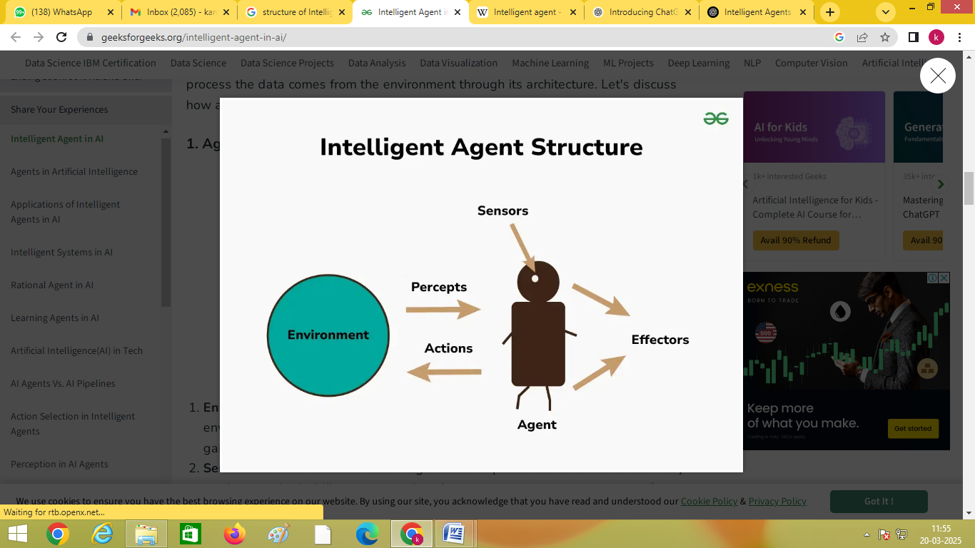

## Figure-2 Structure of an Intelligent Agent

**Examples of Intelligent Agents:**

**Robots:**

Autonomous robots, like those used in manufacturing or exploration, are a prime example of intelligent agents.

**Virtual Assistants:**

Siri, Alexa, and other virtual assistants are intelligent agents that can understand and respond to user requests.

**Self-Driving Cars:**

Self-driving cars rely on intelligent agents to navigate roads, make decisions, and avoid accidents.

**Recommendation Systems:**

Netflix and Amazon use intelligent agents to advise movies, products, and other content on user demands.

**Spam Filters:**

Spam filters are intelligent agents that learn to identify and filter out unwanted emails.

**Characteristics of Intelligent Agent**

An entity that senses its surroundings, interprets data, and acts to accomplish predetermined objectives is known as an intelligent agent. Here are the key characteristics of an intelligent agent as shown in figure-3:

### 1. **Autonomy**

* Operates without direct human intervention
* Makes decisions independently

### 2. **Perceptiveness**

* Uses sensors (e.g., cameras, microphones, or software sensors) to perceive the environment
* Collects data from surroundings

### 3. **Reactivity**

* Responds to varies in the real-time environment
* Adapts to new information dynamically

### 4. **Proactiveness**

* Not just reactive but also goal-driven
* Takes initiative to achieve objectives

### 5. **Adaptability & Learning**

* Improves performance over time using learning mechanisms (e.g., machine learning, deep learning)
* Adjusts behavior based on past experiences

### 6. **Rationality**

* Chooses the best possible action based on available knowledge
* Maximizes success probability while minimizing risks

### 7. **Communication Ability**

* Can interact with other agents, humans, or systems
* Uses languages, protocols, or gestures for effective communication

### 8. **Mobility (for some agents)**

* Some agents can move physically (e.g., robots) or within networks (e.g., software agents)

### 9. **Goal-Oriented Behavior**

* Works towards achieving predefined objectives
* Evaluates success based on goal achievement

### 10. **Flexibility**

* Can handle unexpected changes in the environment
* Adjusts plans dynamically when needed

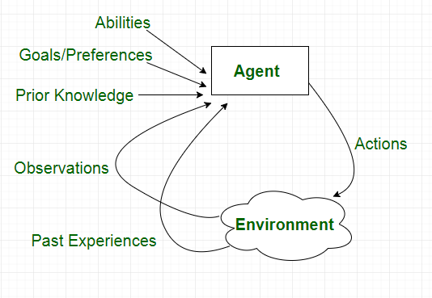 Figure-3 Characteristics of Agent

# Literature Review

A comprehensive review of LLM-based intelligent agents in both single-agent and multi-agent systems is necessary, Yuheng Cheng [1] et al. explore recent research. It goes over their definitions, study frameworks, and fundamental elements including their makeup, planning and cognitive processes, tool use, and reactions to feedback from the environment. A summary of intelligent agents, and multiple-agent systems is given by Rudowsky, I. [2]. Topics covered include: 1. what an agent is, where it came from, and how intelligence is defined; 2. what it does and distinguishes intelligent agents from agents; 3. how agents with opposing goals are coordinated by multi-agent systems to achieve a meaningful result; and 4. how an agent differs from an expert system or a class object. The paper by James A. Hendler [3] provides a striking example of why agent-based computing has gained such prominence in recent years. Moises Lejter and Thomas Dean's last feature piece is about agent-related research, specifically about multiagent architectures. The focus of this technical paper is on creating and assessing a framework that tackles several problems in comprehending multiagent systems.

John Fox and associates [4] These perspectives clarify and consolidate the benchmark agent features while providing varying views into PROforma's advantages and disadvantages. A helpful foundation for analyzing and contrasting other agent systems in medicine or other fields is provided by the consolidated model. A brief overview of the present and prospective uses of agent technology is provided by Michael Wooldridge et al. [5]. V V Sarma[6] identifies certain issue formulations involving agents by surveying the literature on agents (single, intelligent, adaptable, and groups of them). One area where the concept of intelligent agents has generated a lot of interest is distributed artificial intelligence (DAI). Recent studies and uses of multi-agent systems in healthcare that have been presented at international conferences, published in various scientific journals, and used in practice are reviewed by Sajid Iqbal et al. [7].

The focus of Hofmann et al. [8] is on networked business models in which human and intelligent agents interact for economic gain within one or more tiers of economic value chains. In addition to offering significant implications for managers and designers looking to improve human–AI collaboration, Christopher Diebel et al. [9] advance our understanding of assistance from AI-based agents. The concept of "Intelligent Software Agents" has been proposed by Renas Rajab Asaad et al. [10]. Intelligent software agents are programs that act on behalf of their human users to perform time-consuming information gathering tasks like finding and accessing information from various internet information sources, fixing discrepancies in the data that was obtained, and eliminating unnecessary information. Still being determined, though, is the exact definition of an intelligent agent.

**Approaches of Intelligent agent**

In **machine learning**, intelligent agents can be designed using different approaches based on how they perceive the environment and make decisions. The primary approaches for designing intelligent agents include:

### **1. Rule-Based Agents (Symbolic AI)**

* Use **predefined rules** and **logical reasoning** to make decisions.
* Often rely on **if-then statements**, **expert systems**, or **knowledge-based systems**.
* Example: A chatbot that responds based on predefined patterns.

### **2. Supervised Learning-Based Agents**

* Learn from **labeled data** to map inputs to outputs.
* Require **training datasets** to improve accuracy.
* Example: Image classification using neural networks.

### **3. Unsupervised Learning-Based Agents**

* Discover **hidden patterns** in data without labeled outputs.
* Use clustering and dimensionality reduction techniques.
* Example: Customer segmentation in marketing.

### **4. Reinforcement Learning (RL) Agents**

* Acquire knowledge by trial and error, with rewards or penalties determined by actions.
* Use techniques like **Policy Gradient Methods and Q-learning, Deep Q-Networks (DQN).**
* Example: AlphaGo learning to play Go.

### **5. Evolutionary and Genetic Algorithms-Based Agents**

* Use **natural selection-inspired** optimizatio**n techniques.**
* Generate populations of solutions and evolve over time.
* Example: Optimization of neural network architectures.

### **6. Hybrid Approaches**

* Combine multiple learning approaches to enhance performance.
* Example: **Neuro-symbolic AI**, which combines rule-based reasoning with deep learning.

# Types of Intelligent Agents

Five classes of agents can be distinguished according to how intelligent and capable they are thought to be:

### **Simple Reflex Agents**

Simple reflex agents ignore the rest of the perceptual history and just act in response to the current perception. Percept history is the history of all the things an agent has seen thus far. The agent function is based on the condition-action rule. A condition-action rule is a rule that links an action to a state, or condition. If the condition is true, the action is carried out; if not, it is not. This agent function only operates when the environment is fully visible. Infinite loops are frequently inevitable for simple reflex agents functioning in partially visible surroundings. If the agent is able to randomize its activities, it might be possible to break out of infinite loops as shown in figure-4 .

Problems with Simple reflex agents are :

* Very limited intelligence.
* No knowledge of non-perceptual parts of the state.
* The collection of rules must be updated whenever the environment changes because they are typically too large to generate and store. 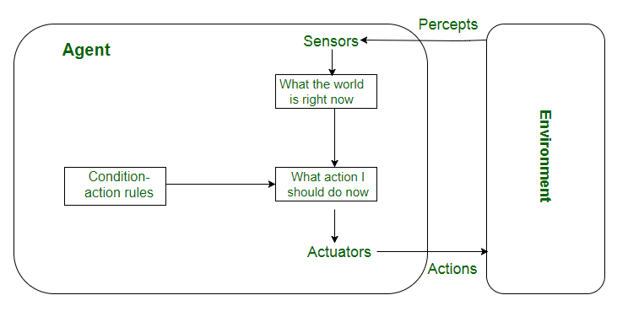

Figure-4 Simple-Reflex Agents

### **Model Reflex Agents**

It works by determining a rule whose condition matches the current situation. A model-based agent may control partially visible environments by utilizing a model about the world. Each percept modifies the internal state, which the agent must monitor based on the percept history. The present state is stored by the agent, which maintains some kind of structure that defines the invisible part of the cosmos. To update the status as depicted in figure 5, information on the following is required:

* How does the world change apart from the agent?
* What impact do the agent's actions have on the outside world? 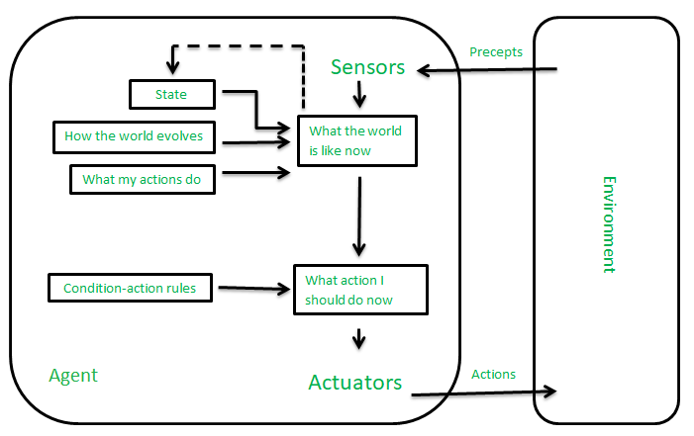

Figure-5 Model-Based Reflex Agents

### **Goal-Based Agents**

These agents make judgments depending on their current distance from their objective, which is a description of desirable circumstances. Every move they make is meant to bring them closer to the objective. This gives the agent the ability to select from a variety of options and choose the one that gets to the desired state. These agents are more adaptable since the information underlying their choices is explicit and changeable. They typically call for preparation and search. It is simple to modify the behavior of the goal-based agent as shown in figure-6.

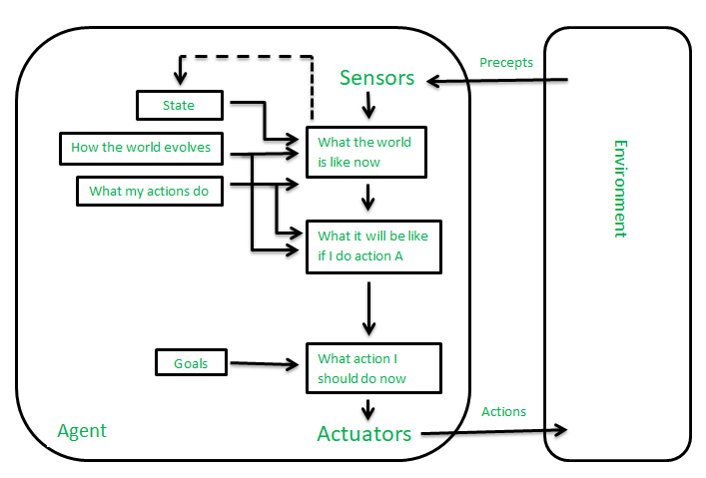

**Figure-6 Goal-Based Agents**

### **Utility-Based Agents**

Agents that are built utilizing their ultimate applications as building blocks are known as utility-based agents. When there are multiple possibilities, utility-based agents are employed to identify the best one. They choose actions for each condition based on utility, or preference. Sometimes achieving the desired result is not enough. We might look for a quicker, safer, and less costly way to get to a destination. Agent happiness should be taken into account. Utility is a measure of the agent's "happiness." A utility agent choose the course of action that maximizes the predicted utility due to the uncertainty in the world. A utility function represents the corresponding level of satisfaction by mapping a state onto a real integer as shown figure-7.

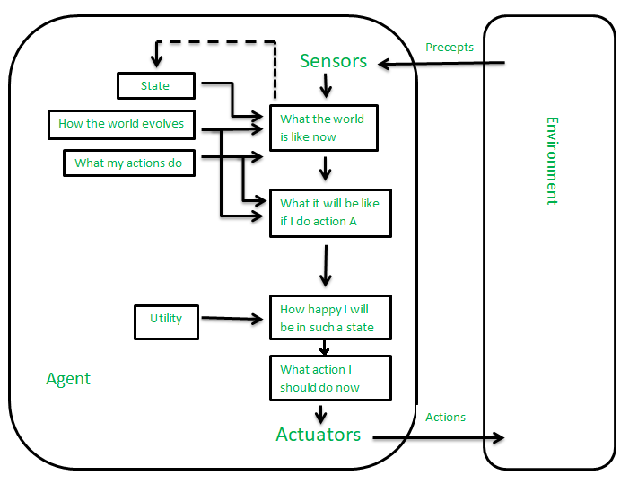

**Figure-7 Utility-Based Agents**

### **Learning Agent**

An artificial intelligence (AI) learning agent is one that has the capacity to learn from its prior experiences. It begins by acting on its basic information before learning to act and adapt on its own. The four primary conceptual components as shown in figure-8 of a learning agent are as follows:

1. Learning element: It is in charge of improving things by taking in knowledge from the surroundings.   
2. Critical: The learning component uses critics' input to indicate how well the agent is performing in relation to a predetermined performance benchmark.   
3. Performance element: It is in charge of choosing outside action.   
4. Problem Generator: This part is in charge of making recommendations for activities that will result in novel and educational experiences. 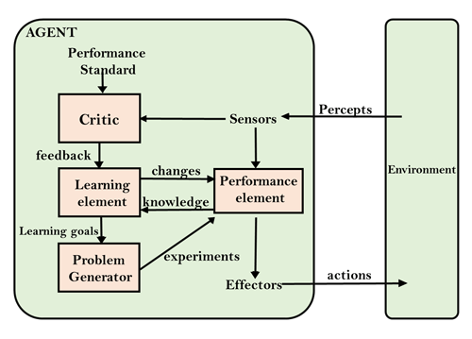

**Figure-8 Learning Agent**

### **Multi-Agent Systems**

To accomplish a shared objective, these agents communicate with one another. To accomplish their goal, they might need to coordinate their efforts and speak with one another.   
A system made up of several interacting agents intended to cooperate in order to accomplish a shared objective is known as a multi-agent system (MAS). These agents can perceive their surroundings, make judgments, and act to accomplish the shared goal. They can be either fully or partially autonomous.

Applications for MAS are numerous and include social networks, robotics, and transportation systems. In complex systems, they can contribute to increased flexibility, cost savings, and efficiency.MAS can be divided into many varieties according to their attributes, including whether the agents are homogenous or heterogeneous, cooperative or competitive, and whether they have similar or distinct goals.

All of the agents in a homogeneous MAS share the same capabilities, objectives, and behaviors; in a heterogeneous MAS, however, the agents differ in these areas.

This can lead to more resilient and flexible systems, but it can also make coordination more difficult. In cooperative MAS, agents collaborate to accomplish a shared objective, whereas in competitive MAS, agents compete with one another to accomplish their individual objectives. When agents must weigh their personal interests against the group's interests, MAS can occasionally involve both cooperative and competitive behavior.   
A variety of methods, including machine learning, game theory, and agent-based modeling, can be used to implement MAS. Agents' strategic interactions are analyzed and their behavior is predicted using game theory. Agents are trained using machine learning to gradually enhance their decision-making skills. Simulating complex systems and researching agent interactions are two applications of agent-based modeling.

Overall, multi-agent systems are a powerful tool in artificial intelligence that can help solve complex problems and improve efficiency in a variety of applications.

## ****Hierarchical Agents****

High-level agents supervise the actions of lower-level agents in this hierarchical organization. While the low-level agents do particular tasks, the high-level agents set objectives and limitations. In complicated environments with numerous tasks and subtasks, hierarchical agents are helpful.

• Agents arranged in a hierarchy, where higher-level agents supervise the actions of lower-level agents, are known as hierarchical agents. While the low-level agents do particular tasks, the high-level agents set objectives and limitations. In complicated contexts, this framework enables more ordered and effective decision-making.

* A wide range of applications, such as manufacturing, transportation systems, and robotics, can use hierarchical agents. They are especially helpful in settings where a lot of tasks and subtasks need to be prioritized and coordinated.

• In a hierarchical agent system, the high-level agents are responsible for setting goals and constraints for the lower-level agents. These limitations and objectives are typically based on the system's overall purpose. For example, in a manufacturing system, the high-level agents may use client demand to set production targets for the lower-level agents, who are then in charge of completing particular tasks in order to meet the targets. Depending on the particular application, these activities could be rather easy or highly complicated. For instance, low-level agents may be in charge of controlling traffic flow at particular crossings in a transportation system.

* Depending on how sophisticated the system is, hierarchical agents can be arranged into several layers. There might only be two tiers in a basic system: high-level agents and low-level agents. Multiple levels may exist in a more complicated system, with intermediate-level agents in charge of directing the actions of lower-level agents. The ability to use resources more effectively is one benefit of hierarchical agents. It is feasible to assign tasks to the agents most qualified to complete them without causing duplication of effort by arranging agents in a hierarchy. Decision-making may become quicker and more effective as a result, and the system may function better overall.
* All things considered, hierarchical agents are an effective artificial intelligence tool that can assist in resolving complicated. Overall, hierarchical agents are a powerful tool in artificial intelligence that can help solve complex problems and improve efficiency in a variety of applications.

## Agent function

An intelligent agent's behavior can be described mathematically by an agent function. This function determines what the agent does based on what it has seen.

A percept refers to the agent's sensory inputs at a single point in time. For example, a self-driving car's percepts might include camera images, lidar data, GPS coordinates, and speed readings at a specific instant. The agent uses these percepts, and potentially its history of percepts, to decide on its next action (e.g., accelerate, brake, turn).

The agent function, often denoted as f, maps the agent's entire history of percepts to an action.[[16]](https://en.wikipedia.org/wiki/Intelligent_agent#cite_note-16)

Mathematically, this can be represented as:

�:�∗→� 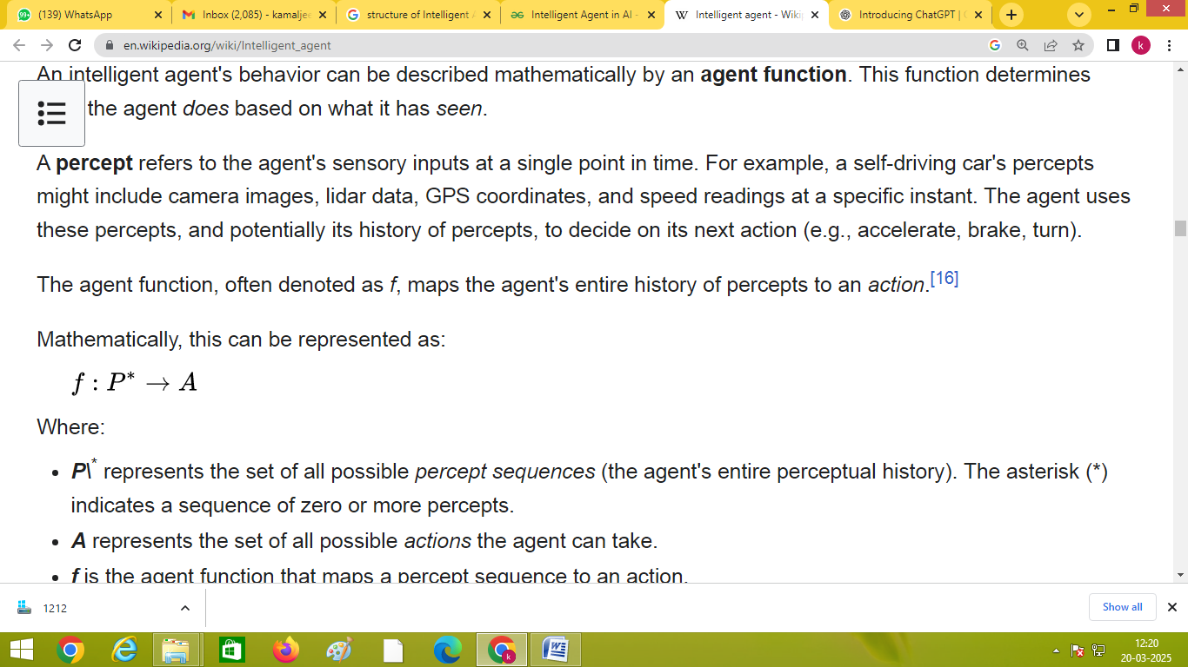

Where:

* ***P***\* represents the set of all possible *percept sequences* (the agent's entire perceptual history). The asterisk (*) indicates a sequence of zero or more percepts.
* ***A*** represents the set of all possible *actions* the agent can take.
* ***f*** is the agent function that maps a percept sequence to an action.

It's crucial to distinguish between the *agent function* (an abstract mathematical concept) and the *agent program* (the concrete implementation of that function).

* The agent function is a theoretical description.
* The agent program is the actual code that runs on the agent. The agent program takes the *current* percept as input and produces an action as output.

The agent function can incorporate a wide range of decision-making approaches, including:

* Calculating the utility (desirability) of different actions.
* Using logical rules and deduction.
* Employing fuzzy logic.
* Other methods.

# Uses of Agents

There are numerous uses for agents in artificial intelligence, such as:   
• Robots: Agents can be used to operate robots and automate processes in a variety of industries, including transportation and manufacturing.   
• Smart buildings and houses: By using agents to manage lighting, heating, and other systems, smart buildings and homes may maximize energy efficiency and enhance comfort.   
• Transportation systems: By controlling traffic flow and optimizing routes for self-driving cars, agents can enhance supply chain and logistics management.   
• Healthcare: Agents are useful for patient monitoring, individualized treatment programs, and the efficient utilization of medical resources.   
The financial sector can employ agents for risk management, automated trading, and fraud detection.

• Games: Agents can be utilized to generate clever opponents in simulations and games, giving gamers a more realistic and difficult experience.   
• Natural language processing: Chatbots and agents that can converse with users in natural language can be employed for natural language translation and question answering.   
• Cybersecurity: Network security, malware analysis, and intrusion detection can all be accomplished with agents.   
• Environmental monitoring: Agents are useful for tracking climate change, managing natural resources, and enhancing environmental sustainability.   
• Social media: Agents can be used to examine data from social media, spot trends and patterns, and offer users tailored suggestions.   
All things considered, agents are a strong and adaptable artificial intelligence tool that can assist in resolving a variety of issues in various domains.

# Conclusion

Intelligent agents in machine learning has significantly transformed the way machines interact with data, environments, and decision-making processes. Intelligent agents, equipped with the ability to perceive, learn, and act autonomously, play a crucial role in various applications, including robotics, recommendation systems, and autonomous systems. Their ability to adapt to dynamic environments, optimize decision-making, and improve efficiency makes them essential in modern AI-driven solutions. As research advances, intelligent agents will continue to evolve, leading to more sophisticated and human-like AI systems capable of handling complex real-world problems.

# Reference

[1] Yuheng Cheng at al. " EXPLORING LARGE LANGUAGE MODEL BASED INTELLIGENT AGENTS: DEFINITIONS, METHODS, AND PROSPECTS", https://arxiv.org/pdf/2401.03428

[2] Rudowsky, I. (2004). Intelligent Agents. Communications of the Association for Information Systems, 14, pp-pp. <https://doi.org/10.17705/1CAIS.01414>

[3] [James A. Hendler](https://www.computer.org/csdl/search/default?type=author&givenName=James%20A.&surname=Hendler)," Intelligent Agents: Where AI Meets Information Technology, Dec. 1996, pp. 20- 23, vol. 11 DOI Bookmark: [10.1109/MEX.1996.546578](https://doi.ieeecomputersociety.org/10.1109/MEX.1996.546578)

[4]   [Fox, John](https://content.iospress.com/search?q=author%3A%28%22Fox,%20John%22%29)  et al. ," Understanding intelligent agents: analysis and synthesis", [AI Communications](https://content.iospress.com/journals/ai-communications), vol. 16, no. 3, pp. 139-152, 2003

[5] [Michael Wooldridge](https://www.cambridge.org/core/search?filters%5BauthorTerms%5D=Michael%20Wooldridge&eventCode=SE-AU) and [Nicholas R. Jennings](https://www.cambridge.org/core/search?filters%5BauthorTerms%5D=Nicholas%20R.%20Jennings&eventCode=SE-AU), " Intelligent agents: theory and practice",  [The Knowledge Engineering Review](https://www.cambridge.org/core/journals/knowledge-engineering-review), [Volume 10](https://www.cambridge.org/core/journals/knowledge-engineering-review/volume/44D4ADFFC34573E5D621A586B0EB9D96), [Issue 2](https://www.cambridge.org/core/journals/knowledge-engineering-review/issue/46C2071215B5B03DBD71D1D1B1A99852),2009

[6] VVS Sarma," Intelligent Agents", Pages 105-109 | Published online: 26 Mar 2015, https://doi.org/10.1080/03772063.1996.11415911

  [7] Iqbal, S., Altaf, W., Aslam, M. et al. Application of intelligent agents in health-care: review. Artif Intell Rev 46, 83–112 (2016). https://doi.org/10.1007/s10462-016-9457-y

[8] Hofmann, P., Urbach, N., Lanzl, J. et al. AI-enabled information systems: Teaming up with intelligent agents in networked business. Electron Markets 34, 52 (2024). https://doi.org/10.1007/s12525-024-00734-y

[9] Christopher Diebel et al.[9], "When AI-Based Agents Are Proactive: Implications for Competence and System Satisfaction in Human–AI Collaboration", https://doi.org/10.1007/s12599-024-00918-y

[10] Renas Rajab Asaad et al. , "Smart Agent and it’s effect on Artificial Intelligence : A Review Study", <https://doi.org/10.46291/ICONTECHvol5iss4pp1-9>