**APPLICATIONS AND SAFETY CHALLENGES OF INTERNET OF THINGS**

**Mohit Kumar Saini1, Mukesh Kumar2**

1Department of Computer Science & Engineering, Tula’s Institute, Dehradun, Uttarakhand, India

[mohitkunwarpal@gmail.com](mailto:mohitkunwarpal@gmail.com)

2Department of Computer Science & Engineering , Dev Bhoomi Uttrakhand University, Dehradun, Uttarakhand, India

[Socse.mukeshkumar@dbuu.ac.in](mailto:Socse.mukeshkumar@dbuu.ac.in)

**ABSTRACT**

The Internet of Things changed over the overall boundless covering of people, keen gadgets, wise things, data, and points of interest. It is no anonymous that as constantly performs significant other to the web, the challenges of protecting the records that they impart and the transportations that they drive have gotten increasingly mindful. Throughout the years, we've evident about pouring in IoT gadgets, comprehensively in 2 territories – in homes and in assembling. With the past, we have unambiguous an entire surrounds developed around Amazon's Echo gadgets the use of the Alexa Voice Service. Google, Microsoft, and Apple have went with sound as correctly. Since those are balanced and shut structures, the responsibilities of protecting the gadgets control with the presentation place. In this section, we will state digital security in fabricate and supplementary organizations. Organizations which integrate modern, oil &petrol, filtering, prescription drugs, consumption times and imbuement, water cure, and a lot more are dependably attempting to include the correct layers of security, as they pass on progressively more gadget and gadgets on the web. Contraption creators and flower actions superiors constantly expression straining to lookout their physical things from numerical dangers. Also, for every one of these activities, the landscape of the data, topologies of IoT appliances, and difficulties of danger control and promising consistence land normally.

**KEYWORDS**

Internet of Things, Cyber-attack, Security threats.

**TABLE OF CONTENTS**

|  |  |  |
| --- | --- | --- |
| Chapter 1 | **APPLICATIONS AND SAFETY CHALLENGES OF INTERNET OF THINGS** | Page No. |
| 1.1 | Introduction | 2 |
| 1.2 | Internet of Things (IOT) | 4 |
| 1.3 | Characteristics of Internet of Things (IOT) | 6 |
|  | 1.3.1 Intelligence | 6 |
|  | 1.3.2 Connectivity | 7 |
|  | 1.3.3 Dynamic Nature | 7 |
|  | 1.3.4 Enormous scale | 8 |
|  | 1.3.5 Sensing | 8 |
|  | 1.3.6Expressing1.3.7 Security | 8 |
| 1.4 | Applications of Internet of Things (IOT) | 9 |
|  | 1.5.1 Connected Health | 9 |
|  | 1.5.2Smart City | 10 |
|  | 1.5.3Connected car | 11 |
|  | 1.5.4Smart home | 12 |
|  | 1.5.5Smart farming | 12 |
|  | 1.5.6Smart retail | 13 |
|  | 1.5.7Smart supply chain | 13 |
|  | 1.5.8Smart retail | 14 |
| 1.5 | IoT Cyber security Challenges and Solutions | 22 |
| 1.6 | IoT Identity Protection | 23 |
| 1.7 | Conclusions | 24 |
|  | References | 24 |

* 1. **INTRODUCTION**

Web of Things is the relations legislature of corporal items that involve equipment presented classified their building to impart and recognize relations among each other or with respect to the outside circumstance. In the up and moving toward years, IoT-based change will recommendation necessary considerations of suggestions and fundamentally modification the incomes where characters suggestion their step by step exists. Developments in prescription, boss, greatness administrations, engendering, reasonableness town developments, and delicate families are just a not a lot of the far reaching models where IoT is capably notable. The Internet of Things (IoT) can be defined as a collection of physical objects or individuals referred to as "things" that are equipped with sensors, programming structures, devices, and frameworks that allow these items to collect and commit data. The goal of IoT is to expand web accessibility from typical items such as PCs, tablets, and smartphones to relatively unneeded devices like toasters. IoT aims to make everything "splendid," integrating AI calculation, associations, and recommendation irregularity into every aspect of our being. IoT is, broadly speaking, a framework in which every physical item is connected to the internet by means of framework attachments, modifications, and commitment materials. IoT licenses trainings to be experienced clearly at right techniques completed present framework encompasses. IoT is a regularly extraordinary and smooth strategy which diminishes human application similarly as basic access to physical machines. This technique additionally makes them rule control integrate by which any mechanism can control with no social corresponding energy.

IoT in the ground work separation has temperately newly happening to make the standard guidance structure dynamically mindless keen experienced investigation admissions tripe are serving substitutes study and take a quality more, although customized collaboration and diverse understudy subsequent systems could make schools increasingly harmless. Web involved in accessible examination entrances will be a success for production countries, making significant route in regions where setting up an even school establishment is silly. Web promised gathering and present day units are giving extrication conclusions, making them gradually protected and progressively feasible through restructured process controls. Plant and imperativeness restructuring, prosperity and prosperity control and security the boarding are at existing continuously life given by bleeding edge sensors, connected with refined microcomputers. Commercial organizations are presently using the web for an extensive part of their organizations. Exponential development in cutting edge founding and the best in class period of IoT empowered things could also clue the advancement of the fiscal region, with advancements, for instance, sharp wearable and keen looking devices, helping customers to screen their money and guesses. IoT-enabled devices may let telcos to withstand a surge in data usage, increasing their average revenue per customer (ARPU). However, they will also need to address a few issues, like as pledge and system security. While the possible results of these new advances are wonderful, they in like way reveal genuine IoT digital security challenges. We've witnessed an exciting increase in the quantity and complexity of ambushes targeting IoT devices over the past several years. In today's technologically advanced world, the interconnectedness of people, technologies, and relationships creates an entirely new set of vulnerabilities—ways that cybercriminals can enter. The affiliation's overall peril "scene" is merely a small, sometimes conflicting, and gloomy world of real and possible threats that typically start with incredibly terrifying and shocking danger performers that can have a positive influence. discussed a number of IOT security issues in this section.? This area presents an examination recently explore in IoT security from 2016 to 2019, its examples and open issues. The critical duty of this section is to give are opinion of the present domain of IoT safety contests.

* 1. **INTERNET OF THINGS (IOT)**

In a general sense, IoT is where each and every physical article is connected with the web through background represents or deviations and business material. IoT allows things to be controlled a little at right points over unresolved framework structure. IoT is an eccentric and strong system which declines human weakness correspondingly as straight access to human policies. This system moreover changes them large managerial attitude by which any implement can control with no unrestricted partnership. Progressively, proposal in a variety of undertakings are spending IoT to work even more successfully, better recognize customers to pass on renovated client support, develop significant expert and control the estimate of the profitable.

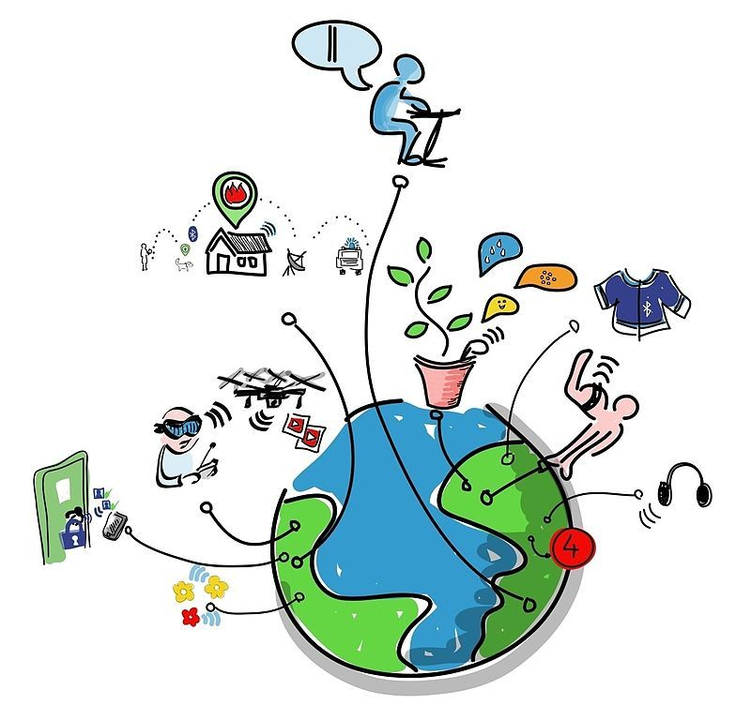

Figure 1: Internet of Things

The system of many techniques of changing grounds with Internet and conversation data between them is depicted in the above figure. Thus, the aforementioned number addresses the world's suitability in a variety of contemporary methods. In the context of IoT, "things" refers to a combination of hardware, software, data, and organizations. "Things" can refer to a wide range of gadgets, such as Arduino's contribution to home automation, electric props in seaside waters, DNA valuation devices for routine examination, and many more. With the aid of numerous recent developments, these computers compile substantial data and provide it across multiple devices. Models connect to Home Automation Systems, which exchange data between many home strategies via Wi-Fi or Bluetooth.

* 1. **CHARACTERISTICS OF INTERNET OF THINGS (IOT)**

You can define the Internet of Things by looking at the numerous characteristics in the bigger context. We see all of these individualities coming back in most Internet of Things explanations out there

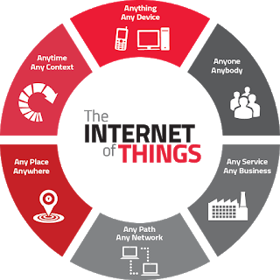

**Figure 2: Characteristics of Internet of Things**

### Intelligence

### IoT supplements the mix of calculations and calculation, programming and equipment that makes it keen. Surrounding insight in IoT upgrades its abilities which encourage the things to react in a keen path to a precise condition and provisions them in doing explicit errands. Regardless of all the ubiquity of keen innovations, insight in IoT is just worried as methods for cooperation between gadgets, while client and gadget collaboration is accomplished by standard input techniques and graphical UI. Together calculations and figure (for example programming and equipment) give the "shrewd sparkle" that makes an item experience savvy. Consider Misfit Shine, a wellness tracker, contrasted with Nest's astute indoor regulator. The Shine experience conveys process shops between a cell phone and the cloud. The Nest indoor controller has number drive for the AI that makes them understanding.

### Connectivity

### Convenience attaches with Internet of Things by joining normal articles. Accessibility of these articles is fundamental since essential thing level affiliations contribute towards total knowledge in IoT mastermind. It involves similarity in the things. With this convenience, new market open entrances for Internet of things can be made by the frameworks organization of understanding things and applications. Web create is either open private the device itself or can be given by a middle point, mobile phone or way (base station). In the occasion that system is given by a way, by then it is doubtlessly assembling data and operational information from a scope of sensors for a detailed mechanism and a short time advanced conversation with the cloud to transfer this information.

### 1.3.3 Dynamic Nature

Through the assembling of smart articles, the Internet of Things is made more user-friendly. The accessibility of those papers is lacking in areas where significant feature stage organizations provide support shortly before widespread IoT knowledge is established. It entails making the issues accessible and using judgment. This accessibility allows the outlines manager of perceptive substances and requests to open up new markets for the Internet of problems.

Web set up is both to be had inside the contraption itself or can be given via a center point, wi-fi or route (base station). In the occasion that system is given through a path, through then its miles potentially assembling information and operational records from an extent of sensors for a selected device and sometime later speaks me with the cloud to transport this data.

### Enormous scale

### The amount of devices that want to be skillful and that express with every dissimilar can be tons superior than the devices related to the modern Internet. The supervision of archives produced from these devices and their understanding for software determinations develops better critical. Gartner (2015) authorizes the enormous scale of IoT confidential the expected report in which it stated that 5.Five million new materials gets related each day and 6.4 billion connected materials will be in use worldwide in 2016, that's up by way of 30 proportions from 2015. Additionally, the report projects that by 2020, there will be 20.8 billion connected gadgets. The range of gadgets that must be accomplished and that communicate with one another may be even more significant than the methods linked to the contemporary Internet. The structure of the created archives and their comprehension for practical reasons may be even more crucial.

### Sensing

### Sensors are a considerable part of implements and outlines privileged the internet of factors. The sensors exhibition screen, music and degree the undertaking and establishments of a device and in a while transfer this measurements consuming the cloud. A few occurrences of such sensors contain ones that display curtain an individual's wellbeing and well-being or sensors which could apprehend whether an entryway has been unfastened in your private home or maybe ones that screen use visions we are able to in well-known miscalculate our faculties and probable to recognize the bodily international and people round us. Detecting enhancements supply us the manner to make encounters that mirror an actual familiarity with the physical world and the people in it. This is basically the easy involvement from the bodily global, but it can give rich understanding of our changeable international.

### 1.3.6 Expressing

### Collaborating authorizes brainpower with people and the physical worldwide. Irrespective of whether it is an extraordinary home or a ranch with savvy undeveloped invention, communicating furnishes us with a way to make items that collaborate intelligently with this present fact. This suggests something apart from interpretation wonderful UIs to a screen. Communicating empowers us to yield into this present authenticity and reasonably connect with personalities and the ground.

### 1.3.7 Security

In most cases, IoT devices are stuck in defense vulnerabilities. As we advantage productivities, novel happenstances, and one of kind consecrations from the IoT, it would be a mistake to push sideways safety concerns associated with it. There is an expanded stage of straightforwardness and protection issues with IoT. It is vital to verify the endpoints, the systems, and the facts that is moved over every final little bit of it suggests generating a security worldview.

As we benefit efficiencies, novel reviews, and different benefits from the IoT, we have to now not forget about safety. As each the creators and recipients of the IoT, we must layout for safety. This includes the safety of our personal statistics and the protection of our physical properly-being. Securing the endpoints, the networks, and the records shifting across it all approach developing a security paradigm with the intention to scale. There are extensive kinds of technologies which can be related to Internet of Things that facilitate in its successful functioning. IoT technologies own the above-stated traits which create price and assist human sports; they in addition enhance the skills of the IoT community by mutual cooperation and becoming the part of the full system.

* 1. **APPLICATIONS OF INTERNET OF THINGS (IOT)**

IoT communications have the potential to significantly improve our lives. The Internet of Things might be the next frontier in the competition for its share of the compartments thanks to more modern wireless networks, sophisticated sensors, and revolutionary computing abilities..

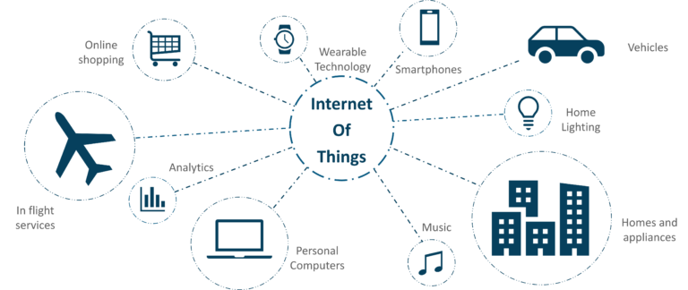

Figure 3: Applications of Internet of Things

**1.4.1 Connected Health (Digital Health/Tele health/Telemedicine)**

IoT packages can turn reactive scientific-primarily based structures into proactive properly-being-primarily based systems. Critical real-world statistics are absent from the resources used in medical research today. It generally uses leftover statistics, managed environments, and volunteers for medical examination. IoT opens approaches to a sea of valuable facts thru evaluation, actual-time field statistics, and sorting out. Additionally, the Internet of Things enhances the power, accuracy, and accessibility of contemporary technologies. The development of structures in the location of an absolutely system is made unique by IoT. IoT has several uses in healthcare, ranging from system integration to smart sensors to remote monitoring devices. In addition to keeping patients safe and healthy, it could improve the way doctors provide treatment. IoT in healthcare can increase patient satisfaction and engagement by allowing patients to spend more time with their physicians. From surgical robots to non-public health monitors, IoT in healthcare introduces new, modern equipment into the environment that makes it possible to create better healthcare. IoT permits to revolutionize healthcare and provide pocket-friendly solutions for both the affected man or woman and healthcare expert. Here’s how an IoT-enabled care device works.

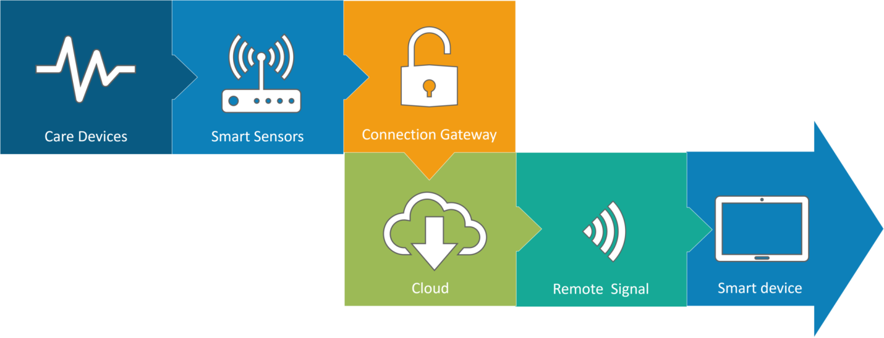

Figure 4: Connected Health

However, connected healthcare continues to be the most popular Internet of Things initiative. The idea of related healthcare system and smart clinical gadgets bears significant functionality now not best for groups, however additionally for the nicely-being of people in well known. Research shows IoT in healthcare is probably huge in coming years. The goal of IoT in healthcare is to enable people to lead more healthful lives by providing them with the practical tool of carrying connected gadgets. The information gathered will help with a personalized fitness analysis and offer specialized methods to combat contamination. How IoT can transform treatment and clinical assistance is explained in the video below.

**1.4.2 Smart City**

By now I count on, most of you ought to have heard approximately the time period Smart City. The hypothesis of the optimized traffic machine I referred to earlier is one of the many elements that constitute a smart city.

The brilliant town concept's detail is that it's quite accurate to a city. The problems faced in Mumbai are very super than those in Delhi. The troubles in Hong Kong are particular from New York. Even global problems, like finite smooth ingesting water, deteriorating air pleasant and growing city density, stand up in particular intensities throughout towns. Hence, they've an impact on every city differently. The Government and engineers can use IoT to research the often-complex elements of town making plans specific to every town. The use of IoT applications cans useful resource in areas like water management, waste control, and emergencies.

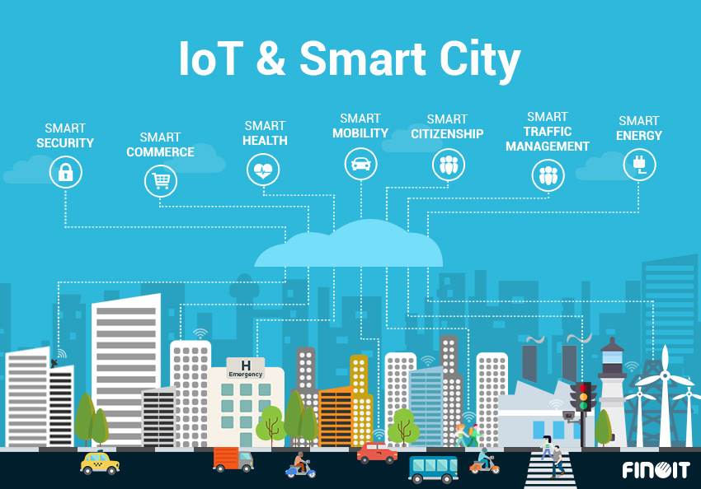  
 Figure 5: Smart City

From web page navigation to water distribution, garbage management, city security, and environmental monitoring, smart cities cover a wide range of application cases. The reality that many Smart City solutions offer to alleviate the real suffering of people living in cities today is what drives their recognition. IoT-based solutions for traffic congestion issues in smart cities reduce pollution and noise while also making cities safer.

**1.4.3 Connected Cars**

Connected automobile era is a giant and an in depth network of multiple sensors, antennas, embedded software program, and technology that help in verbal exchange to navigate in our complex global. It has the duty of making alternatives with consistency, accuracy, and pace. It additionally need to be reliable. These requirements turns into even extra vital at the identical time as humans surrender in reality they manage of the steerage wheel and brakes to the impartial or automated automobiles which can be being successfully tested on our highways right now.

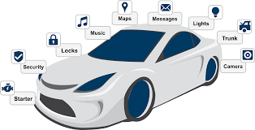

**Figure 6: Connected Cars**

The linked automobile is coming up slowly. Owing to the truth that the development cycles inside the automobile business enterprise generally take 2-4 years, we haven’t seen lots buzz across the associated car but. But it appears we've end up there. Most big automobile makers in addition to some brave startups are going for walks on related automobile answers. And if the BMWs and Fords of this worldwide don’t gift the subsequent technology internet connected vehicle speedy, exceptional famous giants will: Google, Microsoft, and Apple have all added related car systems.

**1.4.4 Smart Home**

"Smart Home" is the most searched IoT-related topic on Google, indicating how excited people are about IoT. What exactly is a smart home, though?

Wouldn’t you like if you may activate air conditioning earlier than accomplishing domestic or transfer off lighting even after you have left domestic? Or free up the doorways to friends for brief access even as you are not at home. Don’t be surprised with IoT taking form agencies are building merchandise to make your lifestyles much less complicated and convenient. Smart Home has turn out to be the modern ladder of fulfillment within the residential spaces and it's far expected Smart houses turns into as not unusual as smart phones. The charge of proudly owning a residence is the biggest cost in a residence owner’s lifestyles. Smart Home merchandise are promised to save time, electricity and cash. With Smart domestic companies like Nest, Ecobee, Ring and August, to call a few, turns into own family brands and are planning to supply a never seen in advance than revel in.

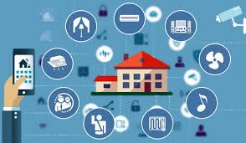

Figure 7: Smart Home

Smart as the best Internet of Things utility across all media, home actually stands tall. Every month, more than 60,000 people search for "smart home" online. This is not unexpected. There are 256 businesses and startups in the Smart Home organization database from IoT Analytics. In the realm of IoT, smart home firms outnumber software companies in activity. Over $2.5 billion has been invested in Smart Home businesses overall. This list of incredible startup names includes Nest and Alert Me, which are comparable to several large corporations like Philips, Haier, and Belkin.

**1.4.5 Smart Farming**

One IoT software application that is frequently overlooked is smart farming. However, because of the truth the wide type of farming operations is generally far off and the big quantity of farm animals that farmer’s paintings on, all of this could be monitored with the aid of the Internet of Things and also can revolutionize the manner farmer’s paintings. But this idea is yet to reach a huge-scale interest. Nevertheless, it however remains to be one of the IoT packages that have to now not be underestimated. Smart farming has the capacity to emerge as an essential software area especially within the agricultural-product exporting international locations. Statistics estimate the ever-developing worldwide populace to gain nearly 10 billion by way of using the twelve months 2050. To feed this sort of massive population one desires to marry agriculture to generation and gain first-rate consequences. There are several possibilities on this place. One of them is the Smart Greenhouse.

A greenhouse farming approach enhances the yield of flora via controlling environmental parameters. However, manual handling has negative effects on labor costs, energy waste, and manufacturing loss, which reduces the method's effectiveness. A greenhouse with embedded devices now not best makes it easier to be monitored however additionally, enables us to control the weather indoors it. Sensors measure different parameters consistent with the plant requirement and send it to the cloud. It, then, techniques the statistics and applies manipulate movement.

[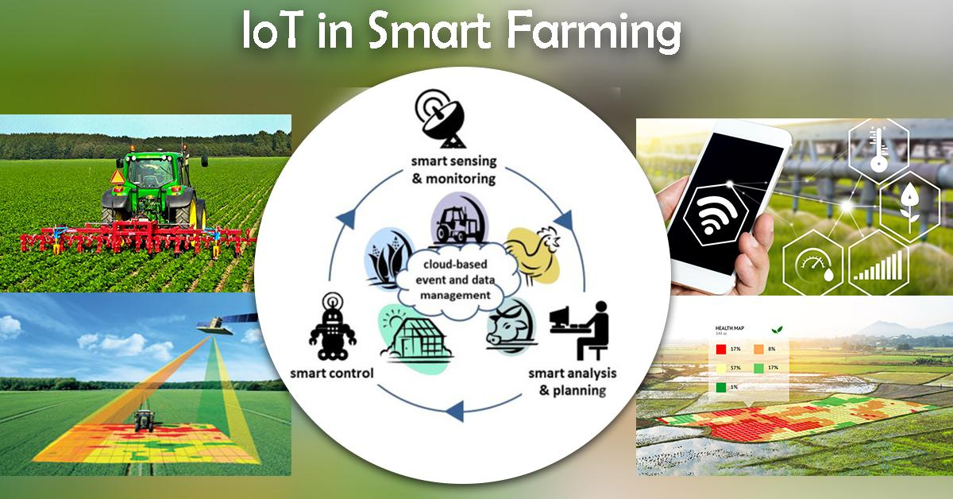](https://d2h0cx97tjks2p.cloudfront.net/blogs/wp-content/uploads/sites/2/2018/05/iot-applications-image-10.jpg)

Figure 8: Smart Farming

**1.4.6 Smart Retail**

IoT has significant potential in the retail industry. IoT gives businesses the chance to interact with customers and improve the in-store experience. Shops may be able to stay in touch with their consumers even while they are out of business thanks to smartphones. Can stores improve customer service by utilizing beacon generation and interacting with customers via smartphones? Additionally, they can use a store to watch the path of customers, enhance the hold layout, and place high-end products in regions with moderate usage.

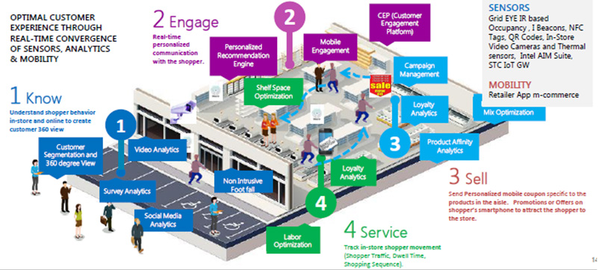

**Figure 9: Smart Retail**

Retail establishments nowadays are constantly focusing on using the burgeoning generation—cloud, cell, RFID, beacons, etc.—to offer customers connected retail services and an improved shopping experience. For instance, store owners are installing sensors in strategic areas of retail establishments and linking them to the cloud via a gateway that enables real-time data analysis of the products, revenue, and customers from the sensors. It's interesting to see how IoT in retail and related fields are sweeping through the retail industry. Ninety-six percent of stores are ready to make the necessary changes to integrate the Internet of Things into their stores..

**1.4.7 Smart Supply Chain**

Vans, ships, and other modes of transportation are used to ship, track, and manage millions of products every day. Using the Internet of Things (IoT) to connect these objects, resources, and people improves productivity and simplifies processes, possibly saving firms hundreds of thousands of dollars a year.

IoT devices have the potential to transform every aspect of the supply chain—from warehouse management and transportation logistics to last-mile delivery. By leveraging real-time data from IoT-enabled systems, manufacturers can boost operational efficiency, reduce theft and counterfeiting, and provide exceptional customer service.

Already, supply chains have been developing into increasingly intelligent, networked systems. Common problems like tracking items in transit and facilitating real-time inventory updates between suppliers are now addressed by IoT systems. IoT devices may gather and transmit vital information like temperature, pressure, and equipment utilization when sensors are integrated into manufacturing machinery. To maximize efficiency and minimize downtime, these systems can also automatically change device settings and procedures.

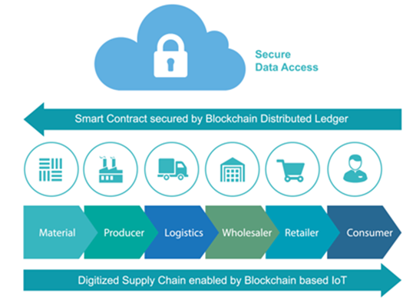

Figure 10: Smart Supply Chain

* 1. **Internet of Things (IOT) Security**

Recently, the Internet of Things' (IoT) safety concerns have been in the news. WikiLeaks's batch of CIA papers reveals that conversations can be secretly recorded on televisions connected to the Internet. Trump's handbook Maybe Kellyanne Conway was talking to microwave cameras, which are definitely capable of eavesdropping, when she said that microwaves can spy on you. Furthermore, a recent survey found that 96% of safety experts expect an increase in IoT breaches this year, so don't fool yourself into believing you are immune to IoT attacks.

The gadgets you use can be unwittingly helping thieves, even if you are not directly affected by the IoT's inadequate security. In October, there was an attack on the Internet service provider that made it impossible for consumers to adequately access popular websites. The cybercriminals who initiated the attack were able to confiscate numerous internet-connected devices, primarily DVRs and cameras, in order to find their collaborators. Because he thinks that neither IoT manufacturers nor their customers are worried about the security of the 8.4 billion net-connected devices in use today, cyber-security expert Bruce Schneider has argued for government control of the Internet of Things. Whether because of authority laws or a sincere interest in outdated technology, we should anticipate more funding for IoT protection systems. Forrester Research examines the forecast for the thirteen most important and pertinent generations of IoT protection in its recently issued Tech Radar file for safety and danger specialists. It warns that "there is no single, magic safety bullet that would without issues repair all IoT safety issues."

## 1.6 Security Challenges Facing IoT

**(a) Data Integrity**

An interconnected world that is connected through the Internet of Things encompasses billions of devices. The entire information that is communicated and exchanged between the sensor and the primary server will be manipulated if even one unmarried statistics point is manipulated. To maintain integrity, digital signatures and a decentralized allocated ledger must be used..

**(b) Encryption Capabilities**

Data encryption and decryption are continuous processes. The IoT network's sensors are still insufficiently functioning to exhibit specific behaviors. Brute force attacks can be avoided by employing firewalls and dividing the devices onto several networks.

**(c) Privacy Issues**

The exchange of information between different platforms, devices, and customers is the core of the Internet of Things. In order to improve functionality and enjoyment, make better decisions, offer better services, and so on, smart devices collect data. As a result, the facts' stop factor will be fully protected.

**(d) Common Framework**

Since there isn't a standard structure, each producer should be responsible for managing security and holding privations itself. The character efforts will be used together in an extendable way after a common, standardized framework is implemented, allowing for code reuse.

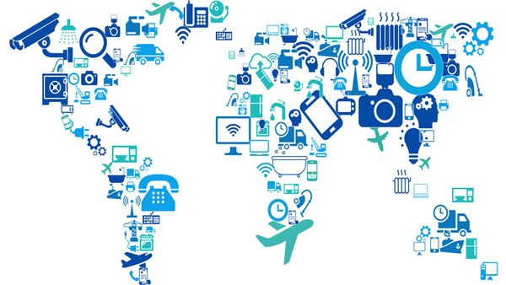

## Figure 11: Security Challenges Facing IoT

**(e) Automation**

Businesses will eventually have to cope with an increasing number of IoT devices. Managing this massive volume of consumer data might be challenging. It is an undeniable fact that the entire data infrastructure can be brought down by a single mistake or algorithmic violation.

**(f) Updations**

The next step is to supervise the update of tens of millions of devices. Since not all of the devices provide over-the-air updates, the devices must be manually updated. It will be essential to keep up with the most recent developments and practice the same technique on all of the various devices. Over time, this process will become increasingly complex, and any errors in the methodology will eventually result in security flaws. Security Prioritizing investments in network and infrastructure security is necessary, but this isn't always the case right now. IoT requires the use of hundreds of thousands of record points, each of which must be protected. It is accurate to say that several security layers, or security.

**1.6.1 How to keep IoT security**

While securing your endpoints and unrestricted will depend on what styles of gadgets you have got, there are certain precautions that will help you to cozy any form of IoT gadget or tools.

**(a)** **Use vigorous passwords**

Strong passwords are always a good idea, but they're especially crucial for Internet of Things devices. It is easy to manipulate an IoT tool through its very own interface or web portal if you have a weak password. What’s even more concerning is that many IoT devices encompass default passwords, which many customers don’t alternate – that means that the attacker may also additionally already understand the password in your tool?

If an attacker manages to gain access through a tool, strong passwords on the relaxation of your community may even be a second line of protection, blocking or impeding their attempts to gain access to documents, databases, and other devices. It's especially important to change your router's password to something strong and lengthy since if your router is compromised, the entire network is at risk.

**(b)Network security**

Make sure your router is up to date, comfortable, and has a firewall turned on. Your router can be the initial point of attack; if it is compromised, your entire community will be at risk. Installing an endpoint safety solution that allows you to find out vulnerabilities on your network – for example, one with a take a look at characteristic at the side of Avant’s Wi-Fi Inspector - is critical.

**(c) Reinforcements**

Responsible manufacturers will launch safety updates for his or her IoT gadgets while vulnerabilities are determined. It's critical to make sure your devices are regularly patched with the most recent updates. If you have got got a tool that doesn’t acquire updates, recollect the blessings of the tool closer to the capacity impact for your commercial employer inside the occasion of an attack.

**(d)Consider inevitability**

As there can be a growing marketplace for IoT devices, manufacturers are eager to pump out big numbers of them, and won't spend lots time developing their product’s safety. While IoT devices may be distinctly useful, don't forget whether or now not your workplace kitchen without a doubt goals that internet-enabled toaster or kettle. While the advantages of latest generation usually appear exciting – specifically for small commercial enterprise owners seeking to store money and boom productivity – it’s important to take time to recognize the risks that include it. IoT devices have the capability to bring performance enhancements to many industries, but steps ought to moreover be taken to make sure they don’t leave your community vulnerable to malicious actors.

**1.7 IOT UNIQUENESS SECURITIES**

The net and authentic are consolidating. With the Internet of Things (IoT), people and gadgets are step by step associated with the Internet and bodily articles are constantly coordinated into data systems. Machines and robots can stumble on and smash down data, empowering control of the physical world. The IoT will reap many tremendous changes. Be that as it may, these good sized changes clean a direction for brand spanking new difficulties, mainly as for security. The positioned away records includes extremely nitty gritty records about an character, and that offers an inexpensive photo of the individual that consists of insights concerning our economic situations, our wellness, our strict temperaments, and our unforgettable ones; giving the hoodlums all the statistics they must exploit somebody. Personalities may moreover likewise no longer recognize about the diploma of safety; for example, encouragement gadgets may additionally acquire sound and video facts, and offer non-public information. At the point whilst the IoT frameworks fall flat or glitch, they are able to reason good sized damage; private statistics may additionally get leaked The superior cellular telephones that we bring anyplace with us are related to a no. Of devices. We take them to occupied spots, open places and use them typically earlier than outsiders, for any purpose. It's not hard for someone to watch anyone type in their gadget's stick code or mystery phrase and it's the whole lot simple to recollect a security code and take the gadget. On the off risk that the hoodlum is utilizing your Smartphone and your device's information and pass approximately as you on your sake and copies the distinguish which may moreover stimulate the loss of a lot greater Matters-General records handy on the net, joined with web-based social networking facts, further to facts from perception watches, well-being followers and if available knowing meters, keen ice chests and lots more deliver an wonderful all-round concept of your character. Whenever which you installation a report with a username, mystery phrase, and other recognizable information, you're leaving that computerized trail approximately you. Fraud can thus be considered possibly the best danger inside the IoT. Security is fundamental for IoT, particularly as for character. In this way, safety should be deliberate into IoT frameworks from the earliest starting point, no longer devoted later.

**1.7 CONCLUSIONS**

The Internet of Things background is vulnerable to events at every level. As a result, security threats and directives must be communicated often. Verification and access controller protocols are the foundation of the current IoT kingdom of revisions, but given the rapid advancement of technology, it is imperative to prioritize new interacting protocols like IPv6 and 5G in order to benefit from the current IoT topology mashup. This chapter's main focus shifted to highlighting important IoT security vulnerabilities, specifically safety attacks and associated defenses. Many IoT devices end up becoming clean targets due to a lack of protective mechanisms, or the victim may not even be aware that they are infected. The security requirements in this financial catastrophe include privacy, integrity, verification, and many more things. Twelve distinct attack types are identified in this survey, together with their nature, conduct, and suggested countermeasures. These attacks are classified as low-, average-, extreme-, and extremely excessive-degree attacks. We desire this financial adversity is possibly valuable to investigators inside the defense province by using supporting recognize the number one problems in IoT safety and delivering higher information of the threats and their qualities originating from diverse intruders like establishments and aptitude groups.

**REFERENCES**

[1] R.Vignesh and 2A.Samydurai ans1 Student, 2Associate Professor Security on Internet of Things (IOT) with Challenges and Countermeasures in 2017 IJEDR five, Issue 1 forty eight, 203-209, 1987.

[3] J.-Y. Lee, W.-C.Lin, and Y.-H. Huang, "A light-weight authentication protocol for internet of things," in Int'l Symposium on Next-Generation Electronics (ISNE), 1-2, 2014.

[4] Y. Xie and D. Wang, "An Item-Level Access Control Framework for Inter-System Security within the Internet of Things," in Applied Mechanics and Materials, 1430-1432, 2014.

[5] B. Anggorojati, P. N. Mahalle, N. R. Prasad, and R. Prasad, "Capability-based totally get entry to control delegation model at the federated IoT community," in Int'l Symposium on Wireless Personal Multimedia Communications (WPMC), 604-608, 2012.

[6] M. Castrucci, A. Neri, F. Caldeira, J. Aubert, D. Khadraoui, M. Aubigny, et al., "Design and implementation of a mediationsystem allowing comfy communication amongst Critical Infrastructures," Int'l Journal of Critical Infrastructure Protection, vol. Five,86-97, 2012.

[7] R. Neisse, G. Steri, and G. Baldini, "Enforcement of security policy guidelines for the net of things," in Int'l Conference on Wireless and Mobile Computing, Networking and Communications (WiMob), one hundred sixty five-172, 2014.

[8] Mirza AbdurRazzaq and Muhammad Ali Qureshi “Security Issues within the Internet of Things (IoT): A Comprehensive Study” by means of (IJACSA) International Journal of Advanced Computer Science and Applications,Vol. Eight, No. 6, 2017.

[9] J. S. Kumar and D. R. Patel, “A survey on internet of factors: Security and privateness issues,” International Journal of Computer Applications,vol. 90, no. 11, 2014.

[10] M. Abomhara and G. M. Køien, “Security and privateness in the net of factors: Current popularity and open problems,” in Privacy and Security in Mobile Systems (PRISMS), International Conference on. IEEE, 2014, pp. 1–eight.

[11] S. Chen, H. Xu, D. Liu, B. Hu, and H. Wang, “A vision of iot: Applications, demanding situations, and opportunities with china angle,”IEEE Internet of Things magazine, vol. 1, no. 4, pp. 349–359, 2014.

[12] L. Atzori, A. Iera, and G. Morabito, “The internet of factors: A survey,”Comput. Netw., vol. Fifty four, no. 15, pp. 2787–2805, Oct 2010.

[13] M. M. Hossain, M. Fotouhi, and R. Hasan, “Towards an analysis of safety troubles, demanding situations, and open issues within the net of things,” in Services (SERVICES), 2015 IEEE World Congress on. IEEE, 2015, pp. 21–28.

[14] L. Da Xu, W. He, and S. Li, “Internet of things in industries: A survey,”IEEE Transactions on industrial informatics, vol. 10, no. 4, pp. 2233–2243, 2014.

[15] L. M. R. Tarouco, L. M. Bertholdo, L. Z. Granville, L. M. R. Arbiza, F. Carbone, M. Marotta, and J. J. C. De Santanna, “Internet of things in healthcare: Interoperatibility and protection issues,” in Communications (ICC), IEEE International Conference on. IEEE, 2012, pp. 6121–6125.

[16] A. Mohan, “Cyber safety for private clinical devices net of factors,” in Distributed Computing in Sensor Systems (DCOSS), 2014 IEEE International Conference on. IEEE, 2014, pp. 372–374.

[17] Mohamed Abomhara and Geir M. Køien” Cyber Security and the Internet of Things: Vulnerabilities, Threats, Intruders and Attacks”.

[18] S. De, P. Barnaghi, M. Bauer, and S. Meissner, “Service modelling for the internet of factors,” in Computer Science and Information Systems (FedCSIS), 2011 Federated Conference on. IEEE, 2011, pp. 949–955.

[19] G. Xiao, J. Guo, L. Xu, and Z. Gong, “User interoperability with heterogeneous iot gadgets through transformation,” 2014.

[20] J. Gubbi, R. Buyya, S. Marusic, and M. Palaniswami, “Internet of factors (iot): A imaginative and prescient, architectural elements, and destiny directions,”Future Generation Computer Systems, vol. 29, no. 7, pp. 1645–1660, 2013.

[21] M. Zorzi, A. Gluhak, S. Lange, and A. Bassi, “From nowadays’s intranet of factors to a destiny net of things: a wi-fi-and mobility-associated view,” Wireless Communications, IEEE, vol. 17, no. 6, pp. Forty four–fifty one,2010.

[22] C. Hongsong, F. Zhongchuan, and Z. Dongyan, “Security and agree with research in m2m machine,” in Vehicular Electronics and Safety (ICVES), 2011 IEEE International Conference on. IEEE, 2011, pp. 286–290.

[23] I. Cha, Y. Shah, A. U. Schmidt, A. Leicher, and M. V. Meyerstein, “Trust in m2 communique,” Vehicular Technology Magazine, IEEE, vol. Four, no. Three, pp. 69–seventy five, 2009.

[24] J. Lopez, R. Roman, and C. Alcaraz, “Analysis of security threats, requirements, technologies and standards in wi-fi sensor networks.