**Competitive and Industry Analysis**

**Mrs. Uusha Patel Dr. Sneha Choudhary**

Assistant Professor Associate Professor

GNIOT MBA Institute NDIM College

Plot no 7, Knowledge Park - II, New Delhi

Greater Noida U.P. 201310

**Learning Outcome**

* General Environment
* External Environment
* Competitive Environment
* Concept of Strategic Groups
* Porter’s Five Forces Framework

Introduction:

In today's fast-paced and competitive business environment, understanding the competitive landscape is crucial for organizations to gain a sustainable competitive advantage. Competitive analysis is a critical component of strategic management that helps organizations identify, assess, and respond to their competitors' strengths, weaknesses, and strategies. In this chapter, we will explore the importance of competitive analysis, its key components, and the tools and techniques used to conduct a comprehensive competitive analysis.

A company's external environment plays a significant role in determining its success or failure. To develop effective strategies, organizations must understand their external environment, which comprises both the general environment and competitive environment. The general environment, also known as the macro-environment, includes factors like politics, economy, society, and technology. Changes in this environment can impact the competitive environment and have far-reaching effects on industries and firms.

For instance, Hitkari Potteries, a once-popular bone-china crockery brand, lost market share to competitors like La Opala and Corelle. This was due to the company's failure to recognize changing social trends, such as the increasing number of working women seeking convenient, durable, and microwave-safe crockery. In contrast, companies like La Opala and Corelle adapted to these changes by introducing ceramic crockery that met emerging consumer needs.

Therefore, it is crucial for organizations to scan their general environment, identify potential factors that can influence or transform their industry, and develop strategies to respond to these changes effectively.

**Competitive Environment**

The competitive environment is a dynamic system where organizations operate and compete. This system can be referred to as an industry or a strategic group. An industry consists of firms producing similar products or close substitutes, while strategic groups are sub-groups within an industry that share similar characteristics and compete on a similar basis.

Competition among firms within a strategic group is more intense than with firms outside the group. For example, the mobile industry encompasses all cell phone manufacturers. However, companies producing smartphones with Android operating systems form a strategic group, competing on similar technological platforms.

These strategic groups have distinct characteristics, such as product quality, geographical coverage, or service levels, which set them apart from other groups. Understanding strategic groups helps organizations identify their direct competitors and anticipate the basis of competitive rivalry within the group.

Gaining in-depth knowledge of an industry's competitive character is crucial for organizations to inform their future strategies. This external analysis enables organizations to navigate their competitive environment effectively and make informed decisions to stay ahead in the market.

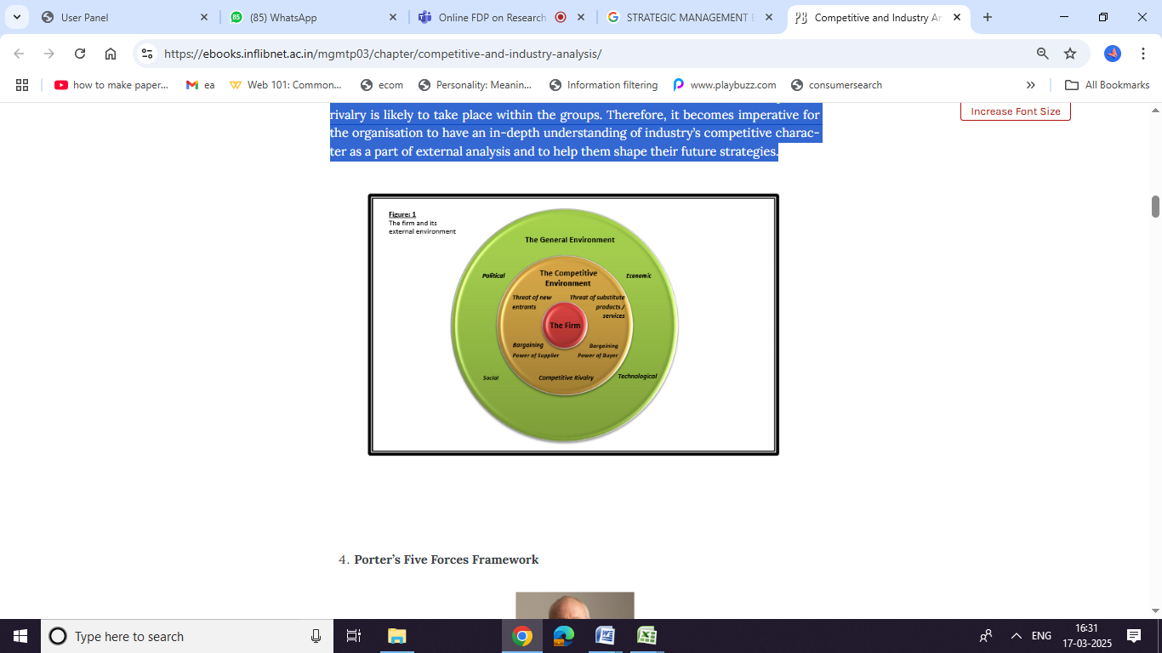

**Porter’s Five Forces Framework**

Michael Porter's Five Forces framework is a widely used tool for analyzing the competitive environment. This framework assesses the industry from the perspective of both existing companies and new entrants. The framework helps organizations evaluate the intensity of competition within an industry by examining the interplay of five key forces.

**These five forces are:**

**1. Threat of new entrants:** The likelihood of new companies entering the market.

**2. Bargaining power of buyers:** The influence customers have on prices and products.

**3. Bargaining power of suppliers:** The control suppliers have over prices and production.

**4. Threat of substitute products or services**: The availability of alternative products or services.

**5. Intensity of rivalry among firms:** The level of competition among existing companies.

By evaluating the strength of these forces, organizations can determine the attractiveness of an industry and its profit potential. A strong force is considered a threat, as it can reduce profitability, while a weak force presents an opportunity for higher profits.

**Threat of new entrants**

The threat of new entrants is a significant concern for industries with growth potential and perceived profitability. New entrants are attracted to invest in these industries to capitalize on emerging opportunities. When new firms enter an industry, existing companies must either share their growing sales with more competitors or surrender some of their market share. This leads to declining sales volumes, revenue, and ultimately, profits for incumbent firms.

The likelihood of new firms entering an industry depends on two key factors:

**1. Barriers to entry:** The obstacles that prevent or discourage new firms from entering the industry.

**2. Expected retaliation:** The potential reaction from existing firms to new entrants.

High entry barriers deter new firms from entering the industry, reducing competition for existing companies. Some common entry barriers include:

- Economies of scale

- Brand loyalty

- High capital requirements

- Government regulations

- Patents and intellectual property

- Access to distribution channels

These barriers can limit the threat of new entrants and protect the market share of existing firms.

1. **Brand benefits:** Established brands can be a significant barrier to entry for new companies. Consumers often develop strong loyalty to well-known brands, making it challenging for newcomers to gain traction. New entrants must invest significant effort and resources to alter consumer perceptions and preferences.

For instance, Johnson & Johnson has dominated the baby care market for over 60 years, earning the trust of generations of mothers. Despite attempts by other companies like Marico, Dabur, Wipro, and Himalaya to enter the market, they have struggled to gain significant market share. This is largely because mothers are hesitant to experiment with new brands when it comes to their babies' care, instead opting for trusted and safe products like those offered by J&J.

1. **Access to Distribution Channels:** Established companies in the FMCG and automobile sectors possess robust distribution networks, making it challenging for new entrants to gain a foothold.

For instance, Pepsico India’s Lay’s potato chips benefit from a well-developed distribution system, ensuring widespread product availability. This has not only created difficulties for competitors like ITC’s Bingo but has also hindered smaller local players from securing a market presence. Similarly, in the automobile industry, Suzuki-Maruti has built an extensive network of dealerships and service centers across India, solidifying its position as the most accessible car brand in the country . Such deeply rooted distribution networks serve as a significant entry barrier for new competitors.

**FIVE FORCE ANALYSIS**

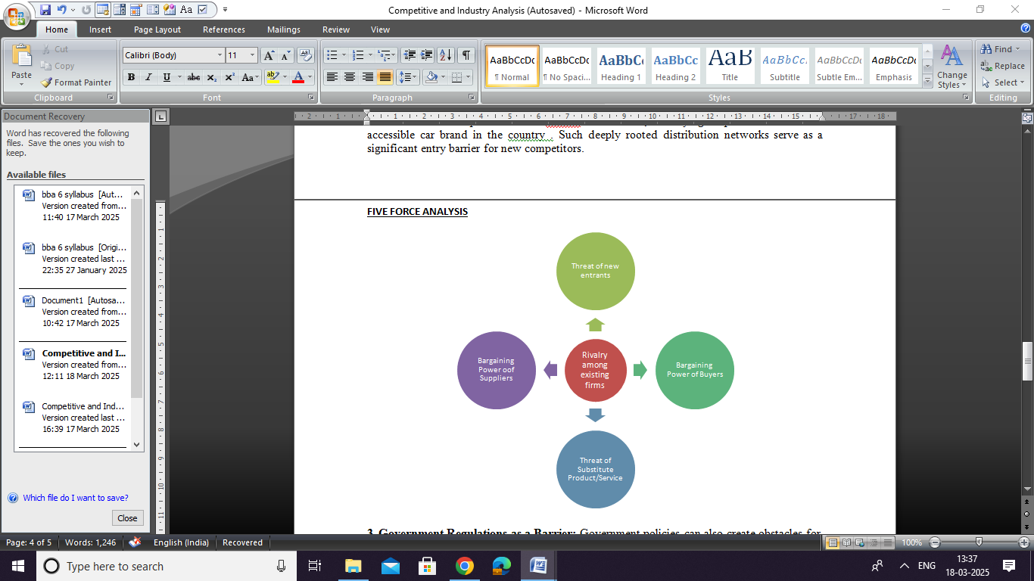**3. Government Regulations as a Barrier:** Government policies can also create obstacles for new entrants, limiting their ability to enter or compete within an industry.

**4. Impact of Switching Costs:** Switching costs play a crucial role in consumer decision-making. These costs, whether financial or psychological, arise when a customer transitions from one brand’s product to another. In industries where switching costs are high, new entrants struggle to gain traction, as consumers are less inclined to change brands. Factors contributing to high switching costs include advanced technology adopted by existing firms, the ease and familiarity of using a particular product, and strong brand loyalty.

**5. Product Differentiation as a Barrier:** Companies like 3M , recognized globally for innovation, have set high entry barriers by distinguishing their products in the market. At 3M, creative ideas are transformed into a vast range of innovative products and practical applications that enhance everyday life. The company’s office supplies division houses some of the most well-known brands worldwide, such as Post-it and Scotch, further strengthening its competitive advantage.

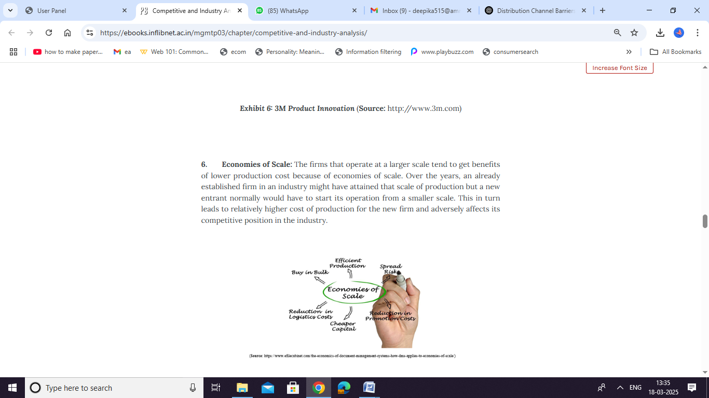**6. Economies of Scale as a Competitive Advantage:** Larger firms benefit from lower production costs due to economies of scale. Established companies in an industry often achieve this advantage over time, whereas new entrants typically begin operations on a smaller scale. As a result, newcomers face higher production costs, which weaken their competitive position in the market.

7. **Capital Requirements as a Barrier:** Significant capital investment can deter new entrants from entering an industry. For instance, establishing telecom infrastructure in rural India demands substantial financial resources due to logistical challenges and extended rollout timelines. Additionally, the shortage of skilled personnel to operate and maintain cellular infrastructure, particularly passive components like towers, further complicates the expansion of telecom services in underserved rural areas.

**Bargaining Power of Suppliers**

Sourcing plays a crucial role in any industry, as businesses rely heavily on suppliers, who, in turn, can impact profitability. Suppliers influence key factors such as pricing, product and service quality, payment terms, and delivery conditions, all of which affect a buyer’s profit margins and industry trends. A supplier or supplier group is considered powerful in the following scenarios:

1. **Significance of the Supplier’s Product to the Buyer:** When a supplier provides essential components that are integral to a buyer’s manufacturing process and product quality, its bargaining power increases. For example, in the Indian automobile industry, Sona Koyo Steering Systems Limited is the leading manufacturer of steering systems for passenger cars and utility vehicles. It supplies major automakers, including Maruti Suzuki, Toyota, Hyundai, Tata Motors, Mahindra & Mahindra, General Motors, and Mahindra-Renault. Since steering is a specialized component, and Sona Koyo is known for its high-precision manufacturing, the company holds significant leverage as a supplier in the industry.
2. **Increased Supplier Concentration:**

An industry with high concentration is one where a few dominant firms control a significant portion of the market. These firms have substantial influence over the industry, as a large share of its output is in their hands. This concentration grants suppliers greater power over businesses that rely on them. The petroleum industry is a prime example of such a scenario.

1. **Buyer’s Importance to Suppliers:**

If an industry purchases only a small fraction of a supplier's total output, its bargaining power diminishes. For instance, in the tire industry, sales of bicycle tires hold greater significance for manufacturers compared to automobile tires, making buyers in this segment more valuable to suppliers.

1. **Risk of Forward Integration by Suppliers:**

When suppliers have the capability to move up the value chain and enter the businesses of their buyers, it creates a challenging situation for the buyers. A relevant example is Ranbaxy Laboratories, which expanded beyond manufacturing bulk drugs and formulations to establish its own retail pharmacy chain, including Fortis Hospital pharmacies.

1. **High Switching Costs for Buyers:**

Buyers may face significant costs when changing suppliers due to the supplier’s strong market position or the specialized nature of the products being sourced. This can make it difficult for buyers to shift to alternative suppliers without incurring substantial financial or operational disadvantages.

**Bargaining Power of Buyers**

Buyers in an industry, whether individually or collectively, hold significant bargaining power when they can influence suppliers to lower prices, demand better quality products or services, or seek added value in their purchases. Conversely, when buyer power is weak, suppliers can easily increase prices or offer lower-quality products at higher costs. Several factors contribute to an increase in buyer bargaining power:

* **Standardized or Undifferentiated Products:** When products and services lack differentiation, buyers focus primarily on price rather than product features, knowing they can easily switch to alternative suppliers.
* **High Buyer Concentration and Large Purchase Volumes:** If a few buyers dominate an industry and make substantial purchases, they gain leverage over suppliers. For instance, large-scale retailers operating on a cash-and-carry model exert significant pressure on suppliers’ profit margins due to their bulk purchasing power.
* **Threat of Backward Integration:** Buyers may strengthen their market position by moving closer to the source of raw materials, reducing their reliance on suppliers. This is the opposite of forward integration, where suppliers attempt to control buyers. For example, a textile company may engage in backward integration by producing its own thread instead of sourcing it from suppliers.
* **Access to Supplier Cost Information:** Buyers who have insight into a supplier’s cost structure can negotiate better deals. If a supplier’s production costs decline, informed buyers can demand a corresponding price reduction. A relevant example is fuel price deregulation—when crude oil prices drop in international markets, consumers expect public transportation costs to decrease accordingly.
* **Customer Price Sensitivity:** Price-sensitive customers focus on maximizing value for money. In industries where such buyers dominate, their collective purchasing behavior strengthens their ability to negotiate better terms with suppliers.

**Threat of Substitute Products**

Companies face competition not only from direct industry rivals but also from alternative products that serve similar customer needs in different ways. These substitutes may appear distinct but fulfill the same function, potentially limiting industry growth.

For example, market research suggests that parents purchase baby care products only until their child is around nine and a half months old. After this period, many parents switch to using their personal care products for their children instead. This shift toward non-baby brands (substitutes) restricts the potential expansion of the baby care market.

**REFERENCES-**

• Porter, M. E. (1980). Competitive Strategy: Techniques for Analyzing Industries and Competitors. Free Press.​[Eaglenet+1TSI+1](https://info.eaglenet.jbu.edu/depts/odl/om/resources/om4224/portersfiveforces.pdf)

• Porter, M. E. (2008). The Five Competitive Forces That Shape Strategy. Harvard Business Review, 86(1), 78-93.​

• Barney, J. B. (1991). Firm Resources and Sustained Competitive Advantage. Journal of Management, 17(1), 99-120.​

• Grant, R. M. (1991). The Resource-Based Theory of Competitive Advantage: Implications for Strategy Formulation. California Management Review, 33(3), 114-135.​

• Hunt, M. S. (1972). Competition in the Major Home Appliance Industry, 1960-1970 (Doctoral dissertation, Harvard University).​

• Porter, M. E. (1979). How Competitive Forces Shape Strategy. Harvard Business Review, 57(2), 137-145.​

• Porter, M. E. (1985). Competitive Advantage: Creating and Sustaining Superior Performance. Free Press.​

• Short, J. C., Ketchen, D. J., Palmer, T. B., & Hult, G. T. M. (2007). Firm, Strategic Group, and Industry Influences on Performance. Strategic Management Journal, 28(2), 147-167.​

• Dess, G. G., & Davis, P. S. (1984). Porter's (1980) Generic Strategies as Determinants of Strategic Group Membership and Organizational Performance. Academy of Management Journal, 27(3), 467-488.​

• McGee, J., & Thomas, H. (1986). Strategic Groups: Theory, Research and Taxonomy. Strategic Management Journal, 7(2), 141-160.​

• Peteraf, M. A. (1993). The Cornerstones of Competitive Advantage: A Resource-Based View. Strategic Management Journal, 14(3), 179-191.​

• Ghemawat, P. (2002). Competition and Business Strategy in Historical Perspective. Business History Review, 76(1), 37-74.