Agriculture Linkage for Rapid Supply Chain

**Deepak Kumar Dwivedi1*, Gayatri Pralhad Turkar2 and Vishal Tiwari3**

1Ph.D. Research Scholar, School of Natural Resource Management, Department of Soil Science & Agricultural Chemistry, College of Post Graduate Studies in Agricultural Sciences, (Central Agricultural University, Imphal), Umiam, 793 103, Meghalaya, India,

**2**Ph.D. Research Scholar, Department of Soil science and Agricultural chemistry, Jawaharlal Nehru Krishi Vishwa Vidyalaya, Jabalpur, 482 004, M.P., India,

**3**Ph.D. Research scholar, Department of Soil science and Agricultural chemistry, Institute of Agricultural Science, Banaras Hindu University, 221 005, Uttar Pradesh, India

**\*Corresponding Author: deepakdwivedi.soil@gmail.com**

Abstract

This chapter delves into the dynamic landscape of India's e-commerce industry, witnessing rapid growth and anticipated to reach USD 200 billion by 2026. The focus is on Quick Commerce (Q-commerce), particularly in online groceries, as a pivotal player in this evolution. Contributing factors include increased smartphone usage, relaxed FDI norms, favorable government policies, and the impact of social media. Rural entrepreneurship emerges as a key strategy for economic growth, drawing insights from China's experience. The study explores success stories like Farmveda, Golden Yolk, AK Supplier, and Nallasanthai, showcasing the transformative impact of Q-commerce in empowering local businesses and fostering sustainable farming practices. Factors influencing e-commerce adoption in micro-enterprises include relative advantage, cost implications, organizational readiness, and government support. Entrepreneurial orientation proves crucial, highlighting the need for a business mindset among micro-entrepreneurs. In conclusion, the Quick Commerce sector presents opportunities for inclusive economic development. Tailored strategies, inspired by successful collaborations, can unlock the full potential of Q-commerce in India, driving financial gains and social impact.

**Keywords:** Supply chain, quick commerce, agribusiness, operating model, business model, hyper local model, E-commerce, bioethanol production.

1. Introduction

The fusion of mobile internet democratization, burgeoning e-commerce penetration, and omnichannel distribution has triggered a paradigm shift in the e-commerce landscape, catalysed by the disruptive forces of the COVID-19 pandemic [1]. This evolution is particularly evident in the online grocery sector, which experienced an unprecedented 80% surge in 2020, reaching USD 2.66 billion, driven by a shift in consumer behavior towards perishables and essentials [2,3]. Quick commerce, epitomizing on-demand delivery, has emerged as a key player, offering a limited yet curated selection of grocery products with a commitment to delivering small quantities within a stringent time frame of 30 minutes to 1 hour [4]. Players like Zepto, Pickily, Swiggy Instamart, Blinkit, Dunzo Daily, Country Delight, and Big Basket Daily are reshaping the industry dynamics, promising convenience and instant gratification for time-strapped consumers.

Simultaneously, the integration of e-commerce into the agricultural sector is revolutionizing traditional farming practices in India [5]. With agriculture contributing significantly to the Indian GDP, the use of mobile phones with internet connectivity among farmers has facilitated the extension of e-commerce services, creating extensive rural connectivity through mobile money. This convergence aligns seamlessly with the changing farming landscape, enabling farmers to leverage technology for market access, sales, and online payment systems. However, challenges emerge as dark stores, micro-fulfilment centres, and cloud stores strategically located in less accessible areas raise questions about accessibility and inclusivity [6]. While these establishments facilitate efficient online grocery order fulfilment, their exclusivity may hinder some consumers' access. The rise of e-commerce disrupts traditional agricultural value chains, characterized by multiple intermediaries, by providing a direct connection between farmers and consumers, eliminating unnecessary middlemen and ensuring a more equitable distribution of profits. Yet, amidst the promise of empowerment, contradictions emerge.

As the digital landscape evolves, the integration of quick commerce into the grocery retail market in India stands out as a notable trend. India's quick commerce market is poised for remarkable growth, with projections suggesting a 10-15x increase by 2025, reaching a market size of close to $5.5 billion [7]. This anticipated growth positions India as a global leader in quick commerce adoption, surpassing even markets like China. The introduction of quick commerce has redefined convenience in the grocery retail market, offering a paradigm shift from days to mere minutes for grocery delivery.

In synthesizing these diverse insights, the convergence of quick commerce, e-commerce, and agriculture marks a transformative moment, heralding opportunities for farmers and reshaping traditional value chains. The promise of empowering farmers and enhancing food systems through quick commerce requires careful consideration of challenges related to inclusivity, accessibility, and the seamless integration of digital solutions into the agricultural landscape. This synthesis provides a nuanced understanding of the multifaceted relationship between quick commerce, agriculture, and the broader e-commerce landscape, laying the groundwork for a comprehensive exploration of the impacts, challenges, and potential solutions in subsequent research.

2. Understanding Quick- Commerce in Agribusiness:

2.1 Definition and Distinction:

Quick commerce, short for "quick commerce," represents an evolution within the broader spectrum of e-commerce, introducing unprecedented speed and efficiency into the delivery process. While traditional e-commerce typically involves a 3-5 day delivery window, Quick commerce slashes this timeframe to mere minutes, often aiming for delivery within 30 minutes to stay competitive. This innovation, also referred to interchangeably as 'on-demand delivery' and 'e-grocery,' marries the strengths of traditional e-commerce with advancements in last-mile delivery.

2.2 Operational Dynamics:

The central premise of Quick commerce mirrors traditional e-commerce but distinguishes itself primarily through accelerated delivery. The emphasis shifts from days to minutes, a crucial factor in meeting the growing demand for instant gratification. Notably, Quick commerce caters to specific niches, with a focus on perishable goods, especially groceries, and a penchant for handling smaller quantities of essential items, such as missing ingredients for a recipe in progress.

Behind the scenes, Quick commerce operates on agile and flexible models, often leveraging 'dark stores'- strategically positioned warehouses- to facilitate swift order processing. These dark stores, ranging from 3229 to 7500 sq ft, stock a diverse range of products, typically exceeding 1,000 unique items. Many Quick commerce players employ a crowd-sourced labour model, maintaining a fleet of individuals ready for prompt action. The integration of the latest technologies and efficient dark store layouts contributes to the adaptability required to meet round-the-clock customer demands.

2.3 Benefits of Quick Commerce:

Quick commerce offers distinct advantages over traditional retailers, delivering a unique value proposition to customers:

1. Speed: Quick commerce companies excel in rapid order fulfillment, leveraging hyper-local micro-fulfillment centers (dark stores) strategically positioned in close proximity to customers. Orders can be fulfilled approximately 25% faster than traditional in-store fulfillment, thanks to optimized floor plans and efficient courier routes.
2. Guaranteed Availability of Relevant Products: Investment in AI and real-time inventory monitoring technologies ensure not only quicker delivery but also increased availability of products. Intelligent software identifies demand patterns, allowing companies to adjust their inventory dynamically.
3. 24-Hour Operation: Dark stores operate round the clock, providing unparalleled accessibility. Unlike brick-and-mortar retailers with set daily opening hours, Quick commerce operates 24/7, 365 days a year.
4. Ease: Quick commerce excels in providing a seamless and user-friendly experience. With mobile technologies, couriers are informed and upskilled, contributing to high levels of customer service.

The fundamental value proposition lies in the ease of use, resonating with customers in an 'always-on' culture where convenience is paramount.

Quick commerce stands at the forefront of retail innovation, transforming the ways consumers experience online shopping by prioritizing speed, availability, operational flexibility, and unparalleled ease of use.

2.4 Quick Commerce Integration in Agribusiness: The integration of Quick Commerce into the realm of agribusiness marks a transformative shift in the dynamics of agricultural trade. Quick commerce, with its emphasis on rapid order fulfillment and leveraging advanced technologies, is not only revolutionizing e-commerce logistics but is also becoming a catalyst for positive change in the agribusiness sector.

1. Swift Order Fulfillment and Last-Mile Delivery: In the broader context of e-commerce logistics, Quick commerce stands out by prioritizing rapid order fulfillment. Utilizing cutting-edge technologies and automation, coupled with strategically located micro-fulfillment centers, Quick commerce ensures swift processing and last-mile delivery. This approach aligns with the growing consumer demand for instant gratification and significantly enhances the overall efficiency of the e-commerce supply chain [8].
2. Integration of Agri-Products through ONDC: The Open Network for Digital Commerce (ONDC), a government-backed e-commerce venture, is fostering the integration of Agri-products from rural hinterlands. Through partnerships with entities like the National Bank of Agriculture and Rural Development (NABARD) and Small Farmers Agri-Business Consortium (SFAC), ONDC is onboarding farmer-producer organizations (FPOs) into its network of sellers. This initiative allows consumers in metropolitan areas to access farm produce directly from distant cultivators, thereby connecting farmers with a broader market [9].
3. Role of Technology in Quick commerce in Agribusiness: The success of Quick commerce in agribusiness hinges on the pivotal role played by technology in streamlining operations and connecting farmers with consumers. Investment in Information and Communication Technology (ICT), internet access, and digital technologies equips agribusiness firms and farmers to expand their market reach, enhancing overall productivity and efficiency [10].
4. Advantages of e-Agribusiness Technology Adoption: The adoption of technology in agribusiness, as highlighted by [11] brings several advantages.
5. Global Market Access: e-Agribusiness provides a virtual global distribution marketplace, leveraging the reach of the internet to conduct business on a limitless scale.
6. Inventory Cost Reduction: Utilizing just-in-time systems minimizes inventory costs, enabling accurate demand forecasting and improving overall industry forecasting.
7. Enhanced Consumer Service: Online platforms allow for the provision of customer and after-sale services, reducing operating costs and improving product/service quality.
8. Direct Link Establishment: Through the internet, companies can establish direct links to customers, suppliers, or distributors, facilitating transactions and communication with greater ease.
9. The integration of technology not only enhances the efficiency of the agribusiness supply chain but also provides a global platform for farmers, enabling them to reach a wider audience and improve their market access.
10. Benefits of Quick commerce for Farmers and Stakeholders: The advantages of Quick commerce extend beyond the operational aspects, bringing tangible benefits to farmers and stakeholders in the agribusiness ecosystem.
11. Market Access and Direct Sales: Quick commerce platforms empower farmers by providing direct access to a broader market. By showcasing and selling their produce directly, farmers can reduce dependency on intermediaries and gain better control over pricing and product quality.
12. Reduced Wastage and Efficient Supply Chain: By streamlining the supply chain, Quick commerce minimizes wastage and ensures efficient delivery of fresh produce. Real-time data analytics and AI-powered algorithms optimize inventory management, allowing farmers to align production with consumer preferences.
13. Empowering Farmer-Producer Organizations (FPOs): Initiatives like ONDC are enabling FPOs to integrate with digital platforms, connecting farmers with consumers and providing better market access. The collaboration with organizations like NABARD aims to raise digital awareness among producers, facilitating a more inclusive and digitally literate agricultural community [9].
14. Direct Procurement and Employment Opportunities: Platforms like Swiggy Instamart have enabled direct procurement from previously inaccessible regions, fostering relationships with farmers. Verified, certified-organic produce and collaboration with farmer organizations not only provide consumers with a variety of options but also create employment opportunities and enhance farmers' daily earnings [12-13].
15. Technology's Crucial Role in Quick commerce Operations: In the domain of Quick commerce, the role of technology cannot be overstated. Advanced order fulfilment systems leverage AI and machine learning for intelligent demand forecasting and efficient inventory management. Real-time tracking and monitoring solutions ensure visibility into the supply chain, while the integration of robotics in warehouses enhances speed and accuracy in picking and packing processes. Mobile applications and user-friendly interfaces optimize the customer experience, and geolocation services facilitate precise tracking of delivery routes, minimizing delivery times. Data analytics plays a crucial role in understanding customer preferences, enabling personalized recommendations, and refining the overall shopping experience. Blockchain technology ensures the security and transparency of transactions, fostering trust between customers and the Quick commerce platform. Automated chatbots and virtual assistants further improve customer service by providing real-time support [8].

The integration of Quick commerce in agribusiness is not just a logistical innovation; it represents a transformative force that empowers farmers, enhances market access, and brings efficiency to the entire agricultural value chain. By leveraging technology and innovative business models, Quick commerce is facilitating a more inclusive and digitally literate agribusiness ecosystem, paving the way for a future where farmers can connect directly with consumers, reduce wastage, and achieve sustainable growth. As we witness the convergence of technology and agriculture, the potential for positive change and economic upliftment in the agribusiness sector becomes increasingly evident.

1. Quick Commerce Industry Operating Model:

The Quick Commerce Industry Operating Model is covered in this section. The business depends on users being able to access the internet. The initial point of interaction between buyers and sellers is the company's app. The order execution system receives the customer's order and routes it to the distribution facility closest to the customer's location. After picking the components in accordance with the orders, packing them, and giving them to the delivery agent, who then delivers the order, is the picker (or the delivery partner). It is noteworthy that order fulfillment occurs quickly when there is cooperation across upstream dark shops, distribution facilities, and downstream delivery partners. (For instance, in fifteen minutes)

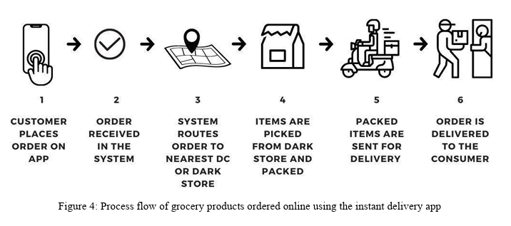

1. Customer Places order on app

2. Order received in the system

3. System routes order to nearest DC

4. Item are picked from dark store and packed

5. Packed items are sent for delivery

6. Order is delivered to the consumer

Fig: 1Process flow of glow of grocery ordered using the instant delivery app [3].

When order fulfilment becomes costly and delayed, warehouse management efficiency is enhanced by data-driven demand estimation models. Various characteristics, including high-demand components, order volumes, and order seasonality, may be forecasted ahead of time through the study of past customer data and real-time data collection. Additionally, distribution centers may be strategically located by utilising cutting-edge data management technologies. To guarantee that delivery times are minimal, a number of factors are taken into account while choosing the locations, including traffic patterns, population density, and road networks.

3.1 Quick Commerce business models:

As previously indicated, a number of firms are breaking into the fast-paced retail market by introducing a range of creative business models on online grocery platforms. Among the major players are Zepto, Bigbasket, Flipkart, Amazon Fresh, Grofers-Blinkit, and Swiggy-Instamart.

Table:1 Quick Commerce firms with their promised delivery time [3].

|  |  |
| --- | --- |
| Q- Commerce firm | Delivery time |
| Swiggy Instamart | 15-30 min |
| Big Basket | 15-30 min |
| Blinkit | 10-30 min |
| Zepto | 10 min |
| Dunzo | 20 min |
| Ola | 30 min |
| Flipkart Quick | 90 min |
| Amazon Fresh | 120 min |

For prompt and effective delivery, businesses can either invent new business models or adapt preexisting ones. But the majority of them make use of "dark stores," which are tiny fulfilment hubs. These are 400–2000 square meter tiny warehouses that hold about 1000 stock-keeping units (SKUs) or special items. In order to expedite order fulfilment, they are positioned strategically close to customer locations. The name suggests that these locations are only for order fulfilment; typical customer walk-ins are not accepted. More broadly, the online grocery sector can accommodate the five main business models that have been mentioned.

* 1. Inventory model
  2. Hyper-local model
  3. Multi-vendor platform model
  4. Revenue channels in the online grocery model
  5. Omnichannel model

1. Inventory model: Under this strategy, goods are acquired from approved suppliers and kept in warehouses that are either owned by the corporation or rented. When a client places an order, the warehouse is alerted. It then gets ready for the delivery partner to complete the order. The ordering and consumption patterns as well as the lead periods for supplier deliveries are taken into account when determining inventory levels. The inventory levels are coupled with the order delivery website or app to show the goods' current availability on the online platform. Quick commerce companies must take into account three factors in order to efficiently manage order fulfilment in the lowest amount of time. The primary storage facility, also known as the central collecting hub, houses the items that are provided by wholesalers, farmers, and retailers. The second strategy is to increase client closeness through the network of distribution facilities and dark shops. Dark shops typically facilitate speedy deliveries. These are smaller warehouses that are situated nearer to the clients. The logistics or last-mile delivery is the third. An effective order fulfilment process requires the integration and alignment of procedures and technology across all of these verticals. According to needed inventory levels and order patterns, inventory is replenished. The distribution centers and dark shops receive their material feed from the main warehouse. Even the distribution hubs occasionally restock inventory at the dark storefronts. A high fill rate and continuous maintenance of the necessary inventory levels are guaranteed by such an omnichannel approach. When demand is erratic, order patterns exhibit significant seasonality, or the items are in a specialised market, the inventory model is employed. Additionally, because this strategy entails a significant upfront investment in leasing premises, recruiting staff, and setting up transportation networks, it is embraced by companies who anticipate strong company development. This model is used by Big Basket to do its last-mile deliveries.

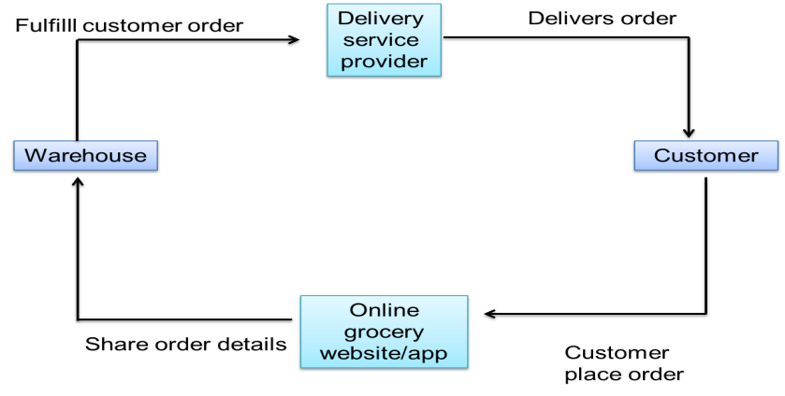

Fig: 2 Systematic diagram of Inventory model [3].

1. Hyper-local model: The concept of employing nearby and local merchants to fulfil the customer's request is the foundation of the hyper-local delivery model. Reaching out to clients in the most remote places is crucial, since the last mile has significant importance in the e-commerce industry. Having local shop owners as retail grocery partners can help achieve this. These store owners use the e-commerce company's web platform to market their goods. These businesses develop grocery ordering marketplace websites or apps. The companies then use their network of local sellers to expedite the delivery of these orders by directing them through the closest physical store or locations. Store owners can also sell their products offline in the interim. Here, the local retailers and e-commerce companies work together to provide last-mile delivery. As a result, this turns into a profitable company plan. This strategy is utilised for a number of purposes, including providing services as quickly as possible and expanding the company's reach to enable it to participate in the e-commerce grocery industry. Quick-commerce businesses are no longer required to operate warehouses or oversee inventory management. The hyperlocal delivery concept is employed by Dunzo. Additionally, the hyperlocal delivery model is employed by startups such as Pidge, Wefast, Blowhorn, Shadowfax, and Grab.



Fig: 3 Systematic diagram of hyper-local model [3].

1. Multi revenue channel model: The models covered above are not the same as the multi-revenue channel model. This model's provider offers a marketplace on which vendors can list their goods in exchange for a fixed commission that goes to the platform owners. The proprietors of the platform may also impose a fee on each order placed by merchants or subscribers. Commissions, membership fees, subscriptions, service charges, promotions, third-party adverts, and leveraging the buyer and seller data for other apps are some of the platform's other revenue sources Manufacturers, retailers, wholesalers, and customers are connected on the e-commerce website Udaan. A number of social media platforms, including Facebook and Instagram, use adverts to encourage speedy purchases.

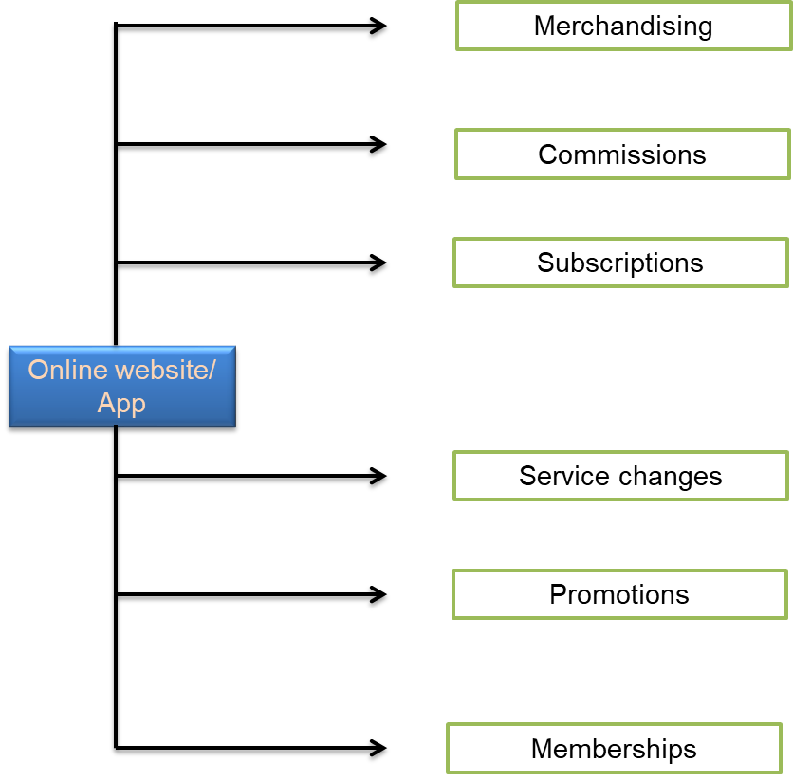

Fig: 4 Systematic diagram of Multi revenue channel model [3].

3.2 Dynamics of E-Commerce:

Understanding the Dynamics of the E-commerce Industry in India is imperative before delving into the specifics of the Quick Commerce sector. In the early 21st century, the advent of advanced technology and internet services gave rise to platform markets that brought about a revolution in Indian commerce. E-commerce emerged as a prominent player in this transformation, experiencing rapid growth and gaining popularity, particularly among India's urban population. The impact of e-commerce on consumer behavior has been profound, reshaping traditional business processes and reducing the necessity for customers to visit physical stores. Projections indicate that the Indian e-commerce market is poised to reach $ 200 billion by 2026 and $ 350 billion by 2030, a significant leap from its recorded value of $ 52.57 billion in 2020.

Several factors contribute to this remarkable growth trajectory:

1. Increase in Smartphone and Internet Users: Data from the World Bank reveals that approximately 43% of the Indian population currently uses the internet. The IAMAI and Kantar Research report forecasts this number to reach 900 million by 2025, with nearly 50% of transactions conducted through mobile applications.
2. Relaxed FDI Norms: The government's current Foreign Direct Investment (FDI) norms allow 100% FDI via the automatic route in B2B e-commerce. For the marketplace model, B2C e-commerce permits 100% FDI under the automatic route.
3. Favourable Government Policies: Government initiatives promoting digital payment methods, such as UPI and Rupay, have played a pivotal role in driving e-commerce growth. The FY22 budget included proposals to incentivize digital payment gateways, and initiatives like Bharatnet aim to improve broadband penetration, particularly in rural areas. The Open Network for Digital Commerce (ONDC) has been launched to bring smaller vendors onto the internet, ensuring a level playing field in the e-commerce industry.
4. Promotion and Visibility through social media: Social media platforms, including YouTube, Facebook, WhatsApp, and Instagram, actively showcase advertisements that encourage users to engage in online purchases. These interconnected factors have collectively fueled the surge in online shopping, and this trend is anticipated to further burgeon in the future. A notable offshoot of the e-commerce boom is the concurrent rise of the online grocery market. All these insights underscore the dynamic nature of the e-commerce landscape in India set the stage for the emergence and evolution of Quick Commerce within this overarching framework.

When it comes to food shopping, consumer behavior is influenced by the method of purchase and its value proposition. There are three different sorts of consumer purchasing tactics for groceries. These three categories influence the way that customers choose to make purchases. These three tactics are as follows:

* + 1. Stock up: This is a large buy intended for consumption over time. The major channels for purchases are neighborhood kirana4 shops and supermarkets.
    2. Top-up: These are regular foods like fruits, vegetables, dairy products, eggs, and so forth. Local Kirana shops and internet e-commerce sites handle their purchases.
    3. Unplanned purchases: Daily consumables and purchases for emergencies. Quick commerce platforms and nearby Kirana shops facilitate the transaction.

The value a customer looks for while making a purchase also influences their purchasing behavior or habit. Traditionally, grocery shopping has been done through local kirana stores or supermarkets. But the rise of online marketplaces has been a major factor in the shift in consumer buying habits, particularly for those who value time and convenience above all else. Based on their value offer, Table summarizes the different customer categories and the stores they choose.

3.3 E-commerce and Entrepreneurship in Rural India:

Encouraging entrepreneurial activities stands as a pivotal strategy for catalyzing economic growth and fostering sustainable development in both urban and, more crucially, rural areas of India. The implications are vast, ranging from economic expansion and job creation to sustainable development and enhanced social integration in rural communities [14]. Despite the evident importance of rural entrepreneurship, the lack of data and empirical analysis has resulted in insufficient research in this domain. The majority of theoretical and empirical contributions regarding the geography of entrepreneurship are predominantly urban-focused, neglecting the unique challenges and opportunities present in rural settings [15]. Rural entrepreneurship in India operates in remote, underdeveloped areas, predominantly engaged in subsistence farming and facing intricate business conditions [16].

The disparity in entrepreneurship rates between rural and urban regions in India may stem from the challenges faced by rural enterprises, isolated from major metropolitan centers that exhibit higher entrepreneurial activity. However, studies have demonstrated that entrepreneurship can indeed thrive in rural areas [17-18].

Drawing parallels with China's experience, where e-commerce has been employed to establish sustainable business models in rural areas, India can learn valuable lessons. In China, e-commerce has played a crucial role in reducing information costs, fostering inclusive growth, and creating a more transparent and open market, notably within the food supply chain [19]. Rural e-commerce in China has significantly enhanced the stability of the food supply chain and contributed to the rapid growth of farmers' incomes. However, challenges persist, and unequal regional development has impacted the adoption of e-commerce, despite its positive influence on farmers' incomes [19]. The concept of "Taobao Villages," with over 3,000 rural markets highly concentrated in online sales, reveals nuanced differences across various villages in China, especially in economically challenged areas [20]. The widespread adoption of e-commerce, particularly in China's impoverished western rural areas, not only offers significant development potential and new revenue sources but also serves as inspiration for migrants to return and establish small-scale businesses in their hometowns [20].

In the context of India, these findings underscore the potential of e-commerce in rural areas to drive economic development and empower local communities. However, it is crucial to tailor strategies to address the specific challenges faced by diverse rural communities in India. The lessons from China's experience provide valuable insights for shaping policies and initiatives that cater to the unique characteristics and challenges of rural entrepreneurship in India.

* 1. Discussion of Key Findings and Implications for India:

1. Relative Advantage and Market Shift: The crucial role of relative advantage in influencing the adoption of e-commerce in rural micro-enterprises aligns with global trends, including the Indian scenario. In India, where micro-enterprises form a significant part of the economy, the prospect of leveraging visuals, live streaming, and targeted marketing through e-commerce platforms can revolutionize business operations. The shift from traditional channels to online platforms, driven by the relative advantage of broader market reach and higher product visibility, mirrors the trends observed in China's Longsheng region.
2. Cost Implications and Financial Constraints: The negative impact of the initial cost of e-commerce adoption resonates with the financial constraints faced by many micro-enterprises in India. Limited financial resources pose a significant barrier, especially when considering the high costs associated with technology adoption, maintenance, and training. This finding is highly applicable to India, where micro-enterprises often operate within constrained budgets, mirroring the challenges faced by their counterparts in China.
3. Technology Readiness and Familiarity: The unexpected finding that technology readiness has no significant effect on the intention to adopt e-commerce aligns with the prevalent familiarity of Indian micro-entrepreneurs with e-commerce platforms like Flipkart and Amazon. India's robust e-commerce ecosystem, including popular platforms designed to resonate with local preferences, ensures that technology readiness is not a significant impediment. Similar to the familiarity observed with Taobao in Longsheng, Indian micro-enterprises may find technology readiness less of a concern in their e-commerce adoption journey.
4. Organizational Readiness as a Critical Factor: The positive impact of organizational readiness on the intention to adopt e-commerce aligns with the challenges faced by Indian micro agri-commerce development in the Indian context, addressing organizational readiness by providing resources and support is imperative, mirroring the findings from the Longsheng region [21].
5. Competitive Pressure and Government Support in Rural India: In the context of India's vast rural landscape, the positive influence of competitive pressure on e-commerce adoption resonates, particularly in remote areas. E-commerce serves as a potent tool for rural agri-business enterprises to enhance their competitive advantage. Government support, mirroring the positive findings in Longsheng, becomes a linchpin for technological development in small and micro enterprises in India. Infrastructure development and financial support are vital components for driving e-commerce adoption in rural Indian counties.
6. Entrepreneurial Orientation and Implications for Indian Micro Enterprises: The interactive effect of entrepreneurial orientation (EO), specifically the significance of relative advantage, underscores the importance of cultivating EO among Indian micro business owners. Strengthening entrepreneurial orientation becomes pivotal to bridging the gap between the Technology-Organization-Environment (TOE) factors and the intention to adopt e-commerce. Aligning with the Resource-Based View (RBV) theory, enhancing the entrepreneurial orientation of Indian micro agri-business owners becomes a strategic imperative. This could involve targeted efforts to improve owners' processes, habits, and decision-making styles, fostering a conducive environment for e-commerce adoption, mirroring the findings from China [22-23].

These findings offer valuable insights for India, emphasizing the need for tailored strategies that address the nuanced challenges faced by micro-enterprises in their journey toward e-commerce adoption, particularly in the dynamic and diverse landscape of rural India.

1. Success Stories
   1. Farmveda: Amidst the vast fields of India's agricultural sector, the success story of Farmveda shines as a beacon of empowerment, illustrating the transformative potential of Quick Commerce for farmers. Founded in 2016 by Dr. Trilochan Sastry, a former Dean at IIM Bangalore, Farmveda embarked on a mission to elevate farmers along the value chain and promote rural businesses in India.

Background and Mission: Farmveda specializes in producing traditional, organic idli/dosa mixes, and podis directly sourced from farmers' households across three districts. The primary objective is to ensure fair pricing for farmers who invest months of hard work during the agricultural season. Driven by a vision to provide complete ownership to Indian farmers, Farmveda has successfully collaborated with over 25,000 farmers across three districts.

The Q-Commerce Transformation: To overcome the challenges of post-harvest wastage and limited market reach, Farmveda embraced Q-commerce through Instamojo's online store. This strategic shift empowered the company to tap into a broader customer base spanning across states, effectively reducing post-harvest losses.

Impact on Farmers: The adoption of Q-commerce has allowed Farmveda to directly connect with consumers, eliminating the need for intermediaries. This direct-to-consumer approach ensures that farmers receive fair compensation for their produce. By leveraging technology, Farmveda provides farmers with easier access to streamlined capital, opening doors to micro-finance loans available through the online platform.

Government Initiatives and Q-Commerce: Aligned with the changing landscape, the Indian government has introduced amendments to the Essential Commodities Act, encouraging farmers and agri-businesses to transition towards e-commerce markets. These initiatives, including tax-saving reforms and ease in supply chain management, complement Farmveda's success in utilizing Q-commerce.

* 1. Golden Yolk, Kolkata:

In the vibrant city of Kolkata, Golden Yolk, once a modest and unorganized venture, experienced a metamorphosis of fortunes through its collaboration with Swiggy Instamart. The alliance not only resulted in a threefold increase in income but also brought about an additional daily revenue of one Lac. Golden Yolk's success story is not just financial; it is deeply intertwined with community development. By leveraging Swiggy Instamart, Golden Yolk forged direct connections with farmers from previously untapped regions. This not only broadened their procurement base but also contributed to local employment, with women from the region actively participating in packing and grading processes. Golden Yolk's journey exemplifies the profound impact that strategic collaborations with platforms like Swiggy Instamart can have on the economic fabric of local businesses.

* 1. A K Supplier, Mumbai and Pune:

Embarking on the digital grocery landscape in July 2021, AK Supplier, with a dedicated focus on locally sourced fruits and vegetables, witnessed a staggering 80% surge in revenue through its association with Swiggy Instamart. Beyond mere financial gains, this collaboration opened new avenues for AK Supplier, enabling them to secure credit facilities from esteemed financial institutions. This financial infusion, a direct result of their success with Swiggy Instamart, empowered AK Supplier to envision and execute plans for robust infrastructure development and process enhancement. The strategic alignment with Swiggy Instamart not only expanded their customer base but also positioned them as a noteworthy player in the competitive landscape of online grocery. AK Supplier's narrative stands as a testament to the transformative power of e-commerce partnerships for local businesses.

* 1. Nallasanthai, Thiruninravur:

Founded in 2002 in Thiruninravur, Tamil Nadu, Nallasanthai embarked on a partnership with Swiggy Instamart in August 2021, with a mission to foster farmer welfare and ensure consistent earnings. The collaboration bore fruit swiftly, as Nallasanthai witnessed a substantial decrease in rejection and wastage costs, coupled with an exponential increase in operational scale. In a mere six months, Nallasanthai expanded its agricultural footprint from 25 cents of land to a sprawling 10 acres, accompanied by a remarkable fivefold surge in daily earnings. This phenomenal growth was underpinned by the demand surge orchestrated through Swiggy Instamart. More than just economic prosperity, Nallasanthai's collaboration has led to the employment of over 50 workers, with a significant focus on female employment. The success of Nallasanthai not only underscores the potential of Swiggy Instamart in boosting agricultural ventures but also showcases its role as a catalyst for sustainable farming practices and community development.

In essence, these detailed success stories highlight the multifaceted impact of Swiggy Instamart's collaborations with local farmers and organizations, transcending mere economic gains to encompass social development, employment generation, and the holistic empowerment of regional businesses.

5. Conclusion:

In conclusion, India's e-commerce industry is experiencing remarkable growth, projected to reach USD 200 billion by 2026. Quick Commerce (Q-commerce), especially in the online grocery sector, is a key player in this evolution. The surge is fueled by factors like increased smartphone usage, relaxed FDI norms, government initiatives, and social media promotion. Rural entrepreneurship, while facing unique challenges, holds immense potential, drawing insights from China's experience. Success stories like Farmveda, Golden Yolk, AK Supplier, and Nallasanthai highlight the transformative impact of Q-commerce in empowering local businesses, fostering community development, and contributing to sustainable farming practices.

Key factors influencing e-commerce adoption in micro-enterprises include relative advantage, cost implications, organizational readiness, and government support. Entrepreneurial orientation plays a crucial role, emphasizing the need to cultivate a business mindset among micro-entrepreneurs.

In essence, the Quick Commerce sector is poised for sustained growth, offering opportunities for inclusive economic development. Tailored strategies, inspired by successful collaborations, can unlock the full potential of Q-commerce in India, driving both financial gains and social impact.

References

[1] Mandloi D, Shetty G, Nougarahiya S. A Review of E-Commerce in India: The Past, Present, and the Future. International Journal of Multidisciplinary. 2021; 6(3):12-22.

[2] Patil U, Sandoval L, Sawant A. COVID-19 accelerates the growth of India’s online grocery market. 2021.

[3] Ranjekar G, Roy D. Rise of Quick Commerce in India: Business Models and Infrastructure Requirements. Centre for transportations and logistics. 2023:5, 76-90.

[4] Pratik K, Arora P. India Quick Commerce Market Outlook to FY’27F- Driven by Increasing demand for Faster Delivery & Convenience and Shifting Customer behavior towards Unplanned Purchases. Ken Research. 2022.

[5] Shahade RG. E-Commerce in Agriculture Development: Advantages & Challenges in knowledge Management of the society through Academic Libraries. Journal of Emerging Technologies and Innovative Research. 2015; 11(2), 2349-5162.

[6] Ganapathy V, Gupta C. Critical success factors for quick commerce grocery delivery in India: an exploratory study. Sustainability, Agri, Food and Environmental Research. 2024;12(2), 22-33. DOI: <http://dx.doi.org/10.7770/safer-V12N1-art691>

[7] Gutgutia M. 15X Growth in Just 3 Years! We’re Talking About India’s Quick Commerce Market. *Redseer Strategy Consultants.* 2022.

[8] Mohan A. Role of quick commerce in e-commerce logistics. Indian Transpost & Logistic News. 2023.

[9] Kar A. Collaboration. Nearly 400 farmer organisations in various stages of integration with ONDC: T Koshy. The Hindu Businessline. 2023.

[10] Ugochukwu AI, Phillips PW. Technology adoption by agricultural producers: A review of the literature. From agriscience to agribusiness: theories, policies and practices in technology transfer and commercialization. 2018:4(5)*,* 361-377.

[11] Balakrishnan M, Kumar BG, Rao CS, Soam SK. Status and scope of e-commerce in agribusiness in India. International Research Journal of Management and Commerce. 2018: 5(1), 400-413.

[12] Shetty S. Five things you probably didn’t know about Swiggy Instamart. Swiggy Diaries. (2022).

[13] Murali S. Get the freshest produce delivered in minutes. Swiggy diaries. (2022)

[14] Boghean C, State M. The relation between foreign direct investments (FDI) and labour productivity in the European Union countries*. Procedia Economics and Finance*, 2020:32, 278-285.

[15] Pato ML, Teixeira AA. Twenty years of rural entrepreneurship: A bibliometric survey. Sociologia ruralis, 2016: 56(1), 3-28.

[16] Lekhanya LM. The digitalisation of rural entrepreneurship. In Entrepreneurship-Trends and Challenges*.* IntechOpen.2018: 24(2), 220-243.

[17] Delfmann H, Koster S, McCann P, Van DJ. Population changes and new firm formation in urban and rural regions. Entrepreneurship in a Regional Context, 2014: 2(1), 96-112.

[18] Eriksson RH, Hane-Weijman E. How do regional economies respond to crises? The geography of job creation and destruction in Sweden (1990–2010). European Urban and Regional Studies, 2017: 24(1), 87-103.

[19] Ma W, Zhou X, Liu M. What drives farmers’ willingness to adopt e‐commerce in rural China? The role of Internet use. Agribusiness, 2020: 36(1), 159-163.

[20] Couture V, Faber B, Gu Y, Liu L. Connecting the countryside via e-commerce: evidence from China. American Economic Review: Insights, 2021: 3(1), 35-50.

[21] Bai J, Ren J. Organizational ambidexterity and innovation performance: the moderating effect of entrepreneurial orientation. Frontiers of Business Research in China, 2016: 10(4), 664.

[22] Ha ST, Lo MC, Mohamad AA, Ramayah T. Determinants of Innovation Performance among SMEs: Moderating Effect of Entrepreneurial Orientation. Global Business & Management Research, 2018: 10(2), 23-54.