Vitamin C in Periodontology

Dr. Sheryl Dolly. A Dr. Priyadarsini Sekar

Dept of Periodontology & Oral Implantology Dept of Periodontology & Oral Implantology

Sri Venkateswara Dental College & Hospital Sri Venkateswara Dental College & Hospital

Thalambur, Chennai, India Thalambur, Chennai, India

[drsheryldolly@gmail.com](mailto:drsheryldolly@gmail.com) [drpriya8984@gmail.com](mailto:drpriya8984@gmail.com)

**I. INTRODUCTION**

Vitamin C or L-ascorbic acid, 1 is an essential water-soluble micronutrient that acts as a powerful antioxidant and a cofactor for many enzymes, supports both innate and adaptive immune responses, carnitine and catecholamine metabolism, dietary iron absorption and collagen biosynthesis. 2

Despite its vital biological functions, humans lack the ability to synthesize vitamin C endogenously due to a non-functional *gulonolactone oxidase* gene - an enzyme needed as the last step in the synthesis pathway of vitamin C necessitating adequate dietary intake. Its biochemical instability underscores the importance of consistent intake through natural or supplemental sources.3

The role of vitamin C was first recognized in 1747 by James Lind, who demonstrated that citrus fruits could prevent scurvy in sailors—a condition later understood to result from vitamin C deficiency (Carpenter, 2012). The compound itself was formally identified in the early 20th century when Albert Szent-Györgyi isolated "hexuronic acid" from adrenal glands, which was later confirmed as vitamin C. Concurrently, Charles Glen King independently isolated the same compound, establishing its identity as the antiscorbutic factor. For his pioneering work, Szent-Györgyi received the Nobel Prize in Medicine in 1937. 4

Vitamin C is involved in numerous physiological processes, including collagen synthesis, tissue repair, immune defense, antioxidant protection and iron absorption. It supports epithelial barrier integrity, enhances leukocyte function and aids in wound healing, making it indispensable for maintaining systemic health. Deficiency in vitamin C can lead to fatigue, poor wound healing, increased susceptibility to infections and in severe cases scurvy. 5

Micronutrients, including vitamins and minerals, are essential for maintaining oral health, as they influence the development, integrity and healing capacity of oral tissues. 6 Among these, vitamin C plays a particularly important role in modulating oxidative stress and inflammation both central to the pathogenesis of periodontal disease. In periodontology, its significance is further amplified due to the high collagen turnover, constant microbial challenge and the need for a competent immune response and tissue regeneration.

**II. STRUCTURE AND SOLUBILITY**

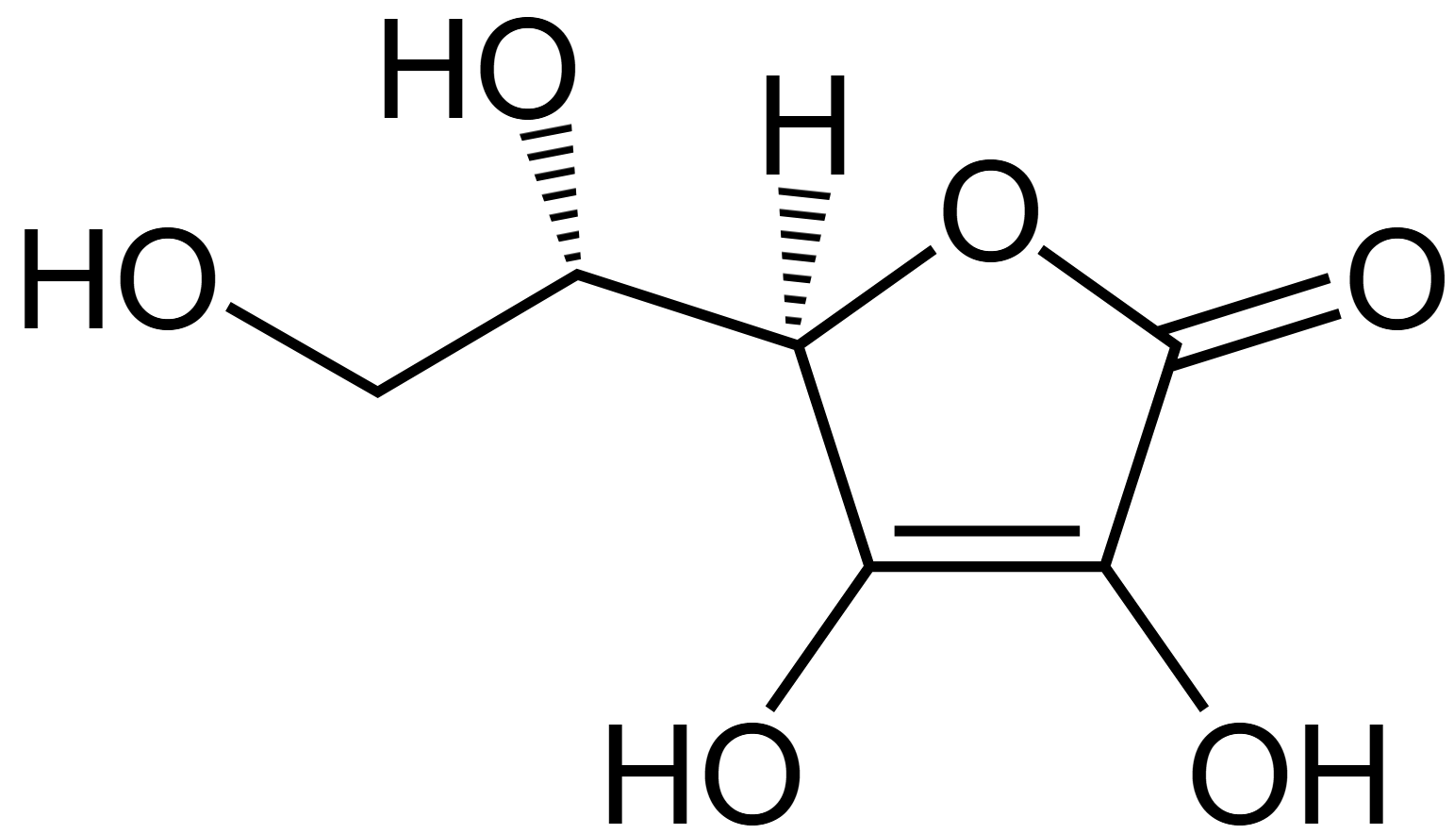

**Figure 1: Structure of Vitamin C**

Vitamin C or Ascorbic acid (AA) is a hydrophilic molecule, composed of six carbons, similar to glucose (Figure 1).

Structurally, it is the aldono-1,4-lactone of a hexonic acid containing an enediol group at carbons 2 and 3, which enables it to donate electrons, contributing to its potent antioxidant and enzymatic cofactor roles. At a physiological pH of 7.4, L-ascorbic acid is found as the ascorbate monoanion that can remain in its reduced form (ascorbic acid—AA) or transform into its oxidized form (dehydroascorbic acid—DHA). AA functions as a reducing agent by donating two electrons. The first electron loss forms a stable, non-reactive ascorbate radical, while the second results in its oxidized form, dehydroascorbic acid (DHA). DHA is unstable and can undergo rapid hydrolysis to 2,3-diketogulonic acid, an inactive form. This degradation is accelerated in aqueous environments and in the presence of metal ions such as Fe³⁺. However, DHA can be reduce back to its ascorbic acid form in the body as it is essential for its antioxidant activity.

Due to its hydrophilic nature, vitamin C is distributed in aqueous compartments of the body, including plasma and intracellular fluid, which is crucial for maintaining redox balance in tissues like the periodontium. Yet AA is unstable and weak in the presence of light, heat, oxygen, alkaline pH and humid environment. To improve stability and bioavailability various derivatives such as zinc ascorbate, calcium ascorbate,sodium ascorbate, sodium calcium ascorbyl phosphate, ascorbyl palmitate are commonly used. 7

**III. DIETARY SOURCES, ABSORPTION AND METABOLISM**

1. **Sources of Vitamin C**

Vitamin C is abundantly found in plant-based sources such as citrus fruits (oranges, lemons), berries, guava, papaya, kiwifruit, tomatoes, bell peppers, cabbage, broccoli and Indian gooseberry, with some varieties containing up to 5,000 mg/100 g (Table 1). In contrast, animal-derived foods have poor vitamin C content, typically <40 mg/100 g. Synthetic forms like L-ascorbic acid—available as tablets, powders, liquids and gummies—exhibit comparable bioavailability to natural sources and are often combined with bioflavonoids or mineral ascorbates. Absorption occurs via passive diffusion in the buccal cavity and primarily through sodium-dependent vitamin C transporters (SVCTs) in the gastrointestinal tract.

**Table 1: Vitamin C Content of Frequently Consumed Raw Fruits and Vegetables (≥10 mg/100 g)**

|  |  |  |  |
| --- | --- | --- | --- |
| **Food Description (Raw)** | **mg Vitamin C per 100 g** | **Food Description (Raw)** | **mg Vitamin C per 100 g** |
| Guava | 228.3 | Currants (red/white) | 40.1 |
| Black currant | 181.0 | Melon (cantaloupe) | 36.7 |
| Kiwi gold | 161.3 | Cabbage | 36.6 |
| Red bell pepper | 127.7 | Mango | 36.4 |
| Kale | 93.4 | Grapefruit | 34.4 |
| Kiwi green | 92.7 | Spinach | 28.1 |
| Broccoli | 89.2 | Blackberries | 21.0 |
| Brussels sprouts | 85.0 | Potato | 19.7 |
| Papaya | 60.9 | Melon (honeydew) | 18.0 |
| Strawberry | 58.8 | Zucchini (courgette) | 17.9 |
| Cabbage (red) | 57.0 | Cranberry | 14.0 |
| Oranges | 53.2 | Tomato | 13.7 |
| Lemon | 53.0 | Green beans | 12.2 |
| Tangerine | 48.8 | Pomegranate | 10.3 |
| Cauliflower | 48.2 | Apricot | 10.0 |
| Pineapple | 47.8 | Avocado | 10.0 |

1. **Pharmacokinetics of Vitamin C**

The bioavailability of vitamin C is regulated by its intestinal absorption and renal excretion. Absorption occurs primarily in the small intestine via sodium-dependent vitamin C transporters (SVCT1), while reabsorption in the proximal renal tubules also involves SVCT1, limiting urinary loss at low plasma concentrations. However, at higher intakes, SVCT1 is downregulated, reducing both absorption and reabsorption, thus capping the maximum achievable plasma concentration (~200 µmol/L) through oral intake. Normal physiological plasma levels range between 60–100 µmol/L, but higher intracellular levels are maintained in cells like leukocytes via SVCT2. Bioavailability may decline under stress, smoking, infections, or heavy metal exposure due to increased utilization or impaired absorption. While generally non-toxic, high doses (>2 g/day) may cause mild gastrointestinal disturbances. No consistent evidence supports severe toxicity in humans. 8

1. **Bioavailability and Plasma Distribution of Vitamin C**

Vitamin C is well absorbed at moderate doses (70–90%), but its absorption decreases when taken in large amounts (above 1 g/day) due to saturation of its transporters. The highest plasma concentration that can be reached with oral intake is around 135 µmol/L and even with high doses, it rarely exceeds 220 µmol/L. The total amount of vitamin C in the body ranges from 300 mg to 2 g, —highest in leukocytes, adrenal glands and pituitary and lowest in plasma and saliva. Excess intake is excreted via urine, reflecting the body's tight regulation of vitamin C homeostasis. 9

1. **Recommended Dietary Allowances (RDA) of Vitamin C**

The recommended dietary allowance (RDA) for vitamin C varies by country and individual needs. In the U.S., it's 90 mg/day for adult men and 75 mg/day for women, while other countries, like Italy, suggest slightly higher intakes. Needs increase during pregnancy, lactation and in smokers due to higher oxidative stress and turnover. Children’s RDAs are adjusted based on body size and older adults may require more due to reduced absorption and lower baseline levels. Most guidelines suggest additional intake for smokers (20–80 mg/day) and 10–20 mg for pregnant women and extra daily intake of 20–60 mg/day for women during lactation. 10

**IV. BIOCHEMICAL PROPERTIES OF VITAMIN C**

1. **Enzymatic Cofactor Role of Vitamin C**

Vitamin C functions as a cofactor for two primary classes of enzymes: iron-dependent dioxygenases and 2-oxoglutarate-dependent dioxygenases (2-OGDDs). Iron-dependent dioxygenases catalyze hydroxylation reactions essential for collagen and carnitine synthesis, while 2-OGDDs regulate gene expression and metabolic pathways. Vitamin C maintains iron in its reduced Fe²⁺ state, which is critical for sustaining enzymatic activity. Additionally, vitamin C supports the function of monooxygenases such as dopamine-β-hydroxylase and peptidyl-glycine α-amidating monooxygenase (PAM) by reducing copper at their active sites. A deficiency in vitamin C disrupts these enzymatic pathways, impairing collagen maturation, energy metabolism and the biosynthesis of neurotransmitters and peptide hormones. 7

1. **Antioxidant Function**

Vitamin C is a potent antioxidant that mitigates oxidative stress by directly neutralizing reactive oxygen species (ROS) and reactive nitrogen species (RNS). It does so by donating electrons and serving as a substrate for ascorbate peroxidase, converting hydrogen peroxide into water. It also regenerates other antioxidants, notably α-tocopherol (vitamin E), by reducing the α-tocopheroxyl radical. This redox cycling underpins its protective role against lipid peroxidation and cellular damage.

In the periodontium, oxidative stress plays a central role in tissue destruction and disease progression; hence, vitamin C's antioxidant activity is critical for maintaining redox homeostasis, protecting connective tissue and modulating inflammation. It ’s antioxidant action has been investigated in various chronic conditions including cardiovascular and neurodegenerative diseases. High levels in brain tissue suggest neuroprotective functions, possibly modulating catecholamine synthesis and serotonin receptor activity. Additionally, in vitro studies show that high-dose vitamin C may exert a pro-oxidant effect in cancer cells by generating hydrogen peroxide, selectively inducing cytotoxicity and enhancing chemotherapy and radiotherapy efficacy. However, further studies are required to clarify its therapeutic mechanisms and clinical significance. 7

1. **Collagen Biosynthesis**

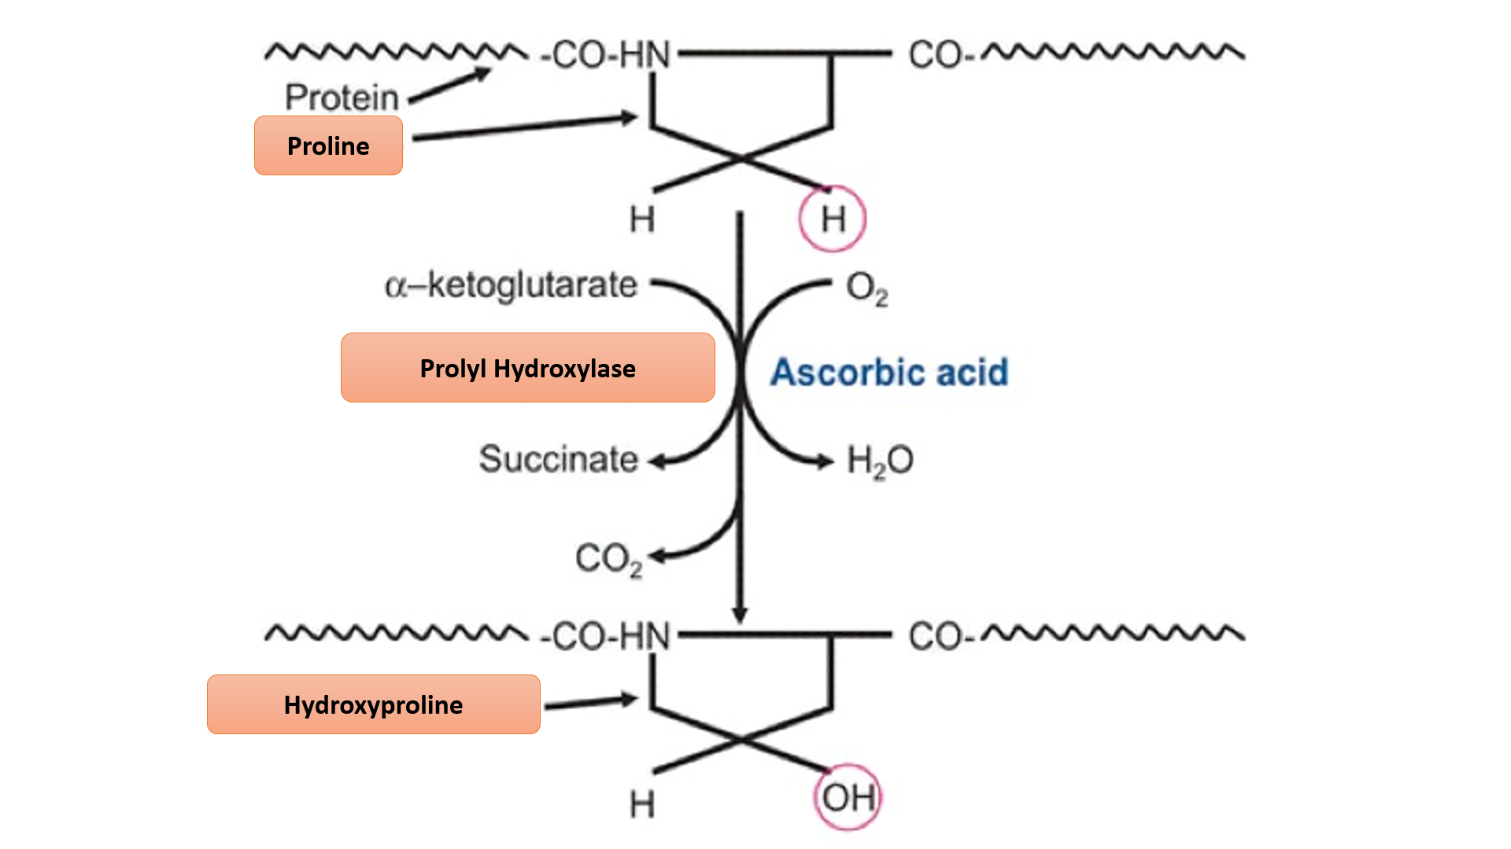

**Figure 2: Ascorbic acid dependent hydroxylation of proline of protocollagen**

Collagen is a major structural protein in connective tissues, essential for mechanical strength, elasticity and extracellular matrix integrity. Among its ~30 types, Type I is the most abundant, especially in gingiva, pdl, bone, ligaments and skin. Vitamin C is a critical cofactor for collagen synthesis, acting through prolyl and lysyl hydroxylases that hydroxylate proline and lysine residues, stabilizing the collagen triple-helix structure (Figure 2). This post-translational modification is vital for proper cross-linking and maturation of collagen fibers. Vitamin C also enhances gene expression of Type I and III collagen by increasing mRNA stability in fibroblasts. Additionally, it may protect collagen from oxidative damage and regulate collagen type selection, supporting tissue repair and regeneration in synergy with growth factors like EGF and FGF. Deficiency in vitamin C disrupts collagen maturation, weakens periodontal attachment and impairs wound healing. 7

1. **Role in Immunity**

Vitamin C plays a critical role in immune defense within the periodontium by enhancing the function of neutrophils, macrophages and natural killer (NK) cells which are essential in combating microbial insult. It supports key immune processes such as chemotaxis, phagocytosis and microbial killing via the oxidative burst mechanism.4 Neutrophils and lymphocytes actively concentrate vitamin C to levels 50 to 100 times higher than in plasma, where it acts as a potent antioxidant, protecting cells from oxidative damage. Additionally, vitamin C modulates the inflammatory response by downregulating pro-inflammatory cytokines like TNF-α and IL-6, thereby mitigating tissue destruction. Its deficiency impairs these immune and regulatory functions, leading to increased susceptibility to periodontal infections and exacerbation of periodontal disease. 11

1. **Role in Osteogenic Gene Expression**

Vitamin C plays a critical role in bone formation by promoting the proliferation and differentiation of pre-osteoblasts. One of its primary functions is to enhance the synthesis of type I collagen, a key extracellular matrix protein that interacts with α2β1 integrins on osteoblast surfaces. This collagen-integrin interaction triggers intracellular signaling cascades, notably activating the MAPK (mitogen-activated protein kinase) pathway. Activation of this pathway leads to the phosphorylation of osteogenic transcription factors such as Runx2 and osterix, which subsequently upregulate the expression of osteoblast-specific genes involved in bone formation. 12

Further insights into this mechanism were provided by Yan et al., who demonstrated that vitamin C induces osteogenic differentiation in periodontal ligament progenitor cells through activation of the ERK pathway. This signaling cascade upregulates PELP1 (Proline-, Glutamic acid- and Leucine-rich Protein 1), which plays a significant role in enhancing Runx2 expression, a master regulator of osteoblast differentiation. These findings suggest a targeted and molecularly defined mechanism through which vitamin C can be harnessed in periodontal regenerative therapy—particularly by leveraging the PELP1–ERK axis to drive tissue and bone regeneration.

A clinical study reported 4% greater clinical attachment loss among elderly Japanese individuals with lower serum vitamin C levels, even after controlling for confounders such as smoking, diabetes, oral hygiene, gender and number of teeth. This inverse relationship further supports vitamin C’s importance in maintaining periodontal tissue integrity.

These findings align with growing evidence that vitamin C influences stem cell gene expression by modulating key intracellular signaling pathways. Its ability to activate the ERK pathway underlines its potential to direct stem cell plasticity and osteogenic differentiation positioning vitamin C as a valuable adjunct in periodontal regeneration and tissue engineering. 13

1. **Epigenetic Regulation**

Emerging evidence indicates that vitamin C modulates epigenetic mechanisms primarily by enhancing the activity of α-ketoglutarate-dependent dioxygenases (α-KGDDs), including the ten-eleven translocation (TET) enzymes and Jumonji-C domain-containing histone demethylases (JHDMs). TET enzymes catalyze DNA demethylation, while JHDMs remove repressive histone methylation marks, thereby influencing gene expression. Additionally, vitamin C has been shown to induce pluripotency genes and erase epigenetic memory in somatic cells, suggesting its broader role in cellular reprogramming and DNA repair. These epigenetic effects offer promising therapeutic potential in periodontal regeneration and repair.7

1. **Synergism with Other Vitamins**

The importance of supplementation and a healthy diet is emphasized in many articles related to dental diseases and may benefit the whole body. Vitamin C and Vitamin D were reported to impact the pathogenesis of periodontitis, leading to alterations in the structure of periodontal ligaments. Vitamin C is a significant nutrient involved in numerous physiological processes. It has a crucial role in the collagen stabilization process, resulting in participation in collagen enzymatic transformation. It was reported that Vitamin C could have a protective effect on periodontal tissues and could decrease levels of proinflammatory cytokines. An inadequate intake was also associated with a higher risk of periodontal disease. Studies showed that patients with periodontitis have a lower level of Vitamin D receptors and a lower number of fibroblast cells compared to healthy patients. Furthermore, studies showed the anti-inflammatory and pro-mineralization effects of Vitamin D. Moreover, a high Vitamin D level decreases levels of inflammatory molecules and Vitamin D is an important molecule for maintaining tooth mineral density and bone structure. Vitamin D concentration was found to be inversely related to periodontitis severity. It was also found that Vitamin D and calcium supplementation showed moderate positive effects after nonsurgical treatment. Both vitamins may decrease gum bleeding, which can be used to improve patient quality of life. A growing number of studies suggest that adequate Vitamin C and Vitamin D intake could have a beneficial effect on both the prevention and treatment of periodontal disease. 14

**V. VITAMIN C AND ORAL HEALTH**

Vitamin C plays a multifaceted role in both systemic and oral health through its chemical, structural and immunomodulatory functions. It is essential for collagen synthesis by converting proline to hydroxyproline and lysine to hydroxylysine—critical steps in forming stable collagen fibers. Structurally, it supports the integrity of connective tissues in bones, teeth, blood vessels and organ capsules by contributing to the intercellular matrix and endothelial function. Vitamin C also participates in folic acid activation, steroid synthesis in the adrenal glands, microsomal drug metabolism and enzyme protection.

In oral health, vitamin C demonstrates a concentration-dependent inhibition of *Streptococcus mutans*, a key bacterium involved in dental caries. It enhances calcium deposition and tooth mineralization, reducing the risk of secondary caries. Also, Vitamin C exerts a strong intracellular antioxidant effect, significantly reducing oxidative stress associated with gingival inflammation. It has been shown to mitigate the cytotoxic and apoptotic effects of *Porphyromonas gingivalis* on human periodontal ligament cells and gingival fibroblasts, thereby preserving cell viability.15

Its antioxidant properties and ability to stimulate collagen synthesis are vital for periodontal healing and tissue regeneration. Vitamin C is present in high concentrations in human neutrophils, where it enhances chemotaxis, supports oxidative killing of pathogens, preserves neutrophil integrity and protects host tissues from damage during respiratory bursts.

Furthermore, L-ascorbic acid plays a key role in endothelial cell function by stimulating the proliferation of these cells—likely due to increased type IV collagen synthesis. It also promotes fibroblast migration and keratinocyte proliferation, which contributes to wound healing and may help reduce gingival inflammation. Studies have shown that vitamin C reduces proinflammatory cytokines, highlighting its potential as a biomarker and therapeutic adjunct in inflammatory conditions. Additionally, evidence suggests that increased vitamin C intake is associated with improved alveolar bone density in pregnant women and enhanced bone mineral density in postmenopausal women.

Vitamin C also exhibits protective effects against oral carcinogenesis. Studies link low salivary levels of vitamin C with oral cancers and show that higher dietary intake correlates with a reduced risk of premalignant and malignant lesions in the oral cavity and head and neck region.16

**VI. VITAMIN C IN PERIODONTAL DISEASE**

Periodontal disease is a chronic inflammatory condition that affects nearly 90% of the global population and is a principal cause of tooth loss due to the progressive destruction of alveolar bone. It begins with bacterial infection and is exacerbated by an exaggerated host immune response, particularly through polymorphonuclear leukocytes (PMNs), which generate ROS. At elevated levels, ROS cause oxidative stress and tissue damage, compromising the structural integrity of periodontal tissues. Vitamin C, a potent antioxidant, plays a crucial role in counteracting ROS and protecting periodontal structures. It also aids in the differentiation of periodontal ligament progenitor cells, promoting tissue repair and regeneration.

Vitamin C is essential for collagen hydroxylation, a process vital for the stability of periodontal ligament fibers. Deficiency in vitamin C impairs this process, weakening the connective tissue matrix, increasing tooth mobility and contributing to eventual tooth loss. Clinical studies have consistently shown that individuals with lower vitamin C intake or plasma levels demonstrate more severe periodontal disease, increased gingival inflammation and delayed wound healing. Supplementation of vitamin C—especially when paired with nonsurgical periodontal therapy—has been shown to reduce gingival bleeding, improve sulcus bleeding index (SBI) scores and enhance post-surgical healing after procedures such as implant placement and guided bone regeneration.17

In addition to its antioxidant and wound-healing roles, vitamin C deficiency may interfere with bone formation by impairing osteoid production from osteoblasts, leading to alveolar bone resorption in advanced deficiency states. It can also compromise the barrier function of gingival epithelium by increasing permeability to bacterial endotoxins, potentially aggravating the inflammatory cascade. Optimal levels of vitamin C improve leukocyte chemotaxis and migration, supporting the host’s defense, although megadoses may paradoxically impair their bactericidal function. Furthermore, vitamin C helps maintain the microvascular integrity of the periodontium and supports appropriate vascular responses during healing. While some theories suggest that vitamin C deficiency may alter plaque microbiota balance toward pathogenicity, this remains to be conclusively proven. 18,19

Also, deficiency of Vitamin C may lead to:

1. **Scurvy**

Scurvy is a severe form of vitamin C deficiency resulting from prolonged intake below 10 mg/day. Symptoms can manifest within a month and include fatigue, malaise, petechiae, ecchymoses, joint pain, poor wound healing and corkscrew hairs. In the oral cavity, scurvy is marked by swollen, spongy, bleeding gums, loosening or loss of teeth and increased susceptibility to infections due to compromised collagen synthesis and capillary fragility. Hemorrhages under the nails, perifollicular bleeding and hyperkeratotic follicles may also be seen. While gingival inflammation in scurvy is often attributed to poor oral hygiene, vitamin C deficiency amplifies these symptoms. Treatment with 1 g/day of ascorbic acid leads to rapid reversal of symptoms, especially subcutaneous hemorrhages. It is important to note, however, that in well-nourished individuals, vitamin C deficiency alone does not cause periodontitis but can exacerbate its severity. 20

1. **Necrotizing Ulcerative Gingivitis (NUG)**

NUG is a painful and acute periodontal condition characterized by ulcerated interdental papillae, gingival bleeding and necrosis. Risk factors include smoking, psychological stress, malnutrition, immunosuppression and existing gingivitis. While vitamin C deficiency has been historically associated with NUG, modern studies suggest that its role is more supportive than causal. A case-control study involving NUG patients revealed lower dietary and plasma vitamin C levels compared to controls, but the significance diminished after adjusting for socioeconomic factors. This indicates that while vitamin C deficiency may not be a primary cause, it can aggravate the disease in conjunction with other systemic and local risk factors.

1. **Gingivitis**

The relationship between vitamin C and gingivitis remains nuanced. Although vitamin C deficiency does not directly cause gingivitis, it contributes to its severity in individuals with poor oral hygiene. In gingivitis populations, lower plasma vitamin C levels have been linked to increased inflammation and bleeding. Supplementation can reduce gingival bleeding, particularly in individuals with suboptimal dietary intake. Experimental studies show that vitamin C-rich foods (e.g., guava) and supplements can prevent the onset of gingivitis during periods of oral hygiene neglect. However, in individuals already consuming adequate amounts (200 mg/day), further supplementation offers no additional benefit, highlighting the importance of maintaining—not exceeding—optimal vitamin C levels for periodontal health. 21

1. **Oral Infections and Ulcers**

Vitamin C plays a vital role in wound healing by enhancing fibroblast migration, keratinocyte proliferation and collagen cross-linking. It supports neutrophil function by improving chemotaxis and reducing oxidative tissue damage during respiratory bursts. Deficiency impairs the integrity of vascular and connective tissues, delaying healing and increasing vulnerability to oral infections, ulcers and tissue breakdown. Moreover, vitamin C enhances alveolar bone and mineral density, particularly in pregnant and postmenopausal women, suggesting its broader relevance in systemic bone health. While not curative on its own, adequate vitamin C intake is essential in optimizing oral immune defense and promoting periodontal healing following surgical and nonsurgical interventions. 16

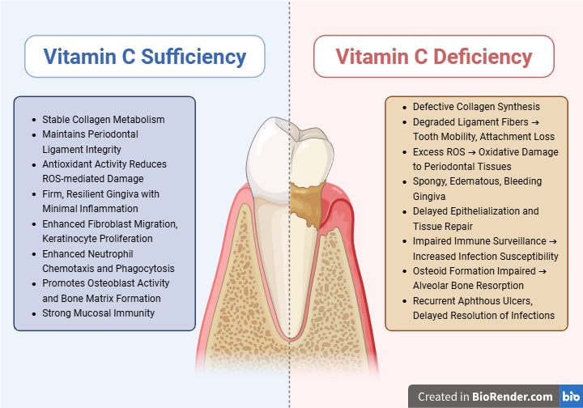

**Figure 3: Oral and Periodontal Effects of Vitamin C in Health and Deficiency**

**VII. SYSTEMIC HEALTH INTERPLAY**

1. **Vitamin C and Diabetes Mellitus**

Vitamin C plays a crucial role in the management of type 2 diabetes mellitus (T2DM) by combating oxidative stress, which is a key factor in the progression of diabetic complications such as neuropathy, nephropathy, retinopathy and cardiovascular disease. It improves insulin sensitivity, supports endothelial function and facilitates the synthesis of vasodilators like nitric oxide (eNO) and prostaglandins (PGE1, PGI2). Low vitamin C levels in diabetic patients are associated with elevated proinflammatory markers (IL-6, TNF-α), increased lipid peroxidation and greater periodontal breakdown (Figure 3).

Studies have shown that:

* Oral vitamin C supplementation (1000 mg/day) reduces hyperglycemia and oxidative biomarkers like isoprostane-F2.
* Increased malondialdehyde (MDA) and decreased glutathione levels (GSH) in diabetic periodontal tissues indicate oxidative damage.
* Vitamin C deficiency in diabetics enhances susceptibility to periodontitis and worsens tissue healing.
* Epidemiological studies report a strong association between low vitamin C intake and higher prevalence of periodontitis in diabetic individuals, especially between ages 30–49.

Although vitamin C cannot *cure* periodontal disease in diabetics, its adjunctive use—especially alongside chlorhexidine—can help control progression and improve healing. 22

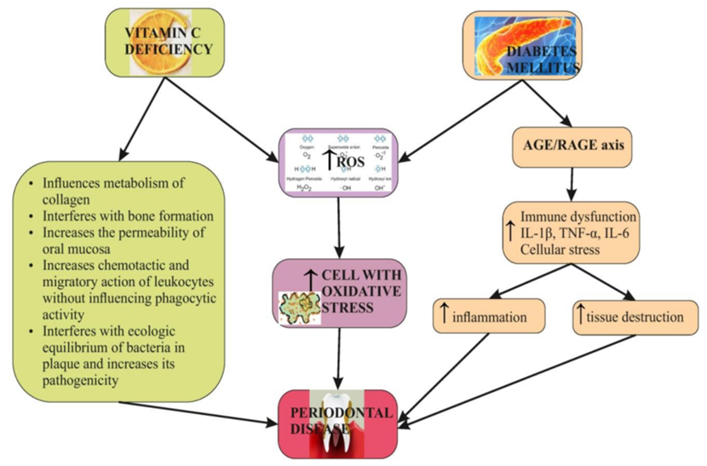

**Figure 4: Relationship between Vitamin C deficiency and Diabetes Mellitus**

**B. Vitamin C and smoking**

Smokers have substantially lower levels of serum vitamin C than non-smokers.Thus, in combination with the tissue destruction directly caused by oxidant stress generated through smoking, poor vitamin C status may further exacerbate periodontal disease. The oxidative stress caused by smoking suggests that vitamin C intakes should be higher in smokers.

Researchers report that when vit.c is administered either systemically, locally or combined it reverses nicotine and cotinine's adverse effects on human gingival fibroblasts; therefore, smokers are encouraged to take antioxidant supplements to combat the adverse effects. 23

**VIII. ADJUNCTIVE USE OF VITAMIN C IN PERIODONTOLOGY**

Vitamin C has emerged as a promising adjunct in periodontal therapy due to its multifaceted biological effects. One notable application is its role in managing gingival hyperpigmentation. Vitamin C suppresses melanin synthesis by inhibiting tyrosinase activity—the rate-limiting enzyme in melanogenesis—through cytoplasmic acidification. Being an acidic compound, it lowers the pH within melanocytes, thus reducing tyrosinase activity and melanin production. Additionally, it competes with tyrosinase for copper ions, essential cofactors for its enzymatic function, further diminishing pigmentation. Its potent antioxidant properties help neutralize free radicals, which are known to trigger melanogenesis. By promoting collagen synthesis and reducing its breakdown, vitamin C also supports proper keratinocyte differentiation, thereby indirectly minimizing melanin formation. These effects suggest vitamin C could offer a minimally invasive alternative to surgical depigmentation, especially for individuals with thin gingival biotype.24

Beyond pigmentation, vitamin C has shown significant promise in periodontal regeneration. Its incorporation into biomaterials such as microspheres, scaffolds, hydrogels and tissue adhesives can enhance soft and hard tissue engineering outcomes. These vitamin C-based systems promote wound healing, stimulate fibroblast proliferation and enhance osteogenic differentiation—making them valuable tools in regenerative periodontal therapies. 25

**IX. FUTURE DIRECTIONS**

The lack of standardized indicators for assessing periodontal disease presents a significant challenge in comparing the strength of associations between vitamin C and periodontal health across various studies. A unified and quantitative framework is essential for accurately evaluating disease severity and treatment outcomes. Additionally, confounding factors such as smoking and diabetes may influence the protective effects of vitamin C on periodontal tissues, as observed in multiple investigations.

Dietary intake remains the most accessible and effective method of maintaining adequate vitamin C levels. Notably, studies have shown that consumption of vitamin C-rich fruits, such as grapefruit, can lead to measurable improvements in periodontal health, including a reduction in sulcus bleeding index among chronic periodontitis patients. This highlights the potential role of nutrition-based strategies in periodontal therapy.

Despite its proven systemic benefits, the use of vitamin C as a local drug delivery agent in periodontal therapy is still an emerging area and requires further exploration. To enhance the impact of preventive and therapeutic strategies, closer collaboration between oral health professionals and dietitians is recommended. Future research should focus on evaluating the effectiveness of such interdisciplinary approaches and developing novel delivery methods for vitamin C in periodontal care. 19

**X. CONCLUSION**

Vitamin C is an essential micronutrient with significant implications for periodontal health and therapy. Its pivotal roles in collagen synthesis, immune modulation and antioxidant defense make it indispensable for maintaining periodontal integrity and promoting healing. Given its systemic benefits and adjunctive potential in periodontal regeneration and depigmentation, ensuring adequate vitamin C intake is not just beneficial—but essential—for comprehensive periodontal care.

**REFERENCES**

1. Dallos A, Hajos-Szikszay E, Liszi J. Enthalpies of solution and crystallization ofL-ascorbic acid in aqueous solution. The Journal of Chemical Thermodynamics. 1998 Feb 1;30(2):263-70.
2. Padayatty SJ, Levine M. Vitamin C: the known and the unknown and Goldilocks. Oral diseases. 2016 Sep;22(6):463-93.
3. Amaliya, Timmerman MF, Abbas F, Loos BG, Van der Weijden GA, Van Winkelhoff AJ, Winkel EG, Van der Velden U. Java project on periodontal diseases: the relationship between vitamin C and the severity of periodontitis. Journal of clinical periodontology. 2007 Apr;34(4):299-304.
4. See XZ, Yeo WS, Saptoro A. A Comprehensive Review and Recent Advances of Vitamin C: Overview, functions, sources, applications, market survey and processes. Chemical Engineering Research and Design. 2024 May 5.
5. Carr AC, Maggini S. Vitamin C and immune function. Nutrients. 2017 Nov;9(11):1211.
6. Moynihan PJ. The role of diet and nutrition in the etiology and prevention of oral diseases. Bulletin of the world health organization. 2005;83:694-9.
7. Alberts A, Moldoveanu ET, Niculescu AG, Grumezescu AM. Vitamin C: A Comprehensive Review of Its Role in Health, Disease Prevention, and Therapeutic Potential. Molecules. 2025 Feb 6;30(3):748.
8. Chambial S, Dwivedi S, Shukla KK, John PJ, Sharma P. Vitamin C in disease prevention and cure: an overview. Indian journal of clinical biochemistry. 2013 Oct;28:314-28.
9. Padayatty SJ, Sun H, Wang Y, Riordan HD, Hewitt SM, Katz A, Wesley RA, Levine M. Vitamin C pharmacokinetics: implications for oral and intravenous use. Annals of internal medicine. 2004 Apr 6;140(7):533-7.
10. Cerullo G, Negro M, Parimbelli M, Pecoraro M, Perna S, Liguori G, Rondanelli M, Cena H, D’Antona G. The long history of vitamin C: from prevention of the common cold to potential aid in the treatment of COVID-19. Frontiers in immunology. 2020 Oct 28;11:574029.
11. Gandhi M, Elfeky O, Ertugrul H, Chela HK, Daglilar E. Scurvy: rediscovering a forgotten disease. Diseases. 2023 May 26;11(2):78..
12. Aghajanian P, Hall S, Wongworawat MD, Mohan S. The roles and mechanisms of actions of vitamin C in bone: new developments. Journal of Bone and Mineral Research. 2015 Nov 1;30(11):1945-55.
13. Buzatu R, Luca MM, Bumbu BA. Does Vitamin C Supplementation Provide a Protective Effect in Periodontal Health? A Systematic Review and Meta-Analysis. International Journal of Molecular Sciences. 2024 Aug 7;25(16):8598.
14. Ustianowski Ł, Ustianowska K, Gurazda K, Rusiński M, Ostrowski P, Pawlik A. The role of vitamin c and vitamin d in the pathogenesis and therapy of periodontitis—narrative review. International journal of molecular sciences. 2023 Apr 5;24(7):6774.
15. Staudte H, Güntsch A, Völpel A, Sigusch BW. Vitamin C attenuates the cytotoxic effects of Porphyromonas gingivalis on human gingival fibroblasts. Archives of oral biology. 2010 Jan 1;55(1):40-5.
16. Murererehe J, Uwitonze AM, Nikuze P, Patel J, Razzaque MS. Beneficial effects of vitamin C in maintaining optimal oral health. Frontiers in Nutrition. 2022 Jan 10;8:805809.
17. Pavithra RS, Ramaprabha G, Rajasekar S, Lakshmi Sree S. Vitamin deficiency and periodontal disease-A tie-in relationship. Sch J App Med Sci. 2017;5(1A):74-81.
18. Nishida M, Grossi SG, Dunford RG, Ho AW, Trevisan M, Genco RJ. Dietary vitamin C and the risk for periodontal disease. Journal of periodontology. 2000 Aug;71(8):1215-23.
19. Tada A, Miura H. The relationship between vitamin C and periodontal diseases: a systematic review. International journal of environmental research and public health. 2019 Jul;16(14):2472.
20. Doseděl M, Jirkovský E, Macáková K, Krčmová LK, Javorská L, Pourová J, Mercolini L, Remião F, Nováková L, Mladěnka P, Oemonom. Vitamin C—sources, physiological role, kinetics, deficiency, use, toxicity, and determination. Nutrients. 2021 Feb 13;13(2):615.
21. Van der Velden U. Vitamin C and its role in periodontal diseases–the past and the present: a narrative review. Oral health & preventive dentistry. 2020 Apr 1;18(2):a44306.
22. Bogdan M, Meca AD, Boldeanu MV, Gheorghe DN, Turcu-Stiolica A, Subtirelu MS, Boldeanu L, Blaj M, Botnariu GE, Vlad CE, Foia LG. Possible involvement of vitamin C in periodontal disease-diabetes mellitus association. Nutrients. 2020 Feb 20;12(2):553.
23. Tatsumi M, Yanagita M, Yamashita M, Hasegawa S, Ikegami K, Kitamura M, Murakami S. Long‐term exposure to cigarette smoke influences characteristics in human gingival fibroblasts. Journal of Periodontal Research. 2021 Oct;56(5):951-63.
24. Miao F, Su MY, Jiang S, Luo LF, Shi Y, Lei TC. Intramelanocytic acidification plays a role in the antimelanogenic and antioxidative properties of vitamin C and its derivatives. Oxidative Medicine and Cellular Longevity. 2019;2019(1):2084805.
25. Torshabi M, Rezaei Esfahrood Z, Jamshidi M, Mansuri Torshizi A, Sotoudeh S. Efficacy of vitamins E and C for reversing the cytotoxic effects of nicotine and cotinine. European Journal of Oral Sciences. 2017 Dec;125(6):426-37.