**Significance of Sustainable Agricultural Systems and Farming Practices in Environmental Conservation**

Waikhom Arunkumar Meetei1, Heikham Narmila Devi2* and Techi Yajo Tara1

1Department of Rural Development and Agricultural Production

2Department of Agribusiness Management and Food Technology

North-Eastern Hill University, Tura Campus, Meghalaya-794002, India

*Corresponding author: hnarmiladevi@gmail.com

**Abstract**

The state of Manipur, known for its rich biodiversity and indigenous communities, shows an intricate interplay between human activity and ecological sustainability. Indigenous communities in the region have historically coexisted with nature, emphasizing the importance of incorporating local knowledge systems into conservation strategies. However, there is a dearth of scientific work portraying the diverse systems of conservation measures in the state. Therefore, this study aims to provide a comprehensive overview of the pivotal role of society, sustainable agriculture, and farming systems in environmental conservation. The study revealed that nature-oriented lifestyles, cultural beliefs, sustainable agricultural practices, and traditional ecological knowledge all play crucial roles in conservation efforts. The study has significant implications for the research community, society, government machinery, and all stakeholders.

**Keywords:** Manipur, conservation, indigenous, farming system, sustainable agriculture

**Introduction**

The North-Eastern Region (NER) of India is a land of immense cultural diversity and environmental richness, where various ethnic communities reside. The region has always been associated with its lush green nature and diverse agro-geographical features and has a marked reputation for environmental conservation. The people have a rich socio-cultural linkage with nature. While the people dwelling close to the forest utilize resources for their livelihood, they also encourage conservation by following their traditional laws, religious beliefs, and cultural practices1. As a crucial part of the Indo-Burma biodiversity hotspots, Manipur not only hosts a rich biological diversity of plants, animals, microorganisms, etc., but also hosts different ethnic communities. The state comprises a small central valley region surrounded by parallel ranges of lush green hills. Approximately 70.79% of the state's total population lives in rural areas, while the rest (29.21%) lives in urban areas2. The state's population consists of more than 30 distinct groups. The Meitei, Naga, Kuki, and Meitei Pangal are the dominant cultural groups in the region. These groups have distinctive customs, traditions, linguistic diversities, dietary practices, traditional attire, cultural dances, and festivals that are unique to each culture.

Manipur is among the top states in terms of forest cover percentage, reaching up to 74.34%3. Manipur is known for its rich biological diversity, with a large number of flora and fauna species featuring numerous angiosperms, gymnosperms, pteridophytes, bryophytes, medicinal plants, edible fungi, orchids, bamboos, mammals, fish species, birds, etc. Manipur has a rich gene pool of primitive cultivars and land races of various agri-horticultural crops, with several important underutilized fruits and vegetables. The state also possesses four GI-tagged agricultural products, namely, Kachai Lemon, Tamenglong Orange, Sirarakhong Hathei and Chak-hao. Well-known endangered species include *Rucervis eldi eldi* and *Lilium macklinae*. Several studies have revealed the presence and ethnobotanical uses of hundreds of medicinal plants in the state4,5. The biological diversity of the state is acknowledged by numerous protected sites, such as national parks, wildlife sanctuaries, and biosphere reserves.

Table 1. Forest cover of Manipur3

|  |  |  |  |  |  |  |  |  |
| --- | --- | --- | --- | --- | --- | --- | --- | --- |
| **State** | **No. of districts** | **Geographical area (sq. km)** | **Forest Cover Assessment of 2021 (sq. km)** | | | | **Percentage of geographical area** | **Recorded forest area (sq. km)** |
| **VDF** | **MDF** | **OF** | **TFC** |
| Manipur | 16 | 83743 | 905 | 6228 | 9465 | 16598 | 74.34% | 17418 |

*\*VDF: very dense forest; *MDF: moderately dense forest; *OF: open forest; *TFC: total forest cover*

Table 2. Protected sites of Manipur

|  |  |  |
| --- | --- | --- |
| **Types of Protected Sites** | **Total number** | **Names** |
| National Park (NP) | 2 | Keibul Lamjao, Shiroi |
| Wildlife Sanctuary (WS) | 7 | Yangoupokpi Lokchao, Khongjaingamba Ching, Jiri Makru, Kailam, Zeilad, Bunning, Thinungei Bird Sanctuary |
| Community Reserves (CR) | 15 | Pfunemai, Azuram, Chiibvii & Veimairii, Sofii Khro, Baneevehdea, Houphai, Chipeivao, Lungphu, Mekrimai Ru & Makramai Bu, Shangneme, M. Tanglian, Lailong S., S. Mollen, Chiuluan, Razai |
| Ramsar Sites | 1 | Loktak Lake |

However, the recent decline in biodiversity and negative forest cover change in the state have become concerning issues. Out of the total forest cover lost in the NE region (1020 km2), Manipur accounts for 24.41% with a 249 km2 dropin forest cover of the state3. This is attributed to shifting cultivation, deforestation, natural calamities, anthropogenic pressure, developmental activities and hydroelectric dams. Considering this prevailing issue, there is an urgent need to look at environmental conservation through a new lens towards the aged practices and redefine the roles of society.

**Role of Society in environmental conservation**

Society plays a huge role in the conservation of the environment and biodiversity in the state. The people have been engaging and participating in various environmental conservation measures since time immemorial. This encompasses the socio-cultural and religious beliefs, sacred groves, traditional agricultural practices, farming systems, home gardens, environmental movements, etc. These societal practices have been undermined by the lack of proper documentation and scientific investigation. Therefore, this section aims to bring out the significance of the role of society in the past and the present as well as the future direction in environmental conservation. The first leap towards environmental conservation begins with awareness. The people of the region possess a deep understanding of nature and the environment. It has been ingrained in their belief systems and social constructs. It is evident in their rituals, lifestyles and different literatures.

*Fig. 1. Role of society in the conservation of the environment in Manipur.*

Sacred groves in Manipur, traditionally protected due to religious and cultural beliefs, serve as critical biodiversity hotspots and carbon stock reserves, conserving a wide range of flora, fauna, and microbes through community-enforced taboos and spiritual practices6,7. A total of 166 sacred groves in the Manipur Valley, associated with belief systems such as the Meitei religion and the worship of *Umanglai* deities, exemplify community-led conservation embedded in socio-religious frameworks6,7. The Meitei community associates flowering patterns and plant characteristics with various ecological and cultural meanings-for instance, *Agave americana* is used to predict wind and storms, *Alocasia indica* is linked to familial difficulties, and *Ficus rumphii* nesting by crows forecasts rainfall8. Other plants like *Brassica campestris, Hibiscus cannabinus,* and *Platycerium wallichii* are believed to signal seasonal transitions or metaphysical phenomena, while species such as *Quercus serrata* are avoided in construction due to spiritual beliefs8. The Mao Naga people observe flowering in species like *Mantisia spathulata, Bauhinia purpurea* L. and *Prunus carmesina* as signals for the onset of rain and optimal periods for planting crops like paddy, maize, and vegetables9. Similarly, the Tangkhul regard the flowering of *Lilium macklinae* as a cue for paddy cultivation10. Social campaigns and activisms for environmental conservation in Manipur hold a significant part in acting against many adverse actions11,12,13. They indicate a strong sense of responsibility towards the environment. These movements inspire various sections of the world to move forward for the conservation of nature even if it is against big forces like government and large companies.

**Farming systems and indigenous knowledge**

The people of the state are largely dependent on agriculture, horticulture, forestry and animal husbandry. People tend to follow the traditional and sustainable farming systems, compatible with geographical features. Local farmers’ knowledge of sustainable agriculture represents a vast body of practical experience and the capacity for knowledge generation, both of which are crucial for achieving sustainability and development goals.

The Mao Naga community practices a unique form of terrace farming9, where fields are carved out of hill slopes to create dikes that retain water and prevent erosion. This method enhances soil moisture conservation and improves agricultural productivity while safely managing runoff. The community employs various natural fertilizers and incorporates non-cereal crops to maintain soil organic matter. Innovative anti-erosion measures like bamboo, stones, and gunny bags are utilized, contributing to improved soil quality and sustainable farming practices. Furthermore, eco-friendly methods, conservation tillage, and crop rotation play a vital role in boosting soil health and supporting community-based agricultural systems through the *Ava Kocho* practice9.

Rice-fish culture is practiced among the Mao Naga tribe and Meitei community, featuring indigenous carps like *Labeo rohita*, *Channa punctata* 14,15. Farmers cultivate these fish alongside local rice varieties. This culture is important for soil health as fish act as bio-control agents and aid in nutrient cycling. Extensive research has been conducted on rice-fish culture and its significance for rural development in Assam and Arunachal Pradesh. *Panikheti* system of rice cultivation (terracing, diverting water from hills to terraces16. Pond-based farming systems integrate pisciculture, fruit crops, vegetables, and animal husbandry16.

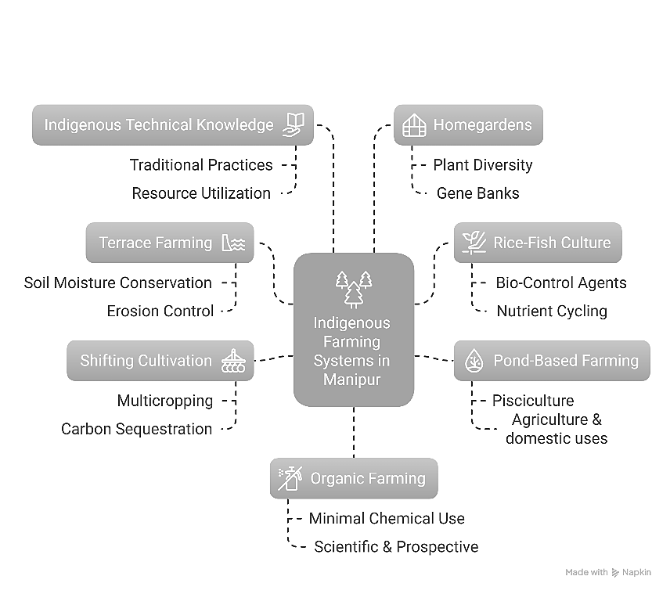

*Fig. 2. Farming systems and indigenous knowledge of different communities of Manipur and their significance in environmental conservation.*

Shifting cultivation (*jhum*) is practised mainly in the hilly regions of Manipur. Though it was various environmental impact mainly owing to decline in period of shifting cycle, jhum cultivation is also known to exhibit various positive attributes such as multicropping, crop rotation, carbon sequestration, source of gene pools, conservation of soil and water17,18. The topographical differences and indigenous innovations prove to be the unique trigger for sustainable management of resources18,19.

The indigenous technical knowledge about agriculture and allied sectors has been a stronghold for sustainable agriculture in the state. Use of ash to crops, burning of left-over straws, soaking of paddy seeds with cowdung, pit nursery for seedlings, protection of crops (using papers, bamboo sticks, polythene), using locally available manures, etc. are common in the state20,21. Meitei and Tangkhul farmers use *Artemisia nilagrica* against insects and pest infestation of rice21. Chinese mustard is used as trap crop for cole crops and bamboo for *Parkia* plant21. Mixed farming systems such as duck rearing in paddy field, poultry in mulberry plantation provide mutual benefits and optimum utilization of resources21. This indigenous technical knowledge reduces the pressure on harsh chemical means in crop management and production.

Homegardens are integral to the local society, providing employment opportunities, additional revenue and cultural significance. They contribute to both *ex situ* and *in situ* conservation efforts, preserving local plant diversity and serving as living gene banks for wild and domesticated species22,23. Home gardens offer eco-friendly waste disposal through composting of household items like kitchen waste and paper, which can be used to nourish the soil. Traditional homegardens of different communities of Manipur are rich in biological diversity harbouring many local crop species including medicinal plants, building materials, fruits, vegetables, spices, wild plants, feeds etc.23. Farmers are highly aware of plant species that they have cultivated indicating their ecological knowledge23.

Manipur has a high prospect for organic farming. With minimal use of fertilizers and chemicals in traditional cultivation, the conversion to organic farming comes with ease. Farmers have a strong mindset against the use of chemicals. This farming system has been proven to be sustainable and feasible socially, ecologically, technologically and economically. Manipur Organic Mission Agency (MOMA) is taking the lead role to promote organic farming and related activities in Manipur state. A brand has been created the “Organic Manipur” to visually propagate values, narratives, and quality parameters. The organic farming area in Manipur stands at 7172.00 ha, while the conversion area is recorded as 25.412.50 ha, making the total area 32584.50 ha24. National Programme for Organic Production (NPOP), Mission Organic Value Chain Development for North East Region (MOVCD-NER) and Act East Policy are significant opportunities for the organic farming sector of the state.

**Conclusion and Future Directions**

Manipur serves as a compelling case study for exploring the interplay between society, agriculture and environmental conservation. Rich socio-cultural and religious beliefs, indigenous knowledge and sustainable agricultural practices account for the standing figures of environmental entities. Any description or interpretation will not do justice to their understanding and awareness of their surrounding environment, and its sustainable utilization and conservation. There is a need for further documentation and scientific interventions for positive and far-reaching results. Inclusion of traditional knowledge and indigenous people in the decision making process and implementation of policy will have a big impact. A holistic approach that respects and integrates traditional practices with modern conservation initiatives is essential for safeguarding long-term biodiversity preservation.

**References**

1. Tynsong, H., Dkhar, M., & Tiwari, B.K. (2020). Traditional ecological knowledge of tribal communities of North East India. Biodiversitas Journal of Biological Diversity. *21*(7):3209–24.
2. Census India. Manipur Population Census 2011, Manipur Religion, literacy, Sex Ratio - Census India. (n.d.). Available at <https://www.censusindia.co.in/states/manipur>
3. Webline Infosoft Pvt. Ltd. Welcome to Forest Survey of India. (n.d.). Available at <https://fsi.nic.in/forest-report-2021>
4. Meitei LR, De A, Mao AA. An ethnobotanical study on the wild edible plants used by forest dwellers in Yangoupokpi Lokchao Wildlife Sanctuary, Manipur, India. Ethnobotany Research and Applications. 2022;23(15):1–25.
5. Yaipharembi N, Huidrom E, Nongalleima K, Singh HB. An ethnobotanical study on the dietary use of wild trees as traditional vegetables by three ethnic communities in Manipur, North East India. Economic Botany. 2023;77(3):324–39.
6. Khumbongmayum AD, Khan ML, Tripathi RS. Sacred groves of Manipur, northeast India: biodiversity value, status and strategies for their conservation. Biodiversity and Conservation. 2005;14:1541-1582.
7. Waikhom AC, Nath AJ, Yadava PS. Aboveground biomass and carbon stock in the largest sacred grove of Manipur, Northeast India. Journal of Forestry Research. 2018;29:425–428.
8. Singh HB. Folklore, traditional beliefs, taboo and practices on climate and weather forecasting by the Meitei community of Manipur, North East India. In: Addressing the Climate Crisis in the Indian Himalayas: Can Traditional Ecological Knowledge Help? Cham: Springer Nature Switzerland; 2024. p. 281–291.
9. Kamei J, Bain WK, Biswas S. Investigation into the traditional terrace farming process and associated knowledge systems among the Mao Naga community in Mao Maram Sub-division, Senapati District, Manipur- An anthropological appraisal. Heritage: Journal of Multidisciplinary Studies in Archaeology. 2023–2024;11(1):1213-1242.
10. Varah F, Varah SK. Indigenous knowledge and seasonal change: insights from the Tangkhul Naga in Northeast India. GeoJournal. 2022;87(6):5149–63.
11. Baite NSD, Easwaran K. Community participation, activism, and community development in Moreh, Manipur. Mizoram University Journal of Humanities and Social Sciences. 2022;8(1):201–214.
12. Khuman KB. People’s movement against Tipaimukh project in Manipur: An assessment. International Journal of Multidisciplinary Research and Growth Evaluation. 2023;4(4):65-74.
13. Kangujam L, Pandey I. The stealth of nations: informal workers in the global economy. Harvard International Review. 2021;42(1):82–87.
14. Haobijam JW, Balkho MR, Mandal TK. Paddy-cum-fish cultivation and the challenges faced by the farmers of Manipur, India. International Journal of Current Microbiology and Applied Sciences. 2018;7(2):998–1004.
15. Abujam S, Soram JS, Singh LS, Sarma J, Bhowmik D. Traditional rice-fish farming of Mao indigenous community, Manipur, India. International Journal of Ecology and Environmental Sciences. 2024;50(5):799-804.
16. Das A, Ramkrushna GI, Choudhury BU, Munda GC, Patel DP, Ngachan SV, et al. Natural resource conservation through indigenous farming systems: wisdom alive in North East India. Indian Journal of Traditional Knowledge. 2012.
17. Reimeingam M. Shifting cultivation in Manipur: land, labour and environment. Journal of Rural Development. 2017:97-119.
18. Pfoze NL, Chhetry GKN, Chanu LB, Devi PA. Indigenous traditional cultivation practices of the Mao ethnic tribe under Senapati District in Manipur. Assam University Journal of Science and Technology. 2010;5(1):105-108.
19. Sitlhou H. Sacred ecology and ritual practices of the Thadou Kukis of Manipur. The Eastern Anthropologist. 2020;73(3-4):445-62.
20. Devi CV, Adhikary MM. Imperatives of indigenous knowledge along with the hill farmers of Manipur. *Journal of Crop and Weed*. 2018;14(1): 130-133.
21. Ansari MA, Sharma SK, Roy SS, Ramakrishna Y, Datt S, Ningombam A, et al. Documenting the agriculture-based indigenous traditional knowledge in Manipur State of North Eastern India. Indian Journal of Traditional Knowledge. 2021;20(4):1065–1074.
22. Tangjang S, Arunachalam A. Role of traditional homegarden systems in Northeast India. Indian Journal of Traditional Knowledge. 2009;8(1):47–50.
23. Shimrah T, Lungleng P, Shimrah C, Khuman YSC, Varah F. Role of traditional homegardens in biodiversity conservation and socioecological significance in Tangkhul community in Northeast India. Tropical Ecology. 2018; 59(3):533-539.
24. Agricultural and Processed Food Products Export Development Authority (APEDA). Organic Certification Data. (2025). Available at <http://sec-npop.apeda.in/Organic-Certification-Data>