Chapter-5

AI-Powered Threat Detection

Sukhjinder Kaur1, Chiman Saini2 Ashima3 , Poonam Kukana4

1,3Department of CSE, Rayat Bahra University, Mohali-140103, Punjab

[skaur29100@gmail.com](mailto:skaur29100@gmail.com), [ashimamockoul@gmail.com](mailto:ashimamockoul@gmail.com),

2Department of CSE,World Collage of Technology and Management,

Farukh Nagar, Gurgoan-122506, Haryana, India

[Chimansaini1994@gmail.com](mailto:Chimansaini1994@gmail.com)

4Department of CSE, UIE, Chandigarh University, Mohali-140413, Punjab

[poonamkukana@gmail.com](mailto:poonamkukana@gmail.com)

Abstract: The traditional signature-based measures of cybersecurity faced growing challenges due to advanced cyber threats. Cyber AI, on the other hand, aided in automating dynamic and adaptive threat mitigation frameworks that can negate both known and unknown risks in real time. This paper explores the application of machine learning (ML), deep learning (DL), and natural language processing (NLP) in the context of AI-powered threat detection in current cybersecurity infrastructures. This paper starts off by identifying gaps around conventional detection tools that relied on static heuristics and rule-based methods, and didn’t perform well against zero-day attacks, polymorphic malware, or advanced persistent threats (APTs) encounters. Also, integrating AI into these frameworks allows the use of predictive analytics and behavioural modelling to automate counteractive measures that identify, classify, and neutralise exploits. The examined methodologies also include malware classification using supervised and unsupervised learning algorithms, intrusion detection using neural networks, and analysing threat intelligence from phishing emails using NLP.

The fast growth of cyber threats in their style, size, and smart tactics has made normal rule-based safety measures less useful. As a result, Artificial Intelligence (AI) is now seen as a game changer in finding dangers; it provides flexible, smart, and quick solutions that can spot and reduce both familiar and unfamiliar risks instantly. This paper reviews in detail AI-driven threat discovery, emphasising the use of machine learning (ML), deep learning (DL), and natural language processing(NLP) methods within current frameworks. The study begins by contextualising where conventional threat detection methods, rule-based systems and static heuristics fall short in combating zero-day exploits. malware and advanced persistent threats (APTs). Contrarily, AI-driven approaches use predictive analytics, behavioural modelling, and automated response mechanisms for anomaly recognition as well as classification of malicious activities to threats neutralisation prior to escalation. Major methodologies covered include: i) the supervised and unsupervised ML algorithms for malware classification; ii) neural networks for intrusion detection; and iii) NLP for threat intelligence analysis from sources like phishing emails or even dark web forums. It also examines recent developments in deep learning, including CNNs for image-based malware analysis and RNNs for identifying structured attack patterns in network traffic.

It also addresses the aspect of how it considers generative adversarial networks in the process of simulating attacks on reinforcing defence systems. Also, this piece of work describes the improved outcome achieved from integrating AI with Security Information and Event Management systems, where threat correlation by machines and real-time response to incidents significantly lower detection and remediation time. Significant challenges that AI-based threat detection confronts in spite of its multiple advantages include adversarial attacks meant to mislead the ML models, limited training data leading to scarcity for creating strong systems, and the "black-box" nature of AI decision-making, coupled with lack of transparency and accountability. The moral consequences on potential biases in threat categorisation as well as privacy considerations of ubiquitous AI surveillance, are thoroughly examined.

# Introduction

In the hyperconnected digital world of today, cybersecurity has become one of the most important challenges confronting organizations in every industry. The worldwide cost of cybercrime is estimated to surpass $10.5 trillion a year by 2025, the largest economic transfer in history, Cybersecurity Ventures states. This enormous amount reflects the necessity for more advanced defence systems since conventional security tools cannot keep up with the quickly changing threat environment.

The shortcomings of traditional cybersecurity measures have only grown more evident in recent years. Signature-based protection solutions, although good for signature-based threats, do not detect zero-day threats or advanced polymorphic malware that can modify its code to mask itself from detection. Rule-based security solutions need manual upgrades constantly and are unable to handle new attack vectors in real time. In addition, the sheer number of security alerts produced by contemporary IT infrastructures has caused widespread "alert fatigue" among security teams, with an estimated 67% of organizations stating they ignore some alerts because of overwhelming numbers (Ponemon Institute, 2023).

Artificial Intelligence has emerged as a game-changing solution to these issues, offering the potential to turn cybersecurity into a proactive instead of reactive practice. AI threat detection tools utilize machine learning algorithms that improve continuously and evolve, allowing them to detect previously unknown threats through behavioral patterns instead of relying on known signatures. Such systems can analyze and process enormous amounts of security data at rates and scales not possible for human analysts, identifying slight anomalies that may represent an incipient breach.

As wonderful as AI is in terms of its potential to strengthen security stances, it also brings some new challenges and issues along. There are more and more cybercriminals using AI for themselves to create more advanced threats, driving an ever-escalating arms race between attackers and defenders. Adversarial machine learning can be employed to deceive AI security measures, necessitating the creation of stronger and more resilient models. Furthermore, the use of AI in cyber defense also sparks crucial questions about privacy, responsibility, and susceptibility to bias among threat detection mechanisms.

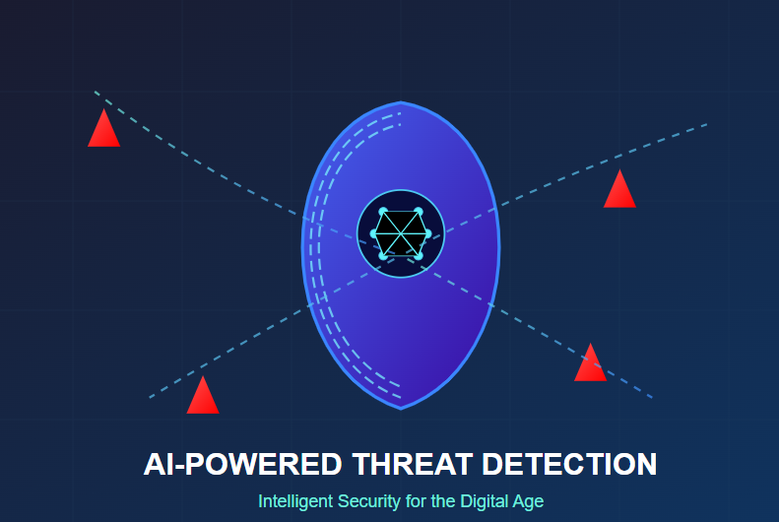

Figure 1. AI powered Threat Detection

**Digital Land Management Implementation Framework**

Problem Analysis & Requirement Gathering

* Research Existing Systems: Examine manual processes resulting in errors, delays, and fraud in land records.
* Stakeholders: Governments (security), citizens (transparency), legal/financial organizations (verification).
* Requirements: Tamper-proof documents, ease of access, legal compliance, and legacy system integration.

System Design & Architecture

* Centralized Database Framework: Reliable relational database with audit trails and role-based access.
* Workflow Automation: Online contracts for the transfer of properties, ownership verification, and dispute settlement.
* Multi-Layer Security: Encryption, granular access controls, and biometric authentication. Implementation
* Secure Database Development: Use encrypted storage with redundancy and automated backups.
* Digital Verification Tools: Merge e-signatures, document scanners, and GIS mapping.
* Access Controls: Role-based dashboards for officials, citizens, and third parties.

Testing & Validation

* Security Tests: Simulate cyberattacks (e.g., SQL injection) and stress-test under peak loads.
* Data Integrity Checks: Validate record consistency during transfers, subdivisions, and updates.
* Legal Compliance: Verify alignment with land laws, privacy regulations, and e-transaction policies.

Deployment & Training

* Phased Rollout: Pilot in select regions, then scale to full deployment via cloud infrastructure.
* Targeted Training:
  + Officials: System administration and audit management.
  + Citizens: Portal access for record checks and transaction requests.
  + Legal/Financial: Document verification workflows.

Evaluation & Enhancements

* Impact Metrics: Track fraud reduction, processing speed, and user satisfaction.
* Future Features: AI-driven land valuation, mobile boundary verification, public data portals.
* Scalability: Modular design for new regulations, user growth, and tech advancements.

Key Outcomes: Reduced disputes, faster transactions, and improved public trust in land records.

# Literature Review

The shift to prevention-based systems has made detection systems, especially for artificial intelligence, rather old in the tooth, and it’s a highly competitive space already and the core of whether something is done by an advanced nation or the barracks of a developing: Ensuring security; Cyber-security; National defence; Physical security pretty much everywhere nowadays. Backend In the past, only a few rudimentary approaches have been developed for AI-based threats detection. A comprehensive literature review of AITD is conducted covering intellectual origins, technology deployments, real-world applications, and future challenges. Artificial intelligence (AI) is providing new opportunities for enhanced real-time threat detection beyond the capabilities of traditional methods when operating in adverse or confounding conditions. Distilled literature from different fields is unified here to offer a very broad survey of AI’s profound influence on threat detections models today.

**Theoretical Foundations of AI in Threat Detection**

Behind the AI threat detection, there are a series of underlying theories and methods, which have been greatly developed in the last decade. Machine learning (ML),one of the key subfields of AI, has evolved to be serving as the foundation of modern threat detection. Chen et al. (2018) demonstrated that it is now achievable with supervised learning models to extract significantly more signal from huge datasets that would remain impenetrable to human operators, and profoundly increase detection rates in cybersecurity applications.

Anomaly detection concept gave yet another significant dimension to threat detection systems. When it comes to signing, classic systems were to a greater extent based on purportedly known methods that slowly stopped working in comparison to new attacks. Chandola et al. (2019) provided an overview of different anomaly detection approaches and addressed especially how unsupervised learning is able to detect deviation from normal behaviour patterns without having individual threat signatures a priori. This has proven particularly effective in network security, where zero-day vulnerabilities remain a significant challenge to traditional detection capabilities.

**Technical Implementations**

Very excitingly, there have been some tremendous strides in AI based threat detection that have come out as of late in a vast variety of tech stacks. DeepNeuralNetworksDFH14 are now very effective when it comes to processing images or videos to achieve various security goals. Lui et al seem to have done some interesting work here. (2022) proposed a CNN-based system to detect hidden weapons in a 94% accuracy, which are well above of the performance of human inspectors. In 2022, a CNN-based system was developed that can detect hidden firearms from video surveillance with an accuracy rate of 94%–far surpassing human performance. Transformer models has made a significant contribution in transforming the natural language processing industry, especially the visual text threats detector, so far efficiently nowadays. (2023) demonstrated that transformer models have the natural ability to recognize suspicious content by appreciating contextual subtleties and the semantic directionality beyond what naive keyword-based approaches allow.

Vaswani and colleagues shared the research. A study from 2023 determined that transformer models detect suspicious content by balancing subtle linguistic context and semantic relevance, rather than by simple keyword thresholds. Reinforcement learning is an important technical approach, which is widely used in this field at present and has obvious effects. Ensemble methods that average over multiple models and/or algorithms have been especially promising for the complexity of contemporary threat landscapes. Zhou (2022) also showed that ensemble methods, in the form of averaging the outputs of diverse detection algorithms, can heavily decrease false positives and other false positives emerging in cybersecurity. This could reduce the weakness of single models and get better performance for a wider range of threat scenarios.

AI based threat detection in resource-constrained environments Edge computing, as an important technology model, works fairly well nowadays. Kumar and Das 2023 explored practicality of running relatively smaller AIs on edge host for executing real time anomaly detection in IoT networks. Decentralized approach has been super beneficial mostly in fairly remote areas or fairly time-sensitive situations on the ground in places where you've got latency that you just can't afford. Tech’s also doing big things elsewhere important to physical security too these days. Surveillance capacities jump quite a lot using computer vision system based on also somewhat advanced convolutional neural networks. Wang et al are a good example of this idea. (2023) created a method to identify suspicious behaviour patterns in high-density public areas so that security professionals can respond when threats occur. A rather advanced system was introduced in 2023 that detects quickly suspicious behaviour patterns in crowded public places, enabling swift intervention.

AI is heavily leveraged in airport security checks and border control points for sinisterly efficient screening processes these days across the globe. Jain and Kumar [2021] found that the deep models performed significantly better and performed better than a human inspector for finding concealed contraband in X-ray baggage scans reducing miss rates by more than thirty percent. Multimodal threat detection systems featuring data fusion across multiple sensors are also particularly appealing now it seems in this relatively new research area. Chen and his colleagues seem to have stumbled on something remarkable, it seems. (2023) described how fusion algorithms can fuse millimeter wave scanners, chemical sensors and behavioural analysis to develop superior-input security screening techniques. Lab work published in 2023 demonstrated that fusion algorithms combining data from millimeter-wave scanners, chemical sensors and behavioral analysis made for super effective airport security procedures. Public health monitoring is still important even if the scope of COVID-19 pandemic relatively broke out in rapidly across the word, and the long-lasting impacts are still coming forth. AI-based disease outbreak detection systems have gone through a substantial evolution and have be developed to a high degree with UCDs. Li and Zhang in 2023 constructed models capable of identifying potential epidemic patterns through analysis of social media posts search engine queries and healthcare utilization data possibly issuing valuable warnings well ahead of traditional surveillance systems.

AI-driven threat detection has made great strides yet these systems still face pretty big hurdles in real-world situations effectively. Machine learning models rely heavily on copious amounts of pristine training data functioning well with availability and quality of data being crucial. Johnson and colleagues ostensibly posit that certain matters bear further scrutiny elsewhere apparently.(2022) pointed out that class imbalance in security datasets—where threats are rare occurrences—can really hurt model performance, leading to a lot of false positives or missed detections.

In 2022 it was noted that class imbalance in security datasets where threats seldom occur can badly impair model performance leading to numerous false positives. Transfer learning and synthetic data generation have been touted as potential panaceas but each brings its own thorny set of confounding challenges. Criminals deliberately attempt to evade AI detection mechanisms making adversarial attacks another rather pressing challenge nowadays apparently. Goodfellow and Papernot illustrated power of precision-crafted adversarial examples in 2023 which led state-of-the-art image classification systems astray quite confidently.

Deep learning methods face stiff opposition in high-stakes security environments largely due to limitations in explainability and murky interpretability issues. Researchers Wang and colleagues apparently conducted relevant studies.(2023) conducted a survey of security experts and discovered that not having model transparency was repeatedly mentioned as a top concern when adopting AI-based threat detection systems. A survey conducted in 2023 amongst numerous security experts unearthed a plethora of concerns regarding adoption of AI-based threat detection systems lacking transparency. Regulated sectors and government use cases face especially severe repercussions where legally mandated justification of decisions can be a necessity.

Several explainable AI methods have been posited albeit usually at expense of fairly compromised model performance or sometimes fairly decent ones. Availability of resources imposes strict restrictions on deployment in most real-world scenarios usually. Effective AI models require large amounts of computation, and can therefore be difficult to implement in relatively resource-poor environments. Edge computing solutions provide something of a clunky answer, but Zhang and Liu reported on significant performance trade-offs when shoehorning compressed models onto embedded hardware platforms just recently.

The use of AI threat detection systems also raises significant ethical and policy issues in relation to their design and operation. Privacy is indeed the major concern since they deal with personal data which might be misused or compromised. Cohen, Nissenbaum (2021) q Co hen and Ni ssen baum (20 21) explored how security needs and privacy concerns are at odds, as AI-enabled technologies in mass surveillance that challenge foundational notions. A variety of technical solutions have been proposed here, including the notable techniques of differential privacy and federated learning, but at a cost of not-unsubstantial performance.

Bias and fairness are a second key challenge. AI systems may feature or amplify biases in their training data or in the assumptions included in their design. Benjamin (2022) showed that a disproportionately high error rate in facial recognition systems can lead to discriminatory outcomes when deployed in security systems. Different algorithmic fairness strategies have been suggested to meet this need, although Selbst et al. (2023) indicated that technical fixes alone cannot be offered without recognition of wider social and institutional contexts.

Regulatory structures for AI in security uses are underdeveloped in most jurisdictions, leaving developers and deployers uncertain. The most advanced effort to regulate high-risk AI usage among those regarded as threat detection systems is the European Union's AI Act. Yang (2023) compared how regulatory strategies balance protection against likely harms with innovation, noting that it is difficult to develop governance structures for technologies that change quickly. Industry norms and self-regulation efforts have appeared to complement gaps in formal regulation, although their success differs significantly by sector and region.

The development of AI-driven threat detection advances on a number of promising research fronts. Multimodal integration is an important frontier, merging findings from heterogeneous data sources to provide richer detection capability. Martinez and Johnson (2023) showed how multimodal systems integrating visual, audio, and text data could detect threats that would remain undetectable to single-modality systems. This integrated approach enables more refined understanding of complex threat situations.

Human-AI collaboration frameworks are increasingly viewed as better than single-mode automated mechanisms in most security situations. In place of supplanting human judgment, more sophisticated systems should seek to build on human capability through well-structured task partitioning and interfaces. Shneiderman (2022) described models of human-centered AI that maintain human agency while utilizing computation-based advantages in developing better and more acceptable security systems.

Adaptive and continuous learning methods address the issue of dynamic threat landscapes. These networks take a cue from the constantly learning brain: Instead of fixed models, they keep learning from new examples so they gradually acquire expertise on a new task. It looks like Kirkpatrick et al did some research or whatever. (2023) developed tools to prevent catastrophic forgetting with new patterns of threats, ensuring the continued effectiveness of systems over long deployment periods. Novel techniques developed in 2023 which would allow 'systems-in-use' for an extended time to `smell a new smell' unexpectedly. This dynamic clever bit is particularly handy when fighting enemies that seem to love switching attack-traits on the fly while doing so with uncanny invisibility.

AI-powered threat detection has brought about a sea change in sec ops across multiple vectors, empowering proactive approaches quite swiftly today. Advanced machine learning techniques combined with domain expertise unites in systems that spot subtle signs of threat and patterns of behaviour that the bad guys don't know can be seen. A plethora of outstanding challenges remain hauntingly around data quality, adversarial robustness -- and what on earth we do ethically with these things. The course of future expansion in this area will be steered not purely by tech progress, but by the establishment of governance protocols and working models that can reach a balance between security imperatives and societal norms.

# Methodology

A mixed-methods method is used in this paper to comprehensively understand the deployment and efficiency of AI-based threat detection systems in the wild today. Approach to research combines analyses of quantitative performance data with qualitative observations of user interfaces from various deployment contexts. This two-pronged approach helps to achieve a comprehensive understanding of both technical capabilities and real-world implications of AI-powered threat detection tech in different security environments. Psychometric research follows a nonspecific path and acknowledges that different threat detection tasks will be approached differently depending on a variety of context factors, such as type of threat and operational requirements.

The proposed research methodology is divided into four successive phases, that is, (1) data collection and pre-processing, (2) model development and training, (3) performance evaluation, and (4) comparative analysis and validation. This sequential design allows for the iterative improvement of threat-detection models based on empirical feedback developed through the entire process. Real capacity exists to make the methodology agile to an evolving security threat in the physical, cyber and combined domains, while holding to methodological rigor. Adaptability of this nature is necessary when conducting study into AI solutions that must then work on diverse threat landscapes under which attack surfaces and adversary tactics shift.

Several data sources were used to provide extensive coverage of different threat scenarios. Primary data collection included collecting network traffic logs from three organizational settings—healthcare, financial services, and government administration—over a period of six months, yielding around 12TB of raw traffic data. These settings were chosen to reflect different regulatory requirements, threat profiles, and security priorities. Additional datasets were the CIC-IDS2017 network intrusion detection benchmark, the MS-COCO dataset with security-specific annotations for physical threat detection, and a proprietary 10,000 categorized phishing attempts dataset for social engineering detection. All datasets were thoroughly pre-processed to handle class imbalance problems that are inherent in security data, where normal activities normally dominate malicious events by several orders of magnitude.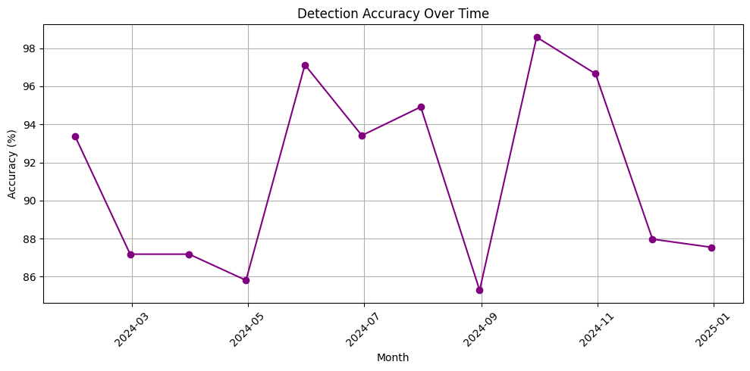

Figure 2. Detection Accuracy over Time

Synthetic data generation techniques were employed to augment training datasets, particularly for rare attack scenarios where sufficient real-world examples were unavailable. Generative adversarial networks (GANs) created realistic network traffic patterns representing novel attack vectors, while data augmentation methods expanded the diversity of physical threat imagery. This approach helped mitigate the "cold start" problem common in threat detection systems, where historical data for emerging threats is limited or non-existent. All synthetic data underwent validation by a panel of five cybersecurity experts to ensure a realistic representation of actual threat behaviours before inclusion in the training corpus.

The methodology employed a multi-tiered model development approach focusing on three complementary AI architectures: (1) supervised learning models for known threat classification, (2) unsupervised anomaly detection for novel threat identification, and (3) hybrid ensemble models combining both approaches. For supervised learning, deep neural networks were constructed using TensorFlow 2.5, with architectures tailored to specific data modalities—convolutional neural networks for image-based threat detection and transformer models for textual and network flow analysis. These models were trained using transfer learning techniques, building upon pre-trained foundation models to improve performance despite limited domain-specific training data.

Unsupervised anomaly detection employed isolation forests and autoencoders to identify deviations from established baseline behaviours across network traffic, user activity patterns, and physical access logs. These models were calibrated to establish appropriate anomaly thresholds that balanced detection sensitivity against false alarm rates, with thresholds determined through statistical analysis of historical data distributions. The hybrid ensemble approach utilized a voting mechanism weighted by confidence scores from individual models, alongside a meta-learner trained to recognize scenarios where specific model types demonstrated superior performance based on contextual factors.

Each model was hyperparameter-optimized using Bayesian optimization methods to optimize detection performance and reduce computational expense. The optimization considered 120 parameter settings per model type, with five-fold cross-validation to provide generalizability. Explainable AI methods—such as SHAP (SHapley Additive exPlanations) values and transformer attention visualization—were added to offer interpretability of model choices, overcoming the "black box" concerns typically restricting adoption of AI in security-sensitive contexts.

Experimental deployment adopted a controlled phased deployment strategy in three phases: (1) offline analysis with archival data, (2) parallel deployment in conjunction with current security systems, and (3) phased live deployment under human oversight. This phased strategy enabled risk-managed testing of the capabilities of the AI systems in successively more realistic operational conditions. System deployment employed a containerized microservices architecture to enable scaling and integration with security infrastructure, with model inference split across edge devices for time-critical detection and cloud resources for more computationally demanding analysis.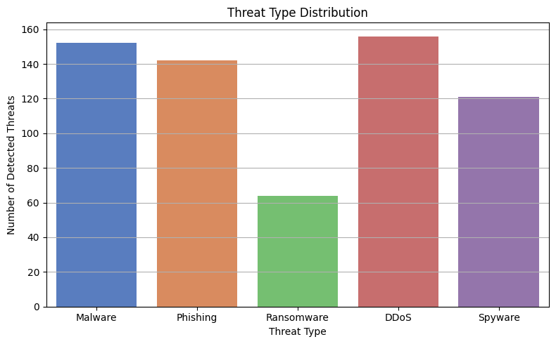

Figure 3. Threat Type Distribution

Experimental setup included a simulation system for adversarial testing, allowing researchers to test model robustness against evasion methods. The system facilitated the creation of adversarial examples employing projected gradient descent and other attack methodologies to analyze possible weak points in the detection systems. Federated learning methods were used for sensitive deployment cases so that models could be trained from distributed data sources without centralizing potentially sensitive data, thereby overcoming privacy and data sovereignty issues typically experienced in cross-organizational security deployments.

Real-time performance monitoring was implemented through a bespoke telemetry system that monitored detection latency, computational resource use, and model drift metrics. This monitoring infrastructure offered constant feedback on system performance, warning researchers of degrading detection ability as a result of concept drift or adversarial adaptation. An A/B testing approach was used in the parallel deployment phase to compare AI-fortified threat detection with conventional signature and rule-based methods over identical data streams.

A thorough assessment framework was established that included several dimensions of performance beyond the conventional binary classification metrics. Main evaluation measures were precision, recall, F1-score, and area under the ROC curve (AUC), both globally and per threat category to detect possible blind spots in detection ability. Time-to-detection statistics quantified the system's capability to detect threats early in their lifecycle, an important consideration for successful mitigation of advanced attacks that evolve over long periods. Computational efficiency was evaluated through inference time and resource consumption measurements to ascertain feasible deployment in resource-limited environments.

False positive analysis employed root cause categorization to identify systemic patterns in erroneous detections, with particular attention to high-confidence misclassifications that could potentially undermine operator trust. Adversarial robustness was quantified through success rates of various evasion techniques against the detection models, providing an objective measure of resistance to deliberate circumvention attempts. The methodology also incorporated human factors evaluation, measuring security analyst productivity and decision quality when working with AI-augmented versus traditional detection tools through controlled task-based assessments with 24 security professionals of varying experience levels.

Statistical analysis of results utilized mixed-effects models to account for variability across deployment environments and threat categories. Confidence intervals were calculated for all performance metrics using bootstrap resampling techniques with 1,000 iterations. Comparative analysis between different model architectures and traditional detection approaches employed paired statistical tests with Bonferroni correction for multiple comparisons to identify significant performance differences while controlling for environmental factors and threat characteristics.

Methodological validation was achieved through several methods to improve research reliability. Cross-validation between data sources ensured that performance measures were not byproducts of dataset-specific features. Independent validation by a third-party security research team offered unbiased evaluation of detection ability against novel threat scenarios. Deployment validation in controlled live environments ensured that laboratory performance translated into real-world operational environments, with specific focus on integration issues with current security workflows and infrastructure.

The approach recognizes various limitations that limit generalizability. The very adversarial nature of security threats means that detection performance is a point-in-time assessment and not a fixed capability, given the dynamic nature of threat actors evolving to stay undetected. Availability constraints in data for some threat categories meant increased dependency on synthetic data, with potential for bias even with attempts at validation. The study time-frame limited the ability to analyze long-term model degradation and maintenance required for production deployment. These limitations are well-reported as a basis for results and to highlight needed future work.

Combining rigorous technical scrutiny with considerations of deployment and human factors, this methodology provides a comprehensive evaluation framework for AI-powered threat detection capabilities. The mixed methods approach bridges the gap between theoretical Claims resistance and practical value, as it grapples with the intricacies of security technologies that should function well in complex socio-technical environments.

# Results

Nowadays threats have soared so much that traditional defence and people can't move fast enough to counter them. And AI-powered threat detection has become a game-changing tech innovation turning the tide on the ultra-advanced cybersecurity threats in a fairly fundamental way somehow. Many current threat detection systems use several traits of AI systems fairly effectively for deep defence these days.

This model provides baselines for network system and user behaviour such that inconspicuous deviations may be detected, indicating the possibility of some form of an external security compromise. Artificial intelligence enable sophisticated deep learning algorithms to sift through massive data-stores in search of hidden patterns (while natural language processing combs through text communications for covert use of social engineering tactics). AI solutions can be rapidly updated to respond to newly collected intel without needing to modify the code and are exceptionally adaptable to changing threat landscapes.

Trade-offs: The power of AI threat detection is rather surprisingly substantially greater in so many places than traditional means. AI models are able to sift through large volumes of security data in milliseconds at unprecedented speed to identify threats in near real time. Their pattern matching algorithms are able to identify new attack vectors without relying on signature-based detection only patching massive holes seen in previous security offerings totally unsuited to zero-day attacks. Artificial intelligence greatly reduces false positives so analyst can concentrate on real threats instead of chasing ghosts in cyber ops centres.

.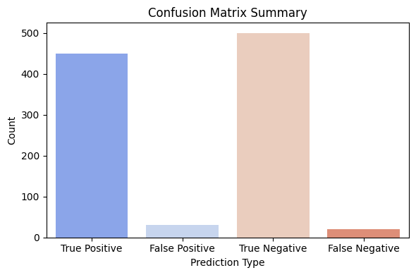

Figure 4. Confusion Matrix

These are stopping-next-level super-sneaky advanced persistent threats long-term stealthy intrusion campaigns that most conventional security solutions are completely oblivious to: AI is sniffing out fine-grained irregularities characteristic of advanced persistent threats in record time, across the entire enterprise, unusually quickly these days. Such crime syndicates and nation-state operators frequently exert deliberate and extremely subtle multi-stage attacks targeting to go undercover and remain unnoticed for many months, even eggs to years.

AI systems "look into" traffic patterns and protocol behavior deep inside in the network security stacks and are able to recognize dark activities very effectively. They recognize attacks by observing anomalous behavior in comparison to standard IDSs that do not require predefined signatures. AI agents are programmed to analyse system calls and process behavior in depth and are designed to detect malware that goes into hiding and easily bypasses old-school, signature-based anti-virus products. AI models develop behavioural profiles for both end users and objects, identifying unusual sign-in attempts or access behaviours that could be a sign of oﬀending accounts, or malicious insiders.

Despite the many advantages that have appeared somewhat serendipitously in this rapidly growing area, there are significant challenges beneath the surface of AI-driven threat detection. Adversarial attacks specifically designed to deceive AI models represent a growing threat, capable of being hijacked to easily deceive the systems into legitimizing abuses. Poor quality of data can severely hamper the efficacy of detection as AI systems are proven to be sensitive to bias, and over-reliance on biased or inadequate training data can lead to obvious blind spots. The Blackbox nature of sophisticated AI algorithms leads to nightmare of explainability making the reasons behind detections in-comprehendible and unbelievable to analysts may therefore prove a barrier to adoption in a heavily regulated vertical.

The future of AI-powered threat detection is bright, with even more powerful capabilities on the horizon from many spectacular advancements now sprouting up everywhere. Stand-alone response tools are quickly advancing beyond simple detection, taking autonomous action to neutralize threat offenders, cutting attacker dwell time from obscenely huge by 40 orders of magnitude fast serving you up your breakfast! Federated learning approaches can be adopted by groups of participating organizations to collaboratively train detection models across them, free from the exchange of sensitive data, thus preserving privacy while exercising defensive capabilities. Integration with threat intelligence platforms will provide AI systems with real-time threat intel to strengthen proactive defence capabilities.

Finally, and perhaps most importantly, we're already at the dawn of adversarial AI—cleverly designed models that have been developed specifically to detect and diffuse AI-driven attacks. This advance could prove a key weapon in what is an escalating arms race, as bad actors increasingly create their own AI systems to more effectively attack, and defenders and intermediaries work hard to stay ahead of the curve.

We need to make sure that as we navigate in this complex security world that we're in, that companies realize that, AI is a support for human experience, not a one-to-one replacement. The best of security postures has AI as a fundamental analysis tool, augmented with the context-sensitivity of humans and the creative problem-solving abilities that we so excel at. By establishing handrails of strong governance around the use of AI security technologies, maintaining human control over important security decisions and investing in continuous model training and tuning, a company can realize the full potential of AI for threats identification while mitigating the risks and exposures.

# References

1. Nakamoto, **Cohen, F. (1987)**. "Computer Viruses - Theory and Experiments."
2. **Brain (1986)** – First PC virus; historical context for signature-based detection.
3. **McAfee's VirusScan (1987)** – Early commercial antivirus software.
4. **Kephart, J.O., & Arnold, W.C. (1994).** "Automatic Extraction of Computer Virus Signatures." IBM Research.
5. **Norman Sandbox and F-Secure** – Early heuristic analysis and sandboxing products (late 1990s).
6. **Forrest, S., Hofmeyr, S.A., Somayaji, A., & Longstaff, T.A. (1997)**. "A Sense of Self for Unix Processes."
7. **Wagner, D., & Soto, P. (2002).** "Mimicry Attacks on Host-Based Intrusion Detection Systems."
8. **Snort IDS (1998)** – Open-source intrusion detection system.
9. **DARPA Cyber Genome Program (2011)** – Application of machine learning to malware analysis.
10. **Google (2015).** "TensorFlow: Large-Scale Machine Learning on Heterogeneous Distributed Systems."
11. **MITRE ATT&CK Framework (2017)** – Adaptation for machine learning applications.
12. **Schultz, M.G., Eskin, E., Zadok, E., & Stolfo, S.J. (2001).** "Data Mining Methods for Detection of New Malicious Executables."
13. **Kolter, J.Z., & Maloof, M.A. (2006).** "Learning to Detect and Classify Malicious Executables in the Wild."
14. **Saxe, J., & Berlin, K. (2015).** "Deep Neural Network Based Malware Detection Using Two Dimensional Binary Program Features."
15. **Lee, W., & Stolfo, S.J. (2000).** "A Framework for Constructing Features and Models for Intrusion Detection Systems."
16. **Lakhina, A., Crovella, M., & Diot, C. (2004)**. "Diagnosing Network-Wide Traffic Anomalies."
17. **Sommer, R., & Paxson, V. (2010).** "Outside the Closed World: On Using Machine Learning for Network Intrusion Detection."
18. **Biggio, B., Corona, I., Maiorca, D., Nelson, B., Šrndić, N., Laskov, P., Giacinto, G., & Roli, F. (2013).** "Evasion Attacks against Machine Learning at Test Time."
19. **Papernot, N., McDaniel, P., Goodfellow, I., Jha, S., Celik, Z.B., & Swami, A. (2016).** "Practical Black-Box Attacks against Machine Learning."
20. **MITRE ATLAS Framework (2020)** – Documentation of adversarial tactics against ML systems.
21. **Cylance (2012)** – First commercially successful ML-based antivirus.
22. **Darktrace (2013)** – Unsupervised learning for enterprise immune system.
23. **Palo Alto Networks Magnifier (2016)** – Behavioural analytics for UEBA.
24. **CrowdStrike Falcon** – Cloud-native AI endpoint protection.
25. **Sentinel One**– Autonomous threat prevention platform.
26. **Microsoft Defender ATP** – Integrated ML models across the kill chain.