DIGITAL AND TELEMEDICINE APPLICATION IN DIAGNOSTIC MICROBIOLOGY

Roshini Youvaraj, Santhosh Manikandan Kumaravel

Department of Optometry, Inlife Institute of Vision Science and Management, Coimbatore,

Tamil Nadu, India.

E-mail: roshiniyouvaraj@iivm.in

AI-Driven digital diagnostics and online diagnostic tools

ABSTRACT

   Technological advancements have created significant opportunities for improving healthcare, especially through telemedicine and artificial intelligence (AI). These innovations have enhanced the speed and scope of medical interventions, particularly in rural areas,

where access to healthcare is often limited. In eye care, conditions like glaucoma and retinal diseases, if left untreated, can lead to permanent blindness. Early diagnosis is crucial for preventing such outcomes. Screening programs in rural communities, combined with digital diagnostic tools and AI, can significantly improve early detection and intervention. These technologies allow for remote consultations and screenings, making it possible to reach

underserved populations more effectively. AI can assist in analyzing diagnostic data, ensuring timely identification of at-risk individuals. With increased awareness and early detection facilitated by digital tools, the impact of preventable blindness in rural areas can be

minimized, ultimately enhancing eye health outcomes.

1.Introduction of AI in ocular diagnostics

Artificial Intelligence is a most recent developing computer system helping human inteligence in different perspectives like analyzing, recognition, diagnosing and helping in the progression of varied industries. Its advanced and quick developing system is playing a high significant role in medical and laboratory industry (Angelica C. Scanzera a, 2022). In healthcare ,AI is serving a crucial role on screening, management and patient triage (Reid & Eaton, 2019). Most of the AI algorithms have been described for analysis in retinal diseases like diabetic retinopathy, Age related macular degeneration, retinopathy of prematurity, retinal vascular occlusion and retinal detachment and also can be used for describing the condition like glaucoma , Keratoconus, cataract, refractive error, Intraocular lens power calculations and strabismus correction surgeries (J Akkara, 2019)

2. Screening ocular conditions with AI and Telemedicine

Telemedicine is the application of communication and information technologies in the health care system between participants in different location (zva, 2020). The establishment of telemedicine can drastically reduce the risk of infection of all the out patient. Some of the features that are available in telemedicine are like telecooperation, teleconsultation, teletherapy, telemonitoring, teleconference, telediagnostics and telemedical emergency (R Gerbutavicius, 2020)

3. AI intelligence and its mechanism

AI technology tries to replicate the ability of cognitive task that are associated with human brain. The enormous technical development of the four factors of Big data, storage and computer power and Global networking on the internet could be branch of deep learning develop (Burgess, 2017). The representation layers which can comprise multitude of successive representation. The learning of these representation layers helps to create a network called as neural network. The deep learning learning models do not replicate the brain’s capacity but it forms a foundation of mathematical framework for learning the representations (Chollet, 2018)

4. Deep learning and examinations of ocular conditions

1. Glaucoma evaluation

The structural and functional damage of the optic disc in any glaucoma patients can be detected using OCT [Optical coherence tomography] and digital fundus photography. The main drawback that was found that no significant data were found to compare the intensity of the condition and it directly depends on the expertise of the practioners (B Al-Bander, 2017)

The DL algorithm for the detection of referable glaucomatous optic neuropathy [GON] based on fundus photography .It is shown that deep learning algorithm can detect the glaucomatous change with high sensitivity and specificity , 95.6% and 92% respectively (Z Li, 2018) . Later on the optic disc and blood vessel evaluation served as an important factor for determining the glaucoma status hence the vertical cup disc ratio is estimated from the topographic distributions of hemoglobin and so called Glaucoma discriminant function [GDF] is used to calculate a risk score of glaucoma (NYQ Tan, 2020)

1. Age related macular degeneration and diabetic retinopathy evaluation

The typical sign of ARMD or Diabetic retinopathy is considered to be accumulation of extracellular deposits between RPE and Bruch’s membrane. The presence of hard or soft drusens are not only seen in ARMD but also seen in other retinal leisions. Thus the development Fundus based DL algorithms bases on the age related eye disease study [AREDS] were developed . A deep learning system was built which used AREDS data to develop its system and used Augsburg data set which consist 5555 fundus images of humans above 55 age group to develop collaborative health research (Grassmann, 2018). A study that performed the effectivity of this algorithm concludes that the system performs comparably to human experts when DR and ARMD are detected simultaneously (González-Gonzalo, 2019)

5. Recent advancements in Diabetes retinopathy examination

World wide patients with diabetic melitus , 75% live in low and middle income countries (K Ogurtsova, 2017). In this scenario, reaching out tertiary and secondary eye centres and early sign detection becomes more difficult to the most common population. Recent advancements in technologies helps rural population in suspecting early diabetic changes in eye and appropriate management can help them to prevent permanent vision loss or retain their functional vision. The technologies like stable , classic non-mydriatic fundus cameras , mobile classic non mydriatic fundus cameras , mobile on vehicle hand mounted diagnostics sets , ultra wide field diagnostic sets, OCT , Portable fundus cameras , smartphone based retinal imaging were used to screen the rural places (Grzybowski, 2021).

6. Recent advancements in microscopy

Recently tremendous advancements has been launced in biomedical field. The traditional microscopes were bulky , lack communication capabilities and require more trained professionals to handle and interpret. Instead new technologies like compact 3D- printed devices intergrated with internet things IoT for data sharing and cloud computing as well as automated image processing using deep learning algorithms, can address these limitation and enhance the conventional imaging work flow (Alessandro MolaniORCID, 2024). In Ophthalmic diagnosis Smart phone microscopy is much more effective and recommended instead of traditional scans for its more instance and cost effective.

7. Advancements in Ophthalmology screening and diagnostics

Earlier rural screening and diagnosis were time consuming and had lot of challenges to overcome and in many condition patients may also lose their vision due to these shortcomings (Fenner, Wong, Lam, Tan, & Cheung, 2018). The use of IoMT and cloud technology can make a positive impact remote patients monitoring and early symptom detection.Technologies like ophthalmic fundus cameras attached to smart phones and lens adaptors can used intergrated with AI features to give an instant report of the diagnosis (Maamari, Keenan, Fletcher, & Margolis, 2014).

8. Diabetic retinopathy screening with AI:

Diabetic retinopathy serves to be leading causes of irreversible blindness in working – age population, and detecting it in earlier stages of life plays a crucial role in preventing the loss of productivity in a mid age life. The integration of retinal grading offline AI into the smart imaging system has significantly impacted. The two core component of the system includes an algorithm checks the quality of the image and second DR assessment mechanism generates detecting DR lesions (Sundaram Natarajan, Astha Jain, Radhika Krishnan, Ashwini Rogye, & Sobha Sivaprasad, 2019).

9. Glaucoma Investigation with AI :

The teleoptometric examination used a 14-second Reichert slit lamp video recording to evaluate the anterior segment and the Eidon ultra-widefield retinal photographer to evaluate posterior segment. DFE was completed with 90D biomicroscopy and binocular indirect ophthalmoscopy. Intraocular measurements were taken via non-contact tonometry by an in-person technician for telehealth examination and secondary centers were using Goldmann applanation tonometry for more precision (Sanghera, 2023)

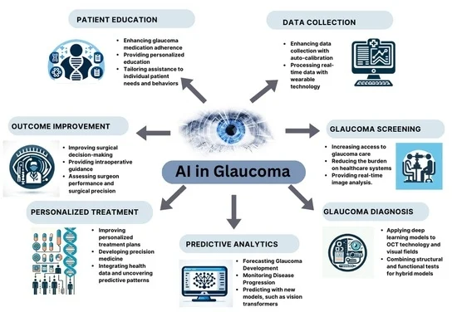

FIG:1 AI IN GLAUCOMA

7. Myopia Management Through Digital Tools

Myopia, or nearsightedness, has become increasingly prevalent across the globe, particularly in children, and digital tools are playing an essential role in managing this condition. One of the most exciting advancements is the integration of artificial intelligence (AI) into myopia care. AI is now being used to analyze vast amounts of data, such as refraction and axial length measurements, to predict how myopia will progress in individual patients. This allows eye care professionals to intervene early, providing personalized treatment options and strategies to slow or even stop myopia's progression. AI is helping practitioners make more accurate predictions about how myopia will evolve, which is especially valuable for managing childhood myopia, where early intervention can make a big difference (Xu et al., 2023).

In addition to AI, specialized devices like the OCULUS Myopia Master® are helping optometrists monitor and manage myopia more effectively. These tools combine multiple important measurements—like refraction, axial length, and keratometry—into one platform, offering a clearer picture of myopia’s progression. With such detailed information, clinicians are better equipped to recommend interventions like orthokeratology, atropine, or multifocal lenses. These technologies streamline the diagnostic process and improve the accuracy of treatment decisions, making it easier to stay on top of myopia management (Oculus, 2022). Platforms like the BHVI Myopia Calculator are also helping practitioners evaluate the long-term benefits of various treatments, guiding them toward the most effective options for their patients (Bennett et al., 2022).

Digital tools are also transforming how eye care professionals keep up with the latest research and clinical techniques. Platforms such as Myopia Profile provide a wealth of resources, including educational courses and updated research summaries, allowing optometrists to stay informed about the latest advancements in myopia management. By offering tools and support for personalized patient care, Myopia Profile fosters a global community of practitioners dedicated to addressing the rising rates of myopia. These innovations are paving the way for more effective, data-driven, and personalized approaches to managing myopia, ultimately leading to better outcomes for patients around the world (Myopia Profile, 2023).

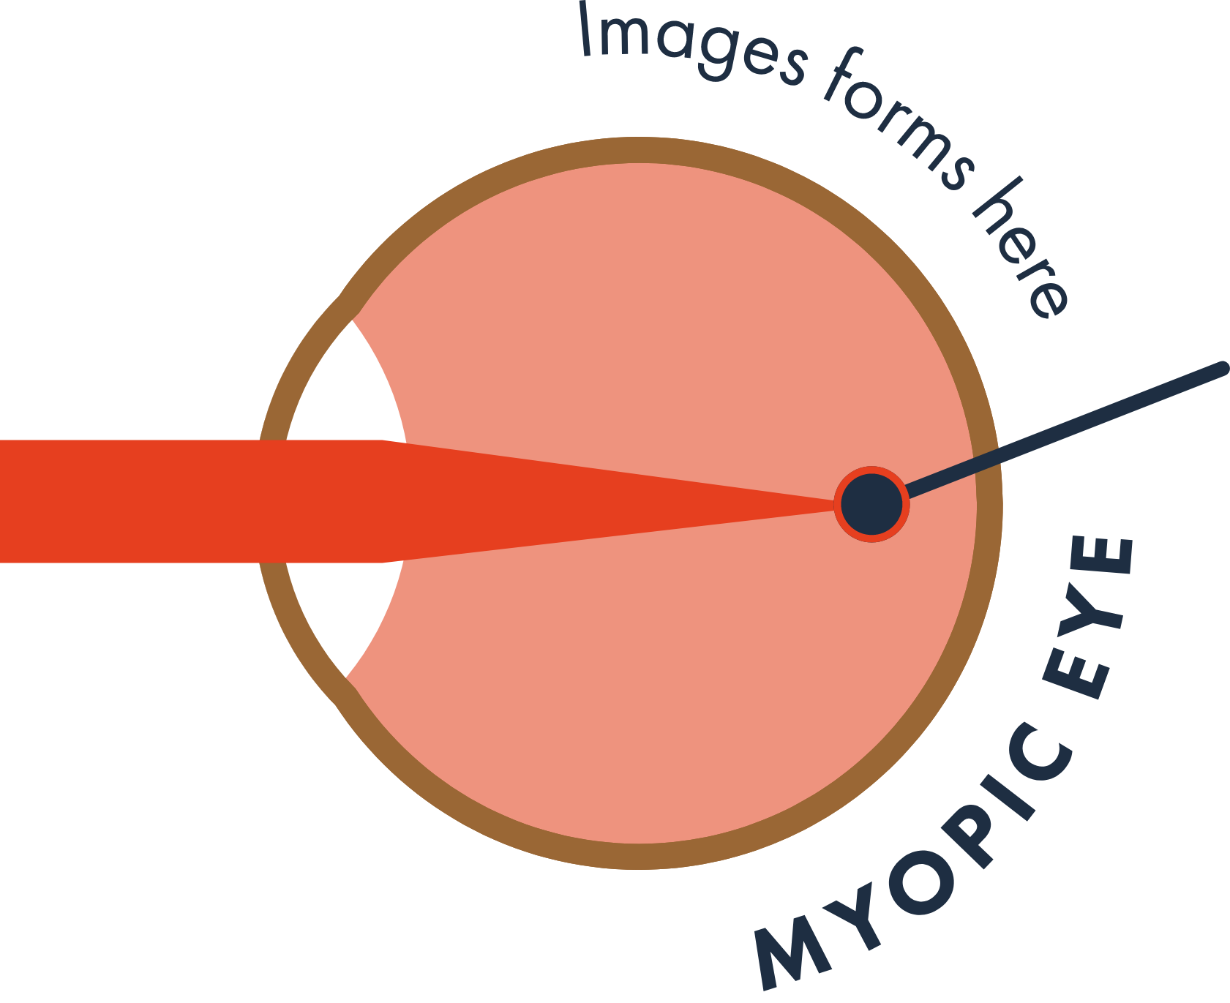

FIG:2 IMAGE FORMATION IN MYOPIC EYE

### **Collaborative Care with AI and Teleoptometry**

The fusion of artificial intelligence (AI) and teleoptometry is transforming how eye care professionals collaborate to manage patients' health. AI has enabled a seamless exchange of information between optometrists, ophthalmologists, and primary care providers, creating a more efficient and coordinated approach to patient care. Through AI-powered teleoptometry platforms, practitioners can share data, receive AI-driven diagnostic recommendations, and consult with specialists—all in real time. This collaboration improves decision-making by offering precise insights into complex eye conditions such as glaucoma or diabetic retinopathy. By streamlining the process, AI and teleoptometry help ensure that patients, even those in remote or underserved regions, receive timely, effective eye care (Dastgheib et al., 2021).

Teleoptometry has been a game-changer in expanding access to eye care, particularly for patients who may otherwise face long wait times or have difficulty traveling to see a specialist. With remote eye exams and the use of high-resolution imaging, practitioners can diagnose conditions like macular degeneration, cataracts, or refractive errors from a distance. This technology allows patients to be seen by experts, no matter where they are, and fosters better collaboration among healthcare providers. The combination of AI and telemedicine makes it possible for multiple professionals to engage in a patient’s care simultaneously, improving the speed and accuracy of diagnoses while also making healthcare more accessible (Aldrich et al., 2022).

Furthermore, AI and teleoptometry are allowing for more personalized and proactive care. AI algorithms can predict how certain eye conditions will progress, helping clinicians tailor treatment plans specifically to each patient’s needs. For example, AI can recommend particular lenses for controlling myopia or suggest interventions for managing dry eye syndrome based on individual health data. These platforms often integrate with electronic health records (EHRs), enabling easy sharing of patient information across multiple providers. This seamless communication ensures that patients receive care that is not only accurate but also fully customized to their unique needs, ultimately leading to better long-term outcomes (Hwang et al., 2023).

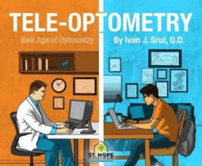

FIG:3 DIFFERENCE OF TRADITIONAL SETUP AND TELEMEDICINE

CONCLUSION

               In conclusion, technological advancements, particularly in telemedicine and artificial intelligence, have revolutionized healthcare delivery, especially in underserved rural communities. These innovations have not only increased the accessibility of medical care but also enhanced the effectiveness of early diagnosis and intervention, especially in critical areas like eye care. By leveraging digital diagnostic tools and AI, healthcare providers can offer timely screenings and consultations, ensuring that conditions such as glaucoma and retinal diseases are detected and treated early. As a result, these technologies hold the potential to significantly reduce the incidence of preventable blindness, improving the quality of life for individuals in rural areas. Ultimately, the integration of these advancements into healthcare systems can transform the future of eye care, making it more accessible and efficient, while also contributing to the overall improvement of public health outcomes.

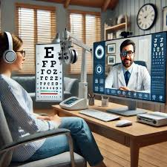

FIG:4 ADVANCED OPTOMETRY FIELD

# Bibliography

Alessandro MolaniORCID, F. P. (2024). *Advances in Portable Optical Microscopy Using Cloud Technologies and Artificial Intelligence for Medical Applications.* MDPI.

Angelica C. Scanzera a, E. S. (2022). Optometrist's perspectives of Artificial Intelligence in eye care. *ELSEVIER*, s91-s97.

Bennett, A. G., et al. (2022). The BHVI Myopia Calculator: Bridging Research and Clinical Application. Bennett Research Institute of Vision.

B Al-Bander, W. A.-N.-T. (2017). *Automated glaucoma diagnosis using deep learning approach .*

Burgess, A. (2017). *[BOOK] The Executive Guide to Artificial Intelligence: How to identify and implement applications for AI in your organization .* springer.

Chollet, F. A. (2018). *Deep Learning mit R und Keras: Das Praxis-Handbuch von den Entwicklern von Keras und RStudio.*

Dastgheib, K., et al. (2021). AI in Teleoptometry: Enhancing Collaborative Care for Remote Eye Health Management. Journal of Telemedicine and Telecare, 27(3), 145-152.

Fenner, B., Wong, R., Lam, W.-C., Tan, G., & Cheung, G. (2018). *Advances in Retinal Imaging and Applications in Diabetic Retinopathy Screening: A Review. Ophthalmol.*

González-Gonzalo, C. S.-G.-M. (2019). *. Evaluation of a deep learning system for the joint automated detection of diabetic retinopathy and age-related macular degeneration.*

Grassmann, J. M. (2018). *HTML] A deep learning algorithm for prediction of age-related eye disease study severity scale for age-related macular degeneration from color fundus photography .* Ophthalmology.

Grzybowski, J. P. (2021). *The Role of Telemedicine, In-Home Testing and Artificial Intelligence to Alleviate an Increasingly Burdened Healthcare System: Diabetic Retinopathy.*

J Akkara, A. K. (2019). *Role of artificial intelligence and machine learning in ophthalmology.* Kerala J Ophthalmol, .

K Ogurtsova, J. d. (2017). *IDF Diabetes Atlas: Global estimates for the prevalence of diabetes for 2015 and 2040 .*

Maamari, R., Keenan, J., Fletcher, D., & Margolis. (2014). *T.P. A Mobile Phone-Based Retinal Camera for Portable Wide Field Imaging.*

Myopia Profile. (2023). Myopia Management Tools for Eye Care Professionals. Retrieved from

NYQ Tan, D. F. (2020). *Glaucoma screening: where are we and where do we need to go? .* Current opinion in ophthalmology.

R Gerbutavicius, U. B. (2020). *Evaluation of patient satisfaction with an ophthalmology video consultation during the COVID-19 pandemic R Gerbutavicius,.*

Reid, J. E., & Eaton, E. (2019). Artificial intelligence for pediatric ophthalmology. *Lippincott*.

Sanghera, N. k. (2023). *The Validity of Ocular Health Testing in Tele-Optometric Eye Examinations in a Young Adult Population.*

Sundaram Natarajan, M., Astha Jain, M., Radhika Krishnan, M., Ashwini Rogye, B. O., & Sobha Sivaprasad, F. (2019). *Diagnostic Accuracy of Community-Based Diabetic Retinopathy Screening With an Offline Artificial Intelligence System on a Smartphone.* JAMA ophthalmology.

Oculus. (2022). Myopia Master: Integrating Key Parameters for Comprehensive Myopia Managemen

Z Li, Y. H. (2018). *Efficacy of a deep learning system for detecting glaucomatous optic neuropathy based on color fundus photographs .* Ophthalmology.

zva. (2020). *Arbeits- und Qualitätsrichtlinien für Augenoptik und Optometrie. 8th ed.,.*

Xu, J., et al. (2023). Artificial Intelligence Applications in Myopia: Current Progress and Future Directions. Journal of Vision Science, 17(2), 156-167.