**Effect of isovalent ion (Co2+) substitution on Structural Properties of ZnFe2O4**

**Gulab Singh1, AjazHussain2 ,Avinash Chand Yadav3, Pravin kumar4, Pradip Kumar Priya2**

1Department of Physics, Feroze Gandhi College, Raebareli -229001, UP, India

2Department of Physics, Ewing Christian College, Prayagraj -211002, India

3Department of Physics S G N Government P G College Muhammadabad Gohana Mau-276403 UP, India

4College of Technology, SardarVallabhbhai Patel University of Agriculture and technology Meerut -250110 (U.P) India

**Abstract**

This work investigates the synthesis of cobalt doped zinc ferrite (Co-doped ZnFe2O4) nano-composite materials via solution-gelation method followed by auto combustion process using nitrate precursors. The fabricated composite samples were characterized by X-ray diffraction (XRD) for their structural exploration. Furthermore Match3! and VESTA softwares were employed for the insight observations and structural possessions of synthesized Co-doped ZnFe2O4 nanomaterials.

**Keywords:** Zinc ferrite, Nano-composites materials, X-ray diffraction.

1. **Introduction**

In general, ferrite is a ceramic class material that includes iron oxide as a core ingredient and metallic element such as Mn, Co, Ni, Mg, and Zn in small scale [1-3]. It has been investigated that the properties of a bulk materials changes as its dimensions reduces. These significant changes are caused to an increase in surface area to volume ratio. The similar reports have been considered for the case of magnetic materials also. In recent years due to vital applications and utility of spinel ferrites like memory storage, high frequency power supply, biomedicines a number of ways have been found to synthesis and investigate for their functional applications in information storage systems, sensors, actuators, magnetic fluid, microwave absorbers and medical diagnostics. Therefore, much attention has been focused on the preparation and characterization of spinel ferrites [4, 5]. The spinel structure is abbreviated in form of AB2O4, where A and B are tetrahedral and octahedral interstitial sites respectively. Spinel structure possess a big unit cell which is made up of 8 small unit cells having face centered cubic structure with tetrahedral(A) site and octahedral(B) site in each. There are 64 A sites and 32 B sites in total and 32 oxygen atoms form a unit cell of closed packed structure [6]. In spinel ferrites A is represented by divalent metal ions like Mn2+,Co2+,Ni2+, Mg2+,Cd2+ etc. and that of B by Fe3+ ions. In Mn-Zn ferrites Zn2+ ions located on A sites while Mn2+ and Fe3+ ions could be positioned on B sites. Basically, zinc ferrite adopts the normal spinel group possessing no net magnetic moment by its unit cell due to d0[Zn2+] and d5,d5[Fe3+,Fe3+] while on the other hand manganese ferrite belongs to inverse spinel group in which two magnetic sub lattices are antiferromagnetically aligned[7].

1. **Experimental section**

**2.1. Material synthesis process**

A series of the system MnxZn(1–x)Fe2O4(for x=0.0, 0.1, 0.2, 0.3) was synthesized via solution-gelation method followed by auto combustion using nitrate precursors. Metal nitrates were utilized as starting chemical regents, Ferric nitrate Nona hydrate [FeN3O9.9H2O] 98+% (metals basis) crystalline from Alfa Aesar, Zinc nitrate hexahydrate [Zn(NO3)2.6H2O] 99% (metals basis) crystalline from Alfa Aesar, Manganese(II) nitrate tetra hydrate [Co(NO3)2.4H2O]98% (metals basis) crystalline from Alfa Aesar and citric acid Anhydrous[C6H8O7.H2O] 99.8% Fizmerk India, for the synthesis of Co-Zn ferrite nanomaterial. The Mn-Zn ferrites nano particles were synthesized by solution-gelation methods followed by auto combustion. In this process, a mixture of [Fe(NO3)3.9H2O], Mn(NO3)2.6H2O, Zn(NO3)2.6H2O salts were dissolved in 100 ml de-ionized water for distinct composition and 6.3042gm of citric acid was added as a fuel to manage the ratio of the fuel to the oxidizer *ϕ* = 1.35[8]. The prepared mixture was stirred in beaker on hot plate for two hours at 80 0C to get a homogeneous solution. The pH was maintained up to 7 by adding drop wise the ammonia solution (NH4OH). Further the temperature of the hot plate was increased to 235-240 °C and prepared solution was gradually evaporated and transformed into gel form. Later this gel was auto ignited and converted into ash powder. After cooling at normal temperature, the ash formed was ground using agate mortar and pestle to obtain homogeneous mixing of powder sample. The powder was calcined in furnace at 600 °C for 4 hours.

**2.2 Characterizations**

The X-ray diffraction patterns of system MnxZn(1–x)Fe2O4 (for x=0.0, 0.1, 0.2, 0.3) were recorded at room temperature employing Miniflex II, Rigaku, Japan with Cu-Kα radiation (λ≈1.5406 A0 , 20° ≤ 2θ ≤ 80° and step size of Δ2θ=0.02˚) and Ni filter at a scanning rate of 2°C/min. Further all these structures were optimized using crystallography open database and Material Project**.** VESTA software (OpenGL version: 3.3.0, Tsukuba, Japan) was utilized for simulation studies**.** Additionally, Match3! software was utilized for theoretical studies of the polycrystalline composite system**.**

**3. Results and Discussion**

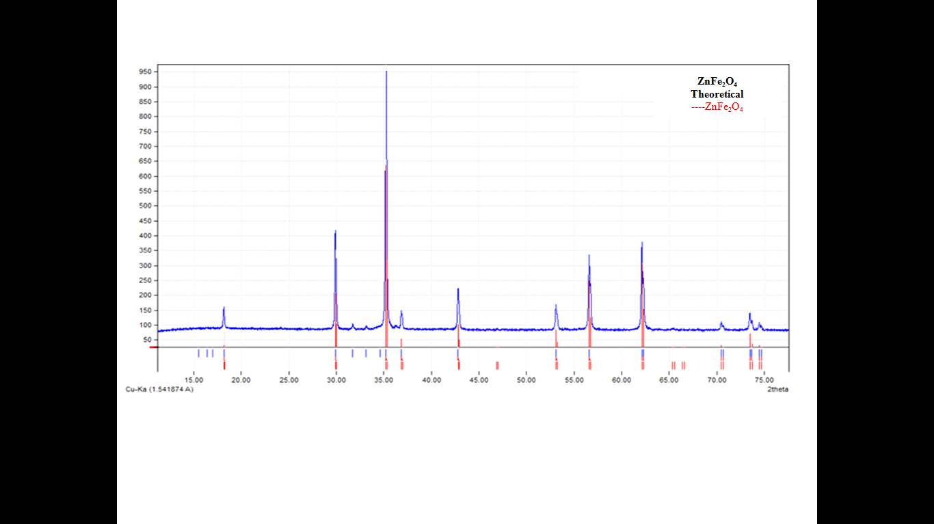

Figure 1. Theoretical XRD pattern of ZnFe2O4

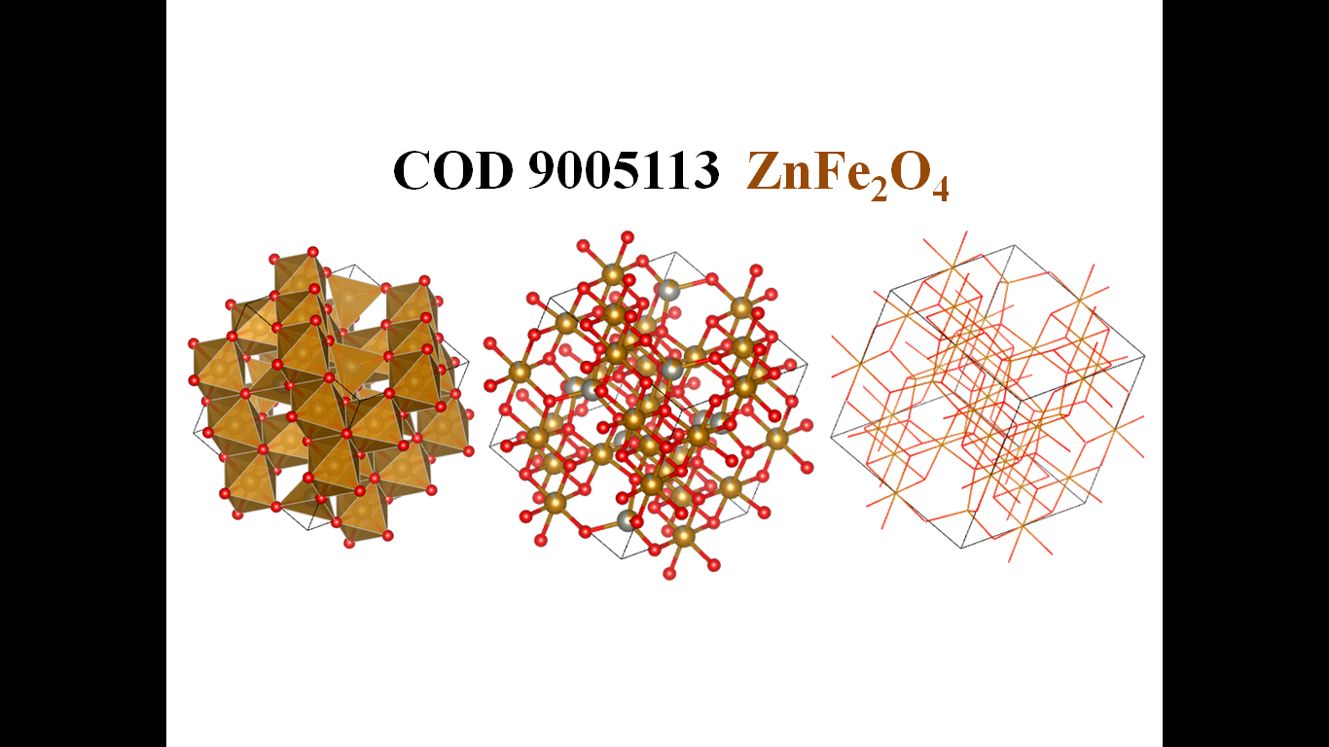

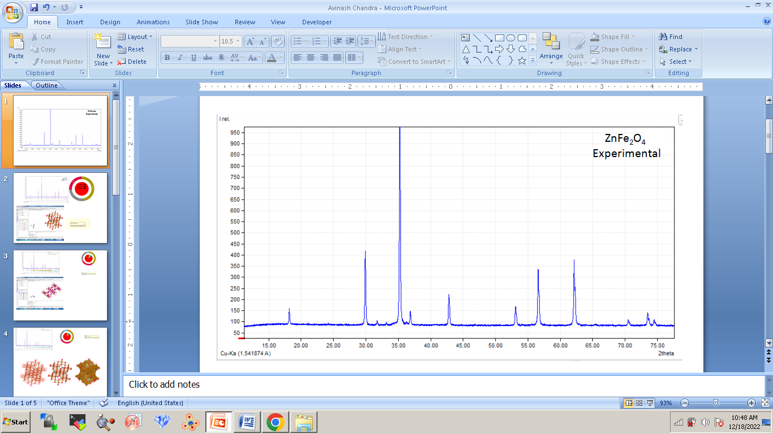

Figure 2. Experimental XRD pattern of ZnFe2O4

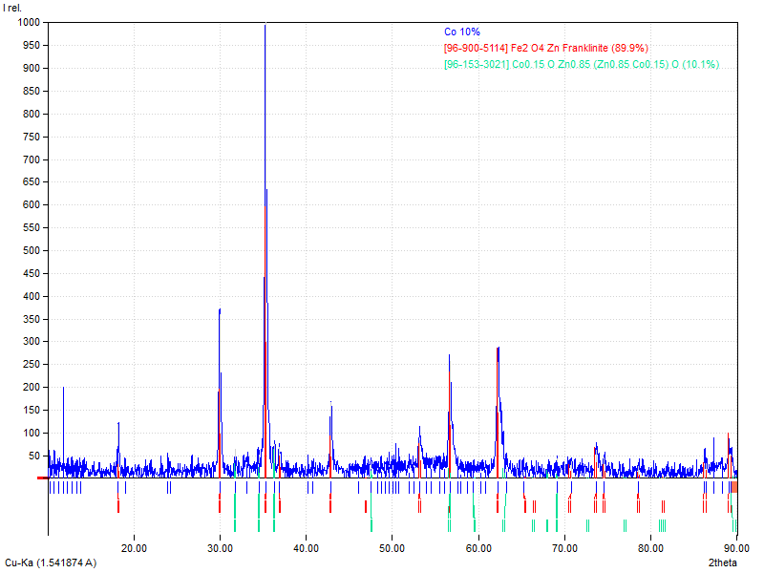

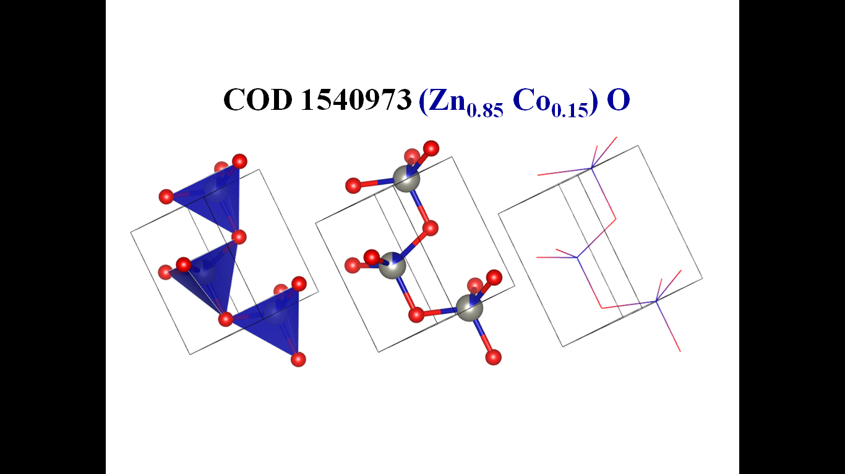

Figure3. Theoretical XRD pattern of 10% Cobalt in ZnFe2O4

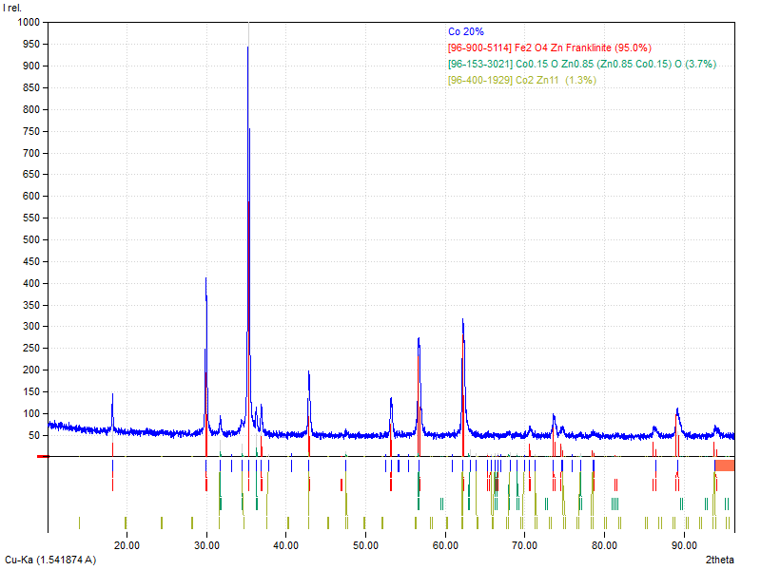

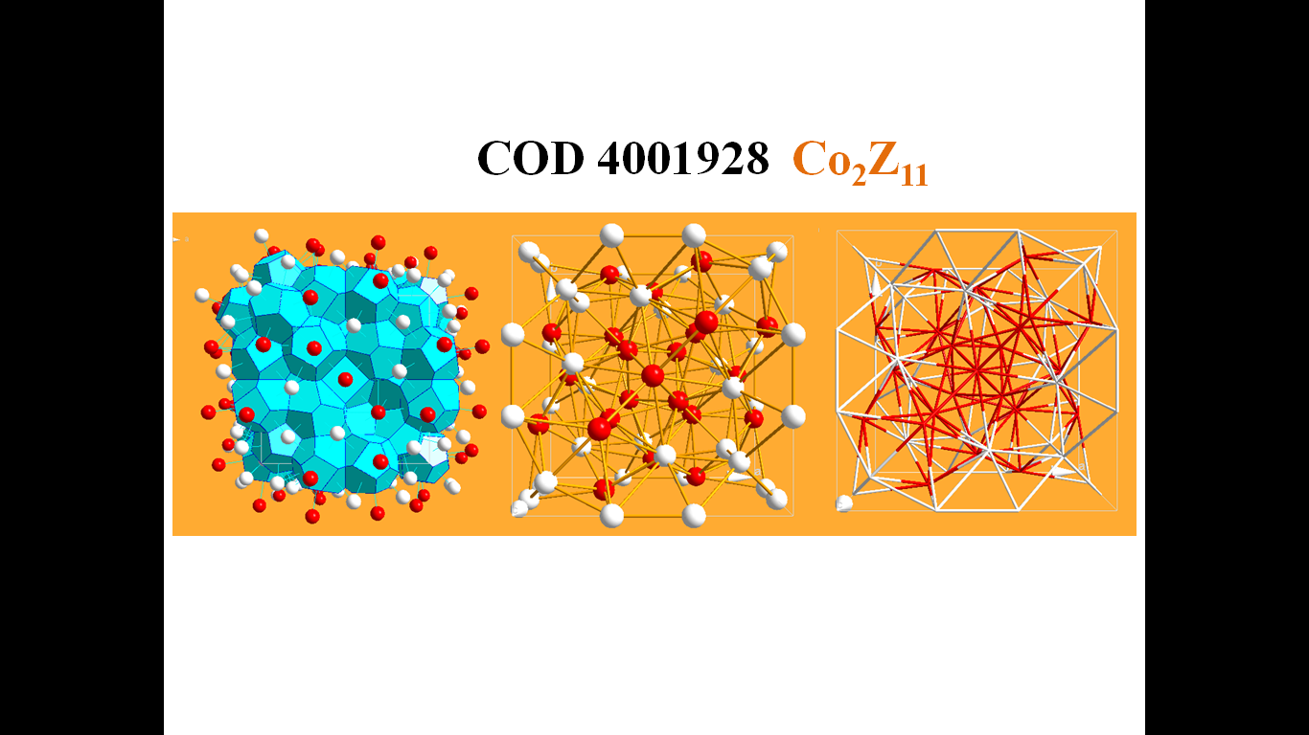

Figure4. Theoretical XRD pattern of 20% Cobalt in ZnFe2O4

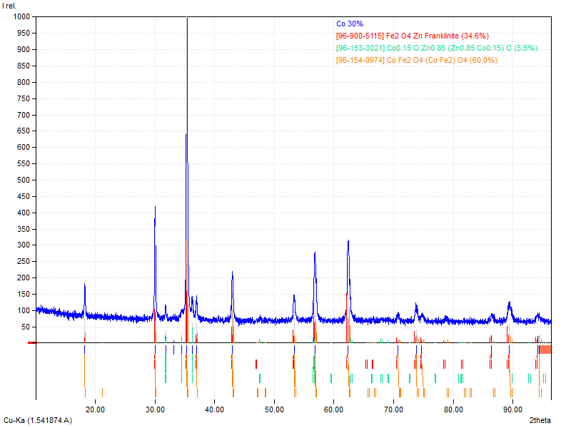

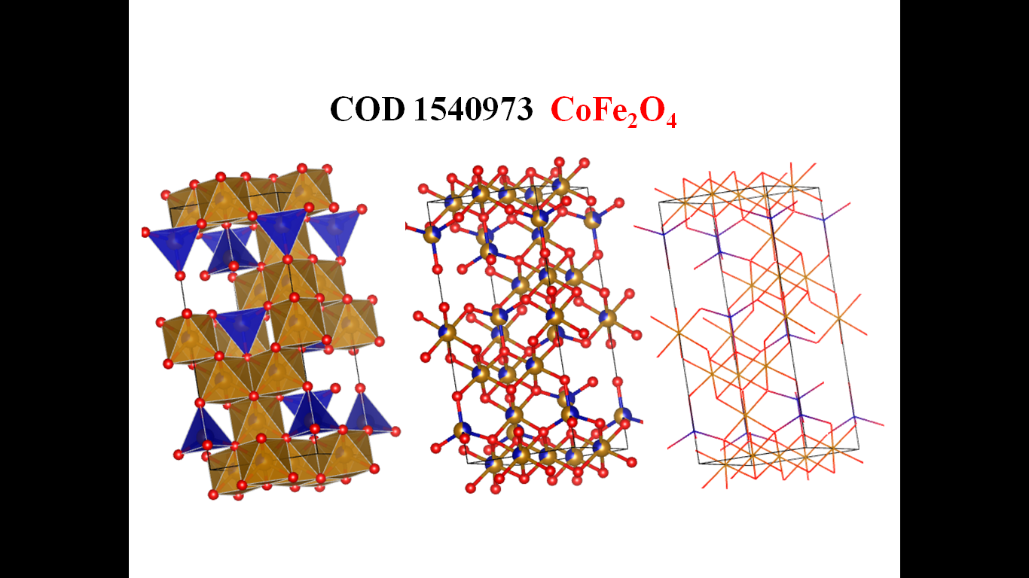

Figure5. Theoretical XRD pattern of 30% Cobalt in ZnFe2O4

The structural breakdown of ZnFe₂O₄ and the consequence of Co2+ substitution divulge noteworthy changes in the material's crystallography, leading to distinguished transformations in its properties. The investigations employed theoretical simulations by using crystallographic databases and the software tools such as VESTA, Match3!, and Material Project, to forecast the arrangement of the synthesized material[9-13]. These foresights were then compared with the experimental X-ray diffraction (XRD) results to confirm the integrity of the synthesized phases.

The uncontaminated ZnFe₂O₄ sample exhibited the cubic spinel configuration with an F-type lattice and having the space group of Fd-3m, which corresponds to the space group number 227. The lattice parameters were traced as a = b = c = 8.4420 Å, having the unit cell dimensions approximately 601.66 Å3. The experimental XRD patterns illustrated admirable consistency with these theoretical values, validating the single-phase development of ZnFe₂O₄ and confirming that the synthesis progression produced a disciplined crystal arrangement.

As cobalt ions were instigated into the ZnFe₂O₄ constitution in incremental extent of 10%, 20%, and 30%, the lattice underwent extensive structural adjustment. These alterations first and foremost resulted from the difference in ionic radii amid Zn²⁺ and Co²⁺, leading to the surfacing of new phases and amendment in crystallographic parameters. At a doping level of 10% Co, a minor hexagonal Zn0.85Co0.₁₅ phase was detected, with a space group of P63mc and unit cell parameters of a = b = 3.2538 Å and c = 5.2044 Å. While the primary ZnFe₂O₄ phase remained intact, the appearance of this secondary phase indicated that a portion of the cobalt ions successfully replaced zinc within the spinel structure, introducing a slight disruption to the material's original symmetry.

Further increasing the Co substitution to 20% led to the formation of two additional minor phases: Zn0.85Co0.₁₅ and Co₂Zn₁₁. The Co₂Zn₁₁ phase exhibit a cubic structure with an I-type lattice, characterized by the space group of I-43m and the unit cell dimensions were as; a = b = c = 8.9654 Å. The increase in the unit cell volume was exhibited to be approximately 720.62 Å³ which suggested that the higher cobalt doping contributed to the lattice expansion, which were most likely due to the variations in the sizes of the ionic constituents and respective bonding interactions. The emergence of these additional phases indicated the structural reconfiguration within the ZnFe₂O₄ matrix, which might significantly influence the magnetic and vibrational properties of materials.

When the cobalt replacement reached 30%, the major phase transition occurred where ZnFe₂O₄ was mostly replaced by CoFe₂O₄. The transition demonstrated that cobalt successfully replaced zinc within the crystal system, basically altering the material’s composition. The new CoFe₂O₄ phase was observed to having a trigonal structure with the lattice type R, which corresponded to space group R-3m. The lattice parameters were documentated as a = b = 5.9366 Å and c = 14.543 Å, with a unit cell volume of 443.87 Å3. Although the major ZnFe₂O₄ phase replaced the minor Zn0.85Co0.₁₅ phase, it still persisted in small amounts, suggesting that a little zinc remained inside the structure in spite of the ascendancy of cobalt.

The atomic arrangements and bonding inside the ZnFe₂O₄ exposed that the cubic spinel structure sticked to the X-Y₂-O₄ configuration, where oxygen anions engaged a distorted face-centered cubic (FCC) lattice. This configuration permitted significant interstitial space, facilitating dopant integration. Zinc ions were found to inhabited tetrahedral (A) sites, whereas iron ions were positioned at octahedral (B) sites, leading to a stoichiometric formula of [Zn²⁺]A[Fe³⁺₂]B O₄²⁻[11]. The structural amendments observed with escalating cobalt doping were attributed to transforms into Zn-O and Fe-O bonding interactions, in addition to the formation of Zn-O-Zn and Fe-O-Fe bonds, which jointly inclined the in general stability of the material[16].

The transformation of the ZnFe₂O₄ configuration due to Co substitution had major implications for the magnetic, the electronic, and the vibrational properties. The introduction of cobalt was expected to modify the material’s magnetic characteristics, mainly because, the CoFe₂O₄ is known to be more magnetically active than the ZnFe₂O₄. Phase transition examined at 30% Co substitution designated that the material might shift from a non-magnetic state /weakly magnetic state to one with pronounced magnetic activities, making it the potential candidate for the applications in the magnetic storage, the sensors, and the spintronic devices. Additionally, the structural dissimilarities caused by Co doping were about to influence the electrical conductivity and dielectric properties of the material respectively.

The emergence of new phases due to cobalt incorporation influenced the vibrational characteristics of the ZnFe₂O₄[16]. The phonon dynamics of the substance experienced alterations, potentially changing its thermal and the optical behavior. These changes could prove beneficial for applications in infrared sensing and laser technology, where defined control over vibrational modes is decisive [11, 14, and 15].

The findings of this study highlighted that Co substitution in ZnFe₂O₄ resulted in the considerable structural alterations, which leads to the development of the new phases and major phase transitions at the higher doping concentrations. These structural changes were unswervingly linked to the material’s magnetic, electronic, and the vibrational behaviors, demonstrating its potential for a wide range of serviceable applications. By fine-tuning cobalt content, the properties of the ZnFe₂O₄ could be tailored for the specific technological uses, particularly in the fields of the biomedicine, the sensors, and the advanced electronic devices. The ability to control the phase formation and the transition through doping offers exciting prospects for optimizing the performance.

1. **Conclusion**

Cobalt modified Nano zinc ferrites were synthesized via sol-gel method subsequently auto-combustion. The XRD, Match3! And VESTAwasusedas use the characterization techniques for the structural properties of the synthesized Nanoparticles. The XRD pattern reveals that the synthesized nanoparticles have a cubic spinel ferrite phase with space group *Fd3m*. The experimental XRD diffraction pattern was perfectly in agreement with simulation pattern of the composite which further confirmed the single phase formation of base materials ZnFe2O4. It was seen that some minor phases Zn0.85Co0.15 for 10 % Cobalt doping , Zn0.85Co0.15 and Co2Zn11 for 20% Cobalt doping were found along with major phase of Zinc Ferrites. When Cobalt substitution is further increased to be 30%, the major phase ZnFe2O4 was replaced by CoFe2O4. These minor phases definitely will affect the Vibrational and Magnetic properties of the synthesized nanomaterials.

**Acknowledgement**

Although we have used freely available Match3! And VESTA software but authors are sincerely thankful to the developer of Match3! And VESTA software and to make it freely available for worldwide researchers.

**References:**

1. *Sugimoto, M., The Past, Present, and Future of Ferrites.Journal of the American Ceramic Society, 1999.****82****(2): p. 269-280.*

*2. Song, Q. and Z.J. Zhang, Controlled synthesis and magnetic properties of bimagnetic spinel ferrite CoFe2O4 and MnFe2O4 nanocrystals with core-shell architecture. J Am ChemSoc, 2012.* ***134****(24): p. 10182-90.*

*3. Skołyszewska, B., et al., Preparation and magnetic properties of MgZn and MnZn ferrites.Physica C: Superconductivity, 2003.* ***387****(1-2): p. 290-294.*

*4. König, U., Substitutions in manganese zinc ferrites.Applied physics, 1974.****4****: p. 237-242.*

*5. Gadkari, A., T. Shinde, and P. Vasambekar, Structural analysis of Y3+-doped Mg–Cd ferrites prepared by oxalate co-precipitation method.Materials Chemistry and Physics, 2009.****114****(2-3): p. 505-510.*

*6. LAMBEBO, T.Y., SUBSTITUTION EFFECT ON THE STRUCTURE, MORPHOLOGY, ELECTRICAL AND DIELECTRIC PROPERTIES OF. 2018.*

*7. Mazen, S., N.I. Abu-Elsaad, and A.S. Nawara, The Influence of Various Divalent Metal Ions (Mn2+, Co2+, and Cu2+) Substitution on the Structural and Magnetic Properties of Nickel–Zinc Spinel Ferrite.Physics of the Solid State, 2020.****62****(7): p. 1183-1194.*

*8. Feng, J., et al., Preparation of cobalt substituted zinc ferrite nanopowders via auto-combustion route: an investigation to their structural and magnetic properties. Journal of Materials Science: Materials in Electronics, 2018.* ***29****(21): p. 18358-18371.*

*9. Vaitkus, A., A. Merkys, and S. Gražulis, Validation of the crystallography open database using the crystallographic information framework.Journal of applied crystallography, 2021.****54****(2): p. 661-672.*

*10. Jain, A., et al., Commentary: The Materials Project: A materials genome approach to accelerating materials innovation.APL Materials, 2013.****1****(1).*

*11. Momma, K. and F. Izumi, VESTA 3 for three-dimensional visualization of crystal, volumetric and morphology data.Journal of applied crystallography, 2011.****44****(6): p. 1272-1276.*

*12. Momma, K. and F. Izumi, VESTA: a three-dimensional visualization system for electronic and structural analysis.Journal of Applied crystallography, 2008.****41****(3): p. 653-658.*

*13. Avinashi, S.K., et al., Morphological, mechanical, and biological evolution of pure hydroxyapatite and its composites with titanium carbide for biomedical applications.Ceramics International, 2022.****48****(13): p. 18475-18489.*

*14. Bohra, M., V. Alman, and R. Arras, Nanostructured ZnFe2O4: an exotic energy material.Nanomaterials, 2021.****11****(5): p. 1286.*

*15. Bohra, M., V. Alman, and R. Arras, Nanostructured ZnFe2O4: An Exotic Energy Material. Nanomaterials 2021, 11, 1286. 2021.*

*16. Y. Avinash Chand, P. R. Tiwari, G. Singh, P. Rajput, M. Kumar, and K. Santosh, "Synthesis and Characterization of Cobalt doped Zinc Ferrite for its Structural and Magnetic Properties," Asian Journal of Chemistry, vol. 35, pp. 2461-2467, 09/28 2023.*