**Formulation, Development and Evaluation of Injection of Poorly Soluble Drug ( tinidazole) using Novel Application of Mixed Solvency Concept**

**Ashish Yadav1, Rekha Birle2**

**Institute of Pharmacy Sage University Indore, Madhya Pradesh , India**

**ABSTRACT**-The objective of present research is the explore the application of mixed solvency technique in the injection formulation of poorly soluble drug and to reduce concentration of individual solubilized (used for solubility enhancement )to minimize the toxic effect of solubilized. the mixed blends in which solubility of tinidazole was more than 1 mg/ml and have much difference in their compositions were selected, such selected mixed blends were FT-5,FT-8 and F-8. To develop 2 ml of aqueous tinidazole injection and constituted dry powder tinidazole injection, the amount of solubilizers and drug that will be administered through each mixed blend was determined. In this case ,the solubility agent employed to give a desirable solubility for the poorly soluble drug may produce its own toxicity . However, if the same enhancement in the solubility can be achieved by mixing, five solubilizer (each in one fifth concentration) then the toxicity level of five solubilizer can be reduced by five fold. In case of synergistic effect in solubility due to mixing of, five solubilizer (in the fifth concentration).These formulation evaluate by UV-visible spectroscopy and IR –Spectroscopy.

**Key Words- Solubilized**, **Injection, Mixed Solvency, Tinidazole, blenzed**

**INTRODUCTION-**

The present investigation was proposed to solubilise tinidazole using combination of various physiologically compatible solubilizers. By increasing the solubility of drug, it might be possible to formulate the small volume parenteral, which will be useful in patient with status epilepticus in which parenteral administration of tinidazole may be required to achieve the required therapeutic plasma concentration rapidly.

**OPTIMIZATION OF VARIOUS PARAMETERS FOR AQUEOUS INJECTION FORMULATION OF TINIDAZOLE**

**Selection of solubilizer blend for injection formulation**

On the basis of results obtained from solubility studies, the mixed blends in which solubility of tinidazole was more than 1 mg/ml and have much difference in their compositions were selected, such selected mixed blends were FT-5,FT-8 and F-8. To develop 2 ml of tinidazole injection, the amount of solubilizers and drug that will be administered through each mixed blend was determined.

Table-1

|  |  |  |  |
| --- | --- | --- | --- |
| **S.No.** | **Ingredient** | **Formula for**  **52.2 mg/ 2ml** | **Formula for 50 ml batch** |
| 1. | Tinidazole | 52.2 mg | 1305 mg |
| 2. | Sodium benzoate | 0.2 gm | 5.0 gm |
| 3. | Ethanol | 0.1 ml | 2.5 ml |
| 4. | PEG 4000 | 0.1 gm | 2.5 gm |
| 5. | Niacinamide | 0.2 gm | 5.0 gm |

**Table-2 Formulation FT-8**

|  |  |  |  |
| --- | --- | --- | --- |
| **S.No.** | **Ingredient** | **Formula for**  **36 mg/ 2ml** | **Formula for 50 ml batch** |
| 1. | Tinidazole | 36.0 mg | 900 mg |
| 2. | Sodium benzoate | 0.2 gm | 5.0 gm |
| 3. | PEG 400 | 0.1 ml | 2.5 ml |
| 4. | Niacinamide | 0.2 gm | 5 gm |
| 5. | Ethanol | 0.1 ml | 2.5 ml |

**FORMULATION OF AQUEOUS INJECTION**

**Preparation of aqueous solution of tinidazole**

Initially, the appropriate weighed amounts (required for 50 ml) of solubilizer were transferred to volumetric flask of 50 ml capacity containing 35 ml sterile water for injection. The flask was shaken to dissolve the solubilizers. The volume was made upto the mark with same sterile water for injection. To prepare aqueous injection of drug, the calculated quantity of tinidazole was transferred to another flask and prepared blend solution was added to dissolve the drug and shaken for 2 hours to assure complete dissolution of drug. After complete dissolution of drug, volume was made up to the mark with same prepared blend and shaken to get homogenous solution. Other excipients like chelating agent, buffering agent, antioxidants were not added as they may upset the basic solubility enhancement ratio.

**Aseptic filtration**

Membrane filter 0.22 µm (Millipore) was used for the filtration. The membrane filtration assembly fitted with the membrane filter was sterilized previously in the autoclave at 121°C and 15 lbs pressure for 20 minutes.

**DETERMINATION OF pH OF THE DEVELOPED AQUEOUS INJECTION**

The pH of prepared formulations was determined using digital pH meter. The pH so obtain were recorded in table 3.

**Table -3: pH of developed injection formulations**

|  |  |  |
| --- | --- | --- |
| **S. No.** | **Formulation code** | **pH** |
| 1 | F-8 | 7.5 |
| 2 | FT-5 | 6.2 |
| 3 | FT-8 | 6.5 |

**ACCELERATED STABILITY STUDIES**

As soon as the product is developed, it is subjected to ageing, as a result its physical properties, chemical composition and even its biological availability may be changed. The prepared formulations were subjected to 2-8 0C, 25 0C, 40 0C and 55 0C to observe the stability of medicament in developed formulations. Samples were withdrawn at interval of 7 days, suitably diluted with demineralised water and analysed using UV/Visible spectrophotometer against respective reagent blanks at 318 nm to determine the amount of drug remaining in formulation. The initial drug content in the formulation was taken as 100%. Percent drug remained at definite time intervals were recorded in table -

**Table -4: Chemical stability data of lamotrigine in formulation F-8**

|  |  |  |  |  |
| --- | --- | --- | --- | --- |
| **Time (days)** | **% Drug remaining** | | | |
| **2-8 0C** | **25 0C** | **40 0C** | **55 0C** |
| 0 | 100 | 100 | 100 | 100 |
| 7 | 99.0 | 98.80 | 84.2 | 82.89 |
| 14 | 97.5 | 97.51 | 73.6 | 72.30 |
| 21 | 96.2 | 95.6 | 61.2 | 56.81 |
| 28 | 95.3 | 94.1 | - | - |

**Fig. 1: Degradation curve for the formulation F-8**

**Table 5: Chemical stability data of tinidazole in formulation FT-8**

|  |  |  |  |  |
| --- | --- | --- | --- | --- |
| **Time (days)** | **% Drug remaining** | | | |
| **2-8 0C** | **25 0C** | **40 0C** | **55 0C** |
| 0 | 0 | 100 | 100 | 100 |
| 7 | 98.6 | 98.0 | 86.99 | 88.78 |
| 14 | 97.2 | 96.2 | 81.12 | 79.13 |
| 21 | 95.91 | 94.01 | 73.49 | - |
| 28 | 94.5 | 92.80 | - | - |

**Fig. 2: Degradation curve for the formulation FT-8**

**Table -6: Chemical stability data of tinidazole in formulation FT-5**

|  |  |  |  |  |
| --- | --- | --- | --- | --- |
| **Time (days)** | **% Drug remaining** | | | |
| **2-8 0C** | **25 0C** | **40 0C** | **55 0C** |
| 0 | 100 | 100 | 100 | 100 |
| 7 | 98.5 | 99.2 | 82.20 | 80.05 |
| 14 | 97.03 | 98.2 | - | - |
| 21 | 95.61 | 97.3 | - | - |
| 28 | 94.82 | 96.3 | - | - |

**Fig. 3: Degradation curve for the formulation FT-7**

**Result and discussion:**

From the results shown in tables 4 to 6 , it is evident that the developed formulations of aqueous injection of tinidazole were not sufficiently stable at room temperature and refrigerated condition. The shelf lives of formulations F-8, FT-8, and FT-5 were found as 28 days, 14 days, and 7days respectively. To overcome the problem of instability of formulation, it may be formulated as dry powder for injection by using the solid solubilising agents.

**DEVELOPMENT OF DRY POWDER INJECTION FORMULATION OF TINIDAZOLE**

Powder for injection constitutes an important category of dosage forms for active molecules which are unstable in aqueous media. There are two strategies for the formulation of dry powder injection, first one is lyophillization and second is dry powder filling. A more-stable crystalline stage can be obtained by crystallization in aseptic conditions, and it can be maintained by directly filling the sterile dry-powder drug into presterilized vials mixed with other excipients. The dry-filling process also is much more cost effective because it requires less infrastructures as well as a reduced amount of energy and a shorter amount of time to produce a batch.

**SELECTION OF SOLUBILIZER BLEND FOR DRY POWDER INJECTION FORMULATION**

On the basis of results obtained from solubility studies in mixed blend containing only solid solubilizer, the mixed blends in which solubility of tinidazole was more than 10 mg/ml and have much difference in their compositions were selected; such blends were F-4, F-5 and F-9. To develop tinidazole dry powder injection, the amount of solubilizers that will be administered through each mixed blend was determined. Injection formulations of various strengths were developed based on solubility of tinidazole in individual blends. The proposed formulations are shown in table -

**Table -6: Formulation F-7**

|  |  |  |  |
| --- | --- | --- | --- |
| **S.No.** | **Ingredient** | **Formula for**  **38.47 mg/ 3ml** | **Formula for 50 ml batch** |
| 1. | Tinidazole | 38.47 mg | 641 mg |
| 2. | Sodium benzoate | 0.3 gm | 5.0gm |
| 3. | PEG 6000 | 0.15 gm | 2.5 gm |
| 4. | Urea | 0.15 gm | 2.5 gm |
| 5. | Niacinamide | 0.15 gm | 2.5 gm |

**Table -7: Formulation F-8**

|  |  |  |  |
| --- | --- | --- | --- |
| **S.No.** | **Ingredient** | **Formula for**  **38.25 mg/ 3ml** | **Formula for 50 ml batch** |
| 1. | Tinidazole | 38.47 mg | 637 mg |
| 2. | Sodium benzoate | 0.3 gm | 5.0gm |
| 3. | PEG 6000 | 0.15 gm | 2.5 gm |
| 4. | Urea | 0.15 gm | 2.5 gm |
| 5. | PEG 4000 | 0.15 gm | 2.5 gm |

**Table -8: Formulation F-8**

|  |  |  |  |
| --- | --- | --- | --- |
| **S.No.** | **Ingredient** | **Formula for**  **27mg/ 2ml** | **Formula for 50 ml batch** |
| 1. | Tinidazole | 40.5 mg | 675 mg |
| 2. | Sodium benzoate | 0.3 gm | 5.0gm |
| 3. | PVP 40,000 | 0.15 gm | 2.5 gm |
| 4. | PEG 6000 | 0.15 gm | 2.5 gm |
| 5. | Niacinamide | 0.15 gm | 2.5 gm |

**FORMULATION OF DRY POWDER INJECTION**

Various steps involved in formulation of aqueous injection of tinidazole are as follows:

**Treatment of packaging material**

Glass vials were first washed three times with distilled water. Finally, these were washed with distilled water, already passed through 0.45 µm membrane filter. All these vials were dried in an oven and sterilized by dry heating in an oven at 160°C for 2 hours in inverted position.

Rubber closures and aluminium seals used for plugging the vials were first washed several times with distilled water and then autoclaved at 15 lbs pressure (121°C) for 20 minutes and finally dried in oven.

**Preparation of aseptic area**

The walls and floor of asceptic room were thoroughly washed with filtered tap water followed by 5% phenol solution. The room was fumigated using a mixture of formaldehyde and potassium permanganate

**Preparation of dry powder injection of tinidazole**

Initially all the required ingredients of formulation were dried in oven at temperature 40-50 0C. After drying all the ingredients were passed through sieve number 80 to reduce the particle size separately. Then the required quantity of all excipients and drug was weighed and mixed by geometric dilution method with the help of mortar and pestle aseptically. The mixed blend was again passed through sieve and mixed manually in plastic bag of suitable size. The mixed powder was then analysed for the uniformity of mixing of drug by taking four samples from the four corners of powder heap. The prepared formulation was then transferred to vials and vials were stoppered and sealed immediately.

**EVALUATION OF DRY POWDER INJECTION**

As soon as the formulation was developed it was subjected for various evaluations.

**Determination of pH of reconstituted injection**

The developed formulations were reconstituted by water for injection and the pH was determined by using digital pH meter. The results so obtained are shown in table 8.1

**Table -8.1: pH values of reconstituted injection formulations**

|  |  |
| --- | --- |
| **Formulation code** | **pH** |
| F-4 | 7.5 |
| F-5 | 8.2 |
| F-8 | 8.5 |

**Determination of reconstitution time**

For reconstitution of developed dry powder injection, 2.5 ml of water for injection was injected into the vial through the rubber closure. The vial was then vigorously shaken for proper mixing of the contents. The reconstitution times so obtained were recorded in table -9.

**Table -9: Reconstitution time of various formulations**

|  |  |
| --- | --- |
| **Formulation code** | **Reconstitution time (minutes)** |
| F-4 | 3.2 |
| F-5 | 5.8 |
| F-8 | 4.2 |

**Clarity testing of reconstituted injection**

Clarity test of reconstituted product was performed by visually inspecting the externally clean vial under a good light, baffled against reflection into the eyes, and viewed against black and white background, with the content set in swirling motion.

During the clarity testing of the reconstituted developed injection formulations, the results so obtained are shown in table -10

**Table 10: Clarity of various reconstituted injections**

|  |  |
| --- | --- |
| **Formulation code** | **Clarity** |
| F-4 | Clear |
| F-5 | Clear |
| F-8 | Clear |

**Stability of tinidazole in reconstituted product**

The stability of tinidazole in the bulk solution after reconstitution was studied up to 10 hrs under room temperature and refrigerated (2 to 8 ˚C) conditions. Seven hundred and fifty mg of dry powder injection was reconstituted with 2.5 ml of water for injection in twelve vials separately. Vials were subjected to refrigerated and room temperature conditions (5 vials at each condition). At interval of 2 hrs one vial from each condition were withdrawn and diluted up to 250 ml with demineralised and analysed under UV/Visible spectrophotometer at 318 nm against respective reagent blanks and absorbances were noted. The % drug remaining was calculated and recorded in table 8.19 to 8.23 and graphically represented in fig. -

**Table -11: Stability of tinidazole in reconstituted product (formulation F-4)**

|  |  |  |  |
| --- | --- | --- | --- |
| **S. No.** | **Time (hr.)** | **% Residual drug** | |
| **Refrigerated conditions**  **(2-8°C)** | **Room temperature** |
| 1 | 0 | 100.00 | 100.00 |
| 2 | 2 | 99.17 | 98.51 |
| 3 | 4 | 97.63 | 97.07 |
| 4 | 6 | 96.65 | 95.40 |
| 5 | 8 | 95.52 | 93.21 |
| 6 | 10 | 94.25 | 91.9 |

**Fig. 1.5: Stability of tinidazole in reconstituted product (formulation F-4) at room temperature (RT) and refrigerated condition (RF).**

**Table 13: Stability of tinidazole in reconstituted product (formulation F-5)**

|  |  |  |  |
| --- | --- | --- | --- |
| **S. No.** | **Time (hr.)** | **% Residual drug** | |
| **Refrigerated conditions**  **(2-8°C)** | **Room temperature** |
| 1 | 0 | 100.00 | 100.00 |
| 2 | 2 | 99.01 | 98.48 |
| 3 | 4 | 98.48 | 96.47 |
| 4 | 6 | 97.95 | 95.33 |
| 5 | 8 | 96.37 | 95.48 |
| 6 | 10 | 95.33 | 93.58 |

**Fig. 1.6: Stability of tinidazole in reconstituted product (formulation F-5) at room temperature (RT) and refrigerated condition (RF).**

**Table 14: Stability of tinidazole in reconstituted product (formulation F-8)**

|  |  |  |  |
| --- | --- | --- | --- |
| **S. No.** | **Time (hr.)** | **% Residual drug** | |
| **Refrigerated conditions**  **(2-8°C)** | **Room temperature** |
| 1 | 0 | 100.00 | 100.00 |
| 2 | 2 | 99.80 | 98.6 |
| 3 | 4 | 99.10 | 96.78 |
| 4 | 6 | 99.71 | 95.39 |
| 5 | 8 | 99.98 | 94.00 |
| 6 | 10 | 98.59 | 91.15 |

**Fig. 1.6: Stability of tinidazole in reconstituted product (formulation F-8) at room temperature (RT) and refrigerated condition (RF).**

**DILUTION PROFILE OF RECONSTITUTED INJECTION**

Series of dilutions were done by diluting reconstituted injection of tinidazole(Formulation F-5 and F-8) with different diluents, normal saline (0.9% NaCl) and 5% dextrose solution. The diluted products were observed for any precipitation up to 24 hours. The observations were recorded in Table 15 and 16.

**Table -15:** **Dilution profile of reconstituted solution of formulation (F-5)**

|  |  |  |  |  |  |  |  |  |  |  |  |  |
| --- | --- | --- | --- | --- | --- | --- | --- | --- | --- | --- | --- | --- |
| **Dilution** | **Time (hrs.)** | | | | | | | | | | | |
| **Normal saline solution** | | | | | | **5% dextrose solution** | | | | | |
| **1** | **2** | **4** | **6** | **8** | **24** | **1** | **2** | **4** | **6** | **8** | **24** |
| **1:1** | - | - | - | - | - | - | - | - | - | - | - | - |
| **1:5** | - | - | - | - | - | - | - | - | - | - | - | - |
| **1:10** | - | - | - | - | - | - | - | - | - | - | - | - |
| **1:20** | - | - | - | - | - | - | - | - | - | - | + | + |
| **1:30** | - | - | - | - | - | - | - | - | - | - | + | + |
| **1:40** | - | - | - | - | - | + | - | - | - | - | + | + |
| **1:50** | - | - | - | - | - | + | - | - | - | - | + | + |
| **1:100** | - | - | - | - | - | + | - | - | - | - | + | + |
| **1:500** | - | - | - | - | - | - | - | - | - | - | - | - |

(-) No precipitation, (+) Precipitation

**Table 16:** **Dilution profile of reconstituted solution of formulation (SB-6)**

|  |  |  |  |  |  |  |  |  |  |  |  |  |
| --- | --- | --- | --- | --- | --- | --- | --- | --- | --- | --- | --- | --- |
| **Dilution** | **Time (hrs.)** | | | | | | | | | | | |
| **Normal saline solution** | | | | | | **5% dextrose solution** | | | | | |
| **1** | **2** | **4** | **6** | **8** | **24** | **1** | **2** | **4** | **6** | **8** | **24** |
| **1:1** | - | - | - | - | - | - | - | - | - | - | - | - |
| **1:5** | - | - | - | - | - | - | - | - | - | - | - | - |
| **1:10** | - | - | - | - | - | - | - | - | - | - | - | - |
| **1:20** | - | - | - | - | - | - | - | - | - | - | - | - |
| **1:30** | - | - | - | - | - | - | - | - | - | - | - | - |
| **1:40** | - | - | - | - | - | - | - | - | - | - | + | + |
| **1:50** | - | - | - | - | + | + | - | - | - | - | + | + |
| **1:100** | - | - | - | - | + | + | - | - | - | - | + | - |
| **1:500** | - | - | - | - | - | - | - | - | - | - | - | - |

**PREFORMULATION STUDIES.**

**IDENTIFICATION OF DRUG:-**

* **The infra-red absorption spectrum: -** The I.R. spectrum of the drug being tested should be concordant with the reference spectrum of Tinidazole or with the spectrum obtained from Tinidazole RS.
* **U.V Spectrophotometry: -**  When examine in the range 230 to 360 nm,a 0.001%w/v solution in methanol shows an absorption maximum at about 310 nm .
* **Test:** - To about 5 mg sample, add 5 ml of 0.1 M HCl ,50 mg of zinc powder, 4 ml of HCl and allow to stand for 30 minutes. Add 4 ml of 1% w/v solution of vaniilin , Heat on a boiling water –bath for 20 minutes, allow to cool at room temperature and dilute 20 ml with water,a greenish yellow colour is produced.

**Identification by Infrared absorption:-**

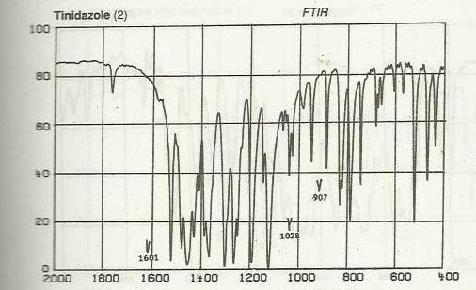

**Fig 6.1 FTIR spectrum of Tinidazole RS**

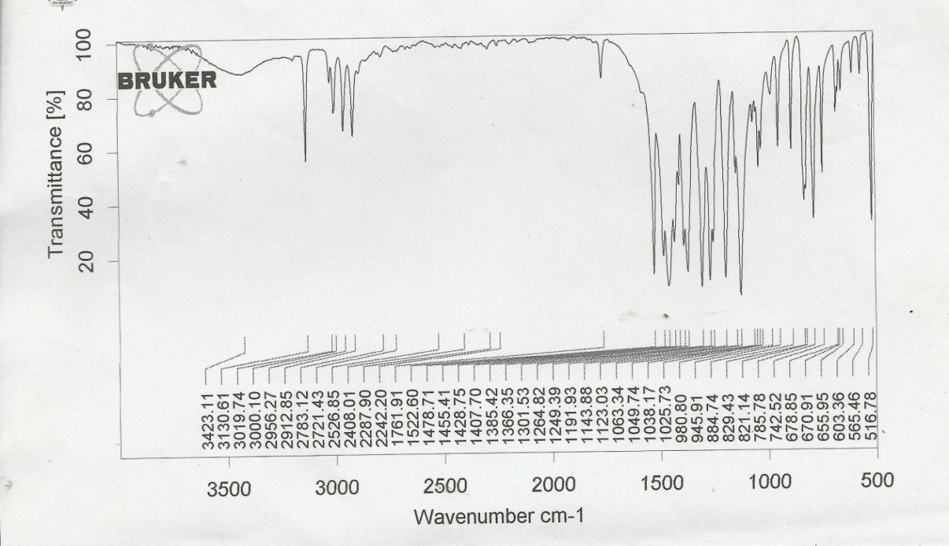

**Fig 6.1 Infrared spectrum of pure drug (Tinidazole).**

**Table -17: Interpretation of infrared spectrum of bands of Tinidazole sample.**

|  |  |  |
| --- | --- | --- |
| **S.NO.** | **Wave number (cm-1)** | **Interpretations** |
|  | **1122.94** | **C-C single bond stretching** |
|  | **1191.93** | **Sulfone** |
|  | **1265.22** | **Strong peak of C-H bending** |
|  | **1390.90** | **Asymemetric sulfone strech** |
|  | **1365.51** | **Tertiary nitrogen** |
|  | **≈1471** | **Overlapping of C=N & C=C** |
| **7.** | **≈1530** | **Strech of NO2** |
| **8.** | **2956.67** | **CH3 streching** |
| **9.** | **3130.25** | **Aromatic =CH Streching** |

**Identification by U.V spectrophotometer:-**

According to the Indian Pharmacopoeia the 0.001%w/v solution of Tinidazole in methanol shows absorption maximum at about 310 nm.

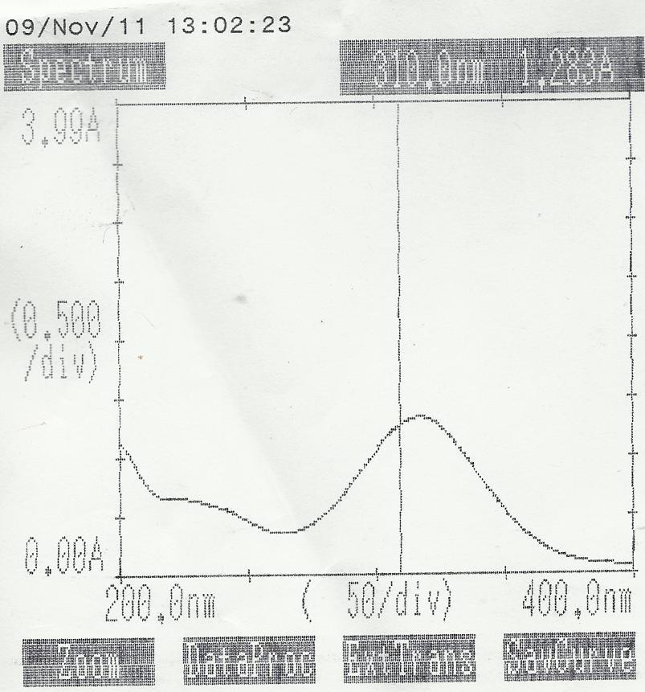

**Fig 6.2 UV spectrum analysis of tinidazole in methanol by 1700 pharmaspec Shimadzu UV spectrophotometer.**

**DETERMINATION OF λ max (MAXIMUM WAVELENGTH):-25**

Theλ max of Tinidazole was determined in distilled water in 1700 pharmaspec shimadzu UV spectrophotometer.

* **Procedure for the determination of λ max:-**

10mg of tinidazole was accurately weighed and dissolved in small quantity of methanol in 100ml of volumetric flask and volume was make up to 100ml water was added to produce stock solution having a concentration of 1000 μg/ml. Aliquotes of the above solution were take and dilute to get tinidazole concentration 10μg/ml . The resulting solution was scanned between 200-400 nm on Shimadzu1700 UV spectrophotometer against distilled water blank. the spectrum is shown in Fig 6.4:-

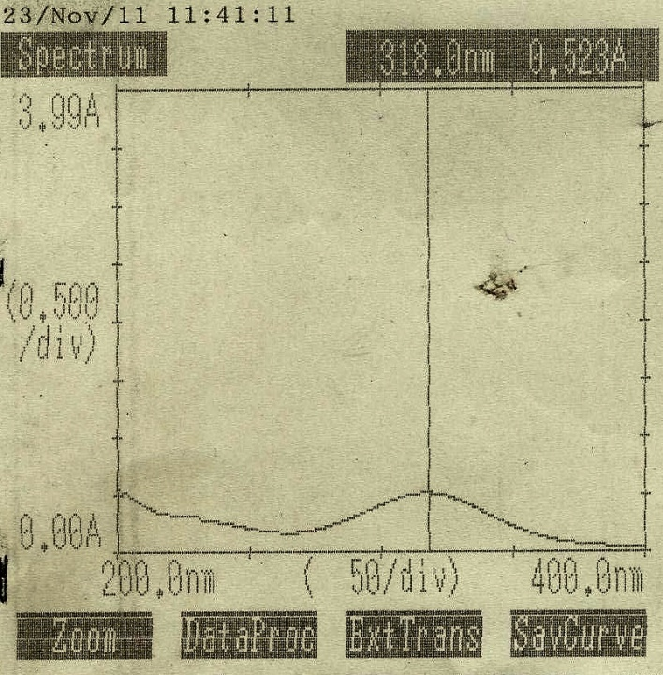

**Fig 6.3** **UV spectrum of tinidazole in distilled water by 1700 pharmaspec Shimadzu UV spectrophotometer.**

**CALIBRATION CURVE OF TINIDAZOLE:-**

**Prepration of calibration curve of tindidazole in distilled water:**

Accurately weight quantity of tinidazole (10 mg) was dissolved in about 80 ml of distilled water in 100 ml volumetric flask and volume was made up to 100 ml by distilled water. Aliquots of the above solution were taken and diluted to get tinidazole concentration in the range of 10-50 μg/ml. The resulting dilution were measured at 318nm on Shimadzu-1700 UV spectrophotometer against distilled water blank .the absorbance are shown in table:

**Table -18 Concentration and absorbance of tinidazole in distilled water at 318 nm.**

|  |  |  |
| --- | --- | --- |
| S.No. | Concentration(μg/ml) | Absorbance |
| 1 | 5 | 0.173 |
| 2 | 10 | 0.324 |
| 3 | 15 | 0.488 |
| 4 | 20 | 0.669 |
| 5 | 25 | 0.818 |

**Fig 6.4 Standard curve of tinidazole in distilled water at 318 nm**

**Statistical parameters:**

* Correlation coefficient r2 =0.999
* Slope = 0.032
* Intercept = 0.001
* Straight line equation = y=0.032x+0.001

**MELTING POINT DETERMINATION:-**

The melting point of the drug was determined by:

* **Melting point apparatus**. The table showing the melting point is given below:

**Table -19 Observation of Melting point determination**

|  |  |  |
| --- | --- | --- |
| **Sample no** | **Melting point(0C)** | **Average** |
| 1 | 125 | 1260C |
| 2 | 126 |
| 3 | 128 |

**PARTITION CO-EFFICIENT DETERMINATION:-**

the partition coefficient was determined by following formula:

Po/w = Coil/Caq

Here, Po/w= partition coefficient,

Coil= concentration of drug in organic phase,

Caq= concentration of drug in aqueous phase

**Table -20 Absorbance and concentration for determination of partition coefficient.**

|  |  |  |  |
| --- | --- | --- | --- |
| **S. no.** | **Solvent** | **Absorbance** | **Concentration (μg/ml)** |
| 1. | n-Octanol | 15.70 | 490.9 |
| 2. | Distilled water | 0.292 | 9.093 |

|  |  |  |
| --- | --- | --- |
| S.no. | Solvent system | Partitioncoefficient |
| 1. | n-Octanol:Distilled water | 1.73 |

**Table -21 Partition coefficient of tinidazole.**

**6.4 HPLC (HIGH PERFORMANCE LIQUID CHROMATOGRAPHY) ANALYSIS:-26**

* **Procedure for the preparation of mobile phase:-**

A mixture of acetonitrile and 0.02M potassium dihydrogen phosphate buffer (adjust to pH 5.0 using orthophosphoric acid) in the ratio of 75:25 v/v was filtered through 0.45 μ membrane filtered and then used as mobile phase and sonicated for 10 min.

* **Procedure for preparation of test solution:-**

Stanadard stock solution of tinidazole was prepared in mobile phase in concentration 500 μg /ml.The stock solution were diluted to obtain working standard solution of concentration of 10 μg /ml to 50 μg /ml.

The resulting solution were sonicated for 10 min.was 20 μl was injected .The retention time for Tinidazole was found to be 3.05 min.The linearity range for tinidazole was found to be 10-80 μg /ml.

**Chromatographic conditions:-**

Inject volume- 20 μl

Run time- 0.27 min.

Flow rate- 1 ml/min.

Maximum wavelength- 295 nm.

* **HPLC graph of Tinidazole:**

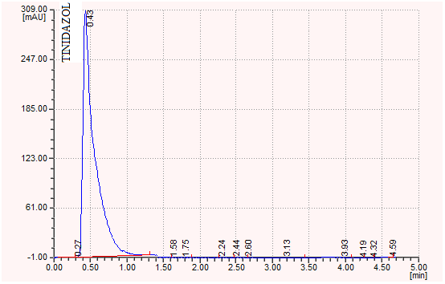

**Figure 6.5 HPLC graph of Tinidazole**

**INTERFERENCE STUDY OF SOLUBILIZERS IN UV SPECTROPHOTOMETRIC ESTIMATION OF DRUG**

* The solutions of each solubilizing agents of known concentration 1000 mcg/ml in demineralized water were prepared and scanned on UV/Visible spectrophotometer (Shimadzu 1700) against same reagent solution in the region from 200-400 nm. The cut off wavelength (nm) and corresponding absorbances so obtained were recorded in table

**Table 22 UV spectral analysis data of solubilizers for cut-off wavelength**

|  |  |  |  |
| --- | --- | --- | --- |
| **S.No.** | **Solubilizer** | **Cutt-off wavelength(nm)** | **Absorbance** |
| 1. | Sodium Benzoate | 287.6 | 0.008 |
| 2. | Niacinamide | 225.2 | 0.005 |
| 3. | Sodium citrate | 245.0 | 0.020 |
| 4. | PEG 4000 | 229.0 | 0.005 |
| 5. | PEG 200 | 240.0 | 0.050 |
| 6. | PEG 6000 | 239.0 | 0.006 |
| 7. | Urea | 218.0 | 0.001 |
| 8 | Propylene glycol | 265.0 | 0.002 |

It is evident from table 6.5, that no one of the selected solubilizers absorbes above 300 nm, so they do not interfere in the spectrophotometric estimation of tinidazole at 318 nm.

**SOLUBILITY STUDIES:-**

**Table -23 Solubility of tinidazole in different solvents**

|  |  |  |
| --- | --- | --- |
| **S.NO.** | **Solvent** | **Concentration (μg/ml)** |
| 1 | Water | 60.54 |
| 2 | HCl | 72.02 |
| 3 | Ethanol | 42 |
| 4 | Chloroform | 34 |
| 5 | Acetone | 67.02 |
| 6 | 0.1NNaOH | 62.02 |
| 7 | Ether | 36 |

**Procedure:-**

Solubility of tinidazole was determined by saturation solubility method. Equivalent amount of drug was added to the test-tubes containing 10ml of solvent to obtained the saturated solution of drug. Finally, it was filtered through the whatman filter paper and the amount of drug dissolved was analysed spectrophotometrically using 1700 Shimadzu UV spectrophotometer at 318 nm.

**SOLUBILIZATION STUDY OF TINIDAZOLE**.

**SOLUBILIZATION STUDY IN DEMENERALIZED WATER**

The solubility of tinidazole in demineralized water was determined by shake flask method. About 5 ml of demineralized water were taken in three vials of 10 ml capacity separately. To the each vial an excess amount of tinidazole was added. Vials were properly sealed and stirred 10 min for proper mixing. They were then kept in orbital flask shaker maintained at 25ºC for 12 hr. The solutions were then allowed to equilibrate for 24 hr. (undisturbed) After 24 hr, the solutions containing excess undissolved drug were transferred into centrifuge tubes and centrifuged at 2000 rpm for 10 min using a centrifuge and supernatant was filtered through Whatman filter paper # 41. Filtrate was suitably diluted with demineralised water and analyzed using double beam UV/Visible spectrophotometer at 318 nm against demineralized water. Amount of drug dissolved in demineralised water was calculated by using calibration curve.

**Result and discussion:** The observed solubility of lamotrigine in demineralised water was found to be 0.75% w/v (average of three studies).

**SOLUBILIZATION STUDY OF TINIDAZOLE IN AQUEOUS SOLUTIONS CONTAINING INDIVIDUAL SOLUBILIZERS (25% W/V)**

**Selection** **of solubilizers for tinidazole solubility enhancement**

.The selected solubilizers are:

1. Polyethylene glycol 4000

2. Sodium benzoate

3. Niacinamide

4. Tween 20

5. Polyethylene glycol 6000

6. Polyethylene glycol 400

7. PVP-40000

**Determination of equilibrium solubility of tinidazole in aqueous solution containing individual solubilizers (25% w/v)**

Aqueous solutions of various solubilizers (25% w/v) were prepared separately in demineralized water and the equilibrium solubility was determined.

The solubility of tinidazole in various solubilizer solutions was determined by shake flask method. About 5 ml of each solubilizer solution was taken in a vial separately. To each vial an excess amount of lamotrigine was added. Vials were properly sealed and stirred using for 10 min for proper mixing. They were then kept in orbital flask shaker maintained at 25ºC for 12 hr. The solution was then allowed to equilibrate for 24 hr (undisturbed). After 24 hr, the solutions containing excess undissolved drug were transferred into centrifuge tubes and centrifuged at 2000 rpm for 10 min using a centrifuge and supernatant was filtered through Whatman filter paper # 41. Filtrate was suitably diluted with demineralised water and analyzed using UV/Visible spectrophotometer at 318 nm against reagent blank. Amount of drug dissolved in each medium was calculated by using calibration curve. The solubilities are recorded in table 6.6 and graphically represented in fig. 6.5.

**Table -24: Solubilities of tinidazole in aqueous solutions containing individual solubilizers**

|  |  |  |  |
| --- | --- | --- | --- |
| **Aqueous solution of solubilizers (25% w/v)** | **Equilibrium solubility of**  **tinidazole (mg/ml)** | | **Solubility enhancement**  **ratio** |
| Demineralize water | 7.58 | | 0 |
| Sodium Benzoate | 100 | | 13.19 |
| Niacinamide | 30.3 | | 3.99 |
| PEG 4000 | 29.0 | | 3.82 |
| Urea | 16.0 | | 2.11 |
| PEG 6000 | 11.4 | | 1.52 |
| Tween 20 | 15.0 | | 1.97 |
| PVP 40,000 | 23.0 | | 3.03 |
| PEG 400 | 14.0 | 1.84 | |

**Fig. 6.5: Solubility profile of lamotrigine in aqueous solution of individual solubilizers (25% w/v)**

**Results and discussion*:*** It is evident from the results that the solubility of tinidazole was increased by use of various solubilizers. The solubilizing power of different solubilizers could be ranked as Sodium benzoate > Niacinamide > PVP 40,000 > Urea > Tween 20 > PEG 400 > PEG 6000 > PEG 4000 > ethanol.

**SOLUBILITY DETERMINATION OF TINIDAZOLE IN AQUEOUS SOLUTION OF MIXED BLEND OF SOLUBILIZERS (25%)**

**Mixed blends containing solubilizers prepared for solubilisation of tinidazole**

Solubilization studies of tinidazole were performed in various aqueous mixed blends of solubilizers, the total concentration of dissolved solubilizer was kept constant at 25% w/v while the concentrations of individual solubilizer were varied. Since there is no fixed criteria for the selection of solubilizer and solubilizer concentration but from the solubility studies done previously (table 6.6), the solubilizers which enhanced the solubility of tinidazole significantly were tried to be present in each blend and in comparatively higher concentration.

For the preparation of mixed blends (aqueous solutions) containing solubilizers, required amount of individual solubilizers were weighed and transferred to volumetric flask of 10 ml capacity containing seven ml of demineralised water, to this the solubilizers were added and flask was shaken vigorously to dissolve to added solubilizers. After complete dissolution of solubilizers the volume was made up to the mark with demineralised water, flask was shaken again to get homogenous solution. The prepared blends were filtered and used for further solubilisation studies.

* **Mixed blends prepared for the solubilisation of tinidazole**

The following mixed blend were tried to observe the solubility of tinidazole:

**Blend F-1**

|  |  |
| --- | --- |
| **Solubilizer** | **Concentration (% w/v)** |
| Niacinamide | 5 |
| Sodium benzoate | 5 |
| PEG 4000 | 5 |
| PEG 400 | 5 |
| PEG 6000 | 5 |

**Blend F-2**

|  |  |
| --- | --- |
| **Solubilizer** | **Concentration (%w/v)** |
| Sodium benzoate | 5 |
| PEG 4000 | 5 |
| PEG 400 | 5 |
| PEG 6000 | 5 |
| PVP 40,000 | 5 |

**Blend F-3**

|  |  |
| --- | --- |
| **Solubilizer** | **Concentration (%)** |
| Sodium benzoate | 10 |
| PEG 4000 | 5 |
| Nicinamide | 5 |
| PEG 6000 | 5 |

**Blend F-4**

|  |  |
| --- | --- |
| **Solubilizer** | **Concentration (%)** |
| Sodium benzoate | 10 |
| PEG 6000 | 5 |
| Urea | 5 |
| Niacinamide | 5 |

**Blend F-5**

|  |  |
| --- | --- |
| **Solubilizer** | **Concentration(%)** |
| Sodium benzoate | 10 |
| PEG 6000 | 5 |
| Urea | 5 |
| PEG 4000 | 5 |

**Blend F-6**

|  |  |
| --- | --- |
| **Solubilizer** | **Concentration (%)** |
| Sodium benzoate | 5 |
| PEG 6000 | 5 |
| Urea | 5 |
| Niacinamide | 5 |
| PEG 4000 | 5 |

**Blend F-7**

|  |  |
| --- | --- |
| **Solubilizer** | **Concentration (%)** |
| Sodium benzoate | 10 |
| Niacinamide | 5 |
| Urea | 5 |
| PEG 4000 | 5 |

**Blend F-8**

|  |  |
| --- | --- |
| **Solubilizer** | **Concentration (%)** |
| Sodium benzoate | 10 |
| PVP 40000 | 5 |
| PEG 6000 | 5 |
| Niacinamide | 5 |

**Blend F-9**

|  |  |
| --- | --- |
| **Solubilizer** | **Concentration (%)** |
| Sodium benzoate | 5 |
| PVP 40,000 | 5 |
| PEG 6000 | 5 |
| Niacinamide | 5 |
| Urea | 5 |

**Blend F-10**

|  |  |
| --- | --- |
| **Solubilizer** | **Concentration (%)** |
| Sodium benzoate | 10 |
| PEG 4000 | 5 |
| PEG 400 | 5 |
| Tween 20 | 5 |

**Blend F-11**

|  |  |
| --- | --- |
| **Solubilizer** | **Concentration (%)** |
| Sodium benzoate | 10 |
| PEG 4000 | 5 |
| PEG 400 | 5 |
| PEG 6000 | 5 |

**Blend F-12**

|  |  |
| --- | --- |
| **Solubilizer** | **Concentration (%)** |
| Sodium benzoate | 10 |
| PEG 6000 | 5 |
| Urea | 5 |
| PEG 400 | 5 |

**Blend F-13**

|  |  |
| --- | --- |
| **Solubilizer** | **Concentration (%)** |
| Sodium benzoate | 5 |
| PEG 4000 | 5 |
| PEG 400 | 5 |
| PEG 6000 | 5 |
| Urea | 5 |

**Blend F-14**

|  |  |
| --- | --- |
| **Solubilizer** | **Concentration (%)** |
| Sodium benzoate | 10 |
| PEG 4000 | 5 |
| PEG 400 | 5 |
| Urea | 5 |

**Mixed blends containing solubilizers prepared for solubilisation of tinidazole containing 30% (w/v)**

**Blend FT-1**

|  |  |
| --- | --- |
| **Solubilizer** | **Concentration (%)** |
| Sodium benzoate | 5 |
| Ethanol | 10 |
| PEG 400 | 10 |
| Niacinamide | 5 |

**Blend FT-2**

|  |  |
| --- | --- |
| **Solubilizer** | **Concentration (%)** |
| Sodium benzoate | 10 |
| Ethanol | 10 |
| PEG 400 | 5 |
| Niacinamide | 5 |

**Blend FT-3**

|  |  |
| --- | --- |
| **Solubilizer** | **Concentration (%)** |
| Sodium benzoate | 10 |
| PEG 400 | 10 |
| Niacinamide | 5 |
| Ethanol | 5 |

**Blend FT-4**

|  |  |
| --- | --- |
| **Solubilizer** | **Concentration (%)** |
| Sodium benzoate | 5 |
| PEG 400 | 10 |
| Niacinamide | 5 |
| Ethanol | 10 |

**Blend FT-5**

|  |  |
| --- | --- |
| **Solubilizer** | **Concntration (%)** |
| Sodium benzoate | 10 |
| Ethanol | 5 |
| PEG 4000 | 5 |
| Niacinamide | 10 |

**Blend FT-6**

|  |  |
| --- | --- |
| **Solubilizer** | **Concentration(%)** |
| Sodium benzoate | 10 |
| Urea | 5 |
| Ethanol | 5 |
| Niacinamide | 10 |

**Blend FT-7**

|  |  |
| --- | --- |
| **Solubilizer** | **Concentration(%)** |
| Sodium benzoate | 5 |
| PEG 4000 | 5 |
| PEG 400 | 5 |
| PEG 6000 | 5 |
| Urea | 5 |
| Niacinamide | 5 |

**Blend FT-8**

|  |  |
| --- | --- |
| **Solubilizer** | **Concentration (%)** |
| Sodium benzoate | 10 |
| PEG 400 | 5 |
| Niacinamide | 10 |
| Ethanol | 5 |

**Blend FT-9**

|  |  |
| --- | --- |
| **Solubilizer** | **Concentration(%)** |
| Sodium benzoate | 5 |
| Niacinamide | 5 |
| PEG 4000 | 10 |
| Urea | 10 |

**Blend FT-10**

|  |  |
| --- | --- |
| **Solubilizer** | **Concentration(%)** |
| Sodium benzoate | 10 |
| PEG 4000 | 5 |
| PEG 400 | 5 |
| Niacinamide | 10 |

**Procedure for solubility determination of tinidazole in mixed blends of solubilizers (aqueous solutions) 25% w/v**

The solubility of tinidazole in various mixed blends containing solubilizers (aqueous solutions) was determined by shake flask method. About 5 ml of each mixed blends solution was taken in a vial separately. To each vial an excess amount of tinidazole was added. Vials were properly sealed and stirred using orbital flask shaker maintained at 25ºC for 12 hr. The solution was then allowed to equilibrate for 24 hrs (undisturbed). After 24 hr, the solutions containing excess undissolved drug were transferred into centrifuge tubes and centrifuged at 2000 rpm for 10 min using a centrifuge and supernatant was filtered through Whatman filter paper # 41. Filtrate was suitably diluted with demineralised water and analyzed using UV/Visible spectrophotometer (Shimadzu 1700) at 318 nm against reagent blank. Amount of drug dissolved in each was calculated by using calibration curve. The solubilities are recorded in table 6.7 and graphically represented in fig. 6.6.

**Table -25: Equilibrium solubility data of lamotrigine in various mixed blends containing solubilizers**

|  |  |  |
| --- | --- | --- |
| **Blend codes** | **Solubility (mg/ml)** | **Solubility enhancement ratio** |
| F-1 | 8.0 | 1.05 |
| F-2 | 8.7 | 1.14 |
| F-3 | 9.5 | 1.25 |
| F-4 | 17.1 | 2.25 |
| F-5 | 17.0 | 2.24 |
| F-6 | 10.5 | 1.38 |
| F-7 | 10.2 | 1.34 |
| F-8 | 18.0 | 2.37 |
| F-9 | 16.0 | 2.11 |
| F-10 | 9.0 | 1.18 |
| F-11 | 11.1 | 1.46 |
| F-12 | 12.5 | 1.64 |
| F-13 | 16.4 | 2.16 |
| F-14 | 10.9 | 1.43 |
| FT-1 | 10.4 | 1.37 |
| FT-2 | 22.0 | 2.90 |
| FT-3 | 17.8 | 2.34 |
| FT-4 | 11.5 | 1.51 |
| FT-5 | 34.8 | 4.59 |
| FT-6 | 22.0 | 2.90 |
| FT-7 | 15.4 | 2.03 |
| FT-8 | 24.0 | 3.16 |
| FT-9 | 16.7 | 2.20 |
| FT-10 | 11.6 | 1.53 |

**Fig. 6.6: Equilibrium solubilities of lamotrigine in various mixed blend containing solubilizers**

**Results and discussion:**The results showed that solubility of tinidazole in different mixed blends was increased significantly. The maximum solubility was observed in FT-5 which showed 4.59 folds enhancement. From the table 6.6 and 6.7, it is evident that many blends showed addative/synergistic enhancement in solubilities of tindazole. The total strength of all solubilizers was 25% w/v and 30% w/v in all aqueous systems containing single solubilizers or combinations of solubilizers.

Taking example of blend FT-5, containing (10% Sodium benzoate, 5 Ethanol, PEG 4000, and 10% Niacinamide here. Experimentally observed solubility of tinidazole in this blend was found to be 34.8 mg/ml (Table 6.7)

**DETERMINATION OF pH DEPENDENT SOLUBILITY OF TINIDAZOLE**

**Table 6.8: Solubilities of lamotrigine in buffer solutions of different pH**

|  |  |
| --- | --- |
| **Buffer (pH)** | **Solubility (mg/ml)** |
| 4 | 5.37 |
| 7.4 | 10.4 |
| 9.0 | 20.2 |

**Fig. 6.7: pH dependent solubility profile of lamotrigine**

**Result and discussion:**

The solubility of tinidazole slightly increase with increase in pH but it did not vary significantly with pH change. The solubility enhancement ratio at pH 9 was 2.6 folds (as compared to solubility in distilled water).

**DRUG-EXCIPIENT INTERACTION STUDIES**.

**Table -26: Drug-excipients physical compatibility study of tinidazole**

|  |  |  |  |  |  |  |  |  |  |  |  |  |  |  |  |
| --- | --- | --- | --- | --- | --- | --- | --- | --- | --- | --- | --- | --- | --- | --- | --- |
| S.  No. | Drug  Excipient  Blend | Initial  Appearance | **Storage conditions** | | | | | | | | | | | | |
| Refrigerator(2-8ºc) | | | | | Room temperature | | | | 40ºc | | | |
| Week | | | | | Week | | | | Week | | | |
| 1 | 2 | 3 | 4 | 1 | | 2 | 3 | 4 | 1 | 2 | 3 | 4 |
| 1. | TNZ | Slight Yellowish white powder | N | N | N | N | N | | N | N | N | N | N | N | N |
| 2. | TNZ+SB | Slight yellowish white powder | N | N | N | N | N | | N | N | N | N | N | N | N |
| 3. | TNZ+FH | Slight yellowish white powder | N | N | N | N | N | | N | N | N | N | N | N | N |
| 4. | TNZ+FT | Slight yellowish white powder | N | N | N | N | N | | N | N | N | N | N | N | N |
| 5. | TNZ+ST | Slight yellowish white powder | N | N | N | N | N | | N | N | N | N | N | N | N |
| 6. | TNZ+UR | Slight yellowish white powder | N | N | N | N | N | | N | N | N | N | N | N | N |
| 7. | TNZ+NM | Slight yellowish white powder | N | N | N | N | N | | N | N | N | N | N | N | N |
| 8. | TNZ+ET | Slight yellow colour liquid. | N | N | N | N | N | | N | N | N | N | N | N | N |
| 9. | TNZ+PVP | Slight yellowish white powder | N | N | N | N | N | | N | N | N | N | N | N | N |

TNZ =Tinidazole FT = PEG 4000

NM =Niacinamide FH = PEG 400

SB =Sodium benzoate ET = Ethanol

PVP =PVP 40,000 ST =PEG 6000

UR = Urea

**REFERENCES-**

1. Gahlot, Neha. “Formulation Development of Topical Solutions of Poorly Water-Soluble Drug Indomethacin Employing Novel Application of Mixed Solvency Concept and Their Evaluation.” *International Journal of Green Pharmacy (IJGP)* 12, no. 02 (August 3, 2018). <https://doi.org/10.22377/ijgp.v12i02.1789>.
2. Gupta, Himanshi, Prakhar Gupta, and R K Maheshwari. “Formulation Development of a Model Dry Injection for Reconstitution of Poorly Water Soluble Drug Using Mixed Solvency Concept and Its Evaluation” 7, no. 4 (2016).
3. Mundada, AtishS., DipakD. Patil, and RajeshK. Maheshwari. “Green Analytical Techniques Using Hydrotropy, Mixed Hydrotropy, and Mixed Solvency.” In *Sustainable Approaches in Pharmaceutical Sciences*, 91–111. John Wiley & Sons, Ltd, 2023. <https://doi.org/10.1002/9781119889878.ch5>.
4. Agrawal, Rinshi, and Maheshwari Rajesh Kumar. “Novel Application of Mixed Solvency Concept in the Development of Oral Liquisolid System of a Poorly Soluble Drug, Cefixime and Its Evaluation. | EBSCOhost,” November 2, 2018. <https://doi.org/10.22270/jddt.v8i6-s.2167>.
5. Jain, Deepak Kumar, Vijay Kumar Patel, Shalini Bajaj, and Nilesh Jain. “NOVEL APPROACH FOR SPECTROPHOTOMETRIC ESTIMATION OF SOLID DOSAGE FORMS OF TINIDAZOLE USING SOLIDS (EUTECTIC LIQUID OF PHENOL AND NIACINAMIDE) AS SOLUBILIZING AGENT (MIXED SOLVENCY CONCEPT),” n.d.
6. Jain, Sanjay, R K Maheshwari, Rajesh Kumar Nema, and Indrajeet Singhvi. “SIMULTANEOUS ESTIMATION OF OFLOXACIN AND ORNIDAZOLE IN SOLID DOSAGE FORM BY U V SPECTROPHOTOMETRY USING MIXED SOLVENCY CONCEPT,” n.d.
7. Thakur, Yashi, and R.K. Maheshwari. “Novel Application of Mixed Solvency Concept to Develop and Formulate Dry Powder Injection for Reconstitution of a Poorly Water Soluble Drug, Amlodipine Besylate and Their Evaluations.” *Journal of Drug Delivery and Therapeutics* 11, no. 4-S (August 15, 2021): 101–8. <https://doi.org/10.22270/jddt.v11i4-S.4991>.
8. Carpenter, Garima, and R. K. Maheshwari. “Formulation and Development of Fast Dissolving Oral Film of a Poorly Soluble Drug, Frusemide with Improved Drug Loading Using Mixed Solvency Concept and Its Evaluation.” *Journal of Drug Delivery and Therapeutics* 8, no. 6 (November 15, 2018): 132–41. <https://doi.org/10.22270/jddt.v8i6.2034>.
9. Singh, Raghvendra, Dr Gopal Rai, Pradeep Vikram, and Dr Vikas Pandey. “Formulation Development and Characterization Of Third Generation Cephalosporin Loaded Dry Injection and Dry Syrup: A Mixed Solvency Concept To Minimize Toxicity And Maximize Bioavailability.” *Clinical Medicine* 09, no. 08 (2022).
10. Baghel, Jaydeep Singh, and R K Maheshwari. “NOVEL APPLICATION OF MIXED SOLVENCY CONCEPT IN THE DEVELOPMENT OF FAST DISSOLVING SOLID DISPERSION OF POORLY WATER-SOLUBLE DRUG, TORSEMIDE AND ITS EVALUATIONS” 9, no. 1 (n.d.).
11. Sharma, Sunidhi, Ravi Sharma, Sweta S Koka, and GN Darwhekar. “A Review: ‘Hydrotropy’ Techniques to Increase The,” n.
12. Ludhiani, Simran, and Rk Maheshwari. “Novel Application of Mixed Solvency Concept to Develop and Formulate Liquisolid System of a Poorly Water-Soluble Drug, Furosemide and Their Evaluations.” *International Journal of Pharmacy Research & Technology (IJPRT)* 12, no. 1 (2022): 28–57. <https://doi.org/10.31838/ijprt/12.01.05>.
13. Shri Vaishnav Institute of Forensic Science, SVVV, Indore, Ketan Soni, and Kavita Sharma. “Eco-Friendly Spectrophotometric Analysis of Mefenamic Acid (Poorly Water-Soluble Drug) Using the Mixed Solvency Concept.” *Indian Journal of Science and Technology* 14, no. 28 (July 25, 2021): 2337–41. <https://doi.org/10.17485/IJST/v14i28.476>.
14. Ps, Gayakwad, Gavit Aj, Rajput Pv, Bari Mm, Barhate Sd, and Maheshwari Rk. “FORMULATION DEVELOPMENT AND EVALUATIONS OF AN AQUEOUS INJECTION OF GATIFLOXACIN BY NOVEL MIXED SOLVENCY TECHNIQUE,” n.d.
15. Solanki, Shailendra Singh. “Development of Parenteral Formulation of Poorly Water Soluble Drugs: The Role of Novel Mixed-Solvency Concept.” *Asian Journal of Pharmaceutics (AJP)* 11, no. 01 (March 20, 2017). <https://doi.org/10.22377/ajp.v11i01.1036>.
16. Jyoti Joshi, Nidhi Nainwal, and Vikas Anand Saharan. “A REVIEW ON HYDROTROPY: A POTENTIAL APPROACH FOR THE SOLUBILITY ENHANCEMENT OF POORLY SOLUBLE DRUG.” *Asian Journal of Pharmaceutical and Clinical Research*, August 10, 2019, 19–26. <https://doi.org/10.22159/ajpcr.2019.v12i10.34811>.
17. Soni, Ketan, and Kavita Sharma. “Eco-Friendly and Economical Spectrophotometric Estimation of the Low Water-Soluble Drug (Norfloxacin) Applying the Concept of Mixed Hydrotropy.” *Journal of Health and Allied Sciences NU* 12 (December 1, 2021): 263–66. <https://doi.org/10.1055/s-0041-1740024>.
18. Ludhiani, Simran, and Rk Maheshwari. “Novel Application of Mixed Solvency Concept to Develop and Formulate Liquisolid System of a Poorly Water-Soluble Drug, Furosemide and Their Evaluations.” *International Journal of Pharmacy Research & Technology (IJPRT)* 12, no. 1 (2022): 28–57. <https://doi.org/10.31838/ijprt/12.01.05>.
19. Ludhiani, Simran, and Rk Maheshwari. “Novel Application of Mixed Solvency Concept to Develop and Formulate Liquisolid System of a Poorly Water-Soluble Drug, Furosemide and Their Evaluations.” *International Journal of Pharmacy Research & Technology (IJPRT)* 12, no. 1 (2022): 28–57. <https://doi.org/10.31838/ijprt/12.01.05>.
20. Singh, Ashish, and R K Maheshwari. “‘SOLID AS SOLVENT’- NOVEL SPECTROPHOTOMETRIC ANALYTICAL TECHNIQUE FOR QUANTITATIVE ESTIMATION OF PIROXICAM IN TABLETS USING SOLIDS (EUTECTIC LIQUID OF PHENOL AND LIGNOCAINE HYDROCHLORIDE) AS SOLUBILIZING AGENTS (MIXED SOLVENCY CONCEPT),” n.d.
21. Maheshwari, R K, Sunil Goyal, Rohit Adhav, and Priyanka Vaswani. “Solid as Solvent” - Novel Spectrophotometric Analysis of Piroxicam Tablets Using Solids (Eutectic Liquid of Phenol and Metformin Hydrochloride) As Solubilizing Agents (Mixed Solvency Concept),” n.d.
22. Vineet, C, P Arun, P Shailendra, D Neelesh, and K Neeraj. “ENHANCEMENT OF SOLUBILITY OF POORLY SOLUBLE DRUG BY MIXED SOLVENCY CONCEPT,” n.d.
23. Padiyar, Anirudh, and Rajesh K. Maheshwari. “FORMULATION DEVELOPMENT OF DICLOFENAC SODIUM LOTION USING MIXED SOLVENCY CONCEPT AND IN VITRO EVALUATION. | EBSCOhost,” May 1, 2022. <https://doi.org/10.53879/id.59.05.13028>.
24. Mehrotra, Archana, Gaurav Malviya, and Rajesh Kumar Maheshwari. “APPLICATION OF MIXED HYDROTROPY IN SPECTROPHOTOMETRIC ANALYSIS OF FRUSEMIDE IN DIFFERENT FORMULATIONS.” Unpublished, 2011. <https://doi.org/10.13140/RG.2.2.24856.00001>.