**Human Resource Management Practices' effect on Organizational Performance and Job Satisfaction**

**\* Dr.S.Pratibha**

***Abstract:***

*Human capital is measured as the most important asset of an organization, though only very few organizations are able to fully harness its potential. Managing human capital plays a prominent role in attaining job satisfaction and there by organizational performance. The demand for goods and services is changing dramatically, which has made it more important for organizations to provide services and to review their procedures, goals, and metrics. For an organization to be effective and efficient, personnel management is essential. The performance of the organization can be sustained and enhanced by a number of HRM techniques. The purpose of the present study is to examine the impact of HRM practices on job satisfaction and organizational performance in IT sector in Hyderabad. The study examined specifically the HRM practices that are under the control of supervisors and managers. The study adopted purposive sampling technique with a sample size of 225. The findings of the study indicate that there is a positive relationship between HRM practices, Job satisfaction and organization performance.*

***Keywords: HRM practices, Job satisfaction, organizational performance, IT Sector.***

*Professor and Principal, Department of Business Management, David Memorial Institute of Management, Hyderabad 500040.

Email: pratibha15077@gmail.com

**1. Introduction**

Currently, numerous organizations are experiencing substantial shifts in the demand for their products and services as they strive to enhance their performance standards. This has resulted in improvements not only in the services they provide but also in the practices they implement, as well as their goals, objectives, and performance metrics (Platonova 2005, Ulrich 1997). Achieving organizational efficiency and effectiveness relies heavily on the effective management of personnel within the organization. Therefore, the focus on human factors is closely linked to overall organizational performance.

A considerable amount of research has been conducted on human resource management (HRM) and its effects on various aspects such as organizational performance, culture, climate, leadership styles, and employee turnover (Huselid 1996, Erbisch 2004, Ferguson 2006, Platonova 2005, Ulrich 1997). Most of these studies have focused on the private sector, with only a few examining the relationship between HRM practices, job satisfaction, and organizational performance in the tertiary sector. Additionally, there has been little to no research comparing employee perceptions specifically within the IT sector. This highlights a gap in the research that the current study aims to address. Therefore, this study investigates HRM practices, perceived job satisfaction, and perceived organizational performance among employees in the IT sector in Hyderabad.

**2. Review of Literature**

The existing literature on the subject is extensive and covers various practices such as recruitment, selection, compensation, job design, and job evaluation, all of which fall under the purview of human resource departments. In recent years, some responsibilities have been delegated to line supervisors and managers by HR departments.

**2.1 Communication**

According to Peter Drucker, communication is a crucial aspect of management, and it is important to grasp the expectations of managers. Organizational communication refers to the methods an organization employs to convey its mission, vision, expectations, and outcomes to employees. Effective communication leads to increased job satisfaction, morale, commitment, and overall organizational performance (LEE, 2006; Penley & Hawkins, 1985).

**2.2 Empowerment**

Empowerment refers to the methods that supervisors and managers employ to motivate employees to recognize their own skills, abilities, and potential. Managers are tasked with helping employees make independent decisions, thereby enhancing their engagement and self-confidence.

**2.3 Motivation**

Motivation is the process that drives employees to behave in specific ways. It is a crucial element in influencing and guiding human behaviour, closely tied to job satisfaction and the degree to which employees' personal needs are met.

**2.4 Participative Management**

Participative management is a theory that emphasizes the involvement of employees in problem-solving and decision-making processes. It seeks to create a balance between the participation of managers and their subordinates in making decisions, sharing information, and addressing issues.

**2.5 Reward and Recognition**

Rewards and recognition can be provided to employees in both financial and non-financial forms to boost morale, commitment, and productivity. These factors play a significant role in shaping employee behaviour, job satisfaction, and overall organizational performance (Keller & Szilagyi, 1976).

**2.6 Supervisory Leadership**

This concept encompasses employees' perceptions of the level of support from supervisors, team-building efforts, and assistance at work, which reflect identifiable leadership styles in everyday organizational settings. Common leadership styles include autocratic, consultative, participative, and laissez-faire.

**2.7 Job Satisfaction**

Job satisfaction is the fulfilment an employee experiences by aligning their values with their work. According to Locke (1969), job satisfaction is centered on individual values that shape a person's contentment with their job. Barber (1986) found that many workers were unhappy in their roles and suggested that a shift in management's approach to motivating and assessing employees is crucial for enhancing performance and, consequently, job satisfaction.

**2.8 Organizational Performance**

Organizational performance is primarily evaluated based on its effectiveness and efficiency, which can be assessed at four levels: performance appraisal, team performance, program performance, and overall organizational performance. Balancing these elements is a challenge for many organizations. However, aligning human resource management practices with organizational goals and objectives can significantly enhance the organization's success.

**3. Statement of the Problem**

A key challenge for managers and supervisors is to achieve the organization's goals and objectives by delivering services in an effective and efficient manner. However, HRM practices like communication, empowerment, motivation, participative management, reward and recognition, supervisory leadership, and job satisfaction are not clearly recognized within the organization's operations. There is limited research on the connection between HRM practices, job satisfaction, and organizational performance. The findings of this study will help administrators make informed decisions regarding the engagement of supervisors and managers in the HRM system.

**4. Objectives of the Study**

* The comprehend the culture of chosen IT sector organizations.
* To gain insight into the human resource management practices within these selected IT companies.
* To assess the degree of employee job satisfaction and their perceived organizational performance.
* To explore the connections between organization culture, human resource management practices, job satisfaction and perceived organization performance.

**5. Research Methodology**

**5.1 Population**

The research employs purposive sampling as its technique. This method is suitable since the study aims to explore the perceptions of a specific group with relevant experience and skills. **5.2 Data Collection Methods**

A questionnaire was utilized for the survey, divided into two sections. The first section gathers personal information from respondents, while the second section addresses various study dimensions, including organizational culture, HRM practices, job satisfaction, and perceived organizational performance. The HRM practices examined include communication, empowerment, motivation, participative management, reward and recognition, supervisory leadership, and job satisfaction. A five-point Likert scale was used to assess individuals' opinions and attitudes. The study's population consists of employees in the IT sector of Hyderabad district. The objective was to identify potential employees, and the survey was distributed to those who met the sampling criteria. A total of 278 questionnaires were sent out, with 264 completed responses received. The study focuses specifically on the role of supervisors and managers in implementing HRM practices and their impact on job satisfaction and organizational performance.

**6. Findings of the Study**

**6.1 Demographic Analysis:**

**Table No 1. Gender wise Classification**

|  |  |
| --- | --- |
| **Gender** | **Percentage** |
| Male | 54% |
| Female | 46% |

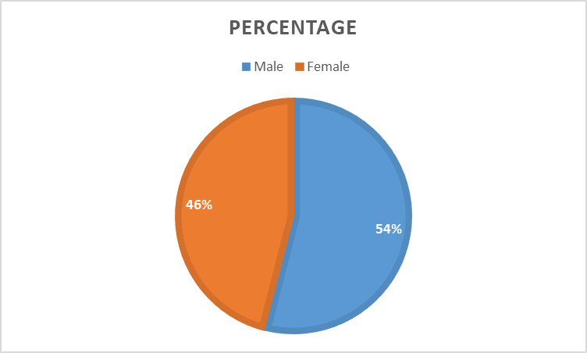

**Fig. No. 1 Gender wise Classification**

**Table No 2. Age Group of the Respondents**

|  |  |
| --- | --- |
| **Age Group** | **Percentage** |
| 20- 30 yrs | 28% |
| 30 – 40 yrs | 38% |
| 40 – 50 yrs | 24% |
| Above 50 yrs | 10% |

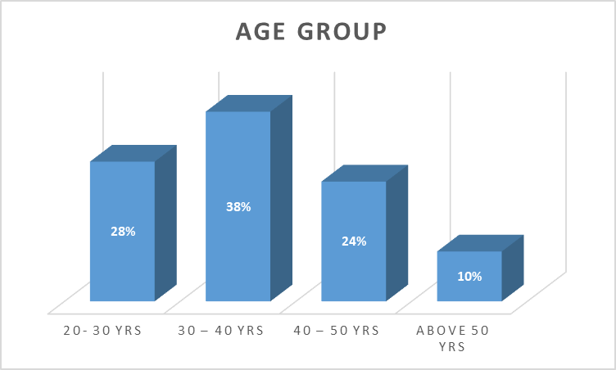

**Fig No. 2 Age Group of the Respondents**

**Table No. 3 Monthly Income of the respondents**

|  |  |
| --- | --- |
| **Monthly Income** | **Percentage** |
| Below Rs.20,000 | 28% |
| 20,000 – 35,000 | 42% |
| 35,000 – 50,000 | 21% |
| Above 50,000 | 9% |

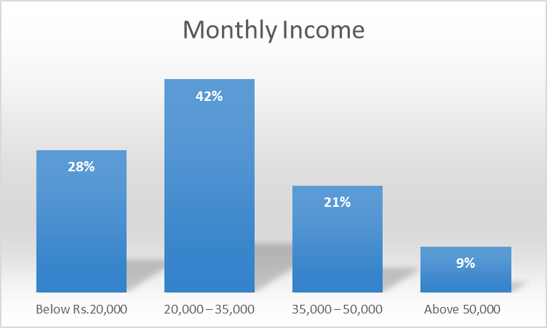

**Figure No. 3 Monthly Income of the respondents**

**Table No. 4 Level of Education**

|  |  |
| --- | --- |
| Education | Percentage |
| Under graduates | 42% |
| Graduates | 38% |
| Post Graduates | 20% |

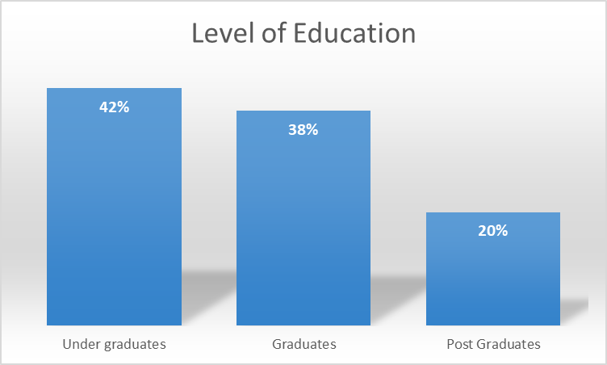

**Figure No. 4 Level of Education**

**6.2 Statistical Analysis**

The relationship between organization culture, HRM practices, Job Satisfaction and Perceived Organizational Performance.

**Table No. 5 Correlation Coefficient**

|  |  |  |  |  |  |
| --- | --- | --- | --- | --- | --- |
|  | | **Organization Culture** | **HRM**  **practices** | **Job Satisfaction** | **Perceived Organization Performance** |
| Organization Culture | Pearson Correlation | 1 | .734** | .654** | .479** |
| Sig. (2-tailed) |  | .000 | .000 | .000 |
| N | 264 | 264 | 264 | 264 |
| HRM practices | Pearson Correlation | .734** | 1 | .695** | .476** |
| Sig. (2-tailed) | .000 |  | .000 | .000 |
| N | 264 | 264 | 264 | 264 |
| Job Satisfaction | Pearson Correlation | .654** | .695** | 1 | .656** |
| Sig. (2-tailed) | .000 | .000 |  | .000 |
| N | 264 | 264 | 264 | 264 |
| Perceived Organization Performance | Pearson Correlation | .479** | .476** | .656** | 1 |
| Sig. (2-tailed) | .000 | .000 | .000 |  |
| N | 264 | 264 | 264 | 264 |

The table indicates that organizational culture (0.734) and job satisfaction (0.654) have a significant relationship with the HRM practices of the organization, with a significance value of (0.000). All aspects of HRM practices show a strong correlation and significance with organizational culture and job satisfaction. Additionally, organizational performance has a moderate correlation with organizational culture (0.479). Perceived organizational performance is also moderately correlated with HRM practices and job satisfaction, with all dimensions being significant at the 0.000 level.

**6.3 Multiple Regression**

The linear relationship between the independent variables—HRM practices, organizational culture, and job satisfaction—and the dependent variable, perceived organizational performance, is established through Multiple Regression analysis.

**Table No. 6 Model Summary**

|  |  |  |  |  |
| --- | --- | --- | --- | --- |
| **Model** | **R** | **R Square** | **Adjusted R Square** | **Std. Error of the Estimate** |
| 1 | .934 | .782 | .832 | .314 |

**Predictors: (Constant), HRM Practices, Organization Culture, Job Satisfaction**

The R value indicates that the relationship between Organization Culture, Job satisfaction and HRM practices support was highly correlated. The R square value shows that the predictors predict HRM practices by 78%.

**Table No. 7 Coefficients**

|  |  |  |  |  |  |  |
| --- | --- | --- | --- | --- | --- | --- |
| **Model** | | **Unstandardized Coefficients** | | **Standardized Coefficients** | **t** | **Sig.** |
| **B** | **Std. Error** | **Beta** |
| 1 | (Constant) | .349 | .067 |  | 4.896 | .000 |
| Organization Culture | .239 | .032 | .328 | 8.506 | .000 |
| Job Satisfaction | .241 | .029 | .230 | 6.512 | .000 |
| HRM practices | .302 | .035 | .318 | 8.3065 | .000 |

*Dependent Variable: Perceived Organizational Performance

The coefficients table shows that HRM practices (Beta value = 0.302) are the strongest predictor of perceived organizational performance and it is very highly significant at (0.001) level of significance. The job satisfaction of the employees with (Beta value = 0.241) is the second strongest predictor and is highly significant at (0.001). Organization culture has the lowest beta loading (beta value = 0.239) and is significant at (0.001) level.

**6.4 Recommendations**

The managers and supervisors of the organization has to take the responsibility in creating a unique platform where the employees can showcase their innovations and creative ideas periodically, which results into better performance of the organization. They should also encourage their employees on personal development and growth. The supervisors and managers should work closely with their employees so that the organizational objectives and goals can be achieved.

**6.5 Conclusion**

The research recognized the importance of supervisors and managers in implementing HRM practices in the IT sector of Hyderabad. It also examined how job satisfaction and organizational culture impact the overall performance of the organization. Consequently, the study concludes that supervisors and managers are crucial in the execution of HRM practices within the organization.

**References**

[1] Arvey, R. D. (1995). Job satisfaction. In N. Nicholson (Ed.), The Blackwell encyclopedic dictionary of organizational behavior (pp. 272-274). Cambridge, MA: Blackwell.

[2] Barber, G. (1986). Correlates of job satisfaction among human service workers. Administration in Social Work, 10(1), 25-38.

[3] Becker, B., & Gerhart, B. (1996). The impact of human resource management on organizational performance: Progress and prospects. Academy of Management Journal, 39(4), 793-815.

[4] Cho, Y. S. (2004). Examining the impact of human resources management: A performance based analytic model, 65(08), 3054A. (UMI No. 3144524)

[5] Cleveland, J. N., Murphy, K. R., & Williams, R. E. (1989). Multiple uses of performance appraisal: Prevalence and correlates. Journal of Applied Psychology, 74(1), 130-135.

[6] Daley, D., Vasu, M. L., & Weinstein, M. B. (2002). Strategic human resource management: Perceptions among North Carolina County social services professionals. Public Personnel Management, 31(3), 359-375.

[7] Delaney, J. T., & Huselid, M. A. (1996). The impact of human resource management practices on perceptions of organizational performance. Academy of Management Journal, 39(4), 949-969.

[8] Drucker, P. (1999). Management challenges for the 21st century. New York, NY: HarperCollins.

[9] Erbisch, P. S. (2004). Management style, organizational climate, and organizational performance in a mental health agency: An integral model. (Dissertations Abstracts International, 65(11), 4341A. (UMI No. 3154494)

[10] Gelade, G. A., Ivery, M. (2003). The impact of human resource management and work climate on organizational performance. Personnel Psychology, 56(2), 383-404.

[11] Huselid, M. A. (1995). The impact of human resource management practices on turnover, productivity, and corporate financial performance. Academy of Management Journal, 38(3), 635-673.

[12] Keller, R. T., & Szilagyi, A. D. (1976). Employee reactions to leader reward behaviors. Academy of Management Journal, 19(4), 19-27.

[13] Kim, S. (2002). Participative management and job satisfaction: Lessons for management leadership. Public Administration Review, 62(2), 232-241.

[14] Lee, H. (2006). Impact of the civil service reforms on human resources management and job satisfaction determinants. (Doctoral dissertation, Arizona State University). Dissertations Abstracts International, 67(03). (UMI No. 3210162)

[15] Penley, L. E., & Hawkins, B. (1985). Studying interpersonal communication in organizations: A leadership application. Academy of Management Journal, 28(2), 309-326.

[16] Platonova, E. A. (2005). The relationship among human resource management, organizational culture, and organizational performance. Dissertations Abstracts International, 67(01). (UMI No. 3201176)

[17] Selden, S. C. (2005). Human resource management in American counties. Public Personnel Management, 34(1), 59-84.

[18] Sprague, R. W., & Del Brocco, S. F. (2002). Calculating the RIO on internal communication. Employee Relations Today, 29(1), 33-44.

[19] Timm, P. R., & Peterson, B. D. (1993). People at work: Human relations in organizations (4th ed.). St. Paul, MN: West.

[20] Ulrich, D. (1997). Measuring human resources: An overview of practice and a prescription for results. Human Resource Management, 36(3), 303-320.

[21] Dr. A. Ramaraju, “A Role of Innovative Idea Management in HRM”. *International Journal of Management (IJM)*, 5(8), 2014, pp. 25–34

[22] Wahida Begum F, Dr.M. Sheik Mohamed, “A Study on HRM practices and its impact on Job satisfaction and organization performance in BPR Sector, Tiruchirappalli, International Journal of Advanced Research in Management, (IJRAM) Vol 7, Issue3. Decemeber 2016.

[23] Wright, B. E. (2001). Public-sector work motivation: A review of the current literature a revised conceptual model. Journal of Public Administration Research and Theory, 11(4), 559-587.