**Designing sgRNA and drug therapeutics: Unlocking CRISPR-based *in-silico* diagnostic techniques**

First Author: Disha Patel

Department of Integrated Biotechnology

Ashok and Rita Patel Institute of Integrated Study and Research in Biotechnology and Allied Sciences

New Vallabh Vidyanagar-388121, Gujarat, India.

Second Author: Hiral Soni

Department of Biotechnology

Institute of Science & Technology for Advanced Studies & Research

Vallabh Vidyanagar-388120, Gujarat, India.

Third Author: Pratiksha Gondkar

Department of Medical Laboratory Technology

Bapubhai Desaibhai Patel Institute of Paramedical Sciences, Charotar University of Science & Technology

Changa-388421, Gujarat, India

Fourth Author: Mansi Patel

Department of Medical Laboratory Technology

Bapubhai Desaibhai Patel Institute of Paramedical Sciences, Charotar University of Science & Technology

Changa-388421, Gujarat, India

**Corresponding author:** Dr. Khushal Patel

Department of Medical Laboratory Technology

Bapubhai Desaibhai Patel Institute of Paramedical Sciences, Charotar University of Science & Technology

Changa-388421, Gujarat, India

Email: [khushalpatel.bdips@charusat.ac.in](mailto:khushalpatel.bdips@charusat.ac.in)

**Abstract**

The CRISPR-Cas system has significantly transformed the fields of genome editing and microbial diagnostics, providing remarkable precision and versatility in genetic manipulation. Initially identified as an adaptive immune mechanism in prokaryotic organisms, CRISPR-Cas technology has been effectively utilized for targeted gene editing, transcriptional regulation, and advanced diagnostic applications. Central to these advancements is the design of single-guide RNA (sgRNA), which is critical for ensuring the specificity and efficiency of CRISPR-based interventions. Recent computational approaches have facilitated the optimization of sgRNA sequences, thereby enhancing target recognition and minimizing off-target effects. In the area of diagnostics, CRISPR-Cas platforms, such as Cas12 and Cas13, have enabled the rapid and highly sensitive detection of microbial pathogens, genetic mutations, and antibiotic-resistance genes. The integration of CRISPR with biosensors and microfluidic devices has further augmented its applicability in point-of-care testing, rendering it a valuable tool in clinical environments. Beyond diagnostics, CRISPR-based therapeutics are emerging as transformative solutions for addressing microbial infections and genetic disorders. Through the precise targeting of pathogenic genes or the modulation of immune responses, CRISPR represents a promising avenue for the advancement of precision medicine. Developments in delivery systems, including lipid nanoparticles and viral vectors, have further improved the efficiency and efficacy of CRISPR therapeutics. This chapter examines the fundamental principles underlying sgRNA design, explores computational strategies for enhancing CRISPR specificity, and outlines recent breakthroughs in CRISPR-based diagnostics and therapeutics. Addressing current challenges and future prospects underscores the potential of CRISPR technology to decode microbial genetics and advance medical applications. The findings presented herein emphasize the essential role of in silico methodologies in developing immunogenic live therapeutics. This establishes a foundation for future in vitro and in vivo applications in cancer treatment and infectious disease management.

**Keywords**: CRISPR, Diagnostics, Drug therapeutics, *In-silico*

**Graphical abstract**

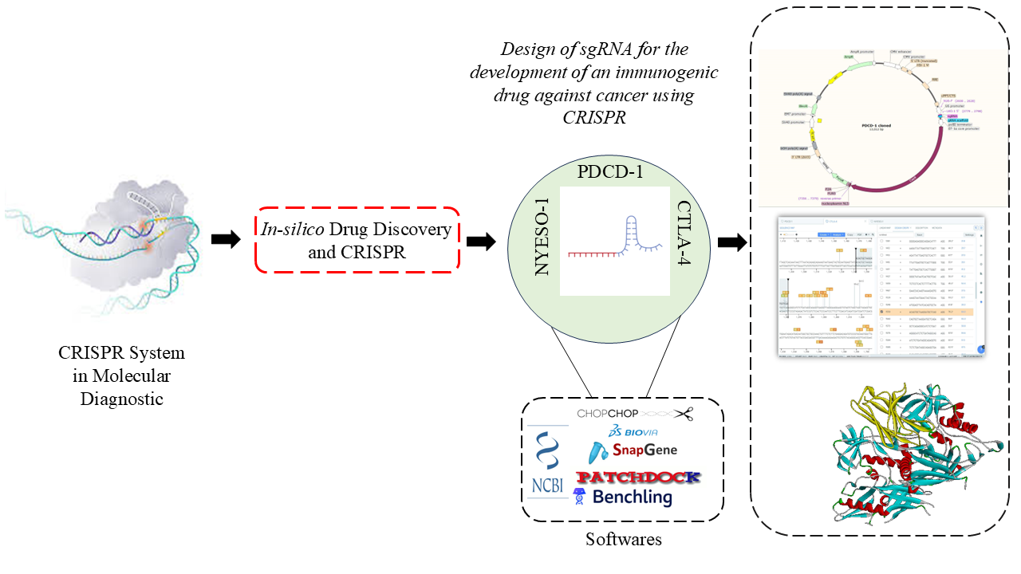

1. **Introduction**

The advent of Clustered Regularly Interspaced Short Palindromic Repeats (CRISPR) and the associated CRISPR-associated proteins (Cas) has profoundly transformed the landscape of genome editing and microbial diagnostics, marking a significant milestone in biotechnology (1). Initially identified as a sophisticated adaptive immune mechanism in prokaryotic organisms, CRISPR-Cas technology has been ingeniously repurposed to facilitate precise and targeted gene editing, as well as to regulate gene expression with remarkable accuracy (2,3). At the core of this innovative technology is the design of single-guide RNA (sgRNA), which plays a pivotal role in determining the efficiency, specificity, and overall success of CRISPR-based interventions. By leveraging advanced computational tools and sophisticated bioinformatics approaches, researchers are now able to meticulously optimize sgRNA sequences, thereby enhancing target recognition and significantly mitigating the risks of off-target effects (4,5).Recent breakthroughs in CRISPR-based diagnostic techniques have enabled rapid and highly sensitive detection of microbial pathogens, which is crucial in clinical settings (6). Notably, platforms like CRISPR-Cas12 and CRISPR-Cas13 capitalize on their unique collateral cleavage activity to produce substantial signal amplification, allowing for the detection of nucleic acids even at attomolar concentrations (7). These cutting-edge methodologies have been successfully implemented to identify a broad range of bacterial and viral pathogens, antibiotic-resistance genes, and genetic variations associated with various diseases (8). Furthermore, the strategic integration of CRISPR technology with sophisticated biosensors and microfluidic devices has significantly enhanced the portability and real-time applicability of these diagnostic systems, making them invaluable tools in clinical diagnostics (9).

In addition to its diagnostic capabilities, CRISPR is emerging as a formidable tool for developing novel therapeutic strategies. By specifically targeting essential genes within microbial pathogens or modulating the immune responses of the host organism, CRISPR-based therapies offer compelling possibilities for precision medicine (10,11). The design and delivery of CRISPR components—including sgRNA and Cas effectors—are critically important for the effectiveness of these therapeutic applications (12). Recent innovations in delivery methodologies, such as lipid nanoparticles, viral vectors, and electroporation techniques, have markedly improved the efficiency of CRISPR delivery, thereby expanding its potential applications in clinical practice (13).This chapter endeavors to explore the fundamental principles underlying sgRNA design, the computational strategies aimed at optimizing the specificity of the CRISPR system, and the latest advancements in CRISPR-based diagnostics and therapeutics. By addressing current challenges and articulating future perspectives, this work aims to illuminate the potential of CRISPR technology in decoding the complexities of microbial genetics and its significant translational implications within the medical field.Ultimately, the findings presented in this study underscore that critical *in-silico* results may play an instrumental role in the development of immunogenic live therapeutics and will serve as a comprehensive foundation for advancing in vitro approaches to cancer treatment, propelling the field toward innovative and effective therapeutic solutions..

1. **CRISPR SYSTEM**

Clustered Regularly Interspaced Short Palindromic Repeats (CRISPR) is a remarkable adaptive defense system found in bacteria to combat infections. It consists of short repeating sequences interspersed with unique spacers, each of the same length but differing in their sequences. (14). It was initially reported by Ishino and colleagues in 1987. The ability of CRISPR-Cas9 for genome editing was recognized in 2012 when Jinek and others showed that it could be customized with guide RNA to accurately identify and cut particular DNA sequences. (15). After the identification of CRISPR sequences, subsequent studies uncovered their function in the adaptive immunity of bacteria, in which CRISPR-associated (Cas) proteins employ small RNA molecules to identify and cut foreign genetic elements (16).The field of genetic engineering has undergone a significant transformation with the introduction of CRISPR-Cas9, an innovative genome-editing tool developed through the collaborative efforts of scientists Jennifer Doudna and Emmanuelle Charpentier. Their pivotal research demonstrated the capability of this system to be programmed for precise modifications of DNA sequences, which has been recognised as a transformative advancement in biological sciences.

Since its inception, CRISPR-Cas9 has revolutionised the methodology of targeted gene modification, enabling researchers to achieve high levels of specificity and efficiency across a diverse range of organisms, including bacteria, plants, and animals (17). Significantly, the applications of CRISPR extend beyond conventional genome editing; it encompasses transcriptional regulation, allowing for the control of gene expression, base editing, which facilitates the precise alteration of nucleotide sequences, and epigenetic modifications that influence gene activity without altering the DNA itself.

Consequently, CRISPR has emerged as an indispensable tool within the realms of molecular biology and biomedical research, facilitating numerous breakthroughs and innovations. Its expansive potential to redefine our understanding of genetics continues to motivate research initiatives globally, affirming its status as a foundational element of contemporary genetic research. (17)

1. **Mechanism of CRISPR**

The adaptive immune system known as CRISPR (Clustered Regularly Interspaced Short Palindromic Repeats) is present in bacteria and archaea and defends against viral infections by identifying and eliminating foreign genetic material (18). The system is composed of two key elements: the CRISPR array, which consists of short repetitive DNA sequences interspaced with unique viral-derived sequences (spacers), and Cas (CRISPR-associated) proteins, which function as molecular scissors to cut invading DNA (19). The CRISPR-Cas mechanism operates in three primary stages: adaptation (spacer acquisition), CRISPR RNA (crRNA) synthesis, and interference (target cleavage) (20).

The adaptation phase happens when a bacterium encounters a new viral infection. During this process, the CRISPR system captures short fragments of the invading viral DNA, called protospacers, and incorporates them into the CRISPR locus as new spacer sequences (21). This process is facilitated by the Cas1-Cas2 complex, which utilizes viral DNA recognition and processing before integrating it into the bacterial genome between short, palindromic repeat sequences (22). The process enables the bacterium to maintain a genetic memory of previous infections, essentially setting up an immunological memory that allows for rapid detection of future infections by the same virus. Importantly, bacteria distinguish self from non-self DNA by depending on the presence of a protospacer-adjacent motif (PAM), a short sequence found in the viral DNA but not in the bacterial CRISPR array, to avoid auto-immunity (23).

The CRISPR locus is transcribed into short RNA molecules known as CRISPR RNAs (crRNAs) (24). When the CRISPR array is transcribed, it produces a long precursor CRISPR RNA (pre-crRNA), which contains all the stored viral sequences (18). The pre-crRNA is processed by endonucleases, such as Cas6 or RNase III (specific to the CRISPR system), which cleave it into smaller crRNAs, each containing a single viral-derived spacer and repeat sequence (25). In Type II CRISPR-Cas systems, a trans-activating crRNA (tracrRNA) plays a role in processing pre-crRNA into mature crRNA by interacting with Cas9 and guiding the complex to target sequences (26). The mature crRNA associates with specific Cas proteins to form an effector complex, which is now programmed to recognize and neutralize future viral infections.

CRISPR interference (CRISPRi) functions through a catalytically inactive Cas9 (dCas9), which binds to a target DNA sequence guided by a single guide RNA (sgRNA). This binding physically blocks RNA polymerase, inhibiting transcription initiation, or elongation thereby repressing gene expression (27). If the same virus enters the bacterium again, the crRNA within the effector complex binds to the complementary sequence found in the viral DNA, enabling the Cas protein to recognize the target site. Recognition is facilitated by the presence of the PAM sequence adjacent to the target region, which is crucial for Cas protein binding and ensures that only foreign DNA is cleaved (28). Once binding occurs, the Cas protein introduces a double-stranded break (DSB) in the viral DNA, effectively disabling the virus and preventing further replication (29). In the Type II CRISPR-Cas9 system, the Cas9 enzyme is responsible for target cleavage, utilizing two nuclease domains: the RuvC domain, which cuts one DNA strand, and the HNH domain, which cuts the complementary strand (24). Other CRISPR variants, such as Cas12, create staggered cuts, whereas Cas13 is specialized for targeting RNA rather than DNA (30).

CRISPR-Cas systems are classified into two major classes according to their protein content. Class 1 systems (including Type I, III, and IV) utilize multi-protein complexes for DNA targeting and cleavage, whereas Class 2 systems (including Type II, V, and VI) rely on a single protein, such as Cas9, Cas12, or Cas13, for interference (31).Among these, CRISPR-Cas9 has emerged as the most widely used system in genome editing due to its simplicity and efficiency (32). Along with Cas9, other enzymes such as Cas12 have also been investigated for genome engineering, as they exhibit distinct targeting properties, including single-stranded DNA cleavage (33). Meanwhile, Cas13 has been adapted for RNA editing, expanding the potential applications of CRISPR technology beyond gene editing (34).

1. **Types of CRISPR SYSTEM**

CRISPR-Cas systems are categorized into two major classes based on their structural complexity and mechanism of action: Class 1, which relies on multi-protein complexes for target recognition and cleavage, and Class 2, which utilizes a single effector protein for interference (35). Class 1 systems include Type I, Type III, and Type IV. Type I systems, the most widespread, employ a multi-protein complex known as Cascade (CRISPR-associated complex for antiviral defense) to recognize target DNA, followed by degradation via Cas3, which has both nuclease and helicase activity (36). Type III systems are unique because they target both DNA and RNA, using Cas10 as the primary effector protein. Additionally, Type III systems can generate secondary signaling molecules that activate other bacterial defense mechanisms (37). Type IV systems are less understood and are mainly associated with plasmids and mobile genetic elements, playing potential roles in gene regulation (38).

In Class 2 systems include Type II (Cas9), Type V (Cas12), and Type VI (Cas13),  all of which use a single large Cas protein to mediate interference (39). Type II systems, best exemplified by Cas9, are the most widely known and used due to their ability to introduce precise double-stranded breaks in DNA (40). Cas9 requires both a CRISPR RNA (crRNA) for target recognition and a trans-activating crRNA (tracrRNA) for maturation and function (41). The recognition of a protospacer adjacent motif (PAM) sequence ensures specificity and prevents self-targeting (23). Type V systems, such as Cas12, also target DNA but generate staggered cuts instead of blunt cuts like Cas9 (42). Additionally, Cas12 exhibits collateral cleavage activity, where it degrades surrounding nucleic acids upon activation, making it valuable for DNA-based diagnostics like DETECTOR (33). Type VI systems, represented by Cas13, are distinct because they exclusively target RNA rather than DNA. Once activated, Cas13 exhibits collateral RNA degradation, making it useful for RNA-based detection methods like SHERLOCK and potential RNA-targeted therapies (43).

Each CRISPR system has unique advantages, with Cas9 being the most widely used for genome editing, Cas12 emerging as a powerful tool for diagnostics and gene modification, and Cas13 showing promise for RNA-based applications. These diverse CRISPR types continue revolutionizing biotechnology, medicine, and synthetic biology, offering new possibilities for gene therapy, disease diagnostics, and antimicrobial strategies.

1. **Application of CRISPR SYSTEM**

CRISPR technology has emerged as a transformative tool in genetic engineering, significantly impacting fields such as disease treatment, molecular diagnostics, studies on microbial resistance, and synthetic biology. Its versatility enables precise modifications to the genome, effective gene regulation, and epigenetic editing, rendering it essential for both research and clinical applications.

1. ***CRISPR in Genome Editing and Gene Therapy***

CRISPR-Cas9 and its advanced variants, including base editing and prime editing, have significantly advanced the field of targeted gene modification, facilitating the correction and disruption of genes. These innovations have led to the development of promising therapeutic strategies for various genetic disorders. CRISPR technology has been effectively utilized to rectify mutations responsible for conditions such as sickle cell anaemia and Duchenne muscular dystrophy (DMD) by modifying hematopoietic stem cells or muscle cells, thereby restoring normal gene function (44,45).Prime editing is a novel gene editing technique that differs from traditional methods by eliminating the need for double-strand breaks in DNA. This characteristic minimizes off-target effects, thereby enhancing the safety of its application in therapeutic contexts (46).CRISPR technology has been utilized to engineer immune cells, specifically chimeric antigen receptor T cells (CAR-T cells), enhancing their capacity to recognize and eliminate malignant cells. This advancement demonstrates significant potential for the development of personalized cancer therapies tailored to the unique characteristics of individual patients (Liu et al., 2020). CRISPR-based antiviral strategies have been investigated for the targeted therapeutics of viral DNA and RNA, encompassing notable pathogens such as HIV, hepatitis B virus (HBV), and SARS-CoV-2. This approach presents a potentially transformative avenue for developing effective treatments against these viral infections (47).

1. ***CRISPR in Molecular Diagnostics***

CRISPR-based detection systems are transforming the methodologies employed in the identification of pathogens and the screening for genetic diseases. Two notable examples are the SHERLOCK and DETECTR systems, which leverage the distinctive properties of Cas12 and Cas13 proteins. These systems possess a remarkable capacity for the accurate detection of specific DNA and RNA sequences, facilitating rapid and sensitive identification of a variety of pathogens. Additionally, they provide a cost-effective solution, positioning them as significant advancements in the domains of diagnostics and disease control (6,48).CRISPR diagnostics have significantly advanced the detection of diseases such as COVID-19, tuberculosis, and Zika virus. These innovations present clear advantages over traditional PCR methods, particularly regarding speed and accuracy. This groundbreaking technology exemplifies how novel approaches can enhance our capacity to diagnose and respond to infectious diseases effectively (49,50). The development of portable CRISPR-based diagnostic test kits is designed to improve field diagnostics, thereby enhancing the accessibility of disease detection in resource-limited settings. This innovative approach has the potential to facilitate timely medical interventions and increase healthcare equity. (51)

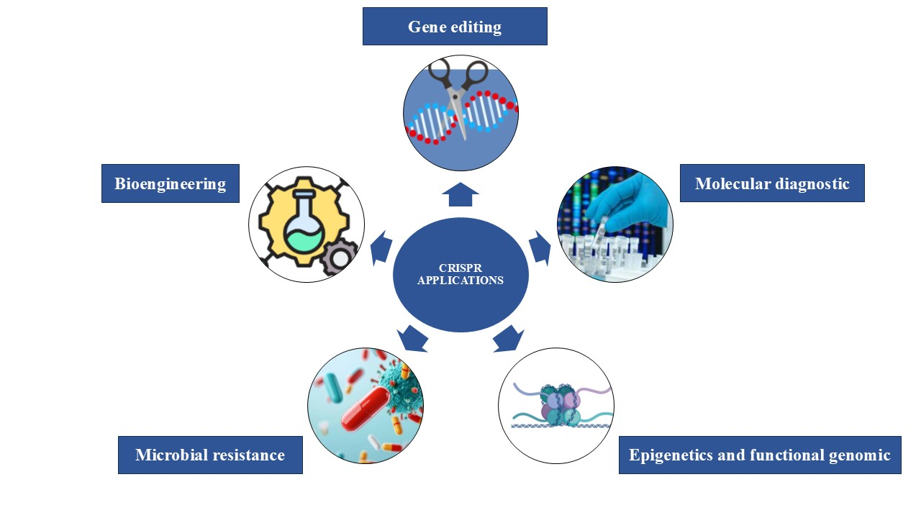**Figure 1: Application of CRISPR**

***C. CRISPR for Microbial Resistance Studies***

The application of a CRISPR-Cas-based approach for the targeted removal of specific bacterial populations presents a promising and innovative strategy for developing new antimicrobial agents. The CRISPR-Cas targeting system is well-regarded for its exceptional versatility and specificity, providing a significant opportunity to combat antibiotic resistance in pathogens by selectively disrupting genes associated with antibiotic resistance, biofilm production, pathogenicity, virulence, or bacterial survival (52),CRISPR interference (CRISPRi) can selectively knock down resistance genes in bacteria, allowing researchers to investigate their role in antimicrobial resistance Engineered bacteriophages with CRISPR systems can selectively target and eliminate antibiotic-resistant bacteria, providing an alternative to traditional antibiotics (52).

***D. CRISPR in Epigenetic and Functional Genomics Studies***

CRISPR technology facilitates precise gene regulation and epigenetic modifications without altering the underlying DNA sequence. The methodologies of CRISPR Interference (CRISPRi) and CRISPR Activation (CRISPRa) are instrumental in silencing or activating specific genes, thereby enhancing functional studies of virulence genes in organisms responsible infection (53).CRISPR technology is utilized to modify DNA methylation and histone modifications, providing valuable insights into gene expression patterns associated with microbial pathogenesis and host immune responses (54)This information may prove valuable in analyzing virulent gene expression in bacteria and developing innovative therapeutic strategies to target epigenetic regulation.

**E. *CRISPR in Synthetic Biology and Bioengineering***

CRISPR technology has significantly advanced the engineering of microbial strains for applications in industrial, agricultural, and environmental contexts. Specifically, CRISPR has been utilised to enhance probiotic strains by improving their antimicrobial properties. This advancement presents opportunities for the exploration of these engineered probiotics in the prevention and treatment of various health conditions (55). CRISPR-modified crops that are better at fighting off diseases and packed with more nutrients could be game-changers for sustainable farming. These advancements hold a lot of potential to improve our food system and make agriculture more resilient in the face of challenges. CRISPR-modified crops that exhibit enhanced disease resistance and improved nutritional content present significant opportunities for advancing sustainable agriculture. These innovations have the potential to enhance food security while promoting environmentally responsible farming practices (56). CRISPR-modified microorganisms are being employed to enhance the efficiency of biofuel production and biopolymer synthesis, thereby reducing dependence on fossil fuels. This innovative approach signifies a substantial advancement in the pursuit of sustainable energy solutions and environmentally friendly materials (Wei and Li, 2023).

CRISPR-based diagnostics utilise the programmability and specificity of CRISPR-*Cas* systems to detect pathogens, biomarkers, and genetic mutations. Bioinformatics and in silico methods are indispensable in the pre-analysis stage, maximising CRISPR-based diagnostics by informing target selection, efficient guide RNA (gRNA) design, and off-target effects prediction.

***F. Bioinformatics Role in CRISPR Diagnostics:***

*Target Selection and Identification:* Bioinformatics software scans genomic sequences for disease-associated mutations, pathogens, or unique biomarkers. NCBI, Ensembl, and UCSC Genome Browser databases assist in pulling out specific genetic information for diagnostic targets.

*gRNA Design and Optimization:* gRNAs should be designed to bind target sequences specifically with minimal off-target activity. Software such as CRISPR-*Cas* Designer, CHOPCHOP, and Benchling aid in the identification of the most effective gRNAs. Thermodynamic modelling provides gRNA stability and binding efficacy.

*Off-Target Prediction and Specificity Analysis:* Off-target effects may generate false-positive results in diagnostics. Bioinformatics tools like CRISPResso2, CCTop, and Cas-OFFinder predict possible off-target sites and optimize gRNA selection.

***G. In-silico* Approaches for CRISPR Pre-Analysis**:

*Computational Modeling of CRISPR-Cas Interactions:* Molecular dynamics simulations forecast how CRISPR enzymes bind to DNA/RNA targets. Structural biology tools like PyMOL, Chimera, and AlphaFold facilitate the visualisation and optimisation of CRISPR complexes.

*Machine Learning for CRISPR Efficiency Prediction:* AI-based models examine large datasets to forecast the efficacy of CRISPR-based detection. Algorithms such as Deep-CRISPR determine the probability of effective target identification and cleavage.

Virtual Screening of CRISPR-Based Assays:

Computational simulations screen CRISPR diagnostic assays before laboratory implementation. *In-silico* screening saves experimental expenses by determining optimal *Cas* proteins and reaction conditions.

***H. Drug development (in-silico) and CRISPR***

*Experimental Study 1:* *Design of sgRNA for the development of an immunogenic drug against cancer using CRISPR*

This portion will elaboratively explain the design of sgRNA for immunogenic drug development with performed exercise. Genome editing uses tools and techniques to manipulate any organism's underlying genetic code or sequence. These changes can include the addition or deletion of base sequences. In this technology, the sequence of the genome can be altered or manipulated precisely to attain a therapeutic effect on the improvement of human life (58). Nowadays, the three primary and most used types of genome editing mechanisms include programmable nucleases like ZFNs, TALENs, and CRISPR (Clustered Regularly Interspaced Short Palindromic Repeats). They follow the DNA repair pathways NHEJ and HDR through DSB on the target (59). The first technologies (ZFNs and TALENs) now suffer from inferior specificity of their off-target side effects (60). Recent advances in CRISPR as a genome-editing tool have become the most powerful technology in genetic engineering (59). CRISPR-based gene editing technology has the potential to revolutionize cancer treatment by enabling precise and effective modification of the genome to target specific genetic mutations that contribute to tumour development and spread (61). CRISPR system with Cas9 protein-coding genes is the more valuable, vigorous, and multiplexable genome editing tool among all other types because, firstly, it has the function as a single protein effector molecule, which does not require other helping *Cas* proteins, unlike in-class I types of *Cas* proteins. Secondly, a *CRISPR/Cas9* contains a nonspecific Cas9 nuclease with a designable sequence-specific CRISPR-RNA (crRNA), which able to guide Cas9 along with Tra- crRNA (trans-activating CRISPR-RNA), spacer sequences, and PAM (proto-spacer adjacent motif) sequence (5’-NGG-3’) to slice DNA and generation of the double-strand breaks of the target sites. Thirdly, it has two functional domains *viz.* HNH nuclease and RuvC-like nuclease domains for DSB generation on the target site. So, among all the types of the CRISPR/*Cas* system, researchers found that *CRISPR/Cas9* is the more impressive whole genome-editing tool than others (62). In some recent preclinical spectrums, *CRISPR/Cas9* entrenched effective strategies further analyzed with phase 1 and 2 trials to expand its clinical applications (63).

In the *CRISPR/Cas9* mechanism, transcribed pre-Cr RNA of CRISPR/Cas9 first forms RNA duplex with Tra-crRNA because of some partly complementary to pre-crRNA. RNase III and an RNA-specific ribonuclease cleaves this duplex for the formation of a crRNA: Tra-crRNA hybrid known as single-guide RNA (sgRNA) (64). CRISPR/Cas9 has a unique way of working that makes it effective for targeting specific genes. This technology uses a type of RNA called sgRNA to create gene knockouts in various species. By introducing the right sgRNA, CRISPR can make precise cuts in the DNA at specific locations. This careful design of sgRNA improves the technology's accuracy and results in better gene modifications compared to other methods, such as RNA interference (RNAi) (65).

*In recent years*, cancer immunotherapy has made a significant breakthrough, using monoclonal antibodies to block the CTLA-4 and PD-1 immune checkpoints, which has led to autoimmune side effects. This shows the use of tumour antigens, specifically cancer/testis antigens (CTA), in cancer immune therapy can help treat tumours (66). NY-ESO-1 (New York oesophageal squamous cell carcinoma 1) is a cancer-testis antigen (CTA) that shows the most valuable and promising criteria among all CTA for cancer immunotherapy as its tumour expression is correlated to extort humoral and cellular immune responses, in tandem with its restricted expression pattern in a wide range of malignancies (67). In the Immune system, T cells (T-helper cells and cytotoxic T cells) are essential in the human body to protect the body from infection by pathogens. It also clears the mutant cells through specific recognition of antigens or immunogens by T cell receptors (TCRs). One study also executed effective T-cells against cancer in PD-1 deficient mice (68). Thus,  researchers found that unleashing the inhibition of immune checkpoints such as CTLA-4 and PD-1 along with modification of T cell receptors by genetic engineering of NY-ESO1 on it generates genetically engineered T cells which able to boost the antitumor activity of T cells (69).

Lentiviruses (HIV) and retroviruses have the advantage that they can reliably integrate DNA into host cells, providing long-term expression, and another is the tolerance capacity for extensive inserts (70). It makes it easier to think about developing the drug within the virus coat and surface immunogenic substances so immune cells can only invade them. Likewise, machinery inside the CRISPR/Cas9 system can help develop a drug that can automatically invade immune cells and deliver the CRISPR/Cas9 into immune cells. The lentivirus-based vectors are more valuable because they hold pseudo-HIV regions that allow the vector to express into a host and synthesize a new immunogenic drug, which consists of HIV coat to attack immune cells; it consists of CRISPR/Cas9 system along with specific sgRNAs as genetic material and the whole pseudo-organism acts as a living immunogenic drug.

This study aimed to design an immunogenic “Living drug” for cancer treatment using an *in-silico* approach and for *in-vitro* findings as a future application.

**H.1.Methodologies**

***Tools and databases***

Chop-chop: ChopChop is a bioinformatics tool used for designing guide RNAs (gRNAs) for CRISPR-based gene editing. It helps researchers identify the most effective target sites in a given DNA sequence while minimizing off-target effects. ChopChop is widely used in genetic engineering, functional genomics, and therapeutic research due to its efficiency and accuracy. It supports various CRISPR-associated nucleases like Cas9 and Cas12, as well as RNA-targeting enzymes like Cas13. The tool provides a user-friendly interface, allowing scientists to input genetic sequences and receive optimized gRNA designs along with visualized results. Its ability to analyze multiple genomes makes it a valuable resource for gene-editing applications across different organisms (71).

CRISPR off

CRISPRoff is a gene-editing tool that enables reversible, heritable, and highly specific gene silencing without altering the DNA sequence. Unlike traditional CRISPR-Cas9, which cuts DNA, CRISPRoff works by adding epigenetic modifications, such as DNA methylation, to suppress gene expression. This approach allows for precise gene regulation while maintaining the ability to reverse the changes using CRISPR, a complementary system that removes the modifications. CRISPRoff is particularly useful in studying gene function, developing therapeutic applications, and creating stable gene silencing models without permanent genetic alterations, making it a powerful tool for epigenetic research and potential medical advancements

CRISPRdirect

CRISPRdirect is an online tool designed for the rapid and accurate design of single guide RNAs (sgRNAs) for CRISPR-based genome editing. It allows users to input a target DNA sequence and identifies optimal sgRNA sequences while minimizing off-target effects. The tool analyzes potential binding sites across the genome and filters out sgRNAs that may lead to unintended mutations. CRISPRdirect supports various CRISPR-associated nucleases, such as Cas9 and Cpf1 (Cas12a), and provides genome-wide specificity checks for multiple organisms. Its simple and efficient interface makes it a valuable resource for researchers aiming to design precise and effective CRISPR experiments (72).

*CRISPR-Cas Designer*

CRISPR-Cas Designer is a bioinformatics tool that facilitates the design of highly specific single guide RNAs (sgRNAs) for CRISPR-based genome editing. It allows researchers to input a target gene or DNA sequence and provides optimized sgRNA sequences by evaluating factors such as on-target efficiency and potential off-target sites. The tool supports various CRISPR-associated nucleases, including Cas9 and Cas12a, and offers genome-wide specificity analysis for multiple organisms. CRISPR-Cas Designer is particularly useful for precision gene editing, functional genomics studies, and therapeutic applications, making it a valuable resource for researchers working in molecular biology and genetic engineering .

*CCTop (CRISPR-Cas9 Target online predictor)*

CCTop (CRISPR-Cas9 Target online predictor) is a bioinformatics tool designed for the identification and evaluation of target sites for CRISPR-Cas9 genome editing. It allows researchers to input a DNA sequence and provides optimized single guide RNA (sgRNA) candidates by analyzing factors such as on-target efficiency and off-target effects. CCTop supports multiple genomes and enables users to customize parameters such as PAM sequences and mismatches to refine sgRNA selection. The tool helps ensure precise gene editing with minimal unintended modifications, making it a valuable resource for genetic engineering, functional genomics, and therapeutic research (73)

*Cas-OFFinder*

Cas-OFFinder is a computational tool designed to identify potential off-target sites for CRISPR-Cas9 and other CRISPR-associated nucleases. It efficiently scans entire genomes to detect mismatches, insertions, and deletions between the designed single guide RNA (sgRNA) and unintended genomic sites. Cas-OFFinder is particularly useful for researchers aiming to minimize off-target effects in gene-editing experiments, ensuring higher precision and safety. The tool supports multiple PAM sequences and allows users to customize mismatch tolerance, making it suitable for various CRISPR applications, including functional genomics and therapeutic research. Its high-speed performance and compatibility with different organisms make it a valuable resource for CRISPR-based studies.Sequence retrieval of gene targets (74)

The nucleotide sequences of three targeted genes, PDCD-1, CTLA-4, and NY-ESO FASTA formats, were downloaded from NCBI (National Centre for Biotechnology Information).

Benchling

Benchling is a cloud-based online platform designed for life sciences research, offering a suite of tools for molecular biology, lab management, and collaboration. It provides features such as CRISPR guide RNA (sgRNA) design, sequence analysis, plasmid mapping, and experiment tracking. Researchers can design, edit, and annotate DNA and protein sequences while integrating data across various workflows. Benchling also includes electronic lab notebooks (ELNs) and inventory management tools, making it a comprehensive solution for academic and industrial biotech research. Its real-time collaboration capabilities allow teams to work efficiently, ensuring streamlined data sharing and project management in CRISPR gene editing, synthetic biology, and drug discovery (https://www.benchling.com/)

*SnapGene*

SnapGene is a molecular biology software designed for DNA sequence visualization, annotation, and cloning simulation. It allows researchers to design, edit, and analyze plasmid maps, PCR products, and other genetic constructs with an intuitive graphical interface. One of its key features is the ability to simulate molecular cloning techniques, including Gibson assembly, restriction cloning, and Golden Gate assembly. SnapGene also supports CRISPR guide RNA (sgRNA) design and provides tools for primer design, sequence alignment, and mutation analysis. Its ability to store a complete history of sequence modifications makes it valuable for tracking experimental changes. Widely used in academic and industrial research, SnapGene simplifies genetic engineering workflows and enhances collaboration in molecular biology and synthetic biology projects (75) .

*Addgene*

Addgene is a nonprofit plasmid repository that provides scientists with a vast collection of plasmids for research, particularly in molecular biology and genetic engineering. It serves as a global resource for sharing and distributing plasmids, including those for CRISPR-Cas9 gene editing, viral vectors, fluorescent reporters, and synthetic biology applications. Researchers can deposit their plasmids into Addgene, making them accessible to the scientific community, which helps standardize and accelerate research. The platform also offers detailed protocols, sequence data, and tools for plasmid design and analysis. Addgene plays a crucial role in advancing biological research by promoting collaboration and reproducibility in labs worldwide (76).

*PatchDock*

PatchDock is a molecular docking algorithm designed for the computational prediction of protein-protein, protein-DNA, and protein-ligand interactions. It follows a shape complementarity-based docking approach, where molecules are treated as geometric shapes, and docking solutions are generated based on their surface complementarities. PatchDock efficiently identifies binding conformations by detecting shape-matching regions and filtering out steric clashes. The algorithm is widely used in drug discovery, structural biology, and computational chemistry to model molecular interactions. Its ability to handle large molecules and provide high-throughput docking solutions makes it a valuable tool for researchers studying biomolecular interactions and drug design (77) .

*FireDock*

FireDock (Fast Interaction Refinement in Molecular Docking) is a computational tool used for refining molecular docking solutions, particularly for protein-protein and protein-ligand interactions. It is often used as a post-processing tool for PatchDock, improving docking accuracy by optimizing molecular flexibility and energetics. FireDock refines docking poses by minimizing steric clashes, optimizing side-chain conformations, and re-ranking solutions based on binding energy calculations. The tool is widely used in structural biology, drug discovery, and computational chemistry to enhance the reliability of docking predictions. Its efficiency and accuracy make it valuable for refining biomolecular interactions and predicting stable binding conformations (78).

*BIOVIA Discovery Studio*

BIOVIA Discovery Studio is a comprehensive molecular modelling and simulation software suite designed for computational chemistry, molecular docking, and drug discovery. Developed by Dassault Systèmes, it provides a wide range of tools for protein-ligand docking, molecular dynamics simulations, pharmacophore modelling, QSAR analysis, and ADMET prediction. Discovery Studio supports structure-based and ligand-based drug design, allowing researchers to analyze biomolecular interactions, optimize lead compounds, and predict molecular properties. It features an intuitive graphical interface, making it accessible for both academic and industrial researchers in bioinformatics, cheminformatics, and structural biology (79). Widely used in pharmaceutical and biotechnology research, Discovery Studio facilitates rational drug design and accelerates the development of novel therapeutics.

**H.2.Sequence retrieval of gene targets**

The nucleotide sequences of three targeted genes, PDCD-1, CTLA-4, and NY-ESO FASTA formats, were downloaded from NCBI (National Centre for Biotechnology Information).

**H.3.Design sgRNA of targeted genes**

The sgRNAs of targeted genes were designed to use Benchling online software. Downloaded nucleotide sequences were given where software intended the number of possible sgRNAs within its on-target activity (specificity score) and off-target activity (efficiency score) through CRISPR design and analyzed guide tool in it.

**H.4.Design immunogenic living drug**

The two vectors of the lentivirus-HIV-based CRISPR were selected from the Addgene home page to perform *in-silico* cloning. Gene knock-out lentiCRISPRv2 was performed, and for insertion, pCas-Guide-EF1a-CD4 was selected. Along with it, designed sgRNAs were prepared as a gene to insert in cloning using SnapGene offline software. According to their respective vectors, the restriction sites were created for both ends of sgRNAs. For PDCD-1 and CTLA-4, to create sticky ends nucleotides ‘CGTCTCACACC’ (bases for BsmBI restriction site) on 5’prime and another end nucleotide, ‘GTTTTGAGACG’ (bases to create BsmBI restriction site on 3’prime) was inserted. Whereas for NYESO-1, BamHI Restriction site on start 5’ prime by adding nucleotide ‘GGATC’ to create BsmBI Restriction site on another end nucleotide ‘TTTTGGAGACG’ inserted. Then, by using the restriction and insertional cloning tool of SnapGene, *in-silico* cloning of prepared PDCD-1 and CTLA-4 inserts with lentiCRISPRv2 vector and NYESO-1 insert with pCas-Guide-EF1a-CD4 was performed.

*In-vitro* isolation of the lentivirus (pseudo-HIV within designed vectors, called immunogenic living drug) can be done using a favourable host, for example, HEK 293(Human embryonic kidney 293 cells) derived suspension cells. The Gibco LV-MAX Lentiviral Production system of Thermo Fisher SCIENTIFIC is the first optimized system that provides all the high-quality components you need in a chemically defined, serum-free environment along with the protocol. (<https://www.thermo-fisher.com/in/en/home/life-science/cell-culture/transfection/lentiviral-vector-production>)

**H.5.Analysis of protein-protein interactions**

Protein-protein docking was performed using PatchDock online software to analyze the binding efficiency of designed immunogenic living drugs. The HIV gp120 core protein, T cell receptor CD4+ protein, and T cell receptor CD8+ protein were downloaded from PDB (protein data bank). The receptor (HIV gp120 protein) was prepared by removing extra ligands and water molecules in the BIOVIA Discovery studio (**figure 1**). The binding energy score as a binding efficiency was performed using PatchDock followed by FireDock.

**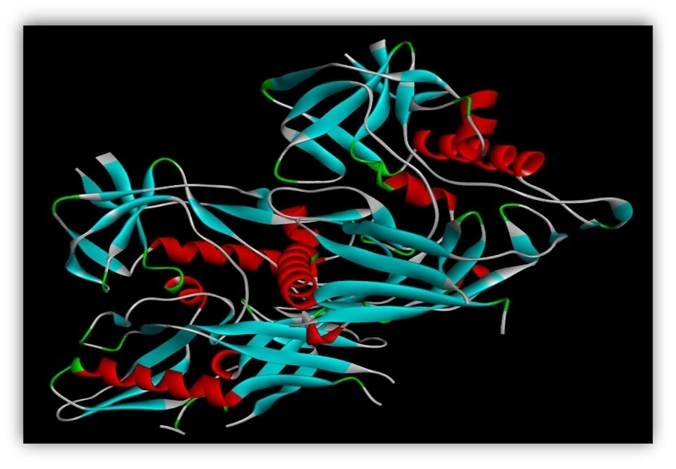*Figure 2: Modified structure of HIV enveloped core protein gp120***

**H.6.Observations**

CRISPR/Cas9 genome editing tool is recognized as a dominant genome-editing tool, enabling researchers to precise modification of genomic sequences and helping change target gene function in the cure of many diseases (62). Cancer is now one of the most popularly diagnosed diseases, and it can be cured by using an immunogenic living drug. The following results are obtained to design precise and impactful sgRNA for immunogenic cancer drug design.

**H.7.Data retrieval is based on the experimental requirement.**

The three genes were selected as the experimental targets. The sgRNAs for the genes should be designed first using the CRISPR/Cas9 system to target them for knock-out/knock-in. To create the sgRNAs, the FASTA sequences of all three genes (PDCD-1, CTLA-4, and NYESO-1) were downloaded from the NCBI gene databank.

**H.8.Selection of designed sgRNAs**

The sgRNAs for all three genes were designed using the Benchling bioinformatics tool. The Benchling supplies all the possible sgRNAs for the selected target region on the genes. The starting regions sgRNAs were mainly chosen for better specificity and efficiency (80). Because targeting end regions of the genes does not give proper efficiency and specificity for gene knockout/in, from all the designed sgRNAs, sgRNAs with specificity and efficiency scores near 100 were selected (**figure 2**). The sgRNA for the PDCD-1 gene “CTATTTTGGAATCCACCCCG” was chosen with its reasonable specificity and efficiency score (Table 1). Likewise, the sgRNAs for CTLA-4 and NYESO-1 genes were “ACAGTGCTAAGGATGCTCAG” and “TTCTGACAGTTCTGGTGGCG” selected respectively (**Table-2 and Table-3**).

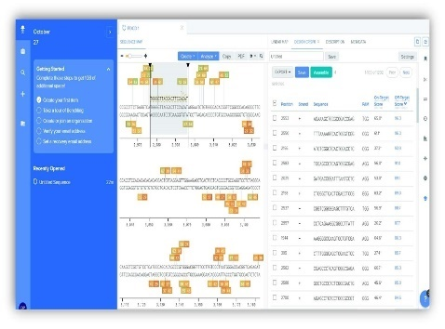

**Figure 3: Selected PDCD-1, CTLA-4 and NYESO-1 sgRNAs with on-target and off-target scores near 100**

**Table 1 : Designed sgRNAs for PDCD-1 gene, selected sgRNA highlighted in light blue.**

|  |  |  |  |  |  |
| --- | --- | --- | --- | --- | --- |
| **Position** | **Strand** | **Sequence** | **PAM** | **Specificity**  **Score** | **Efficiency**  **Score** |
| **3760** | -1 | CTATTTTGGAATCCACCCCG | GGG | 84.39 | 73.86 |
| **2553** | -1 | CTGTTTAAAAGCCACTCGGT | CGG | 82.61 | 67.05 |
| **2161** | -1 | GAGAATTGCTTGAGCCCCGG | AGG | 80.43 | 67.25 |
| **2994** | 1 | TGGGGTTAGGACTTCCACAT | AGG | 69.72 | 72.64 |

**Table 2:Designed sgRNAs for CTLA-4 gene selected sgRNA highlighted in light blue.**

|  |  |  |  |  |  |
| --- | --- | --- | --- | --- | --- |
| **Position** | **Strand** | **Sequence** | **PAM** | **Specificity**  **Score** | **Efficiency**  **Score** |
| **1559** | 1 | ACAGTGCTAAGGATGCTCAG | AGG | 64.04 | 76.23 |
| **1693** | -1 | CTTCCACCAAGCCACTTGCA | CGG | 63.62 | 60.23 |
| **1777** | -1 | CCAATTCCAATCTATCACTC | TGG | 77.66 | 56.55 |
| **1798** | 1 | AGATTGGAATTGGATCATGG | GGG | 60.70 | 71.89 |
| **1927** | 1 | ACTTGTCAGACTGACTGGAG | AGG | 69.84 | 63.28 |
| **1949** | 1 | GGGCCTGGTTAGTTACAGGA | AGG | 67.22 | 66.65 |

**Table 3:Designed sgRNAs for NYESO-1 gene, selected sgRNA highlighted in light blue.**

|  |  |  |  |  |  |
| --- | --- | --- | --- | --- | --- |
| **Position** | **Strand** | **Sequence** | **PAM** | **Specificity**  **Score** | **Efficiency**  **Score** |
| **389** | 1 | TTCTGACAGTTCTGGTGGCG | AGG | 77.65 | 56.61 |
| **461** | 1 | GGAGATGCGAGTAAGTGGT | GGG | 73.78 | 52.34 |
| **514** | 1 | GATATGAGAGGCCAGCTGC | AGG | 68.00 | 67.29 |

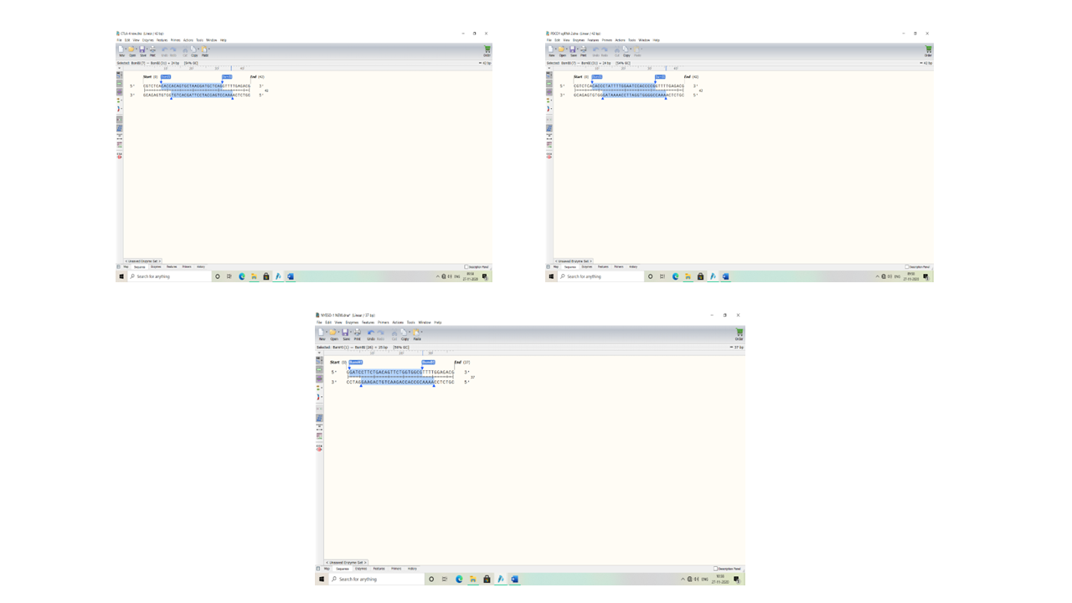

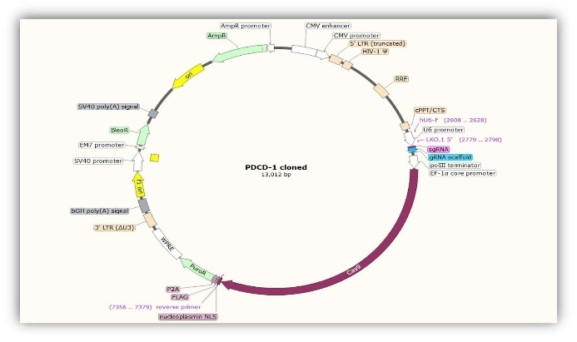**Figure 4: Edited PDCD-1, CTLA-4 and NYESO-1 sgRNA for insertion**

**Figure 5: Cloned PDCD-1 and CTLA-4 gene into lentivrirusv2 cloning vector along with its sequence, sgRNA highlighted in pink.**

**H.9.Lentivirus-based immunogenic living drug designing.**

LentiCRISPRv2 is the lentivirus-based vector consisting of a CRISPR/Cas9 system (35) along with pseudo-HIV regions, which allows the formation of HIV viral coat, selected for knockout of PDCD-1 and CTLA-4 genes. The pCas-Guide-EF1a-CD4 is also a lentivirus-based vector consisting of a *CRISPR/Cas9* system, pseudo-HIV regions, and truncated CD4 gene, which allows knock-in by specific Cas9 enzyme. Besides that, all three target genes were prepared by editing restriction sites on both edges of genes through SnapGene (figure 3). Then, restriction and insertional cloning were performed using BsmBI restriction enzyme sites of the LentiCRISPRv2 vector and BamHI and BsmBI restriction sites of the pCas-Guide-EF1a-CD4 vector. The PDCD-1 and CTLA-4 sgRNAs were inserted into LentiCRISPRv2 (**figure 4**) and NYESO-1 sgRNA into the pCas-Guide-EF1a-CD4 vector (**figure 5**). A clinical study using Cas9-edited T cells in cancer patients may preclude an immune response to exogenous peptides. This cloning Graphical user interface, text, application, email
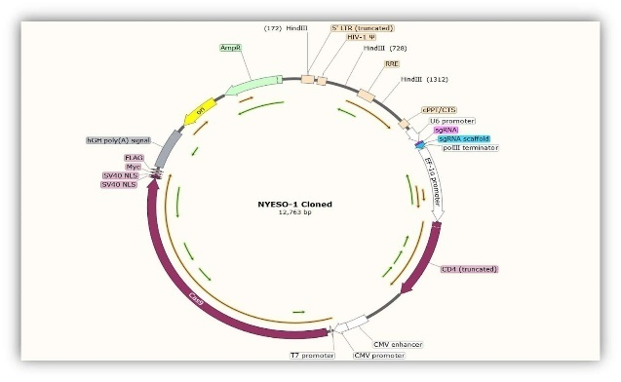strategy can effectively limit the use of CRISPR Cas9

***Figure 6: Cloned NYESO-1 gene into pCas-Guide-EF1a-CD4 cloning vector along with its sequence, sgRNA highlighted in pink.***

**H.10.Protein-Protein Docking**

The protein-protein docking was executed to analyze protein-protein interactions and their binding efficiency. The docking was performed using PatchDock, followed by FireDock online docking tools. PatchDock exemplifies the results according to molecular shape representation, surface patch matching, and filtering, scoring and ranking the structures based on geometric shape complementarity score (81). The highest score stands for the best complementarity of two proteins. The highest-ranked structure was selected for HIV gp120 and CD4+ and HIVgp120 and CD8+ on PatchDock. After that, the results of PatchDock's best 10 models were continued for FireDock. FireDock is used to facilitate PatchDock algorithm results by giving a binding score based on binding free energy (global energy), Atomic Contact Energy (ACE), softened van der Waals interactions, partial electrostatics, and hydrogen bonding (82).

**Table 4-:Protein-Protein Docking result of gp120 and CD4+ on FireDock**

|  |  |  |  |  |  |  |
| --- | --- | --- | --- | --- | --- | --- |
| **Rank** | **Solution Number** | **Global Energy** | **Attractive VdW** | **Repulsive VdW** | **ACE** | **HB** |
| 1 | 3 | -7.58 | -38.18 | 34.75 | 14.95 | -6.69 |
| 2 | 6 | -3.75 | -7.78 | 2.86 | -3.79 | 0.00 |
| 3 | 4 | 28.28 | -33.86 | 95.34 | -2.32 | -3.01 |
| 4 | 8 | 193.51 | -56.83 | 331.43 | 14.05 | -5.33 |
| 5 | 10 | 590.60 | -41.73 | 811.59 | -6.27 | -1.59 |
| 6 | 9 | 1008.87 | -51.71 | 1304.40 | 25.08 | -8.94 |
| 7 | 1 | 1044.32 | -70.88 | 1385.30 | 26.17 | -8.86 |
| 8 | 5 | 2097.43 | -66.85 | 2719.39 | 17.14 | -6.04 |
| 9 | 7 | 2375.66 | -55.93 | 3046.01 | 2.66 | -9.15 |
| 10 | 2 | 3667.12 | -93.99 | 4707.94 | 18.63 | -10.81 |

**Figure 7 : Structure of docked proteins (i) HIV gp120 protein into blue, red, and green colour and (ii) T cell receptor CD4+ into yellow colour**

**Table 5: Protein-Protein Docking result of gp120 and CD8+ on FireDock**

|  |  |  |  |  |  |  |
| --- | --- | --- | --- | --- | --- | --- |
| **Rank** | **Solution Number** | **Global Energy** | **Attractive VdW** | **Repulsive VdW** | **ACE** | **HB** |
| 1 | 8 | -17.63 | -19.87 | 7.08 | 7.00 | -2.88 |
| 2 | 1 | -11.48 | -23.79 | 16.39 | 3.96 | -1.80 |
| 3 | 2 | -4.99 | -34.61 | 25.11 | 11.20 | -5.10 |
| 4 | 6 | 0.60 | -6.31 | 2.57 | 0.25 | -0.82 |
| 5 | 7 | 3.93 | -5.59 | 0.10 | 2.51 | -0.48 |
| 6 | 9 | 6.99 | -4.88 | 7.20 | 3.38 | -1.26 |
| 7 | 10 | 20.89 | -1.54 | 0.00 | 2.15 | 0.00 |
| 8 | 4 | 27.51 | -19.47 | 37.78 | 14.00 | -2.60 |
| 9 | 5 | 32.74 | -23.26 | 8.33 | 16.17 | -2.41 |
| 10 | 3 | 314.88 | -40.68 | 470.26 | -0.66 | -7.08 |

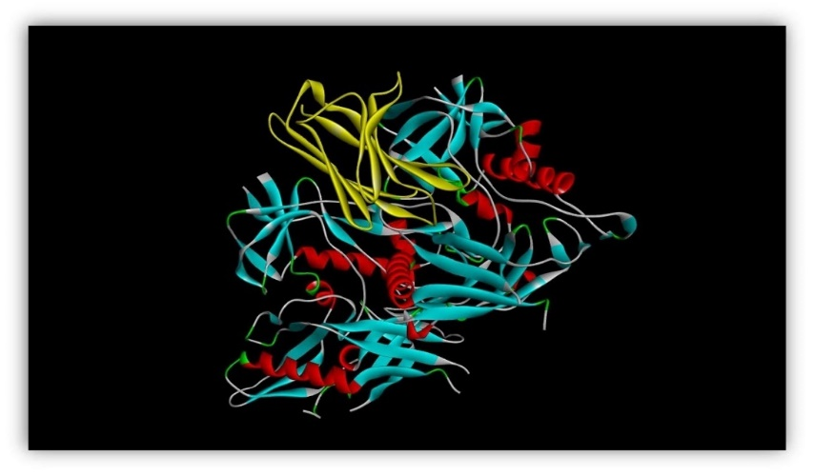

**Figure 8: Structure of docked proteins (i) HIV gp120 protein into blue, red, and green colour and (ii) T cell receptor CD8+ into yellow colour**

FireDock automatically ranks the best Docking model for the inputs based on Global energy. The more negative value of global energy stands for a more specific binding of two proteins (Esam et al., 2022). The HIVgp120 and CD4+ show a -7.58 global energy value (Table-4), and HIVgp120 and CD8+ showed a -17.63 global energy value (Table-5), which stands for both CD4+ and CD8+ have good binding efficiency with HIV gp120 protein, means both T helper cell and Cytotoxic T cell receptors can interact with HIV envelop protein gp120. The binding structure of both docked proteins opened in BIOVIA Discovery studio is shown in Figures 6 and 7.

This research aimed to design sgRNAs to target specific genes PDCD-1, CTLA-4, and NYESO-1 to activate helper T cells (CD4+) and cytotoxic T cells (CD8+) of the immune system against cancer. Based on *in-silico* analysis and findings, it can be concluded that selecting the *CRISPR/Cas9* delivery system is a crucial factor to consider when targeting tumour cells. The three sgRNAs were selected based on their specificity score, 84.39001, 64.0453326, and 77.657999 and efficiency scores, 73.863324, 76.237004, and 56.615160, respectively. The selected lentivirus-based lentiCRISPRv2 and pCas-Guide-EF1a-CD4 vectors were shown successfully in-silico cloning the designed three sgRNAs into the above vectors. They can be isolated easily in-vitro as an immunogenic living drug consisting of delivered clones as a genome of a virus surrounded by an HIV viral coat called pseudo-HIV. By analysing protein-protein interactions of HIV coat protein gp120 and T cell receptors (CD4+ and CD8+), the study showed good binding efficiency as a global energy value of -7.58 and -17.63, respectively, of the designed drug to the targeted immune genes and tumour antigen. The pipeline of this study will be the foundation for the in-vitro cancer treatment.

H.11. ***In-silico* methods associated with future directions and challenges**

1. Integration with Next-Generation Sequencing (NGS): Merging CRISPR diagnostics with NGS increases the sensitivity and throughput of pathogen and disease detection.
2. Cloud-Based CRISPR Analytics: Cloud computing environments may enable real-time analysis of CRISPR-based diagnostic output, facilitating prompt disease surveillance.
3. Standardization and Validation: *In-silico* predictions must be experimentally verified for diagnostic accuracy. Regulatory authorities will require robust frameworks to approve bioinformatics-informed CRISPR diagnostics.

**IV.Challenges and Future Aspects of CRISPR-Based Diagnostics**

CRISPR-based diagnostics, specifically CRISPR-Cas12 and CRISPR-Cas13, have exhibited significant potential due to their high specificity and precision. Nevertheless, these technologies are not devoid of challenges. Concerns regarding sensitivity and specificity persist, as the occurrence of false positives and off-target effects can complicate analyses, particularly when examining complex biological samples where background noise may affect detection accuracy. Moreover, the intricacies associated with sample preparation represent a considerable limitation. Efficient nucleic acid extraction and amplification are critical for effective diagnostics; however, these procedures are often labour-intensive and time-consuming, complicating point-of-care applications, especially in resource-limited settings. Another challenge lies in the delivery and stability of CRISPR components. The maintenance of functional Cas proteins and guide RNAs necessitates stringent storage and transportation conditions, which can be challenging to uphold in remote or underdeveloped regions.

Regulatory and ethical considerations further impede widespread adoption. International regulatory bodies, such as the FDA and EMA, require extensive validation, which can hinder the rapid implementation of these diagnostics in clinical settings. Additionally, ethical concerns surrounding genetic data privacy and the potential for misuse must be carefully addressed. Financial implications and scalability also present obstacles to accessibility. Although CRISPR diagnostics are generally more cost effective than traditional PCR methods, the associated expenses for reagents and specialized equipment can be considerable, necessitating significant investment in large-scale production and distribution to ensure equitable access for underserved populations. To address these challenges, several future advancements are being explored. The integration of CRISPR-based diagnostics with microfluidics and lab-on-a-chip technologies may streamline sample preparation, enhancing portability and efficiency for real-time disease detection. Furthermore, the adoption of isothermal amplification techniques, such as Loop-mediated Isothermal Amplification (LAMP), can simplify workflows by eliminating the need for thermal cycling, thus improving accessibility in field applications. Incorporating artificial intelligence (AI) and machine learning (ML) represents another promising avenue, as these technologies can enhance target identification, minimize false positives, and facilitate the interpretation of complex data patterns, ultimately increasing diagnostic accuracy and efficiency. Future innovations also aim to enable multiplexed detection, which would facilitate the simultaneous identification of multiple pathogens or genetic markers within a single CRISPR test. This capability would greatly improve diagnostic efficiency, particularly in syndromic testing scenarios. Additionally, ongoing research into lyophilized reagents and novel delivery mechanisms, such as nanoparticle-based systems, is expected to enhance the stability and usability of CRISPR diagnostics, making them suitable for deployment in diverse healthcare environments, including those with limited resources. In conclusion, while CRISPR-based diagnostics offer a transformative approach to molecular detection characterized by speed, precision, and affordability, several challenges must be addressed to achieve widespread clinical acceptance. Advances in microfluidics, AI integration, multiplexing, and reagent stability will be pivotal in propelling CRISPR-based diagnostics toward becoming a standard tool in contemporary healthcare.

**Conclusion**

The selection of an appropriate delivery system for CRISPR/Cas9 is a critical factor when targeting tumor cells. This chapter examines the fundamental principles of designing single guide RNAs (sgRNAs), alongside computational strategies aimed at optimising the specificity of CRISPR. Additionally, it discusses recent advancements in CRISPR-based diagnostics and therapeutics. By addressing current challenges and outlining future opportunities, this work highlights the significant potential of CRISPR technology in elucidating microbial genetics and enhancing medical applications. The findings presented herein underscore the essential role of in-silico methodologies in developing immunogenic live therapeutics, establishing a foundation for subsequent in vitro and in vivo applications, particularly in cancer treatment and infectious disease management.

**Abbreviations:**

CRISPR**;** Clustered Regularly Interspaced Short Palindromic Repeats

sgRNA;single-guide RNA sgRNA

crRNA; CRISPR RNA

CRISPRi; CRISPR interference

tracrRNA;t rans-activating crRNA

DSB; Double-stranded break

Cas: CRISPR-associated

DNA: Deoxyribonucleic acid

RNA: Ribonucleic acid

PAM: Protospacer-Adjacent Motif

DSB: Double-Stranded Break

DMD: Duchenne muscular dystrophy

CAR-T cells: Chimeric Antigen Receptor T Cells

HIV: Human immunodeficiency viruses

HBV: Hepatitis B Virus

SARS-CoV-2: Severe Acute Respiratory Syndrome Coronavirus 2

PCR: Polymerase chain reaction

gRNA: guide RNA

NCBI: National Center for Biotechnology Information

UCSC: University of California Santa Cruz genome browser

ZFNs: Zinc-Finger Nucleases

TALEN: Transcription Activator-Like Effector Nucleases

NHEJ: Non-Homologous End Joining

HDR: Homology-Directed Repair

CTA: Cancer-Testis Antigen

TCRs: T cell receptors

**Acknowledgement**

We would like to express our sincere gratitude to all the institutions for their invaluable support in conducting this research.

**Conflict of interest**

The authors declare a conflict of interest.

**References**

1. Huang YY, Zhang XY, Zhu P, Ji L. Development of clustered regularly interspaced short palindromic repeats/CRISPR-associated technology for potential clinical applications. World J Clin Cases. 2022 Jun 26;10(18):5934–45.

2. Hidalgo-Cantabrana C, Goh YJ, Barrangou R. Characterization and Repurposing of Type I and Type II CRISPR–Cas Systems in Bacteria. Vol. 431, Journal of Molecular Biology. Academic Press; 2019. p. 21–33.

3. Dominguez AA, Lim WA, Qi LS. Beyond editing: Repurposing CRISPR-Cas9 for precision genome regulation and interrogation. Vol. 17, Nature Reviews Molecular Cell Biology. Nature Publishing Group; 2016. p. 5–15.

4. Yuan S. Mitigating the Off-target Effects in CRISPR/Cas9-mediated Genetic Editing with Bioinformatic Technologies. Transactions on Materials, Biotechnology and Life Sciences. 2024;3:318–26.

5. Ganbaatar U, Liu C. CRISPR-Based COVID-19 Testing: Toward Next-Generation Point-of-Care Diagnostics. Vol. 11, Frontiers in Cellular and Infection Microbiology. Frontiers Media S.A.; 2021.

6. Gootenberg JS, Abudayyeh OO, Lee JW, Essletzbichler P, Dy AJ, Joung J, et al. Nucleic acid detection with CRISPR-Cas13a/C2c2. Science (1979). 2017 Apr 28;356(6336):438–42.

7. Aman R, Mahas A, Mahfouz M. Nucleic Acid Detection Using CRISPR/Cas Biosensing Technologies. ACS Synth Biol. 2020 Jun 19;9(6):1226–33.

8. Bakhrebah MA, Nassar MS, Alsuabeyl MS, Zaher WA, Meo SA. CRISPR technology: New paradigm to target the infectious disease pathogens. Eur Rev Med Pharmacol Sci. 2018;22(11):3448–52.

9. Razavi ZS, Soltani M, Pazoki-Toroudi H, Chen P. CRISPR-microfluidics nexus: Advancing biomedical applications for understanding and detection. Vol. 376, Sensors and Actuators A: Physical. Elsevier B.V.; 2024.

10. Binnie A, Fernandes E, Almeida-Lousada H, de Mello RA, Castelo-Branco P. CRISPR-based strategies in infectious disease diagnosis and therapy. Vol. 49, Infection. Springer Science and Business Media Deutschland GmbH; 2021. p. 377–85.

11. Bonowicz K, Jerka D, Piekarska K, Olagbaju J, Stapleton L, Shobowale M, et al. CRISPR-Cas9 in Cardiovascular Medicine: Unlocking New Potential for Treatment. Vol. 14, Cells. Multidisciplinary Digital Publishing Institute (MDPI); 2025.

12. Glass Z, Lee M, Li Y, Xu Q. Engineering the Delivery System for CRISPR-Based Genome Editing. Vol. 36, Trends in Biotechnology. Elsevier Ltd; 2018. p. 173–85.

13. Chen F, Alphonse M, Liu Q. Strategies for nonviral nanoparticle-based delivery of CRISPR/Cas9 therapeutics. Vol. 12, Wiley Interdisciplinary Reviews: Nanomedicine and Nanobiotechnology. Wiley-Blackwell; 2020.

14. Loureiro A, Da Silva GJ. Crispr-cas: Converting a bacterial defence mechanism into a state-of-the-art genetic manipulation tool. Antibiotics. 2019 Mar 1;8(1).

15. Ishino Y, Krupovic M, Forterre P. History of CRISPR-Cas from encounter with a mysterious repeated sequence to genome editing technology. J Bacteriol. 2018 Apr 1;200(7).

16. Mojica FJM, Díez-Villaseñor C, García-Martínez J, Soria E. Intervening sequences of regularly spaced prokaryotic repeats derive from foreign genetic elements. J Mol Evol. 2005 Feb;60(2):174–82.

17. Hsu PD, Lander ES, Zhang F. Development and applications of CRISPR-Cas9 for genome engineering. Vol. 157, Cell. Elsevier B.V.; 2014. p. 1262–78.

18. Hille F, Richter H, Wong SP, Bratovič M, Ressel S, Charpentier E. The Biology of CRISPR-Cas: Backward and Forward. Vol. 172, Cell. Cell Press; 2018. p. 1239–59.

19. Mohamadi S, Bostanabad SZ, Mirnejad R. CRISPR arrays: A review on its mechanism. Vol. 7, Journal of Applied Biotechnology Reports. Baqiyatallah University of Medical Sciences; 2020. p. 81–6.

20. Nussenzweig PM, Marraffini LA, Cornell W, Rockefeller /, Sloan /, Tri K. Molecular Mechanisms of CRISPR-Cas Immunity in Bacteria INTRODUCTION: THE ANATOMY OF CRISPR LOCI AND THE PHASES OF THE CRISPR IMMUNE RESPONSE. 2025; Available from: https://doi.org/10.1146/annurev-genet-022120-

21. Sternberg SH, Richter H, Charpentier E, Qimron U. Adaptation in CRISPR-Cas Systems. Vol. 61, Molecular Cell. Cell Press; 2016. p. 797–808.

22. Nuñez JK, Lee ASY, Engelman A, Doudna JA. Integrase-mediated spacer acquisition during CRISPR-Cas adaptive immunity [Internet]. Vol. 519. 2015. Available from: www.nature.com/reprints.

23. Gleditzsch D, Pausch P, Müller-Esparza H, Özcan A, Guo X, Bange G, et al. PAM identification by CRISPR-Cas effector complexes: diversified mechanisms and structures. Vol. 16, RNA Biology. Taylor and Francis Inc.; 2019. p. 504–17.

24. Mengstie MA, Wondimu BZ. Mechanism and applications of crispr/ cas-9-mediated genome editing. Vol. 15, Biologics: Targets and Therapy. Dove Medical Press Ltd; 2021. p. 353–61.

25. Wright A V., Nuñez JK, Doudna JA. Biology and Applications of CRISPR Systems: Harnessing Nature’s Toolbox for Genome Engineering. Vol. 164, Cell. Cell Press; 2016. p. 29–44.

26. Liao C, Beisel CL. The tracrRNA in CRISPR Biology and Technologies. Vol. 55, Annual Review of Genetics. Annual Reviews Inc.; 2021. p. 161–81.

27. Ghavami S, Pandi A. CRISPR interference and its applications. In: Progress in Molecular Biology and Translational Science. Elsevier B.V.; 2021. p. 123–40.

28. Newsom S, Parameshwaran HP, Martin L, Rajan R. The CRISPR-Cas Mechanism for Adaptive Immunity and Alternate Bacterial Functions Fuels Diverse Biotechnologies. Vol. 10, Frontiers in Cellular and Infection Microbiology. Frontiers Media S.A.; 2021.

29. Nguyen GT, Schelling MA, Sashital DG. CRISPR-Cas9 target-strand nicking provides phage resistance by inhibiting replication [Internet]. 2024. Available from: http://biorxiv.org/lookup/doi/10.1101/2024.09.05.611540

30. Bigini F, Lee SH, Sun YJ, Sun Y, Mahajan VB. Unleashing the potential of CRISPR multiplexing: Harnessing Cas12 and Cas13 for precise gene modulation in eye diseases. Vision Res. 2023 Dec 1;213.

31. Makarova KS, Wolf YI, Iranzo J, Shmakov SA, Alkhnbashi OS, Brouns SJJ, et al. Evolutionary classification of CRISPR–Cas systems: a burst of class 2 and derived variants. Vol. 18, Nature Reviews Microbiology. Nature Research; 2020. p. 67–83.

32. Zhu Y. Advances in CRISPR/Cas9. Vol. 2022, BioMed Research International. Hindawi Limited; 2022.

33. Chen JS, Ma E, Harrington LB, Da Costa M, Tian X, Palefsky JM, et al. CRISPR-Cas12a target binding unleashes indiscriminate single-stranded DNase activity One Sentence Summary. Vol. 360. 2018.

34. Azeez SS, Hamad RS, Hamad BK, Shekha MS, Bergsten P. Advances in CRISPR-Cas technology and its applications: revolutionising precision medicine. Vol. 6, Frontiers in Genome Editing. Frontiers Media SA; 2024.

35. Xu Y, Li Z. CRISPR-Cas systems: Overview, innovations and applications in human disease research and gene therapy. Vol. 18, Computational and Structural Biotechnology Journal. Elsevier B.V.; 2020. p. 2401–15.

36. Nimkar S, Anand B. Cas3 Mediated Target DNA Recognition and Cleavage is Independent of the Composition and Architecture of Cascade Surveillance Complex [Internet]. 2019. Available from: http://biorxiv.org/lookup/doi/10.1101/666776

37. Hoikkala V, Graham S, White MF. Bioinformatic analysis of type III CRISPR systems reveals key properties and new effector families. Nucleic Acids Res. 2024 Jul 8;52(12):7129–41.

38. Koonin E V., Makarova KS. CRISPR in mobile genetic elements: counter-defense, inter-element competition and RNA-guided transposition. Vol. 22, BMC Biology. BioMed Central Ltd; 2024.

39. Yan WX, Hunnewell P, Alfonse LE, Carte JM, Keston-Smith E, Sothiselvam S, et al. Functionally diverse type V CRISPR-Cas systems. Science (1979). 2019 Jan 4;363(6422):88–91.

40. Liu G, Lin Q, Jin S, Gao C. The CRISPR-Cas toolbox and gene editing technologies. Vol. 82, Molecular Cell. Cell Press; 2022. p. 333–47.

41. Jiang F, Doudna JA. CRISPR-Cas9 Structures and Mechanisms. 2025;17:30. Available from: https://doi.org/10.1146/annurev-biophys-

42. Yan WX, Hunnewell P, Alfonse LE, Carte JM, Keston-Smith E, Sothiselvam S, et al. Functionally diverse type V CRISPR-Cas systems. Science (1979). 2019 Jan 4;363(6422):88–91.

43. Burmistrz M, Krakowski K, Krawczyk-Balska A. RNA-targeting CRISPR–cas systems and their applications. Vol. 21, International Journal of Molecular Sciences. MDPI AG; 2020.

44. Dewitt MA, Magis W, Bray NL, Wang T, Berman JR, Urbinati F, et al. Selection-free genome editing of the sickle mutation in human adult hematopoietic stem/progenitor cells [Internet]. Available from: http://stm.sciencemag.org/

45. Long C, Amoasii L, Mireault AA, McAnally JR, Li H, Sanchez-Ortiz E, et al. Postnatal genome editing partially restores dystrophin expression in a mouse model of muscular dystrophy. Science (1979). 2016 Jan 22;351(6271):400–3.

46. Anzalone A V., Randolph PB, Davis JR, Sousa AA, Koblan LW, Levy JM, et al. Search-and-replace genome editing without double-strand breaks or donor DNA. Nature. 2019 Dec 5;576(7785):149–57.

47. Baddeley HJE, Isalan M. The Application of CRISPR/Cas Systems for Antiviral Therapy. Front Genome Ed. 2021;3.

48. Saltepe B, Bozkurt EU, Güngen MA, Çiçek AE, Şeker UÖŞ. Genetic circuits combined with machine learning provides fast responding living sensors. Biosens Bioelectron. 2021 Apr 15;178.

49. Ganbaatar U, Liu C. CRISPR-Based COVID-19 Testing: Toward Next-Generation Point-of-Care Diagnostics. Vol. 11, Frontiers in Cellular and Infection Microbiology. Frontiers Media S.A.; 2021.

50. Kwon S, Shin HY. Advanced CRISPR-Cas Effector Enzyme-Based Diagnostics for Infectious Diseases, Including COVID-19. Vol. 11, Life. MDPI; 2021.

51. Kellner MJ, Koob JG, Gootenberg JS, Abudayyeh OO, Zhang F. SHERLOCK: nucleic acid detection with CRISPR nucleases. Nat Protoc. 2019 Oct 1;14(10):2986–3012.

52. Mayorga-Ramos A, Zúñiga-Miranda J, Carrera-Pacheco SE, Barba-Ostria C, Guamán LP. CRISPR-Cas-Based Antimicrobials: Design, Challenges, and Bacterial Mechanisms of Resistance. Vol. 9, ACS Infectious Diseases. American Chemical Society; 2023. p. 1283–302.

53. Du D, Qi LS. An introduction to CRISPR technology for genome activation and repression in mammalian cells. Cold Spring Harb Protoc. 2016 Jan 1;2016(1):1–5.

54. Liu XS, Wu H, Krzisch M, Wu X, Graef J, Muffat J, et al. Rescue of Fragile X Syndrome Neurons by DNA Methylation Editing of the FMR1 Gene. Cell. 2018 Feb 22;172(5):979-992.e6.

55. van Pijkeren JP, Britton RA. Precision genome engineering in lactic acid bacteria. Microb Cell Fact. 2014 Aug 29;13(1).

56. Miki D, Zhang W, Zeng W, Feng Z, Zhu JK. CRISPR/Cas9-mediated gene targeting in Arabidopsis using sequential transformation. Nat Commun. 2018 Dec 1;9(1).

57. Wei J, Li Y. CRISPR-based gene editing technology and its application in microbial engineering. Vol. 3, Engineering Microbiology. Elsevier B.V.; 2023.

58. Maeder ML, Gersbach CA. Genome-editing technologies for gene and cell therapy. Vol. 24, Molecular Therapy. Nature Publishing Group; 2016. p. 430–46.

59. Montaño A, Forero-Castro M, Hernández-Rivas JM, García-Tuñón I, Benito R. Targeted genome editing in acute lymphoblastic leukemia: A review. Vol. 18, BMC Biotechnology. BioMed Central Ltd.; 2018.

60. Lee CM, Cradick TJ, Fine EJ, Bao G. Nuclease target site selection for maximizing on-target activity and minimizing off-target effects in genome editing. Vol. 24, Molecular Therapy. Nature Publishing Group; 2016. p. 475–87.

61. Chehelgerdi M, Chehelgerdi M, Khorramian-Ghahfarokhi M, Shafieizadeh M, Mahmoudi E, Eskandari F, et al. Comprehensive review of CRISPR-based gene editing: mechanisms, challenges, and applications in cancer therapy. Vol. 23, Molecular Cancer. BioMed Central Ltd; 2024.

62. Zhang F, Wen Y, Guo X. CRISPR/Cas9 for genome editing: progress, implications and challenges Downloaded from [Internet]. at Serials Section Norris Medical Library. 2014. Available from: http://hmg.oxfordjournals.org/

63. Stefanoudakis D, Kathuria-Prakash N, Sun AW, Abel M, Drolen CE, Ashbaugh C, et al. The Potential Revolution of Cancer Treatment with CRISPR Technology. Vol. 15, Cancers. MDPI; 2023.

64. Deltcheva E, Chylinski K, Sharma CM, Gonzales K, Chao Y, Pirzada ZA, et al. CRISPR RNA maturation by trans-encoded small RNA and host factor RNase III. Nature. 2011 Mar 31;471(7340):602–7.

65. Karlapudi AP, T.C V, Tammineedi J, Srirama K, Kanumuri L, Prabhakar Kodali V. In silico sgRNA tool design for CRISPR control of quorum sensing in Acinetobacter species. Genes Dis. 2018 Jun 1;5(2):123–9.

66. Vigneron N. Human Tumor Antigens and Cancer Immunotherapy. Vol. 2015, BioMed Research International. Hindawi Limited; 2015.

67. Fratta E, Coral S, Covre A, Parisi G, Colizzi F, Danielli R, et al. The biology of cancer testis antigens: Putative function, regulation and therapeutic potential. Vol. 5, Molecular Oncology. John Wiley and Sons Ltd; 2011. p. 164–82.

68. Li T, Yang Y, Qi H, Cui W, Zhang L, Fu X, et al. CRISPR/Cas9 therapeutics: progress and prospects. Vol. 8, Signal Transduction and Targeted Therapy. Springer Nature; 2023.

69. Li D, Li X, Zhou WL, Huang Y, Liang X, Jiang L, et al. Genetically engineered t cells for cancer immunotherapy. Vol. 4, Signal Transduction and Targeted Therapy. Springer Nature; 2019.

70. Fricano-Kugler CJ, Williams MR, Luikart B, Salinaro JR, Li M. Designing, packaging, and delivery of high titer crispr retro and lentiviruses via stereotaxic injection. Journal of Visualized Experiments. 2016 May 23;2016(111).

71. Labun K, Montague TG, Gagnon JA, Thyme SB, Valen E. CHOPCHOP v2: a web tool for the next generation of CRISPR genome engineering. Nucleic Acids Res. 2016 Jul 8;44(W1):W272–6.

72. Naito Y, Hino K, Bono H, Ui-Tei K. CRISPRdirect: Software for designing CRISPR/Cas guide RNA with reduced off-target sites. Bioinformatics. 2015 Apr 1;31(7):1120–3.

73. Stemmer M, Thumberger T, Del Sol Keyer M, Wittbrodt J, Mateo JL. CCTop: An intuitive, flexible and reliable CRISPR/Cas9 target prediction tool. PLoS One. 2015 Apr 24;10(4).

74. Aach J, Mali P, Church GM. CasFinder: Flexible algorithm for identifying specific Cas9 targets in genomes [Internet]. 2014. Available from: http://biorxiv.org/lookup/doi/10.1101/005074

75. Bevilacqua V, Menolascina F, Aurora D, Lucivero S, Quatela NF. A Novel Tool for Assisted In-silico Cloning and Sequence Editing in Molecular Biology. Vol. 93, CCIS. 2010.

76. Kamens J. Addgene: Making Materials Sharing “Science As Usual.” PLoS Biol. 2014;12(11).

77. Schneidman-Duhovny D, Inbar Y, Nussinov R, Wolfson HJ. PatchDock and SymmDock: Servers for rigid and symmetric docking. Nucleic Acids Res. 2005 Jul;33(SUPPL. 2).

78. Mashiach E, Schneidman-Duhovny D, Andrusier N, Nussinov R, Wolfson HJ. FireDock: a web server for fast interaction refinement in molecular docking. Nucleic Acids Res. 2008;36(Web Server issue).

79. Baroroh, S.Si., M.Biotek. U, Muscifa ZS, Destiarani W, Rohmatullah FG, Yusuf M. Molecular interaction analysis and visualization of protein-ligand docking using Biovia Discovery Studio Visualizer. Indonesian Journal of Computational Biology (IJCB). 2023 Jul 21;2(1):22.

80. Matson AW, Hosny N, Swanson ZA, Hering BJ, Burlak C. Optimizing sgRNA length to improve target specificity and efficiency for the GGTA1 gene using the CRISPR/Cas9 gene editing system. PLoS One. 2019 Dec 1;14(12).

81. Schneidman-Duhovny D, Inbar Y, Nussinov R, Wolfson HJ. PatchDock and SymmDock: Servers for rigid and symmetric docking. Nucleic Acids Res. 2005 Jul;33(SUPPL. 2).

82. Andrusier N, Nussinov R, Wolfson HJ. FireDock: Fast interaction refinement in molecular docking. Proteins: Structure, Function and Genetics. 2007 Oct;69(1):139–59.