**Significance of Sustainable Agricultural Systems and Farming Practices in Environmental Conservation**

Waikhom Arunkumar Meetei1, Heikham Narmila Devi2\* and Techi Yajo Tara1

1Department of Rural Development and Agricultural Production

2Department of Agribusiness Management and Food Technology

North-Eastern Hill University, Tura Campus, Meghalaya-794002, India

\*Corresponding author: hnarmiladevi@gmail.com

**Abstract**

Manipur, rich in biodiversity and indigenous communities, reflects a complex relationship between human activity and ecological sustainability. The historical coexistence of indigenous communities with nature in the region lays the foundation for local knowledge systems and environmental stewardship. However, there is a dearth of scientific work portraying the diverse systems of conservation measures in this state. Therefore, the present study aims to provide a comprehensive overview of the pivotal roles of society, sustainable agriculture and farming systems in environmental conservation. This study highlights the importance of nature-oriented lifestyles, cultural beliefs, sustainable agricultural practices and traditional ecological knowledge in conservation efforts. This study has significant implications for the research community, society, government machinery and all stakeholders.

**Keywords:** Manipur, conservation, indigenous, farming system, sustainable agriculture

**Introduction**

The North-Eastern Region (NER) of India has a marked reputation for environmental conservation in the country. The people possess strong socio-cultural values in term of environment, as evident by the lush green forests and diverse wildlife being preserved till now and sustainable lifestyles of the indigenous communities in the region. People living near forests depend on forest resources to meet their subsistence needs, while encouraging conservation through their customary laws, religious beliefs, and cultural practices1. As a crucial part of the Indo-Burma biodiversity hotspot, Manipur is known for its rich biological diversity and diverse ethnic communities. Geographically, the state is characterized by a central valley enclosed by parallel ranges of lush green hills. Approximately 70.79% of the state's total population lives in rural areas, while the rest (29.21%) lives in urban areas2. The state's population consists of more than 30 distinct groups. The Meitei, Naga, Kuki and Meitei Pangal are the dominant communities of the state. Distinctive customs, traditions, linguistic diversities, dietary practices, traditional attire, cultural dances and festivals of different communities form the backbone of cultural and knowledge diversity of the state.

The state's environmental significance is reflected in its forest coverage of 74.34%, comprising 16,598 km² of total forest cover distributed across very dense forests (905 km²), moderately dense forests (6,228 km²) and open forests (9,465 km²)3. This extensive forest cover supports remarkable biodiversity featuring numerous angiosperms, gymnosperms, pteridophytes, bryophytes, medicinal plants, edible fungi, orchids, bamboos, mammals, fish species, birds, etc. Manipur has a rich gene pool of primitive cultivars and land races of various agri-horticultural crops, with several important underutilized fruits and vegetables. The state also possesses four GI-tagged agricultural products, namely, Kachai Lemon, Tamenglong Orange, Sirarakhong Hathei and Chak-hao. Moreover, well-known endangered species include *Rucervis eldi eldi* (Sangai) and *Lilium macklinae* (Shirui Lily). Many studies have documented the diversity and ethnobotanical uses of hundreds of medicinal plants in the state4,5. The state’s biological diversity is recognized by numerous protected sites, including national parks, wildlife sanctuaries and biosphere reserves (Table 1).

Table 1. Protected sites of Manipur

|  |  |  |
| --- | --- | --- |
| **Types of Protected Sites** | **Total number** | **Names** |
| National Park | 2 | Keibul Lamjao, Shiroi |
| Wildlife Sanctuary | 7 | Yangoupokpi Lokchao, Khongjaingamba Ching, Jiri Makru, Kailam, Zeilad, Bunning, Thinungei Bird Sanctuary |
| Community Reserves | 15 | Pfunemai, Azuram, Chiibvii & Veimairii, Sofii Khro, Baneevehdea, Houphai, Chipeivao, Lungphu, Mekrimai Ru & Makramai Bu, Shangneme, M. Tanglian, Lailong S., S. Mollen, Chiuluan, Razai |
| Ramsar Sites | 1 | Loktak Lake |

However, the recent decline in biodiversity and forest cover in the state is concerning. Manipur accounts for 24.41% of the total forest cover loss in the northeastern region, representing a decline of 249 km² out of the total loss of 1020 km² in the region3. This is attributed to shifting cultivation, deforestation, natural calamities, anthropogenic pressure, developmental activities and hydroelectric dams3. Given this issue, it is crucial to re-examine traditional practices and redefine societal roles in environmental conservation.

**Role of Society in environmental conservation**

The responsibility of environmental conservation is not only fixed for government agencies and environmentalists but for each one of us living on this planet. The relationship between human communities and their environment is a critical factor in determining the sustainability of ecological systems. Environmental conservation begins with awareness, and the region's inhabitants possess profound ecological knowledge deeply embedded in their belief systems and social structures. The significant roles of society in the environment conservation are reflected in their integral practices and belief systems. This chapter provides a critical overview of different conservation mechanisms prevalent in the state of Manipur such as socio-cultural and religious beliefs, sacred groves, traditional agricultural systems, home gardens and environmental movements (Fig. 1).

Fig. 1: Role of society in the conservation of the environment in Manipur.

Sacred groves in Manipur, traditionally protected by religious and cultural beliefs, serve as critical biodiversity hotspots and carbon stock reserves, conserving a wide range of flora, fauna and microbes through community-enforced taboos and spiritual practices6,7. A total of 166 sacred groves in the Manipur Valley, associated with belief systems such as the Meitei religion and the worship of *Umanglai* deities, exemplify community-led conservation embedded in socio-religious frameworks6,7. The Meitei community associates flowering patterns and plant characteristics with various ecological and cultural meanings-for instance, *Agave americana* is used to predict wind and storms, *Alocasia indica* is linked to familial difficulties, and *Ficus rumphii* nesting by crows forecasts rainfall8. Other plants like *Brassica campestris, Hibiscus cannabinus,* and *Platycerium wallichii* are believed to signal seasonal transitions or metaphysical phenomena, while species such as *Quercus serrata* are avoided in construction due to spiritual beliefs8. The Mao Naga people observe flowering in species such as *Mantisia spathulata, Bauhinia purpurea* L. and *Prunus carmesina* as signals for the onset of rain and optimal periods for planting crops like paddy, maize, and vegetables9. Similarly, the Tangkhul regard the flowering of *Lilium macklinae* as a cue for paddy cultivation10. Environmental conservation campaigns and activism in Manipur play a crucial role in opposing environmentally detrimental activities11,12,13. They reflect a profound collective commitment to environmental stewardship. These grassroots movements inspire global advocacy for nature protection, demonstrating how communities can mobilize even when confronting formidable institutions such as government bodies and large corporations.

**Farming systems and indigenous knowledge**

The population of the state is predominantly dependent on agriculture, horticulture, forestry, and animal husbandry. They typically employ traditional and sustainable farming systems that are adapted to local geographical conditions. Local farmers’ knowledge of sustainable agriculture represents a vast body of practical experience and the capacity for knowledge generation, both of which are crucial for achieving sustainability and development goals.

The Mao Naga community practices a unique form of terrace farming9, where fields are carved out of hill slopes to create dikes that retain water and prevent erosion. This method enhances soil moisture conservation and improves agricultural productivity while safely managing runoff. The community employs various natural fertilizers and incorporates non-cereal crops to maintain soil organic matter. Innovative anti-erosion measures like bamboo, stones, and gunny bags are utilized, contributing to improved soil quality and sustainable farming practices. Furthermore, eco-friendly methods, conservation tillage and crop rotation play a vital role in boosting soil health and supporting community-based agricultural systems through the *Ava Kocho* practice9.

Rice-fish culture is practiced among the Mao Naga tribe and Meitei community, featuring indigenous carps like *Labeo rohita*, *Channa punctata*14,15. Farmers cultivate these fish alongside local rice varieties. This culture is important for soil health as fish act as bio-control agents and aid in nutrient cycling. Extensive research has been conducted on rice-fish culture and its significance for rural development in Assam and Arunachal Pradesh. *Panikheti* system of rice cultivation (terracing, diverting water from hills to terraces16. Pond-based farming systems integrate pisciculture, fruit crops, vegetables, and animal husbandry16.

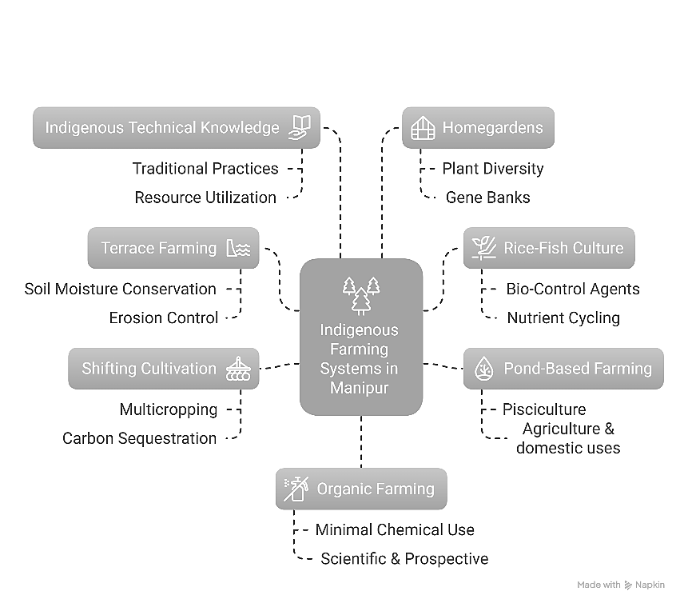

Fig. 2: Farming systems and indigenous knowledge of different communities of Manipur and their significance in environmental conservation.

*Jhum* (shifting cultivation) is predominantly found in the hilly regions of Manipur. Though it was various environmental impact mainly owing to decline in period of shifting cycle, jhum cultivation is also known to exhibit various positive attributes such as multicropping, crop rotation, carbon sequestration, source of gene pools, conservation of soil and water17,18. The topographical differences and indigenous innovations prove to be the unique trigger for sustainable management of resources18,19.

The indigenous technical knowledge about agriculture and allied sectors has been a stronghold for sustainable agriculture in the state. Use of ash to crops, burning of left-over straws, soaking of paddy seeds with cowdung, pit nursery for seedlings, protection of crops (using papers, bamboo sticks, polythene), using locally available manures, etc. are common in the state20,21. Meitei and Tangkhul farmers use *Artemisia nilagrica* against insects and pest infestation of rice21. Chinese mustard is used as trap crop for cole crops and bamboo for *Parkia* plant21. Mixed farming systems such as duck rearing in paddy field, poultry in mulberry plantation provide mutual benefits and optimum utilization of resources21. This indigenous technical knowledge reduces the pressure on harsh chemical means in crop management and production.

Home-gardens constitute a fundamental component of the local sociocultural framework, facilitating employment opportunities and supplementary income. They play a vital role in both *ex situ* and *in situ* conservation strategies, safeguarding local floral diversity and functioning as dynamic gene banks for both indigenous and cultivated species22,23. They provide an environmentally sustainable mechanism for waste management through the composting of domestic refuse, such as organic kitchen waste and paper, which can subsequently be utilized to enhance soil fertility. The traditional home-gardens prevalent among various communities in Manipur exhibit considerable biological diversity, hosting numerous local crop varieties, including medicinal flora, construction materials, fruits, vegetables, spices, wild plants and animal feeds23. Farmers exhibit a strong awareness of the plant species they cultivate, thereby reflecting their extensive ecological knowledge23.

The success of organic farming initiatives and community-based conservation efforts demonstrates the viability of scaling up traditional approaches through appropriate policy frameworks and market mechanisms. Traditional farming methods that use few fertilizers and chemicals can easily transition to organic farming. Farmers have a strong mindset against the use of chemicals. This farming system has been proven to be sustainable and feasible socially, ecologically, technologically and economically. Manipur Organic Mission Agency (MOMA) is taking the lead role to promote organic farming and related activities in Manipur state. A brand has been created the “Organic Manipur” to visually propagate values, narratives and quality parameters. The organic farming area in Manipur stands at 7172.00 ha, while the conversion area is recorded as 25.412.50 ha, making the total area 32584.50 ha24. National Programme for Organic Production (NPOP), Mission Organic Value Chain Development for North East Region (MOVCD-NER) and Act East Policy are significant opportunities for the organic farming sector of the state.

**Conclusion and Future Directions**

Manipur’s experience of sustainable agriculture and traditional ecological knowledge upholds the important role of society in environmental conservation. Socio-cultural diversity and rigid religious beliefs are major factors for the strong standing of environmental entities. The indigenous communities have developed sophisticated agricultural and conservation systems that maintain biodiversity while providing livelihoods for rural populations. Sacred groves, traditional farming systems, home-gardens and community-based management practices demonstrate effective conservation approaches that complement formal protection mechanisms. Further systematic documentation and scientific interventions are needed to achieve affirmative and long-term benefits. Including traditional knowledge and indigenous peoples in policy development and implementation will greatly improve outcomes. The integration of traditional ecological knowledge with contemporary conservation science offers a promising pathway for achieving sustainable development and lasting biodiversity protection.

**References**

1. Tynsong, H., Dkhar, M., & Tiwari, B.K. (2020). Traditional ecological knowledge of tribal communities of North East India. Biodiversitas Journal of Biological Diversity, *21*(7), 3209–24.
2. Census India. (n.d.). *Manipur Population Census 2011, Manipur Religion, literacy, Sex Ratio - Census India*. Available at [https://www.censusindia.co.in/states/manipur](https://www.censusindia.co.in/states/manipur" \t "_new)
3. Webline Infosoft Pvt. Ltd. Welcome to Forest Survey of India. (n.d.). Available at [https://fsi.nic.in/forest-report-2021](https://fsi.nic.in/forest-report-2021" \t "_new)
4. Meitei, L. R, De, A., & Mao, A. A. (2022). An ethnobotanical study on the wild edible plants used by forest dwellers in Yangoupokpi Lokchao Wildlife Sanctuary, Manipur, India. Ethnobotany Research and Applications, *23*(15), 1–25.
5. Yaipharembi, N., Huidrom, E., Nongalleima, K., & Singh, H. B. (2023). An ethnobotanical study on the dietary use of wild trees as traditional vegetables by three ethnic communities in Manipur, North East India. Economic Botany, *77*(3), 324–39.
6. Khumbongmayum, A. D., Khan, M. L., & Tripathi, R. S. (2005). Sacred groves of Manipur, northeast India: biodiversity value, status and strategies for their conservation. Biodiversity and Conservation, *14,* 1541-1582.
7. Waikhom, A. C., Nath, A. J., & Yadava, P. S. (2018). Aboveground biomass and carbon stock in the largest sacred grove of Manipur, Northeast India. Journal of Forestry Research, *29,* 425–428.
8. Singh, H. B. (2024). Folklore, traditional beliefs, taboo and practices on climate and weather forecasting by the Meitei community of Manipur, North East India. In: *Addressing the Climate Crisis in the Indian Himalayas: Can Traditional Ecological Knowledge Help?* p. 281–291. Cham: Springer Nature Switzerland.
9. Kamei, J., Bain, W. K., & Biswas, S. (2023). Investigation into the traditional terrace farming process and associated knowledge systems among the Mao Naga community in Mao Maram Sub-division, Senapati District, Manipur- An anthropological appraisal. Heritage: Journal of Multidisciplinary Studies in Archaeology, *11*(1), 1213-1242.
10. Varah, F., & Varah, S. K. (2022). Indigenous knowledge and seasonal change: insights from the Tangkhul Naga in Northeast India. GeoJournal, *87*(6), 5149–63.
11. Baite, N. S. D., & Easwaran, K. (2022). Community participation, activism, and community development in Moreh, Manipur. Mizoram University Journal of Humanities and Social Sciences, *8*(1), 201–214.
12. Khuman, K. B. (2023). People’s movement against Tipaimukh project in Manipur: An assessment. International Journal of Multidisciplinary Research and Growth Evaluation, *4*(4), 65-74.
13. Kangujam, L., & Pandey, I. (2021). The stealth of nations: informal workers in the global economy. Harvard International Review, *42*(1), 82–87.
14. Haobijam, J. W., Balkho, M. R., & Mandal, T. K. (2018). Paddy-cum-fish cultivation and the challenges faced by the farmers of Manipur, India. International Journal of Current Microbiology and Applied Sciences, *7*(2), 998–1004.
15. Abujam, S., Soram, J. S., Singh, L. S., Sarma, J., & Bhowmik, D. (2024). Traditional rice-fish farming of Mao indigenous community, Manipur, India. International Journal of Ecology and Environmental Sciences, *50*(5), 799-804.
16. Das, A., Idapuganti, R. G., Choudhury, B. U., Munda, G. C., Patel, D. P., Ngachan, S. V., Ghosh, P. K., Tripathi, A. K., Das, S., & Kumar, M. (2012). Natural resource conservation through indigenous farming systems: wisdom alive in North East India. Indian Journal of Traditional Knowledge, 11(3), 505-513.
17. Reimeingam, M. (2017). Shifting cultivation in Manipur: land, labour and environment. Journal of Rural Development, *36*(1), 97-119.
18. Pfoze, N. L., Chhetry, G. K. N., Chanu, L. B., & Devi, P. A. (2010). Indigenous traditional cultivation practices of the Mao ethnic tribe under Senapati District in Manipur. Assam University Journal of Science and Technology, *5*(1), 105-108.
19. Sitlhou, H. (2020). Sacred ecology and ritual practices of the Thadou Kukis of Manipur. The Eastern Anthropologist, *73*(3-4), 445-62.
20. Devi, C. V., & Adhikary, M. M. (2018). Imperatives of indigenous knowledge along with the hill farmers of Manipur. *Journal of Crop and Weed*, *14*(1), 130-133.
21. Ansari, M. A., Sharma, S. K., Roy, S. S., Ramakrishna, Y., Datt, S., Ningombam, A., Singh, N. A., Luiram, S., & Prakash, N. (2021). Documenting the agriculture-based indigenous traditional knowledge in Manipur State of North Eastern India. Indian Journal of Traditional Knowledge, *20*(4), 1065–1074.
22. Tangjang, S., & Arunachalam, A. (2009). Role of traditional homegarden systems in Northeast India. Indian Journal of Traditional Knowledge, *8*(1), 47–50.
23. Shimrah, T., Lungleng, P., Shimrah, C., Khuman, Y. S. C., & Varah, F. (2018). Role of traditional homegardens in biodiversity conservation and socioecological significance in Tangkhul community in Northeast India. Tropical Ecology, *59*(3), 533-539.
24. Agricultural and Processed Food Products Export Development Authority (APEDA). (2025). *Organic Certification Data*. Available at [http://sec-npop.apeda.in/Organic-Certification-Data](http://sec-npop.apeda.in/Organic-Certification-Data" \t "_new)